Transmission Type and Fuel Efficiency
Alyssa Goldberg
January 10, 2016

Executive Summary

Hypotheses and Questions
Using the mtcars dataset from a 1974 Motor Trend US magazine, we examine the following hypotheses: $H_{0}$ = There is no significant difference in fuel efficiency between cars with automatic and manual transmission. $H_{01}$ = There are no confounding variables that contribute to the acceptance or rejection of $H_{0}$.
- Is an automatic or manual transmission better for MPG ?
- If so, quantify the MPG difference between automatic and manual transmissions

Summary of Findings
All figures are in the appendix 1. Cars with manual transmission get 7.24 more mpg than automatic transmission when only transmission type is considered 2. Exploring regression models using multivariate analysis strongly suggests that both weight wt, number of cylinders cyl and hp have a significant confounding effect on fuel efficiency as it relates to transmission type.
With other variables factored in, cars with manual transmission get an additional 1.8 mpg better than those with automatic transmission.

Data
The data was extracted from the 1974 Motor Trend US magazine, and comprises fuel consumption and 10 aspects of automobile design and performance for 32 automobiles (1973-74 models).
Note: The 1/4 mile time qsec is a measure of performance rather than a manufacturing variable and thus we remove qsec from the dataset for the purposes of analysis.

Factors and Measurements
mpg Miles/(US) gallon (the measure of, performance we are interested in), disp Displacement (cu.in.), hp Gross horsepower, drat Rear axle ratio, wt Weight (lb/1000), qsec 1/4 mile time, cyl Number of cylinders, vs V/S, am Transmission (0 = automatic, 1 = manual), gear Number of forward gears, carb Number of carburetors.
Figure 1 and Table 1 (below) include only mpg and am indicate that manual transmission has a mean mpg 7.245 automatic.
A t-test of mpg and am can reveal both the confidence interval and p-values for the two factors in the am variable:
t.test(mtcars[,-7]$mpg~mtcars[,-7]$am)
##
## Welch Two Sample t-test
##
## data: mtcars[, -7]$mpg by mtcars[, -7]$am
## t = -3.7671, df = 18.332, p-value = 0.001374
## alternative hypothesis: true difference in means is not equal to 0
## 95 percent confidence interval:
## -11.280194 -3.209684
## sample estimates:
## mean in group Automatic mean in group Manual
## 17.14737 24.39231
The CI, -11.2801944, -3.2096842, does not contain zero and a p-value of 0.0013736, significantly better than our 95% confidence level $alpha=0.05$. If the only two variable measured were fuel efficiency and transmission type, we could safely reject $H_{0}$.
There are 8 additional manufacturing variables in the data set and the adjusted $R^{2}$ for mpg~am is low, only 0.338, so transmission alone accounts for only 33.85% of the total effect. We need to find a better model.
kable(xt, caption = "Table 1: Linear Regression Coefficients for Automatic vs. Manual Transmission")
 | Estimate | Std. Error | t value | Pr(>|t|)
(Intercept) | 17.147368 | 1.124602 | 15.247492 | 0.000000
amManual | 7.244939 | 1.764422 | 4.106127 | 0.000285
Table 1: Linear Regression Coefficients for Automatic vs. Manual Transmission
Figure 2 shows that cyl, disp, wt and hp all have a negative effect on fuel efficiency.

Find the Best Model

Step Analysis for AIC
We employ R's step() function to find the model with the lowest AIC. (results hidden to limit length of report) and produce a table comparing our three models, mpg ~ am, mpg ~ . and the result of the step analysis, mpg ~ cyl + hp + wt + am.
fitAIC=extractAIC(lm(mpg ~ am, mtcars[,-7]))
allAIC=extractAIC(lm(mpg ~ ., mtcars[,-7]))
bestAIC=extractAIC(lm(mpg ~ cyl + hp + wt + am, mtcars[,-c(7)]))
tblAIC<-as.data.frame(rbind("mpg ~ am"= fitAIC[2],"mpg ~ ." = allAIC[2],"mpg ~ cyl + hp + wt + am" = bestAIC[2]))
names(tblAIC)<-"AIC"
kable(tblAIC, caption = "Comparison of AIC Values of Three Models")
 | AIC
mpg ~ am | 103.67231
mpg ~ . | 74.73161
mpg ~ cyl + hp + wt + am | 61.65483
Comparison of AIC Values of Three Models
The model which includes: mpg~cyl + hp + wt + am has the lowest AIC value of 61.654829 and is recommended as the best fit by the step analysis. A summary of the best fit model coefficients confirm we are moving in the right direction. The net influence of the am variable when am = 1 (manual transmission) is 1.809. We will continue to test this model against the others.
 | Estimate | Std. Error | t value | Pr(>|t|)
(Intercept) | 33.7083239 | 2.6048862 | 12.940421 | 0.0000000
cyl6 | -3.0313445 | 1.4072835 | -2.154040 | 0.0406827
cyl8 | -2.1636753 | 2.2842517 | -0.947214 | 0.3522509
hp | -0.0321094 | 0.0136926 | -2.345025 | 0.0269346
wt | -2.4968294 | 0.8855878 | -2.819404 | 0.0090814
amManual | 1.8092114 | 1.3963045 | 1.295714 | 0.2064597

Analysis of Variance
An analysis of variance shows us that number of cyl, wt and disp are significant at a 95% confidence level, while the p-value of hp is higher than .05 indicating we might reject it as a significant factor.
kable(as.data.frame(summary(aov(mpg~., data))[[1]]))
 | Df | Sum Sq | Mean Sq | F value | Pr(>F)
cyl | 2 | 824.784590 | 412.392295 | 54.2425208 | 0.0000001
disp | 1 | 57.642804 | 57.642804 | 7.5818366 | 0.0141316
hp | 1 | 18.502205 | 18.502205 | 2.4336203 | 0.1383175
drat | 1 | 11.914476 | 11.914476 | 1.5671272 | 0.2286170
wt | 1 | 55.786898 | 55.786898 | 7.3377268 | 0.0154894
vs | 1 | 1.391962 | 1.391962 | 0.1830867 | 0.6744376
am | 1 | 13.368787 | 13.368787 | 1.7584147 | 0.2034425
gear | 2 | 3.390542 | 1.695271 | 0.2229813 | 0.8025747
carb | 5 | 17.620932 | 3.524186 | 0.4635410 | 0.7976639
Residuals | 16 | 121.643991 | 7.602749 | NA | NA
The next step in finding out how closely correlated these confounding variables are. A correlation matrix (figure X) shows that disp and cyl have a correlation of 90% while wt and disp are 89%. Both show significantly lower p-values so it is possible that including disp to a model might result in "overfit."
kable(c4, caption = "Correlation among variables with lowest p-value in analysis of variance model")
 | correlation
wt & cyl | 0.7824958
wt & disp | 0.8879799
cyl & disp | 0.9020329
Correlation among variables with lowest p-value in analysis of variance model
We compare several models to determine which one is truly "best" and the fourth model which retains hp does have the highest $R^{2}$: 0.8400875, accounting for 84% of the variability in fuel efficiency.
kable(fitsummary)
 | Adj. R-squared
mpg ~ . | 0.8015942
mpg ~ am | 0.3384589
mpg ~ cyl + wt + am | 0.8121603
mpg ~ cyl + hp + wt + am | 0.8400875
Running an ANOVA test on our best fit model and our original model we see that with a p-value of 1.6910^{-8} indicating that we can reject $H_{01}$ that number of cylinders, weight and horsepower are not confounding factors (more cylinders = lower mpg, higher weight = lower mpg, higher horsepower=lower mpg ) to transmission type as regards fuel efficiency.
Finally, we see that when number of cylinders, weight and horsepower are included as confounding variables, the net increase in fuel efficiency for an automobile with automatic transmission is 1.809
The table below generated with R's bootstrap function lists the relative importance of each variable and how much it contributes to the final $R^{2}$ value of 84%.
kable(btbl,caption = "% contribution to R-squared value of best fit model" )
 | % Contribution
cyl | 32.12
hp | 29.59
wt | 24.80
am | 13.49
% contribution to R-squared value of best fit model

Appendix
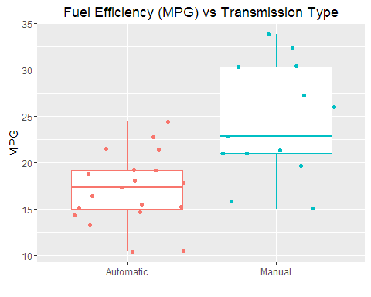
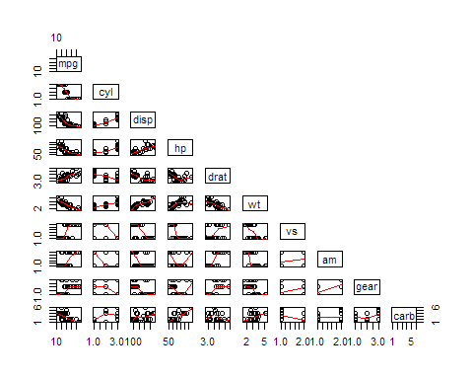
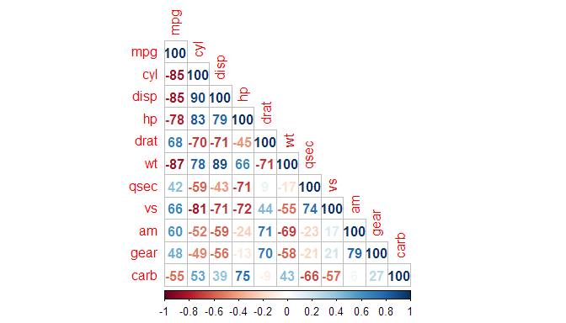
Figure 4: Residual Plots 