Study: PAL0708

From: 2009-11-09 To: 2009-12-01

Alyssa Goldberg

2020-09-01

Table of Contents

# Eggs Observed

Number of eggs observed by date within 2009-11-09 and 2009-12-01

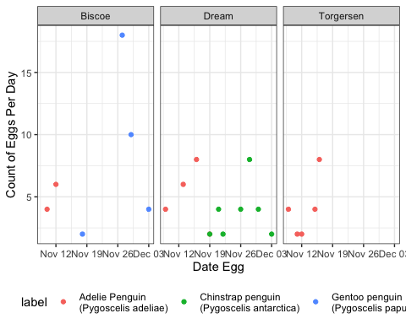

# Body Mass

Body mass distribution among the separate species

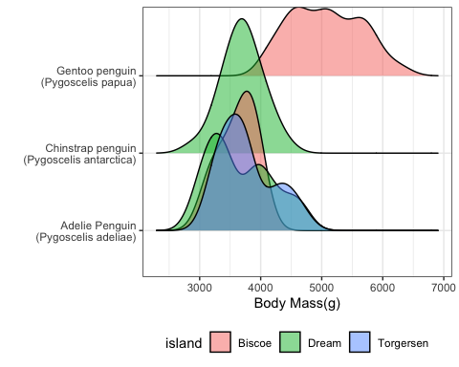

# Flipper Length and Body Mass

Comparison of flipper length as a function of body mass 