**NAME:-** ANMOL PANDEY

**Enrolment No. :-** E22CSEU1069

**LAB-2 Solns**

**Task-1**

1. **Bus Topology**: In a bus topology, all devices are connected to a single central cable, the bus. Data from the source travels in both directions to all machines connected on the bus network until it finds the intended recipient.

2. **Star Topology**: In a star topology, all devices are connected to a central hub. The hub acts as a repeater for data flow. This means that data sent by one device to another has to pass through the central hub.

3. **Ring Topology**: In a ring topology, each device is connected to two other devices, forming a circular network path. Data travels from one device to another in a circular manner until it reaches its destination.

4. **Hybrid Topology**: A hybrid topology is a combination of two or more different types of topologies. It inherits the advantages and disadvantages of the topologies it is composed of. The structure of the network depends on the specific topologies used.

**Task-2**

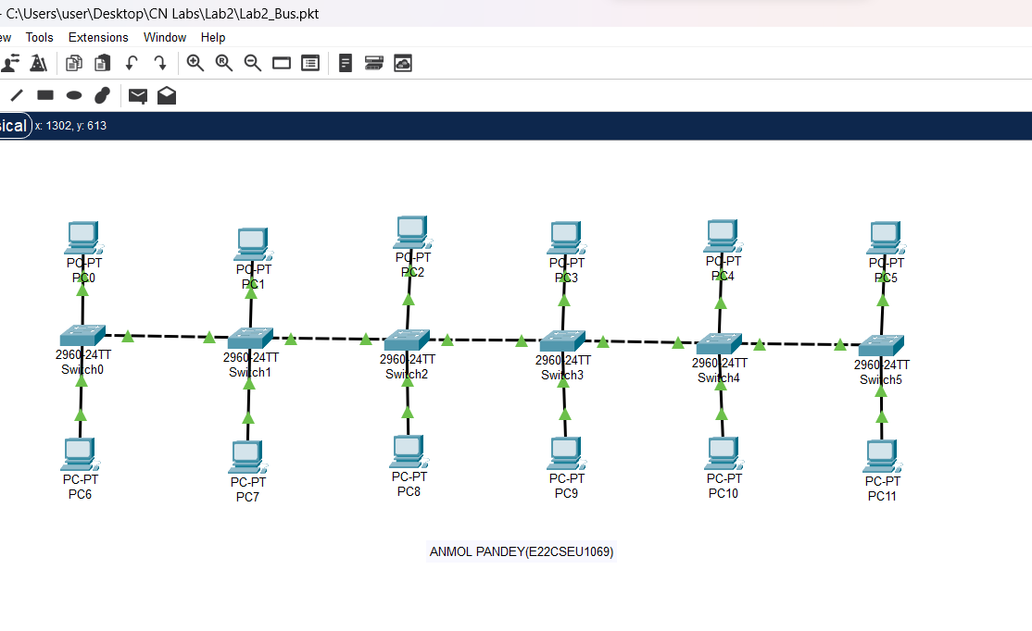

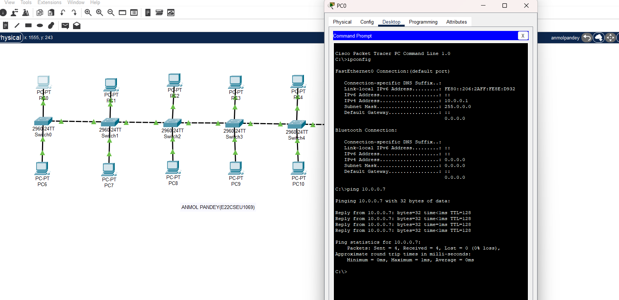

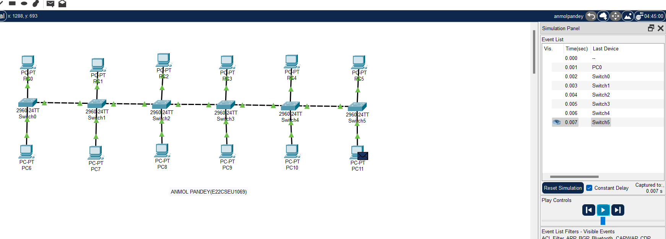

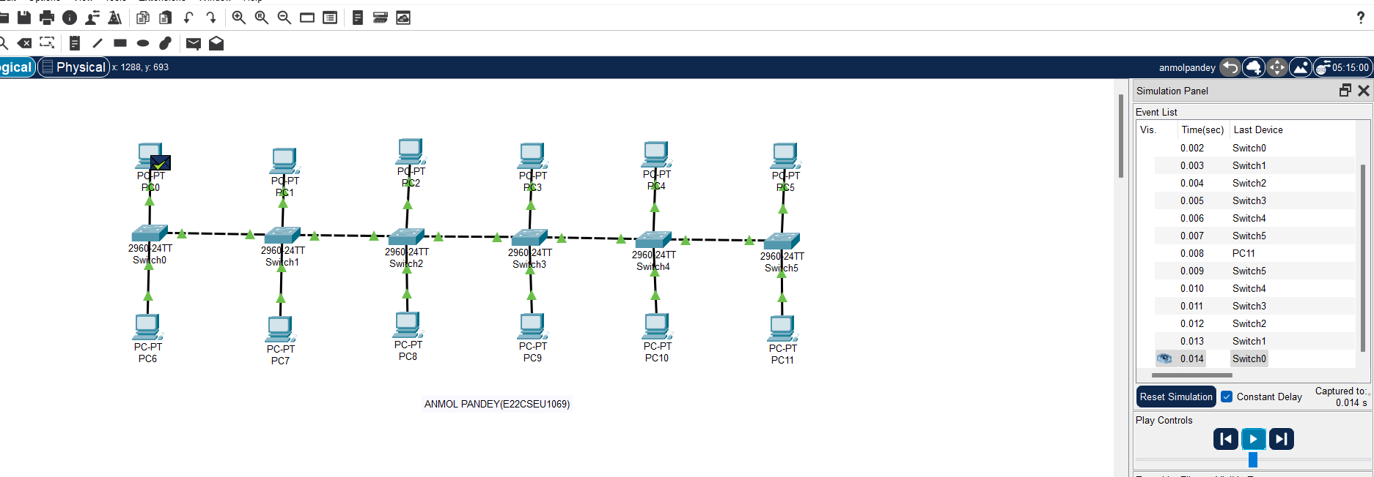

**Task-3**

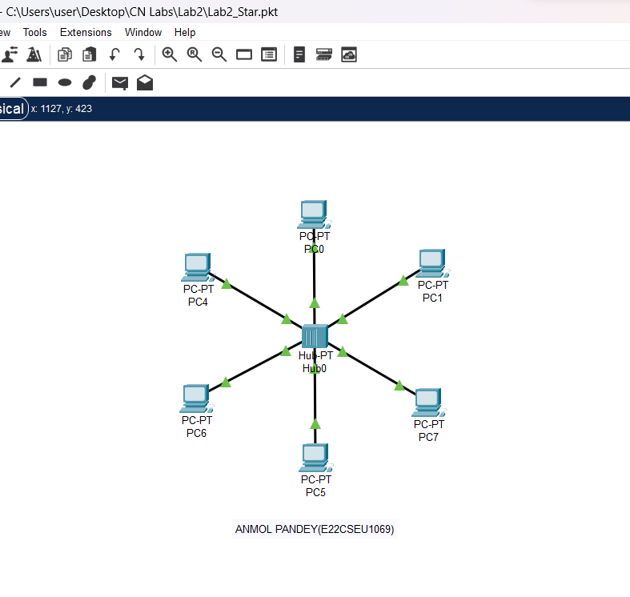

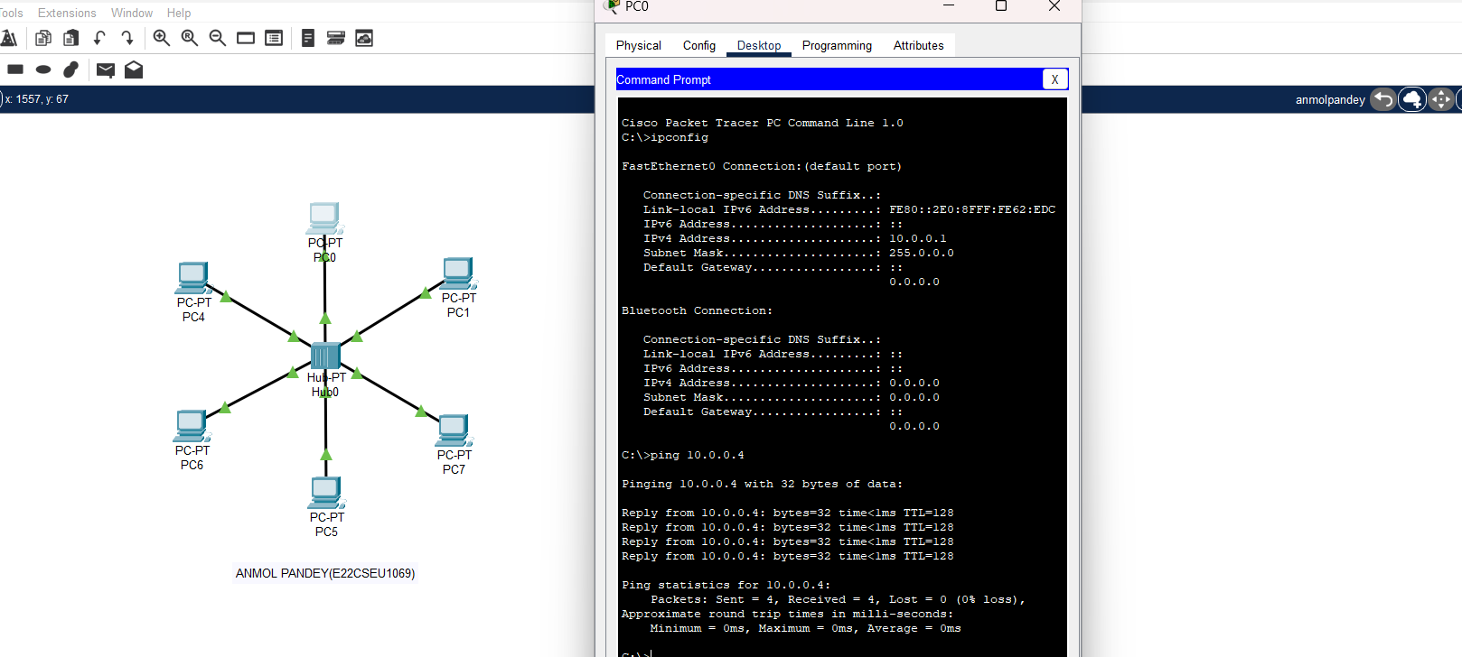

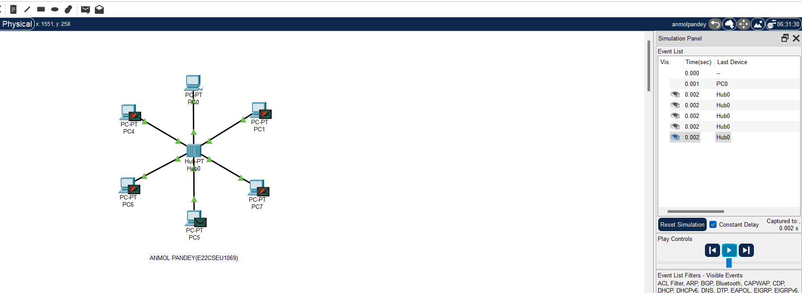

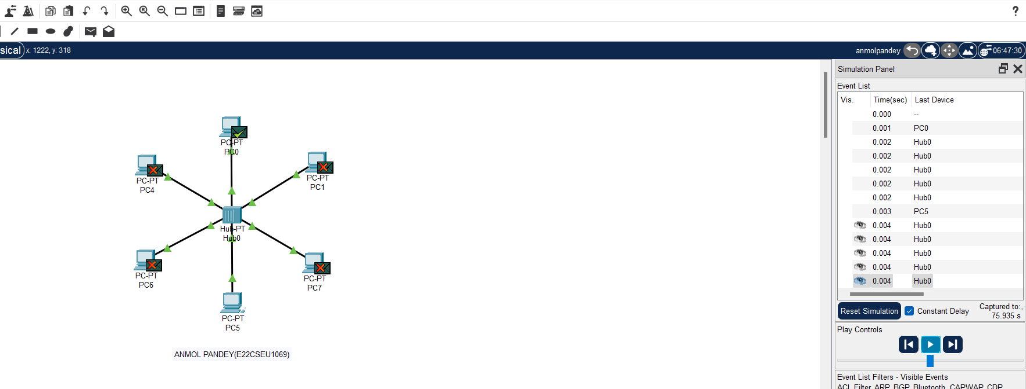

**Task-4**

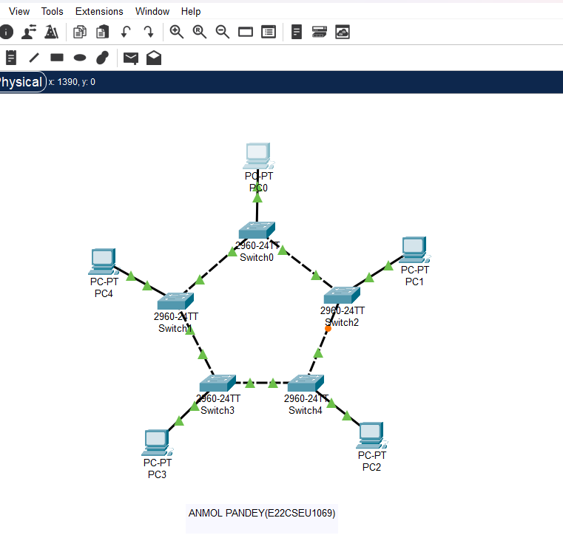

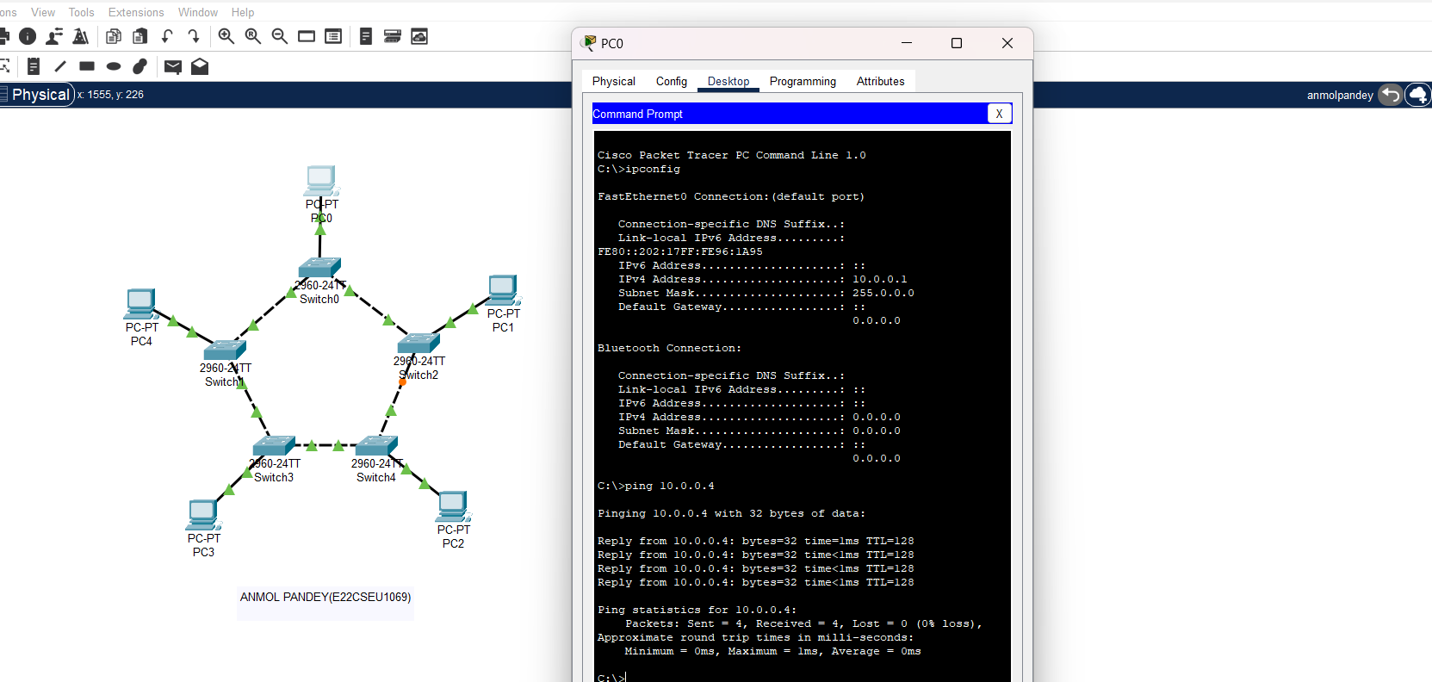

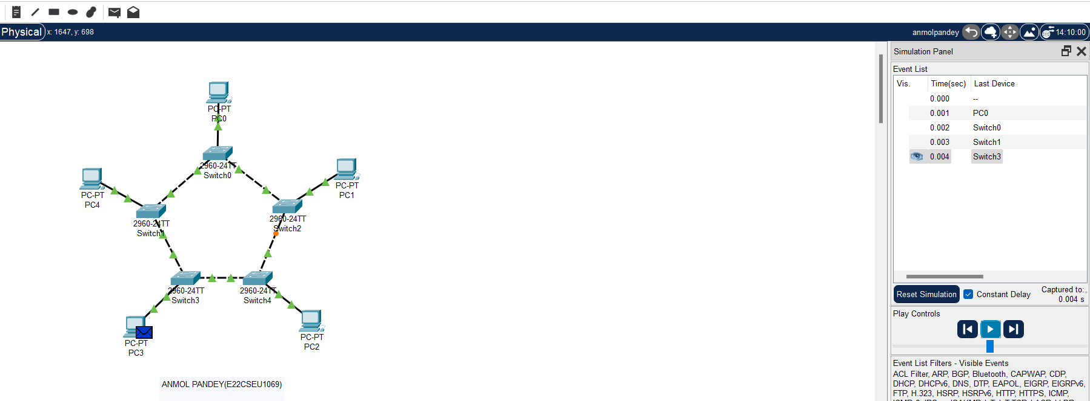

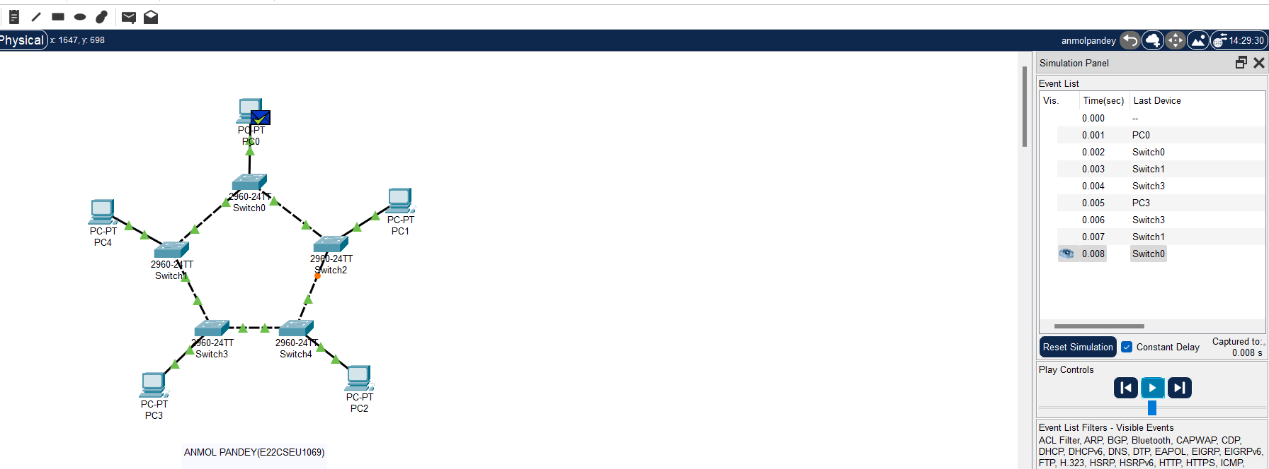

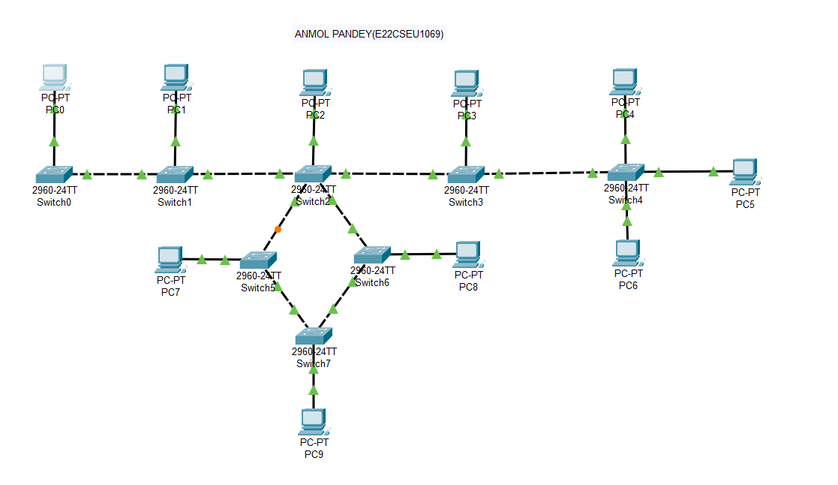

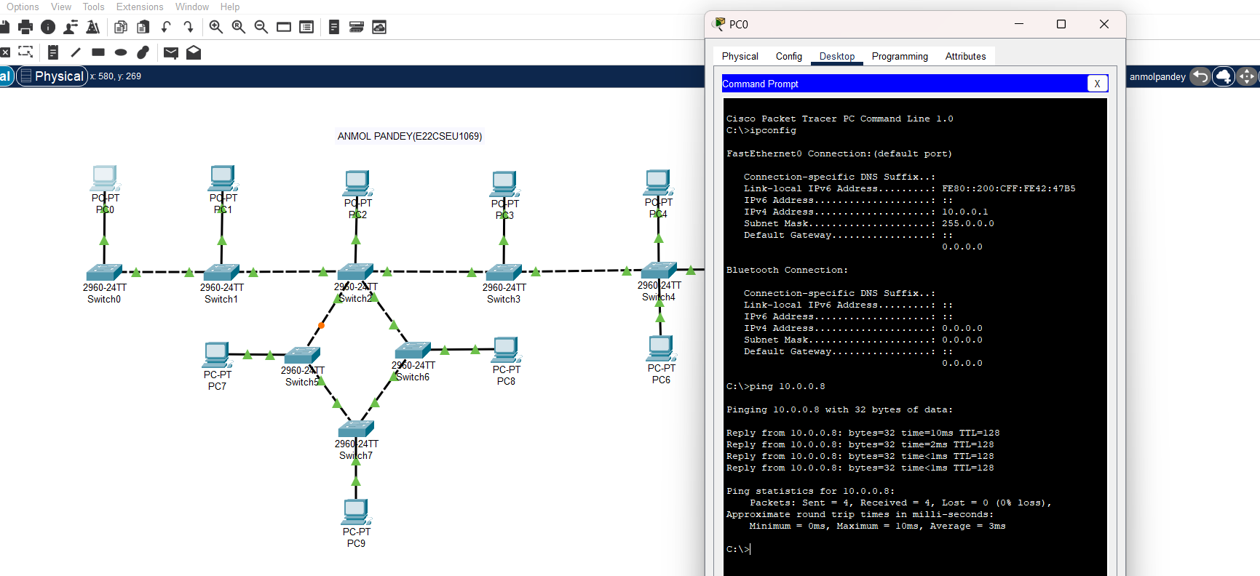

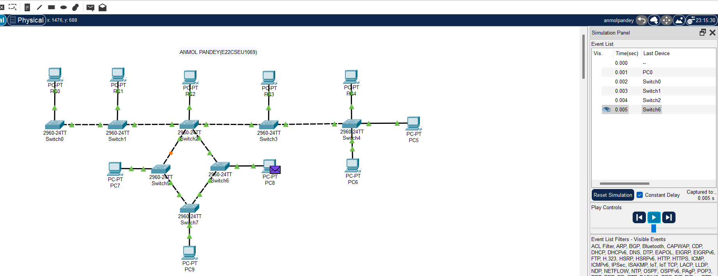

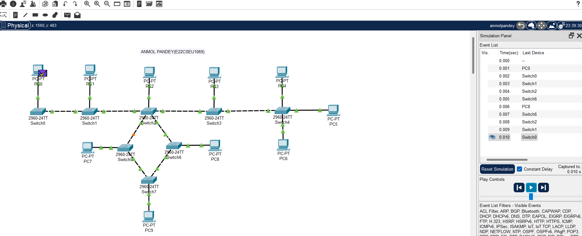

**Task-5**

Different types of switches in the Cisco Packet Tracer tool:

1. **Cisco Catalyst 2960**: The Cisco Catalyst 2960 is a fixed-configuration switch that provides Fast Ethernet and Gigabit Ethernet connectivity. This switch is designed for midsized networks and the metro access edge. It supports a variety of features such as hostname configuration, message of the day banner, password encryption, and console access.

2. **Cisco Catalyst 2950-24**: The Cisco Catalyst 2950-24 is a member of the Catalyst 2950 Series Intelligent Ethernet Switches. It provides 24 10/100 ports. This switch is designed for small to mid-sized networks and supports a variety of features including IP address configuration and DHCP server connectivity.

3. **Cisco Catalyst 2950T**: The Cisco Catalyst 2950T is similar to the 2950-24 but has additional features. It provides 24 10/100 ports with 2 fixed 10/100/1000BaseT uplink ports. This switch is designed for enhanced network performance and supports a variety of features including auto-crossover detection.

ThankYou!