Nicole Slipp

INFO 6540

Elvira Mitraka (Sarah Vela)

March 3 2019

RuPaul’s Drag Race All Stars 2: An Ontology

*RuPaul’s Drag Race All Stars* (2012-2019) is a reality competition television program created, hosted, and judged by American drag queen RuPaul Charles, aka RuPaul. In this show, drag queen contestants who did not win earlier seasons of *RuPaul’s Drag Race* (2009-2019) compete for a spot in the Drag Race Hall of Fame and a prize of 100,000 USD. *All Stars* has four seasons. The first three seasons aired on the Logo Network; season four aired on VH1 (IMDB, 2019). In every regular episode of *All Stars*, the contestants complete challenges testing their skills in dance, comedy, acting, and makeup to determine the top and bottom queens of the week. The two top queens then engage in a lipsync battle for an extra 10,000 USD prize and the power to eliminate one of the queens on the bottom.

This ontology describes *RuPaul’s Drag Race All Stars* season 2 (McCoy, 2016) in particular. The season consists of nine episodes; each episode is forty-two minutes long, except for episode 2, which is one hour and two minutes (“RuPaul’s Drag Race All Stars”, 2019). Other than including the season on which each contestant originally competed, the ontology only includes entities relating to this particular season of the show. For example, the popular challenge Snatch Game occurs in every season of *RuPaul’s Drag Race* since season 2; however, only information about *All Stars 2*’s Snatch Game is in the ontology. Many of the Drag Race contestants have successful careers as performers and recording artists outside of the show; however, this ontology will not include any of these accomplishments, since those are not part of this show. My ontology describes *All Stars 2*’s contestants, episodes, and episode contents that contribute to the competition outcome (lipsyncs and challenges).

**My classes are:**

Contestants, where sub classes are each individual drag queen on the season

Episodes, where sub classes are an individual Episode by title

Lipsync Battles, where sub classes are the title of the song for the lipsync

Challenges, where the sub classes of MaxiChallenges and MiniChallenges have sub classes naming individual challenges

OriginalSeason, where sub classes are the seasons of *Drag Race* the contestants come from

**My object properties are:**

“hasChallenge” and its inverse “isChallangeFrom”

These properties connect Challenges and Episodes

“hasLipsync” and its inverse “isLipsyncFrom”

These properties connect Lipsync Battles and Episodes

“isOriginallyFrom” and its inverse “hasContestant”

These properties connect Contestants and the Original Seasons. “Is OriginallyFrom” is functional because contestants on *All Stars 2* come from only one original season.

“isWinnerOf” and its inverse “hasWinner”

“isLoserOf” and its inverse “hasLoser”

These four properties connect Contestants and Challenges

“isLipsyncWinnerOf” and “hasLipsyncWinner”

These properties connect Lipsync Battles and winning Contestants.

“isEliminatorOf” and its inverse “isEliminatedBy”

These properties connect the Contestants and eliminated Contestants

“hasEliminatedQueen” and its inverse “isEliminatedOn”

These properties connect Contestants and Episodes

The object properties that I chose illustrate multiple relationships between properties and make the connections between challenges, episodes, and winners and losers. For example, choosing a contestant in the Ontograf (Figure 1) will show what Original Season the contestant comes from, which challenges she lost and/or won, if she eliminated anyone else or if she was eliminated by someone, and which Lipsync battles she won. Choosing a Lipsync Battle will show who won the battle, and which episode the battle is in (Figure 2). Figure 3 from the Ontograf shows that the episode Drag Fish Tank is a subclass of Episodes, contains the mini challenge Beastly Golf and the maxi challenge Product Design and Marketing, both of which were won by Alaska, and that Alaska also won the lipsync battle for Cherry Bomb and eliminated Tatianna.

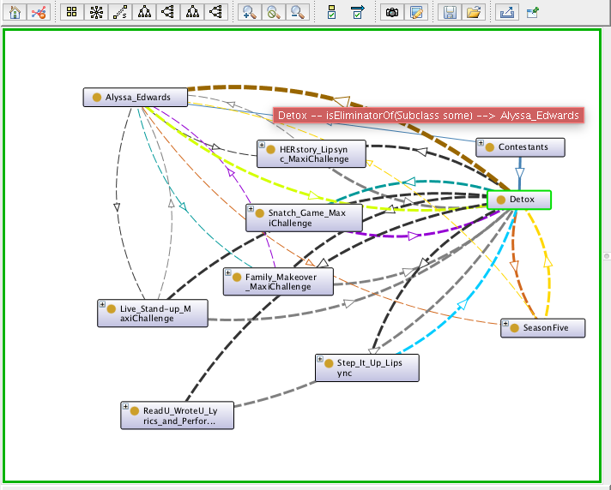

Figure 1

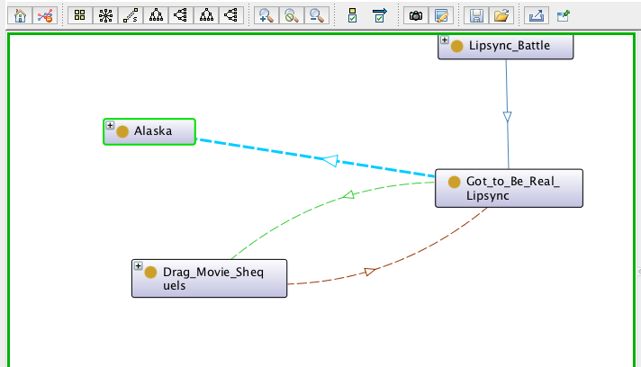

Figure 2

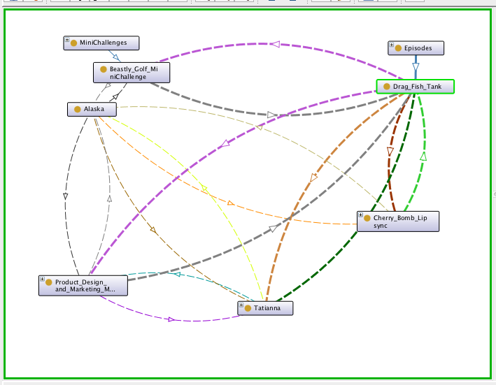

Figure 3

References

McCoy, B. (Producer). (2016). *RuPaul’s drag race all stars: Season 2* [Television series]. Hollywood, CA: Logo TV.

IMDB. (2019). *RuPaul’s Drag Race All Stars*. Retrieved from https://www.imdb.com/title/tt2301351/?ref_=ttep_ep_tt

<https://rupaulsdragrace.fandom.com/wiki/RuPaul%27s_Drag_Race_All_Stars_(Season_2)>

All Stars Citations:

McCoy, B. (Producer). (2016). *RuPaul’s drag race all stars: Season 2* [Television series]. Hollywood, CA: Logo TV.

<https://ca.outtvgo.com/page/5a2f33b323eec6000db5fdca>

Murray, N. (Director). (2016, August 25). All star talent show extravaganza [Television series episode]. In B. McCoy (Producer), *RuPaul’s drag race all stars: Season 2*. Hollywood, CA: Logo TV.

<https://ca.outtvgo.com/page/5a2f33b323eec6000db5fdca?clip=_5733845367001>

Murray, N. (Director). (2016, September 1). All stars snatch game [Television series episode]. In B. McCoy (Producer), *RuPaul’s drag race all stars: Season 2*. Hollywood, CA: Logo TV.

<https://ca.outtvgo.com/page/5a2f33b323eec6000db5fdca?clip=_5733870056001>

Murray, N. (Director). (2016, Sepetmber 8). HERstory of the world [Television series episode]. In B. McCoy (Producer), *RuPaul’s drag race all stars: Season 2*. Hollywood, CA: Logo TV.

<https://ca.outtvgo.com/page/5a2f33b323eec6000db5fdca?clip=_5733889970001>

Murray, N. (Director). (2016, September 15). Drag movie shequels [Television series episode]. In B. McCoy (Producer), *RuPaul’s drag race all stars: Season 2*. Hollywood, CA: Logo TV.

<https://ca.outtvgo.com/page/5a2f33b323eec6000db5fdca?clip=_5733020163001>

Murray, N. (Director). (2016, September 22). Revenge of the queens [Television series episode]. In B. McCoy (Producer), *RuPaul’s drag race all stars: Season 2*. Hollywood, CA: Logo TV.

<https://ca.outtvgo.com/page/5a2f33b323eec6000db5fdca?clip=_5733043879001>

Murray, N. (Director). (2016, September 29). Drag fish tank [Television series episode]. In B. McCoy (Producer), *RuPaul’s drag race all stars: Season 2*. Hollywood, CA: Logo TV.

<https://ca.outtvgo.com/page/5a2f33b323eec6000db5fdca?clip=_5733063620001>

Murray, N. (Director). (2016, October 6). Family that drags together [Television series episode]. In B. McCoy (Producer), *RuPaul’s drag race all stars: Season 2*. Hollywood, CA: Logo TV.

<https://ca.outtvgo.com/page/5a2f33b323eec6000db5fdca?clip=_5733088307001>

Murray, N. (Director). (2016, October 13). All stars supergroup [Television series episode]. In B. McCoy (Producer), *RuPaul’s drag race all stars: Season 2*. Hollywood, CA: Logo TV.

<https://ca.outtvgo.com/page/5a2f33b323eec6000db5fdca?clip=_5733104960001>

Murray, N. (Director). (2016, October 27). Reunited [Television series episode]. In B. McCoy (Producer), *RuPaul’s drag race all stars: Season 2*. Hollywood, CA: Logo TV.

<https://ca.outtvgo.com/page/5a2f33b323eec6000db5fdca?clip=_5733119206001>