Appendix A : High-frequency 3D Data Analysis
This section describes methods to adapt a commercial high-frequency scanner system to perform 3D imaging research.

A.1 Collection and analysis of 3D RF data

A.1.1 VisualSonics Vevo 770 system
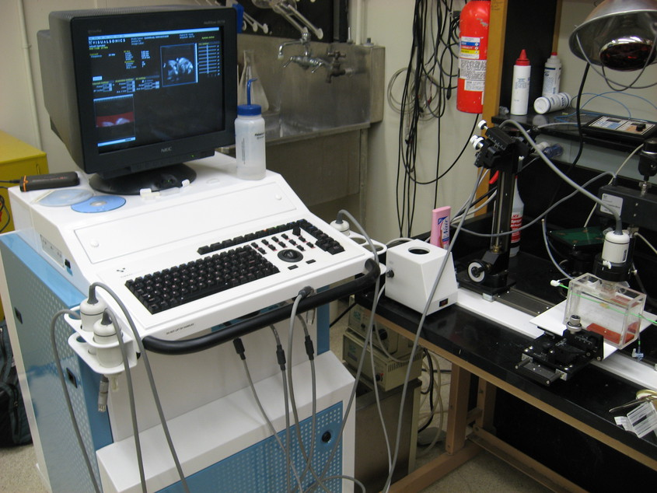
Figure 1: VisualSonics Vevo 770 imaging system. The Vevo 770 supports multiple transducers and has a standard console for interaction common to commercial imaging systems. The system also comes with a motion table designed to secure and position the transducer (right). Typically, animals are imaged on a platform equipped with physiological monitoring and anesthesia systems, but this has been replaced with a water bath to image the excised tissues.
VisualSonics (Toronto, Canada) manufactures high-frequency ultrasound imaging systems designed for pre-clinical research on small animal models. Anatomical and real-time physiological imaging of mice and rats is possible with resolutions up to 30 μm and frame rates up to 240 frames per second (fps). Primary features of the system are intended to allow longitudinal, non-invasive monitoring of anatomical and hemodynamic features as well as for therapeutic intervention. Some of these features include 2D B-Mode, 3D B-Mode with a stepper motor system, M-Mode, pulse-wave Doppler, power Doppler, tissue Doppler, and contrast agent imaging. An ancillary feature of the system is the output of radio-frequency (RF) data for analysis. In this section we describe methods to harness the RF output to perform advanced imaging research.
The Vevo 770 system is the last generation of Vevo line systems that are designed around rotated single-element transducers; beginning with the Vevo 2100 and later systems, the transducers are a high frequency linear array design. The newer linear array transducer systems have better capabilities for pre-clinical imaging: a programmable transmit focus and dynamic receive focusing allow for a greater depth of field and better lateral resolution [1]. However, the single-element, high-frequency, wide bandwidth transducers of the Vevo 770 are desirable for the purpose of creating parametric ultrasound images. As discussed in Chapter 6 and 7, the simpler transducer geometry allows the system to be modeled during quantification of tissue-mimicking (TM) phantom acoustic properties. The same transducer can then be used in the collection of planar reflector, TM phantom, and echo-signals from tissue.
A photograph of the Vevo 770 imaging system is shown in Fig. 1 with a close-up of the transducer assembly in Fig. 2. The single element transducer rests at the end of a shaft whose pivot point is high within the body of the case assembly. The angular position is measured with a rotary encoder above the pivot point and scan conversion is necessary for proper display. In order to achieve high frame rates, the transducer is rotated quickly about the pivot point by a motor in the transducer housing. To facilitate good coupling between the transducer and in vivo animal models outside a water bath, the transducer element is encapsulated by a plastic basin and a replaceable thin film over the active element. The thin film must be placed on the transducer and the scanhead filled with water prior to each application.
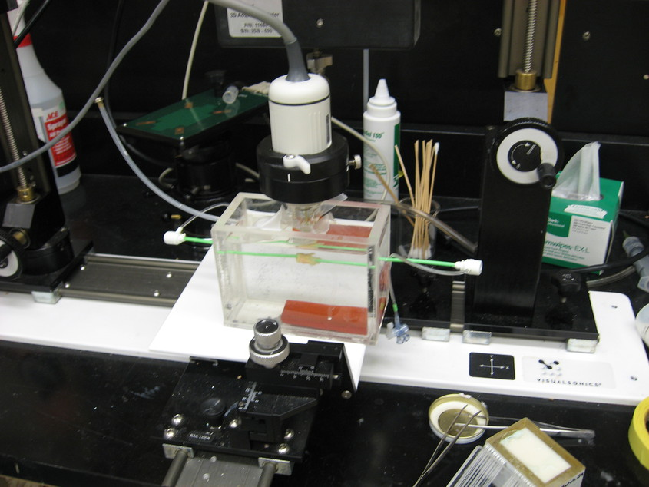
Figure 2: The Vevo 770 transducer (white) is held by a clamp connected to a precise linear stepper motor (top). The transducer element is suspended in a water filled capsule by a rod whose pivot point is high in the assembly housing above the clamp.
Two options exist on the system to collect RF data: a BNC output for triggered signal acquisition with an external oscilloscope or other analog-to-digital (A/D) device, or RF data can be collected with an on-board A/D board integrated with the Digital-RF software module if available. An advantage to the latter system is an integrated preview of the acquired data at the time of acquisition along with coordinated 3D acquisition via system software control of the stepper-motor.
A variety of transducers are available that differ in their focal length, aperture, center frequency, and bandwidth. The transducer selected was a RMV710B that has a center frequency of 25 MHz, on the lower end the center frequency for available transducers. This transducer outputs frequencies up to 37.5 MHz, with an axial resolution of 70 μm, lateral resolution of 140 μm, focal length 15 mm, and a maximum field of view of 20.0 mm. The RMV710B was selected because the frequency was low enough to penetrate plaque tissue and the field of view was large enough to encompass the entire sample.

A.1.2 File storage and metadata extraction
RF acquisition is performed in M-mode and is considerably slower than B-mode frame rates. The collection of a single 3D data set covering an entire plaque takes approximately two hours. RF acquisition was previously limited to single 2D frames, but we worked with VisualSonics engineers such that RF acquisitions can be collected in 3D with the optional high-precision stepper motor. Data is stored in a pair of non-standard plain text and binary files that contain system settings and raw data respectively with B-mode and saturation image of the region-of-interest (ROI) window for the first frame along with the RF data. A/D conversion is 12 bit with 71 dB dynamic range, 410 MS/s sampling rate, and 73 dB gain.
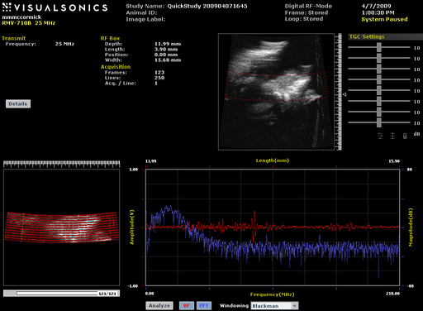
Figure 3: The Digital-RF user interface on the VisualSonics Vevo 770. System B-Mode is shown in the upper right with a red overlay of the RF collection ROI. The lower right shows the ROI window B-Mode and saturation content, which is saved in the acquired file along with the RF data. The time and frequency content a selected A-line in the ROI window is shown in the lower right.
Data collection is well integrated into the user interface of the machine, but buffer limits on the A/D card limit the length of acquisition to a subset of the field of view, as illustrated in Fig. 3. When data files are exported in RAW format, two files are saved for each acquisition. A file with the .rdb extension denotes a binary format file. This .rdb contains three images in sequence: two image of the ROI selected in the scout window followed by the RF data. Regardless of whether the 3D acquisition occurs, the ROI images are always 2D images. These images contain the content found in the system preview of the scan ROI before scan conversion. The first image is a B-Mode images in two byte unsigned integer format written sequentially in an A-line format. All binary data is in Little Endian format, i.e. the least significant byte (LSB) precedes the most significant byte (MSB). A saturation image with the same size as the B-Mode image follows. The saturation image is again in two-byte unsigned integer format, but the content is Boolean; a non-zero sample indicates that the digitizer was saturated at that datum. The ROI data is followed by RF data in the acquired volume of interest. Unlike the ROI images, the RF data is in a two-byte signed integer format. The RF data is written sequentially by samples within an A-line, followed by A-lines within a frame, followed by the frame in the volume. There is more than one pulse-echo data segment saved for each A-line. To allow signal averaging with the transducer fixed in a given position, an average A-line signal is saved followed by the individual pulse-echo signals. For the beta 3D Digital-RF acquisition software, only a single pulse-echo acquisition is possible per A-line when in 3D mode. Information on the number of A-lines, averaged number of signals, etc. that are required to read, analyze, and scan convert the binary data must be extracted from the metadata header file.
Each .rdb binary file has a .rdi metadata header file associated with it. This file has three sections, Image Info, Image Data, and Image Parameters. The Image Info section contains information related to the current acquisition such as an operator defined labels, the number of frames, or the acquisition time. The Image Data section contains information on byte offsets to A-line locations in the binary file for the ROI B-mode, ROI saturation, and the RF data. Finally, the Image Parameters section contains system settings such as the transmit pulse settings, time-gain compensation (TGC) settings, characteristics of the current transducer, ECG settings, or the stepper motor position. Example content from an .rdi is shown in Fig. 4.
"=== IMAGE INFO ==="
"Study Name","QuickStudy 201001201737"
"Image Id","54HTKMSSMJCKL2JSKMMF1TPCDW"
"Image Label",""
"Image Frames","136"
"Image Lines","250"
"Image Acquisition Per Line","1"
"Image Acquisition Size","4256","bytes"
...
"=== IMAGE DATA ==="
"ROI Data Offset - B-Mode","0","bytes"
"ROI Data Size - B-Mode","73472","bytes"
"ROI Data Offset - Saturation","73472","bytes"
"ROI Data Size - Saturation","73472","bytes"
"Image Data Offset - Frame 0 - Line 0 - Acq 0","146944","bytes"
"Image Data Offset - Frame 0 - Line 1 - Acq 0","151200","bytes"
....
"=== IMAGE PARAMETERS ==="
"RF-Mode/ActiveProbe/Notes","Rat Cardiology"
"RF-Mode/ActiveProbe/Sample-Time","154","µs"
"RF-Mode/BModeSoft/V-Relative-Frame-Rate","4"
"RF-Mode/ActiveProbe/Focal-Length","15","mm"
Figure 4: Example data from a Vevo 770 .rdi file. Example content from the three sections of the ASCII plain text content, Image Info, Image Data, and Image Parameters, are given.
Each parameter is described on a line with two to three fields delimited by quotations and commas. The first field is generally a key name. In the Image Parameters section, this can take a hierarchical form delimited by a forward slash. The second field is the value for the given key, which will contain an array of comma delimited numbers for an array of values. An optional third field contains the units for the value. The voluminous amount of Image Parameters results in a large file; typical size is 35,000 lines.
Parameters for parsing the binary file can be found or derived from the Image Info section, which makes the Image Data section largely redundant. Parametric image formation and scan conversion relies on content dispersed throughout the Image Parameters section. To facilitate the extraction of values of a given key and conversion from plain text to the appropriate data type, a library was developed to parse the header content into an intermediate eXtensible Markup Language (XML) form [2]. The advantages of XML for this data set includes its broad support under diverse tools and programming languages as an open standard, a native text-based and hierarchical form, and some explicit specification of data types. The structure of the .rdi is transformed into an XML hierarchy by considering the main three sections as top level elements and division and sorting of the keys in the Image Parameters section into a hierarchy of child elements. This structure was determined by parsing an example header file instance with a Python [3] script and defined using XMLSchema [4]
<?xml version="1.0" encoding="UTF-8" standalone="no" ?>
<rdi xmlns:xsi="http://www.w3.org/2001/XMLSchema-instance" xsi:noNamespaceSchemaLocation="rdi.xsd">
<image_info>
<Study_Name>QuickStudy 201001201737</Study_Name>
<Image_Id>54HTKMSSMJCKL2JSKMMF1TPCDW</Image_Id>
<Image_Label/>
<Image_Frames>136</Image_Frames>
<Image_Lines>250</Image_Lines>
<Image_Acquisition_Per_Line>1</Image_Acquisition_Per_Line>
<Image_Acquisition_Size>4256</Image_Acquisition_Size>
<Animal_ID/>
<Acquisition_Mode>Digital RF-Mode</Acquisition_Mode>
<Acquisition_Date>1/20/2010</Acquisition_Date>
<Acquisition_Time>5:42:14 PM</Acquisition_Time>
<Acquisition_Operator>Default Operator</Acquisition_Operator>
</image_info>
<image_data/>
<image_parameters>
<RF-Mode>
<ActiveProbe>
<Notes>Rat Cardiology</Notes>
<Sample-Time units="µs">154</Sample-Time>
<Focal-Length units="mm">15</Focal-Length>
<Acceleration-Limit-Slope>0</Acceleration-Limit-Slope>
Figure 5: Content of the header file in Fig. 4 after transformation into XML format.
The content is imported in C++ into a Xerces-C++ [5] object, from which it can be serialized into an XML file, as shown in Fig. 5 to be easily processed by other programs. Alternatively, it can be transformed into a Hyper-Text Markup Language (HTML) to be easily examined in web browsers, Fig. 6. Transformation is specified through an EXtensible Stylesheet Language (XSLT) document and applied in memory with Xalan-C++ [6]. Most importantly, the parameters can be accessed in C++ as native data objects through the use of XML data binding with CodeSynthesis XSD [7] since an XMLSchema has been generated.
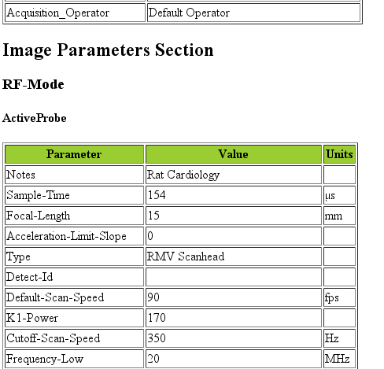
Figure 6: Rendering of the header file contents after transformation from XML to HTML.
An Insight Toolkit (ITK) [Yoo2002] ImageIO class was written for processing the data with ITK. The data is imported as an "image", i.e. geometry of uniform, anisotropic spacing in Cartesian format, with angle and radius information stored in the metadata dictionary for scan conversion after B-Mode or parametric image formation from the A-lines at their original sample locations.

A.1.3 Scan conversion and volume concatenation
The raw data collected on the Vevo 770 is structured grid data. Structured grid data has implicit connectivity, i.e. the topology is determined by a dimensional index [9]. However, the geometric locations of the points do not necessary fall on a uniform grid. An image, on the other hand, has both regular topology and geometry [9]. While there is some support in computer graphics hardware and software for rendering datasets in a structured grid from, the most widespread support exist for images with isotropic spacing. Medical imaging or scientific rendering programs may have support for rendering of images with anisotropic spacing. Volume rendering support for structured grid data is less common and less efficient than volume rendering algorithms for image data. Also, most analysis algorithms are designed for image data. For these reasons, we must scan convert the Vevo 770 data; we must resample the structured grid data onto a orthogonal grid with regular spacing.
Locations of the RF is determined by the transducer geometry, which is diagrammed in Fig. 7. Header file keys that define the geometry include: PE, the pivot-to-encoder distance, RF-Mode/ActiveProbe/Pivot-Encoder-Dist, SL, the shaft-length, RF-Mode/ActiveProbe/Pivot-Transducer-Fact-Dist, DL, the delay length in the water path from the transducer to start of acquisition, RF-Mode/RX/V-Delay-Length, DD, the digitizer depth, RF-Mode/RX/V-Digi-Depth-Imaging, and EP, the encoder position, RF-Mode/RfModeSoft/V-Lines-Pos. Note that the last value is an array since it changes with every A-line.
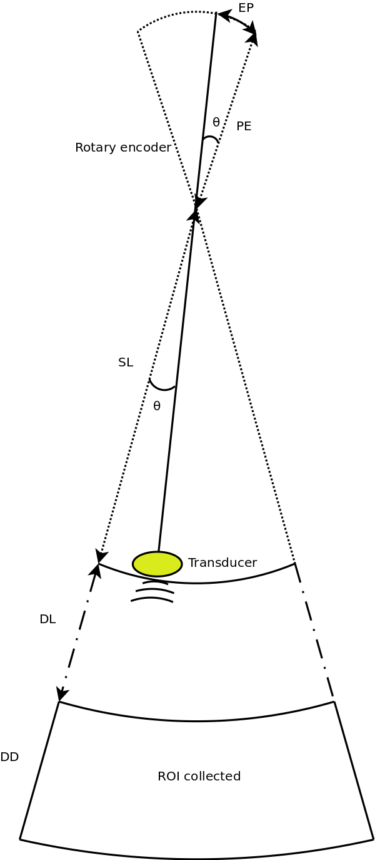
Figure 7: Diagram of the Vevo 770 geometric parameters used in field of view calculations. The transducer sits at the end of a shaft, and the angle of rotation is recorded by a rotary encoder attached to an extension of the shaft across the pivot point. Parameters stored in the metadata file include PE, the pivot-to-encoder distance, SL, the shaft length, DL, the delay length in the water path from the transducer to start of acquisition, DD, the digitizer depth, and EP, the encoder position.
This polar coordinate configuration is common in ultrasound imaging; it also occurs with a curvilinear array or phased array transducer, for example. The radius is given by 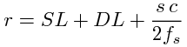 where s is the sample number along the A-line, c is the assumed speed of sound (usually 1540 m/s), and is the sampling frequency (RF-Mode/RfModeSoft/SamplesPerSec). The angle in radians is simply 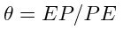. The Cartesian coordinates are then 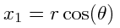 and 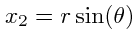. For 3D imaging, the only other geometric parameter of importance is the frame spacing, which is found at RF-Mode/3D/StepSize.

A.1.4 Data streaming
Due to memory capacity limitations of modern computers, it is necessary to process a large image file in independent chunks, also known as streamed data processing. A single Vevo 770 plaque volume prior to scan conversion with 2128 samples per A-line, 250 lines per frame, 250 frames per subvolume, and four subvolumes per plaque has 532 million samples. If the data samples are stored as single-byte char datatypes or two-byte unsigned short samples, as may be the case for clinical scanner's volume rendering software, a high-end modern computer is capable of storing a copy of the image in system RAM or graphics card global memory. When processing the data to create parametric ultrasound images or to perform scan conversion, we use the eight-byte floating point double data type, and multiple copies of the data are required as it passes through our processing pipeline. This size exceeds the capacity of most computers, and streaming is required.
The process of resampling during scan conversion involves defining a transformation from the output space to the input space [10]. In general, at the time of transformation all of the input data must be available because the transformation of point from output space may result in a point at any location in the input space. This prevents streaming of the resampling process because the entire input dataset must be made available.
At least for special cases, streaming during resampling may be possible, though, if we can restrict the region required for a transformation. With a general affine transform [10],
where x is a vector of the output point position, y is the input point position, A is a matrix of coefficients that apply rotation, shearing or scaling to the output space, and b is a vector defining the rigid translation, lines remain lines after transformation. Recognizing this fact, we see that the region required by a linear transformation of an image is the bounding box defined by the transformation of image's corners. The result of a resampling implementation that takes advantage of this property to perform streaming is shown in Fig. 8. An affine transform is applied with scaling by a factor of 1.25 in all directions, rotation of 1 radian about the y-axis and 0.2 radians about the z-axis, and translation of three pixel spacings in the y-direction and seven pixel spacings in the z-direction. The resampling process is applied without streaming and streaming with eight stream divisions. The results are the same for both cases.
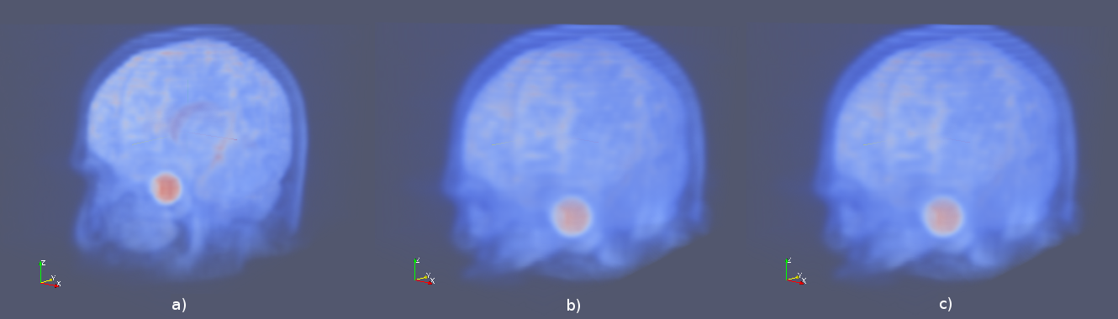
Figure 8: Magnetic resonance head image a) before transformation, b) after an affine transformation without streaming, and c) after the same transformation with streaming. Pixel-wise difference calculation on the transformed images show that they are identical.
This same implementation can be applied to perform streaming when performing scan conversion for the Vevo 770. Even though the inplane transformation is non-linear and applying this algorithm would be insufficient at the bottom of the scan plane, the transformation is linear in the stepper-motor direction (an identity transform). Measurements of peak heap memory usage made with Valgrind [11] versus the number of frames per stream are plotted in Fig. 9. A linear trend is clearly observed. Decreased memory usage comes with a slight performance trade-off as the number of image processing pipeline updates required is directly proportional to the number of stream divisions.
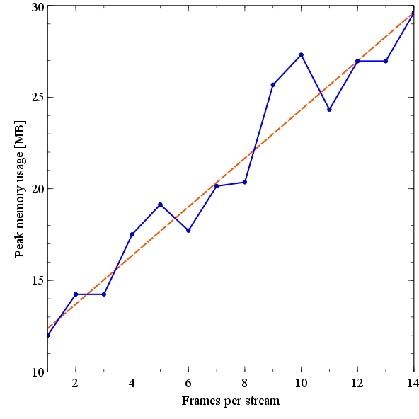
Figure 9: Peak heap memory usage during B-Mode image creation and scan conversion of a Vevo 770 file. The slope of a linear fit to the data is 1.33 MB/frame and the intercept is 11.0 MB.

A.2 References
[1] E. Madsen, G. Frank, M. McCormick and M. Deaner. Anechoic Sphere Phantom for Estimating 3-D Resolution of Very High Frequency Ultrasound Scanners. IEEE Transactions on Ultrasonics Ferroelectrics and Frequency Control 57, 2284--2292. 2010.
[2] T. Bray, J. Paoli, C. M. Sperberg-McQueen, E. Maler and F. Yergeau. Extensible Markup Language (XML) 1.0. . 2008. http://www.w3.org/TR/REC-xml/.
[3] G. VanRossum. The Python Programming Language. Python Software Foundation. 2011. http://www.python.org/.
[4] D. Fallside and P. Walmsley. XML Schema Part 0: Primer Second Edition. W3C Recommendation. 2004. http://www.w3.org/TR/xmlschema-0.
[5] Anonymous. Xerces-C++ XML Parser. The Apache Software Foundation. 2011. http://xerces.apache.org/xerces-c/.
[6] Anonymous. Xalan-C++ XSLT Processor. The Apache Software Foundation. 2010. http://xml.apache.org/xalan-c/.
[7] Anonymous. XSD: XML Data Binding for C++. CodeSynthesis. 2010. http://www.codesynthesis.com/products/xsd/.
[9] W. Schroeder, K. Martin and B. Lorensen. The Visualization Toolkit An Object-Oriented Approach To 3D Graphics. : Kitware, Inc.. 2006.
[10] L. Ibanez, W. Schroeder, L. Ng and J. Cates. The ITK Software Guide. 2005.
[11] Anonymous. Massif: A heap profiler. Valgrind User Manual. 2011. http://valgrind.org/docs/manual/ms-manual.html.

