Upgrading an existing installation
Important: if you are already familiar with upgrading an existing Xerte installations there are important additional steps outlined in this guide. There are also two methods outlined here:
- Easy option – some previous files will remain duplicated in new locations
- Clean upgrade – this involves removing non-unique files before applying the updated files
Step 1. Backup first.
As always whichever of these methods you choose you should backup your existing database and directory first in case of problems.
Easy option
This is the easiest upgrade option but some previous files may remain, or be duplicated if they have been moved to new locations in later versions. However this will not cause any problems.
Important note: If your existing installation is already 1.9 or later a file named auth_config.php exists and is where the authentication method was previously set. From 3.1 onwards the authentication method is set via the management page. Upon first upgrading to 3.1 you will need to visit yourinstalladdress/upgrade.php and then login via yourinstalladdress/management.php and change the authentication method back to your chosen method. Once this is set via management you will not need to repeat this step for future upgrades.
Step 2.
Drop the latest code over the top of the existing code being careful to merge or protect any local customisations or restore those after upgrade.
Step 3.
If your existing installation was older and didn’t contain auth_config.php or was overwritten then your upgrade will initially have guest access set. In this case it’s an opportunity to test the basics are working ok via guest access (e.g. create and test an LO) before changing the authentication back to your usual method via management.
Step 4.
Important step: Now visit http://yourinstall/upgrade.php This will copy any older ldap details from the sitedetails table to the ldap table as well as setting other new default values including enabling authentication to be set via management.
Step 5.
Change from guest to ldap or one of the other authentication options via yourinstalladdress/management.php and the Authentication Settings options.
Step 6.
If you are using Moodle for authentication read and follow the instructions in the moodle_integration_readme file
Step 7.
Refresh index.php and test login and creation etc again
Step 8.
Remove the folder named setup or move it outside of the web root.

Clean upgrade
This method is very similar to the easy option except that it involves removing most of the existing installation files before applying the upgrade.
Step 1. Backup first.
As always whichever of these methods you choose you should backup your existing database and directory first in case of problems.
Step 2.
Remove most of the existing installation files being careful not to remove user files and files/folders unique to your installation. The list and screenshot below outlines the files and folders that should NOT be removed:
error_logs
This may contain previous error logs which should obviously be investigated anyway but as the folders probably also has different permissions shouldn’t be removed.
import
again this folder probably also has different permissions and may contain imported projects so shouldn’t be removed.
library
This folder can actually be removed unless you are using static authentication. If you are using static authentication then backup or protect \library\Xerte\Authentication\Static.php as this will contain your static usernames and passwords.
USER-FILES
This is where all user projects are saved and definitely should not be removed.
database.php
This contains the unique database credentials for your installation so be careful not to remove this file. Note: the Xerte Online Toolkits download does not contain database.php as this is created during initial installation.
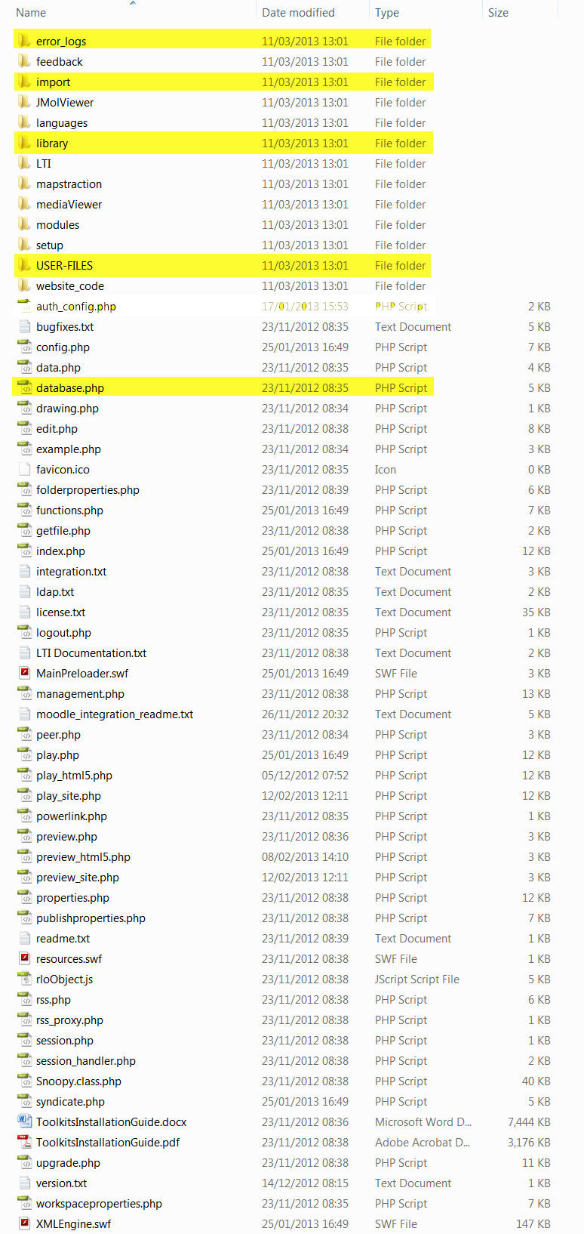

Step 3.
If your existing installation was older and didn’t contain auth_config.php or was overwritten then your upgrade will initially have guest access set. In this case it’s an opportunity to test the basics are working ok via guest access (e.g. create and test an LO) before changing the authentication back to your usual method via management.
Step 4.
Important step: Now visit http://yourinstall/upgrade.php This will copy any older ldap details from the sitedetails table to the ldap table as well as setting other new default values including enabling authentication to be set via management.
Step 5.
Change from guest to ldap or one of the other authentication options via yourinstalladdress/management.php and the Authentication Settings options.
Step 6.
If you are using Moodle for authentication read and follow the instructions in the moodle_integration_readme file.
Step 7.
Refresh index.php and test login and creation etc again.
Step 8.
Remove the folder named setup or move it outside of the web root.

Common Issues/Considerations
1. Common configuration issues
Directory permissions e.g. code can’t write to user-files
PHP upload settings e.g. max upload set too small preventing upload of larger files such as video or importing projects exported from another installation
Mime types especially on Windows/IIS servers
xwd, rlt & rlm as mime-type 'text/xml' possibly flv too.
2. General issues with installation/upgrading
Contact Xerte technical list for free help – provide as much info as possible
http://lists.nottingham.ac.uk/mailman/listinfo/xerte

