**Natter - Multiplatform Mobile Chat Application**

Submitted in partial fulfillment of the requirements for the award of degree of

**BACHELOR OF ENGINEERING**

**IN**

**COMPUTER SCIENCE AND ENGINEERING**



**Submitted to:**

**ER. SAAKSHI (E7918)**

**Submitted by:**

**Name / UID: Deepam Kumar / 18BCS1522**

**Name / UID: Saurabh Kumar / 18BCS1517**

**Name / UID: Deepakshi Sharma / 18BCS1537**

**Name / UID: Gaurav Sharma / 18BCS1528**

**DEPARTMENT OF COMPUTER SCIENCE AND ENGINEERING**

**CHANDIGARH UNIVERSITY, GHARUAN**

**August 2020**

**TABLE OF CONTENTS**

|  |  |  |
| --- | --- | --- |
| **S.NO** | **TOPIC** | **PAGE NO** |
| 1 | INTRODUCTION | 2 |
|  | 1.1 - PROBLEM STATEMENT | 2 |
|  | 1.2 - PROBLEM BACKGROUND | 3 |
|  | 1.3 - TECHNOLOGY USED | 3 |
| 2 | FEASIBILITY STUDY | 4 |
| 3 | METHODOLOGY AND PLANNING | 5 |
|  | 3.1 - PLANNING OF WORK | 5 |
| 4 | MODULE AND TEAM DISTRIBUTION | 6 |
|  | 4.1 - TEAM WISE DISTRIBUTION | 6 |
|  | 4.2 - PROPOSED COMPLETION | 6 |
| 5 | INNOVATION | 7 |
| 6 | SOFTWARE AND HARDWARE REQIREMENTS | 8 |
|  | 6.1 - SOFTWARE REQUIREMENTS | 8 |
|  | 6.2 - HARDWARE REQUIREMENTS | 8 |
| 7 | BIBLIOGRAPHY | 9 |
|  | 7.1 - CONCLUSION | 9 |
|  | 7.2 - REFERENCES | 9 |
|  |  |  |

1. **INTRODUCTION**

In the present situation, travel and transportation is becoming very popular amongst millions of travelers around the world. It is also one of the biggest demands of many people since it is compulsory for them to travel around the world. We need to travel from one place to another place in our daily life due to many factors.

In the past, it was very difficult to enjoy travels around the world. However in later, the mechanical modes of transportation were introduced and today we see different types of automobiles on the roads, each designed to fulfill precise travel requirements. The trend of private car hire and cabs began soon after the advent of cars and other automobiles in our society. Hiring a private car usually means a car which is not a cab and a driver for managing travel requirements. There are lots of car hire online companies in every part of the world offering private car rental services. Hiring of private car or cab can be done with ease with the help of few clicks of mouse before you are leaving for the journey.

For transportation, it began from animals and till today, it has reached taxis and limousines. People utilize cab services for traveling from one place to another. Aside from public transportation that includes local buses and coaches, taxis are considered as the most convenient and comfortable means of transportation. They give you the ease and convenience of departing from your doorsteps to the exact destination within a short period of time.

We are going to make a Complete Cab Application for both the rider and driver. Also an admin panel from everything can easily be controlled.

**1.1 PROBLEM STATEMENT**

This project is to create a cab application that runs both on android and ios so that every user irrespective of platform can contact with each other.

Also, to help drivers to provide a completely a commission free platform for their earnings.

**1.2 PROBLEM BACKGROUD**

Well there are lots of applications out there in the both android and ios market. But we basically wants to provide a commission free platform to both rider and driver with very functional and simplistic approach.

**1.3 TECHNOLOGY USED**

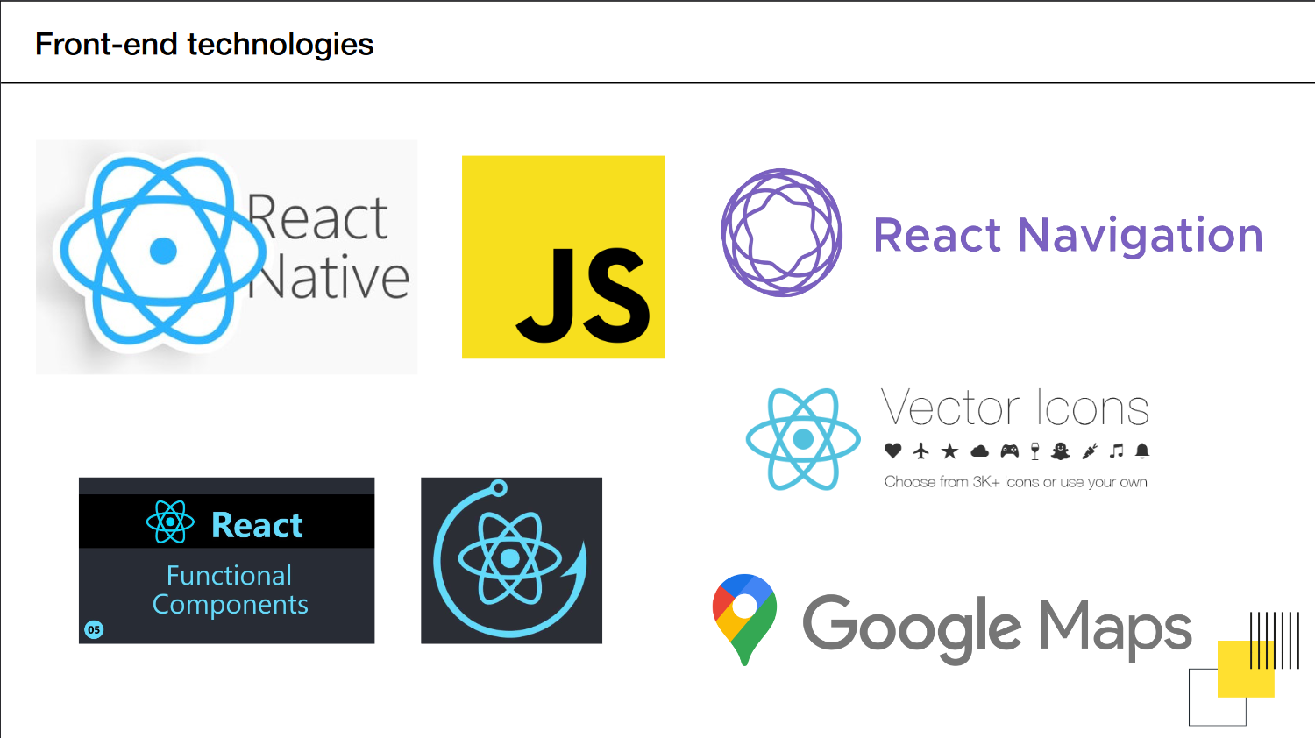

**Back-end technologies**

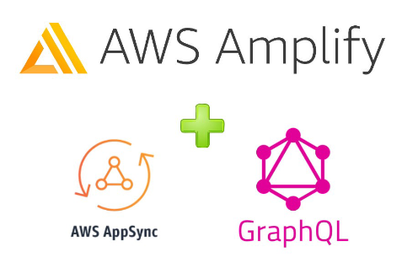

**2. FEASIBILITY STUDY**

The last century has seen the car culture spreading over the entire globe. All of us have been experiencing the absolute duopoly in the cab-hailing market unless you have been living under a rock. Between the global major Uber technologies, some home-grown ride-sharing companies at various locations and countries have conquered the streets, leaving little room for the new competitors to join. This fact is taking its toll on the regional cab aggregators which seem to be ready to give up on their dreams to become a part of the ride-sharing world. Many of the home-grown taxi aggregators that have managed to stay afloat are striving hard to do something that could gain them an audience. But the coming years seem promising for these small taxi aggregators. Be it the passenger comfort or ease of booking, the global ride-hailing market is just not by any chance dying. There is a sure sign of a surge in the demand for ride-hailing services on a worldwide basis. But there are some recent reports that show a major shift in the industry.

According to the latest report, the worldwide global ride-hailing market is expected to grow at a CAGR of 21% by 2023.

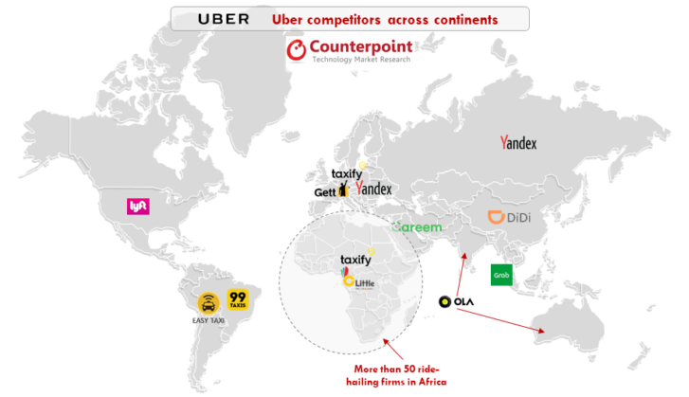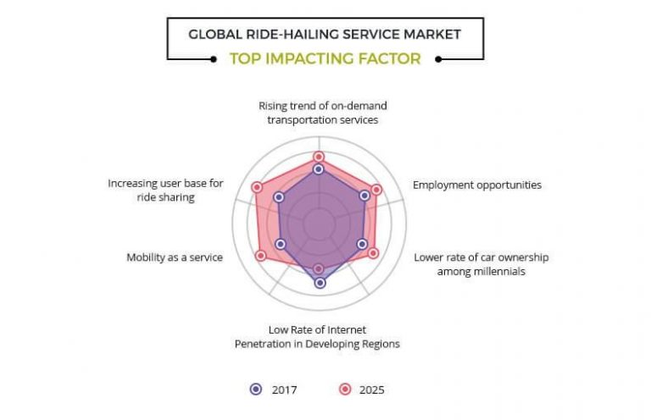

**3. METHODOLOGY AND PLANNING OF WORK**

Agile is a set of techniques to manage software development projects. It consists in:

• Being able to respond to changes and new requirements quickly.

• Teamwork, even with the client.

• Building operating software over extensive documentation.

• Individuals and their interaction over tools.

We believed it was a perfect fit for our project since we did not know most requirements beforehand. By using the Agile, we were able to focus only on the features which had the most priority at the time

**3.1 PLANNING OF WORK**

1. **DESIGN :**

In this project we will be using the tools like figma and adobe xd to create the screens and the front UI layers of our app and try to use the material UI so that it support both native platform.

1. **DEVELOPMENT:**

In this project, we will be building the application like Uber from scratch, starting from setting up a React Native project and finishing with connecting the application with a GraphQL backend using AWS Amplify. We will use React Native, an open-source mobile application framework created by Facebook, Inc. It is used to develop applications for Android, iOS, Web.

And then we’ll will walk through designing the UI layout of the app, structuring everything in components, and putting everything together. We will also implement navigation between screens, header bars, and tab bars for the Uber app menu using React Navigation.

For the backend, we will be using AWS Amplify, which is an amazing combination of tools and services from AWS, that helps us build mobile and web applications faster. It offers pre-made authentication components and flows, database, API (REST and GraphQL), storage, and much more.

**4. MODULE AND TEAM MEMBER WISE DISTRIBUTION**

In order to achieve our goal in very planned and organized manner we divided our complete project phase development into 4 modules where every team member has been assigned their roles. The 4 modules in this Project are:-

1. Design
2. Development
3. Testing
4. Documentation

**4.1 TEAM WISE DISTRIBUTION**

1. Deepam Kumar (18BCS1522):
   1. Development of Architecture and framework
   2. Front end development ( react native )
   3. Backend development ( AWS AMPLIFY )
   4. Controlling Pull and Push requests of Git.
2. Saurabh Kumar (18BCS1517 ):
   1. Testing work (Jest)
   2. Controlling Pull and Push requests of Git.
   3. Framework Design
3. Deepakshi Sharma (18BCS1537):
   1. Documentation
   2. UI Design
4. Gaurav Sharma (18BCS1528):
   1. Documentation
   2. Testing work(UX)

**4.2 PROPOSED COMPLETION DATE**

|  |  |
| --- | --- |
| **PHASES OF PROJECT** | **DEADLINE DATES** |
| Project proposal |  |
| Project synopsis |  |
| Project design and modelling |  |
| Project implementation |  |
| IEEE paper |  |

**5. INNOVATION**

The previous work of this already exists. The similar application can be found on the project either Android market. This project will focus on providing high quality usability experiences to users mainly following Google’s user interface guideline.

Apart from basic features of Cab Application, we are adding some advance features for both rider and driver applications:-

* Split Payment (For Rider app)
* Interactive map (For both Rider and Driver app)
* Voice Recognition (For both Rider and Driver app)
* Panic Button (For both Rider and Driver safety)
* Heat Map (For Driver app)
* Forward Dispatch (For both Driver app)

In the later stage of development we can add features like:-

* Secret secure chats with messages that self-destruct on both devices within a specified time after being read
* Scheduling messages in advance
* Temporary content like status and stories
* Games (provide more fun)
* Ecommerce features (for example, Chabot’s)

**6. SOFTWARE AND HARDWARE REQUIREMENT 6.1 Software Requirements**

|  |  |
| --- | --- |
| Operating system | Technical requirement |
| iOS | iOS 11+ with Safari 12+ or Chrome 77+ |
| Android | Android 7+ with Chrome 77+ |

**Mobile applications**

**Pc web**

|  |  |
| --- | --- |
| browser | Technical requirement |
| chrome | v77+ |
| firefox | v68+ |
| safari | v12+ |
| edge | v44+ |

**6.2 HARDWARE REQUIREMENTS**

RAM : 1GB OR MORE

STORAGE: 50 MB OR MORE

**7. BIBLIOGRAPHY**

**7.1 CONCLUSION**

**7.2 REFERENCES**