QUIZ 1
History of Mathematics
Undergraduate (92.435) / Graduate (92.535)
Name: Joel Savitz Date: 15 July 2020

1. Explain two difficulties / challenges with the development of early number systems. Support each answer with an example.

Two significant challenges in the development of early number systems, among many others, were the representation of large numbers and the lack of a value for zero in most systems. The Egyptians, with a different symbol for each multiple of ten, had to continue to invent more and more symbols, and for values that have many of the largest digits,
such as one that we would represent using only the digits 8 or 9, would require many repetitions of many distinct symbols for larger numbers. The lack of a symbol for zero was a challenge for the early Babylonians, who later added a symbol to stand as an empty place value, i.e. 0 times a power of 60, but not as a value in its own right.

- What is the Rhind Papyrus and what was its purpose?

The Rhind Papyrus is the name for a collection of fragments of papyrus dating back to ancient Egypt. On this text, Egyptian scribes recorded a series of mathematical problems and solutions. This text gives us great insight into the state of the art of Mathematics at the time the scribes wrote this text. The mathematical content within describes the abstract machinery necessary for the efficient function of a state of any non trivial size. Using this knowledge, Egyptian land surveyors were able to accurately assess the value of property for tax purposes, priests were able to account for the revenues and expenses of a temple, and the bureaucracy knew what and when to plant and harvest in the country.

3. Solve these problems the way that early Egyptians would have, as shown on the Rhind Papyrus. (Show your work)

a. 16 * 5 b. 23 * 18

1 5 (yes) 1 18
2 10 (yes) 2 36
4 20 (yes) 4 72
8 40 8 144
(yes) 16 80 (yes) 16 288
================ ===============
Therefore, 16 * 5 = 80 We have: 18 + 36 + 72 + 288 = 414
Therefore, 23 * 18 = 414

c. 246 ÷ 6 d. 101 ÷ 8

(yes) 1 6 1 8
2 12 2 16
4 24 4 32
(yes) 8 48 8 64
16 96 ½ 4
(yes) 32 192 ¼ 2
================= 1/8 1
We have:192 + 48 + 6 = 246 ================
And: 32 + 8 + 1 = 41 We have: 64 + 32 + 4 + 1 = 101
Therefore, 246 ÷ 6 = 41 And: 8 + 4 + ½ + 1/8 = 12 + ½ + 1/8
Therefore, 101 ÷ 8 = 12 + ½ + 1/8

- Why is it important to study the History of Math? Answer in terms of a mathematician or a teacher and support it with at least two reasons.

As a mathematician, is is important to study math because by learning how earlier thinkers developed mathematics, one can better approach the problem of expanding the field of mathematics today. For instance, if one learns what motivated the Babylonians to use use sixty degrees as the angle of an equilateral triangle and the resulting trigonometry that follows, one can compare this system to that of radians, and beyond that one can define and develop new systems for understanding the relationships between mathematical objects in higher dimensional space. In addition, it is important to study mathematics in order to understand the mistakes that were made along the way and to better appreciate, for instance, the feeling of frustration, a feeling as important to mathematical and axiomatic method as physical tension is to weightlifting. When one considers the centuries of attempts that some of the great math problems have been attacked with, one can more easily perceive the hour long or even multi-day frustration due to some math problem as movement in the right direction rather than a sign of personal weakness.

See next page for extra credit problem.

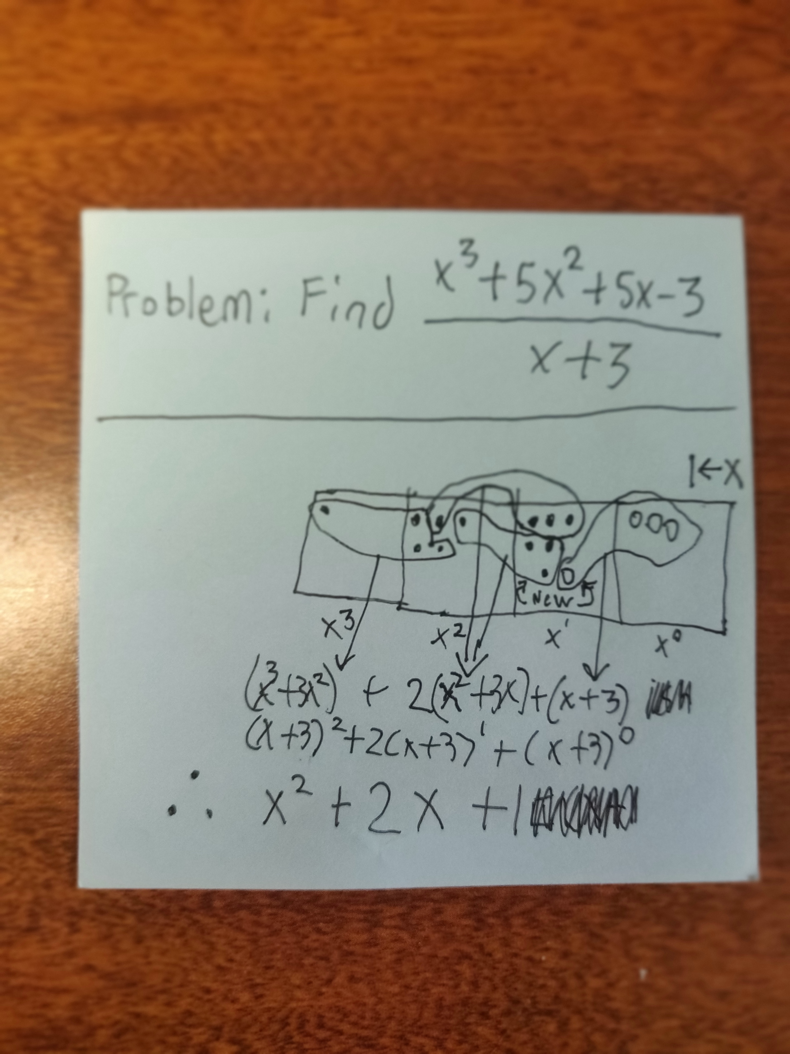
EXTRA CREDIT: Solve using Exploding Dots only (X^3 + 5X^2 + 5X – 3) ÷ (X+3)

