COURSEWORK SUBMISSION FORM
STUDENT USE |  | STAFF USE
Module Name | Web Technologies | First Marker’s  (acts as signature)
Module Code | 4BUIS011C | Second Marker’s  (acts as signature)
Lecturer Name | Bunyod Khoshimkhujaev | Agreed Mark
UoW Student IDs |  | For Registrar’s office use only (hard copy submission)
WIUT Student IDs | 00005744
Deadline date | 15.11.2017
Assignment Type | GroupIndividual

SUBMISSION INSTRUCTIONS

COURSEWORKS must be submitted in both HARD COPY (to the Registrar’s Office) and ELECTRONIC unless instructed otherwise.
For hardcopy submission instructions refer to: http://intranet.wiut.uz/Shared%20Documents/Forms/AllItems.aspx - Coursework hard copy submission instructions.doc
For online submission instructions refer to: http://intranet.wiut.uz/Shared%20Documents/Forms/AllItems.aspx - Coursework online submission instructions.doc

MARKERS FEEDBACK (Continued on the next page)
Table of contents

Site plan 3
Target audience 3
Goals and objectives 3
Functions and features 3
Navigation and structure 4
Evaluation 4
First competitor 4
Second competitor 5
Usability test 6
Appendix 7

Site plan

Target audience
The website http://piedpiper.ml/ is a website of an imagined web-development studio based in Palo Alto. Main target audience of this website is potential clients of the company. Those may be ordinary people willing to have a personal website, businessmen who want to make their business online or just have a landing page on internet with information about their business. Those may also be representatives of any kind of creative or freelance professions like photographers, designers, music artists who want to place their portfolio or contact information on internet. Company is assumed to provide wide-range of services: designing and building websites, web-applications, cross-platform applications, search-engine optimization and social media marketing. Anyone who is looking for these services are considered as the main target audience as well.
Secondary target audience of the website are the potential employees of the company. These may be web-developers, user-interface and user-experience designers, SEO and SMM specialists.

Goals and objectives
The main goal of the website is to represent the company, provide all necessary information about the company to its potential customers, partners and employees. Website attracts attention of customers, presents list of services and costs of those services, presents projects that are built by the company. All necessary contact information and mail form are provided on the website. Website has a page containing vacancies for two job positions.

Functions and features
One of the features that makes the website more attractive is animation on scroll, that was implemented with the help of Animate-on-Scroll JavaScript library. Blocks containing images and text appear one by one with fade up animation on home page, but this feature is deliberately switched off for mobile devices in order not to make devices’ performance and page loading slow. Another feature is carousel on the “clients” page, implemented using Owl Carousel library. Logotypes of company’s clients are nested in carousel-slide. Clients page has commenting functionality too, that works only on the client-side and has no back-end functionality. The function just takes the user input from the fields and puts the into the Document Object Model in appropriate output form, that appears on the page. One more feature is switching tabs on portfolio page (projects.html) that switches between the content of tabs with fade-in and fade-out animation. Contact page contains a block of contact form that has validation functionality. It accepts English letters for name and more than 20 separate words for message input only, and email input is checked with Regular Expressions. If user fills all the forms correct, then page is redirected to ‘success’ page, that informs the user that message is sent and redirects to home page after 5 seconds.

Navigation and structure
The website was build using modern Bulma CSS-Framework that is based on Flexbox. It allowed to build responsive layout for all devices, although some specific parts needed additional styling with media queries for screen sizes. Navigation bar of website is dynamically generated using JavaScript functionality. Navigation bar is linear and responsive, it transforms into vertical hamburger toggle menu when the screen size is small, that is also one of the advantages presented by Bulma Framework. Also, navigation bar has toggle on scroll functionality that is when user scrolls down, the bar disappears and appears immediately after user make a little scroll-up.

Evaluation

First competitor
The first competitor’s website is https://www.oxagile.com/. The site belongs to international software and web-development company that operates in USA, UK and Belarus. The site has horizontal navigation bar and showcase block with video on background. On mobile screen size video is just paused and navigation bar similarly transforms to so called hamburger menu. An advantage is that quick contact form is located at the bottom of home page and ‘free quote’ button is quickly accessible on one click, being positioned on the right side. Color choices are appropriate: black, white and dark shade of red that is supposed to be company’s brand color, as used in logotype. The site justifies its goal, as it is attractive and has facts, statistics about company’s achievements and list of awards that company collected. As one more user-friendly functionality, we can observe the search button above the navigation bar. Generally, this site is well-built selling site since everything is delivered properly to the client and all necessary information are available on one click.
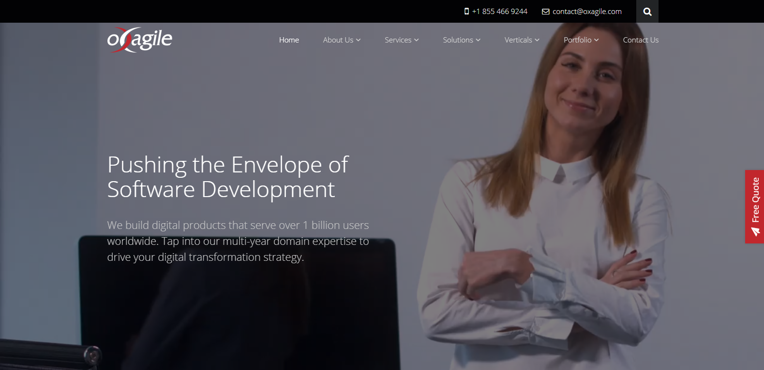

Second competitor
The next potential competitor site may be https://www.bluefountainmedia.com/. This site also has a fixed horizontal navigation bar that transforms to trendy hamburger menu on small-screen devices. Color scheme rules are followed well, company’s brand color (blue) used mostly with black and white. The site also presents company’s achievement on the home page, but page loading speed is too slow, as it is overloaded with animation/slide scripts and high-definition images. Too many words on one page and long home page, with few illustrations, users may be confused scrolling down. Generally the website design is a bit old-fashioned and messy, because of many words and animation. The arrows on the page around the round block (presenting 400% increase in traffic) and an arrow pointing down are hoverable, but not clickable or do not work because of slow page-loading speed. Using less words and more illustrations for infographics may be suggested as well as using less animation scripts, that overload the page.


Usability test
Two different people were asked to fill the usability test questionnaire that is available from link on the bottom of http://piedpiper.ml/ home page. Questionnaire consisted of six questions. First 5 of them were Yes/No questions and the last one was optional recommendation. Both users were satisfied with all conditions, and responded positively. However, both users noticed in response for the last question, that page “About” is not working.

The report is also available from http://piedpiper.ml/00005744.doc
and attached in the footer of the website

Appendix
