E-Business CCP
PROJECT REPORT
Full-Stack E-Commerce Store & Admin CMS Portal
ZMAH Technologies
Zeeshan, Mudassir, Ali, Hassan (ZMAH)

Document Scope: Project architecture, features, database configuration, and application screens walkthrough.
Submitted to: Miss Shilpa Kumari
Group Members:
Zeeshan Mehdi (62616)
Mudassir Nazeer (62790)
Ali Raza (62960)
Hassan ur Rehman ()
Contents
1. Executive Summary 3
3. Technology Stack & Infrastructure 3
4. Core Features 4
3.1 Customer Features 4
3.2 Administrator Features 4
5. Database Schema Design 4
4.1 User Schema 4
4.2 Admin Schema 4
4.3 Product Schema 5
4.4 Order Schema 5
6. Application Interface Walkthrough 5
6.1 E-Commerce Landing Page (Index) 5
6.2 Shop Grid & Category Navigation 6
6.3 Single Product Detailed Page 7
6.5 Contact Us Page 7
6.6 Interactive Shopping Cart 8
6.9 Customer Authentication & OTP Recovery 10
6.12 Admin Login Portal 11
6.13 Admin Management Dashboard 12
6.16 Admin CMS - Product Management 13
6.17 Admin - Order Tracking & AWB PDF Generation 14
7. Conclusion & Future Scope 16

Executive Summary
This project report details the design, architecture, and system implementation of the ZMAH TechnologiesFull-Stack E-Commerce Store. The system provides a unified solution for onlineretail, featuring an interactive customer frontend and a powerful administration console.
The project stands out through its choice of a clean, responsive, and dependency-free Vanilla JavaScriptfrontend combined with a robust Express/MongoDB backend. Recent development cycles focused onenhancing business analytics, ensuring seamless cross-module navigation through URL state synchronization,and resolving data retrieval anomalies for administrators.

Key Achievement: Successfully delivered a 100% responsive, high-performance platform running on asingle integrated backend server. Features automated PDF Air Waybill (AWB) generation, emailnotification workflows via SMTP, and real-time Revenue Analytics.

- Introduction
This project report describes the implementation of a modern, responsive, and full-stack E-Commerce Store with an integrated Content Management System (CMS) Admin Dashboard. The system is designed using the MEN stack (MongoDB, Express, and Node.js) on the backend and native web technologies (HTML6, CSS3, and ES6+ JavaScript) on the frontend. By avoiding heavy framework dependencies, the project achieves excellent rendering speed, low bundle sizes, and easily customizable design layout sheets.
The system has been designed with two user roles in mind:
- Store Customer: Can browse products, view details, search, filter, manage cart items, sign up, log in, recover password using Email OTPs, and place orders.
- Store Administrator: Can view dashboard sales analytics, manage products (adding multi-images/videos), update order status (Seller to Pack, Shipped, Delivered, Cancelled), and print automated Air Waybills (AWB).

Technology Stack & Infrastructure
The core architecture consists of a decoupled structure where the backend server exposes RESTful API endpoints, and the frontend makes asynchronous fetch calls to process data dynamically. Below is the detailed breakdown:
Component | Technology / Library | Description
Frontend | HTML6, CSS3, Vanilla JavaScript | Structured with semantic HTML, fully styled using custom responsive CSS, and dynamic behavior powered by plain JavaScript.
Backend | Node.js, Express.js | Fast and modular API routing and server middleware to handle request parsing, media storage, and MongoDB interaction.
Database | MongoDB & Mongoose | NoSQL database storage with structured schema modeling using Mongoose ODM for Users, Products, and Orders.
Authentication | JWT & Bcrypt.js | Token-based session management and secure one-way password hashing.
File Handling | Multer | Server-side file upload middleware to save and serve product images and video clips.
Email Service | Nodemailer | Integration with SMTP relays to securely send OTP verification emails.
PDF Engine | html2pdf.js | Frontend PDF exporter converting structured templates into high-quality digital documents.

Core Features

3.1 Customer Features
- Responsive Store Front: Designed with a modern dark theme and custom glassmorphism components. Adjusts dynamically to all viewport resolutions.
- Dynamic Catalog & Filter System: Enables users to search keywords and filter products by categories on the fly without refreshing the page.
- Interactive Cart Flow: Users can add items, change quantities, and see prices update instantly. The state is synced with Local Storage for persistence.
- Account Security & Email OTP Recovery: Secure password hashing utilizing bcryptjs. Password recovery operates securely by issuing a one-time passcode to the user's email, verified on the node server.

3.2 Administrator Features
- Analytics Engine: Dashboard widgets displaying Total Earnings, Order Counts, and critical notifications such as Low Stock alerts.
- Media Product Management: Allows uploading up to 6 images and 1 video for product descriptions, handled securely via Multer.
- Interactive Order Tracker: Complete workflow state updates. Allows updating statuses which immediately syncs with customer profile views.
- Automated Air Waybill Generator: Renders clean shipping labels with custom barcodes, customer address details, weight, and automated pricing, downloadable instantly in PDF format.

Database Schema Design
The database contains four collection schemas configured using Mongoose:

4.1 User Schema
- fullName (String): The complete name of the user.
- email (String, Unique): Registered contact address.
- contact / city / address (Strings): Shipping details.
- password (String): Hashed password value.
- resetOTP / otpExpires: Used during recovery cycles.

4.2 Admin Schema
- username (String): Admin unique handle.
- password (String): Hashed admin credential.
- email (String): Admin contact / backup email.

4.3 Product Schema
- title / description (Strings): Product identifiers.
- price / discount / shippingFee (Numbers): Costs structure.
- stock / sold (Numbers): Inventory monitoring.
- images / video (Array/String): Media asset routes.

4.4 Order Schema
- customer_details (Object): Fast-snapshot of billing info.
- cart_items (Array): Ordered items copy.
- total_bill (Number): Net transaction amount.
- status (String): Current tracking state.
- order_id (String): Short tracking code.

Application Interface Walkthrough
This section presents visual screens of the system. Insert your actual screenshot into each block.

6.1 E-Commerce Landing Page (Index)
The store home page showing product slider, featured categories, and footer newsletter subscription.
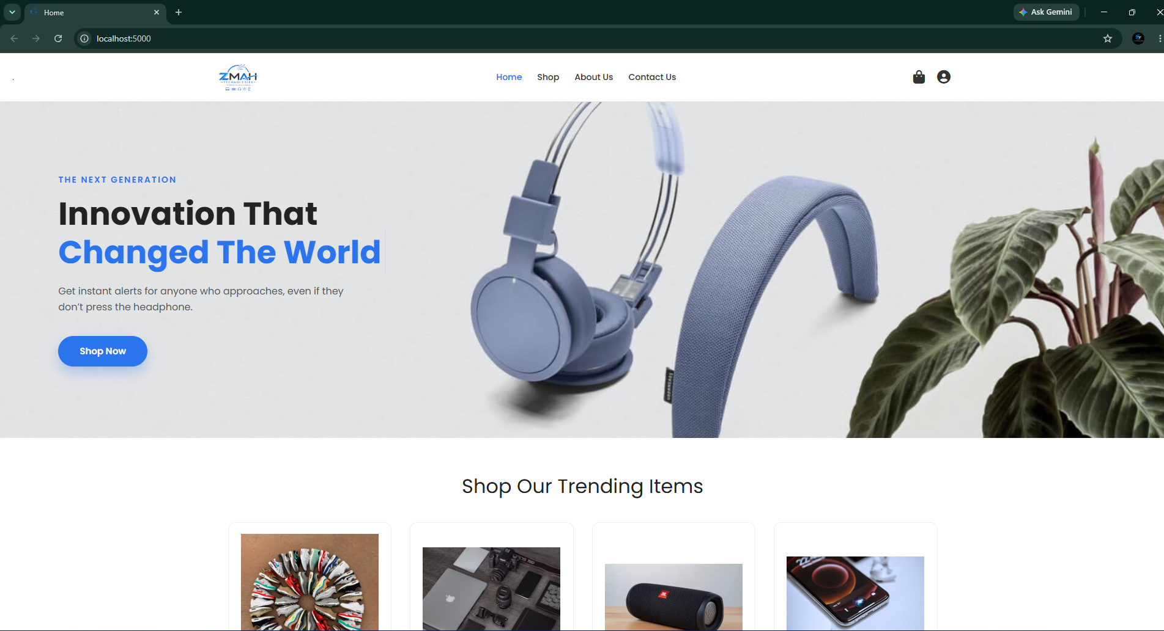

Footer
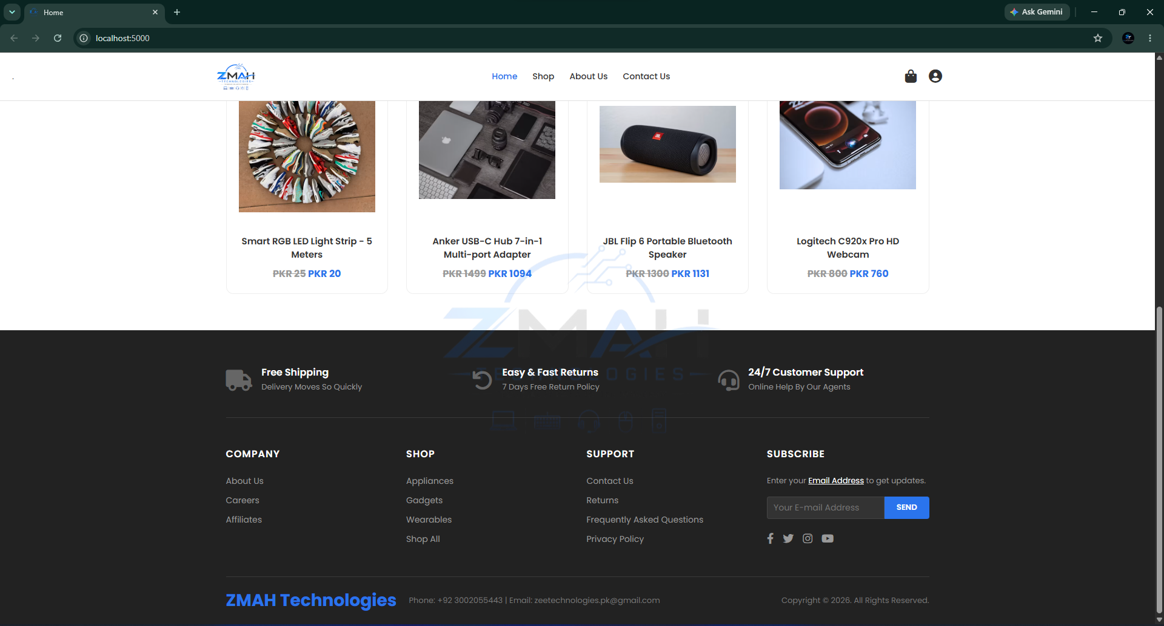

6.2 Shop Grid & Category Navigation
Product list containing search filters, sorting dropdown, and quick cart buttons.
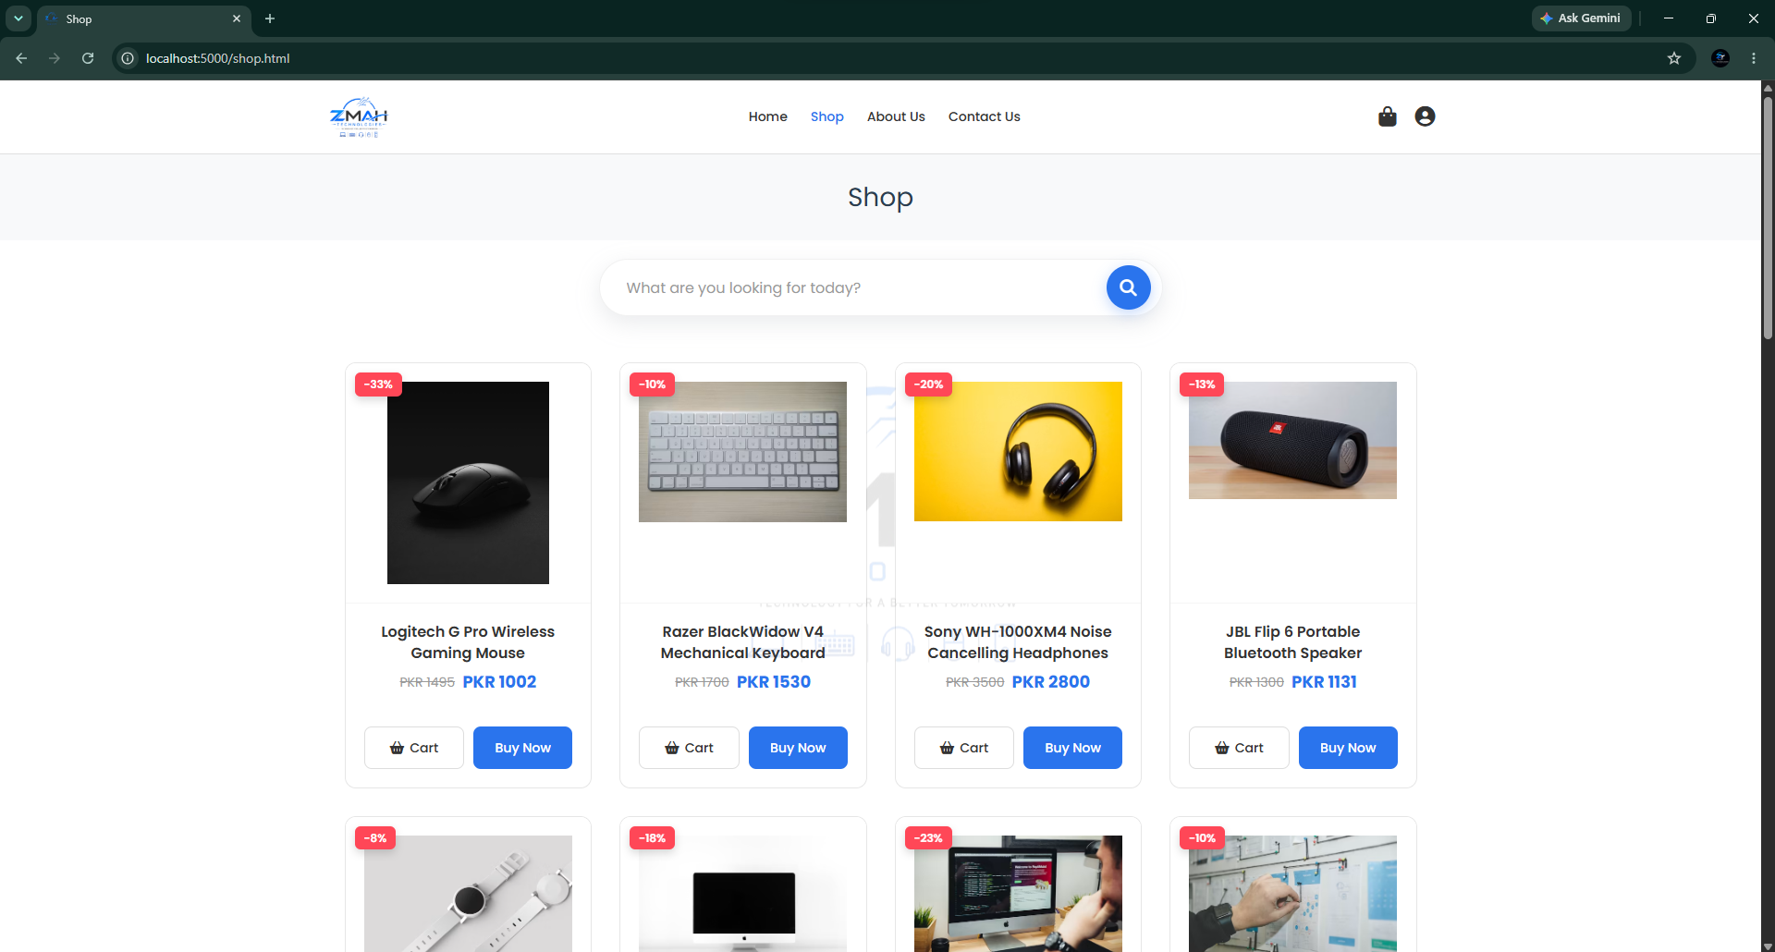

6.3 Single Product Detailed Page
Dedicated product view showcasing the description, stock count, weight, video preview, and image slider.
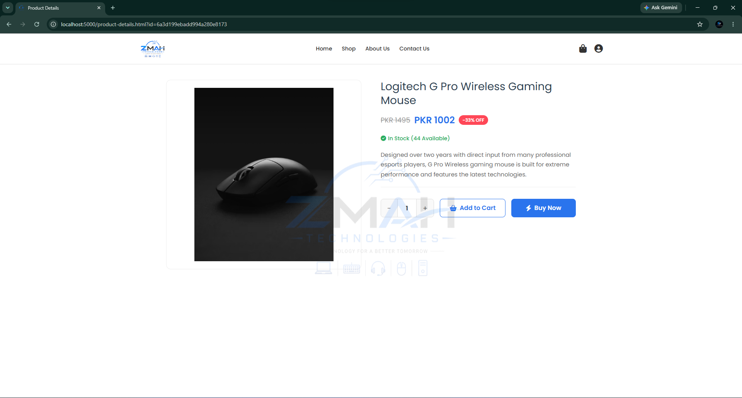

6.4 About Us Page
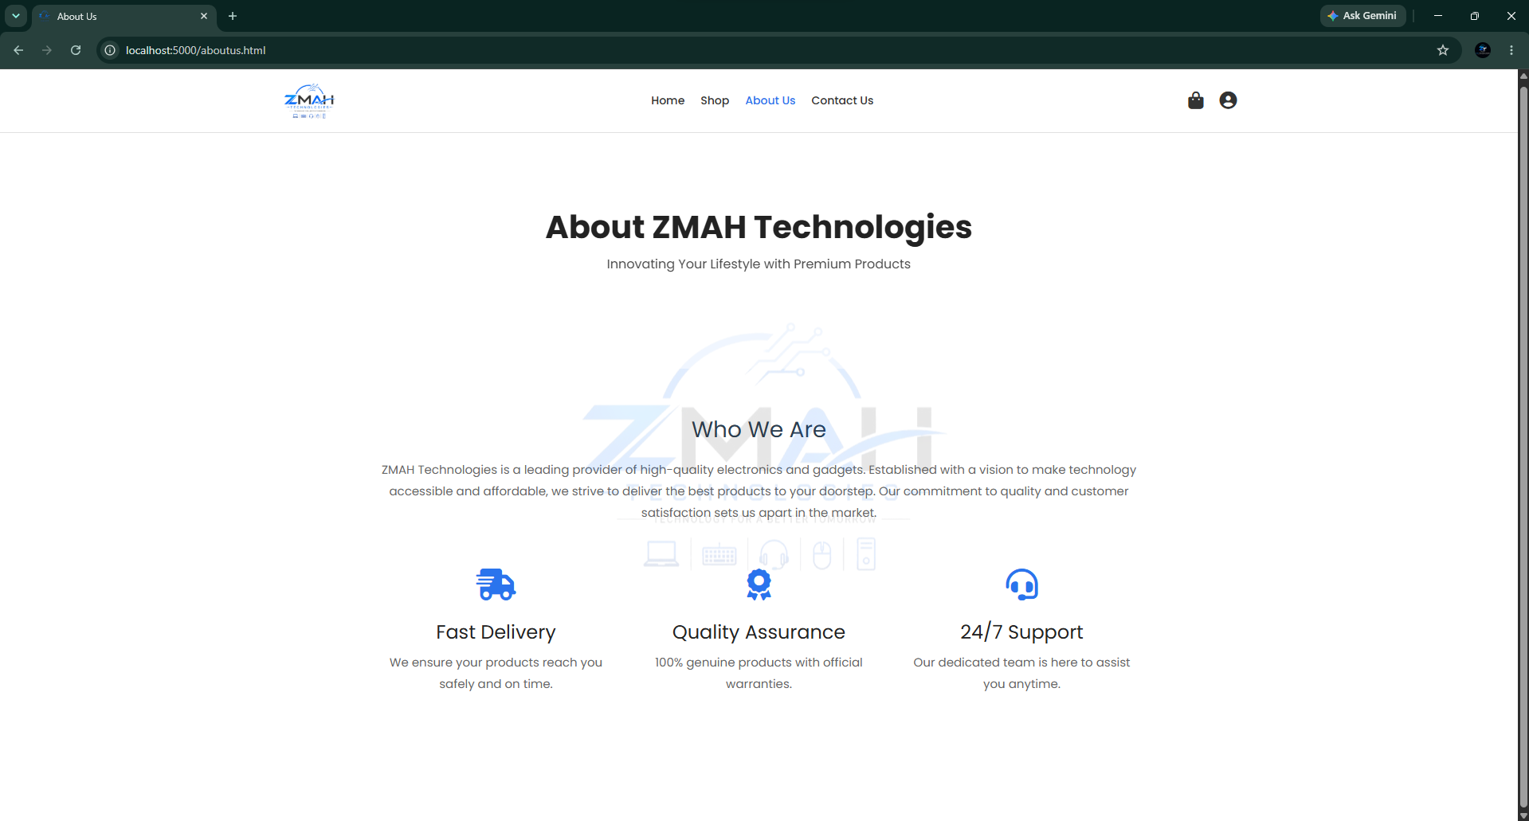

6.5 Contact Us Page
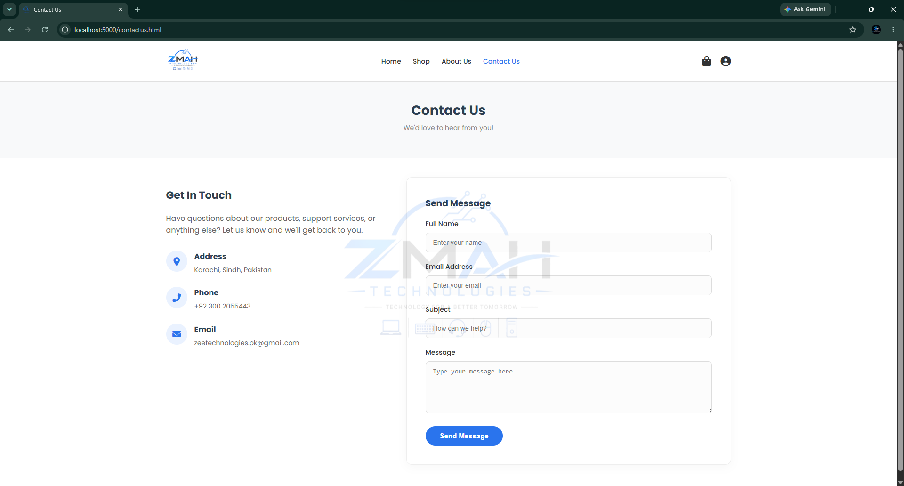

6.6 Interactive Shopping Cart
Details of selected items, quantity selectors, checkout triggers, and running subtotal.
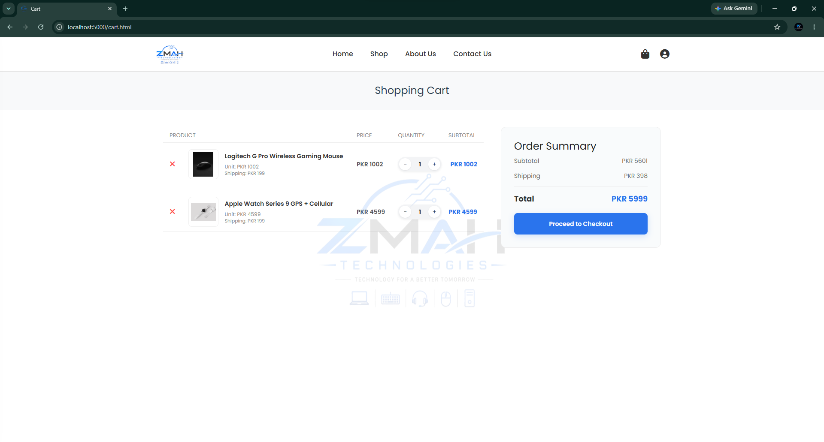

6.7 Checkout & Order Placement
Billing address capture, total calculation including shipping, and order submission.
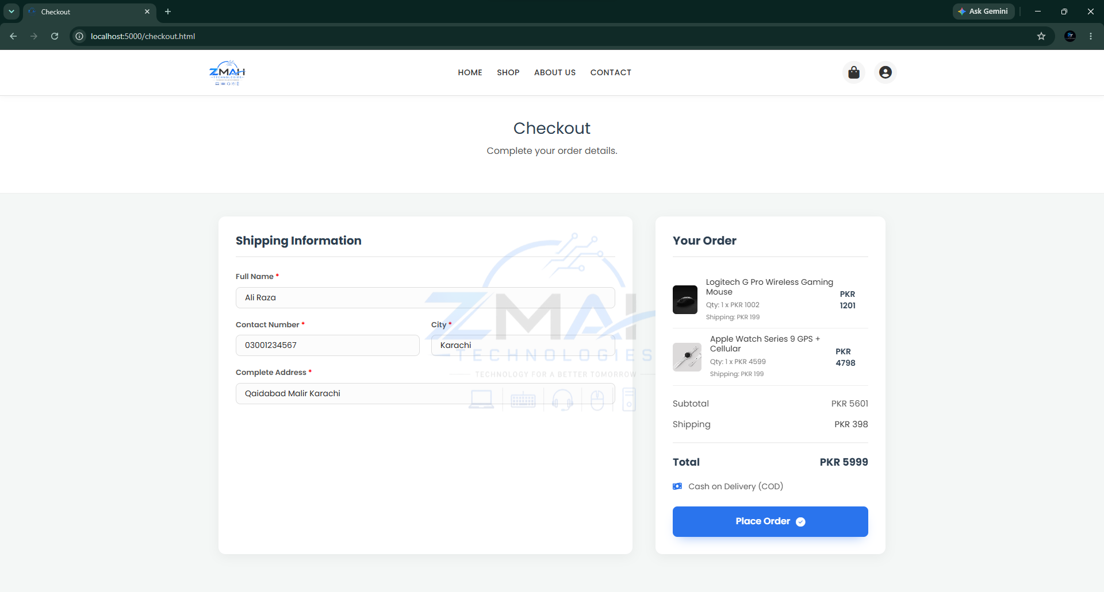

6.8 User track order
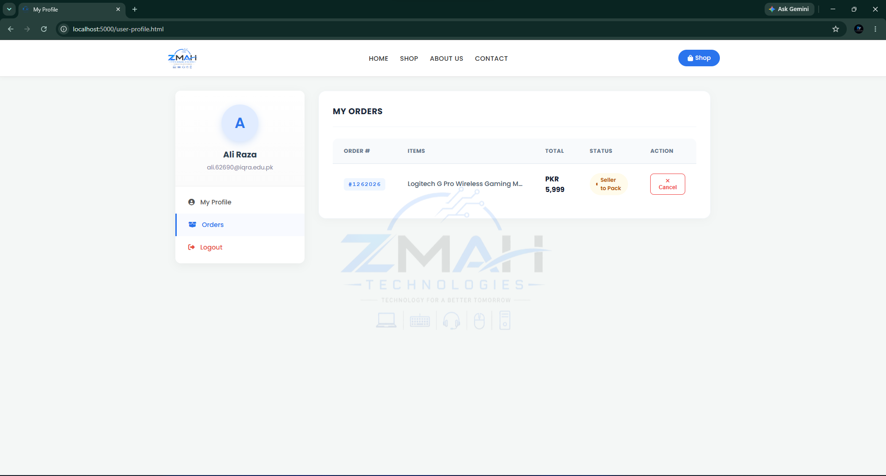

6.9 Customer Authentication & OTP Recovery
User Login and SignUp forms, plus the secure OTP validation request screen.
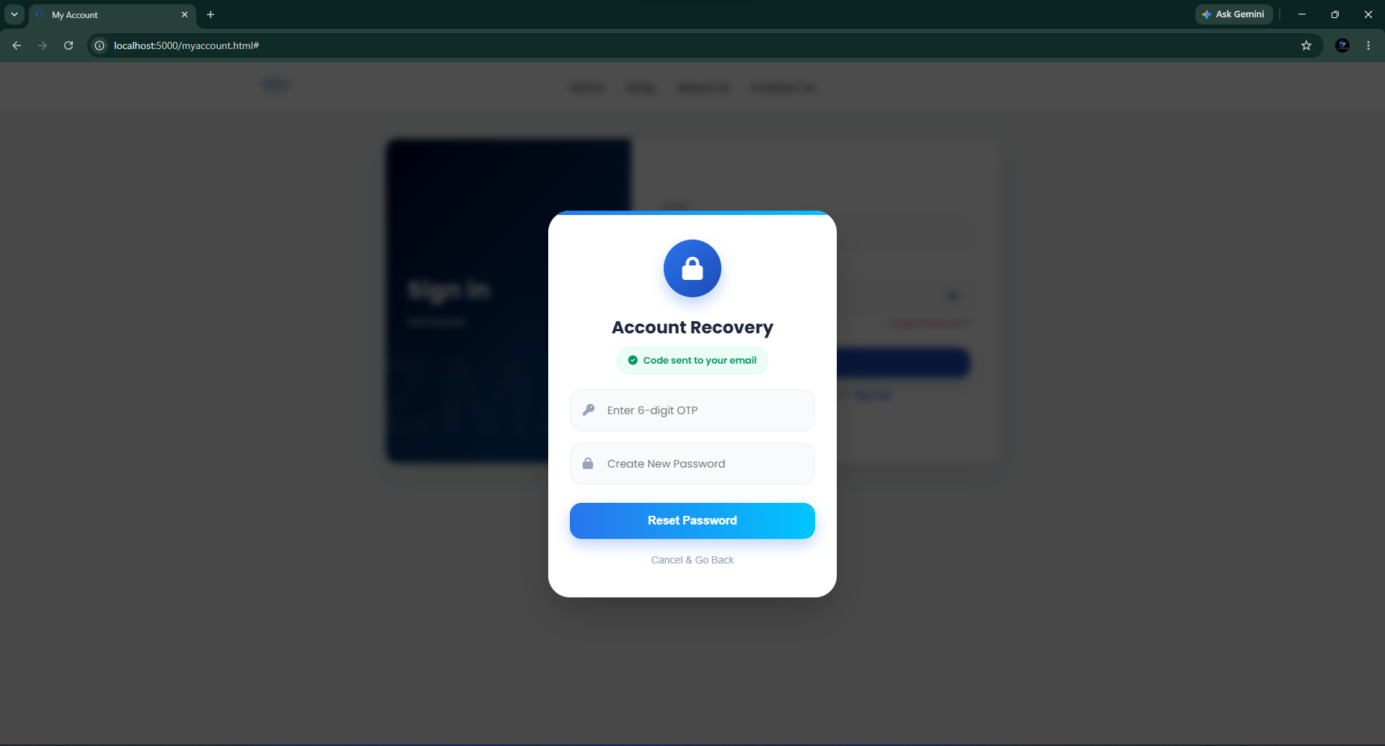

6.10 OTP Received Email Inbox
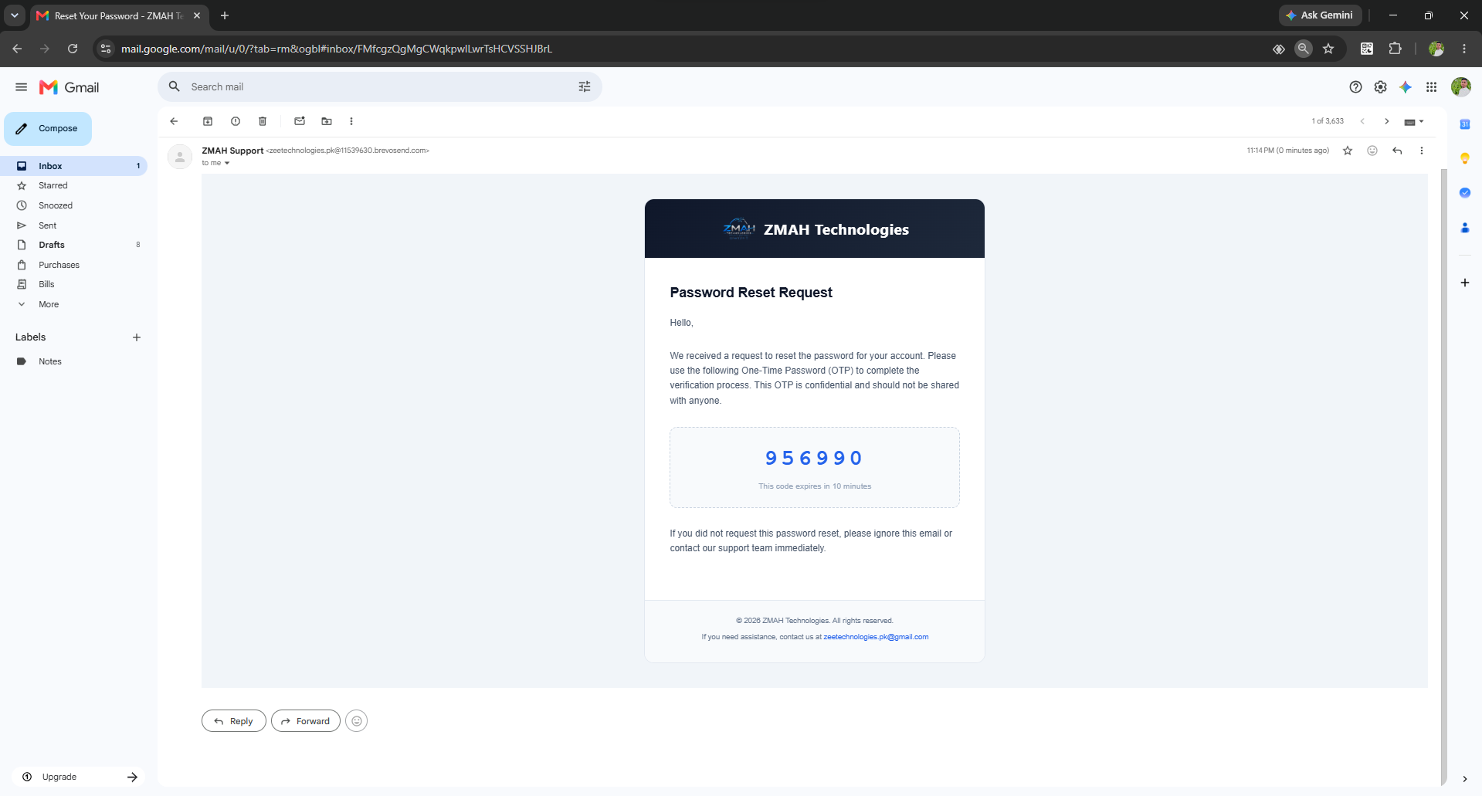

6.11 Password Reset Successfully
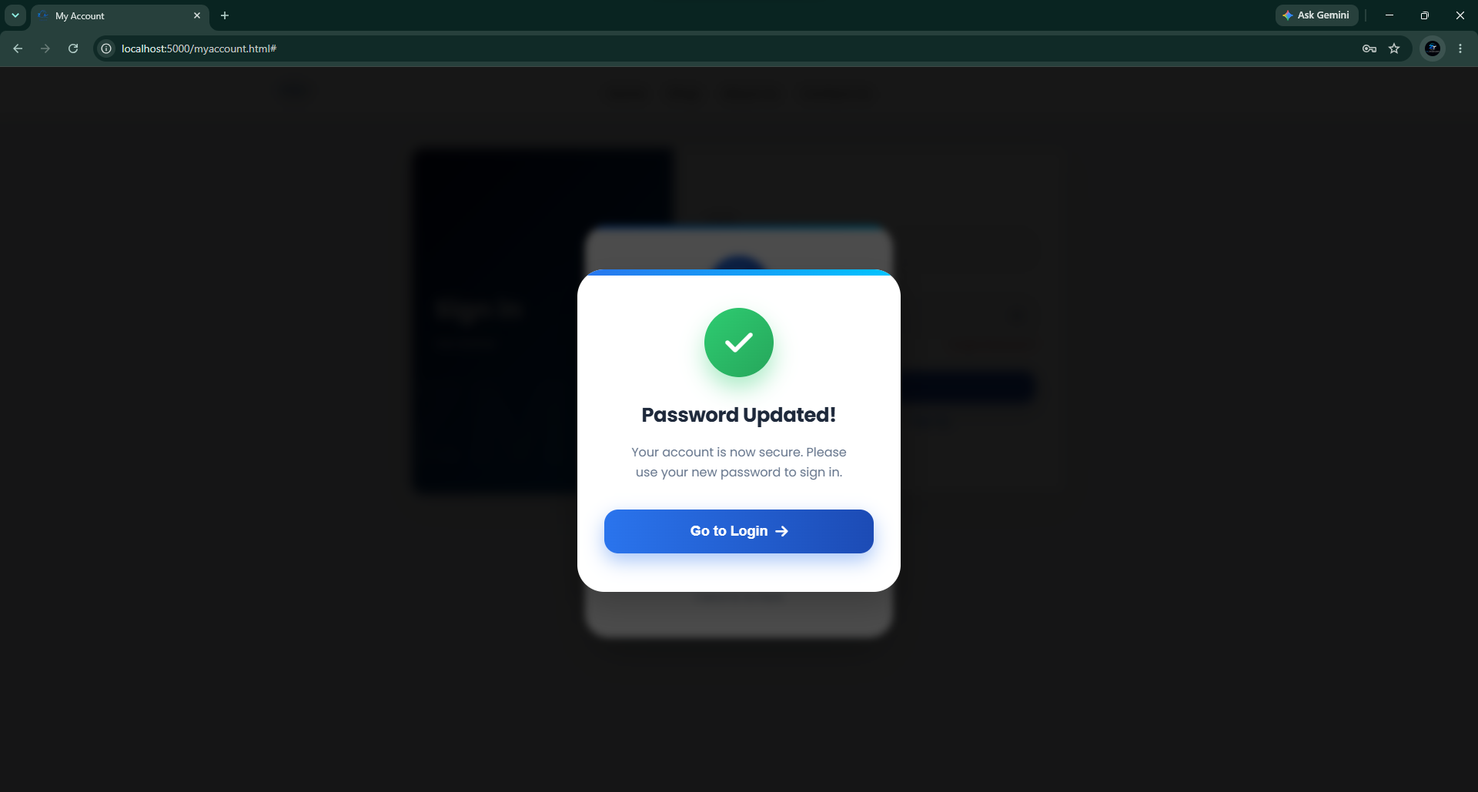

6.12 Admin Login Portal
Secure administrator authorization access panel.
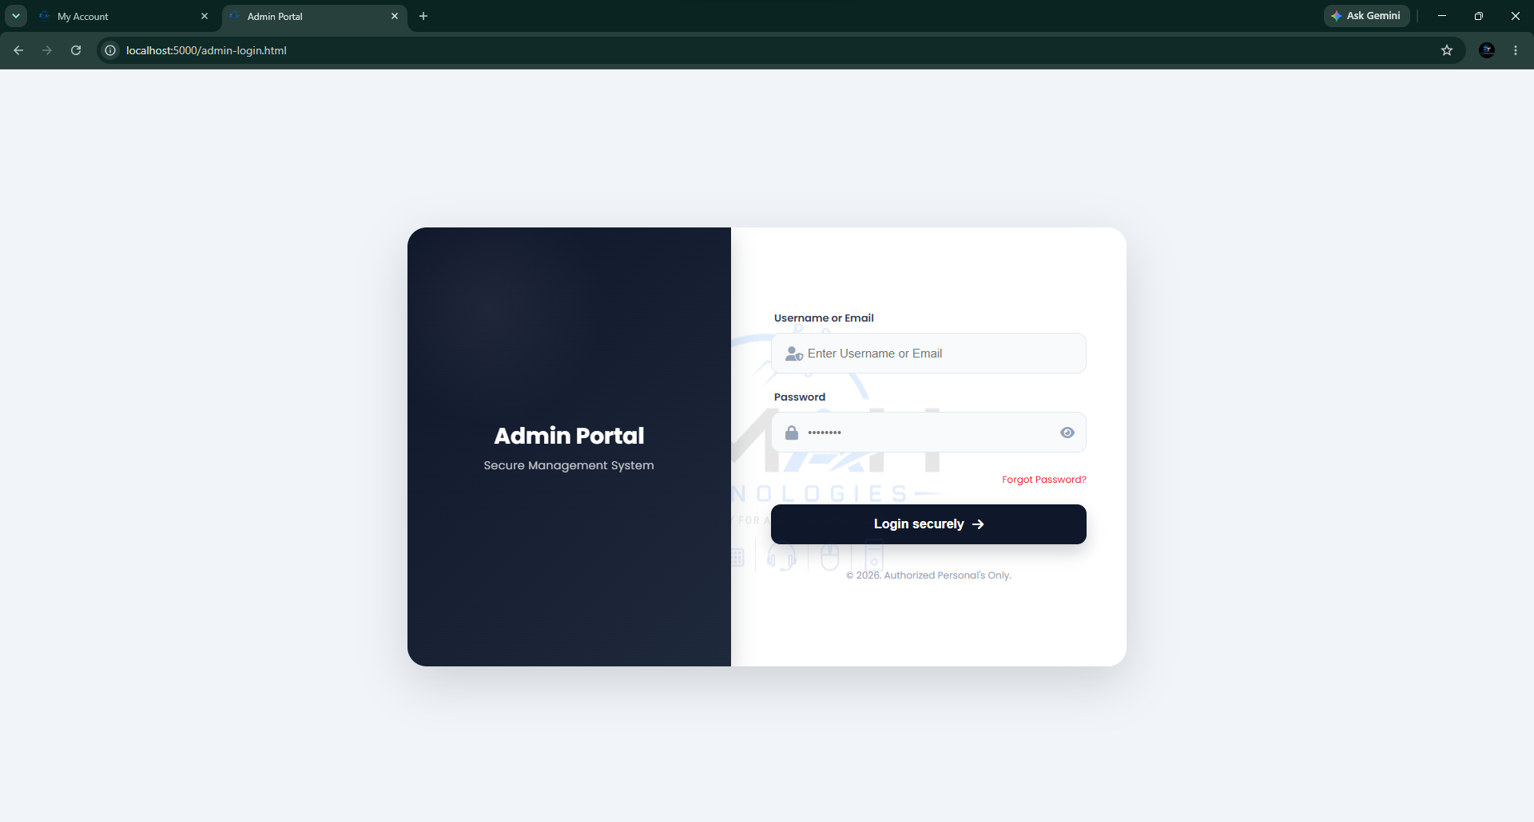

6.13 Admin Management Dashboard
Real-time metrics charts, inventory trackers, and low-stock indicator listings.
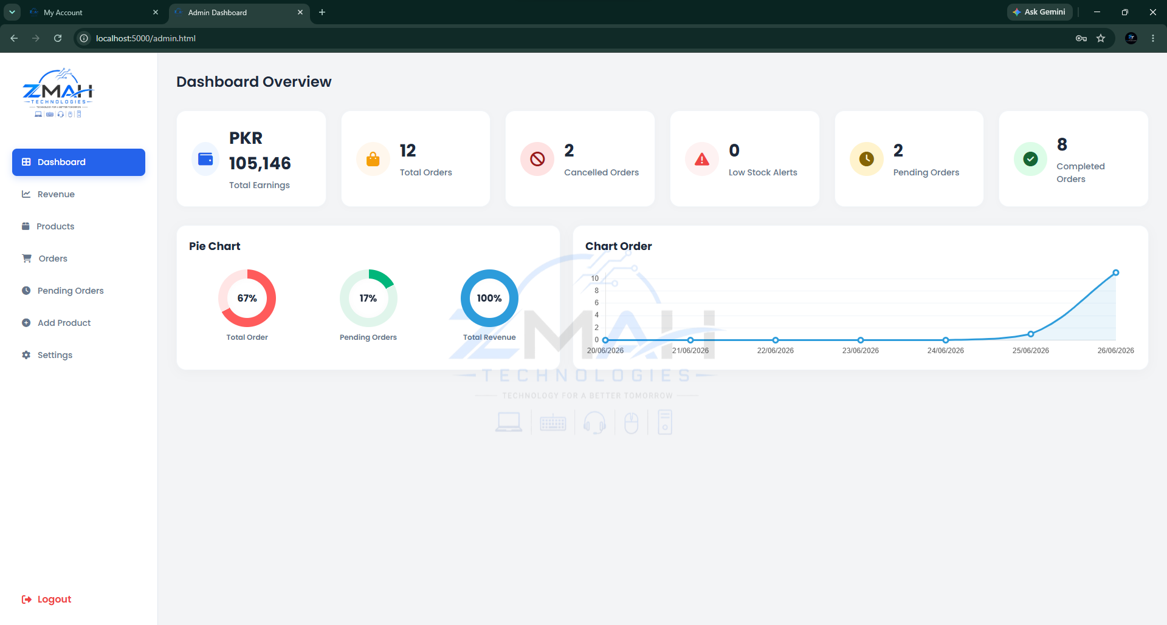

6.14 Revenue Analytics
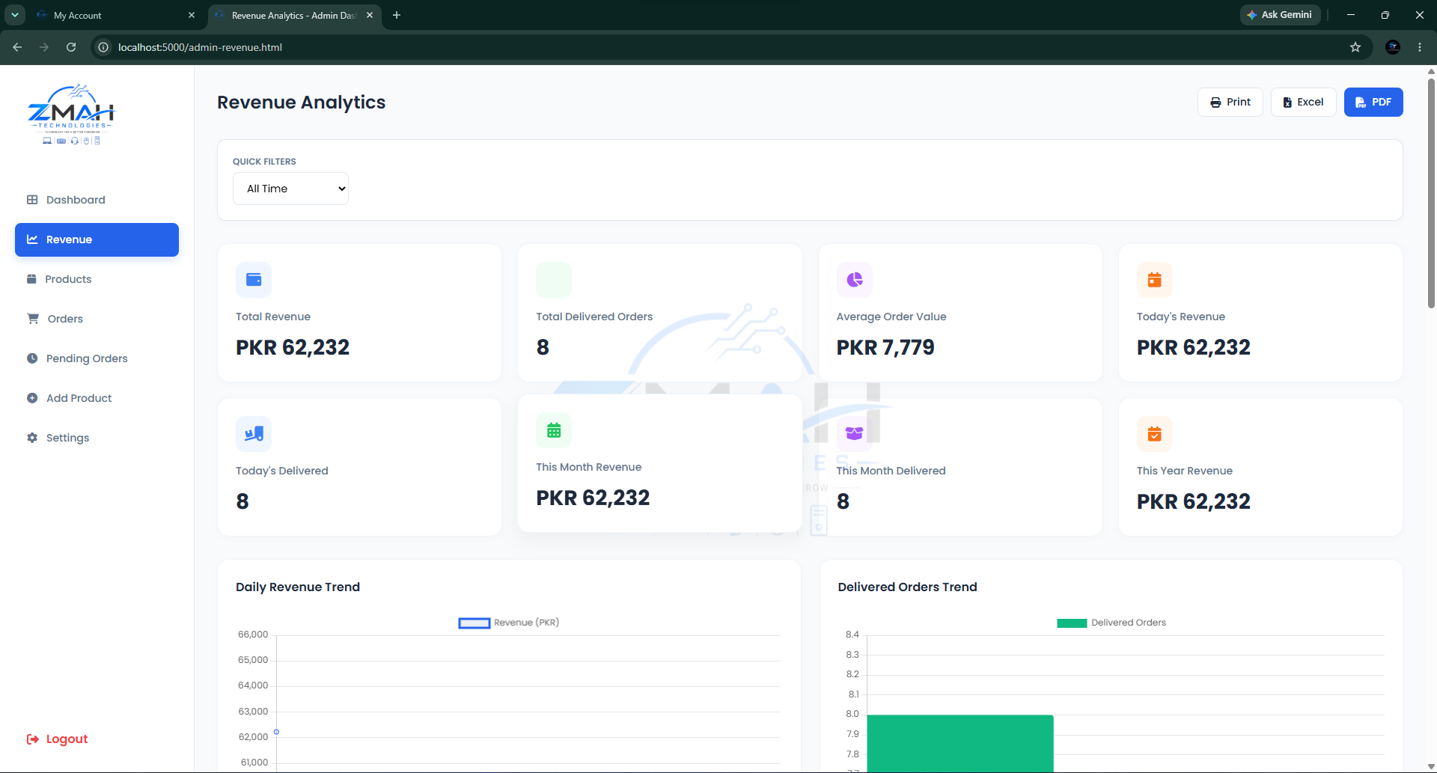

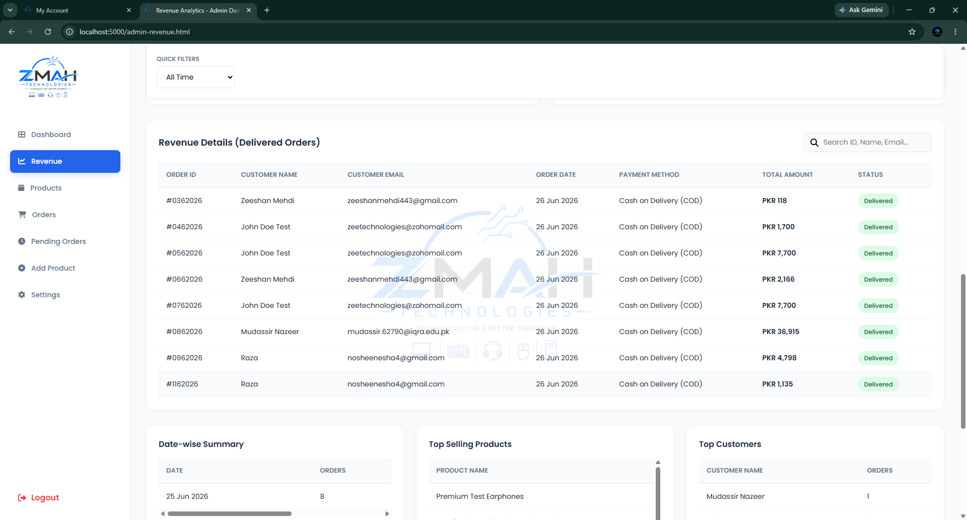

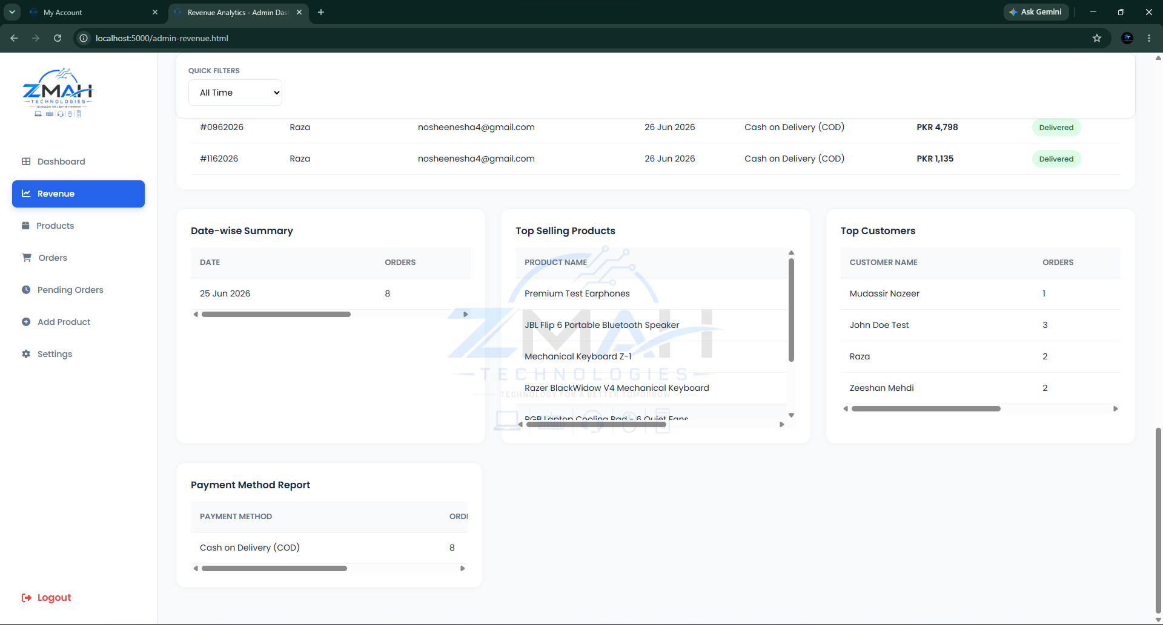

6.16 Admin CMS - Product Management
Adding new products with multi-image selectors, video files, weights, and stock adjustments.
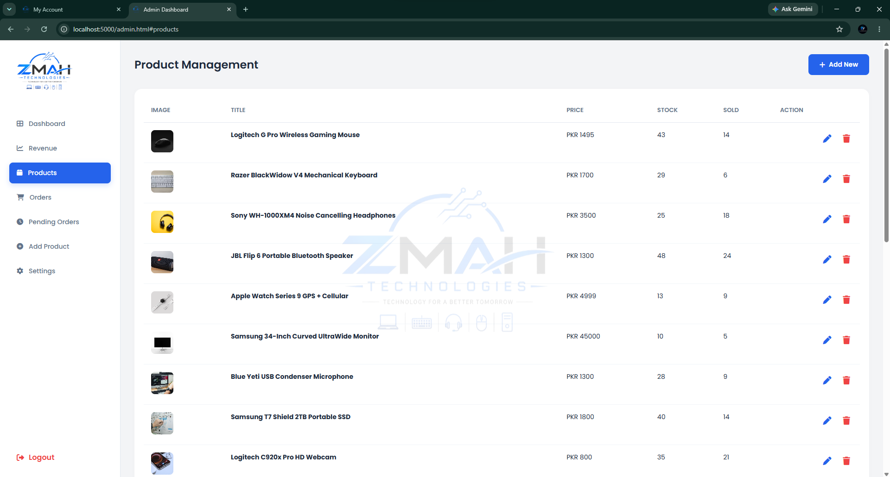

6.16 Add Product Page
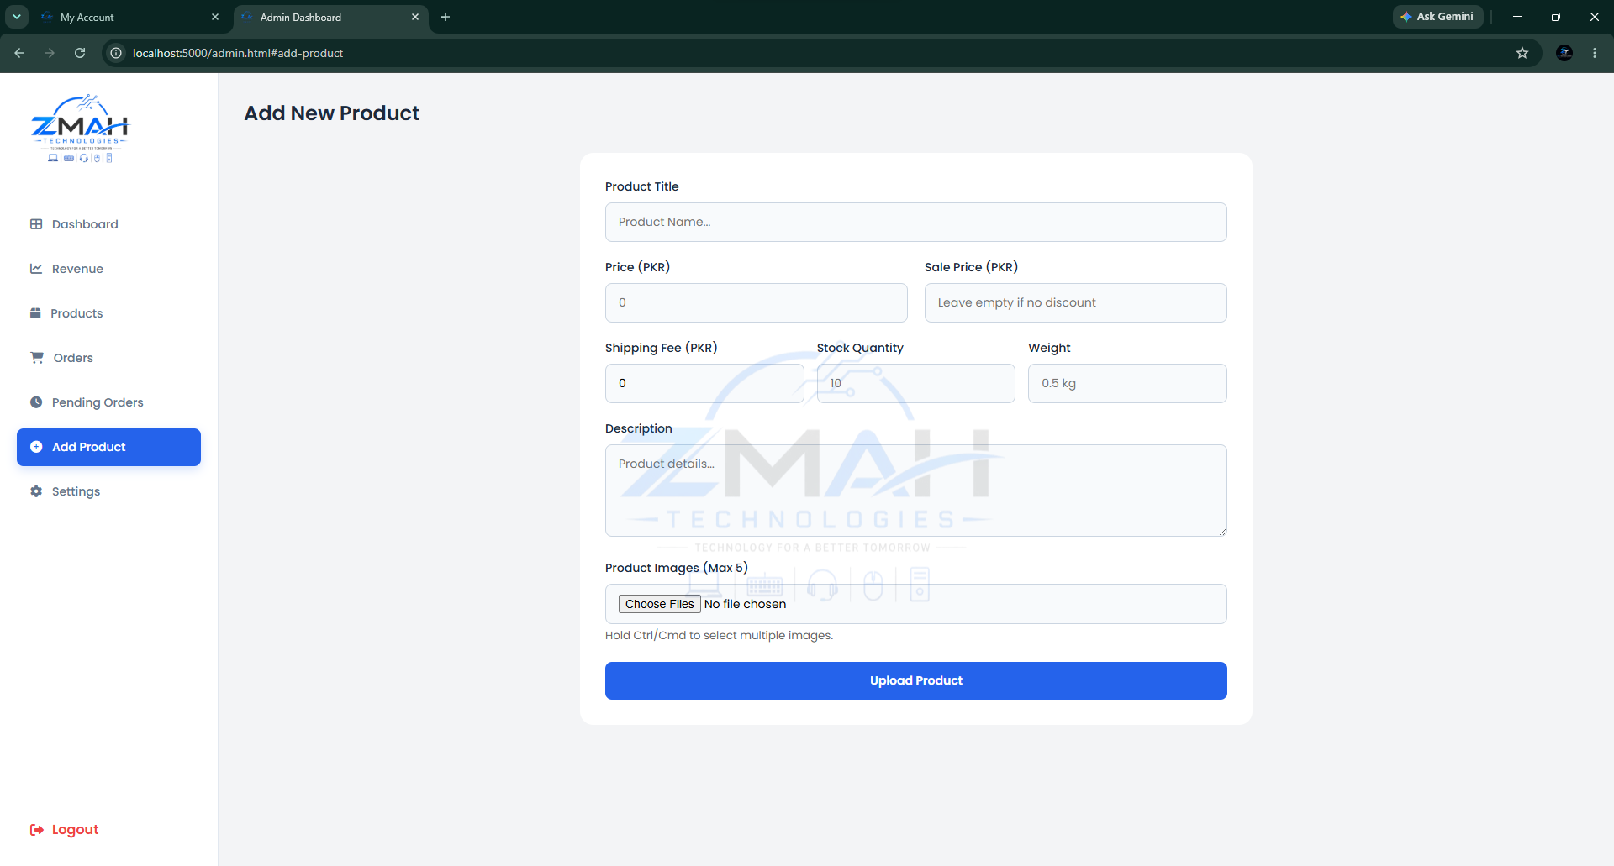

6.17 Admin - Order Tracking & AWB PDF Generation
The main order overview showing all customer orders, status modification dropdowns, and download AWB options.
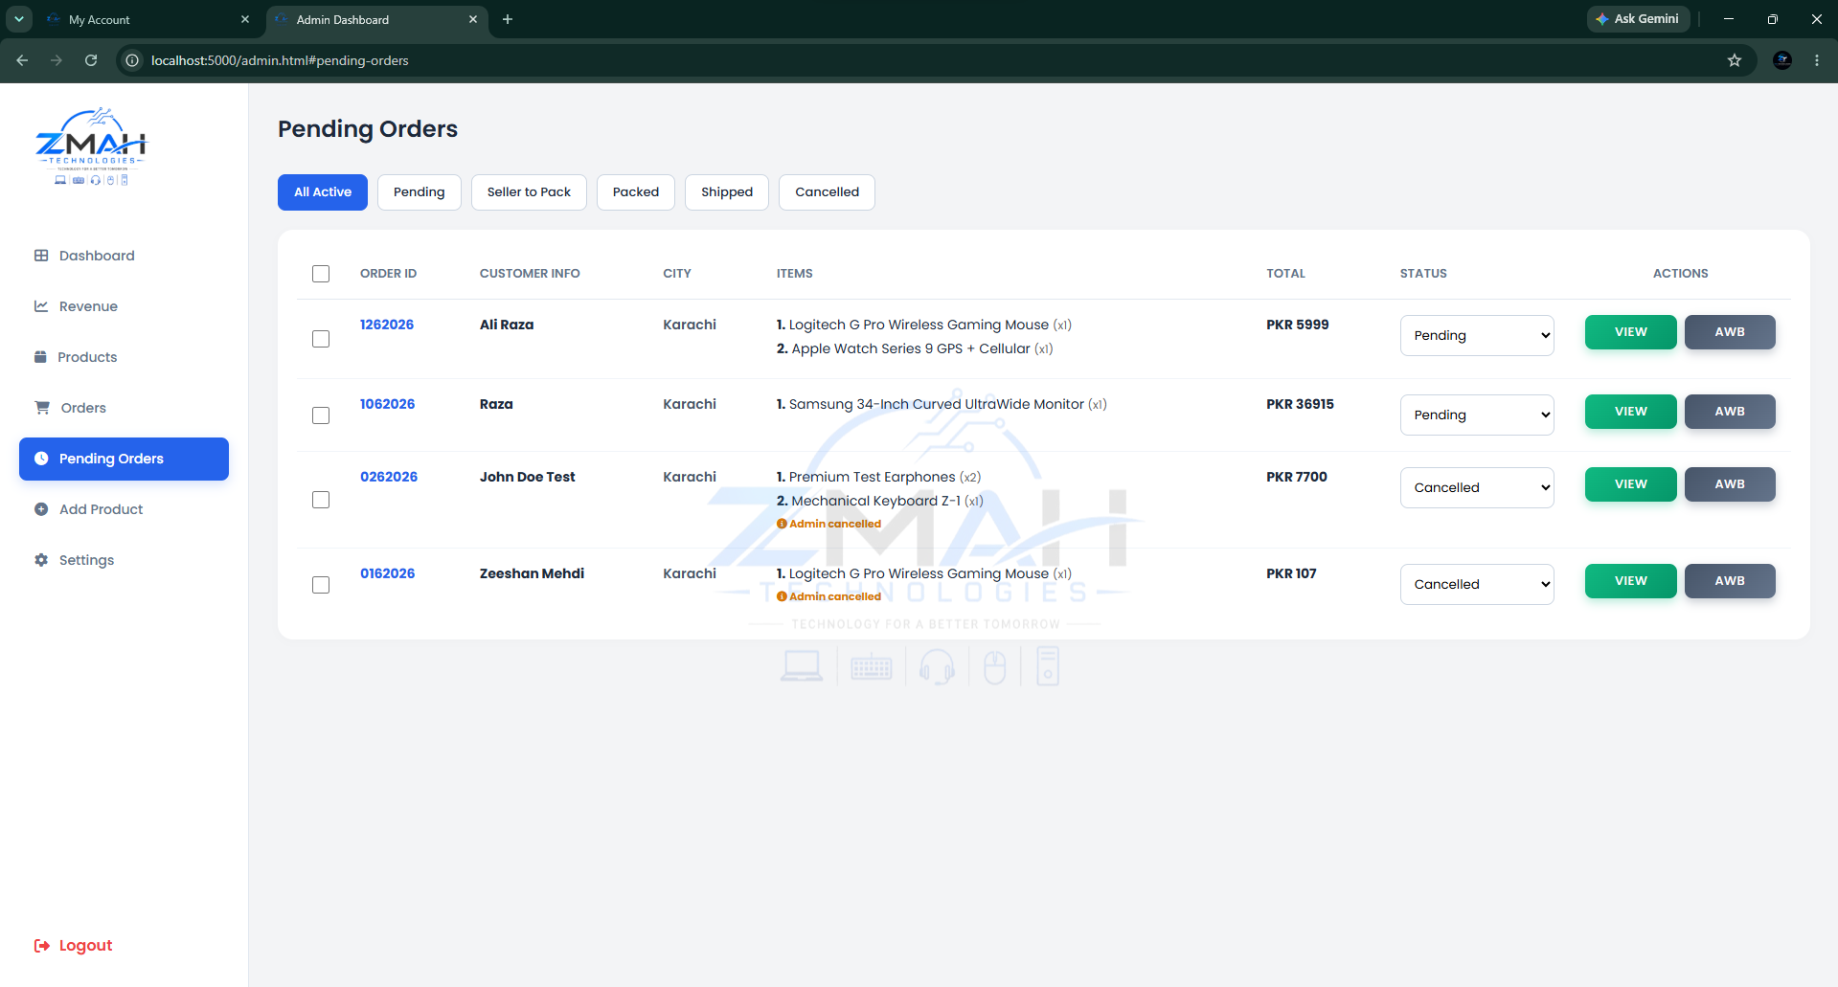

6.18 View Order Details
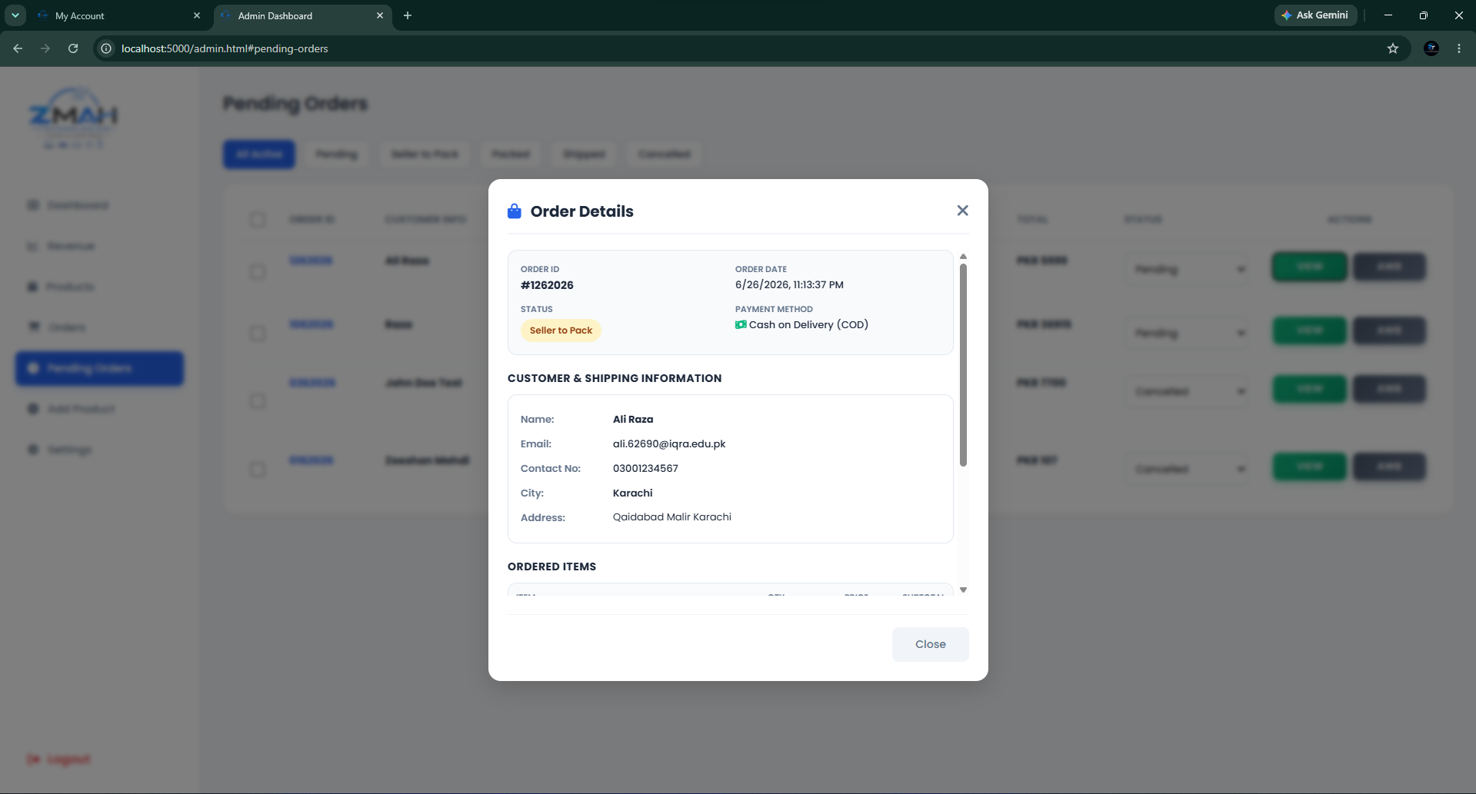

6.19 AWB Shipping Label
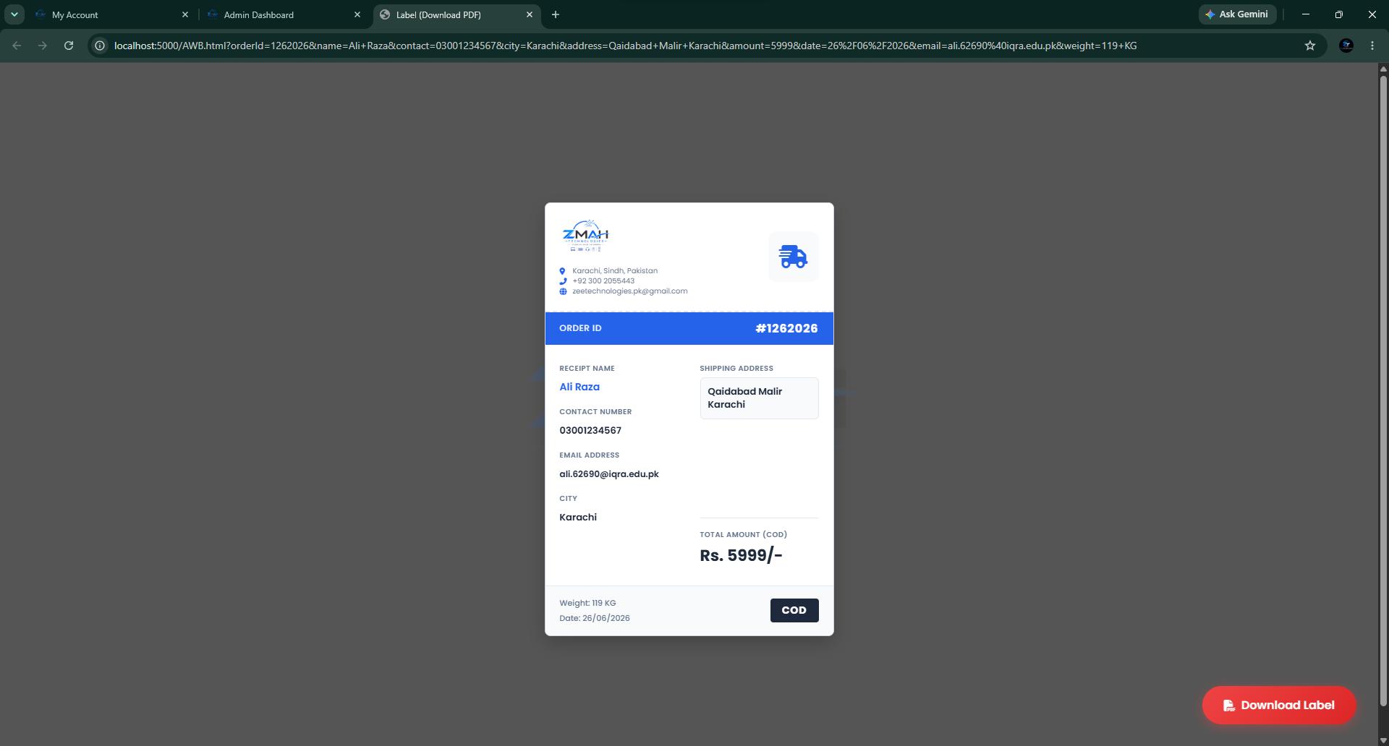

Conclusion & Future Scope
The project provides a stable, performant foundation for an e-commerce platform. Moving away from client-side UI frameworks ensures that pages load rapidly even on slower mobile networks. Future updates could implement automated email tracking links, credit card payment integration (e.g., Stripe/EasyPaisa), and advanced admin notifications for out-of-stock items.

GitHub Link

https://github.com/thezeeshanmehdi/ZMAH-Technologies---Full-Stack-E-Commerce-Store-Admin-CMS

