**CVIP HW 3 REPORT**

**GAUTAM SHENDE 50245840**

***1) HOMOGRAPHY:***

***A) Putative Matches:*** I have used Blob detection from HW2 before getting SIFT descriptors)

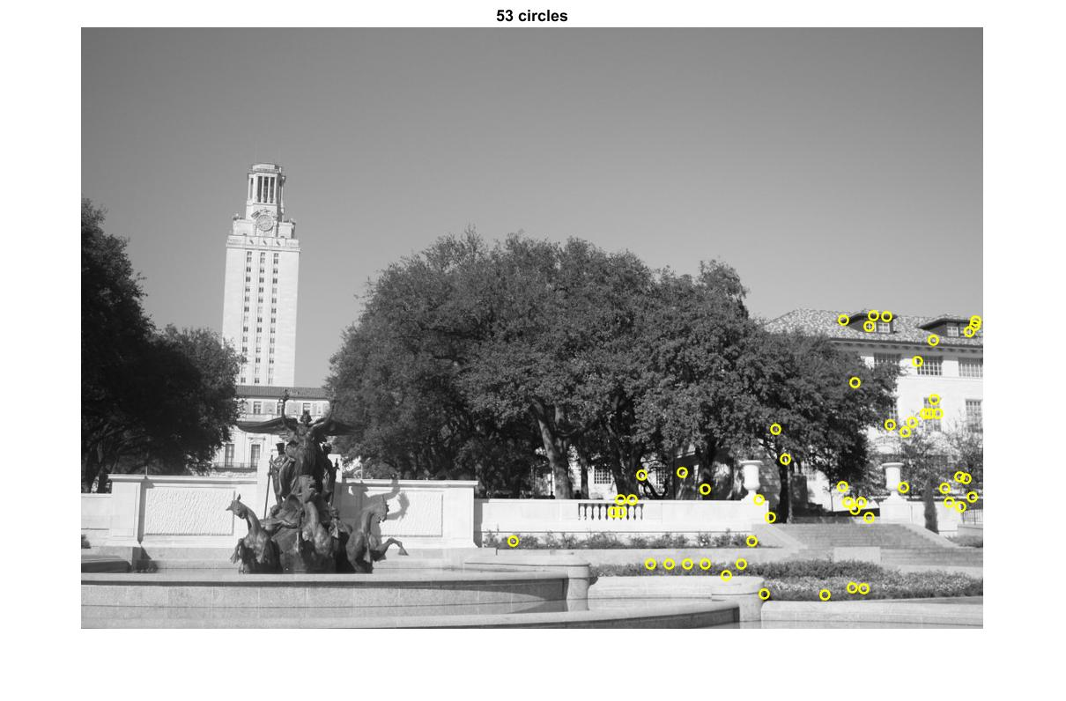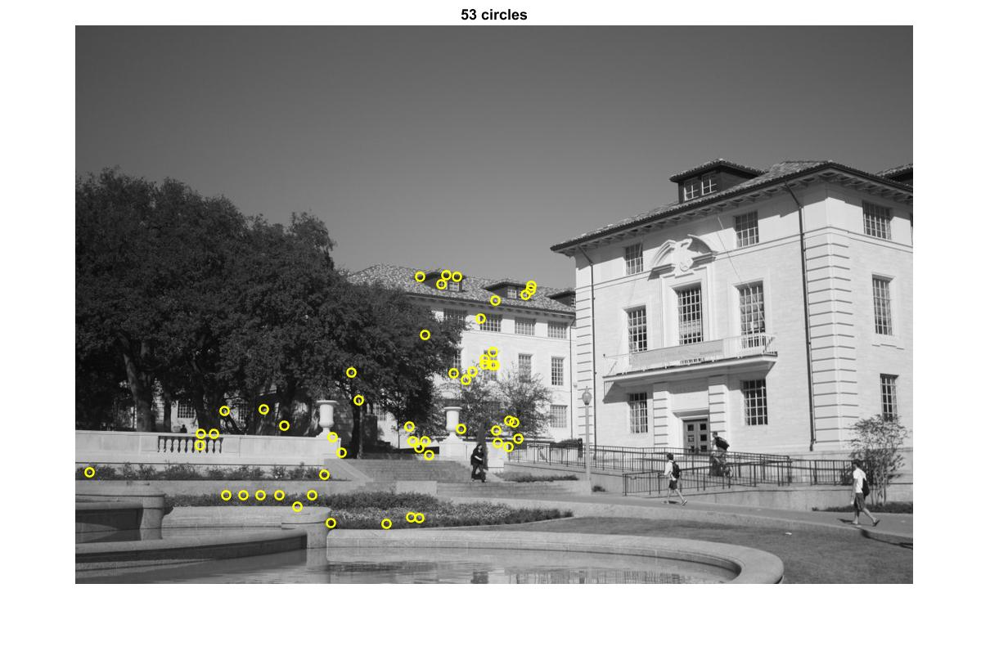

***B) Image Stitching Outputs including 3 image panoramas (Extra Credit)***

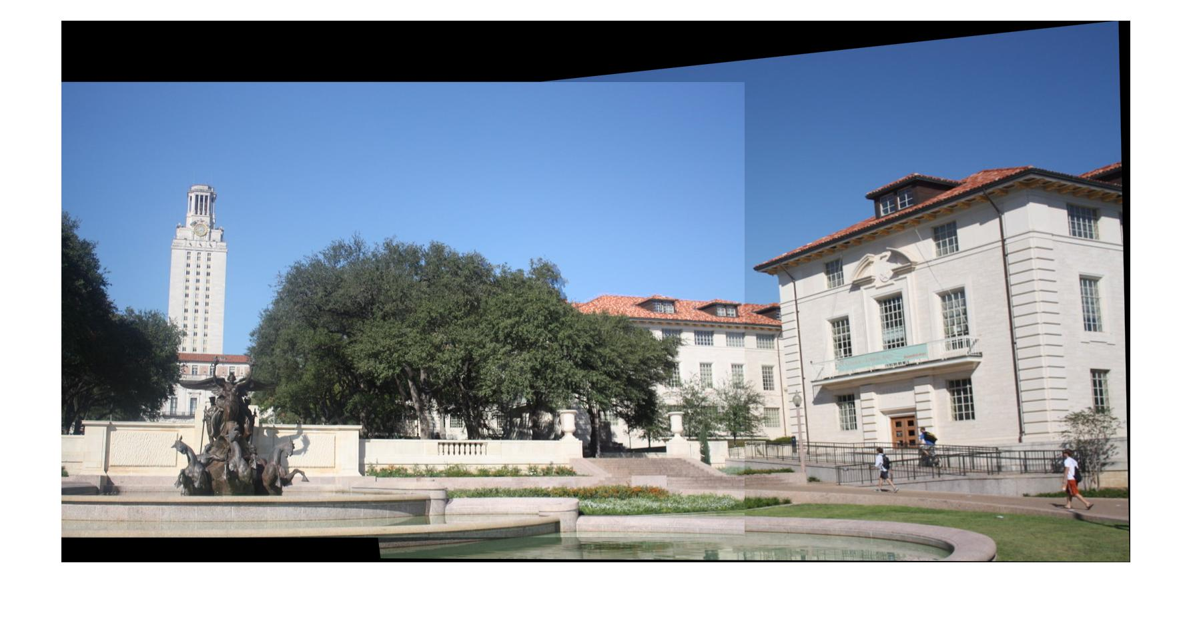

***Max_inliers = 52, Mean inlier residual = 5.4384***

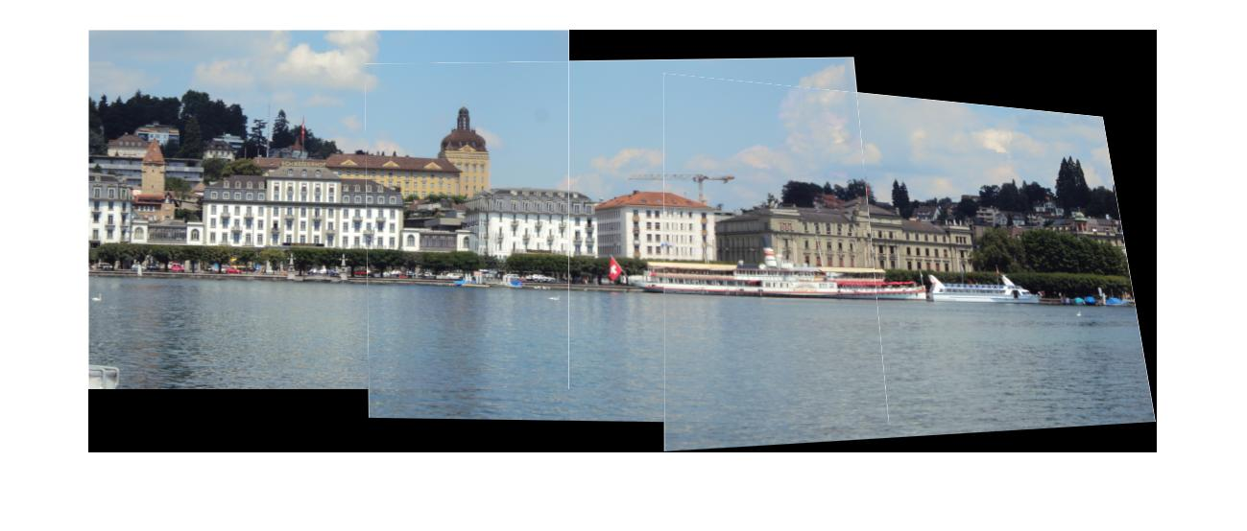

***Max_inliers = 128, mean_residual = 10.5469***

**sa**

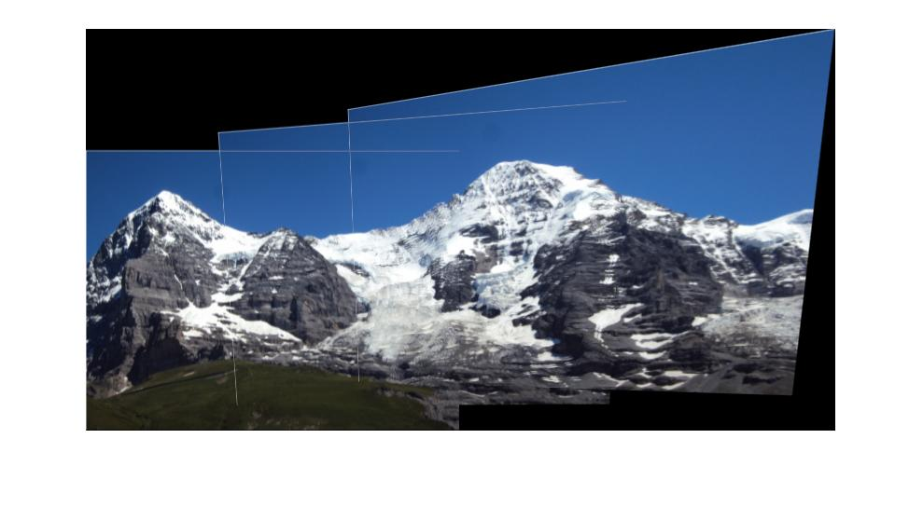

***Max_inliers = 135, mean_residual = 1.7555***

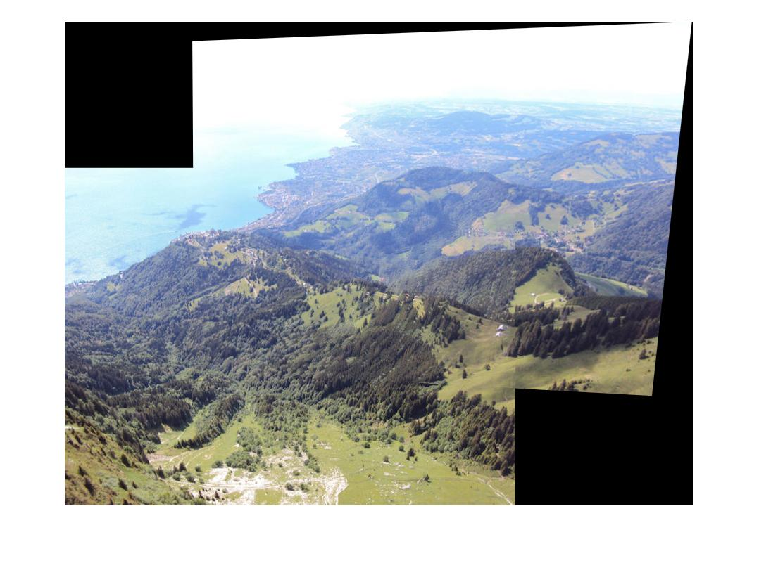

***Max_inliers = 155, mean_residual = 6.4514***

***2.2) FUNDAMENTAL MATRIX & EPIPOLAR GEOMETRY***

**GROUND TRUTH**

Library Mean Residual Errors:

*Un-normalized: 11.8459* *Normalized: 9.9614*

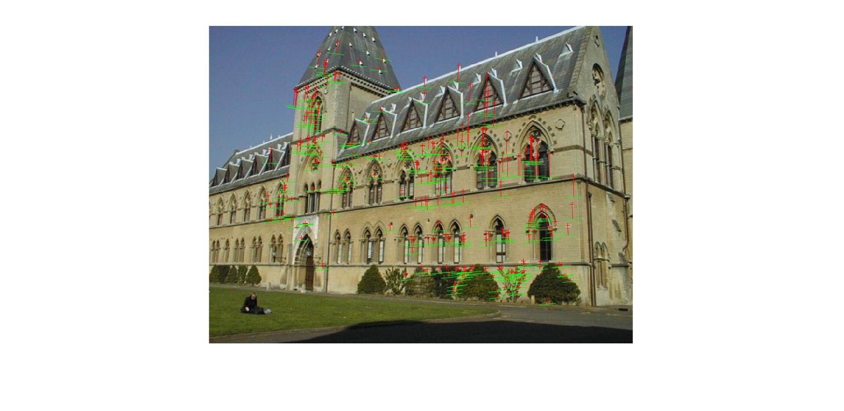 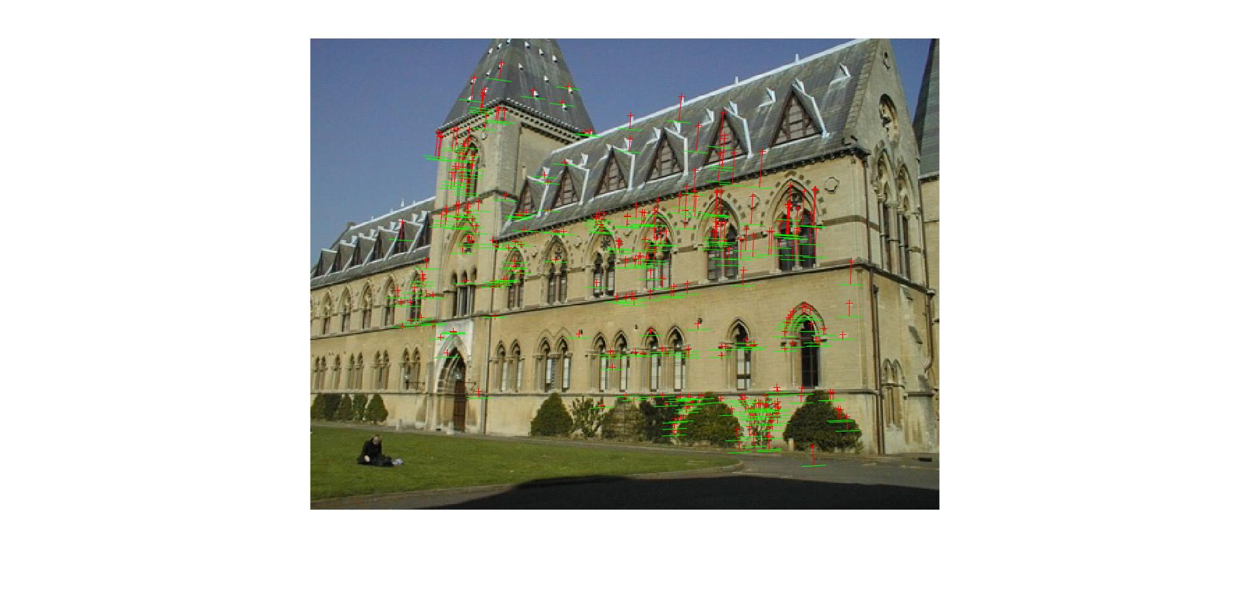

House Mean Residual Errors:

*Un-normalized: 26.7532*  *Normalized: 14.1954*

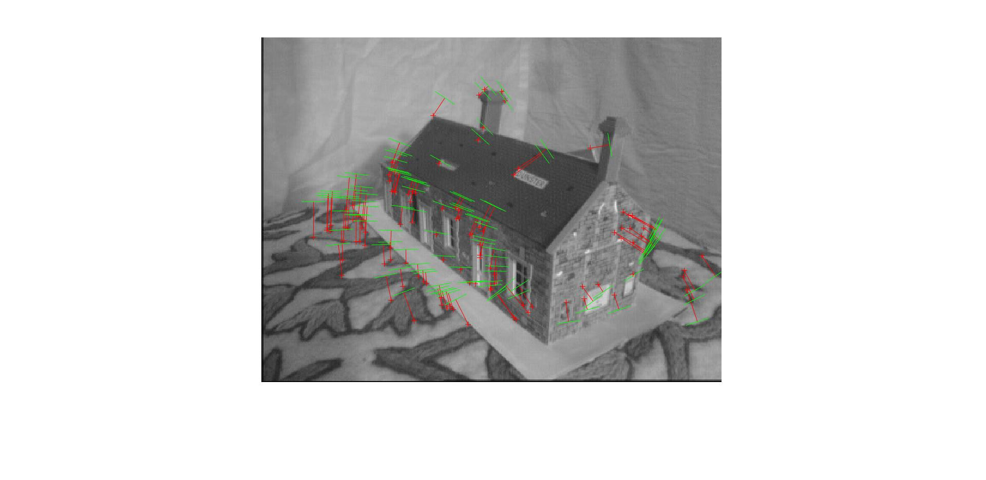 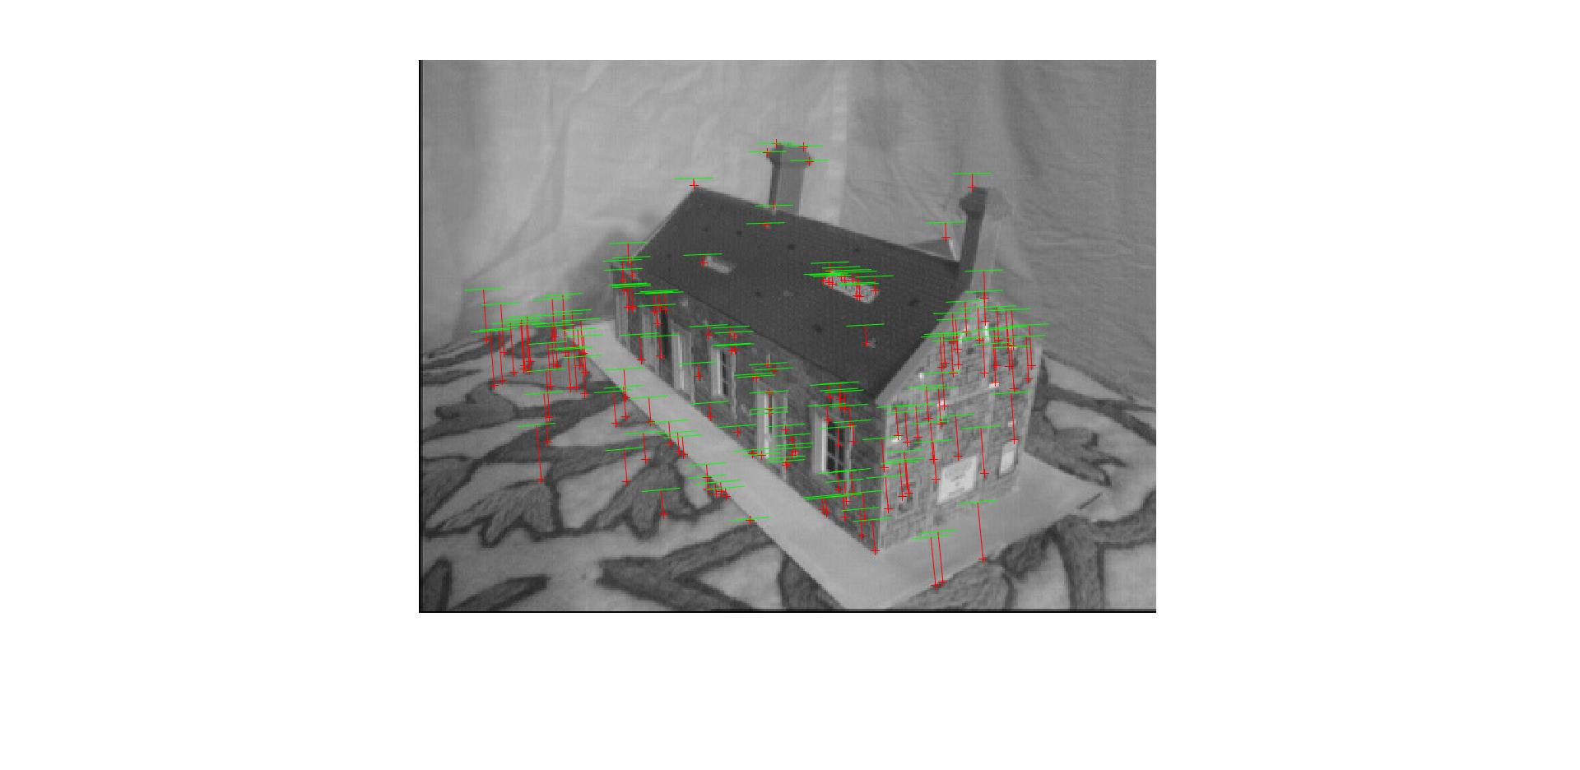

**2.3) RANSAC**

Since I used blobs in Part1, I decided to use Harris detection before getting SIFT descriptors in Part 2.

House Inlier Mean Residual error: Library Inlier Mean Residual error:

*Threshold = 20, max inliers = 57/99, mean_inliers_res= 7.414* *Threshold = 30 max_inliers = 93/199, mean_inliers_res =13.46*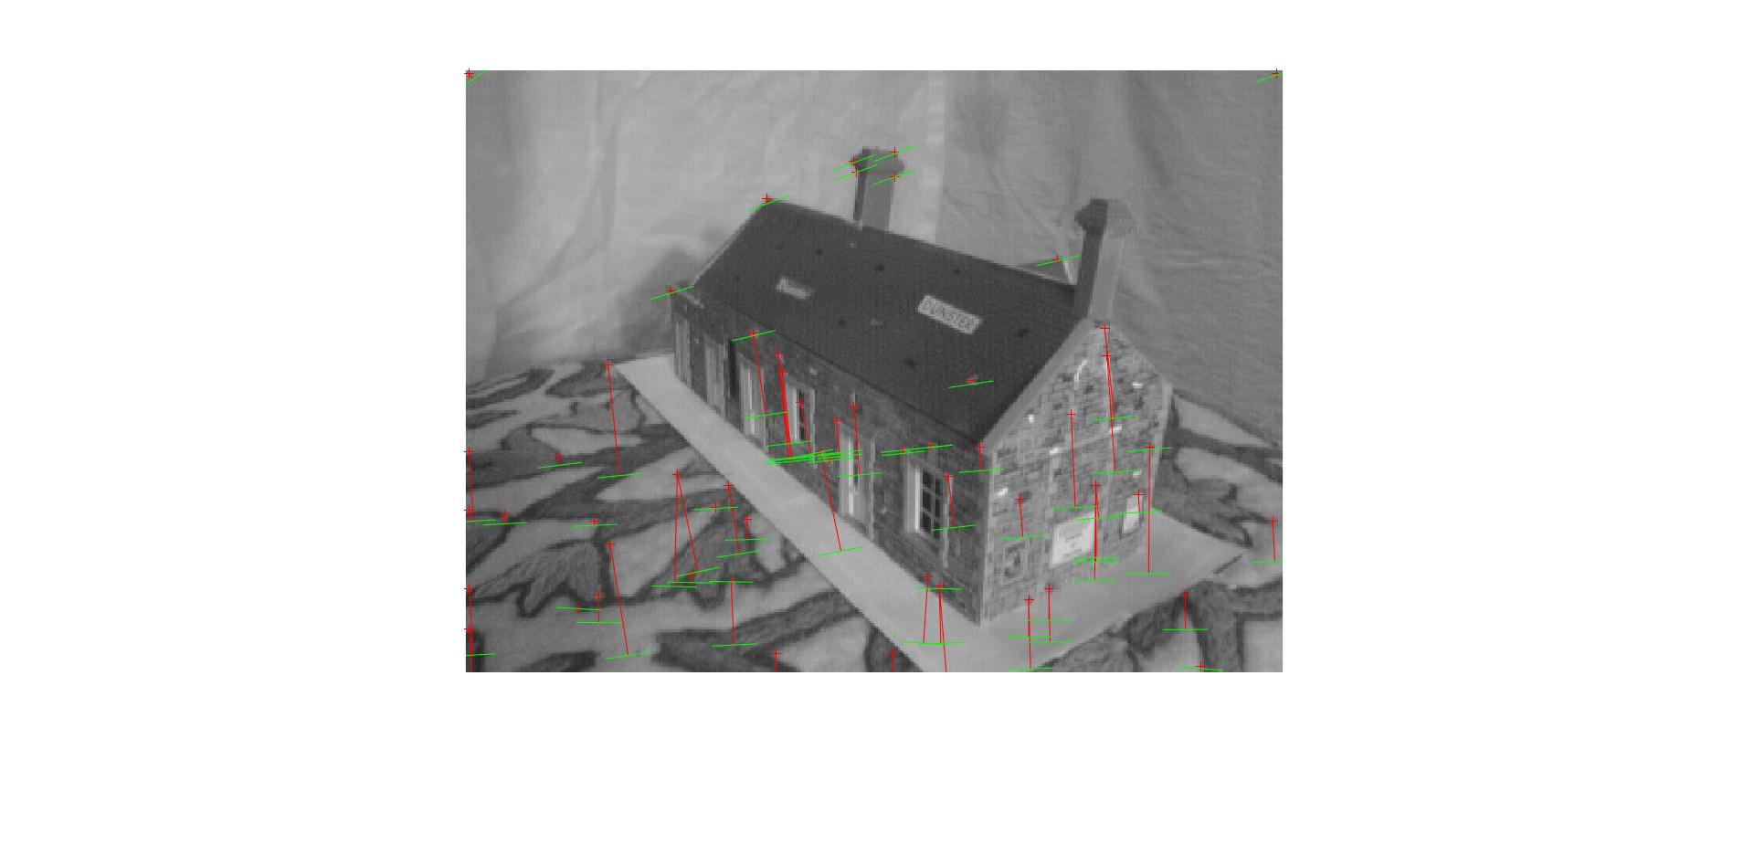 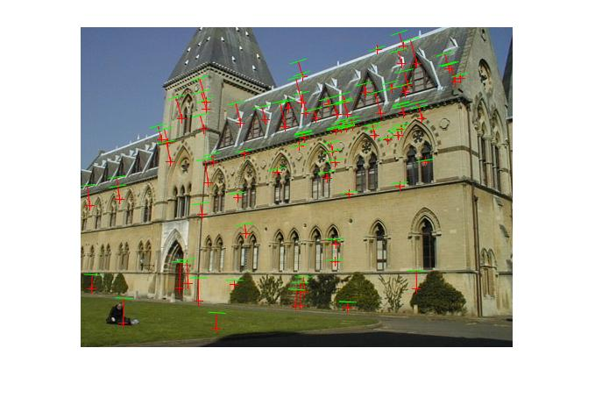

***Ground Truth results were much better in comparison to Ransac !***

With RANSAC, the general residual error had increased so I had to set a lower threshold in order to avoid erroneous results with overlapping epi-polar lines.

I was running RANSAC for a total of 10^5 iterations in the estimation of fundamental matrix and yet there was a lot of scope for improvement. The matches and epi-polar lines are far from accurate when compared to the ground truth matches. A lot of the parameters needed to be tuned in RANSAC based on the image. The library image needed more *correspondences* than the house.

***2.4) Reconstructed Camera Centers and Points in 3D:***

GIF : <https://drive.google.com/open?id=1CYs29KXmEc_Z8zJ0J0E2LOfGly2HbRpm>

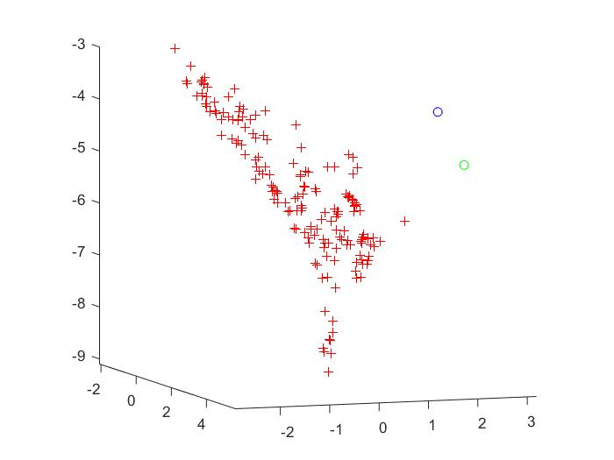

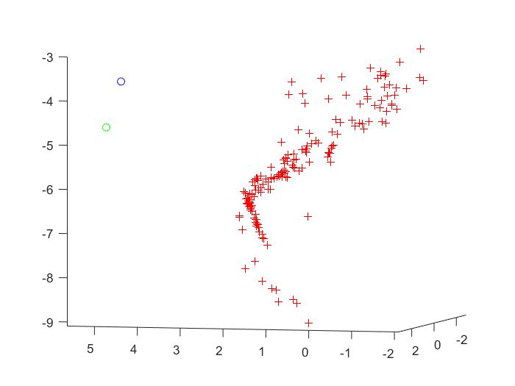 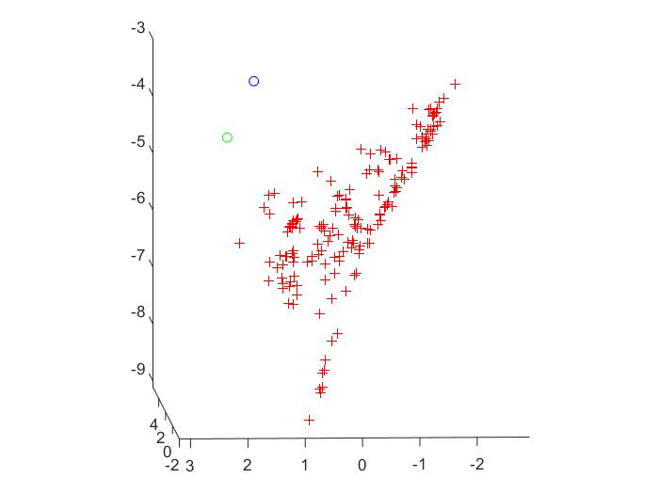

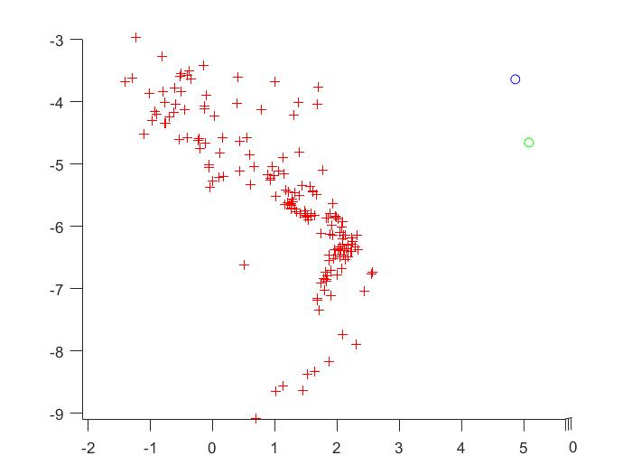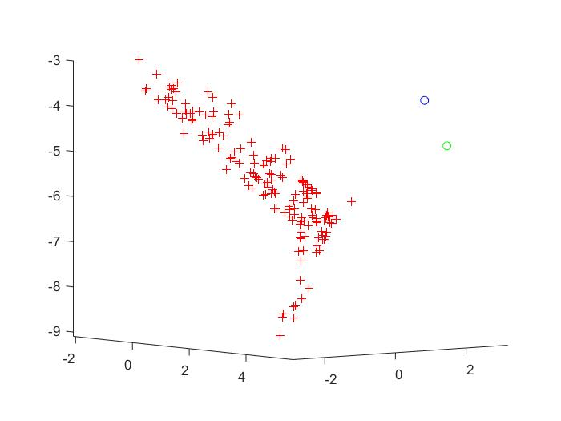

**Residual Errors between original 2D and projected 3D points:**

* **Image1 = *0.0025*,**
* **Image2 = *0.156***

***References:***

*Homography and RANSAC: https://www.youtube.com/watch?v=oT9c_LlFBqs*

*Fundamental Matrix: https://www.youtube.com/watch?v=DgGV3l82NTk*

*Image stitching: http://home.deib.polimi.it/boracchi/teaching/IAS/Stitching/stitch.html*

*Triangulation: dcyoung.weebly.com/fundamental-matrix--triangulation.html*