PAIR Platform
Project Overview Document – TalentBridge Platform

Project Name | PAIR – TalentBridge Platform
Document Type | Project Overview
Version | v1.0
Status | Draft – To be reviewed and validated with client/stakeholders
Date | April 2026

1. Project Overview
This project, internally referred to as the TalentBridge Platform, is a capstone system designed to support the development of a web-based talent and recruitment solution.
The final product of this project is a platform named PAIR, which aims to connect talent users (students, graduates, and professionals) with recruiters through project-based evidence of skills rather than traditional CV-based applications.
Many employers face challenges in assessing candidate capability due to the limitations of traditional resumes and online professional profiles, where skills and experiences are often difficult to verify.
PAIR addresses this issue by enabling users to showcase verified project artifacts, skills, and collaborative contributions, allowing recruiters to evaluate candidates based on real work outputs.
The system focuses on improving transparency, employability, and recruitment efficiency by shifting from credential-based evaluation to evidence-based talent assessment.
2. Problem Statement
- Problem 1: Emerging talent struggles to demonstrate practical experience to employers.
- Problem 2: CV-based systems do not effectively verify real project-based skills.
3. Stakeholder Analysis
This stakeholder analysis identifies key stakeholders using an influence–interest framework to support requirement definition and prioritisation for the platform. This approach is consistent with the stakeholder analysis methodology outlined in the BABOK Guide (IIBA, 2015), which recommends classifying stakeholders by their level of influence and interest to prioritise engagement and communication strategies.
3.1 Primary Stakeholders (High Influence – High Interest)
Stakeholder | Role & Rationale
Project Client / Sponsor | Defines business objectives, approves requirements, allocates resources, and determines project success. Has direct influence over scope, priorities, and acceptance.
Graduate Students | Primary end users with a strong interest in demonstrating verified skills and project experience. Their participation and adoption directly determine the platform's value and effectiveness.
Recruiters / Employers | Primary end users who rely on the platform to access credible, structured graduate evidence for hiring decisions. Their engagement is critical to platform credibility and success.
Platform Administration / IT Support | Responsible for system configuration, maintenance, security, and operational stability. Exerts high operational influence over platform reliability and performance.

3.2 Secondary Stakeholders (High Interest – Low Influence)
Stakeholder | Role & Rationale
Universities and Lecturers | Have a strong interest in graduate employability and learning outcomes and may encourage participation or support validation but have limited influence over platform design and adoption.
Community (Alumni, Donors) | Have a strong interest in platform outcomes and future opportunities, including participation and potential financial contribution, but have limited influence over platform design and adoption.

3.3 Stakeholder Map Rationale
The platform is user-driven; its success depends primarily on active adoption by talents and recruiters rather than organisational authority alone. Therefore, these user groups are classified as high-influence, high-interest stakeholders, while supporting academic stakeholders are classified as high interest with lower influence.
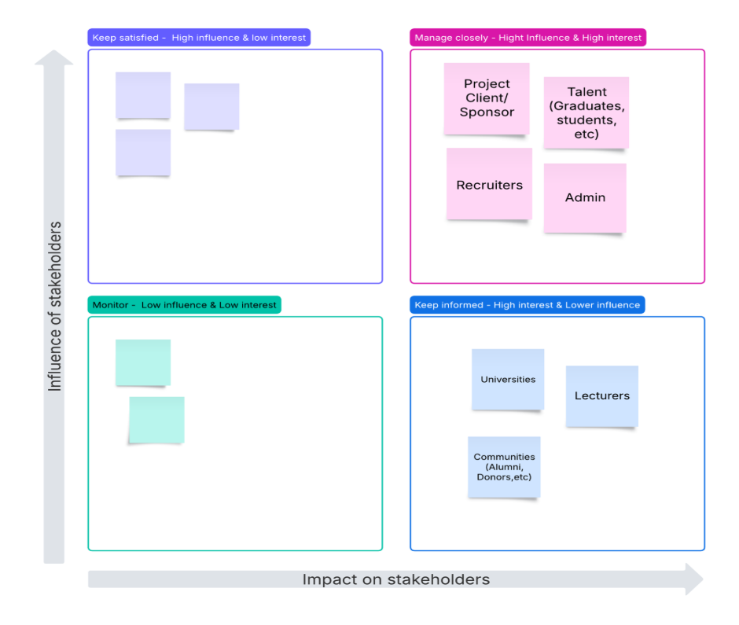Figure 1: Stakeholder map
4. Project Scope
The PAIR platform supports the following core functional areas:
- Talent profile creation (skills, projects, artifacts)
- Recruiter discovery and filtering system
- Project-based collaboration visibility
- Participant-based project contribution tracking

5. Assumptions
The following assumptions were identified during client engagement sessions and are documented to provide context for the requirements and design decisions made throughout the project. Documenting assumptions is consistent with best practice in business analysis (IIBA, 2015) and project management (PMI, 2021), ensuring all stakeholders share a common understanding of the conditions under which the platform is expected to operate.
5.1 User Assumptions
Assumption | Description
Internet & Device Access | Users have stable internet access and access to a desktop browser to use the platform.
Digital Literacy | Users possess basic digital literacy to create profiles, upload documents, and navigate dashboards without requiring technical training.
Authentic Content | Talents will upload authentic project artifacts and provide accurate profile information. The admin verification process provides a layer of quality assurance.
Professional Use | Recruiters are genuinely seeking talent and will use the platform professionally and in good faith.

5.2 Platform & Technical Assumptions
Assumption | Description
Google OAuth Availability | Google OAuth 2.0 remains available and functional for user authentication throughout the project lifecycle.
Secure File Storage | The platform hosting environment (Microsoft Azure) supports the secure storage of uploaded PDF files and user data.
Email & Notification Services | Notification and email services function reliably to support artifact verification outcomes and recruiter interest alerts.

5.3 Business & Process Assumptions
Assumption | Description
Admin Availability | Admins are available to manually review and verify uploaded artifacts within a reasonable timeframe to avoid delays in talent profile visibility.

5.4 Legal & Compliance Assumptions
Assumption | Description
User Consent | Users consent to the platform's privacy policy and terms of use before creating an account and publishing personal information.
Content Ownership | Uploaded content does not infringe copyright or confidentiality agreements. Talents are responsible for ensuring their uploaded artifacts are their own work or that they have appropriate permissions to share.

6. Risk Identification & Mitigation
The following risks were identified during the project planning and client engagement phases. Risk identification and mitigation planning is conducted in accordance with the PMBOK Guide (PMI, 2021), which defines risk management as a core project management knowledge area. Proactively identifying and addressing risks demonstrates awareness of potential project challenges and supports informed decision-making by the client and project team.
Risk | Likelihood | Impact | Description | Mitigation
Low Recruiter Adoption | High | Medium | Recruiters may not register or actively use the platform if they are unaware of it or do not trust the quality of talent profiles. | Conduct targeted outreach to recruiters during the launch phase. Ensure artifact verification builds credibility. Gather feedback early to improve the recruiter experience.
Delays in Admin Verification | Medium | High | Manual artifact verification by Admin may create bottlenecks if verification requests exceed admin capacity, delaying talent profile visibility. | Set clear service level expectations for verification turnaround time. Consider future automation or bulk verification features (Should-Have). Monitor pending verification queue regularly.
Security & Privacy Breach | Low | High | Unauthorised access to user personal data or uploaded artifacts could compromise user privacy and platform trust. | Implement role-based access control (RBAC), encrypted password storage, and secure file storage on Azure Blob Storage. Comply with Australian Privacy Principles (APPs) throughout development.
Scope Creep | High | Medium | Continuous addition of new features during development could overload the single developer and delay project delivery. | Maintain strict MoSCoW prioritisation. Review scope at each weekly meeting. Defer new features to Should-Have or Could-Have categories. Document all scope change decisions.
Limited User Engagement After Launch | Medium | Medium | Talents may not actively maintain their profiles or upload artifacts after initial registration, reducing platform value for recruiters. | Design an intuitive and rewarding user experience. Implement a profile completion indicator (Should-Have) to encourage ongoing engagement. Consider email reminders for incomplete profiles.
Third-Party Service Dependency | Low | Medium | Platform dependency on Google OAuth 2.0 and Microsoft Azure means any service disruption could affect platform availability and authentication. | Monitor service status of Google OAuth and Azure. Maintain fallback email/password authentication as an alternative login method. Ensure regular database backups are scheduled.
References
IIBA. (2015). A guide to the business analysis body of knowledge (BABOK Guide) (3rd ed.). International Institute of Business Analysis.
Office of the Australian Information Commissioner. (n.d.). Australian privacy principles. Retrieved April 2026, from https://www.oaic.gov.au/privacy/australian-privacy-principles/
Project Management Institute. (2021). A guide to the project management body of knowledge (PMBOK Guide) (7th ed.). Project Management Institute.

