PAIR Platform
Use Case Document

Project Name | PAIR – TalentBridge Platform
Document Type | Use Case Document
Version | v1.0
Status | Draft – To be reviewed and validated with client/stakeholders
Date | April 2026

1. Introduction
This document presents the use case diagram and use case descriptions for the PAIR platform. Use cases are modelled using the Unified Modelling Language (UML) notation as defined by Rumbaugh, Jacobson & Booch (2004), which provides a standardised approach to visualising system behaviour from the perspective of external actors.
Use cases bridge the gap between business requirements and system design, providing a shared understanding of system behaviour for both business stakeholders and the development team (IIBA, 2015). Each use case is traceable to the functional requirements defined in the PAIR Business Requirements Document.
2. Actors
The following actors interact with the PAIR platform:
Actor | Description
Talent | A registered graduate, student, or professional who creates a profile, uploads project artifacts, manages participants, and receives recruiter notifications.
Recruiter | A registered employer or hiring professional who searches for talent, reviews project artifacts, expresses interest, saves favorites, and uses the Quick Summary feature.
Admin | A platform administrator who manages user accounts, reviews and verifies uploaded artifacts, and maintains platform security and compliance.

3. Use Case Diagram
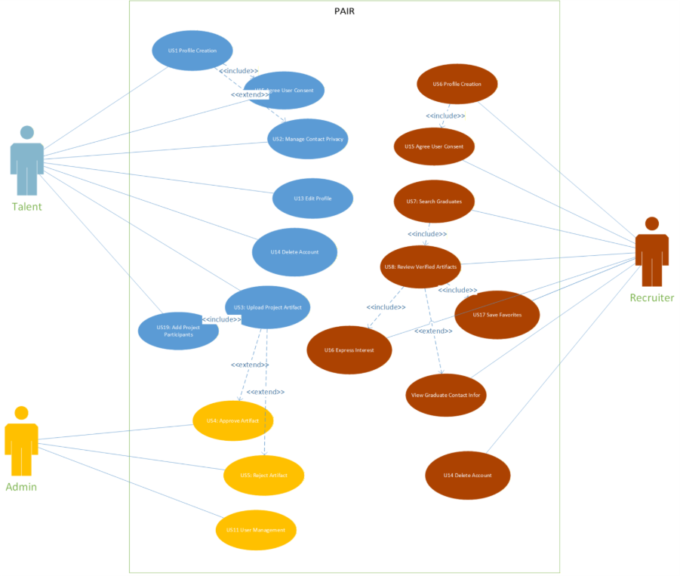
4. Use Case Descriptions
Each use case below provides a structured description including actors, preconditions, main flow, and postconditions, following the standard use case template format (Cockburn, 2001).
UC-01: User Registration & Login
Actor(s) | Talent, Recruiter
FR Reference | FR1.1, FR1.2, FR1.3, FR1.5, FR1.8
Pre-condition | User is on the registration or login page.
Main Flow | 1. User navigates to registration page.  2. User selects role (Talent or Recruiter).  3. User enters email, password, and required details.  4. User agrees to consent statement.  5. System creates account and redirects to dashboard.  Alternatively: User clicks "Sign in with Google" and authenticates via Google OAuth 2.0.
Post-condition | User account is created. User is authenticated and redirected to the appropriate dashboard.

UC-02: Talent Profile Management
Actor(s) | Talent
FR Reference | FR2.1 – FR2.8
Pre-condition | Talent is registered and logged in.
Main Flow | 1. Talent navigates to profile page.  2. Talent fills in or updates profile fields (name, education, skills, summary, LinkedIn).  3. Talent sets contact information visibility.  4. Talent clicks "Save".  5. System stores and displays updated profile.
Post-condition | Talent profile is created or updated and displayed on the dashboard.

UC-03: Artifact Upload & Management
Actor(s) | Talent
FR Reference | FR2.4 – FR2.6
Pre-condition | Talent is logged in and has a profile.
Main Flow | 1. Talent navigates to artifact upload.  2. Talent fills in project name, description, and classification category.  3. Talent uploads a PDF file.  4. System validates the file and stores it.  5. System sets artifact status to "Pending Verification" and notifies the talent.
Alternative Flow | 3a. File type is invalid → System displays error and prevents submission.  3b. Mandatory fields missing → System displays error specifying missing fields.
Post-condition | Artifact is stored with status "Pending Verification" and displayed on the talent's profile.

UC-04: Artifact Verification
Actor(s) | Admin
FR Reference | FR3.1 – FR3.4
Pre-condition | Admin is logged in. At least one artifact has status "Pending Verification".
Main Flow | 1. Admin navigates to the verification queue.  2. Admin opens a pending artifact.  3. Admin reviews the artifact content and supporting PDF.  4. Admin clicks "Approve" or "Reject".  5. System updates artifact status and sends email notification to talent.
Post-condition | Artifact is marked as "Verified" or "Rejected". Talent is notified by email.

UC-05: Recruiter Search & Discovery
Actor(s) | Recruiter
FR Reference | FR4.1 – FR4.4
Pre-condition | Recruiter is logged in.
Main Flow | 1. Recruiter navigates to project search.  2. Recruiter enters a keyword or applies filters (name, classification, favorites).  3. System returns a list of matching projects.  4. Recruiter selects a project to view full details including talent name, description, participants, Interested button, and Favorite button.
Alternative Flow | No results found → System displays "No Results Found" message.
Post-condition | Recruiter views a list of matching projects and can access full project details.

UC-06: Recruiter Interaction (Interest & Favorites)
Actor(s) | Recruiter
FR Reference | FR4.5 – FR4.12
Pre-condition | Recruiter is viewing a project detail page.
Main Flow | 1. Recruiter clicks the "Interested" button.  2. System records the interaction and sends a notification to the talent including recruiter name, company, email, and timestamp.  3. Recruiter clicks the star (Favorite) button.  4. System stores the favorite selection for later retrieval.
Alternative Flow | Recruiter attempts duplicate "Interested" → System prevents the duplicate action.
Post-condition | Interest interaction is recorded and talent is notified. Favorite is saved.

UC-07: AI Quick Summary
Actor(s) | Recruiter
FR Reference | FR4.15 – FR4.17
Pre-condition | Recruiter is viewing a project detail page with a verified PDF artifact.
Main Flow | 1. Recruiter clicks the "AI" button.  2. System generates an AI-powered summary of the PDF content.  3. System displays the summary in a side panel on the right side of the screen, structured in sections (e.g., Overview, Tech Stack).
Post-condition | A structured summary of the project PDF is displayed in the side panel.

UC-08: Notification Management
Actor(s) | Talent
FR Reference | FR4.7 – FR4.14
Pre-condition | Talent is logged in and has received at least one recruiter interest notification.
Main Flow | 1. Talent navigates to the notification interface.  2. System displays all notifications with recruiter name, company, email, and timestamp.  3. Talent hovers over a notification to reveal the delete icon and clicks it.  4. System displays a confirmation message. Talent confirms.  5. System removes the individual notification.  Alternatively: Talent clicks "Delete All", confirms, and system removes all notifications.
Post-condition | Selected notifications are permanently removed from the talent's notification interface.

UC-09: Project Participants Management
Actor(s) | Talent, Recruiter
FR Reference | FR2.9 – FR2.13
Pre-condition | Talent is uploading or editing a project.
Main Flow | 1. Talent enters a participant email address.  2. System verifies the email belongs to a registered user.  3. System adds the participant to the project (up to maximum of 7 including the owner).  4. Participants are displayed in the project detail view.  5. Recruiters can click a participant name to view their profile.
Alternative Flow | Email not registered → System displays error.  Participant limit exceeded → System displays error.
Post-condition | Participants are added to the project and visible in the project detail view.

UC-10: Admin User Account Management
Actor(s) | Admin
FR Reference | FR5.1 – FR5.2
Pre-condition | Admin is logged in.
Main Flow | 1. Admin navigates to user management page.  2. System displays all talent and recruiter accounts.  3. Admin selects an account and clicks "Activate" or "Deactivate".  4. System displays a confirmation prompt.  5. Admin confirms. System applies the change.
Post-condition | Selected user account is activated or deactivated.

References
Cockburn, A. (2001). Writing effective use cases. Addison-Wesley.
IIBA. (2015). A guide to the business analysis body of knowledge (BABOK Guide) (3rd ed.). International Institute of Business Analysis.
Rumbaugh, J., Jacobson, I., & Booch, G. (2004). The unified modeling language reference manual (2nd ed.). Addison-Wesley.

