PAIR Platform
User Manual– TalentBridge Platform

Project Name | PAIR – TalentBridge Platform
Document Type | User Manual
Version | v1.0
Status | Draft – To be reviewed and validated with client/stakeholders
Date | May 2026

Executive Summary
The PAIR Platform is a privacy-first digital talent and recruitment system designed to connect verified professionals with trusted recruiters through secure, portfolio-driven engagement. Unlike traditional networking systems, PAIR prioritises profile authenticity, controlled, and secure professional interaction to create a more reliable and transparent hiring environment.
This manual guide serves as a comprehensive user manual, providing users and talent with a structured understanding of platform functionality, operational workflows, security expectations, and best practices. The manual is intended to support onboarding, improve usability, and establish a professional reference framework for future platform growth.


1. Introduction

Purpose of the Platform

PAIR - Projects · Artifacts · Intelligence · Recruitment
Cconnecting talent with opportunity through verified project evidence

PAIR was developed to bridge the gap between talent discovery and secure hiring by creating a system where:
- Verified candidates can present portfolio-ready professional identities
- Recruiters can access trustworthy talent efficiently
- Privacy remains under user control
- Connections are purpose-driven rather than socially broad

Platform Objectives
The primary objectives of PAIR include:
- Enhancing trust in recruitment
- Reducing profile fraud
- Improving recruiter-candidate matching
- Supporting digital professional identity
- Creating secure hiring pathways

User Categories & Roles

Talent Users (Candidates)
These users are professionals seeking employment, networking, and portfolio visibility.
Key Responsibilities:
- Account creation
- Profile completion
- Verification compliance
- Portfolio upload
- Visibility management



1.3.2 Recruiters / Hiring Teams
Recruiters represent organisations seeking qualified talent.

Key Responsibilities:
- Recruiter registration
- Employer verification
- Candidate search by project/artifact
- Connection requests
- Recruitment communication

1.3.3 Platform Administrators
Administrative oversight may include:
- User verification
- Security management
- Compliance oversight
- System performance

How to use Pair

Looking for ways to make Pair work for you? Here are four simple steps to get you started.

Create a great profile
The first step to using Pair is making sure your profile stands out. To do that, read our best practices for profiles, learn how to add skills to your profile, and see how to set visibility settings for your profile.

To access the PAIR Platform, please click the following link:

https://pairweb-ae.azurewebsites.net/

Step 1: Visit the Platform and Click “Talent”
Navigate to the homepage:
PAIR Home Page
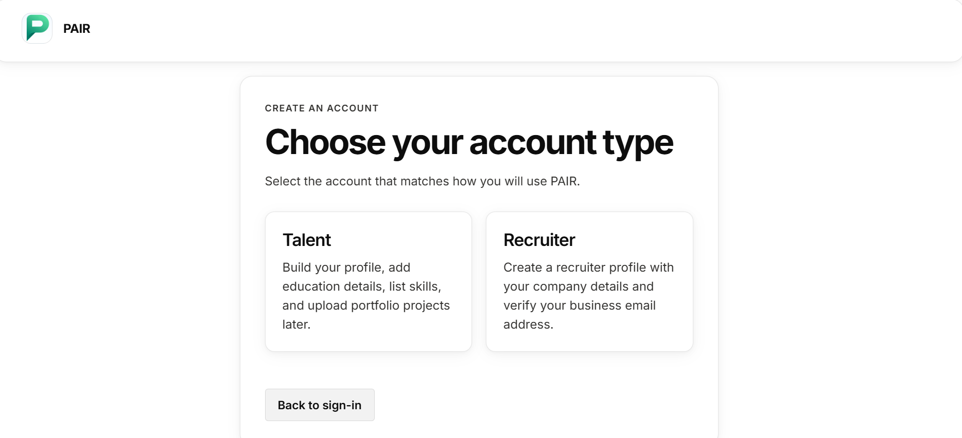

Step 2: Click “Create talent account”
This appears to be the primary onboarding.
Enter your details and create a strong, secure password.
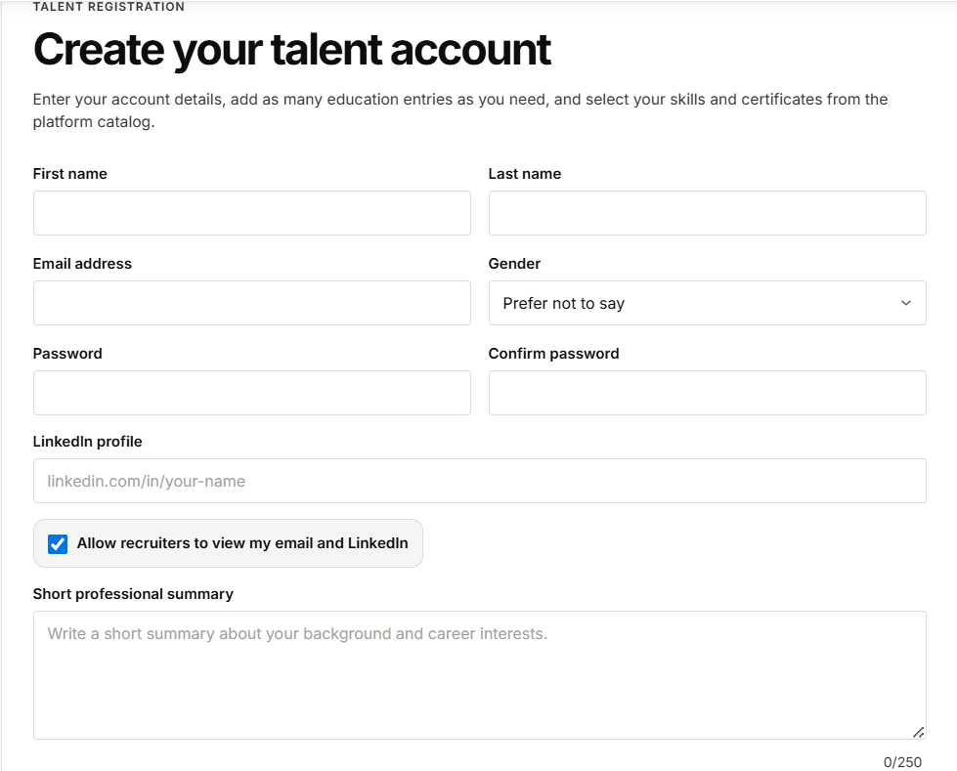
Enter your LinkedIn Profile Link
Select the visibility setting
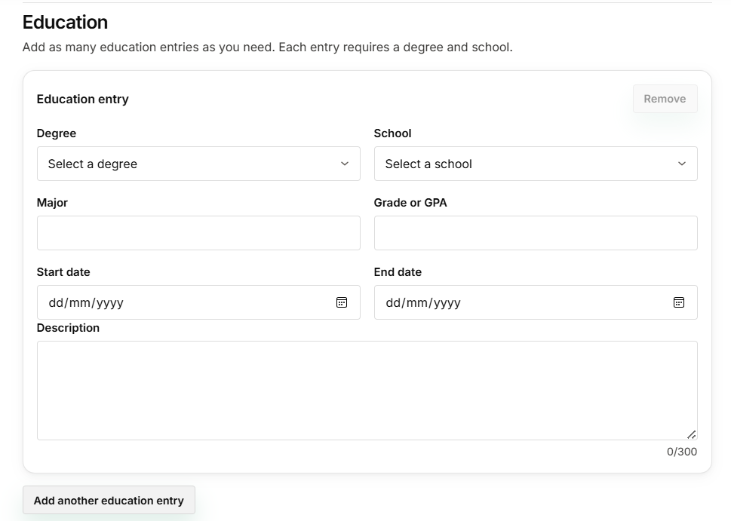
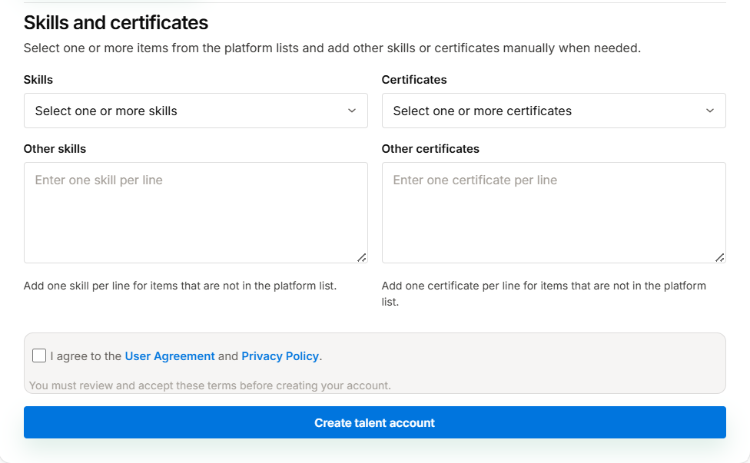
Add any number of education
Select the degree by dropdown list

Select the User Agreement and Privacy Policy before creating the talent account

Step 3: Click the “Plus icon” to upload projects
This appears to be the talent landing page.
Add project and talent desired artifacts

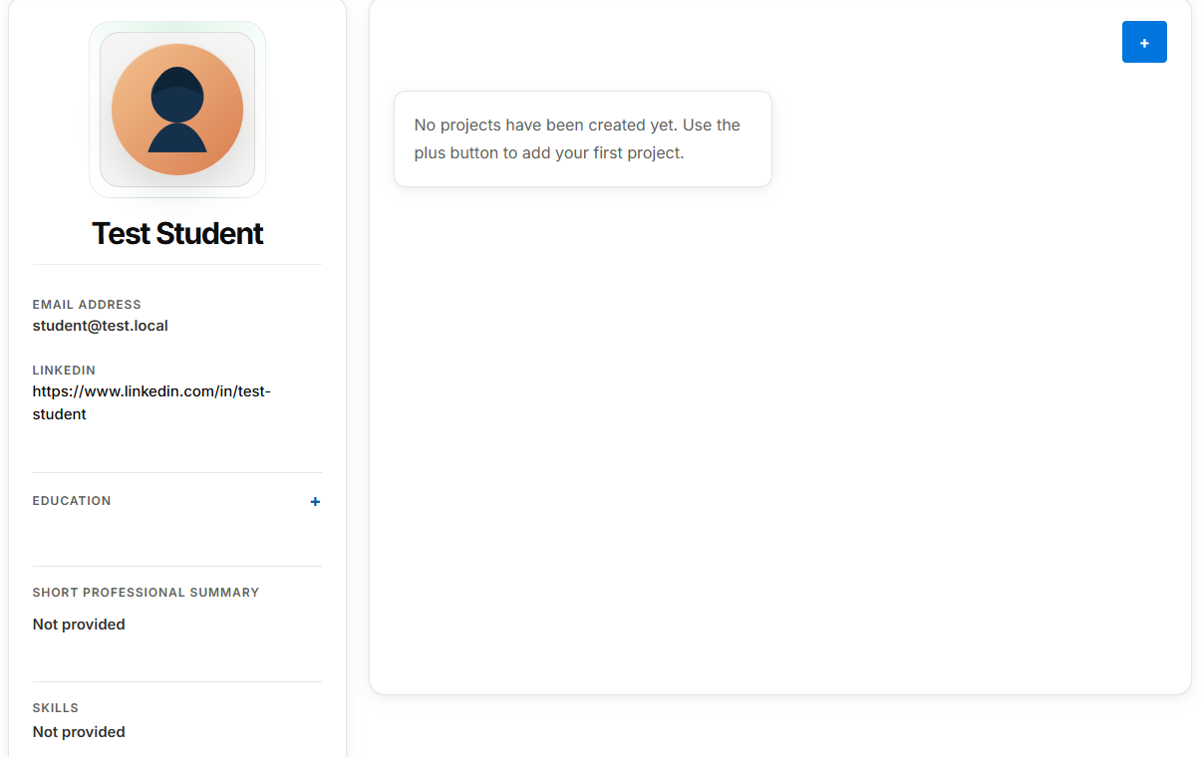
Step 4: Click “Create Project”
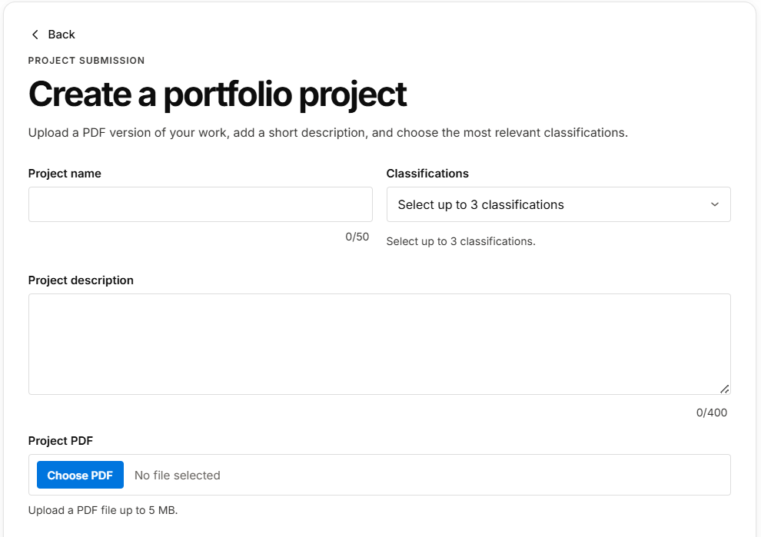
If your project involves multiple contributors, add Participants to include all relevant team members
Select not more than 3 Project Classifications
Select ‘Choose PDF’ to add Project
Enter Project Description
Enter Project Name
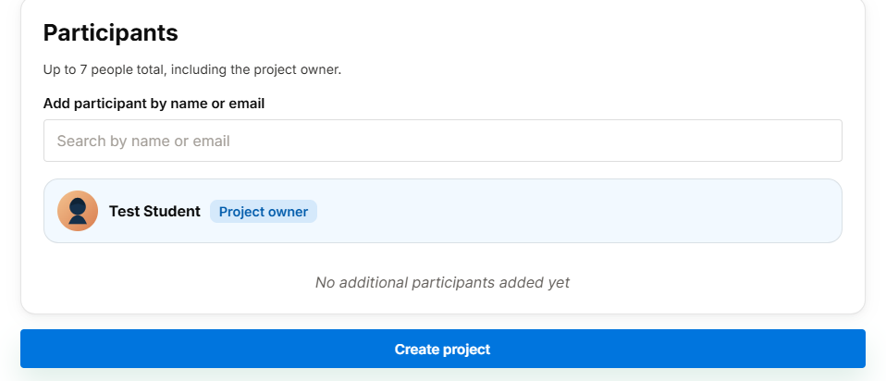

Note: Once project verification is completed, a notification will appear on the Project Dashboard to confirm the project’s verified status.

Explore job opportunities
Once you create your profile, start building your connections on PAIR. Follow the steps below to understand how Recruiter Connections works, learn how to get notified about job opportunities, and discover how to connect with the recruiters you’re looking for.
Step 1: Navigate to the “Notification Bar”
Click “Bell Icon”
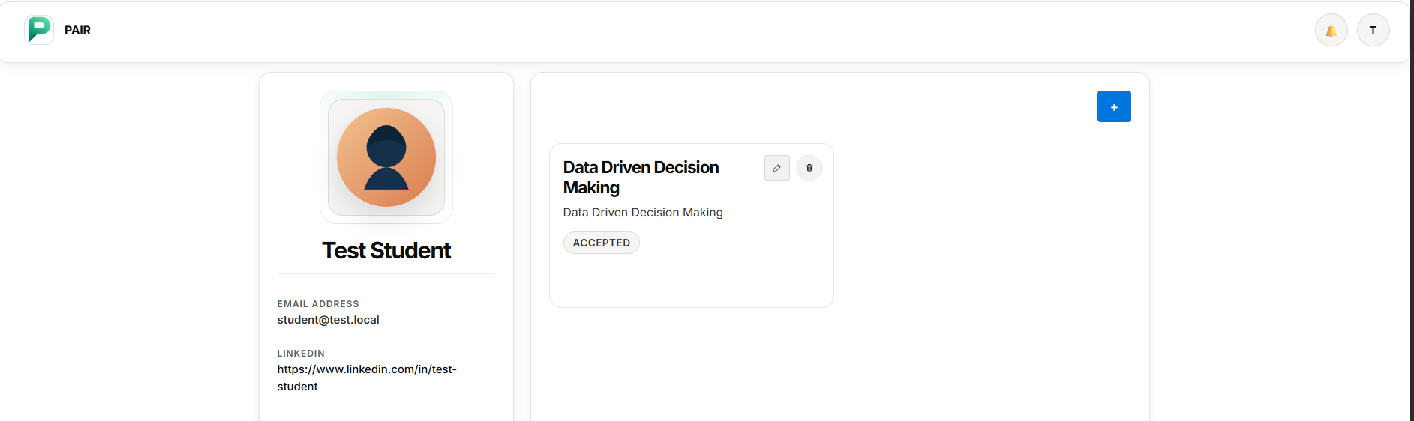
When a recruiter connection request is received, a notification will appear in the Notification Bar for review and action.
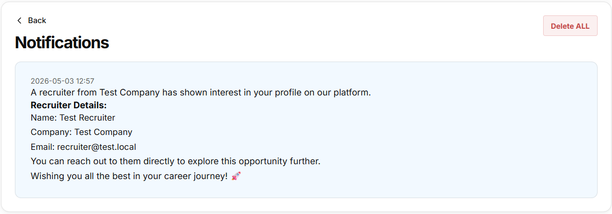
Note: When a recruiter shows interest, their contact details will be sent to your email for direct connection.

Best Practices for Talent Users

Recommended:
- Complete all verification steps
- Upload portfolio-ready achievements
- Maintain updated experience details
- Use privacy settings strategically
- Share selectively with recruiters
Avoid:
- Incomplete profiles
- Unverified claims
- Overexposure of personal data

Troubleshooting Guide

Issue | Possible Cause | Solution
Cannot register | Missing required fields | Complete all onboarding steps
Profile not visible | Privacy settings enabled | Adjust visibility controls
Limited connections | Incomplete portfolio | Improve profile quality

PAIR FAQs

- What is PAIR?
PAIR is an evidence-based talent and recruitment platform that connects users with recruiters through verified projects and real-world skills.
- Who can use PAIR?
Students, graduates, professionals (talent users), and recruiters or employers can use the platform.
- How is PAIR different from traditional CV platforms?
PAIR focuses on verified project work and practical skills instead of relying only on resumes or self-reported experience.
- How do I create a profile on PAIR?
Sign up on the platform, complete your profile by adding skills, projects, and supporting artifacts, and save your information.
- What are project artifacts?
Project artifacts are evidence of your work, such as documents, presentations, code, or designs that demonstrate your skills.
- How do recruiters find candidates?
Recruiters can search and filter talent profiles based on skills, projects, and verified contributions.
- Can I track my contributions in group projects?
Yes, PAIR tracks individual contributions to ensure transparency and accurate representation of your work.
- How do I get notified about recruiter interest?
You will receive notifications through the platform dashboard and email when recruiters show interest.
- Can I update my profile anytime?
Yes, you can edit and update your profile, skills, and projects at any time.

PAIR Support
If you need assistance or have any questions about features or functionality, please contact the admin support team.
For system queries, please contact: admin@test.local

