Prospective Student Lead Capture – Business Analysis Objectives
Demonstrating purpose only
Case Study: Prospective students are browsing the course pages on the University’s website. They want to be able to express their interest in studying at the University. The Marketing team are interested to know about these prospective students so they can include them in a future lead nurture campaign e.g. the upcoming Open Day campaign.
Problem Statement:
Problem 1 – No online lead capture form on the University’s website currently exists. Marketing team only know about these prospective students when they turn up to an event e.g. Open Day. Not great student and staff experiences.
Problem 2 – Current process to capture prospective students is reactive. Marketing team would like to be more proactive so they can include them in future lead nurture campaigns.
Problem 3 – Current capture of prospective student contact information are inconsistent and makes it difficult for the Marketing team to include them in any lead nurture campaigns. They can only send out marketing materials if they have opted in to receive them.
Business Requirements:
• Goal – Implement an online Lead Capture form to allow future students to provide their contact information.
• Objectives – 1. Capture key contact information of the future students; 2. Capture their opt-in status; 3. Record this information in the University’s Marketing system (Salesforce).
Activity 1: Identify Stakeholders:
- Primary stakeholders (users of system or data): Prospective Students, Marketing Team, CRM Admin
- Secondary stakeholders (support/oversee): Web Team, Compliance, Admissions
Format for clarity:
Stakeholder | Role | Responsibility
Prospective Student | Form user | Provide contact info & consent
Marketing Team | Lead owner | Use data for campaigns

Activity 2 Clarify Requirements:

Functional requirements:
- Allow students to submit name, email address, course interest.
- Store lead in Salesforce automatically
- Prevent duplicate submissions by checking existing email addresses.
- Allow students to select their preferred course from a dropdown menu.
- Send a confirmation email to the student after submission.
- Allow the marketing team to export leads in CSV or Excel format.
- Provide error messages for invalid or incomplete submissions.
- ensure compatibility with desktop and mobile browsers.
- EOI form must be land on the course page.

Non-functional requirements:
- Form loads in under 3 seconds.
- Data stored securely, compliant with privacy laws
- Available 24/7
- Easy for marketing to access and exported leads
- Form interface should be user-friendly and intuitive (being simple)
- All interactions logged for monitoring and troubleshooting.
- Backup and recovery mechanisms are in place to prevent data loss.
- Support multiple browsers (Chrome, Edge, Safari, Firefox) and mobile devices.

Activity 3: Create a Mind Map to Identify and Expand Requirements
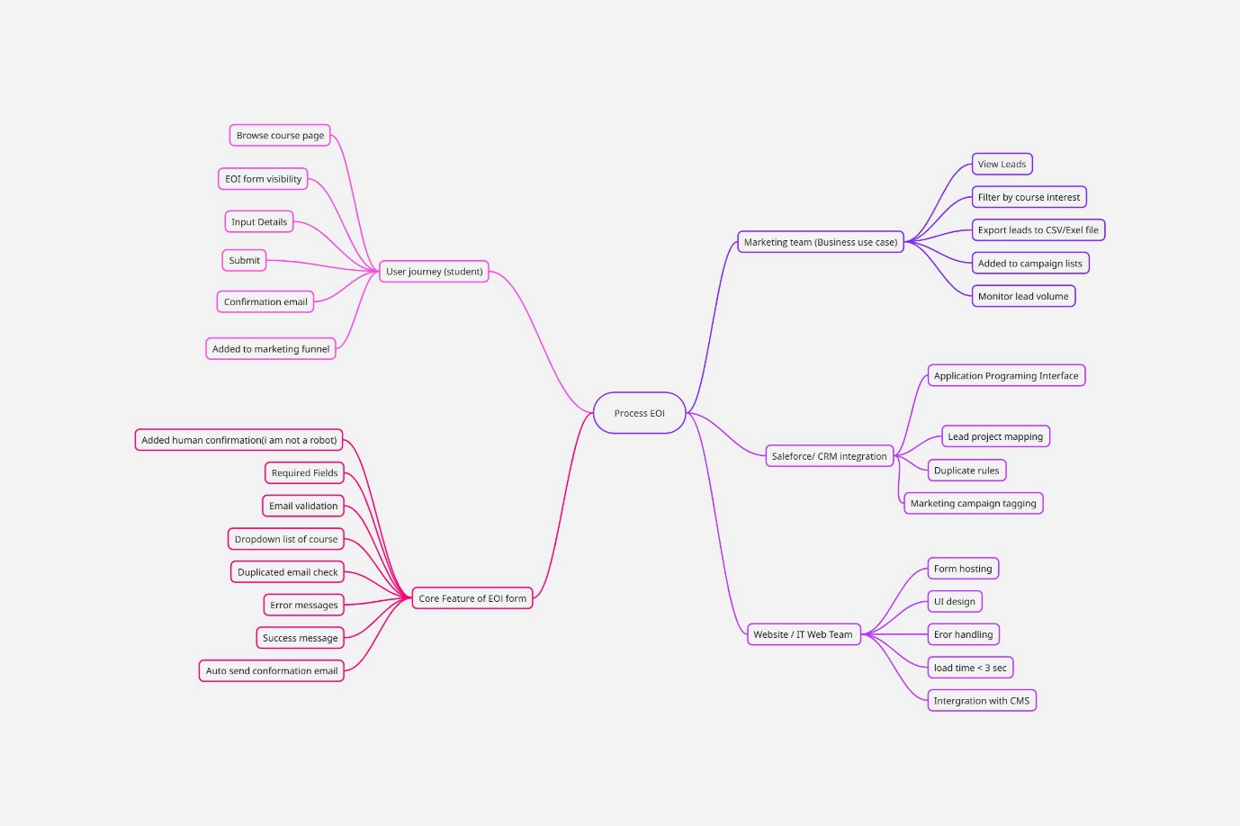

Activity 4: Creating Process Follow level 1 – Process EOI (Future state)
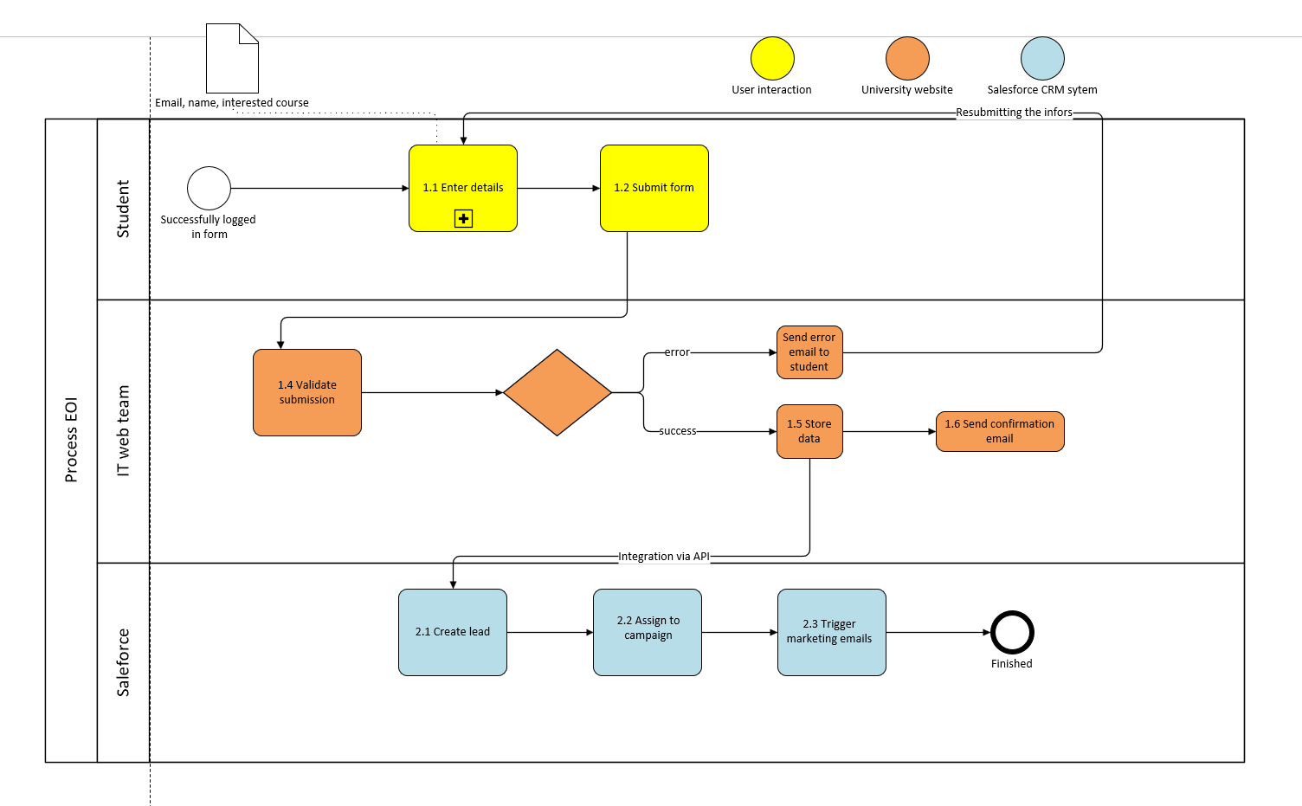

Process follows level 2

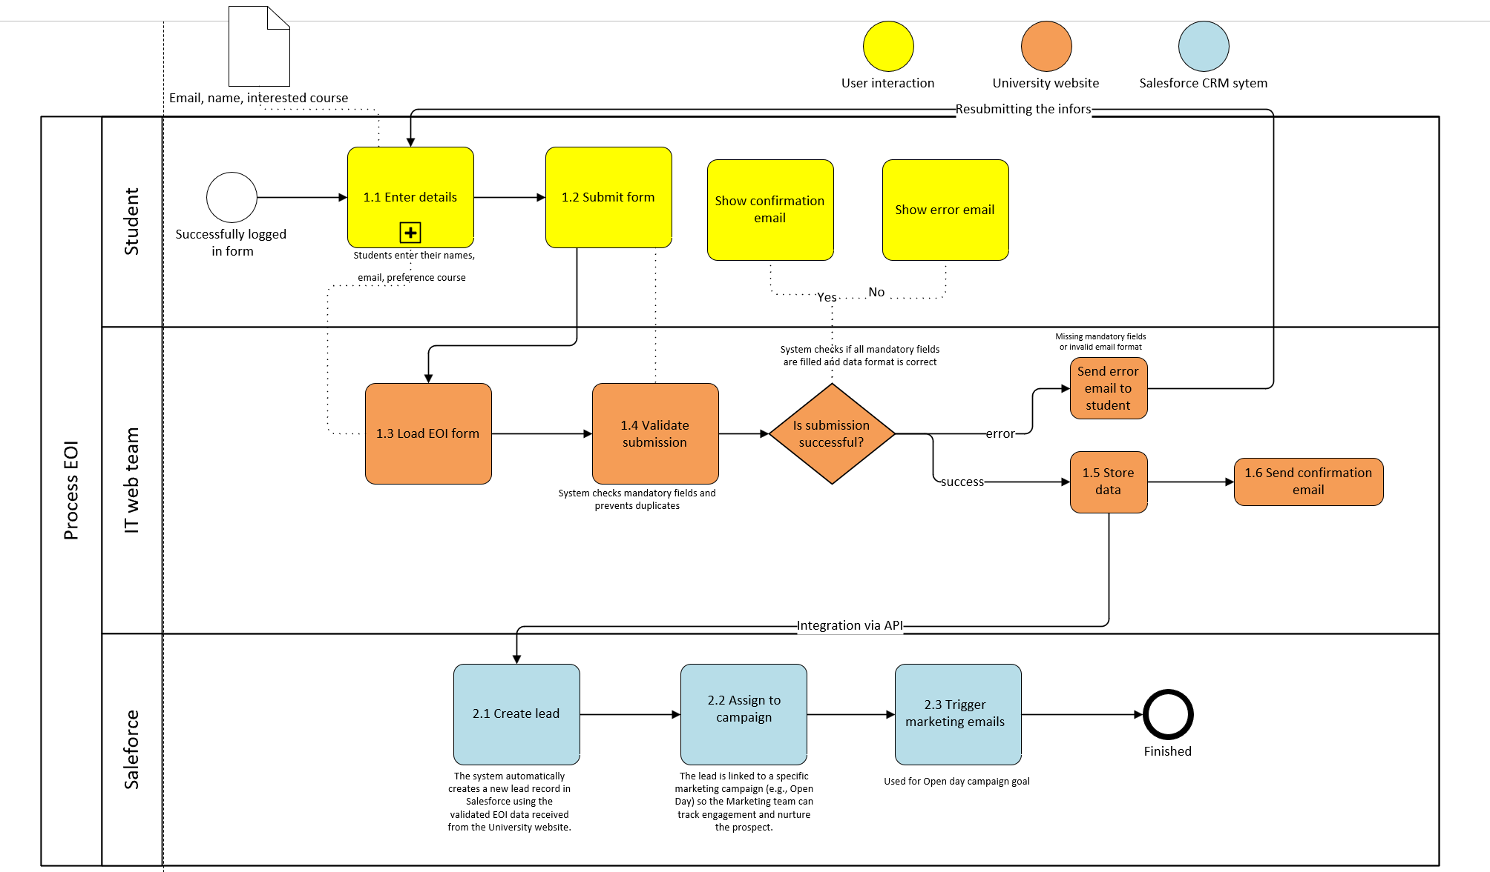

Activity 5: User story
As a prospective student
I want to submit my contact details and course interest through an online Expression of Interest (EOI) form
So that I can receive relevant information and updates about studying at the University, including upcoming events like Open Day.
Acceptance criteria:
Given the student is browsing a course page on the University website And the EOI form is available on the page When the student enters their name, email, and selects a course And opts in to receive marketing communications And clicks "Submit" Then the system validates mandatory fields and checks for duplicates And if valid, stores the data in Salesforce And sends a confirmation email to the student But if invalid, sends an error email and prompts the student to correct and resubmit
Priority (MoSCoW)
Must-Have
- Capture name, email, and course interest
- Validate mandatory fields and prevent duplicates
- Store lead in Salesforce
- Send confirmation email
Should-Have
- Mobile-friendly form
- Dropdown for course selection
Could-Have
- Multi-language support
- Progress indicator on form
Won’t-Have for now
- Integration with chatbots
Status:
Draft (to be reviewed by stakeholders)
Estimate:
Medium (depends on API integration complexity)
Notes:
- Ensure compliance with privacy laws
- Risk: Incorrect API mapping could delay Salesforce integration
- Backup and recovery required for data integrity

