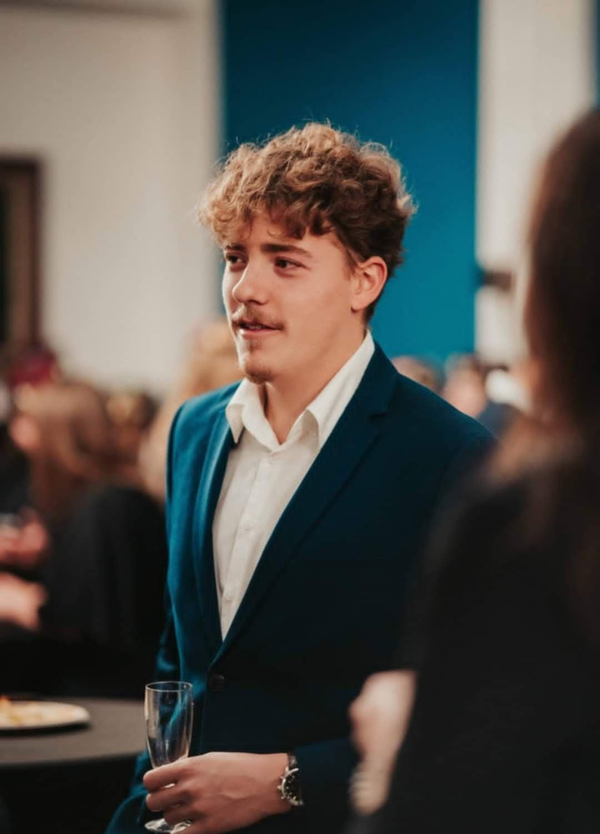
Gheysens théo
Computer Technology Student
About me  My name is Théo Gheysens. I was born on the 27th of July 2003. I am a young Belgian student in Computer Technology. I would like to broaden my professional experience as a full- stack developer. I am a sociable person who likes to work either alone or as part of a team.  I am resourceful and helpful.  Contact  : +32 472 71 36 06  : theogheysens27@gmail.com  Languages  French: native  English: C1  Dutch: A2/B1 |  | EDUCATION  University of Ho Chi Minh City, Vietnam - IT department  • March 2025 – « Rubik’s cube solver » project  EPHEC, Louvain-la-Neuve – Bachelor in Computer Technology  - 2023-2024: first year in Computer Technology  - 2024-2025: second year in Computer Technology  - 2025–2026: Third year in Information Technology, with the first semester spent on an Erasmus exchange at the University of South-Eastern Norway (USN), Kongsberg campus.  Catholic University of Louvain-la-Neuve  - 2021-2022: first year of civil engineering  - 2022-2023: first year of civil engineering  Collège Sainte-Marie, Mouscron  - 2006-2021, secondary education  experiences  Restaurant Les Charmettes – The Moresto Group - Waiter and Barman  November 2023 till now  Provided table service and managed bar orders  Restaurant-Pub « Au bœuf by Greg et Steph » - Waiter  July 2023  Provided table service and managed bar orders  Scout -1st Unit of Mouscron - member - leader - youth activities - organisation of camps  2019-2021  Volunteer at large-scale events as a waiter or barman (Compass Night, pi bars, etc.)  2021-2023  Group leader in charge of a group of around forty children, preparation of group activities.  Soft Skills  - Able to work in an international environment  - At ease in public  - Team management  - Flexible and adaptable to change  - Empathy

