NSW Syllabus

for the Australian

curriculum

**Physics**

**Stage 6**

**Syllabus**

**Original published version updated:**

March 2017 – NESA Official Notice 30 March 2017 (NESA 18/17)

August 2017 – NESA Official Notice 28 August 2017 (NESA 35/17)

September 2017 – NESA Official Notice 14 September 2017 (NESA 36/17)

January 2018 – NESA Official Notice 29 January 2018 (NESA 1/18)

© 2017 NSW Education Standards Authority (NESA) for and on behalf of the Crown in right of the State of New South Wales.

The NESA website holds the ONLY official and up-to-date versions of these documents available on the internet. ANY other copies of these documents, or parts of these documents, that may be found elsewhere on the internet might not be current and are NOT authorised. You CANNOT rely on copies from any other source.

The documents on this website contain material prepared by NESA for and on behalf of the Crown in right of the State of New South Wales. The material is protected by Crown copyright.

All rights reserved. No part of the Material may be reproduced in Australia or in any other country by any process, electronic or otherwise, in any material form, or transmitted to any other person or stored electronically in any form without the prior written permission of NESA, except as permitted by the Copyright Act 1968.

When you access the material you agree:

* to use the material for information purposes only
* to reproduce a single copy for personal bona fide study use only and not to reproduce any major extract or the entire material without the prior permission of NESA.
* to acknowledge that the material is provided by NESA.
* to include this copyright notice in any copy made
* not to modify the material or any part of the material without the express prior written permission of NESA.

The material may contain third-party copyright materials such as photos, diagrams, quotations, cartoons and artworks. These materials are protected by Australian and international copyright laws and may not be reproduced or transmitted in any format without the copyright owner’s specific permission. Unauthorised reproduction, transmission or commercial use of such copyright materials may result in prosecution.

NESA has made all reasonable attempts to locate owners of third-party copyright material and invites anyone from whom permission has not been sought to contact the Copyright Officer.

Phone: (02) 9367 8289

Fax: (02) 9279 1482

Email: [copyright@nesa.nsw.edu.au](mailto:copyright@nesa.nsw.edu.au)

Published by

NSW Education Standards Authority

GPO Box 5300

Sydney NSW 2001

Australia

[www.educationstandards.nsw.edu.au](http://www.educationstandards.nsw.edu.au)

DSSP–27616

D2016/58519

# Contents

Introduction 4

Physics Key 7

Rationale 10

The Place of the Physics Stage 6 Syllabus in the K–12 Curriculum 11

Aim 12

Objectives 13

Outcomes 14

Year 11 Course Structure and Requirements 16

Year 12 Course Structure and Requirements 17

Assessment and Reporting 18

Content 19

Physics Year 11 Course Content 32

Physics Year 12 Course Content 48

Glossary 65

# Introduction

## Stage 6 Curriculum

NSW Education Standards Authority (NESA) Stage 6 syllabuses have been developed to provide students with opportunities to further develop skills which will assist in the next stage of their lives.

The purpose of Stage 6 syllabuses is to:

* develop a solid foundation of literacy and numeracy
* provide a curriculum structure which encourages students to complete secondary education at their highest possible level
* foster the intellectual, creative, ethical and social development of students, in particular relating to:
  + application of knowledge, understanding, skills, values and attitudes in the fields of study they choose
  + capacity to manage their own learning and to become flexible, independent thinkers, problem-solvers and decision-makers
  + capacity to work collaboratively with others
  + respect for the cultural diversity of Australian society
  + desire to continue learning in formal or informal settings after school
* provide a flexible structure within which students can meet the challenges of and prepare for:
  + further academic study, vocational training and employment
  + changing workplaces, including an increasingly STEM-focused (Science, Technology, Engineering and Mathematics) workforce
  + full and active participation as global citizens
* provide formal assessment and certification of students’ achievements
* promote the development of students’ values, identity and self-respect.

The Stage 6 syllabuses reflect the principles of the NESA *K–10 Curriculum Framework* and *Statement of Equity Principles*, the reforms of the NSW Government *Stronger HSC Standards* (2016), and nationally agreed educational goals. These syllabuses build on the continuum of learning developed in the K–10 syllabuses.

The syllabuses provide a set of broad learning outcomes that summarise the knowledge, understanding, skills, values and attitudes important for students to succeed in and beyond their schooling. In particular, the attainment of skills in literacy and numeracy needed for further study, employment and active participation in society are provided in the syllabuses in alignment with the *Australian Core Skills Framework* (ACSF).

The Stage 6 syllabuses include the content of the Australian curriculum and additional descriptions that clarify the scope and depth of learning in each subject.

NESA syllabuses support a standards-referenced approach to assessment by detailing the important knowledge, understanding, skills, values and attitudes students will develop and outlining clear standards of what students are expected to know and be able to do. The syllabuses take into account the diverse needs of all students and provide structures and processes by which teachers can provide continuity of study for all students.

## Diversity of Learners

NSW Stage 6 syllabuses are inclusive of the learning needs of all students. Syllabuses accommodate teaching approaches that support student diversity, including students with special education needs, gifted and talented students, and students learning English as an additional language or dialect (EAL/D). Students may have more than one learning need.

### Students with Special Education Needs

All students are entitled to participate in and progress through the curriculum. Schools are required to provide additional support or adjustments to teaching, learning and assessment activities for some students with special education needs. [Adjustments](http://educationstandards.nsw.edu.au/wps/portal/nesa/11-12/Diversity-in-learning/stage-6-special-education/adjustments) are measures or actions taken in relation to teaching, learning and assessment that enable a student with special education needs to access syllabus outcomes and content, and demonstrate achievement of outcomes.

Students with special education needs can access the outcomes and content from Stage 6 syllabuses in a range of ways. Students may engage with:

* Stage 6 syllabus outcomes and content with adjustments to teaching, learning and/or assessment activities; or
* selected Stage 6 Life Skills outcomes and content from one or more Stage 6 Life Skills syllabuses.

Decisions regarding curriculum options, including adjustments, should be made in the context of [collaborative curriculum planning](http://educationstandards.nsw.edu.au/wps/portal/nesa/11-12/Diversity-in-learning/stage-6-special-education/collaborative-curriculum-planning) with the student, parent/carer and other significant individuals to ensure that decisions are appropriate for the learning needs and priorities of individual students.

Further information can be found in support materials for:

* Physics
* Special education needs
* Life Skills.

### Gifted and Talented Students

Gifted students have specific learning needs that may require adjustments to the pace, level and content of the curriculum. Differentiated educational opportunities assist in meeting the needs of gifted students.

Generally, gifted students demonstrate the following characteristics:

* the capacity to learn at faster rates
* the capacity to find and solve problems
* the capacity to make connections and manipulate abstract ideas.

There are different kinds and levels of giftedness. Gifted and talented students may also possess learning difficulties and/or disabilities that should be addressed when planning appropriate teaching, learning and assessment activities.

Curriculum strategies for gifted and talented students may include:

* differentiation: modifying the pace, level and content of teaching, learning and assessment activities
* acceleration: promoting a student to a level of study beyond their age group
* curriculum compacting: assessing a student’s current level of learning and addressing aspects of the curriculum that have not yet been mastered.

School decisions about appropriate strategies are generally collaborative and involve teachers, parents and students with reference to documents and advice available from NESA and the education sectors.

Gifted and talented students may also benefit from individual planning to determine the curriculum options, as well as teaching, learning and assessment strategies, most suited to their needs and abilities.

### Students Learning English as an Additional Language or Dialect (EAL/D)

Many students in Australian schools are learning English as an additional language or dialect (EAL/D). EAL/D students are those whose first language is a language or dialect other than Standard Australian English and who require additional support to assist them to develop English language proficiency.

EAL/D students come from diverse backgrounds and may include:

* overseas and Australian-born students whose first language is a language other than English, including creoles and related varieties
* Aboriginal and Torres Strait Islander students whose first language is Aboriginal English, including Kriol and related varieties.

EAL/D students enter Australian schools at different ages and stages of schooling and at different stages of English language learning. They have diverse talents and capabilities and a range of prior learning experiences and levels of literacy in their first language and in English. EAL/D students represent a significant and growing percentage of learners in NSW schools. For some, school is the only place they use Standard Australian English.

EAL/D students are simultaneously learning a new language and the knowledge, understanding and skills of the *Physics Stage 6 Syllabus* through that new language. They may require additional support, along with informed teaching that explicitly addresses their language needs.

The *ESL Scales* and the[*English as an Additional Language or Dialect: Teacher Resource*](http://www.acara.edu.au/curriculum/student-diversity/english-as-an-additional-Language-or-dialect) provide information about the English language development phases of EAL/D students. These materials and other resources can be used to support the specific needs of English language learners and to assist students to access syllabus outcomes and content.

# Physics Key

The following codes and icons are used in the *Physics Stage 6 Syllabus*.

## Outcome Coding

Syllabus outcomes have been coded in a consistent way. The code identifies the subject, Year and outcome number. For example:

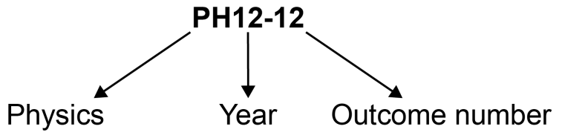

| **Outcome code** | **Interpretation** |
| --- | --- |
| PH11/12-1 | Physics – outcome number 1 |
| PH11-8 | Year 11 Physics – outcome number 8 |
| PH12-14 | Year 12 Physics – outcome number 14 |

Working Scientifically outcomes 1–7 are common across Year 11 and Year 12.

Knowledge and Understanding outcomes in Year 11 are numbered 8–11.

Knowledge and Understanding outcomes in Year 12 are numbered 12–15.

## Coding of Australian Curriculum Content

Australian curriculum content descriptions included in the syllabus are identified by an Australian curriculum code which appears in brackets at the end of each content description. For example:

Conduct investigations, including using temperature, current and potential difference measuring devices, safely, competently and methodically for the collection of valid and reliable data (ACSPH003).

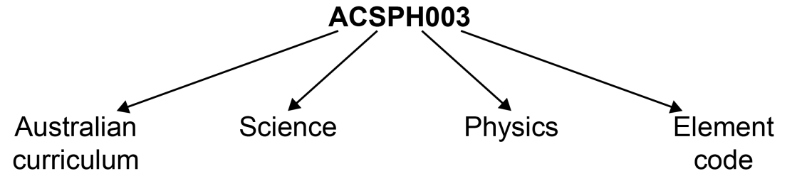

Where a number of content descriptions are jointly represented, all description codes are included, for example (ACSPH001, ACSPH002, ACSPH003).

## Learning Across the Curriculum Icons

Learning across the curriculum content, including cross-curriculum priorities, general capabilities and other areas identified as important learning for all students, is incorporated and identified by icons in the syllabus.

**Cross-curriculum priorities**

Aboriginal and Torres Strait Islander histories and cultures icon Aboriginal and Torres Strait Islander histories and cultures

Asia and Australia’s engagement with Asia icon Asia and Australia’s engagement with Asia

Sustainability icon Sustainability

**General capabilities**

Critical and creative thinking icon Critical and creative thinking

Ethical understanding icon Ethical understanding

 Information and communication technology capability icon Information and communication technology capability

Intercultural understanding icon Intercultural understanding

Literacy icon Literacy

Numeracy icon Numeracy

Personal and social capability icon Personal and social capability

**Other learning across the curriculum areas**

Civics and citizenship icon Civics and citizenship

Difference and diversity icon Difference and diversity

Work and enterprise icon Work and enterprise

# Rationale

The *Physics Stage 6 Syllabus* involves the study of matter and its motion through space and time, along with related concepts that include energy and force. Physics deals with the study of phenomena on scales of space and time – from nuclear particles and their interactions up to the size and age of the Universe. This allows students to better understand the physical world and how it works, appreciate the uniqueness of the Universe, and participate in navigating and influencing the future.

The problem-solving nature of physics further develops students’ Working Scientifically skills by focusing on the exploration of models and the analysis of theories and laws, which promotes an understanding of the connectedness of seemingly dissimilar phenomena.

Students who study physics are encouraged to use observations to develop quantitative models of real-world problems and derive relationships between variables. They are required to engage in solving equations based on these models, make predictions, and analyse the interconnectedness of physical entities.

The Physics course builds on students’ knowledge and skills developed in the Science Stage 5 course and help them develop a greater understanding of physics as a foundation for undertaking post-school studies in a wide range of Science, Technology, Engineering and Mathematics (STEM) fields. A knowledge and understanding of physics often provides the unifying link between interdisciplinary studies.

The study of physics provides the foundation knowledge and skills required to support participation in a range of careers. It is a discipline that utilises innovative and creative thinking to address new challenges, such as sustainability, energy efficiency and the creation of new materials.

# The Place of the Physics Stage 6 Syllabus in the K–12 Curriculum

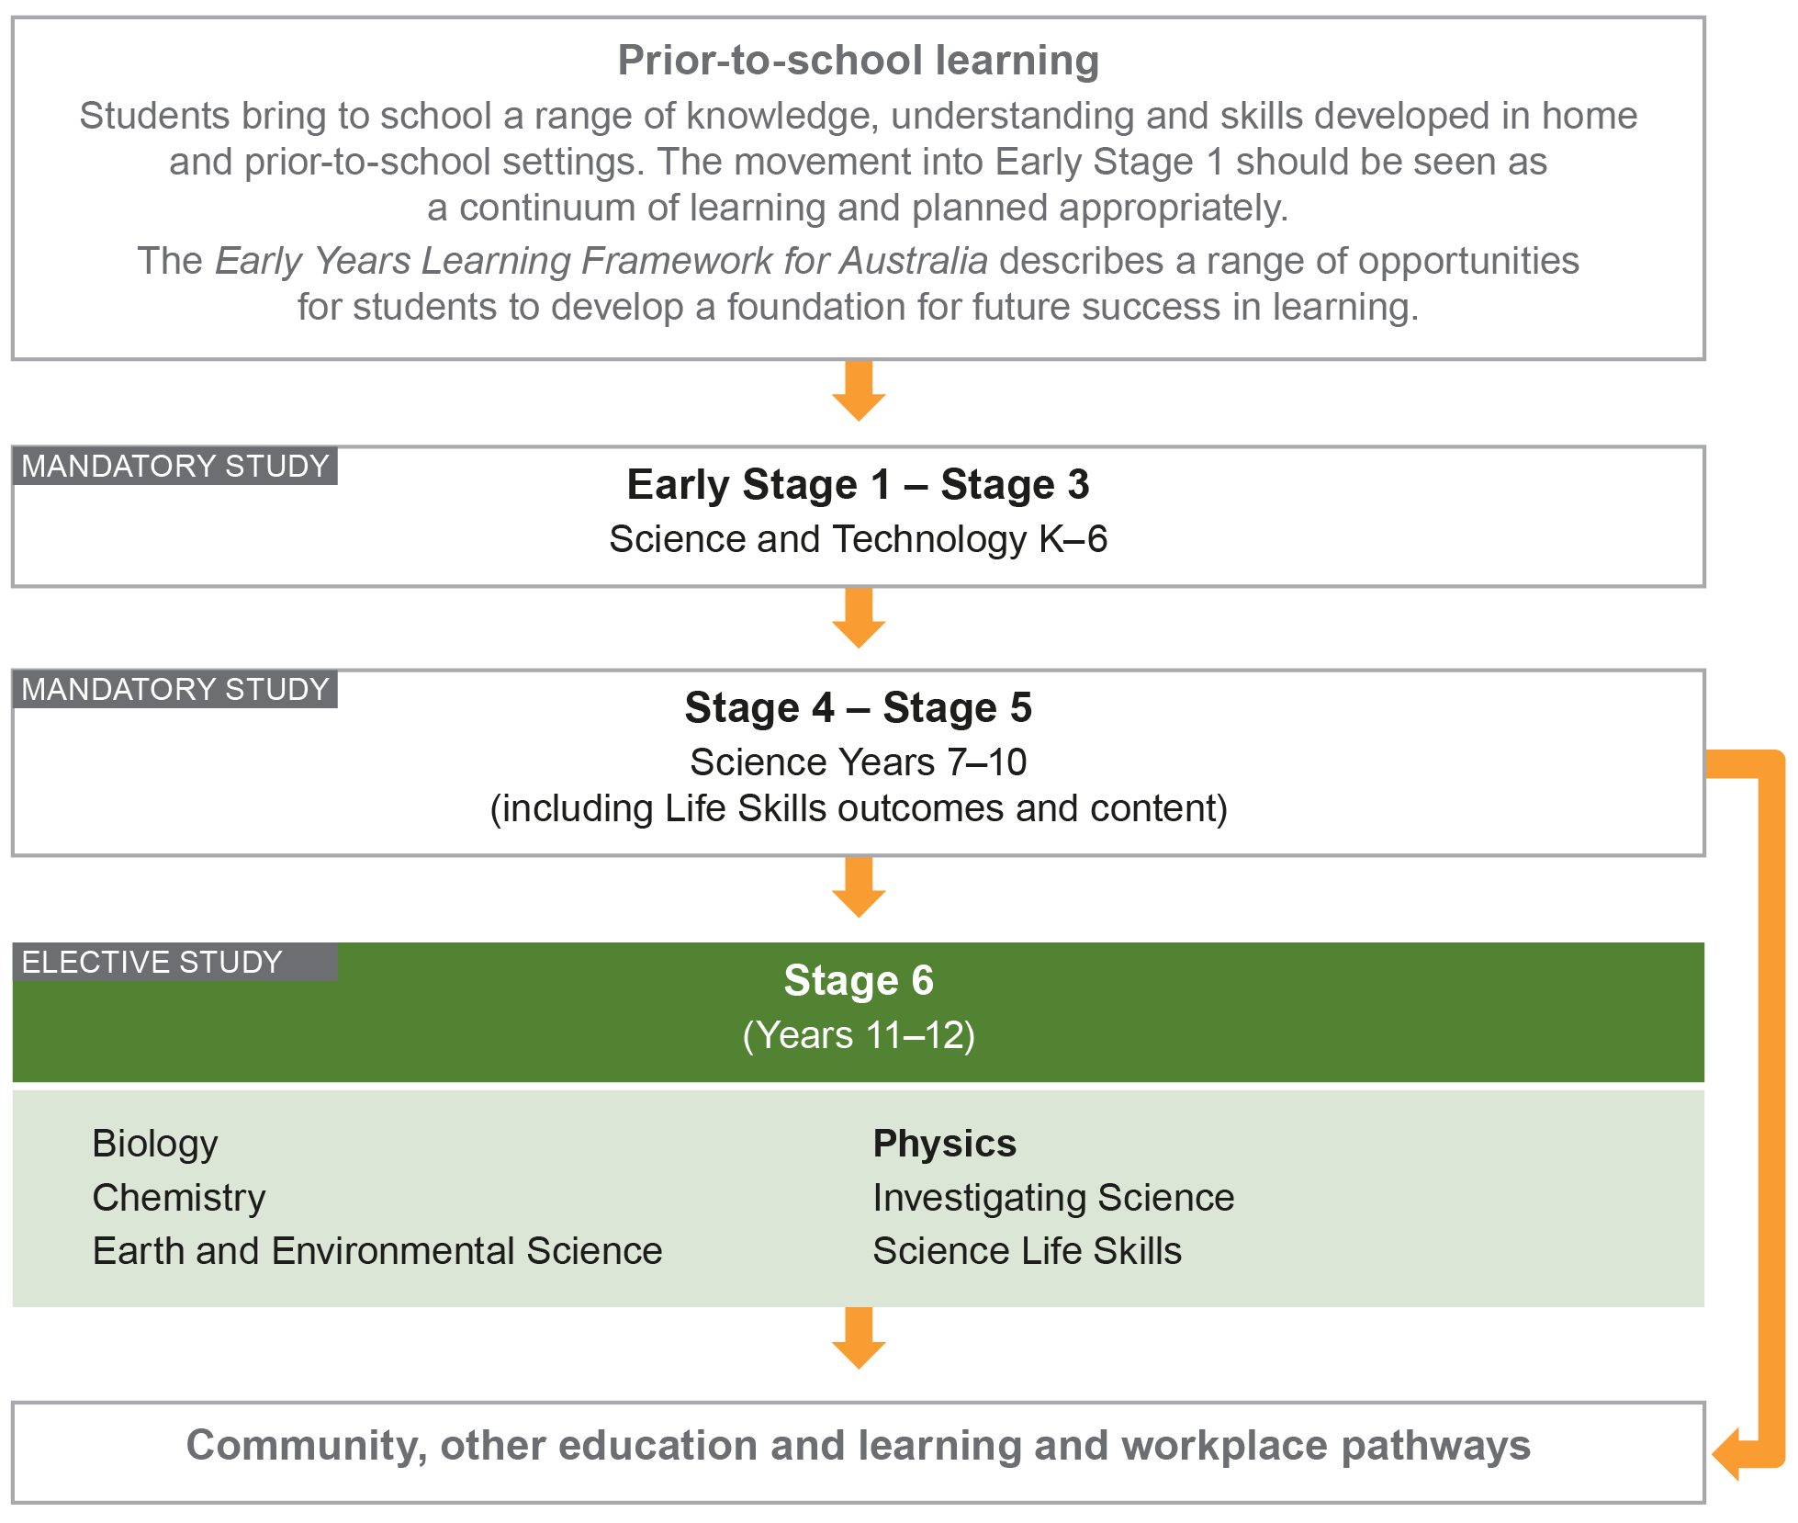

# Aim

The study of Physics in Stage 6 aims to enable students to develop an appreciation and understanding of the application of the principles of physics, and of the theories, laws, models, systems and structures of physics. It also enables students to apply Working Scientifically skills processes to examine physics models and practices and their applications.

# Objectives

## Skills

Students:

* develop skills in applying the processes of Working Scientifically.

## Knowledge and Understanding

Year 11 students:

* develop knowledge and understanding of fundamental mechanics
* develop knowledge and understanding of energy.

Year 12 students:

* develop knowledge and understanding of advanced mechanics and electromagnetism
* develop knowledge and understanding of the role of evidence and prediction in the development of theories in physics.

## Values and Attitudes

Students:

* develop positive, informed values and attitudes towards physics
* recognise the importance and relevance of physics in their lives
* recognise the influence of economic, political and societal impacts on the development of scientific knowledge
* develop an appreciation of the influence of imagination and creativity in scientific research.

# Outcomes

## Table of Objectives and Outcomes – Continuum of Learning

### Skills

|  |
| --- |
| **Objective**  Students:   * develop skills in applying the processes of Working Scientifically |
| **Stage 6 course outcomes**  A student: |
| **Questioning and predicting**  **PH11/12-1** develops and evaluates questions and hypotheses for scientific investigation |
| **Planning investigations**  **PH11/12-2** designs and evaluates investigations in order to obtain primary and secondary data and information |
| **Conducting investigations**  **PH11/12-3** conducts investigations to collect valid and reliable primary and secondary data and information |
| **Processing data and information**  **PH11/12-4** selects and processes appropriate qualitative and quantitative data and information using a range of appropriate media |
| **Analysing data and information**  **PH11/12-5** analyses and evaluates primary and secondary data and information |
| **Problem solving**  **PH11/12-6** solves scientific problems using primary and secondary data, critical thinking skills and scientific processes |
| **Communicating**  **PH11/12-7** communicates scientific understanding using suitable language and terminology for a specific audience or purpose |

The Working Scientifically outcomes at the beginning of each module are targeted for emphasis. The other Working Scientifically outcomes may also be addressed in each module**.**

### Knowledge and Understanding

| **Year 11 course** | **Year 12 course** |
| --- | --- |
| **Objective**  Students:   * develop knowledge and understanding of fundamental mechanics | **Objective**  Students:   * develop knowledge and understanding of advanced mechanics and electromagnetism |
| **Year 11 course outcomes**  A student: | **Year 12 course outcomes**  A student: |
| **PH11-8** describes and analyses motion in terms of scalar and vector quantities in two dimensions and makes quantitative measurements and calculations for distance, displacement, speed velocity and acceleration | **PH12-12** describes and analyses qualitatively and quantitatively circular motion and motion in a gravitational field, in particular, the projectile motion of particles |
| **PH11-9** describes and explains events in terms of Newton’s Laws of Motion, the law of conservation of momentum and the law of conservation of energy | **PH12-13** explains and analyses the electric and magnetic interactions due to charged particles and currents and evaluates their effect both qualitatively and quantitatively |
| **Objective**  Students:   * develop knowledge and understanding of energy | **Objective**  Students:   * develop knowledge and understanding of the role of evidence and prediction in the development of theories in physics |
| **Year 11 course outcomes**  A student: | **Year 12 course outcomes**  A student: |
| **PH11-10** explains and analyses waves and the transfer of energy by sound, light and thermodynamic principles | **PH12-14** describes and analyses evidence for the properties of light and evaluates the implications of this evidence for modern theories of physics in the contemporary world |
| **PH11-11** explains and quantitatively analyses electric fields, circuitry and magnetism | **PH12-15** explains and analyses the evidence supporting the relationship between astronomical events and the nucleosynthesis of atoms and relates these to the development of the current model of the atom |

# Year 11 Course Structure and Requirements

| **Year 11 course**  **(120 hours)** | **Working Scientifically Skills** | **Modules** | **Indicative hours** | **Depth studies** |
| --- | --- | --- | --- | --- |
| **Module 1**  Kinematics | 60 | *15 hours  in Modules 1–4 |
| **Module 2**  Dynamics |
| **Module 3**  Waves and Thermodynamics | 60 |
| **Module 4**  Electricity and Magnetism |

*15 hours must be allocated to depth studies within the 120 indicative course hours.

## Requirements for Practical Investigations

Scientific investigations include both practical investigations and secondary-sourced investigations. Practical investigations are an essential part of the Year 11 course and must occupy a minimum of 35 hours of course time, including time allocated to practical investigations in depth studies.

Practical investigations include:

* undertaking laboratory experiments, including the use of appropriate digital technologies
* fieldwork.

Secondary-sourced investigations include:

* locating and accessing a wide range of secondary data and/or information
* using and reorganising secondary data and/or information.

# Year 12 Course Structure and Requirements

| **Year 12 course**  **(120 hours)** | **Working Scientifically Skills** | **Modules** | **Indicative hours** | **Depth studies** |
| --- | --- | --- | --- | --- |
| **Module 5**  Advanced Mechanics | 60 | *15 hours  in Modules 5–8 |
| **Module 6**  Electromagnetism |
| **Module 7**  The Nature of Light | 60 |
| **Module 8**  From the Universe to the Atom |

*15 hours must be allocated to depth studies within the 120 indicative course hours.

## Requirements for Practical Investigations

Scientific investigations include both practical investigations and secondary-sourced investigations. Practical investigations are an essential part of the Year 12 course and must occupy a minimum of 35 hours of course time, including time allocated to practical investigations in depth studies.

Practical investigations include:

* undertaking laboratory experiments, including the use of appropriate digital technologies
* fieldwork.

Secondary-sourced investigations include:

* locating and accessing a wide range of secondary data and/or information
* using and reorganising secondary data and/or information.

# Assessment and Reporting

Information about assessment in relation to the Physics syllabus is contained in *Assessment and Reporting in Physics Stage 6*. It outlines course-specific advice and requirements regarding:

* Year 11 and Year 12 school-based assessment requirements
* Year 11 and Year 12 mandatory components and weightings
* External assessment requirements including HSC examination specifications.

This information should be read in conjunction with requirements on the [Assessment Certification Examination (ACE)](http://ace.bostes.nsw.edu.au/) website.

Additional advice is available in the *Principles of Assessment for Stage 6*.

# Content

Content defines what students are expected to know and do as they work towards syllabus outcomes. It provides the foundations for students to successfully progress to the next stage of schooling or post-school opportunities.

Teachers will make decisions about content regarding the sequence, emphasis and any adjustments required based on the needs, interests, abilities and prior learning of students.

Content in Stage 6 syllabuses defines learning expectations that may be assessed in Higher School Certificate examinations.

## Organisation of Content

The following diagram provides an illustrative representation of elements of the course and their relationship.

The Year 11 and Year 12 courses each comprise four modules. The skills of Working Scientifically are integrated as course content throughout the syllabus. Each module includes a specific focus on some of the Working Scientifically skills. However, there is scope within each module to engage with all of the Working Scientifically skills.

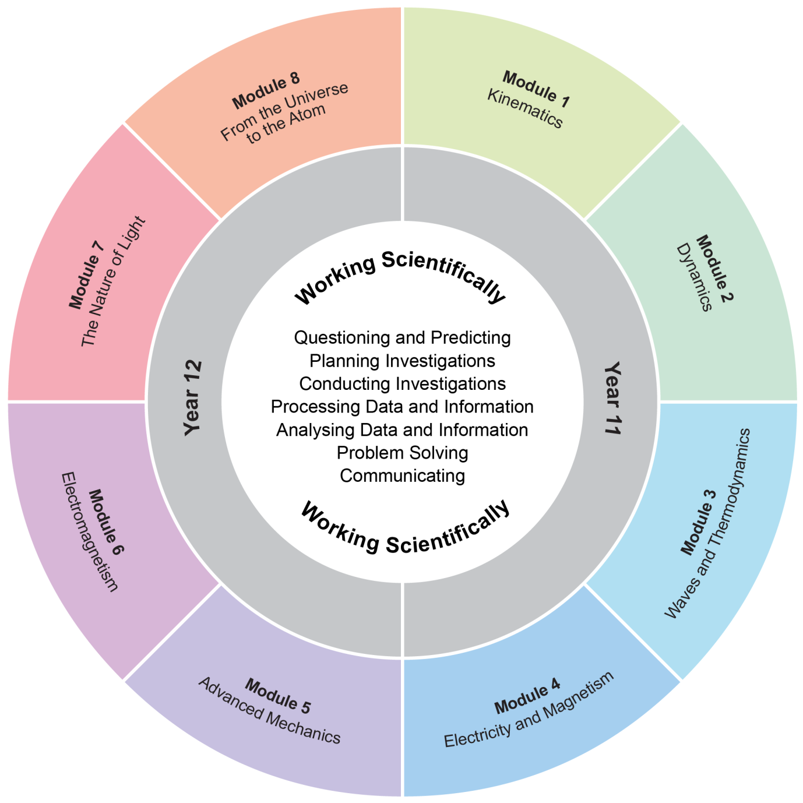

The Working Scientifically outcomes and content are integrated into each module wherever students undertake an investigation.

## Working Scientifically

Working Scientifically skills are at the core of conducting practical and secondary-sourced investigations in science.

Opportunities should be provided for students to engage with all the Working Scientifically skills in investigations. In each module, particular outcomes have been identified as those that are most relevant to the intended learning.

Students are challenged to further develop their understanding of Working Scientifically as a group of dynamic and interdependent processes that are applied in each scientific investigation in a way that is appropriate and determined by the activity. This dynamism and interrelatedness adds a level of sophistication to students’ understanding of the true nature and practice of science. Through regular involvement in these processes, applying them as appropriate, in a range of varied practical investigations; students can broaden their interpretation of Working Scientifically beyond the common linear model.

Students are encouraged to select the most appropriate gateway to the Working Scientifically processes. The pathways within the processes become self-evident through the nature of the investigation. An investigation may be instigated by, for example:

* direct observation of a phenomenon
* inconsistencies arising from results of a related investigation
* the quantitative and qualitative analysis of data
* secondary-sourced research.

Students are challenged to be open to:

* refining or redeveloping their chosen procedures
* redefining their questions and/or hypotheses
* modifying their methodologies or designs
* conducting further practical investigations
* conducting further secondary research.

Students are also encouraged to communicate evidence-based conclusions and suggest ideas for future research. Unexpected results are to be welcomed to refine methodologies and to generate further investigation. Knowledge and understanding of science is essential to these processes. Through this practice of science, students can acquire a deeper knowledge and understanding of scientific concepts.

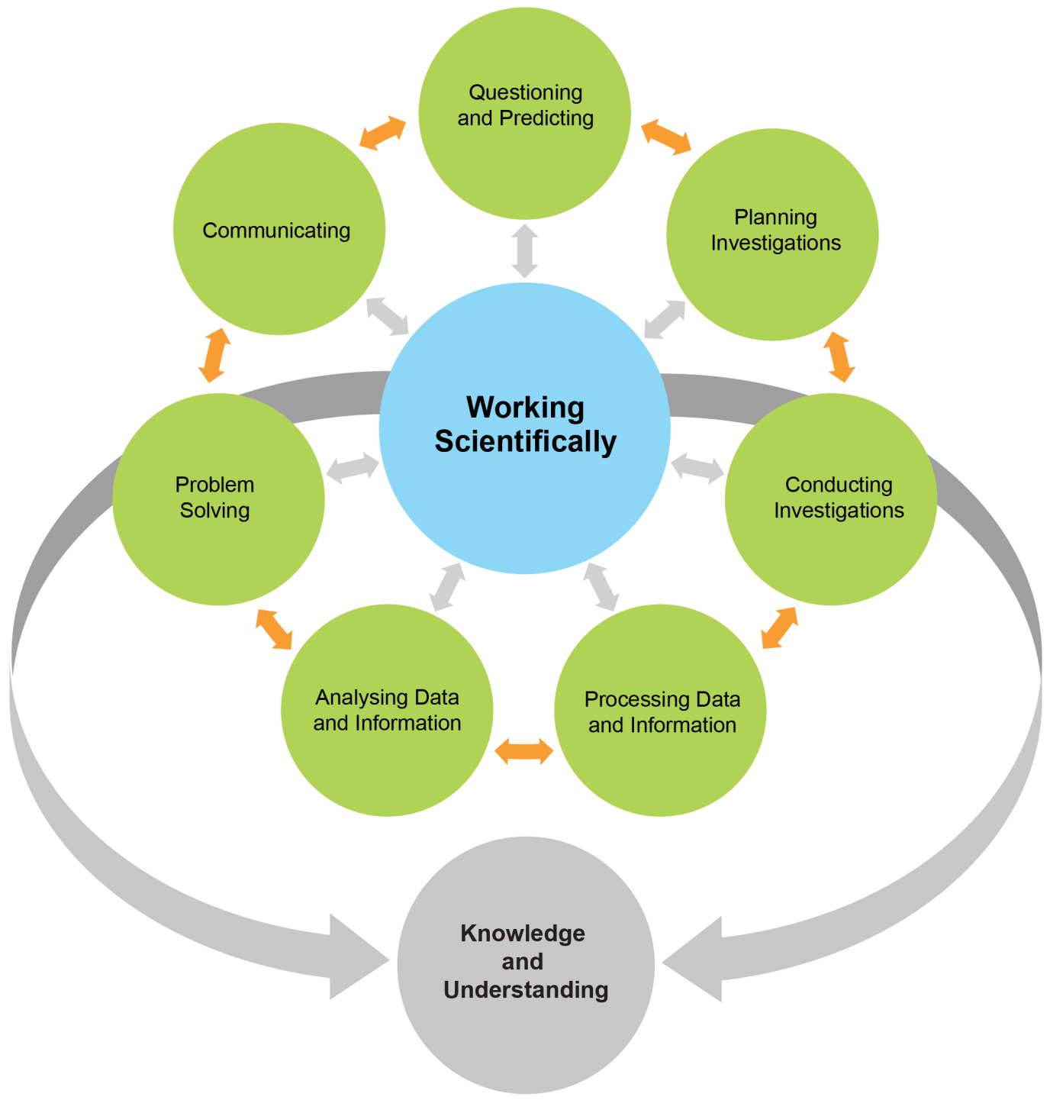

Each of the seven Working Scientifically outcomes represents one of the interdependent dynamic processes that are central to the study of Science and the acquisition of scientific knowledge and skills. This course is structured to provide ongoing opportunities for students to implement these processes, particularly through the depth study provision. The following descriptions of the Working Scientifically outcomes provide further information about the skills students are expected to develop throughout the course.

### Questioning and Predicting

Developing, proposing and evaluating inquiry questions and hypotheses challenges students to identify an issue or phenomenon that can be investigated scientifically by gathering primary and/or secondary-sourced data. Students develop inquiry question(s) that require observations, experimentation and/or research to aid in constructing a reasonable and informed hypothesis. The consideration of variables is to be included in the questioning process.

### Planning Investigations

Students justify the selection of equipment, resources chosen and design of an investigation. They ensure that all risks are assessed, appropriate materials and technologies are sourced, and all ethical concerns are considered. Variables are to be identified as independent, dependent and controlled to ensure a valid procedure is developed that will allow for the reliable collection of data. Investigations should include strategies that ensure controlled variables are kept constant and an experimental control is used as appropriate.

### Conducting Investigations

Students are to select appropriate equipment, employ safe work practices and ensure that risk assessments are conducted and followed. Appropriate technologies are to be used and procedures followed when disposing of waste. The selection and criteria for collecting valid and reliable data is to be methodical and, where appropriate, secondary-sourced information referenced correctly.

### Processing Data and Information

Students use the most appropriate and meaningful methods and media to organise and analyse data and information sources, including digital technologies and the use of a variety of visual representations as appropriate. They process data from primary and secondary sources, including both qualitative and quantitative data and information.

### Analysing Data and Information

Students identify trends, patterns and relationships; recognise error, uncertainty and limitations in data; and interpret scientific and media texts. They evaluate the relevance, accuracy, validity and reliability of the primary or secondary-sourced data in relation to investigations. They evaluate processes, claims and conclusions by considering the quality of available evidence, and use reasoning to construct scientific arguments. Where appropriate, mathematical models are to be applied, to demonstrate the trends and relationships that occur in data.

### Problem Solving

Students use critical thinking skills and creativity to demonstrate an understanding of scientific principles underlying the solutions to inquiry questions and problems posed in investigations. Appropriate and varied strategies are employed, including the use of models, to qualitatively and quantitatively explain and predict cause-and-effect relationships. In Working Scientifically, students synthesise and use evidence to construct and justify conclusions. To solve problems, students: interpret scientific and media texts; evaluate processes, claims and conclusions; and consider the quality of available evidence.

### Communicating

Communicating all components of the Working Scientifically processes with clarity and accuracy is essential. Students use qualitative and quantitative information gained from investigations using primary and secondary sources, including digital, visual, written and/or verbal forms of communication as appropriate. They apply appropriate scientific notations and nomenclature. They also appropriately apply and use scientific language that is suitable for specific audiences and contexts.

## Investigations

An investigation is a scientific process to answer a question, explore an idea or solve a problem. Investigations include activities such as planning a course of action, collecting data, processing and analysing data, reaching a conclusion and communicating. Investigations may include the collection of primary and/or secondary-sourced data or information.

Practical investigations involve the collection of primary data. They may include:

* undertaking laboratory investigations, including fair tests and controlled experiments
* undertaking fieldwork and surveys
* constructing models.

Secondary-sourced investigations can include:

* researching by using a variety of media
* extracting and reorganising secondary-sourced information in the form of flow charts, tables, graphs, diagrams, prose, keys, spreadsheets and databases
* using models to inform understanding.

### Safety

Schools have a legal obligation in relation to safety. Teachers will need to ensure that they comply with relevant legislation as well as system and school requirements in relation to safety when implementing their programs. This includes legislation and guidelines relating to Work Health and Safety, and the handling and storage of chemical and dangerous goods.

### Animal Research

Schools have a legal responsibility in relation to the welfare of animals. The keeping of animals and all practical activities involving animals must comply with relevant guidelines or legislation.

## Inquiry Questions

Inquiry questions are included in the course content and used to frame the syllabus content within each module. The depth of knowledge and understanding and skill development required to fully address the inquiry questions may vary. This allows for differentiation of the course content to cater for the diversity of learners.

## Depth Studies: Year 11 and Year 12

### What are Depth Studies?

A depth study is any type of investigation/activity that a student completes individually or collaboratively that allows the further development of one or more concepts found within or inspired by the syllabus. It may be one investigation/activity or a series of investigations/activities.

Depth studies provide opportunities for students to pursue their interests in physics, acquire a depth of understanding, and take responsibility for their own learning. Depth studies promote differentiation and engagement, and support all forms of assessment, including assessment for, as and of learning. Depth studies allow for the demonstration of a range of Working Scientifically skills.

A depth study may be, but is not limited to:

* a practical investigation or series of practical investigations and/or a secondary-sourced investigation or series of secondary-sourced investigations
* presentations, research assignments or fieldwork reports
* the extension of concepts found within the course, either qualitatively and/or quantitatively.

The length of time for any individual study and the pedagogies employed are not prescribed. The time for the depth studies may be allocated to a single study or spread over the year, and incorporate several studies depending on individual school and/or class requirements.

### Requirements for Depth Studies

* A minimum of 15 hours of in-class time is allocated in both Year 11 and Year 12.
* At least one depth study must be included in both Year 11 and Year 12.
* The two Working Scientifically outcomes of Questioning and Predicting and Communicating must be addressed in both Year 11 and Year 12.
* A minimum of two additional Working Scientifically skills outcomes, and further development of at least one Knowledge and Understanding outcome, should be addressed in all depth studies.

### Ideas for Depth Studies

#### Practical Investigations

* Design and conduct experiments
* Test a claim
* Test a device

#### Secondary-sourced Investigations

* Make a documentary or media report
* Conduct a literature review
* Develop an evidence-based argument
* Write a journal article
* Write an essay – historical or theoretical
* Develop an environmental management plan
* Analyse a work of fiction or film for scientific relevance
* Create a visual presentation
* Investigate emerging technologies

#### Creating

* Design and invent
* Create a working model
* Create a portfolio

#### Fieldwork

Fieldwork may be a starting point for a practical investigation or secondary-sourced study and could be initiated by the following stimuli:

* an excursion
* engagement with community experts.

#### Data Analysis

Data analysis may be incorporated into a practical investigation or secondary-sourced investigation. For example:

* construction and analysis of graphs/tables
* data analysis from a variety of sources
* research analysis, eg of longitudinal data, resource management data.

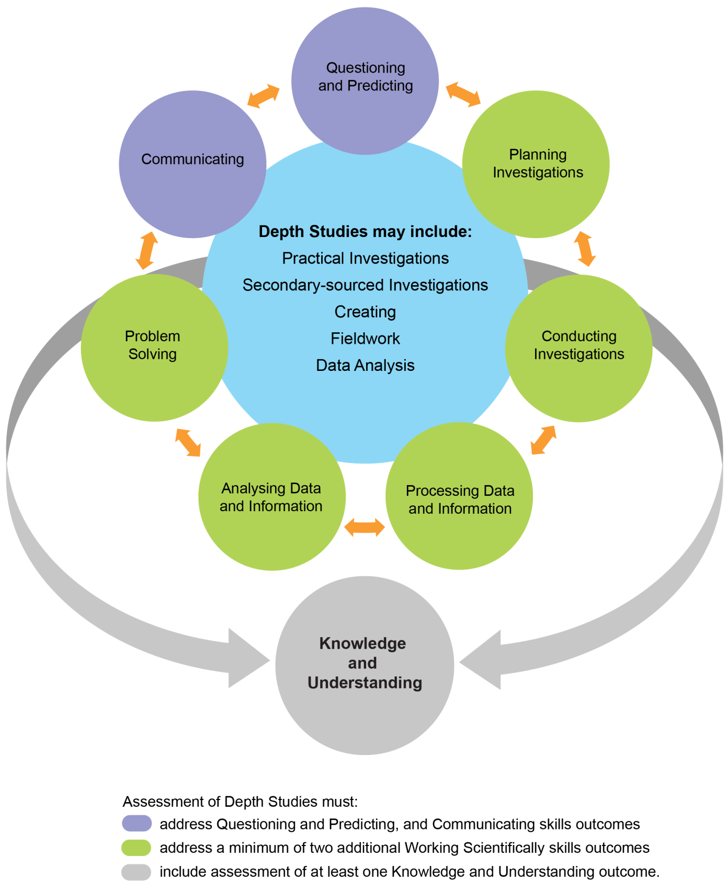

## Learning Across the Curriculum

Learning across the curriculum content, including the cross-curriculum priorities and general capabilities, assists students to achieve the broad learning outcomes defined in the NESA *Statement of Equity Principles*, the *Melbourne Declaration on Educational Goals for Young Australians* (December 2008) and in the Australian Government’s *Core Skills for Work Developmental Framework* (2013).

Cross-curriculum priorities enable students to develop understanding about and address the contemporary issues they face.

The cross-curriculum priorities are:

* Aboriginal and Torres Strait Islander histories and cultures Aboriginal and Torres Strait Islander histories and cultures icon
* Asia and Australia’s engagement with Asia Asia and Australia’s engagement with Asia icon
* Sustainability. Sustainability icon

General capabilities encompass the knowledge, skills, attitudes and behaviours required to assist students live and work successfully in the 21st century.

The general capabilities are:

* Critical and creative thinking Critical and creative thinking icon
* Ethical understanding Ethical understanding icon
* Information and communication technology capability  Information and communication technology capability icon
* Intercultural understanding Intercultural understanding icon
* Literacy Literacy icon
* Numeracy Numeracy icon
* Personal and social capability. Personal and social capability icon

NESA syllabuses include other areas identified as important learning for all students, including:

* Civics and citizenship Civics and citizenship icon
* Difference and diversity Difference and diversity icon
* Work and enterprise. Work and enterprise

Learning across the curriculum content is incorporated, and identified by icons, in the content of the *Physics Stage 6 Syllabus* in the following ways.

### Aboriginal and Torres Strait Islander Histories and Cultures Aboriginal and Torres Strait Islander histories and cultures icon

Aboriginal and Torres Strait Islander communities have diverse cultures, social structures and a history of unique, complex knowledge systems. In Physics students are provided with opportunities to learn about how Aboriginal and Torres Strait Islander Peoples have developed and refined knowledge about the world through observation, making predictions, testing (trial and error) and responding to environmental factors within specific contexts. Students investigate examples of Aboriginal and Torres Strait Islander Peoples’ understanding of the environment and the ways in which traditional knowledge and Western scientific knowledge can be complementary.

When planning and programming content relating to Aboriginal and Torres Strait Islander histories and cultures teachers are encouraged to:

* involve local Aboriginal communities and/or appropriate knowledge holders in determining suitable resources, or to use Aboriginal or Torres Strait Islander authored or endorsed publications
* read the [*Principles and Protocols*](http://ab-ed.bostes.nsw.edu.au/principles-and-protocols) relating to teaching and learning about Aboriginal and Torres Strait Islander histories and cultures and the involvement of local Aboriginal communities.

### Asia and Australia’s Engagement with Asia Asia and Australia’s engagement with Asia icon

Asia and Australia’s engagement with Asia provides rich and engaging contexts for developing students’ scientific and technological knowledge, understanding and skills. In Physics students are provided with opportunities to recognise that the Asia region includes diverse environments. They are provided with opportunities to appreciate how interactions within and between these environments and the impacts of human activity influence the region, including Australia, and have significance for the rest of the world.

Asia plays an important role in scientific and technological research and development in areas such as medicine, natural resource management and natural disaster prediction and management.

### Sustainability Sustainability icon

Sustainability is concerned with the ongoing capacity of the Earth to maintain all life. It provides authentic contexts for exploring, investigating and understanding systems in the natural and human-made environments. In Physics students are provided with opportunities to investigate relationships between systems and system components, and consider the sustainability of food sources and the natural and human environments. Students engage in ethical debate and with different perspectives in solving ethical problems.

### Critical and Creative Thinking Critical and creative thinking

Critical and creative thinking are integral to activities where students learn to generate and evaluate knowledge, clarify concepts and ideas, seek possibilities, consider alternatives and solve problems. Critical and creative thinking are embedded in the skills and processes of Working Scientifically. In order to make evidence-based decisions, students are provided with opportunities to develop critical and creative thinking skills through: asking and posing questions; making predictions; engaging in practical and secondary-sourced investigations; and analysing and evaluating evidence.

### Ethical Understanding Ethical understanding icon

Students are provided with opportunities to develop the capability to assess ethical values and principles, and to understand how reasoning can assist ethical judgement. In Physics students are provided with opportunities to form and make ethical judgements in relation to scientific investigations, design, codes of practice, and the use of scientific information and applications. Students explore the importance of reporting honestly based on evidence. They apply ethical guidelines in their investigations, particularly in regard to the implications for others and the environment.

### Information and Communication Technology Capability Information and communication technology capability icon

Information and communication technology (ICT) can be used effectively and appropriately to access, create and communicate information and ideas, solve problems and work collaboratively. In Physics students are provided with opportunities to develop ICT capability when they: develop alternative ideas and solutions; research science concepts and applications; investigate scientific phenomena; and communicate their scientific and technological understandings. In particular, they have opportunities to learn to: access information; collect, analyse and represent data; model and interpret concepts and relationships; and communicate scientific and technological ideas, processes and information.

### Intercultural Understanding Intercultural understanding icon

Students develop intercultural understanding as they learn to understand themselves in relation to others. This involves students valuing their own cultures and those of others, and engaging with people of diverse cultures in ways that recognise commonalities and differences, create connections and cultivate respect. In Physics students are provided with opportunities to appreciate how diverse cultural perspectives have impacted on the development, breadth and diversity of scientific knowledge and applications. They learn about and engage with issues requiring cultural sensitivity, and learn that scientists work in culturally diverse teams to address issues and solve problems of national and international importance.

### Literacy Literacy icon

Literacy is the ability to use a repertoire of knowledge and skills to communicate and comprehend effectively, using a variety of modes and media. Being ‘literate’ is more than the acquisition of technical skills – it includes the ability to identify, understand, interpret, create and communicate effectively using written, visual and digital forms of expression and communication for a number of purposes. In Physics students are provided with opportunities to understand that language varies according to the context and engage with different forms of written and spoken language to communicate scientific concepts. They learn that scientific information can also be presented in the form of diagrams, flow charts, tables, graphs and models.

### Numeracy Numeracy icon

Numeracy involves recognising and understanding the role of mathematics in the world. Students become numerate as they develop the confidence, willingness and ability to apply mathematics in their lives in constructive and meaningful ways. In Physics students are provided with opportunities to develop numeracy skills through practical measurement and the collection, representation and interpretation of data from first-hand investigations and secondary sources. Students consider issues of uncertainty and reliability in measurement and have opportunities to learn data analysis skills, identifying trends and patterns from numerical data and graphs. They apply mathematical relationships and concepts in order to solve problems.

### Personal and Social Capability Personal and social capability icon

Students develop personal and social capability as they learn to understand and manage themselves, their relationships and their lives more effectively. This includes establishing positive relationships, making responsible decisions, working effectively individually and in teams, and constructively handling challenging situations. Through applying the processes of Working Scientifically, students can develop skills in collaboration, peer assessment and review. They plan and conduct a depth study either individually or in a team.

### Civics and Citizenship Civics and citizenship icon

Civics and citizenship content involves knowledge and understanding of how our Australian society operates. In Physics students are provided with opportunities to broaden their understanding of aspects of civics and citizenship related to the application of scientific ideas and technological advances, including ecological sustainability and the development of environmental and sustainable practices at a local, regional and national level.

### Difference and Diversity Difference and diversity icon

Difference and diversity comprise gender, race and socio-economic circumstances. Students are provided with opportunities to understand and appreciate the difference and diversity they experience in their everyday lives. Working Scientifically provides opportunities for students to work collaboratively, where they can develop an appreciation of the values and ideas of all group members. This appreciation also enables students to identify individual rights, challenge stereotypes and engage with opinions that are different to their own.

### Work and Enterprise Work and enterprise icon

Students can develop work-related skills and an appreciation of the value of working individually and collaboratively when conducting investigations. In Physics students are provided with opportunities to prioritise safe practices and understand the potential risks and hazards present when conducting investigations. They engage with risk assessment while working safely in the laboratory or the field.

# Physics Year 11 Course Content

## Year 11 Course Structure and Requirements

| **Year 11 course**  **(120 hours)** | **Working Scientifically Skills** | **Modules** | **Indicative hours** | **Depth studies** |
| --- | --- | --- | --- | --- |
| **Module 1**  Kinematics | 60 | *15 hours  in Modules 1–4 |
| **Module 2**  Dynamics |
| **Module 3**  Waves and Thermodynamics | 60 |
| **Module 4**  Electricity and Magnetism |

*15 hours must be allocated to depth studies within the 120 indicative course hours.

### Requirements for Practical Investigations

Scientific investigations include both practical investigations and secondary-sourced investigations. Practical investigations are an essential part of the Year 11 course and must occupy a minimum of 35 hours of course time, including time allocated to practical investigations in depth studies.

Practical investigations include:

* undertaking laboratory experiments, including the use of appropriate digital technologies
* fieldwork.

Secondary-sourced investigations include:

* locating and accessing a wide range of secondary data and/or information
* using and reorganising secondary data and/or information.

## Working Scientifically Skills

**It is expected that the content of each skill will be addressed by the end of the Stage 6 course.**

## Questioning and Predicting

### Outcomes

**A student:**

* develops and evaluates questions and hypotheses for scientific investigation PH11/12-1

### Content

Students:

* develop and evaluate inquiry questions and hypotheses to identify a concept that can be investigated scientifically, involving primary and secondary data (ACSPH001, ACSPH061, ACSPH096) Literacy icon
* modify questions and hypotheses to reflect new evidence Critical and creative thinking icon

## Planning Investigations

### Outcomes

**A student:**

* designs and evaluates investigations in order to obtain primary and secondary data and information PH11/12-2

### Content

Students:

* assess risks, consider ethical issues and select appropriate materials and technologies when designing and planning an investigation (ACSPH031, ACSPH097) Ethical understanding icon Personal and social capability icon
* justify and evaluate the use of variables and experimental controls to ensure that a valid procedure is developed that allows for the reliable collection of data (ACSPH002)
* evaluate and modify an investigation in response to new evidence Critical and creative thinking icon

## Conducting Investigations

### Outcomes

**A student:**

* conducts investigations to collect valid and reliable primary and secondary data and information PH11/12-3

### Content

Students:

* employ and evaluate safe work practices and manage risks (ACSPH031) Personal and social capability icon Work and enterprise icon
* use appropriate technologies to ensure and evaluate accuracy  Information and communication technology capability icon Numeracy icon
* select and extract information from a wide range of reliable secondary sources and acknowledge them using an accepted referencing style Literacy icon

## Processing Data and Information

### Outcomes

**A student:**

* selects and processes appropriate qualitative and quantitative data and information using a range of appropriate media PH11/12-4

### Content

Students:

* select qualitative and quantitative data and information and represent them using a range of formats, digital technologies and appropriate media (ACSPH004, ACSPH007, ACSPH064, ACSPH101) Literacy icon Numeracy icon
* apply quantitative processes where appropriate Numeracy icon
* evaluate and improve the quality of data Critical and creative thinking icon Numeracy icon

## Analysing Data and Information

### Outcomes

**A student:**

* analyses and evaluates primary and secondary data and information PH11/12-5

### Content

Students:

* derive trends, patterns and relationships in data and information
* assess error, uncertainty and limitations in data (ACSPH004, ACSPH005, ACSPH033, ACSPH099) Numeracy icon
* assess the relevance, accuracy, validity and reliability of primary and secondary data and suggest improvements to investigations (ACSPH005) Critical and creative thinking icon Numeracy icon

## Problem Solving

### Outcomes

**A student:**

* solves scientific problems using primary and secondary data, critical thinking skills and scientific processes PH11/12-6

### Content

Students:

* use modelling (including mathematical examples) to explain phenomena, make predictions and solve problems using evidence from primary and secondary sources (ACSPH006, ACSPH010) Critical and creative thinking icon
* use scientific evidence and critical thinking skills to solve problems Critical and creative thinking icon

## Communicating

### Outcomes

**A student:**

* communicates scientific understanding using suitable language and terminology for a specific audience or purpose PH11/12-7

### Content

Students:

* select and use suitable forms of digital, visual, written and/or oral forms of communication Literacy icon Numeracy icon
* select and apply appropriate scientific notations, nomenclature and scientific language to communicate in a variety of contexts (ACSPH008, ACSPH036, ACSPH067, ACSPH102) Literacy icon Numeracy icon
* construct evidence-based arguments and engage in peer feedback to evaluate an argument or conclusion (ACSPH034, ACSPH036) Civics and citizenship icon Difference and diversity icon

## Module 1: Kinematics

### Outcomes

**A student:**

* designs and evaluates investigations in order to obtain primary and secondary data and information PH11/12- 2
* conducts investigations to collect valid and reliable primary and secondary data and information PH11/12-3
* selects and processes appropriate qualitative and quantitative data and information using a range of appropriate media PH11/12-4
* analyses and evaluates primary and secondary data and information PH11/12-5
* solves scientific problems using primary and secondary data, critical thinking skills and scientific processes PH11/12-6
* describes and analyses motion in terms of scalar and vector quantities in two dimensions and makes quantitative measurements and calculations for distance, displacement, speed, velocity and acceleration PH11-8

### Content Focus

Motion is a fundamental observable phenomenon. The study of kinematics involves describing, measuring and analysing motion without considering the forces and masses involved in that motion. Uniformly accelerated motion is described in terms of relationships between measurable scalar and vector quantities, including displacement, speed, velocity, acceleration and time.

Representations – including graphs and vectors, and equations of motion – can be used qualitatively and quantitatively to describe and predict linear motion.

By studying this module, students come to understand that scientific knowledge enables scientists to offer valid explanations and make reliable predictions, particularly in regard to the motion of an object.

### Working Scientifically

In this module, students focus on designing, evaluating and conducting investigations to examine trends in data and solve problems related to kinematics. Students should be provided with opportunities to engage with all the Working Scientifically skills throughout the course.

### Content

#### Motion in a Straight Line

**Inquiry question:** How is the motion of an object moving in a straight line described and predicted?

Students:

* describe uniform straight-line (rectilinear) motion and uniformly accelerated motion through:
  + qualitative descriptions
  + the use of scalar and vector quantities (ACSPH060)
* conduct a practical investigation to gather data to facilitate the analysis of instantaneous and average velocity through:  Information and communication technology capability icon
  + quantitative, first-hand measurements
  + the graphical representation and interpretation of data (ACSPH061) Numeracy icon
* calculate the relative velocity of two objects moving along the same line using vector analysis
* conduct practical investigations, selecting from a range of technologies, to record and analyse the motion of objects in a variety of situations in one dimension in order to measure or calculate:  Information and communication technology capability icon Numeracy icon
  + time
  + distance
  + displacement
  + speed
  + velocity
  + acceleration
* use mathematical modelling and graphs**,** selected from a range of technologies,to analyse and derive relationships between time, distance, displacement, speed, velocity and acceleration in rectilinear motion, including:
  + (ACSPH061)  Information and communication technology capability icon Numeracy icon

#### Motion on a Plane

**Inquiry question**:How is the motion of an object that changes its direction of movement on a plane described?

Students:

* analyse vectors in one and two dimensions to:
  + resolve a vector into two perpendicular components
  + add two perpendicular vector components to obtain a single vector (ACSPH061) Numeracy icon
* represent the distance and displacement of objects moving on a horizontal plane using:
  + vector addition
  + resolution of components of vectors (ACSPH060)  Information and communication technology capability icon Numeracy icon
* describe and analyse algebraically, graphically and with vector diagrams, the ways in which the motion of objects changes, including:  Information and communication technology capability icon
  + velocity
  + displacement (ACSPH060, ACSPH061) Numeracy icon
* describe and analyse, using vector analysis, the relative positions and motions of one object relative to another object on a plane (ACSPH061)
* analyse the relative motion of objects in two dimensions in a variety of situations, for example:
  + a boat on a flowing river relative to the bank
  + two moving cars
  + an aeroplane in a crosswind relative to the ground (ACSPH060, ACSPH132)  Information and communication technology capability icon Numeracy icon

## Module 2: Dynamics

### Outcomes

**A student:**

* designs and evaluates investigations in order to obtain primary and secondary data and information PH11/12-2
* selects and processes appropriate qualitative and quantitative data and information using a range of appropriate media PH11/12-4
* solves scientific problems using primary and secondary data, critical thinking skills and scientific processes PH11/12-6
* describes and explains events in terms of Newton’s Laws of Motion, the law of conservation of momentum and the law of conservation of energy PH11-9

### Content Focus

The relationship between the motion of objects and the forces that act on them is often complex. However, Newton’s Laws of Motion can be used to describe the effect of forces on the motion of single objects and simple systems. This module develops the key concept that forces are always produced in pairs that act on different objects and add to zero.

By applying Newton’s laws directly to simple systems, and, where appropriate, the law of conservation of momentum and law of conservation of mechanical energy, students examine the effects of forces. They also examine the interactions and relationships that can occur between objects by modelling and representing these using vectors and equations.

In many situations, within and beyond the discipline of physics, knowing the rates of change of quantities provides deeper insight into various phenomena. In this module, the rates of change of displacement, velocity and energy are of particular significance and students develop an understanding of the usefulness and limitations of modelling.

### Working Scientifically

In this module, students focus on designing, evaluating and conducting investigations and interpreting trends in data to solve problems related to dynamics. Students should be provided with opportunities to engage with all the Working Scientifically skills throughout the course.

### Content

#### Forces

**Inquiry question:** How are forces produced between objects and what effects do forces produce?

Students:

* using Newton’s Laws of Motion, describe static and dynamic interactions between two or more objects and the changes that result from:
  + a contact force
  + a force mediated by fields
* explorethe concept of net force and equilibrium in one-dimensional and simple two-dimensional contexts using: (ACSPH050)  Information and communication technology capability icon Numeracy icon
  + algebraic addition
  + vector addition
  + vector addition by resolution into components
* solve problems or make quantitative predictions about resultant and component forces by applying the following relationships:  Information and communication technology capability icon Numeracy icon
  + ,
* conduct a practical investigation to explain and predict the motion of objects on inclined planes (ACSPH098) Critical and creative thinking icon  Information and communication technology capability icon

#### Forces, Acceleration and Energy

**Inquiry question**: How can the motion of objects be explained and analysed?

Students:

* apply Newton’s first two laws of motion to a variety of everyday situations, including both static and dynamic examples, and include the role played by friction ACSPH063) Critical and creative thinking icon
* investigate, describe and analyse the acceleration of a single object subjected to a constant net force and relate the motion of the object to Newton’s Second Law of Motion through the use of: (ACSPH062, ACSPH063)
  + qualitative descriptions Critical and creative thinking icon
  + graphs and vectors  Information and communication technology capability icon Numeracy icon
  + deriving relationships from graphical representations including and relationships of uniformly accelerated motion  Information and communication technology capability icon Numeracy icon
* apply the special case of conservation of mechanical energy to the quantitative analysisof motion involving:  Information and communication technology capability icon Numeracy icon
  + work done and change in the kinetic energy of an object undergoing accelerated rectilinear motion in one dimension
  + changes in gravitational potential energy of an object in a uniform field
* conduct investigations over a range of mechanical processes to analyse qualitatively and quantitatively the concept of average power , including but not limited to:  Information and communication technology capability icon Numeracy icon
  + uniformly accelerated rectilinear motion
  + objects raised against the force of gravity
  + work done against air resistance, rolling resistance and friction

#### Momentum, Energy and Simple Systems

**Inquiry question**:How is the motion of objects in a simple system dependent on the interaction between the objects?

Students:

* conduct an investigation to describe and analyse one-dimensional (collinear) and two-dimensional interactions of objects in simple closed systems (ACSPH064) Critical and creative thinking icon
* analyse quantitatively and predict, using the law of conservation of momentum  
   and, where appropriate, conservation of kinetic energy  
  , the results of interactions in elastic collisions (ACSPH066)  Information and communication technology capability icon Numeracy icon
* investigate the relationship and analyse information obtained from graphical representations of force as a function of time
* evaluate the effects of forces involved in collisions and other interactions, and analyse quantitatively the interactions using the concept of impulse  Information and communication technology capability icon Numeracy icon
* analyse and compare the momentum and kinetic energy of elastic and inelastic collisions (ACSPH066)  Information and communication technology capability icon Numeracy icon

## Module 3: Waves and Thermodynamics

### Outcomes

**A student:**

* conducts investigations to collect valid and reliable primary and secondary data and information PH11/12-3
* selects and processes appropriate qualitative and quantitative data and information using a range of appropriate media PH11/12-4
* solves scientific problems using primary and secondary data, critical thinking skills and scientific processes PH11/12-6
* communicates scientific understanding using suitable language and terminology for a specific audience or purpose PH11/12-7
* explains and analyses waves and the transfer of energy by sound, light and thermodynamic principles PH11-10

### Content Focus

Wave motion involves the transfer of energy without the transfer of matter. By exploring the behaviour of wave motion and examining the characteristics of wavelength, frequency, period, velocity and amplitude, students further their understanding of the properties of waves. They are then able to demonstrate how waves can be reflected, refracted, diffracted and superposed (interfered) and to develop an understanding that not all waves require a medium for their propagation. Students examine mechanical waves and electromagnetic waves, including their similarities and differences.

Students also examine energy and its transfer, in the form of heat, from one place to another. Thermodynamics is the study of the relationship between energy, work, temperature and matter. Understanding this relationship allows students to appreciate particle motion within objects. Students have the opportunity to examine how hot objects lose energy in three ways: first, by conduction, and, second, by convection – which both involve the motion of particles; and, third, the emission of electromagnetic radiation. An understanding of thermodynamics is a pathway to understanding related concepts in many fields involving Science, Technology, Engineering and Mathematics (STEM).

### Working Scientifically

In this module, students focus on conducting investigations, collecting and processing data and information, interpreting trends in data and communicating scientific ideas about waves and thermodynamics. Students should be provided with opportunities to engage with all the Working Scientifically skills throughout the course.

### Content

#### Wave Properties

**Inquiry question**: What are the properties of all waves and wave motion?

Students:

* conduct a practical investigation involving the creation of mechanical waves in a variety of situations in order toexplain: Critical and creative thinking icon
  + the role of the medium in the propagation of mechanical waves
  + the transfer of energy involved in the propagation of mechanical waves (ACSPH067, ACSPH070)
* conduct practical investigations to explain and analyse the differences between: Critical and creative thinking icon
  + transverse and longitudinal waves (ACSPH068)
  + mechanical and electromagnetic waves (ACSPH070, ACSPH074)
* construct and/or interpret graphs of displacement as a function of time and as a function of position of transverse and longitudinal waves, and relate the features of those graphs to the following wave characteristics:
  + velocity
  + frequency
  + period
  + wavelength
  + displacement and amplitude (ACSPH069)  Information and communication technology capability icon Numeracy icon
* solve problems and/or make predictions by modelling and applying the following relationships to a variety of situations:  Information and communication technology capability icon Numeracy icon

#### Wave Behaviour

**Inquiry question**: How do waves behave?

Students:

* explainthe behaviour of waves in a variety of situations by investigating the phenomena of:
  + reflection
  + refraction
  + diffraction
  + wave superposition (ACSPH071, ACSPH072)
* conduct an investigation to distinguish between progressive and standing waves (ACSPH072)
* conduct an investigation to exploreresonance in mechanical systems andthe relationships between: Critical and creative thinking icon
  + driving frequency
  + natural frequency of the oscillating system
  + amplitude of motion
  + transfer/transformation of energy within the system (ACSPH073)  Information and communication technology capability icon Numeracy icon

#### Sound Waves

**Inquiry question:** What evidence suggests that sound is a mechanical wave?

Students:

* conduct a practical investigation to relate the pitch and loudness of a sound to its wave characteristics
* model the behaviour of sound in air as a longitudinal wave
* relate the displacement of air molecules to variations in pressure (ACSPH070)
* investigate quantitatively the relationship between distance and intensity of sound
* conduct investigations to analyse the reflection, diffraction, resonance and superposition of sound waves (ACSPH071)
* investigate and model the behaviour of standing waves on strings and/or in pipes to relate quantitatively the fundamental and harmonic frequencies of the waves that are produced to the physical characteristics (eg length, mass, tension, wave velocity) of the medium (ACSPH072)  Information and communication technology capability icon Numeracy icon
* analyse qualitatively and quantitatively the relationships of the wave nature of sound to explain: Critical and creative thinking icon
  + beats
  + the Doppler effect

#### Ray Model of Light

**Inquiry question**:What properties can be demonstrated when using the ray model of light?

Students:

* conduct a practical investigation to analyse the formation of images in mirrors and lenses via reflection and refraction using the ray model of light (ACSPH075)
* conduct investigations to examine qualitatively and quantitatively the refraction and total internal reflection of light (ACSPH075, ACSPH076)
* predict quantitatively, using Snell’s Law, the refraction and total internal reflection of light in a variety of situations Critical and creative thinking icon
* conduct a practical investigation to demonstrate and explain the phenomenon of the dispersion of light Critical and creative thinking icon
* conduct an investigation to demonstrate the relationship between inverse square law, the intensity of light and the transfer of energy (ACSPH077)
* solve problems or make quantitative predictions in a variety of situations by applying the following relationships to:  Information and communication technology capability icon Numeracy icon
  + – for the refractive index of medium , is the speed of light in the medium
  + (Snell’s Law)
  + – to compare the intensity of light at two points, and

#### Thermodynamics

**Inquiry question:** How are temperature, thermal energy and particle motion related? Critical and creative thinking icon

Students:

* explain the relationship between the temperature of an object and the kinetic energy of the particles within it (ACSPH018)
* explain the concept of thermal equilibrium (ACSPH022)
* analyse the relationship between the change in temperature of an object and its specific heat capacity through the equation (ACSPH020)
* investigate energy transfer by the process of:
  + conduction
  + convection
  + radiation (ACSPH016)
* conduct an investigation to analyse qualitatively and quantitatively the latent heat involved in a change of state
* model and predict quantitatively energy transfer from hot objects by the process of thermal conductivity Critical and creative thinking icon
* apply the following relationships to solve problems and make quantitative predictions in a variety of situations:  Information and communication technology capability icon Numeracy icon
  + , where *c* is the specific heat capacity of a substance
  + where is the thermal conductivity of a material

## Module 4: Electricity and Magnetism

### Outcomes

**A student:**

* develops and evaluates questions and hypotheses for scientific investigation PH11/12-1
* analyses and evaluates primary and secondary data and information PH11/12-5
* communicates scientific understanding using suitable language and terminology for a specific audience or purpose PH11/12-7
* explains and quantitatively analyses electric fields, circuitry and magnetism PH11-11

### Content Focus

Atomic theory and the laws of conservation of energy and electric charge are unifying concepts in understanding the electrical and magnetic properties and behaviour of matter. Interactions resulting from these properties and behaviour can be understood and analysed in terms of electric fields represented by lines. Students use these representations and mathematical models to make predictions about the behaviour of objects, and explore the limitations of the models.

Students also examine how the analysis of electrical circuits’ behaviour and the transfer and conversion of energy in electrical circuits has led to a variety of technological applications.

### Working Scientifically

In this module, students focus on developing questions and hypotheses, processing and analysing trends and patterns in data, and communicating ideas about electricity and magnetism. Students should be provided with opportunities to engage with all the Working Scientifically skills throughout the course.

### Content

#### Electrostatics

**Inquiry question**: How do charged objects interact with other charged objects and with neutral objects?

Students:

* conduct investigations to describe and analyse qualitatively and quantitatively: Critical and creative thinking icon  Information and communication technology capability icon
  + processes by which objects become electrically charged (ACSPH002)
  + the forces produced by other objects as a result of their interactions with charged objects (ACSPH103)
  + variables that affect electrostatic forces between those objects (ACSPH103)
* using the electric field lines representation, model qualitatively the direction and strength of electric fields produced by:
  + simple point charges
  + pairs of charges
  + dipoles
  + parallel charged plates  Information and communication technology capability icon
* apply the electric field model to account for and quantitatively analyse interactions between charged objects using:  Information and communication technology capability icon Numeracy icon
  + (ACSPH103, ACSPH104)
  + (ACSPH102)
* analyse the effects of a moving charge in an electric field, in order torelate potential energy, work and equipotential lines, by applying: (ACSPH105)
  + , where is potential energy and is the charge

#### Electric Circuits

**Inquiry question:** How do the processes of the transfer and the transformation of energy occur in electric circuits?

Students:

* investigate the flow of electric current in metals and apply models to represent current, including:
  + (ACSPH038) *Critical and creative thinking icon  Information and communication technology capability icon Numeracy icon*
* investigate quantitatively the current–voltage relationships in ohmic and non-ohmic resistors to explore the usefulness and limitations of Ohm’s Law using:
  + (ACSPH003, ACSPH041, ACSPH043)  Information and communication technology capability icon Numeracy icon
* investigate quantitatively and analyse the rate of conversion of electrical energy in components of electric circuits, including the production of heat and light, by applying and and variations that involve Ohm’s Law (ACSPH042)  Information and communication technology capability icon Numeracy icon
* investigate qualitatively and quantitativelyseries and parallel circuits to relate the flow of current through the individual components, the potential differences across those components and the rate of energy conversion by the components to the laws of conservation of charge and energy, by deriving the following relationships: (ACSPH038, ACSPH039, ACSPH044)  Information and communication technology capability icon Numeracy icon
  + (Kirchhoff’s current law – conservation of charge)
  + (Kirchhoff’s voltage law – conservation of energy)
* investigate quantitatively the application of the law of conservation of energy to the heating effects of electric currents, including the application of and variations of this involving Ohm’s Law (ACSPH043) Critical and creative thinking icon Numeracy icon

#### Magnetism

**Inquiry question:** How do magnetised and magnetic objects interact?

Students:

* investigate and describe qualitatively the force produced between magnetised and magnetic materials in the context of ferromagnetic materials (ACSPH079)
* use magnetic field lines to model qualitatively the direction and strength of magnetic fields produced by magnets, current-carrying wires and solenoids and relate these fields to their effect on magnetic materials that are placed within them (ACSPH083)  Information and communication technology capability icon
* conduct investigations into and describe quantitatively the magnetic fields produced by wires and solenoids, including: (ACSPH106, ACSPH107)
  +  Information and communication technology capability icon Numeracy icon
  +  Information and communication technology capability icon Numeracy icon
* investigate and explain the process by which ferromagnetic materials become magnetised (ACSPH083)
* apply models to represent qualitatively and describe quantitatively the features of magnetic fields  Information and communication technology capability icon Numeracy icon

# Physics Year 12 Course Content

## Year 12 Course Structure and Requirements

| **Year 12 course**  **(120 hours)** | **Working Scientifically Skills** | **Modules** | **Indicative hours** | **Depth studies** |
| --- | --- | --- | --- | --- |
| **Module 5**  Advanced Mechanics | 60 | *15 hours  in Modules 5–8 |
| **Module 6**  Electromagnetism |
| **Module 7**  The Nature of Light | 60 |
| **Module 8**  From the Universe to the Atom |

*15 hours must be allocated to depth studies within the 120 indicative course hours.

### Requirements for Practical Investigations

Scientific investigations include both practical investigations and secondary-sourced investigations. Practical investigations are an essential part of the Year 12 course and must occupy a minimum of 35 hours of course time, including time allocated to practical investigations in depth studies.

Practical investigations include:

* undertaking laboratory experiments, including the use of appropriate digital technologies
* fieldwork.

Secondary-sourced investigations include:

* locating and accessing a wide range of secondary data and/or information
* using and reorganising secondary data and/or information.

## Working Scientifically Skills

**It is expected that the content of each skill will be addressed by the end of the Stage 6 course.**

## Questioning and Predicting

### Outcomes

**A student:**

* develops and evaluates questions and hypotheses for scientific investigation PH11/12-1

### Content

Students:

* develop and evaluate inquiry questions and hypotheses to identify a concept that can be investigated scientifically, involving primary and secondary data (ACSPH001, ACSPH061, ACSPH096) Literacy icon
* modify questions and hypotheses to reflect new evidence Critical and creative thinking icon

## Planning Investigations

### Outcomes

**A student:**

* designs and evaluates investigations in order to obtain primary and secondary data and information PH11/12-2

### Content

Students:

* assess risks, consider ethical issues and select appropriate materials and technologies when designing and planning an investigation (ACSPH031, ACSPH097) Ethical understanding icon Personal and social capability icon
* justify and evaluate the use of variables and experimental controls to ensure that a valid procedure is developed that allows for the reliable collection of data (ACSPH002)
* evaluate and modify an investigation in response to new evidence Critical and creative thinking icon

## Conducting Investigations

### Outcomes

**A student:**

* conducts investigations to collect valid and reliable primary and secondary data and information PH11/12-3

### Content

Students:

* employ and evaluate safe work practices and manage risks (ACSPH031) Personal and social capability icon Work and enterprise icon
* use appropriate technologies to ensure and evaluate accuracy  Information and communication technology capability icon Numeracy icon
* select and extract information from a wide range of reliable secondary sources and acknowledge them using an accepted referencing style Literacy icon

## Processing Data and Information

### Outcomes

**A student:**

* selects and processes appropriate qualitative and quantitative data and information using a range of appropriate media PH11/12-4

### Content

Students:

* select qualitative and quantitative data and information and represent them using a range of formats, digital technologies and appropriate media (ACSPH004, ACSPH007, ACSPH064, ACSPH101) Literacy icon Numeracy icon
* apply quantitative processes where appropriate Numeracy icon
* evaluate and improve the quality of data Critical and creative thinking icon Numeracy icon

## Analysing Data and Information

### Outcomes

**A student:**

* analyses and evaluates primary and secondary data and information PH11/12-5

### Content

Students:

* derive trends, patterns and relationships in data and information
* assess error, uncertainty and limitations in data (ACSPH004, ACSPH005, ACSPH033, ACSPH099) Critical and creative thinking icon
* assess the relevance, accuracy, validity and reliability of primary and secondary data and suggest improvements to investigations (ACSPH005) Critical and creative thinking icon Numeracy icon

## Problem Solving

### Outcomes

**A student:**

* solves scientific problems using primary and secondary data, critical thinking skills and scientific processes PH11/12-6

### Content

Students:

* use modelling (including mathematical examples) to explain phenomena, make predictions and solve problems using evidence from primary and secondary sources (ACSPH006, ACSPH010) Critical and creative thinking icon
* use scientific evidence and critical thinking skills to solve problems Critical and creative thinking icon

## Communicating

### Outcomes

**A student:**

* communicates scientific understanding using suitable language and terminology for a specific audience or purpose PH11/12-7

### Content

Students:

* select and use suitable forms of digital, visual, written and/or oral forms of communication Literacy icon Numeracy icon
* select and apply appropriate scientific notations, nomenclature and scientific language to communicate in a variety of contexts (ACSPH008, ACSPH036, ACSPH067, ACSPH102) Literacy icon Numeracy icon
* construct evidence-based arguments and engage in peer feedback to evaluate an argument or conclusion (ACSPH034, ACSPH036) Civics and citizenship icon Difference and diversity icon

## Module 5: Advanced Mechanics

### Outcomes

**A student:**

* selects and processes appropriate qualitative and quantitative data and information using a range of appropriate media PH11/12-4
* analyses and evaluates primary and secondary data and information PH11/12-5
* solves scientific problems using primary and secondary data, critical thinking skills and scientific processes PH11/12-6
* communicates scientific understanding using suitable language and terminology for a specific audience or purpose PH11/12-7
* describes and analyses qualitatively and quantitatively circular motion and motion in a gravitational field, in particular, the projectile motion of particles PH12-12

### Content Focus

Motion in one dimension at constant velocity or constant acceleration can be explained and analysed relatively simply. However, motion is frequently more complicated because objects move in two or three dimensions, causing the net force to vary in size or direction.

Students develop an understanding that all forms of complex motion can be understood by analysing the forces acting on a system, including the energy transformations taking place within and around the system. By applying new mathematical techniques, students model and predict the motion of objects within systems. They examine two-dimensional motion, including projectile motionand uniform circular motion, along with the orbital motion of planets and satellites, which are modelled as an approximation to uniform circular motion.

### Working Scientifically

In this module, students focus on gathering, analysing and evaluating data to solve problems and communicate ideas about advanced mechanics. Students should be provided with opportunities to engage with all the Working Scientifically skills throughout the course.

### Content

#### Projectile Motion

**Inquiry question:** How can models that are used to explain projectile motion be used to analyse and make predictions?

Students:

* analyse the motion of projectiles by resolving the motion into horizontal and vertical components, making the following assumptions:
  + a constant vertical acceleration due to gravity
  + zero air resistance
* apply the modelling of projectile motion to quantitatively derive the relationships between the following variables:
  + initial velocity
  + launch angle
  + maximum height
  + time of flight
  + final velocity
  + launch height
  + horizontal range of the projectile (ACSPH099)
* conduct a practical investigation to collect primary data in order to validate the relationships derived above.
* solve problems, create models and make quantitative predictions by applying the equations of motion relationships for uniformly accelerated and constant rectilinear motion  Information and communication technology capability icon Numeracy icon

#### Circular Motion

**Inquiry question**:Why do objects move in circles?

Students:

* conduct investigations to explain and evaluate, for objects executing uniform circular motion, the relationships that exist between:
  + centripetal force
  + mass
  + speed
  + radius
* analyse the forces acting on an object executing uniform circular motion in a variety of situations, for example:
  + cars moving around horizontal circular bends
  + a mass on a string
  + objects on banked tracks (ACSPH100) Critical and creative thinking icon  Information and communication technology capability icon
* solve problems, model and make quantitative predictions about objects executing uniform circular motion in a variety of situations, using the following relationships:
  +  Information and communication technology capability icon Numeracy icon
* investigate the relationship between the total energy and work done on an object executing uniform circular motion
* investigate the relationship between the rotation of mechanical systems and the applied torque
  +  Information and communication technology capability icon Numeracy icon

#### Motion in Gravitational Fields

**Inquiry question**: How does the force of gravity determine the motion of planets and satellites?

Students:

* applyqualitatively and quantitatively Newton’s Law of Universal Gravitation to:
  + determine the force of gravity between two objects
  + investigate the factors that affect the gravitational field strength
  + predict the gravitational field strength at any point in a gravitational field, including at the surface of a planet (ACSPH094, ACSPH095, ACSPH097)
* investigate the orbital motion of planets and artificial satellites when applying the relationships between the following quantities: Critical and creative thinking icon  Information and communication technology capability icon Numeracy icon
  + gravitational force
  + centripetal force
  + centripetal acceleration
  + mass
  + orbital radius
  + orbital velocity
  + orbital period
* predict quantitatively the orbital properties of planets and satellites in a variety of situations, including near the Earth and geostationary orbits, andrelate these to their uses (ACSPH101)  Information and communication technology capability icon Numeracy icon
* investigate the relationship of Kepler’s Laws of Planetary Motion to the forces acting on, and the total energy of, planets in circular and non-circular orbits using: (ACSPH101)
  +  Information and communication technology capability icon Numeracy icon
* derive quantitatively and apply the concepts of gravitational force and gravitational potential energy in radial gravitational fields to a variety of situations, including but not limited to:  Information and communication technology capability icon Numeracy icon
  + the concept of escape velocity
  + total potential energy of a planet or satellite in its orbit
  + total energy of a planet or satellite in its orbit
  + energy changes that occur when satellites move between orbits (ACSPH096)
  + Kepler’s Laws of Planetary Motion (ACSPH101)

## Module 6: Electromagnetism

### Outcomes

**A student:**

* develops and evaluates questions and hypotheses for scientific investigation PH11/12-1
* designs and evaluates investigations in order to obtain primary and secondary data and information PH11/12-2
* conducts investigations to collect valid and reliable primary and secondary data and information PH11/12-3
* selects and processes appropriate qualitative and quantitative data and information using a range of appropriate media PH11/12-4
* analyses and evaluates primary and secondary data and information PH11/12-5
* explains and analyses the electric and magnetic interactions due to charged particles and currents and evaluates their effect both qualitatively and quantitatively PH12-13

### Content Focus

Discoveries about the interactions that take place between charged particles and electric and magnetic fields not only produced significant advances in physics, but also led to significant technological developments. These developments include the generation and distribution of electricity, and the invention of numerous devices that convert electrical energy into other forms of energy.

Understanding the similarities and differences in the interactions of single charges in electric and magnetic fields provides students with a conceptual foundation for this module. Phenomena that include the force produced on a current-carrying wire in a magnetic field, the force between current-carrying wires, Faraday’s Law of Electromagnetic Induction, the principles of transformers and the workings of motors and generators can all be understoodas instances of forces acting on moving charged particles in magnetic fields.

The law of conservation of energy underpins all of these interactions. The conversion of energy into forms other than the intended form is a problem that constantly drives engineers to improve designs of electromagnetic devices.

### Working Scientifically

In this module, students focus on developing and evaluating questions and hypotheses when designing and conducting investigations; and obtaining data and information to solve problems about electromagnetism. Students should be provided with opportunities to engage with all the Working Scientifically skills throughout the course.

### Content

#### Charged Particles, Conductors and Electric and Magnetic Fields

**Inquiry question:** What happens to stationary and moving charged particles when they interact with an electric or magnetic field?

Students:

* investigate and quantitatively derive and analyse the interaction between charged particles and uniform electric fields, including: (ACSPH083)  Information and communication technology capability icon Numeracy icon
  + electric field between parallel charged plates
  + acceleration of charged particles by the electric field
  + work done on the charge
* model qualitatively and quantitatively the trajectories of charged particles in electric fields and compare them with the trajectories of projectiles in a gravitational field Critical and creative thinking icon  Information and communication technology capability icon Literacy icon Numeracy icon
* analysethe interaction between charged particles and uniform magnetic fields, including: (ACSPH083)
  + acceleration, perpendicular to the field, of charged particles
  + the force on the charge Numeracy icon
* compare the interaction of charged particles moving in magnetic fields to: Critical and creative thinking icon
  + the interaction of charged particles with electric fields
  + other examples of uniform circular motion (ACSPH108)

#### The Motor Effect

**Inquiry question:** Under what circumstances is a force produced on a current-carrying conductor in a magnetic field?

Students:

* investigate qualitatively and quantitatively the interaction between a current-carrying conductor and a uniform magnetic field to establish: (ACSPH080, ACSPH081) Critical and creative thinking icon  Information and communication technology capability icon Numeracy icon
  + conditions under which the maximum force is produced
  + the relationship between the directions of the force, magnetic field strength and current
  + conditions under which no force is produced on the conductor
* conduct a quantitative investigation to demonstrate the interaction between two parallel current-carrying wires
* analyse the interaction between two parallel current-carrying wires and determine the relationship between the International System of Units (SI) definition of an ampere and Newton’s Third Law of Motion (ACSPH081, ACSPH106) Information and communication technology capability icon Literacy icon Numeracy icon

#### Electromagnetic Induction

**Inquiry question:** How are electric and magnetic fields related?

Students:

* describe how magnetic flux can change, with reference to the relationship (ACSPH083, ACSPH107, ACSPH109)  Information and communication technology capability icon Numeracy icon
* analyse qualitatively and quantitatively, with reference to energy transfers and transformations, examples of Faraday’s Law and Lenz’s Law , including but not limited to: (ACSPH081, ACSPH110)  Information and communication technology capability icon Numeracy icon
  + the generation of an electromotive force (emf) and evidence for Lenz’s Law produced by the relative movement between a magnet, straight conductors, metal plates and solenoids
  + the generation of an emf produced by the relative movement or changes in current in one solenoid in the vicinity of another solenoid
* analyse quantitatively the operation of ideal transformers through the application of: (ACSPH110)  Information and communication technology capability icon Numeracy icon
* evaluate qualitatively the limitations of the ideal transformer model and the strategies used to improve transformer efficiency, including but not limited to: Critical and creative thinking icon
  + incomplete flux linkage
  + resistive heat production and eddy currents
* analyse applications of step-up and step-down transformers, including but not limited to:
  + the distribution of energy using high-voltage transmission lines Critical and creative thinking icon

#### Applications of the Motor Effect

**Inquiry question:** How has knowledge about the Motor Effect been applied to technological advances?

Students:

* investigate the operation of a simple DC motor to analyse:
  + the functions of its components
  + production of a torque
  + effects of back emf (ACSPH108) Critical and creative thinking icon  Information and communication technology capability icon Numeracy icon
* analyse the operation of simple DC and AC generators and AC induction motors (ACSPH110) Critical and creative thinking icon
* relate Lenz’s Law to the law of conservation of energy and apply the law of conservation of energy to:
  + DC motors and
  + magnetic braking Critical and creative thinking icon

## Module 7: The Nature of Light

### Outcomes

**A student:**

* develops and evaluates questions and hypotheses for scientific investigation PH11/12-1
* designs and evaluates investigations in order to obtain primary and secondary data and information PH11/12-2
* conducts investigations to collect valid and reliable primary and secondary data and information PH11/12-3
* selects and processes appropriate qualitative and quantitative data and information using a range of appropriate media PH11/12-4
* communicates scientific understanding using suitable language and terminology for a specific audience or purpose PH11/12-7
* describes and analyses evidence for the properties of light and evaluates the implications of this evidence for modern theories of physics in the contemporary world PH12-14

### Content Focus

Prior to the 20th century, physicists, including Newton and Maxwell, developed theories and models about mechanics, electricity and magnetism and the nature of matter. These theories and models had great explanatory power and produced useful predictions. However, the 20th century saw major developments in physics as existing theories and models were challenged by new observations that could not be explained. These observations led to the development of quantum theory and the theory of relativity. Technologies arising from these theories have shaped the modern world. For example, the independence of the speed of light on the frame of observation or the motion of the source and observer had significant consequences for the measurement, and concepts about the nature, of time and space.

Throughout this module, students explore the evidence supporting these physical theories, along with the power of scientific theories to make useful predictions.

### Working Scientifically

In this module, students focus on developing and evaluating questions and hypotheses when designing and conducting investigations; evaluating the data obtained from investigations; and communicating ideas about the nature of light. Students should be provided with opportunities to engage with all the Working Scientifically skills throughout the course.

### Content

#### Electromagnetic Spectrum

**Inquiry question:** What is light?

Students:

* investigate Maxwell’s contribution to the classical theory of electromagnetism, including:
  + unification of electricity and magnetism
  + prediction of electromagnetic waves
  + prediction of velocity (ACSPH113) Critical and creative thinking icon  Information and communication technology capability icon
* describe the production and propagation of electromagnetic waves and relate these processes qualitatively to the predictions made by Maxwell’s electromagnetic theory (ACSPH112, ACSPH113)
* conduct investigations of historical and contemporary methods used to determine the speed of light and its current relationship to the measurement of time and distance (ACSPH082) Critical and creative thinking icon  Information and communication technology capability icon
* conduct an investigation to examine a variety of spectra produced by discharge tubes, reflected sunlight or incandescent filaments
* investigate how spectroscopy can be used to provide information about:  Information and communication technology capability icon
  + the identification of elements
* investigate how the spectra of stars can provide information on: Critical and creative thinking icon  Information and communication technology capability icon
  + surface temperature
  + rotational and translational velocity
  + density
  + chemical composition

#### Light: Wave Model

**Inquiry question:** What evidence supports the classical wave model of light and what predictions can be made using this model?

Students:

* conduct investigations to analyse qualitatively the diffraction of light (ACSPH048, ACSPH076)  Information and communication technology capability icon
* conduct investigations to analyse quantitatively the interference of light using double slit apparatus and diffraction gratings (ACSPH116, ACSPH117, ACSPH140)  Information and communication technology capability icon Numeracy icon
* analyse the experimental evidence that supported the models of light that were proposed by Newton and Huygens (ACSPH050, ACSPH118, ACSPH123) Critical and creative thinking icon
* conduct investigations quantitatively using the relationship of Malus’ Law for plane polarisation of light, to evaluate the significance of polarisation in developing a model for light (ACSPH050, ACSPH076, ACSPH120)  Information and communication technology capability icon Numeracy icon

#### Light: Quantum Model

**Inquiry question**: What evidence supports the particle model of light and what are the implications of this evidence for the development of the quantum model of light?

Students:

* analyse the experimental evidence gathered about black body radiation, including Wien’s Law related to Planck's contribution to a changed model of light (ACSPH137) Critical and creative thinking icon  Information and communication technology capability icon Numeracy icon
* investigate the evidence from photoelectric effect investigations that demonstrated inconsistency with the wave model for light (ACSPH087, ACSPH123, ACSPH137) Critical and creative thinking icon  Information and communication technology capability icon
* analyse the photoelectric effect as it occurs in metallic elements by applying the law of conservation of energy and the photon model of light, (ACSPH119)  Information and communication technology capability icon Numeracy icon

#### Light and Special Relativity

**Inquiry question:** How does the behaviour of light affect concepts of time, space and matter?

Students:

* analyse and evaluate the evidence confirming or denying Einstein’s two postulates:
  + the speed of light in a vacuum is an absolute constant
  + all inertial frames of reference are equivalent (ACSPH131)
* investigate the evidence, from Einstein’s thought experiments and subsequent experimental validation, for time dilation and length contraction , and analyse quantitatively situations in which these are observed, for example:
  + observations of cosmic-origin muons at the Earth’s surface  Information and communication technology capability icon Numeracy icon
  + atomic clocks (Hafele–Keating experiment) Critical and creative thinking icon  Information and communication technology capability icon Numeracy icon
  + evidence from particle accelerators Critical and creative thinking icon  Information and communication technology capability icon Numeracy icon
  + evidence from cosmological studies  Information and communication technology capability icon
* describe the consequences and applications of relativistic momentum with reference to:
  +  Information and communication technology capability icon Numeracy icon
  + the limitation on the maximum velocity of a particle imposed by special relativity (ACSPH133) Critical and creative thinking icon
* Use Einstein’s mass–energy equivalence relationship to calculate the energy released by processes in which mass is converted to energy, for example: (ACSPH134)  Information and communication technology capability icon Numeracy icon
  + production of energy by the sun
  + particle–antiparticle interactions, eg positron–electron annihilation
  + combustion of conventional fuel

## Module 8: From the Universe to the Atom

### Outcomes

**A student:**

* analyses and evaluates primary and secondary data and information PH11/12-5
* solves scientific problems using primary and secondary data, critical thinking skills and scientific processes PH11/12-6
* communicates scientific understanding using suitable language and terminology for a specific audience or purpose PH11/12-7
* explains and analyses the evidence supporting the relationship between astronomical events and the nucleosynthesis of atoms and relates these to the development of the current model of the atom PH12-15

### Content Focus

Humans have always been fascinated with the finite or infinite state of the Universe and whether there ever was a beginning to time. Where does all the matter that makes up the Universe come from? Ideas and theories about the beginnings of the Universe, based on sound scientific evidence, have come and gone. Current theories such as the Big Bang theory and claims of an expanding Universe are based on scientific evidence available today through investigations that use modern technologies. Evidence gathered on the nucleosynthesis reactions in stars allows scientists to understand how elements are made in the nuclear furnace of stars. On scales as large as the Universe to those as small as an atom, humans look to the sky for answers through astronomical observations of stars and galaxies.

Beginning in the late 19th and early 20th centuries, experimental discoveries revolutionised the accepted understanding of the nature of matter on an atomic scale. Observations of the properties of matter and light inspired the development of better models of matter, which in turn have been modified or abandoned in the light of further experimental investigations.

By studying the development of the atomic models through the work of Thomson and Rutherford, who established the nuclear model of the atom – a positive nucleus surrounded by electrons – students further their understanding of the limitations of theories and models. The work of Bohr, de Broglie and, later, Schrödinger demonstrated that the quantum mechanical nature of matter was a better way to understand the structure of the atom. Experimental investigations of the nucleus have led to an understanding of radioactive decay, the ability to extract energy from nuclear fission and fusion, and a deeper understanding of the atomic model.

Particle accelerators have revealed that protons themselves are not fundamental, and have continued to provide evidence in support of the Standard Model of matter. In studying this module, students can appreciate that the fundamental particle model is forever being updated and that our understanding of the nature of matter remains incomplete.

### Working Scientifically

In this module, students focus on analysing and evaluating data to solve problems and communicate scientific understanding about the development of the atomic model and the origins of the Universe. Students should be provided with opportunities to engage with all the Working Scientifically skills throughout the course.

### Content

#### Origins of the Elements

**Inquiry question:** What evidence is there for the origins of the elements?

Students:

* investigate the processes that led to the transformation of radiation into matter that followed the ‘Big Bang’ Critical and creative thinking icon  Information and communication technology capability icon
* investigate the evidence that led to the discovery of the expansion of the Universe by Hubble (ACSPH138)  Information and communication technology capability icon Numeracy icon
* analyse and apply Einstein’s description of the equivalence of energy and mass and relate this to the nuclear reactions that occur in stars (ACSPH031) Critical and creative thinking icon
* account for the production of emission and absorption spectra and compare these with a continuous black body spectrum (ACSPH137) Critical and creative thinking icon  Information and communication technology capability icon
* investigate the key features of stellar spectra and describe how these are used to classify stars Numeracy icon
* investigate the Hertzsprung-Russell diagram and how it can be used to determine the following about a star: Critical and creative thinking icon  Information and communication technology capability icon Numeracy icon
  + characteristics and evolutionary stage
  + surface temperature
  + colour
  + luminosity
* investigate the types of nucleosynthesis reactions involved in Main Sequence and Post-Main Sequence stars, including but not limited to: Critical and creative thinking icon  Information and communication technology capability icon
  + proton–proton chain
  + CNO (carbon-nitrogen-oxygen) cycle

#### Structure of the Atom

**Inquiry question:** How is it known that atoms are made up of protons, neutrons and electrons?

Students:

* investigate, assess and model the experimental evidence supporting the existence and properties of the electron, including:  Information and communication technology capability icon
  + early experiments examining the nature of cathode rays
  + Thomson’s charge-to-mass experiment
  + Millikan's oil drop experiment (ACSPH026)
* investigate, assess and model the experimental evidence supporting the nuclear model of the atom, including:  Information and communication technology capability icon
  + the Geiger-Marsden experiment
  + Rutherford’s atomic model
  + Chadwick’s discovery of the neutron (ACSPH026)

#### Quantum Mechanical Nature of the Atom

**Inquiry question:** How is it known that classical physics cannot explain the properties of the atom?

Students:

* assess the limitations of the Rutherford and Bohr atomic models  Information and communication technology capability icon
* investigate the line emission spectra to examine the Balmer series in hydrogen (ACSPH138)  Information and communication technology capability icon
* relate qualitatively and quantitatively the quantised energy levels of the hydrogen atom and the law of conservation of energy to the line emission spectrum of hydrogen using:
  + (ACSPH136)  Information and communication technology capability icon Numeracy icon
* investigate de Broglie’s matter waves, and the experimental evidence that developed the following formula:
  + (ACSPH140)  Information and communication technology capability icon Numeracy icon
* analyse the contribution of Schrödinger to the current model of the atom

#### Properties of the Nucleus

**Inquiry question:** How can the energy of the atomic nucleus be harnessed?

Students:

* analyse the spontaneous decay of unstable nuclei, and the properties of the alpha, beta and gamma radiation emitted (ACSPH028, ACSPH030)  Information and communication technology capability icon
* examine the model of half-life in radioactive decay and make quantitative predictions about the activity or amount of a radioactive sample using the following relationships:

where number of particles at time , number of particles present at decay constant, time for half the radioactive amount to decay (ACSPH029)  Information and communication technology capability icon Numeracy icon

* model and explain the process of nuclear fission, including the concepts of controlled and uncontrolled chain reactions, and account for the release of energy in the process (ACSPH033, ACSPH034)  Information and communication technology capability icon
* analyse relationships that represent conservation of mass-energy in spontaneous and artificial nuclear transmutations, including alpha decay, beta decay, nuclear fission and nuclear fusion (ACSPH032)  Information and communication technology capability icon Numeracy icon
* account for the release of energy in the process of nuclear fusion (ACSPH035, ACSPH036)  Information and communication technology capability icon
* predict quantitatively the energy released in nuclear decays or transmutations, including nuclear fission and nuclear fusion, by applying: (ACSPH031, ACSPH035, ACSPH036)  Information and communication technology capability icon Numeracy icon
  + the law of conservation of energy
  + mass defect
  + binding energy
  + Einstein’s mass–energy equivalence relationship

#### Deep inside the Atom

**Inquiry question:** How is it known that human understanding of matter is still incomplete?

Students:

* analyse the evidence that suggests:
  + that protons and neutrons are not fundamental particles
  + the existence of subatomic particles other than protons, neutrons and electrons
* investigate the Standard Model of matter, including:
  + quarks, and the quark composition hadrons
  + leptons
  + fundamental forces (ACSPH141, ACSPH142)  Information and communication technology capability icon
* investigate the operation and role of particle accelerators in obtaining evidence that tests and/or validates aspects of theories, including the Standard Model of matter (ACSPH120, ACSPH121, ACSPH122, ACSPH146)  Information and communication technology capability icon

# Glossary

| **Glossary term** | **Definition** |
| --- | --- |
| **ampere** | A unit of electric current equal to a flow of one coulomb per second. |
| **black body** | An imaginary object that perfectly absorbs radiation (and also a perfect emitter) at all wavelengths. |
| **charge** | The intrinsic electrical nature of a body. May be positive or negative. |
| **classical physics** | Physics as it was understood before the advent of quantum physics and relativity. The term is generally applied to the rules of physics that were established before the end of the 19th century. |
| **collision** | An interaction, usually involving contact, between two or more bodies. |
| **conclusion** | A judgement based on evidence. |
| **controlled variable** | A variable that is kept constant (or changed in constant ways) during an investigation. |
| **dependent variable** | A variable that changes in response to changes to the independent variable in an investigation. |
| **digital technologies** | Systems that handle digital data, including hardware and software, for specific purposes. |
| **dipole** | Having opposite electric charge at opposite ends of a molecule or body. |
| **dynamic** | Changing over time, eg moving. |
| **elastic** | The property of a body that enables it to regain its original shape following the removal of a force that deformed it. |
| **elastic collision** | A collision in which the total kinetic energy of the colliding bodies after collision is equal to their total kinetic energy before collision. |
| **electric current** | The flow of electric charge, usually through a conductor or resistor. The term may refer to the flow of charged particles through a vacuum. In the context of current, charge may be electrons, ions or positive holes (in a semiconductor). |
| **electric field** | A region in which a stationary electric charge experiences a force due to the influence of another charged object. |
| **electrical resistance** | The ratio of the voltage across a component of a circuit to the current flowing through it: *R = V/I*. The Systems Internationale (SI) unit for electrical resistance is ohm (equivalent to a volt/ampere). |
| **energy** | The capacity of a physical system to do work. The capacity of electromagnetic radiation to do work. |
| **energy potential** | The energy that an object possesses due to its position in a force field or that is stored in a system by virtue of the configuration and interaction between bodies in that system, eg elastic potential energy. |
| **environment** | All surroundings, both living and non-living. |
| **equilibrium** | A state of balance resulting from the application of two or more forces that produce a zero net force. |
| **equipotential** | Points in a field that have the same potential. |
| **field** | A region in which a body experiences a force due to the effects of another body. The effect can be the mass within the bodies, their charges or magnetic properties. |
| **force** | An influence that acts to change the motion of a body or to impose an elastic strain on it. |
| **frame of reference** | A coordinate system that enables the position of a body to be specified. |
| **hypothesis** | A tentative explanation for an observed phenomenon, expressed as a precise and unambiguous statement that can be supported or refuted by investigation. |
| **independent variable** | A variable that is changed in an investigation to see what effect it has on the dependent variable. |
| **inelastic collision** | A collision in which the total kinetic energy of the colliding bodies after collision is less than their total kinetic energy before collision. |
| **inertial frame of reference** | A reference frame in which a body moves at a constant velocity unless acted on by a net force. |
| **investigation** | A scientific process of answering a question, exploring an idea or solving a problem, which requires activities such as planning a course of action, collecting data, interpreting data, reaching a conclusion and communicating these activities. Investigations can include practical and/or secondary-sourced data or information. |
| **kinetic energy** | The energy that an object possesses by virtue of its motion. |
| **law** | A statement describing invariable relationships between phenomena in specified conditions, frequently expressed mathematically. |
| **linear momentum** | The product of the mass (*m*) and the velocity (*v*) of a body. |
| **magnet** | A magnetic material that has been magnetised, ie has a magnetic field. |
| **magnetic material** | A material that is capable of being magnetised. |
| **magnetised material** | Magnetic material that has magnetic poles. |
| **model** | A representation that describes, simplifies, clarifies or provides an explanation of the workings, structure or relationships within an object, system or idea. |
| **net force** | The vector sum of the forces acting on a body. |
| **non-ohmic** | Relating to a circuit element, whose electrical resistance does not obey Ohm’s Law. |
| **ohmic** | Relating to a circuit element, whose electrical resistance obeys Ohm’s Law. |
| **photoelectric effect** | The process in which a photon ejects an electron from an atom so that all the energy of the photon is absorbed in separating the electron and imparting kinetic energy to it. |
| **plan** | Decide on a course of action, and make arrangements relating to that course of action, in advance. |
| **practical investigation** | An investigation that involves systematic scientific inquiry by planning a course of action and using equipment to collect data and/or information. Practical investigations include a range of hands-on activities, and can include laboratory investigations and fieldwork. |
| **primary sources/primary data** | Information created by a person or persons directly involved in a study or observing an event. |
| **qualitative** | Relating to, measuring, or measured by the quality of something. |
| **quantitative** | Relating to, measuring, or measured by the quantity of something. |
| **reliability** | An extent to which repeated observations and/or measurements taken under identical circumstances will yield similar results. |
| **resistor** | An electrical component or material the properties of which limit the flow of an electric current through it. |
| **secondary-sourced investigation** | An investigation that involves systematic scientific inquiry by planning a course of action and sourcing data and/or information from other people, including written information, reports, graphs, tables, diagrams and images. |
| **solenoid** | An electrical conductor that is wound into a helix with a small pitch, or into two or more coaxial helices, through which a current passes and establishes a magnetic field, usually to activate a metal bar within the helix and perform some mechanical task. |
| **static** | Not changing over time. |
| **technology** | All types of human-made systems, tools, machines and processes that can help solve human problems or satisfy needs or wants, including modern computational and communication devices. |
| **theory** | A set of concepts, claims and/or laws that can be used to explain and predict a wide range of related observed phenomena. Theories are typically founded on clearly identified assumptions, are testable, produce reproducible results and have explanatory power. |
| **validity** | An extent to which tests measure what was intended; an extent to which data, inferences and actions produced from tests and other processes are accurate. |
| **variable** | In an investigation, a factor that can be changed, maintained or measured − eg time, distance, light, temperature. |
| **vector** | A quantity having both magnitude and direction. |
| **voltage** | A measure of the electrical potential difference between two points. The SI unit for voltage is the volt (equivalent to joule/coulomb). |
| **work (in physics)** | Work done by a force when the application of that force results in movement having a component in the direction of the applied force. |