Table of Contents

Revantage Luxembourg workshop: build-along click-path
Two days, 16 demos, one dataset. Every participant builds each asset in their own schema (<my_schema>), guided by Genie Code; the finished answer key is deployed as ref_* objects. Each demo below is a Critical User Journey: numbered stages with the exact prompt, the expected result, the checkpoint, and the recovery path. Every prompt was run in the Genie Code UI on 2026-10-08/09 (log: code/prompts/verification/s9-genie-code-ui.md).
Placeholders: <catalog> and <schema> are the shared workshop catalog and schema (revantage_20261008); <my_schema> is your sandbox schema; :workspace_id is the number after ?o= in your browser URL.
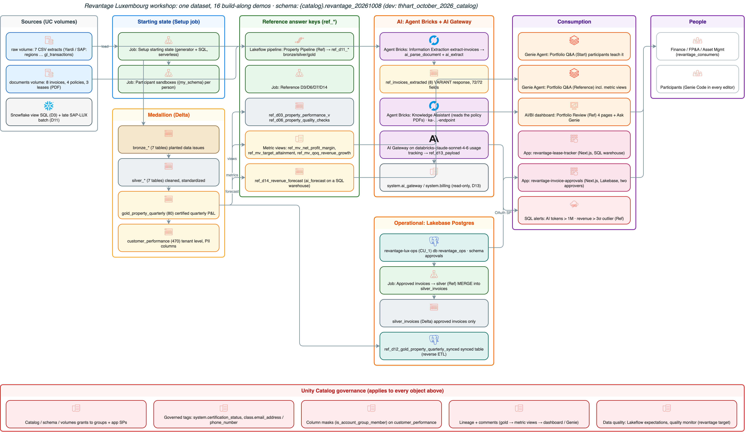
Architecture

Contents
- Demo 1: Welcome & Platform Overview — “Where does my data live?”
- Demo 2: Genie One — Property Performance Q&A
- Demo 3: Genie Code — migrate and fix a Snowflake view
- Demo 4: Extraction Agent — “Invoice-to-Table”
- Demo 5: Knowledge Assistant — “Ask the Policy Book”
- Demo 6: Genie One Data Exploration — “Audit your data before you trust it”
- Demo 7: Semantic Layer & UC Metric Views — “Define Net Profit Margin once”
- Demo 8: AI/BI Dashboards — “Executive Portfolio Review”
- Demo 9: Databricks Apps — “Lease Expiry Tracker”
- Demo 10: Unity Catalog & Governance — “Who can see what, and why?”
- Demo 11: Lakeflow — “Bronze-Silver-Gold in 20 minutes”
- Demo 12: Lakebase & Production Operations — “Approval workflow state machine”
- Demo 13: AI Gateway & Monitoring — “Who’s using what, and what’s it costing us?”
- Demo 14: Time Series Forecasting — “Where is revenue heading?”
- Demo 15: Hands-On Lab — Build Your Own
- Demo 16: Data Quality & Observability — “Trust scorecard”
## Demo 1: Welcome & Platform Overview — “Where does my data live?”
Session: Day 1, 9:00–9:30 (30 min) · You build: your bearings: catalog, SQL editor, Genie Code · Reference: none (navigation) Starting state: <catalog>.<schema> with bronze_* (7), silver_* (7), gold_property_quarterly, customer_performance; volumes raw (7 CSVs) and documents (invoices/ 8, policies/ 4, leases/ 3 PDFs) Where: Catalog Explorer, SQL editor, Genie Code side panel
Everything the workshop builds, on one governed dataset.
Everything the workshop builds, on one governed dataset.

Stage 1: Open platform, 3 minutes of talk
Delta/Iceberg in your own cloud storage (S3/ADLS/GCS); any model (Claude, GPT, open source, behind the AI Gateway); any data type (tables, PDFs, Excel). Unity Catalog governs all of it.

Stage 2: The three-level namespace (7 min)
Catalog → <catalog> → <schema>: point out tables, views, metric views (later), volumes, functions. Snowflake mapping: database ≈ catalog, schema = schema, stage ≈ volume, warehouse ≈ SQL warehouse. Checkpoint: open documents → invoices/ → preview HV-2026-0417.pdf in the browser.

Stage 3: First query (5 min)
SQL editor, Serverless warehouse:
SELECT * FROM <catalog>.<schema>.gold_property_quarterly LIMIT 10;
SELECT COUNT(*) AS rows, COUNT(DISTINCT property_id) AS properties, MIN(fiscal_quarter), MAX(fiscal_quarter)
FROM <catalog>.<schema>.gold_property_quarterly;
Expected: 80 rows · 8 properties · 2024-Q1 · 2026-Q2.

Stage 4: Meet Genie Code (10 min)
Open the Genie Code panel (top right): > What tables are in . and how do the bronze, silver and gold tables relate?
Expected: Genie Code explains raw → cleaned → aggregated and names gold_property_quarterly as the fact table. > Write a query showing 2026-Q2 net profit by region from gold_property_quarterly.
Expected: Western Europe ≈ €2.69M, Northeast ≈ €1.59M, Southeast ≈ €2.09M.

Stage 5: Any data type (5 min)
Prompt: > Read the PDFs in /Volumes///documents/leases/ with read_files as binaryFile and parse them with ai_parse_document.
Expected: 3 rows, ~20 elements each; the first element of lease-harbor-tower-anchor.pdf is “EXPIRED” (the anchor tenant who left on 31 March; we’ll see the impact all day).
SELECT path, ai_parse_document(content, map('version','2.0')):document.elements[0].content::string AS first_element
FROM read_files('/Volumes/<catalog>/<schema>/documents/leases/', format => 'binaryFile')

Wrap-up
- So what: everyone can find the data, run a query, and ask Genie Code before the real work starts.
- Verified: 2026-10-08 on the FEVM workspace: counts (80 / 8 / 2024-Q1–2026-Q2), Q2 by region from gold, and the lease parse (3 files, first element “EXPIRED”, ~20 elements each) run in SQL. Stages 4–5 run in the Genie Code UI (S9): S4 Genie Code listed bronze/silver/gold, named gold_property_quarterly as the quarterly P&L fact table (it also sees the ref_* answer-key objects and pipeline internals: say so up front), and returned €2.69M / €2.09M / €1.59M; S5 it parsed the 3 lease PDFs (21 / 20 / 21 elements) with Harbor Tower’s first element “EXPIRED”.
## Demo 2: Genie One — Property Performance Q&A
Session: Day 1, 9:30–10:15 (45 min) · You build: five answered, shareable business questions · Reference: Genie Agent “Revantage Portfolio Q&A (Reference)” Starting state: Genie Agent “Revantage Portfolio Q&A (Start)” over gold_property_quarterly, silver_properties, bronze_properties, silver_leases, silver_tenants Where: Genie One (browser), then the desktop/mobile app if installed
Open the Start agent from Genie One (left nav Genie → Revantage Portfolio Q&A (Start)). Ask each question, then open Show thinking and Show code on every answer. That’s the habit to build: read the SQL behind the number.
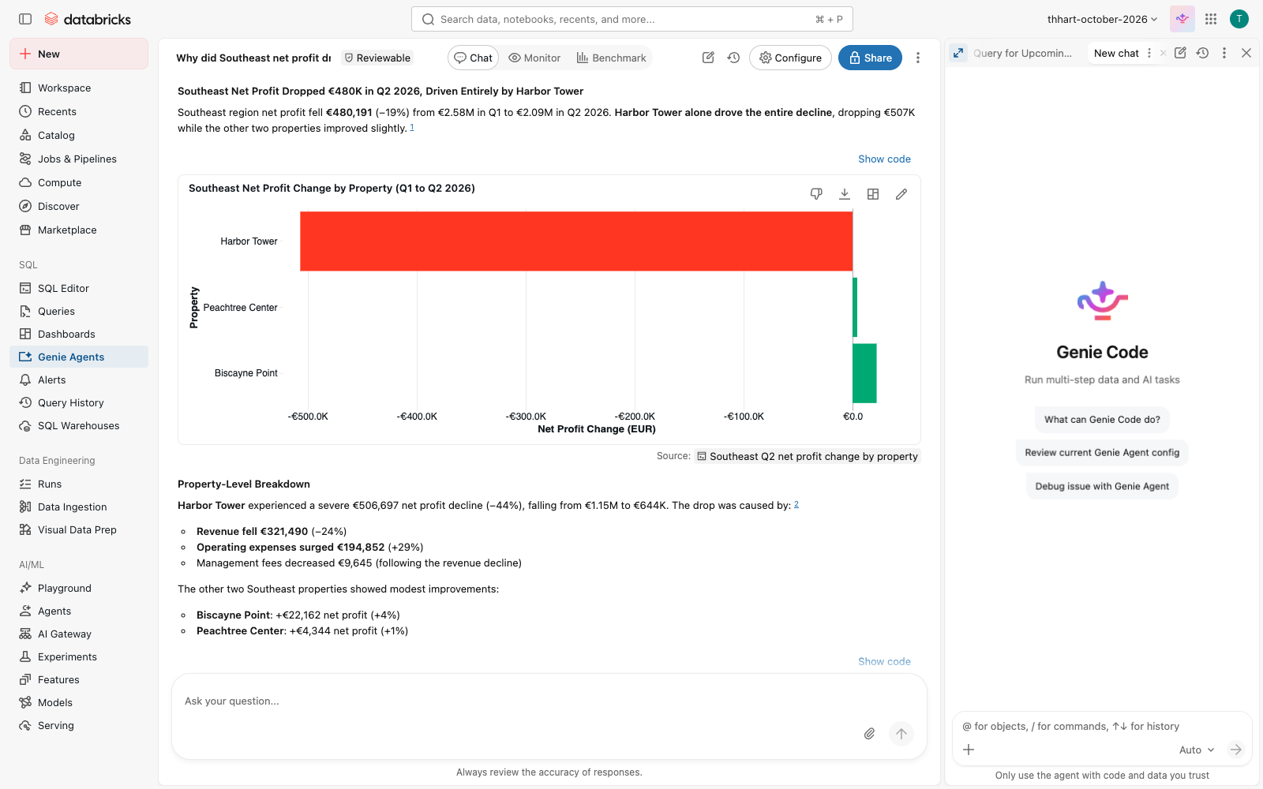
Genie One answers the Southeast question: Harbor Tower drives the whole drop.
Genie One answers the Southeast question: Harbor Tower drives the whole drop.

Stage 1: Who missed target? (6 min)
Prompt (Genie One): > Which properties missed their quarterly target in 2026-Q2?
Expected: 3 properties: Peachtree Center (−€71,293), Harbor Tower (−€43,235), Zuidas Residences (−€41,702). Checkpoint: open Show code: WHERE fiscal_quarter = '2026-Q2' AND met_target = false on gold_property_quarterly. If stuck: ask the same question in the Reference agent; it answers from the metric view ref_mv_target_attainment.

Stage 2: What changed in the Southeast? (8 min)
Prompt: > What changed from Q1 to Q2 for the Southeast region?
Expected: revenue down ~€267k (−6.4%), operating expense up ~€221k, net profit €2.58M → €2.09M (−18.6%). Then follow up in the same thread: > Which property drove that, and was it revenue or costs?
Expected: Harbor Tower, net profit −€507k: revenue −€321k (anchor tenant left on 31 March) and costs +€185k. Checkpoint: Harbor Tower is the only Southeast property whose net profit fell. If stuck: in the Reference agent, ask “Why did Southeast net profit drop in Q2?”.

Stage 3: Charts (6 min)
Prompt: > Show me revenue by property type as a bar chart
Expected: bar chart: Office €46.7M, Multifamily €37.2M, Retail €19.7M (all quarters). Ask “Only for 2026-Q2” to refine; use the chart menu to switch type.

Stage 4: Growth (5 min)
Prompt: > Which market has the highest quarter-over-quarter net profit growth?
Expected: Luxembourg City, +10.0% (2026-Q2 vs Q1). Checkpoint: Show code compares 2026-Q2 with 2026-Q1. The agent’s instructions set that default; without them Genie ranked every quarter in history (Boston 2024-Q4). That’s the lesson for Demo 13 (context matters).

Stage 5: Risks (8 min)
Prompt: > Summarize the top 3 risks across the portfolio this quarter
Expected (Start agent): target misses (€156k shortfall across 3 properties), one QoQ decline. Grounded but shallow. Ask the same in the Reference agent: 14 leases expiring within 180 days, 3 missed targets, 1 QoQ decline. Same data, better context.

Stage 6: Share and take it with you (7 min)
- Share the thread with a colleague (share icon, top right): they see the same answers and SQL.
- Show the desktop and mobile apps, the Slack / Microsoft 365 connectors, attaching a file to a question (e.g. the Q2 board pack PDF from documents/), and scheduling a question (“Every Monday 8:00, which properties are behind target?”). Facilitator demo; check what’s enabled in the workspace first (pre-flight).

Wrap-up
- So what: a portfolio manager got five board-ready answers in minutes, each with the SQL to prove it.
- Snowflake equivalent: Cortex Analyst answers over a semantic model; Genie One adds threads, charts, sharing, and the agent context you’ll govern in Demo 7.
- Verified: 2026-10-08 via the Genie Conversation API on both agents; transcript in verification/raw/d02-genie-start-2026-10-08.txt, summary in verification/d02-d06-d07-genie.md. Desktop/mobile, connectors, attachments, schedules are facilitator show-items: check them in the Revantage workspace pre-flight (availability varies by workspace).
## Demo 3: Genie Code — migrate and fix a Snowflake view
Session: Day 1, 10:15–10:45 (30 min) · You build: <my_schema>.property_performance_v · Reference: <catalog>.<schema>.ref_d03_property_performance_v Starting state: gold_property_quarterly, silver_properties; the Snowflake view in code/sql/d03_snowflake_property_view.sql (also in the participant handout) Where: SQL editor, Genie Code side panel
The point to land: most Snowflake SQL runs on Databricks unchanged (NVL, IFF, DATEADD, QUALIFY, :: casts all work). Genie Code finds the few things that don’t, and a logic bug that was already there in Snowflake.
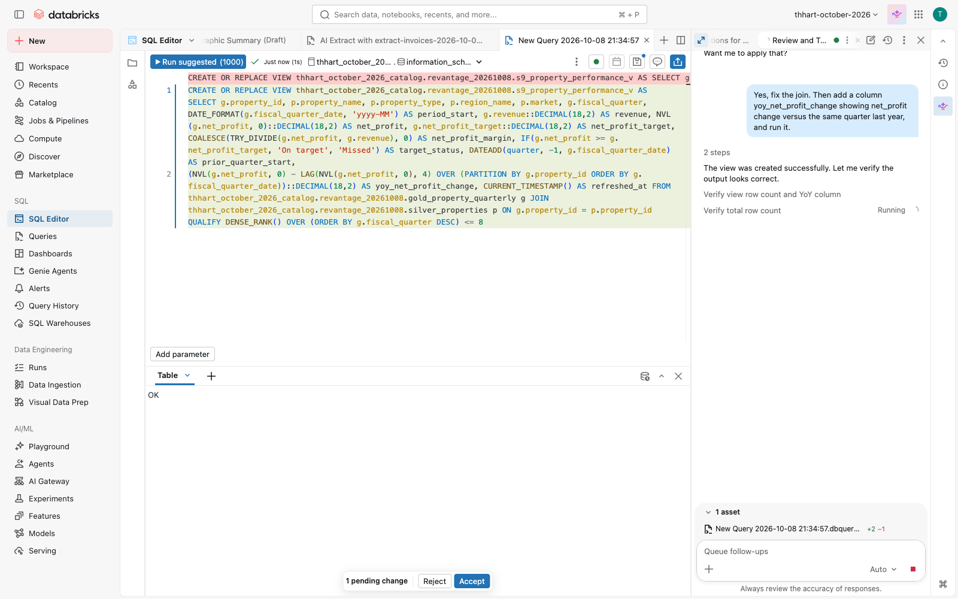
Genie Code explains the Snowflake view and lists what to change for Databricks SQL.
Genie Code explains the Snowflake view and lists what to change for Databricks SQL.

Stage 1: Paste and run (3 min)
Paste the Snowflake view into a new SQL editor tab. Replace the table prefixes with <catalog>.<schema> and the view name with <my_schema>.property_performance_v. Run it.
Expected: [UNSUPPORTED_DATATYPE] Unsupported data type "NUMBER(18,2)". Checkpoint: the error appears in the results panel. If stuck: check the three-part names. The error must be about NUMBER, not “table not found”. Watch for: the editor’s automatic Genie Code Quick Fix pops up an inline “Accept & Run” that only rewrites ::NUMBER as CAST(… AS NUMBER(18,2)), which still fails. Click Reject and use the Genie Code chat (Stage 2). A good lesson: one-click fixes are shallow; a conversation migrates.

Stage 2: Explain and find the issues (5 min)
Prompt (Genie Code, SQL editor, with the query selected): > Explain this query and identify any issues for Databricks SQL. It was written for Snowflake.
Expected: Genie Code flags NUMBER(18,2) (use DECIMAL), TO_VARCHAR(date, 'YYYY-MM') (use date_format(date, 'yyyy-MM')), DIV0 (use try_divide), and SYSDATE() (use current_timestamp()). It may also note that NVL, IFF, DATEADD, and QUALIFY work as-is. Checkpoint: all four incompatibilities are listed. If stuck: ask the follow-up “Which functions in this query don’t exist in Databricks SQL?”

Stage 3: Fix the syntax (5 min)
(In the pre-build run Genie Code already applied all fixes after Stage 2’s prompt, plus IFF → IF, and then paused for approval because CREATE OR REPLACE VIEW is destructive. Click Accept all, then Run.)
Prompt: > Fix the syntax errors and adapt this for Databricks SQL. Keep the logic the same.
Expected: the view is created. Then run: SELECT COUNT(*) FROM <my_schema>.property_performance_v → 176. Checkpoint: 176 rows. That’s suspicious: 8 properties × 8 quarters should be 64. If stuck: copy the syntax lines from the reference view (SHOW CREATE TABLE <catalog>.<schema>.ref_d03_property_performance_v), but keep your join as it is.

Stage 4: Why are there duplicate rows? (5 min)
Prompt: > Why does this view return 176 rows when there are 8 properties and 8 quarters? Are there duplicate rows?
Expected: Genie Code spots the join ON g.region_name = p.region_name: each property row matches every property in its region (3 in Southeast, 2 in Northeast, 3 in Western Europe), and property_name comes from the wrong side of the join. Fix: ON g.property_id = p.property_id. Checkpoint: after the fix, COUNT(*) = 64 and COUNT(DISTINCT property_id, fiscal_quarter) = 64. If stuck: “Compare row counts with and without the join to silver_properties.”

Stage 5: Add YoY (7 min)
Prompt: > Add a column yoy_net_profit_change showing net_profit change versus the same quarter last year.
Expected: net_profit - LAG(net_profit, 4) OVER (PARTITION BY property_id ORDER BY fiscal_quarter). Watch for LAG(..., 1): that’s quarter-over-quarter, not YoY. Ask Genie Code “Is that the same quarter last year or the previous quarter?” if it uses 1. Checkpoint:
SELECT property_name, yoy_net_profit_change FROM <my_schema>.property_performance_v
WHERE fiscal_quarter = '2026-Q2' ORDER BY yoy_net_profit_change LIMIT 1
→ Harbor Tower, −478,309.66. 2024-Q3 and 2024-Q4 are NULL (no 2023 data). If stuck: compare with the reference view.

Stage 6: Verify (5 min)
Prompt: > Write a query that checks my view against ..ref_d03_property_performance_v row by row and returns any differences.
Expected: an EXCEPT or full-outer-join check returning 0 rows (ignore refreshed_at).

Wrap-up
- So what: the migration is a conversation. Genie Code found the 4 incompatible functions and a join bug that was already wrong in Snowflake.
- Snowflake equivalent: Snowflake Copilot explains and drafts SQL. Genie Code also fixes, runs, and checks against governed tables in the same editor.
- Verified: 2026-10-08 on the FEVM workspace, all stages in the Genie Code UI (S9): Stage 1 error UNSUPPORTED_DATATYPE NUMBER(18,2); Stage 2 Genie Code listed NUMBER→DECIMAL ×3, TO_VARCHAR→DATE_FORMAT ‘yyyy-MM’, DIV0→COALESCE(TRY_DIVIDE), IFF→IF, SYSDATE→CURRENT_TIMESTAMP and said NVL/DATEADD/QUALIFY need no change; Stage 3 view = 176 rows; Stage 4 it explained the region fan-out (72 + 72 + 32 = 176) and proposed property_id; Stage 5 it reasoned to LAG(…, 4) and the view returned 64 rows, Harbor Tower 2026-Q2 YoY −478,309.66 (identical to the reference); Stage 6 Genie Code read both schemas and wrote a full-outer-join diff on (property_id, fiscal_quarter) with a per-column differing_columns list: 0 rows. Screenshots notes/agent-notes/screenshots/s9-d03-*.png.
## Demo 4: Extraction Agent — “Invoice-to-Table”
Session: Day 1, 11:00–11:45 (45 min) · You build: an Information Extraction agent over the invoices + a Delta table of extracted fields · Reference: agent extract-invoices-2026-10-08-15-39-15 (“Invoice Extractor (Reference)”), table <catalog>.<schema>.ref_invoices_extracted Starting state: 8 invoice PDFs in /Volumes/<catalog>/<schema>/documents/invoices/ (5 vendors’ layouts, EUR ×5, USD ×2, GBP ×1); ground truth code/documents/out/invoices_ground_truth.json Where: left nav Agents → Create Agent → Information Extraction; then the SQL editor
Timing reality (measured 2026-10-08): clicks take ~3 minutes; file parsing + schema generation ~6 minutes; the first extraction ~2 minutes. Plan ~12 minutes wall-clock from “Create” to results. Start it, then talk through the platform story while it parses. The agenda’s “3–4 minutes” is the clicking, not the waiting.
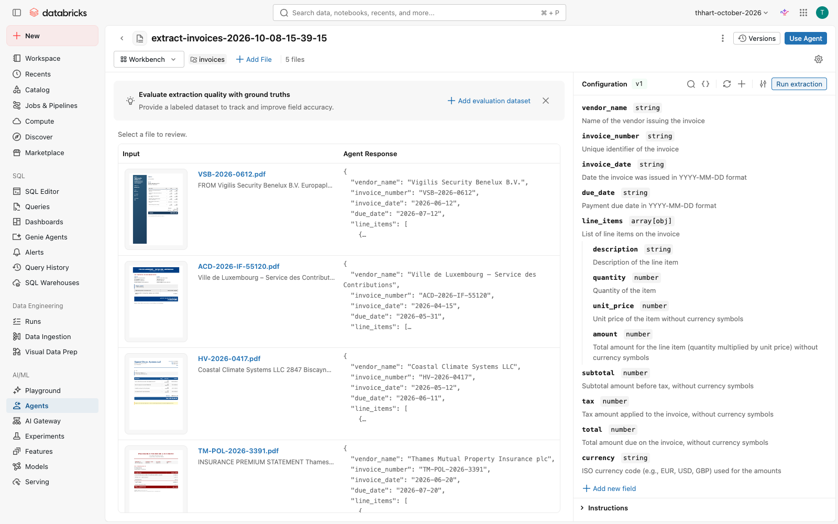
The Information Extraction agent reads every invoice into typed fields.
The Information Extraction agent reads every invoice into typed fields.

Stage 1: Create and point at the documents (3 min)
Agents → Create Agent → Information Extraction → Select volume. Choose All volumes, search documents, click the volume, then expand it and click invoices (the breadcrumb must end in /documents/invoices) → Select.
Expected: “Processing 5 files…”; the build view samples 5 of the 8 invoices. If stuck: if expanding the volume shows “Request access”, wait a few seconds and expand again: the folder list loads late. Don’t select the volume root, or the policies and leases get sampled too.

Stage 2: Describe what to extract (3 min)
Prompt (the “Describe what you want to extract” box): > Extract from each vendor invoice: vendor_name, invoice_number, invoice_date, due_date, line_items (an array where each item has description, quantity, unit_price, amount), subtotal, tax, total, and currency (ISO code like EUR, USD, GBP). Dates as YYYY-MM-DD. Amounts as numbers without currency symbols.
Click Generate schema. Expected: the 9 fields, with line_items as array[obj] of 4 sub-fields. Checkpoint (important): open line_items › quantity. Genie generates integer; change it to Number. The legal invoice bills 4.5 / 2.5 / 1.5 hours, and integer would truncate them.

Stage 3: Run and review (5 min)
Click Run extraction. Click each file to see the PDF next to the JSON. Expected (Coastal Climate Systems, HV-2026-0417): total 339600, currency USD, 4 line items (chiller 214,500; crane 38,900; installation 61,200; commissioning 25,000), tax null. Also check the bilingual Luxembourg tax notice (ACD-2026-IF-55120, €27,826.50) and the UK insurance statement (£55,272 incl. 12% IPT).

Stage 4: Use the agent in production (5 min)
Click Use Agent. Show the five paths: Run in SQL, Run in Notebook, REST API, Create a Lakeflow Job, Create a Spark Declarative Pipeline. Click Run in SQL → Start extraction. A SQL editor tab opens with the generated query: read_files(..., format => 'binaryFile') → ai_parse_document(content, map('version','2.0')) → ai_extract(parsed, '<json schema>', options => map('version','2.0')).
Prompt (Genie Code, in that SQL editor tab): > Explain this query step by step, then wrap it in CREATE OR REPLACE TABLE .invoices_extracted so the results are saved as a Delta table.
Expected: a CTAS over the same query; 8 rows; response is a VARIANT with response.response.<field>. Checkpoint: SELECT response:response.invoice_number::string, response:response.total::double FROM <my_schema>.invoices_extracted → 8 rows incl. HV-2026-0417 | 339600. If stuck: run code/reference/d04_extract_invoices.sql (the captured agent SQL as a CTAS).

Stage 5: Reconcile to the GL (6 min)
Prompt (Genie Code): > Join the extracted invoices to ..silver_gl_transactions where the GL description starts with the invoice number, and show invoice total, currency, GL amount in EUR, and the GL account name and category.
Expected: HV-2026-0417: USD 339,600 ↔ €312,390.76 booked to Repairs & Maintenance (OpEx). The others don’t match by invoice number (the GL has monthly accruals). Hold that thought: in Demo 5 the policy says this chiller is CapEx.

Stage 6: Into a pipeline (3 min, show)
Back in the agent: Use Agent → Create a Spark Declarative Pipeline. Show that new PDFs dropped into the volume are extracted incrementally on schedule. Don’t run it in the room; it’s the production path.

Wrap-up
- So what: an analyst built an invoice extractor without code, verified it against the PDFs, and got production SQL, a job, or a pipeline from the same agent.
- Snowflake equivalent: Document AI (model building + !PREDICT). On Databricks it’s ai_parse_document + ai_extract in SQL, governed in Unity Catalog, with one-click pipelines.
- Verified: 2026-10-08 in the browser on the FEVM workspace: agent built from the invoices folder; the reference CTAS over all 8 invoices scored 72/72 fields (100%) vs ground truth (code/reference/d04_score_extraction.py); the GL reconciliation returned the €312,390.76 R&M posting. Stages 4–5 run in the Genie Code UI (S9) in the agent’s Run in SQL tab: S4 explained read_files → ai_parse_document → ai_extract step by step, wrapped it in a CTAS, 8 rows incl. HV-2026-0417 339,600 (it called that “€339,600”; the invoice is USD: point at the currency column); S5 the join returned exactly HV-2026-0417, USD 339,600 ↔ €312,390.76, Repairs & Maintenance (OpEx). Screenshots: notes/agent-notes/screenshots/d04-*.png.
## Demo 5: Knowledge Assistant — “Ask the Policy Book”
Session: Day 1, 11:45–12:15 (30 min) · You build: a Knowledge Assistant over the group policies · Reference: agent revantage-policy-assistant (endpoint ka-234e391f-endpoint on the FEVM; a new ID in your workspace) Starting state: 4 policy PDFs in /Volumes/<catalog>/<schema>/documents/policies/ (Expense Approval, Capital Expenditure Guidelines, Lease Renewal Procedures, Intercompany Transfer); ground truth code/documents/out/policies_qa_ground_truth.md Where: Agents → Create Agent → Knowledge Assistant
Timing reality (measured 2026-10-08): the form takes ~3 minutes; the endpoint and vector index then take ~15–25 minutes before the first answer. Until then questions fail with “Vector index … is not ready”. Start the build at the beginning of Demo 4 (11:00) so it’s ready at 11:45, or use the reference agent while yours indexes.
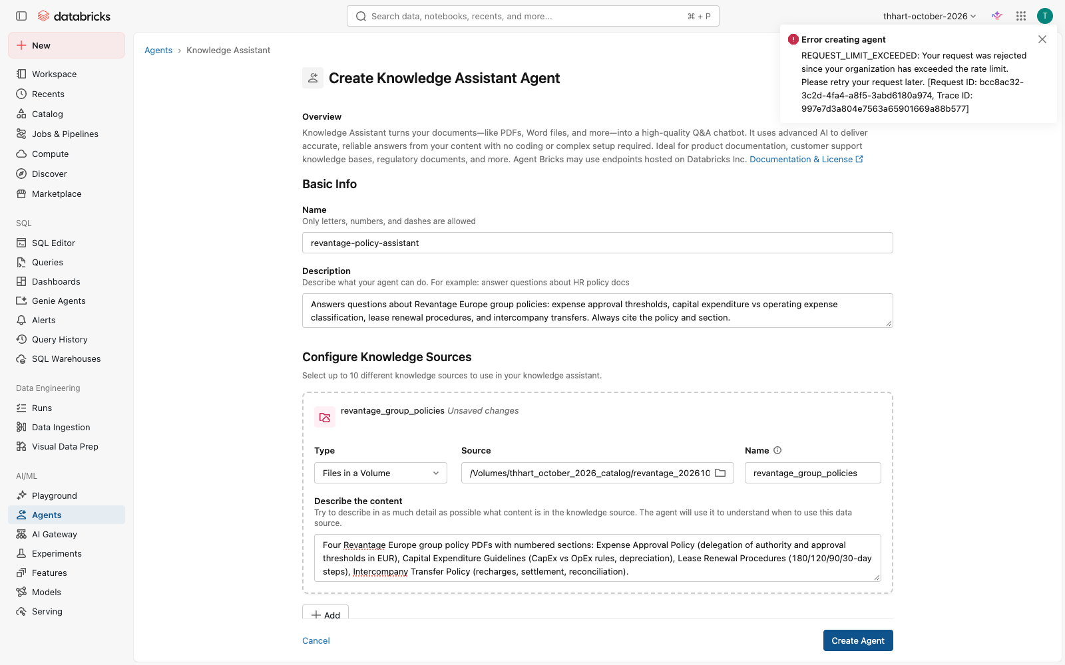
The Knowledge Assistant indexes the four policy PDFs.
The Knowledge Assistant indexes the four policy PDFs.

Stage 1: Create (3 min, start it early)
Agents → Create Agent → Knowledge Assistant. - Name: policy-assistant-<your_name> (letters, numbers, dashes; ≤ 64 characters; clear the default name first) - Description: > Answers questions about Revantage Europe group policies: expense approval thresholds, capital expenditure vs operating expense classification, lease renewal procedures, and intercompany transfers. Always cite the policy and section. - Knowledge source: Type Files in a Volume → Source → All volumes → documents → expand → policies → Select. Name revantage_group_policies. - Describe the content: > Four Revantage Europe group policy PDFs with numbered sections: Expense Approval Policy (delegation of authority and approval thresholds in EUR), Capital Expenditure Guidelines (CapEx vs OpEx rules, depreciation), Lease Renewal Procedures (180/120/90/30-day steps), Intercompany Transfer Policy (recharges, settlement, reconciliation).
Create Agent. If stuck: “REQUEST_LIMIT_EXCEEDED” → wait a few seconds and click Create again; if the button spins for minutes, reload, re-enter, and check the agent list first (it may already exist).

Stage 2: Ask the three business questions (10 min)
In the agent’s Test panel (or the reference agent while yours indexes): > What is the approval threshold for expenses over €50,000?
Expected: co-signature of the CFO and the Asset Management Director, two different people, with supporting documentation. Cites expense-approval-policy.pdf. > If a tenant’s lease expires in 90 days, what steps should I take?
Expected: Day-90 step: formal written notice by registered letter if there’s no response to the renewal proposal, escalate to the Head of Asset Management, start re-letting marketing in parallel; final decision at day 30. Cites lease-renewal-procedures.pdf. > Is a new HVAC system for Harbor Tower classified as CapEx or OpEx?
Expected: CapEx: replaces a building system, > €25,000, useful life 20 years (> 3); routine servicing would be OpEx. Cites capital-expenditure-guidelines.pdf. Land it: Demo 4 showed this exact chiller (HV-2026-0417, €312k) booked to Repairs & Maintenance (OpEx). That’s why Harbor Tower “missed” its Q2 target by €43k. The policy says reclassify it.

Stage 3: Citations and follow-ups (5 min)
Open the citation on each answer: it links to the source PDF passage. Try: > What credit rating threshold requires Head of Asset Management sign-off for lease renewal?
Expected: tenants rated below BB.

Stage 4: Share and use from SQL (7 min)
- Share: agent page → Permissions → add the team (Can Query). Anyone with access can use it in the Playground or through the endpoint.
- From SQL (the “agents scale to production via SQL” point):
SELECT ai_query('<your KA endpoint name>',
'Does invoice HV-2026-0417 (USD 339,600 chiller replacement) need CFO approval? Answer in one sentence.') AS answer
Expected: “Yes … exceeds the €50,000 threshold that requires co-signature of the CFO and Asset Management Director.” Prompt (Genie Code, SQL editor): > Use ai_query with my Knowledge Assistant endpoint to add a column policy_check to a copy of ..ref_invoices_extracted in that says, for each invoice, which approvers it needs under the Expense Approval Policy.
Expected (seen in pre-build): Genie Code pauses for approval of the CREATE OR REPLACE, then 8 answers grounded in the policy, and it handles the USD/GBP conversion caveat. But only 6 of 8 are right: for VSB-2026-0612 (€30,782.40) and PE-2026-06-0088 (USD 41,000 ≈ €37.7k) the Knowledge Assistant quoted the correct €25,000.01–€50,000 row and then named the Asset Manager instead of the Head of Asset Management. Teach (the point of this stage): check agent output against a deterministic rule before trusting it at scale. For the EUR invoices:
SELECT response:response.invoice_number::string AS invoice, response:response.total::double AS total,
CASE WHEN response:response.total::double > 50000 THEN 'CFO + AM Director'
WHEN response:response.total::double > 25000 THEN 'Head of Asset Management'
WHEN response:response.total::double > 5000 THEN 'Asset Manager' ELSE 'Property Manager' END AS rule_approver,
policy_check
FROM <my_schema>.invoices_policy WHERE response:response.currency::string = 'EUR'
(USD/GBP need the ECB rate first; Demo 12’s approvals.invoice_approvals.total_eur has them converted.) Thresholds belong in code (Demo 12 puts requires_two_approvers in a generated column); use the agent for the questions code can’t answer (CapEx vs OpEx, exceptions, renewals). Note: write the new column into <my_schema> (e.g. CREATE TABLE <my_schema>.invoices_policy AS SELECT …), not into the shared ref_ table.

Stage 5: Tour of other agent types (5 min, show)
In Create Agent point out: Information Extraction (Demo 4), Document Parsing, Text Classification, Supervisor Agent (combine Genie Agents, Knowledge Assistants, and MCP tools, e.g. “Portfolio Q&A + Policy Assistant”), Knowledge Assistant, code your own agent (Apps template), Genie Agent.

Wrap-up
- So what: policies answer themselves, with citations, and the same agent works from chat, SQL, and other agents.
- Snowflake equivalent: Cortex Search + Cortex Agents. On Databricks the Knowledge Assistant is built from a volume in minutes, governed in Unity Catalog, and callable from SQL with ai_query.
- Verified: 2026-10-08 on the FEVM workspace. Agent built in the browser at 15:54 (first create hit a rate limit); index ready in ~25 min. All 6 ground-truth questions answered correctly with the right PDF cited (verification/raw/d05-ka-2026-10-08.txt); ai_query from SQL verified. Stage 4 run in the Genie Code UI (S9) against a scratch copy of the extracted invoices (since dropped): 8 ai_query answers via ka-234e391f-endpoint, 6/8 correct as described above (the two errors come from the KA text itself, not from Genie Code’s summary).
## Demo 6: Genie One Data Exploration — “Audit your data before you trust it”
Session: Day 1, 12:15–12:30 (15 min) · You build: a recurring quality check from Genie’s SQL · Reference: view <catalog>.<schema>.ref_d06_property_quality_checks Starting state: Genie Agent “Revantage Portfolio Q&A (Start)” (includes bronze_properties); silver_properties, gold_property_quarterly Where: Genie One, then SQL editor with Genie Code
Fast-paced: one question per ~2 minutes. After each answer open Show code.

Stage 1: Layer counts (2 min)
Prompt (Genie One): > How many properties are in the bronze layer vs. the gold layer?
Expected: bronze 10, gold 8.

Stage 2: What got dropped (2 min)
Prompt: > Which properties exist in bronze but not in gold?
Expected: id 9 Riverside Annex (Charlotte) and id 10 Harbor Tower (Miami Bch), both with no region.

Stage 3: Completeness (2 min)
Prompt: > Show me the null rate for every column in bronze_properties
Expected: region_id 20% (2 of 10). _rescued_data 100% NULL: that’s Auto Loader’s column for values that didn’t fit the schema, and all-NULL is good news.

Stage 4: Duplicates (2 min)
Prompt: > Are there any duplicate property names with different IDs?
Expected: Harbor Tower, ids 3 and 10. Id 10 is the bad record from Stage 2.

Stage 5: Cross-source consistency (2 min)
Prompt: > Compare market names between bronze and silver for mismatches
Expected: 3: Miami Bch → Miami Beach, NYC → New York, Lux-Ville → Luxembourg City.

Stage 6: Keep the checks (5 min)
Copy the SQL from Stages 1–5 (Show code → copy) into a SQL editor tab, then:
Prompt (Genie Code, SQL editor): > Combine these five checks into one view .property_quality_checks with columns check_name, observed, issue_count, one row per check.
Expected: a view returning 5 rows with issue counts 2, 2, 2, 1, 3. Checkpoint: SELECT * FROM <my_schema>.property_quality_checks matches SELECT * FROM <catalog>.<schema>.ref_d06_property_quality_checks. If stuck: SHOW CREATE TABLE <catalog>.<schema>.ref_d06_property_quality_checks and copy it. Teaser for Demo 16: schedule this view as an alert so the next bad load is caught automatically.

Wrap-up
- So what: a 15-minute conversation found every planted issue and produced a reusable check, without writing SQL by hand.
- Verified: 2026-10-08. Stages 1–5 via the Genie Conversation API (verification/d02-d06-d07-genie.md, raw transcript verification/raw/d06-genie-start-2026-10-08.txt); reference view returns 2, 2, 2, 1, 3. Stage 6 run in the Genie Code UI (S9) with the five checks described in words (scratch view, since dropped): Genie Code read the three schemas, wrote a 5-branch UNION ALL view and returned issue counts 2, 2, 2, 1, 3, identical to the reference. If participants paste their Stage 1–5 SQL instead, the result should be the same.
## Demo 7: Semantic Layer & UC Metric Views — “Define Net Profit Margin once”
Session: Day 1, 1:30–2:15 (45 min) · You build: three metric views in <my_schema> · Reference: <catalog>.<schema>.ref_mv_net_profit_margin, ref_mv_target_attainment, ref_mv_qoq_revenue_growth (source code/reference/d07_metric_views.sql) Starting state: gold_property_quarterly with revenue, operating_expense, mgmt_fee, capex, intercompany, net_profit (Finance), targets Where: SQL editor with Genie Code; Catalog Explorer; Genie One
The story: Finance’s net profit = revenue − opex − management fees. Asset Management also subtracts capex. Same portfolio, two “net profit margins”: 59.3% vs 54.0% in 2026-Q2. A metric view puts the approved one in the catalog.
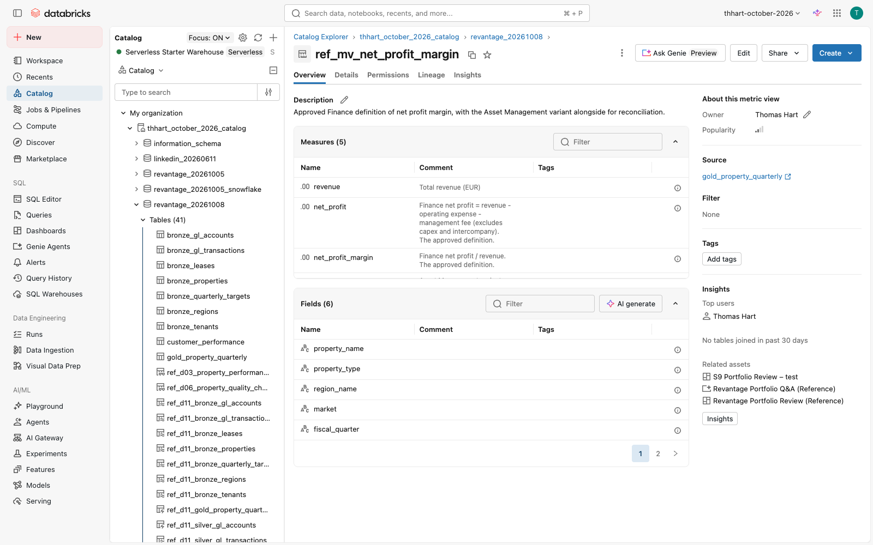
The approved net profit margin as a Unity Catalog metric view, with its measures documented.
The approved net profit margin as a Unity Catalog metric view, with its measures documented.

Stage 1: Net profit margin (12 min)
Prompt (Genie Code, SQL editor): > Create a Unity Catalog metric view .mv_net_profit_margin over ..gold_property_quarterly with dimensions property_name, property_type, region_name, market, fiscal_quarter, fiscal_quarter_date and measures revenue = SUM(revenue), net_profit = SUM(net_profit), net_profit_margin = SUM(net_profit) / SUM(revenue), plus asset_mgmt_net_profit_margin = SUM(net_profit - capex) / SUM(revenue) labelled as not approved.
Expected: CREATE OR REPLACE VIEW … WITH METRICS LANGUAGE YAML AS $$ version: 1.1 … $$. (Metric views are views with a YAML body; there is no CREATE METRIC TABLE.) Checkpoint:
SELECT MEASURE(net_profit_margin), MEASURE(asset_mgmt_net_profit_margin)
FROM <my_schema>.mv_net_profit_margin WHERE fiscal_quarter = '2026-Q2'
→ 0.5933 · 0.5395. By region: GROUP BY region_name. If stuck: copy the first statement of code/reference/d07_metric_views.sql, change the view name. Teach: ratios belong in measures (SUM/SUM), never as a stored column: the margin re-aggregates correctly at any grouping.

Stage 2: Target attainment (8 min)
Add a metric view mv_target_attainment with measures properties = COUNT(DISTINCT property_id), properties_met_target = COUNT(DISTINCT property_id) FILTER (WHERE met_target), target_attainment = their ratio, and net_profit_vs_target = SUM(net_profit) - SUM(net_profit_target). Format amounts as EUR.
Checkpoint (2026-Q2): properties 8, met 5, attainment 0.625; (Without “Format amounts as EUR” Genie Code tends to add a USD format.) GROUP BY property_name HAVING MEASURE(net_profit_vs_target) < 0 → Peachtree Center −71,293; Harbor Tower −43,235; Zuidas Residences −41,701.

Stage 3: QoQ growth (10 min)
Add mv_qoq_revenue_growth whose source is a query adding prior_quarter_revenue = LAG(revenue) per property, with measures qoq_revenue_growth = SUM(revenue) / SUM(prior_quarter_revenue) - 1 and qoq_net_profit_growth using prior_quarter_net_profit.
Checkpoint (2026-Q2, by market): qoq_net_profit_growth: Luxembourg City +10.0% (highest), Miami Beach −44.1%; by region Southeast −18.6% (the Demo 2 Genie numbers). qoq_revenue_growth is smaller: Luxembourg City +9.2%, Miami Beach −17.6%, Southeast −6.4%. Make sure participants compare the right measure. Teach: compute “prior” in the source; then growth is correct for any grouping (property, market, region, portfolio).

Stage 4: Govern it (5 min)
Catalog Explorer → your metric view → owner, comment, Certified tag (system.certification_status), grants. Point out lineage back to gold.

Stage 5: Genie answers from the definition (10 min)
In Genie One open Revantage Portfolio Q&A (Reference) (it includes the ref_mv_* views): > Which properties missed their quarterly target in 2026-Q2?
Expected: the same 3 properties, answered from ref_mv_target_attainment (net_profit_vs_target). The answer names the metric view. > What is our net profit margin this quarter, and how would it differ under the Asset Management definition?
Expected: 59.33% vs 53.95% (−5.38 pp), labelled as the approved vs the non-approved definition.

Wrap-up
- So what: the KPI argument happens once, in the catalog, and every dashboard, Genie answer, and query uses that answer.
- Snowflake equivalent: semantic views in Snowflake. UC metric views are queried with plain SQL (MEASURE()), used natively by AI/BI dashboards and Genie, and governed like any table.
- Verified: 2026-10-08 on the FEVM workspace: reference views created and every checkpoint number above returned by SQL; the Genie Stage 5 answers via the Conversation API (verification/d02-d06-d07-genie.md). Stage 1 run in the Genie Code UI (S9): Genie Code loaded its metric-view skill, wrote valid YAML 1.1 DDL (4 measures, no join), ran it and the query, and reported 59.33% / 53.95% with the capex explanation; the view it created returned 0.5933 / 0.5395. Stages 2–3 run in the Genie Code UI (S9): S2 view returned 8 / 5 / 0.625 and the 3 shortfalls (−71,293.16 / −43,234.95 / −41,701.20), formatted as USD; S3 Genie Code put LAG in the source and its view matched ref_mv_qoq_revenue_growth on every market for both measures.
## Demo 8: AI/BI Dashboards — “Executive Portfolio Review”
Session: Day 1, 2:15–3:15 (60 min) · You build: dashboard “Portfolio Review – ” · Reference: “Revantage Portfolio Review (Reference)” Starting state: metric views ref_mv_net_profit_margin, ref_mv_target_attainment, ref_mv_qoq_revenue_growth (or your own from Demo 7), gold_property_quarterly, ref_d14_revenue_forecast Where: Dashboards → Create dashboard; Genie Code panel in the dashboard editor
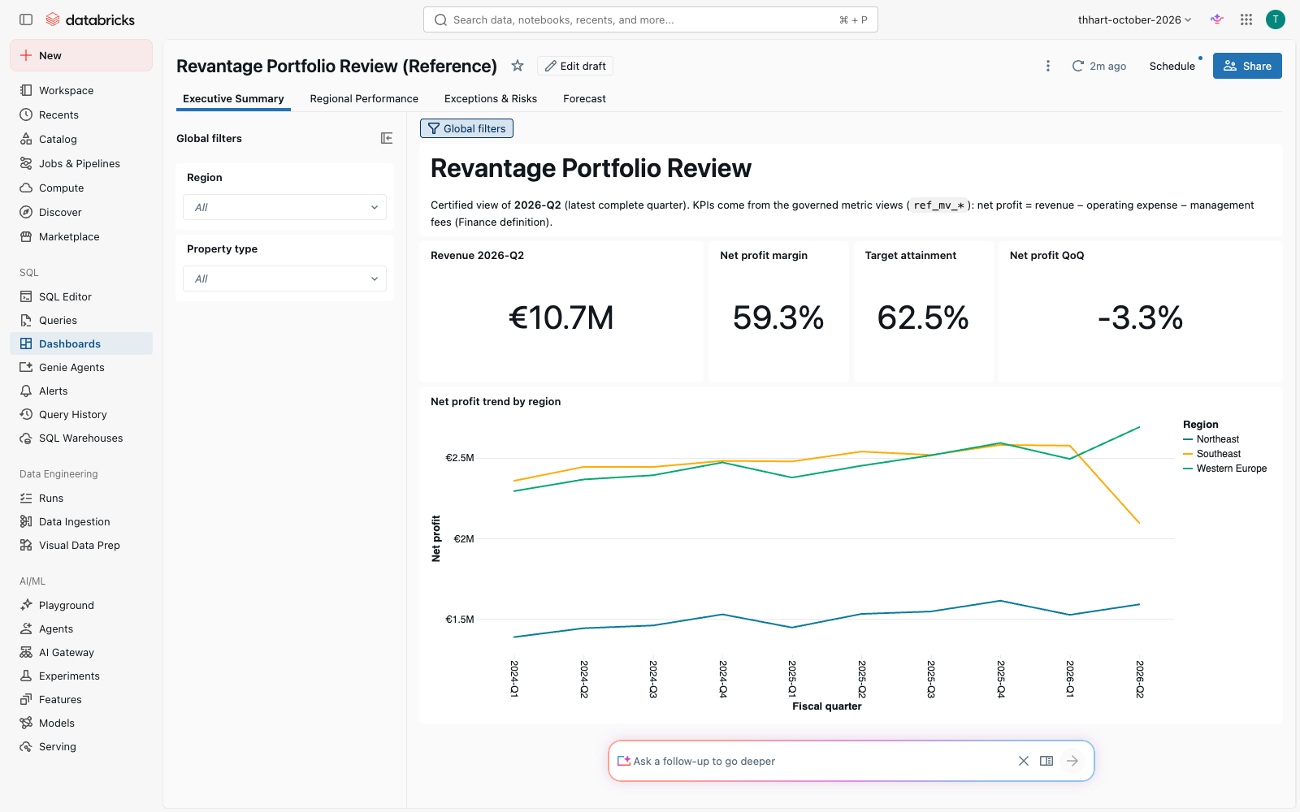
The Executive Summary page: €10.7M revenue, 59.3% margin, 62.5% target attainment.
The Executive Summary page: €10.7M revenue, 59.3% margin, 62.5% target attainment.

Stage 1: Create and add data (5 min)
Dashboards → Create dashboard → rename “Portfolio Review – ”. Data tab → Add data source → pick ref_mv_net_profit_margin, ref_mv_target_attainment, gold_property_quarterly.
Prompt (Genie Code, dashboard editor): > Add a dataset kpi_latest that returns, for fiscal_quarter 2026-Q2, revenue, net profit and net profit margin from ref_mv_net_profit_margin and target attainment from ref_mv_target_attainment, one row. Metric views can’t be joined: aggregate each with MEASURE() in its own subquery and cross join the two results. Run the dataset and check it.
Expected: one row: revenue 10,744,919; net_profit 6,375,345; margin 0.5933; target_attainment 0.625. Watch for (seen in pre-build): without the MEASURE()/subquery sentence Genie Code joined the two metric views ON 1 = 1 and said “created” without running it; the dataset fails with METRIC_VIEW_JOIN_NOT_SUPPORTED. Teach: always ask Genie Code to run and check what it builds. If stuck: copy the kpi_latest query from the reference dashboard (open it → Data tab).

Stage 2: Page 1, Executive Summary (10 min)
Prompt: > On a page “Executive Summary”, add counters for Revenue 2026-Q2 (EUR, compact), Net profit margin (%), and Target attainment (%) from kpi_latest, and a line chart of net profit by fiscal_quarter colored by region_name from ref_mv_net_profit_margin.
Expected: €10.7M · 59.3% · 62.5%; the line chart shows Southeast dropping in 2026-Q2. Checkpoint: the counters match the reference dashboard’s Executive Summary.

Stage 3: Page 2, Regional Performance (12 min)
Prompt: > Add a page “Regional Performance” with a bar chart of net profit by region and a scatter of revenue vs revenue_target by property, both from one dataset on gold_property_quarterly, and a heatmap of quarter-over-quarter net profit growth by market and quarter from ref_mv_qoq_revenue_growth. Add a single-select fiscal_quarter filter defaulting to 2026-Q2 that applies to the bar and scatter.
Expected: bar (2026-Q2): Western Europe highest, Southeast €2,094,950; heatmap: Miami Beach 2026-Q2 is the darkest negative cell (−44%), Luxembourg City +10%. Checkpoint: if the bar shows ~€24.5M for Southeast, it isn’t filtered (all 10 quarters summed): the filter only binds to datasets it was created on. Ask: “Make the Fiscal Quarter filter apply to the bar too, and check the 2026-Q2 Southeast value.” Without “from gold_property_quarterly” Genie Code looks only in the metric views, can’t find revenue_target, and substitutes net_profit. If stuck: switch the widget type in the widget panel; Genie Code sometimes picks a table first.

Stage 4: Page 3, Exceptions & Risks (8 min)
Prompt: > Add a page “Exceptions & Risks” with a table of properties from gold_property_quarterly showing net profit, target, variance (net_profit - net_profit_target), qoq_change_pct (already in percent units, -44.05 means -44.05%) and a flag “Sharp decline” when qoq_change_pct < -10, with filters for fiscal_quarter (default 2026-Q2) and met_target.
Expected: filtering met_target = false gives 3 rows: Peachtree Center −€71,293, Harbor Tower −€43,235 (Sharp decline, −44%), Zuidas Residences −€41,701.

Stage 5: Global filters (5 min)
Prompt: > Add global filters for region_name and property_type that apply to all pages. Bind them to every dataset that has those columns, then set Region = Western Europe and verify each page.
Checkpoint: Region = Western Europe: the bar shows one bar (€2.69M), the Exceptions table 3 properties, the heatmap 2 markets. The three counters don’t change: kpi_latest is a one-row portfolio dataset (a good talking point: which KPIs should be filterable?). Watch for (seen in pre-build): with the short prompt Genie Code bound the filters to one dataset and still said they apply to all pages; Exceptions kept showing 8 rows. A filter only applies to the datasets listed in its fields.

Stage 6: Ask Genie on the dashboard (8 min)
Publish the dashboard. In the published view use the Ask Genie bar at the bottom (or select a chart, then ask about it): > Why did Southeast net profit drop in Q2?
Expected: Genie drills down by property type, then property: Harbor Tower net profit €1.15M → €0.64M (−44%) while revenue fell only 18%, so a cost spike sits on top of the revenue loss. Other Southeast properties were flat or up. Follow-up for Demo 5: “What made Harbor Tower’s operating expense jump?” → repairs & maintenance (the chiller invoice HV-2026-0417).

Stage 7: Share, schedule, cache (5 min)
- Share → add the revantage_consumers group as Can view (viewers use the publisher’s or their own credentials, as you choose).
- Schedule → daily 07:00 refresh + email snapshot to yourself.
- Explain caching: published dashboards serve cached results, refreshed on schedule or on demand.
- Talk track: Tableau/Power BI import, custom visuals, and embedding are available; show only if enabled in the workspace (pre-flight).

Stage 8 (optional, with Demo 14): Forecast page
Prompt: > Add a page “Forecast” with a line chart from ref_d14_revenue_forecast showing actual, forecast, lower and upper interval and target over fiscal_quarter_date for one property, with a property filter defaulting to Harbor Tower.

Wrap-up
- So what: the quarterly review pack is a live, governed dashboard with Genie for the follow-up questions. No Excel, no emailed PDFs.
- Snowflake equivalent: Snowsight dashboards are SQL tiles. AI/BI adds a semantic layer (metric views), Genie Q&A, and publishing/sharing on the same governed data.
- Verified: 2026-10-08 on the FEVM workspace. The reference dashboard renders all 4 pages with correct numbers (screenshots notes/agent-notes/screenshots/d08-*.png). The dashboard Genie answered the Southeast question correctly in the browser. Stages 1–5 and 8 run in the dashboard editor’s Genie Code (S9) on a scratch dashboard: S1 one row 10,744,918.88 / 6,375,345.36 / 0.5933 / 0.625 (first-time right with the prompt above; the original prompt produced a failing join); S2 counters €10.7M · 59.3% · 62.5% and the line chart with the Southeast drop (Genie Code fixed its own METRIC_VIEW_MISSING_MEASURE_FUNCTION error); S3 needed the two follow-ups now baked into the prompt/checkpoint, then Southeast €2,094,949.91 and the heatmap Miami Beach −44%; S4 8 rows, Harbor Tower “Sharp decline”, variances −71.3K/−43.2K/−41.7K; S5 after the binding follow-up every page filters; S8 Harbor Tower actual + forecast + interval + target (the Forecast page didn’t pick up the global filters). Screenshots s9-d08-*.png. Stage 6–7 (Ask Genie, share/schedule) are UI clicks, not Genie Code prompts.
## Demo 9: Databricks Apps — “Lease Expiry Tracker”
Session: Day 1, 3:30–4:15 (45 min) · You build: a lease-expiry quick tool as a Databricks App · Reference: app revantage-lease-tracker (Next.js + TypeScript, code/app/) Starting state: silver_leases (50), silver_tenants (40), silver_properties (8); a SQL warehouse; the reference app deployed and shared Where: Apps (new Apps UI: New → App), the app’s source folder in the workspace with Genie Code
Expected numbers (live, from current_date(); as of 2026-10-13 the planted windows are 4 expired · 6 ≤ 90 d · 8 more ≤ 180 d · 10 more ≤ 365 d): on 2026-10-08 the reference app shows 6 / 14 / 23 leases in the 90 / 180 / 365-day windows and 50 incl. expired; 90-day monthly rent at risk €103k.
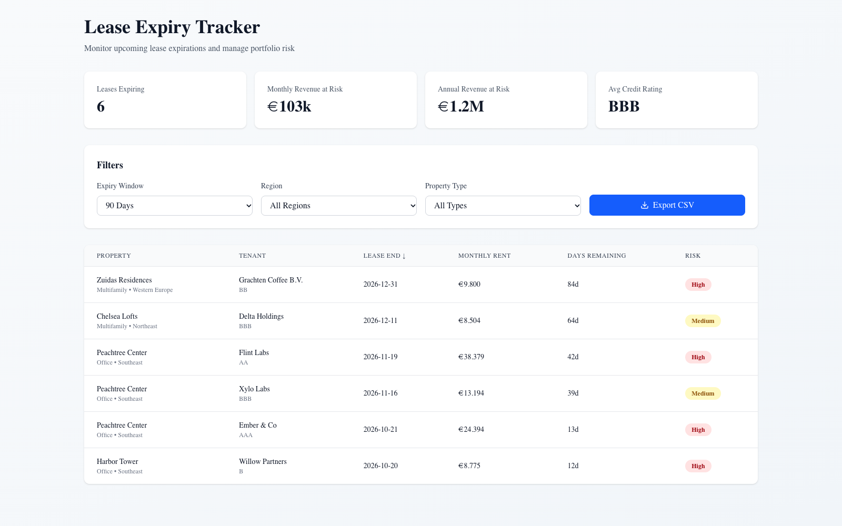
The lease expiry tracker: windows, risk, rent at risk, CSV export.
The lease expiry tracker: windows, risk, rent at risk, CSV export.

Stage 1: Start from a template (5 min)
New → App → Install from templates → Hello world → Streamlit. Name lease-tracker-<your_name>, Create. Wait for Running (~2–3 min), open it. The hello-world create flow only asks for compute, so add the warehouse afterwards: app page → Edit → App resources → Add resource → SQL warehouse (Can use), resource key sql-warehouse, Save. Checkpoint: the template renders. Open Edit in workspace to see the source folder.

Stage 2: Query the leases (10 min)
Open the app’s main file (e.g. app.py) and Genie Code: > The app has a SQL warehouse resource named sql-warehouse; in app.yaml read it into DATABRICKS_WAREHOUSE_ID with valueFrom: sql-warehouse (no resources block in app.yaml). Change this app to query ..silver_leases joined to silver_tenants and silver_properties through that warehouse, and show property, tenant, lease end, monthly rent, and days remaining (datediff from current_date) for leases ending in the next 90 days, sorted by days remaining.
Expected: a table with 6 rows (today), earliest Harbor Tower / Willow Partners (11 days on 9 Oct; the count is from current_date). Watch for (seen in pre-build): without the first sentence Genie Code wrote valueFrom: resources.sql_warehouse.id plus a resources: block in app.yaml; the app deployed but showed “No SQL warehouse configured”. One follow-up naming sql-warehouse fixed it. Checkpoint: redeploy (Deploy) and refresh. Grant your app’s service principal USE CATALOG + USE SCHEMA + SELECT if it errors with permission denied (the facilitator can run it for everyone). If stuck: open the reference app and compare its query: code/app/src/app/api/leases/route.ts.

Stage 3: Filters and risk (10 min)
Add filters for expiry window (90 / 180 / 365 days / all including expired), region, and property type, and a risk column: High if within 90 days and not ‘Pending Renewal’ or the tenant’s credit rating is below BB; Medium if within 180 days; otherwise Low.
Expected: 180-day window → 14 rows; Southeast filter shows Peachtree Center and Harbor Tower leases. Watch for: the forward windows must exclude leases that have already expired (the reference app had this bug in pre-build).

Stage 4: Summary cards and export (8 min)
Add summary cards at the top: number of leases expiring in the window, monthly and annualised rent at risk in EUR, and the average credit rating of the tenants. Add a button that downloads the filtered table as CSV.
Expected (90 days): 6 leases · €103k / month · €1.2M / year · average rating BBB (Genie Code’s version showed BBB+: it rounds the averaged rating scale differently; either is fine, discuss the method).

Stage 5: Share it like a Google Doc (5 min)
App page → Permissions → add revantage_consumers (Can use). Send the URL. Viewers sign in with their Databricks identity; the app reads data as its service principal (or, with on-behalf-of-user auth enabled, as the viewer, so UC row filters and masks apply). Show where the app is listed for business users: the app list and Genie One’s Discover page (facilitator show-item: check it in the Revantage workspace pre-flight).

Stage 6: Talk track (7 min)
- When an app instead of a dashboard: workflows (sort, flag, export, write back). Demo 12 adds approve/reject writes on Lakebase.
- Embedding Genie and agents: apps can call a Genie Agent (Conversation API) or the Knowledge Assistant endpoint (Demo 5), or use Databricks-managed MCP servers for Genie, UC functions, and vector search.
- Row Zero / spreadsheet-style analytics: UNVERIFIED in the Databricks context. Confirm with the account team before mentioning it. Don’t present it as a Databricks feature without confirmation.
- No per-seat cost: apps bill compute (shown on the create page: Medium ≈ 0.5 DBU/hour), not users.

Wrap-up
- So what: an always-current lease tool on governed data, shared with a link, with no separate hosting stack and no per-seat licences.
- Verified: 2026-10-08 on the FEVM workspace: reference app deployed (databricks bundle run demo_app), 27 Playwright tests pass locally (filters, sort, cards, export, live-data match, no-expired-in-window); deployed API returns 6 / 14 / 23 / 50 for the four windows, checked in the browser (notes/agent-notes/screenshots/d09-app.png). Template → Genie Code path (Stages 1–4) run in the UI (S9) on a scratch Streamlit app (deleted afterwards, grants revoked): S1 Running in ~3 min; S2 6 rows after the warehouse-wiring follow-up (now in the prompt); S3 filters + risk, 90 d → 6 (4 High), 180 d → 14, expired excluded from forward windows; S4 cards 6 · €103,046.05 · €1,236,552.60 · BBB+ and a working Download CSV button. Screenshots s9-d09-template-app*.png.
## Demo 10: Unity Catalog & Governance — “Who can see what, and why?”
Session: Day 1, 4:15–4:45 (30 min) · You build: business metadata, a certification, and PII masks on the gold layer · Reference: code/reference/d10_governance.sql (apply) and d10_reset.sql (back to the starting state) Starting state: gold_property_quarterly ships with no table description and no comments on net_profit, met_target, qoq_change_pct; customer_performance has unmasked tenant emails and phones Where: Catalog Explorer, SQL editor with Genie Code

Stage 1: Look before you touch (5 min)
Catalog → <catalog> → <schema> → gold_property_quarterly: Overview (owner, no description), Details, Permissions, Lineage (upstream silver tables, downstream metric views, the Portfolio Review dashboard, the Genie Agents).

Stage 2: Describe it for business users (8 min)
In Catalog Explorer use AI generate on the description, or in the SQL editor: Prompt (Genie Code): > Write a description for ..gold_property_quarterly suitable for a non-technical business user, and column comments for net_profit, met_target and qoq_change_pct. Give me the SQL to apply them, run it, and confirm with DESCRIBE TABLE EXTENDED.
Expected: COMMENT ON TABLE … IS '…' and ALTER TABLE … ALTER COLUMN net_profit COMMENT '…' (not TBLPROPERTIES). Net profit must say: revenue minus operating expenses minus management fees; capex and intercompany not deducted. Checkpoint: DESCRIBE TABLE EXTENDED <catalog>.<schema>.gold_property_quarterly shows the comment; Genie answers improve because it reads these.

Stage 3: Certify it (3 min)
ALTER TABLE <catalog>.<schema>.gold_property_quarterly SET TAGS ('system.certification_status' = 'certified');
Expected: a Certified badge in Catalog Explorer and search. Free-form keys like data_owner may be blocked by a governed tag policy (“not an allowed value”); that’s governance working.

Stage 4: Mask PII (8 min)
Prompt: > Create a column mask function that shows the full email only to members of revantage_finance_stewards and otherwise the first letter plus the domain, a similar one for phone numbers showing only the last 3 digits, and apply them to contact_email and contact_phone on ..customer_performance. Put the functions in . Tag the columns with the governed tags class.email_address and class.phone_number. Run it and show me what I see now.
Expected: two SQL UDFs with is_account_group_member(...), ALTER TABLE … ALTER COLUMN contact_email SET MASK …, tags class.email_address / class.phone_number. Watch for (seen in pre-build): with “tag with the PII classes” Genie Code chose the account’s governed pii key, got UC_TAG_POLICY_VALUE_NOT_ALLOWED … Allowed values: [ssn, address], and proposed extending the tag policy. Stop it: tag policies are account-level, owned by the governance team, and participants shouldn’t change them. Naming class.email_address / class.phone_number avoids it. Good governance talking point. Checkpoint: SELECT contact_email, contact_phone FROM <catalog>.<schema>.customer_performance LIMIT 1 → l***@nimbus.example.com | *** *** 597 for you (you’re not in the stewards group).

Stage 5: Permissions and sharing (4 min)
Permissions tab: SELECT for revantage_consumers inherited from the schema; SHOW GRANTS ON TABLE …. The same group has CAN_RUN on the Genie Agents and CAN_READ on the dashboard, so permissions follow the data. Mention the AI Gateway (Demo 13): model access is governed in the same place.

6. Reset (facilitator, after the session)
Run code/reference/d10_reset.sql: removes the description, the 3 comments, the tags, and the masks, so the next group starts clean.

Wrap-up
- So what: governance is in the product: descriptions make Genie smarter, certification tells people what to trust, and masks follow the data everywhere it’s used.
- Snowflake equivalent: object tagging, masking policies, and data classification. UC applies them uniformly across tables, dashboards, Genie, apps, and AI, with lineage.
- Verified: 2026-10-08 on the FEVM workspace: reference apply → comments, certified tag, PII class tags, masks (l***@nimbus.example.com, *** *** 597) confirmed via information_schema and a query; reset → all removed, unmasked values back (code/tests/check_d10.py). Stages 2 and 4 run in the Genie Code UI (S9): S2 business-friendly description + 3 comments (net_profit correctly “capex and intercompany excluded”); it first ran the wrong statement in a long query tab, noticed via DESCRIBE that nothing applied, and re-ran directly (use a clean query tab). S4 two mask UDFs with is_account_group_member('revantage_finance_stewards'), masks applied (l***@nimbus.example.com, ***597); tagging failed on the pii policy as described above (stopped before any policy change; policy verified unchanged). Reset run afterwards; starting-state check ALL PASS.
## Demo 11: Lakeflow — “Bronze-Silver-Gold in 20 minutes”
Session: Day 2, 9:30–10:30 (60 min) · You build: a Lakeflow Spark Declarative Pipeline from the raw CSVs into <my_schema> · Reference: pipeline “[Revantage workshop] Property Pipeline (Reference)”, tables <catalog>.<schema>.ref_d11_*, source code/pipelines/ref_property_pipeline/ Starting state: 7 CSVs in /Volumes/<catalog>/<schema>/raw/ (regions, properties, tenants, leases, gl_accounts, gl_transactions, quarterly_targets); oracle gold_property_quarterly Where: Jobs & Pipelines → Create → ETL pipeline (Lakeflow Pipelines Editor), Genie Code in Agent mode
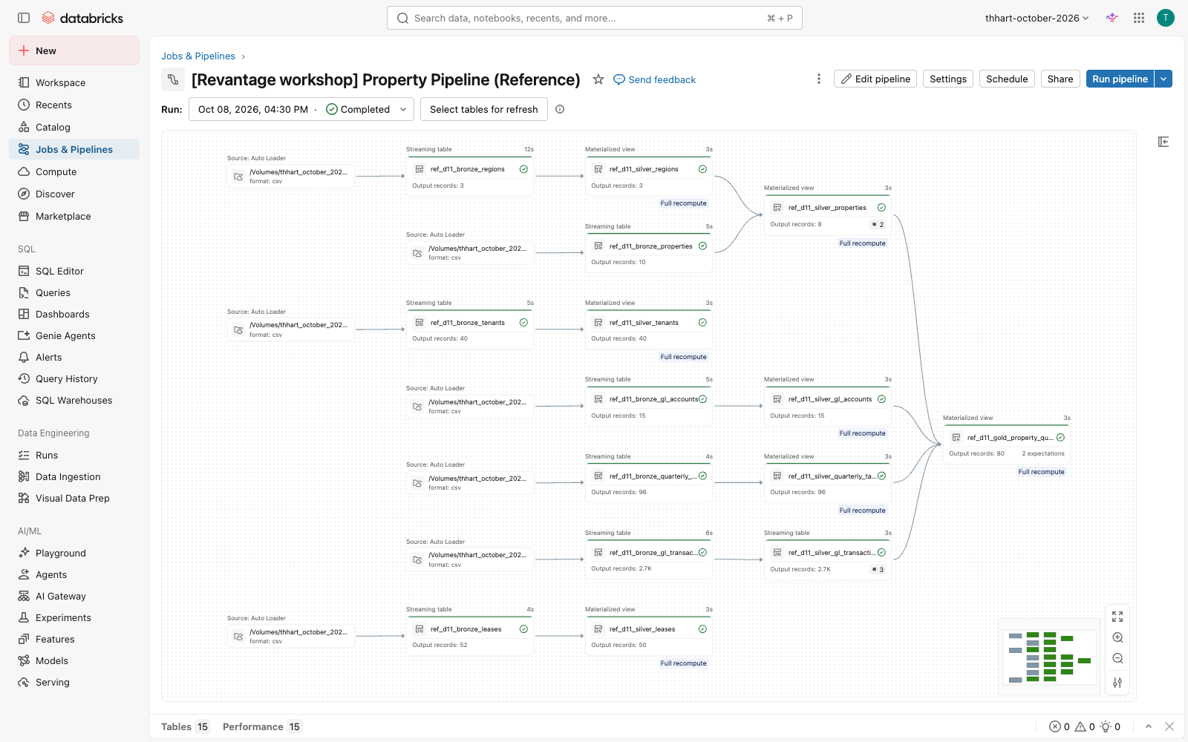
The reference pipeline graph: 7 Auto Loader sources → bronze → silver → gold.
The reference pipeline graph: 7 Auto Loader sources → bronze → silver → gold.

Stage 0: Show, don’t build (5 min)
- Lakeflow Connect: Data Ingestion → show the connector tiles (Salesforce, Workday, SQL Server, SharePoint…): authenticate once, pick objects, schedule. Revantage’s Yardi/SAP extracts land as files today, so we use Auto Loader.
- Lakeflow Designer / Visual Data Prep: left nav Visual Data Prep: drag-and-drop for analysts; it generates the same pipeline code.

Stage 1: Create the pipeline and ask for a design (8 min)
Create an ETL pipeline named property-pipeline-<your_name>, default catalog <catalog>, schema <my_schema>, SQL. Open Genie Code (Agent mode): > I have raw CSV files in /Volumes///raw/ for regions, properties, tenants, leases, gl_accounts, gl_transactions and quarterly_targets. Design a Bronze → Silver → Gold Lakeflow Declarative Pipeline in SQL. Bronze: Auto Loader streaming tables with read_files; more files will arrive for each entity, so match .csv (for example gl_transactions.csv), and read gl_transactions.amount as STRING. Silver: typed and cleaned, latest lease version per lease_id by updated_at, properties without a region removed, market names standardized (Miami Bch → Miami Beach, NYC → New York, Lux-Ville → Luxembourg City). Gold: a materialized view gold_property_quarterly with revenue, operating_expense, mgmt_fee, capex, intercompany by property and fiscal quarter, net_profit = revenue - operating_expense - mgmt_fee, joined to quarterly_targets, with met_target and qoq_change_pct. Dry-run it, run it, and check the gold output.
Expected: Genie Code proposes 3 files (bronze / silver / gold) with CREATE OR REFRESH STREAMING TABLE … FROM STREAM read_files(...) and CREATE OR REFRESH MATERIALIZED VIEW. Accept. Watch for (seen in pre-build): Genie Code samples each CSV, writes the files, dry-runs, fixes its own errors (it first pointed read_files at single files: “Input path … regions.csv is not a directory”), then runs. Without the <entity>*.csv sentence it used pathGlobFilter => 'gl_transactions.csv', which silently ignores the Stage 5 late batch, so nothing fails. Without the STRING sentence it infers amount as DOUBLE (see Stage 2). If stuck: copy the three files from code/pipelines/ref_property_pipeline/ and replace ${raw_path} with your raw path.

Stage 2: Bronze (5 min)
Checkpoint: every bronze table reads <entity>*.csv (either read_files('<raw path>/<entity>*.csv', …) or the raw folder plus pathGlobFilter => '<entity>*.csv', both work), and amount is STRING in DESCRIBE <my_schema>.bronze_gl_transactions. Teach: keep amount as STRING in bronze (schemaHints => '... amount STRING ...'). Stage 6 shows why.

Stage 3: Expectations (7 min)
Prompt: > Make sure amount is STRING in bronze and try_cast to DECIMAL(18,2) in silver. Add data quality expectations: on silver gl_transactions drop rows whose fiscal_period doesn’t match YYYY-Qn and fail the update if amount is NULL after casting; on silver properties drop rows without a region; on gold expect revenue IS NOT NULL and fiscal_quarter in YYYY-Qn format. Run the pipeline with a full refresh and report the expectation metrics.
Expected:
CONSTRAINT valid_fiscal_period EXPECT (fiscal_period RLIKE '^[0-9]{4}-Q[1-4]$') ON VIOLATION DROP ROW,
CONSTRAINT amount_parsed EXPECT (amount IS NOT NULL) ON VIOLATION FAIL UPDATE
(the agenda’s MATCHES isn’t SQL; RLIKE is), with try_cast(amount AS DECIMAL(18,2)) in silver. Note: if bronze amount changed from DOUBLE to STRING, a normal update fails with CANNOT_UPDATE_TABLE_SCHEMA; that’s why the prompt asks for a full refresh (Genie Code explains this itself).

Stage 4: Run and inspect (10 min)
Click Run pipeline. Open the graph: 7 bronze → silver → 1 gold. Expected (data quality tab): valid_fiscal_period 3 failed (a zero-sum manual accrual with period “2026Q2”); has_region 2 failed (Riverside Annex, the duplicate Harbor Tower); gold 80 rows. Checkpoint:
SELECT COUNT(*) FROM <my_schema>.gold_property_quarterly g
JOIN <catalog>.<schema>.gold_property_quarterly r USING (property_id, fiscal_quarter)
WHERE abs(g.net_profit - r.net_profit) > 0.01 -- expect 0

Stage 5: A late batch arrives (facilitator, 2 min)
Facilitator runs scripts/d11_bad_batch.sh inject <profile> <catalog> <schema>: it drops gl_transactions_late_batch_lux.csv (3 rows from SAP-LUX, amounts like "1.850,75") into the raw volume. Everyone clicks Run pipeline again.
Expected: the update fails: EXPECTATION_VIOLATION … Violated expectations: 'amount_parsed' … "amount":"1.850,75" … source_file …/gl_transactions_late_batch_lux.csv.

Stage 6: Diagnose and fix with Genie Code (10 min)
Prompt (Genie Code, on the failed update): > Why did this pipeline update fail? Show me the offending rows and propose a fix.
Expected: Genie Code points at amount_parsed and the European decimal format. A good fix in silver:
CASE WHEN amount RLIKE ',[0-9]{1,2}$' THEN CAST(replace(replace(amount, '.', ''), ',', '.') AS DECIMAL(18,2))
ELSE try_cast(amount AS DECIMAL(18,2)) END AS amount
(verified: 1.850,75 → 1850.75, 980,40 → 980.40, 258689.5 unchanged). The lesson: during pre-build we first read amount as DECIMAL in bronze. The CSV reader silently turned "980,40" into 98,040.00 and "1.850,75" into 1.85, with no error and no rescued data. The string-in-bronze + expectation pattern is what caught it.

Stage 7: Clean up (facilitator, 3 min)
scripts/d11_bad_batch.sh remove …, then Full refresh all (streaming tables keep already-ingested rows until a full refresh). Note: production-mode pipelines retry failed updates automatically, so expect several failed retries in the history until the fix or removal lands.

Wrap-up
- So what: a governed bronze-silver-gold pipeline from a paragraph of requirements, with quality rules that stop bad money from reaching the board pack.
- Snowflake equivalent: Snowpipe + Streams + Tasks + dynamic tables, stitched together. Lakeflow is one declarative pipeline with lineage, expectations, retries, and monitoring built in.
- Verified: 2026-10-08 on the FEVM workspace: reference pipeline gold = oracle (80 rows, all numeric columns exact, code/tests/check_ref_pipeline.py); expectation metrics as above; inject → FAILED with the message shown → remove → full refresh → COMPLETED and oracle match again. Stages 1, 3, 5 run with Genie Code in the pipeline editor (S9) on a scratch pipeline with s9_ table names: S1 Genie Code sampled all 7 CSVs, wrote bronze/silver/gold, self-fixed a dry-run error and ran it; its gold matched the oracle on all 80 rows (net_profit, revenue, met_target, qoq_change_pct; plus the 2026Q2 junk row before Stage 3); S3 metrics exactly valid_fiscal_period 2,693/3, amount_not_null 0 failed, has_region 8/2, gold 80; S5 (after the glob fix now in the S1 prompt) update FAILED with EXPECTATION_VIOLATION … 'amount_not_null' … "amount":"1.850,75" … SAP-LUX. S6 Genie Code read the failed update’s events, named amount_not_null, listed all 3 SAP-LUX rows with raw and expected values (1.850,75 → 1850.75; 2.410,00 → 2410.00; 980,40 → 980.40) and proposed CASE WHEN amount LIKE '%,%' THEN replace(replace(amount,'.',''),',','.') …; on “apply the fix and run” it dry-ran, ran, and the 3 rows landed correctly in silver. Scratch pipeline and s9_* tables deleted afterwards.
## Demo 12: Lakebase & Production Operations — “Approval workflow state machine”
Session: Day 2, 10:45–11:30 (45 min) · You build: an approval table in Lakebase, approvals through an app, and a job that loads only approved invoices to Delta · Reference: Lakebase instance revantage-lux-ops (db revantage_ops, schema approvals), app revantage-invoice-approvals, job “[Revantage workshop] Approved invoices -> silver (Reference)”, Delta silver_invoices, synced table ref_d12_gold_property_quarterly_synced Starting state: 5 Pending invoices in approvals.invoice_approvals (from Demo 4’s extraction; HV-2026-0417 €312,391 and TM-POL-2026-3391 €64,730 need two approvers); silver_invoices empty Where: Compute → Lakebase Postgres; SQL editor connected to Lakebase; the Invoice Approvals app; Jobs & Pipelines
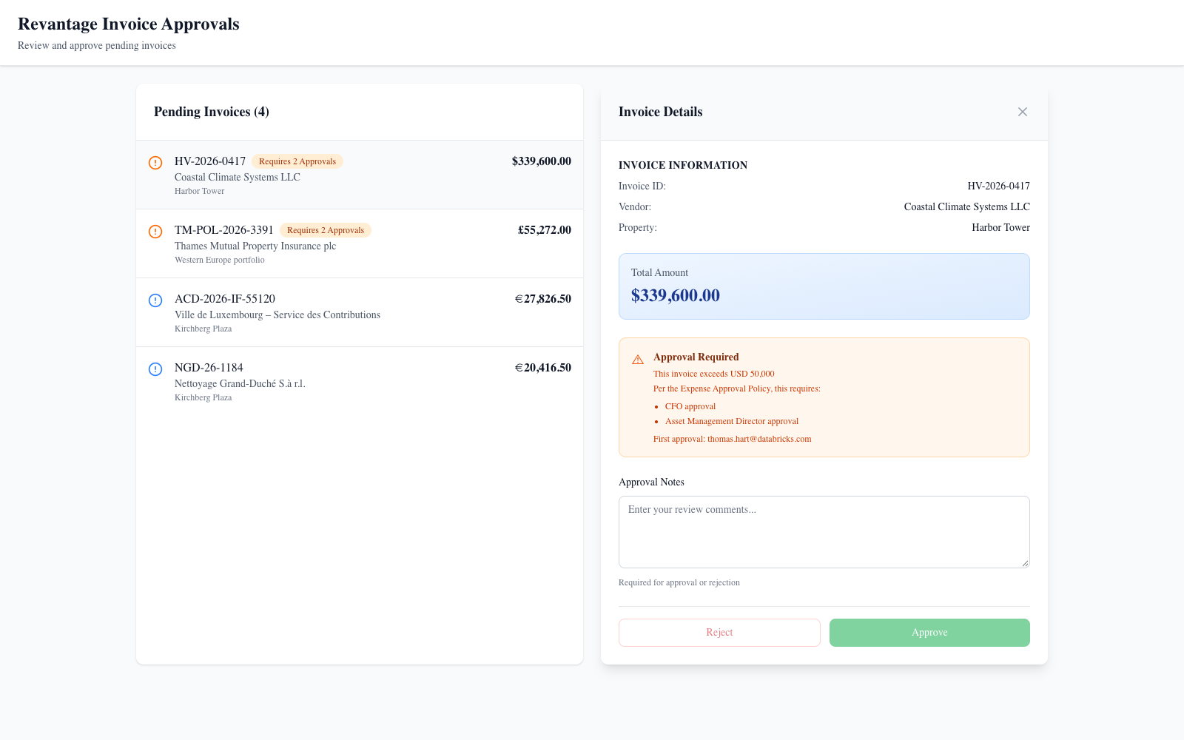
Invoice approvals on Lakebase: the €312k chiller waits for a second approver.
Invoice approvals on Lakebase: the €312k chiller waits for a second approver.

Stage 1: Why Lakebase (5 min, talk)
A dashboard can show invoices; it can’t hold who approved what, when, enforce two signatures, or stop unapproved rows reaching the GL. That’s transactional state: row-level updates, constraints, millisecond reads. Lakebase is managed Postgres next to the lakehouse; analytical data stays in Delta.

Stage 2: Create the database objects (10 min)
Open SQL Editor → Create new → Query, then the compute picker → More… → Lakebase Postgres → Provisioned → revantage-lux-ops → Attach, and pick the database revantage_ops in the database dropdown (the instance page itself only offers psql connection details). Or your own instance: Create database instance, CU_1; ~5 min to provision. Watch for (seen in pre-build): the database dropdown sometimes stays empty and the tab stays on databricks_postgres. Reload the tab, or ask everyone to use their own schema name (approvals_<your_name>) in whichever database is attached. Prompt (Genie Code / Lakebase SQL editor): > Create a Postgres schema approvals with a table invoice_approvals (invoice_id primary key, vendor_name, property_name, total_amount, currency, total_eur, status Pending/Approved/Rejected with a check constraint, first_approver, first_approved_at, reviewed_by, reviewed_at, notes, and a generated column requires_two_approvers = total_eur > 50000) and an audit table approval_events. The final approver must differ from the first approver.
Expected: DDL like code/lakebase/d12_invoice_approvals.sql (generated column + CHECK constraint). Checkpoint: insert the 5 invoices (code/lakebase/d12_reset.sql), then SELECT invoice_id, total_eur, requires_two_approvers FROM approvals.invoice_approvals ORDER BY total_eur DESC → HV-2026-0417 and TM-POL-2026-3391 are true.

Stage 3: Approve in the app (10 min)
Open Invoice Approvals (the reference app). Everyone signs in with their own identity. - Approve PE-2026-06-0088 (€37.7k) with a note → Invoice approved. - Approve HV-2026-0417 (€312k) → First approval recorded. Awaiting a second approver. The panel shows “First approval: ”. - Try to approve HV-2026-0417 again yourself → “The second approval must come from a different person (Expense Approval Policy).” - A second participant approves HV-2026-0417 → Approved. Checkpoint (Lakebase SQL): SELECT * FROM approvals.approval_events ORDER BY at shows every action with the actor. How it’s wired: the app has a database resource (Lakebase) that injects PGHOST/PGUSER/PGDATABASE; its service principal logs in with an OAuth token; code/app-approvals/src/lib/lakebase.ts does each decision in a transaction with SELECT … FOR UPDATE.

Stage 4: Only approved invoices reach the lakehouse (10 min)
Run the job Approved invoices -> silver (Reference) (Jobs & Pipelines → Run now). Expected: approved invoices in Lakebase: N; SELECT * FROM <catalog>.<schema>.silver_invoices holds exactly the Approved ones. An invoice with only one signature isn’t there. Show on the job: retries (2, 60 s apart), failure email, run history, and the trigger (periodic 15 min, paused for the workshop). Prompt (Genie Code, on the job’s Python file): > Explain how this job reads from Lakebase and why the MERGE makes re-runs safe.
Talk track on triggers: table-update (“data-readiness”) triggers fire on Unity Catalog Delta tables, not on Postgres tables, so this job runs on a schedule or on demand. To trigger downstream work on approval, have the next job use a table-update trigger on silver_invoices.

Stage 5: Reverse ETL (5 min)
Catalog → ref_d12_gold_property_quarterly_synced: a synced table copying certified gold into Postgres (snapshot mode). Checkpoint: in Lakebase SQL, SELECT count(*), sum(net_profit) FROM revantage_20261008.ref_d12_gold_property_quarterly_synced → 80 rows, 64,214,088.70, identical to gold. Apps read it in milliseconds without hitting a warehouse.

Stage 6: Production health (5 min, show)
Pipeline and job health in one place: Jobs & Pipelines → runs, durations, failures; Demo 11’s expectation metrics; Demo 16’s data quality monitors and freshness.

7. Reset (facilitator)
uv run --with "psycopg[binary]" code/lakebase/lakebase_sql.py --profile <p> --instance revantage-lux-ops --db revantage_ops -f code/lakebase/d12_reset.sql and TRUNCATE TABLE <catalog>.<schema>.silver_invoices.

Wrap-up
- So what: the approval workflow from Demo 4’s extraction to the GL has state, a two-signature rule, an audit trail, and a hard gate, all next to the governed lakehouse.
- Snowflake equivalent: Hybrid Tables / Unistore for operational rows. Lakebase is full Postgres (extensions, drivers, apps) with synced tables from Delta and branching.
- Verified: 2026-10-08 on the FEVM workspace. Local Playwright 5/5 against Lakebase (queue order, single approval, reject, two-approver rule, same-person 409). Deployed app in the browser: first approval recorded, same-person second approval rejected with 409, single approval OK. Job run SUCCESS: only the Approved invoice landed in silver_invoices. Synced table online, 80 rows, sums match gold. State reset afterwards. Stages 2 and 4 run in the Genie Code UI (S9): S2 in the SQL editor attached to Lakebase Postgres (scratch schema approvals_s9, since dropped): status CHECK, reviewed_by <> first_approver CHECK, GENERATED ALWAYS AS (total_eur > 50000) STORED, audit table with FK; test rows 37,700 → false, 312,390.76 → true. S4 on the job file: correctly explained the REST-minted short-lived credential, the status = 'Approved' read, and MERGE on invoice_id as idempotent.
## Demo 13: AI Gateway & Monitoring — “Who’s using what, and what’s it costing us?”
Session: Day 2, 11:30–12:15 (45 min) · You build: a usage + cost query pack and a SQL alert · Reference: code/reference/d13_ai_gateway_queries.sql, alert “[Revantage workshop] Daily AI tokens > 1M (Reference)” Starting state: AI Gateway usage tracking (+ inference table ref_d13_payload) on databricks-claude-sonnet-4-6; read access to system.ai_gateway, system.serving, system.billing (admin grant, check in pre-flight) Where: Serving → endpoint → AI Gateway; SQL editor with Genie Code; Alerts
Important: system tables cover the whole account/metastore. Every query filters on your workspace ID (:workspace_id, the number after ?o= in your browser URL). There’s no current_workspace_id() function. Usage rows arrive with a delay of up to a few hours.
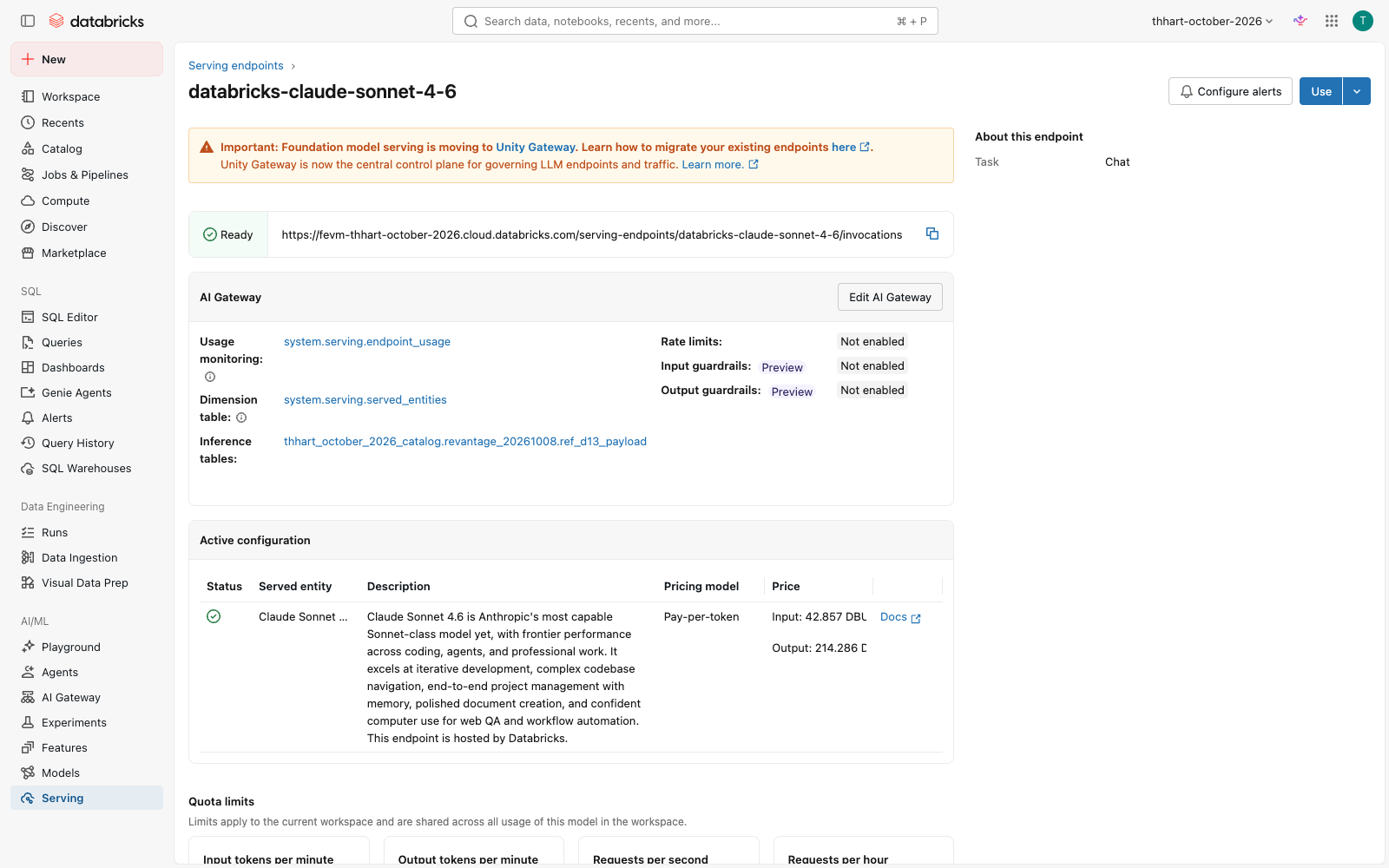
AI Gateway on the Claude endpoint: usage tracking and the inference table.
AI Gateway on the Claude endpoint: usage tracking and the inference table.

Stage 1: Models without deploying (5 min)
Serving → show the pay-per-token endpoints already there (Claude, GPT, Llama, Qwen…). Open databricks-claude-sonnet-4-6 → AI Gateway: usage tracking, inference table, rate limits, guardrails, fallbacks. Then call it from SQL:
SELECT ai_query('databricks-claude-sonnet-4-6', 'In one sentence: why did Harbor Tower miss its Q2 target?')

Stage 2: Tokens by endpoint (7 min)
Prompt (Genie Code, SQL editor): > Using system.ai_gateway.usage, show total requests, total tokens and average latency by endpoint (or service_name when endpoint_name is null) for workspace :workspace_id over the last 30 days.
Expected: like Q1 in the reference file. On the FEVM: system.ai.gpt-5-6-sol ~1.58M tokens (46 requests), plus ~135–145 calls each to MCP services (Gmail, Slack, Google Drive, Atlassian, Microsoft 365, GitHub). Those are Genie One connectors, governed through the same gateway.
Then (pay-per-token models such as the one ai_query calls): > Show total requests, total tokens and errors (status_code >= 400) by endpoint for Foundation Model endpoints in workspace :workspace_id over the last 30 days using system.serving.endpoint_usage joined to system.serving.served_entities on served_entity_id.
Expected: like Q6: databricks-claude-sonnet-4-6 with the workshop’s ai_query traffic. Run in the Genie Code UI 2026-10-09: 4 FM endpoints; sonnet-4-6 37 requests, 10,387 tokens, the 3 deliberate errors.

Stage 3: Who, and what fails (8 min)
Show the top 5 users by tokens with their email masked like t***@domain, then the error rate (status_code >= 400) by endpoint.
Expected: masked requesters; error rate per endpoint (FEVM: gpt-5-6-sol 2.2%). Point out routing_information (fallback attempts) and mcp_metadata (which tool was called).

Stage 4: What it costs (10 min)
Estimate list-price cost by product and endpoint for the last 30 days by joining system.billing.usage to system.billing.list_prices on sku_name, cloud, usage_unit and the price validity window, for billing_origin_product in MODEL_SERVING, AI_GATEWAY, AI_FUNCTIONS, AGENT_BRICKS, VECTOR_SEARCH.
Expected: Q4 in the reference file. On the FEVM the biggest AI line was VECTOR_SEARCH for a Knowledge Assistant’s index (~200 DBU, ~$14 of ~$19 in 30 days), more than all LLM calls. Lesson: KA indexes cost money while idle; delete the ones you don’t use.

Stage 5: Alert before the bill does (10 min)
Write a query returning today’s total tokens for workspace :workspace_id from system.ai_gateway.usage as a single column tokens_today.
Alerts → Create alert on that query: condition tokens_today > 1000000, schedule hourly, notify yourself (email). Checkpoint: open the reference alert “Daily AI tokens > 1M (Reference)”; it evaluates OK today. Q5 shows 2026-10-05 at 1.47M tokens, a day it would have fired.

Stage 6: Governance tie-in (5 min, talk)
Usage and inference tables are Unity Catalog tables: grant, lineage, and retention like any data. Guardrails (PII, safety) and rate limits per user/group live on the gateway. The same view covers Genie, agents, Genie Code sessions, and MCP connectors.

Wrap-up
- So what: one place to see every AI call, by person, model, and cost, with an alert before budget surprises.
- Snowflake equivalent: Cortex usage views (ACCOUNT_USAGE). The AI Gateway adds runtime controls (rate limits, guardrails, fallbacks, inference logging) across external and hosted models and MCP.
- Verified: 2026-10-08 on the FEVM workspace: all 5 reference queries run with real results (above); the alert deployed and ACTIVE, query returns tokens_today. 40 ai_query rows + 3 deliberate 400 errors were sent to sonnet-4-6 at 21:18 UTC; they landed in system.serving.endpoint_usage (14 batched requests, 1,110 tokens, 3 errors; reference Q6), and never in system.ai_gateway.usage, which covers the system.ai.* gateway (Genie One, MCP). The endpoint page also shows a banner that Foundation Model serving is moving to Unity Gateway: re-check which table the Revantage workspace uses in pre-flight. Stages 2–5 run in the Genie Code UI (S9): S2 8 rows identical to reference Q1 (7 MCP services + gpt-5-6-sol 1,577,845 tokens); S3 one masked user t***@databricks.com, gpt-5-6-sol error rate 2.17%, all MCP 0%; S4 Genie Code read both billing schemas and wrote the validity-window join: 19 rows, ~$19 total, VECTOR_SEARCH ka-…-vs-endpoint $14.02 the top line; S5 tokens_today = 0 (single column, ready for the alert).
## Demo 14: Time Series Forecasting — “Where is revenue heading?”
Session: Day 2, 12:15–12:30 (15 min) · You build: a revenue forecast for 2026-Q3/Q4 vs target · Reference: <catalog>.<schema>.ref_d14_revenue_forecast (code/reference/d14_forecast.sql), dashboard page “Forecast” Starting state: gold_property_quarterly (10 quarters per property, 2024-Q1..2026-Q2, fiscal_quarter_date = quarter start), silver_quarterly_targets (includes 2026-Q3/Q4 targets) Where: SQL editor (a SQL warehouse: ai_forecast is disabled on serverless job compute)
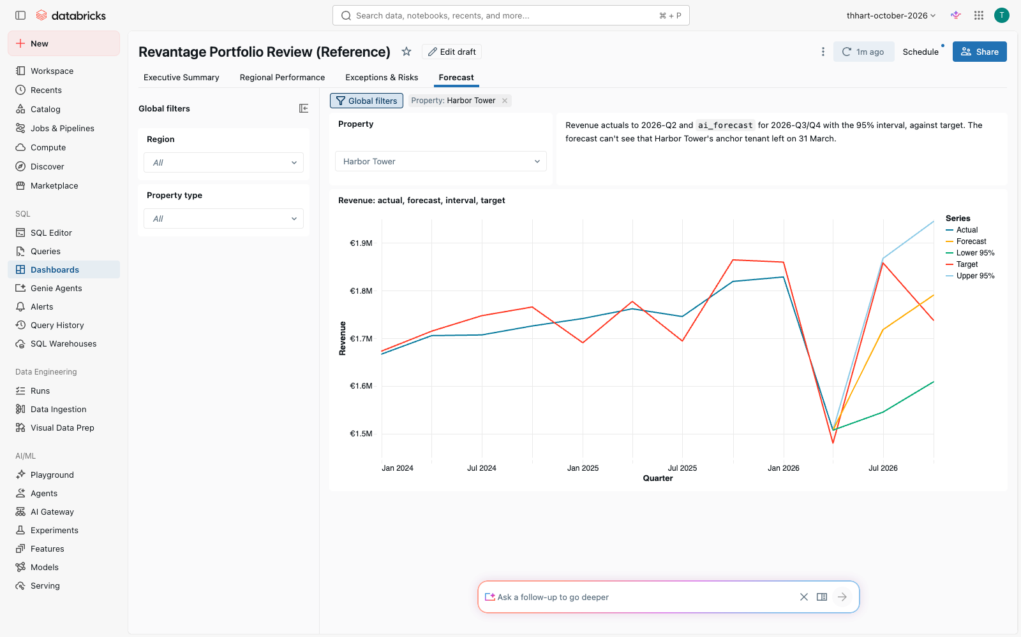
Forecast page: actuals, ai_forecast with its interval, and the target.
Forecast page: actuals, ai_forecast with its interval, and the target.

Stage 1: One property (4 min)
Prompt (Genie Code): > Forecast Harbor Tower’s (property_id 3) quarterly revenue through 2026-12-31 with ai_forecast from ..gold_property_quarterly.
Expected SQL (the agenda’s horizon => 2 form doesn’t run; frequency => 'Q' fails on DATE columns, 'QS' works):
SELECT * FROM AI_FORECAST(
TABLE(SELECT fiscal_quarter_date, revenue FROM <catalog>.<schema>.gold_property_quarterly WHERE property_id = 3),
horizon => '2026-12-31', time_col => 'fiscal_quarter_date', value_col => 'revenue', frequency => 'QS')
Expected: 2026-07-01 ≈ €1.71–1.72M (95% interval ≈ 1.54–1.89M), 2026-10-01 ≈ €1.78–1.79M (values vary slightly run to run). Watch for (seen in pre-build): Genie Code may probe ai_forecast on its own serverless compute, get AI_FUNCTION_PREVIEW, and tell you the function is disabled and an admin must enable a preview. That’s misleading: click Run in the SQL editor (SQL warehouse) and the query it wrote works.

Stage 2: Every property at once (3 min)
Do the same for all properties at once using group_col.
Expected: 16 rows (8 properties × 2 quarters), columns property_id, fiscal_quarter_date, revenue_forecast, revenue_upper, revenue_lower.

Stage 3: Who will miss budget? (4 min)
Join the forecast to silver_quarterly_targets (fiscal_quarter = year-Qn of fiscal_quarter_date) and list properties whose 2026-Q3 forecast is below revenue_target.
Expected: exactly Harbor Tower (€1.72M vs €1.86M target) and Zuidas Residences (€1.32M vs €1.43M).

Stage 4: Know the limits (4 min, talk)
Harbor Tower’s actual Q2 revenue was €1.51M after the anchor tenant left on 31 March, yet the forecast says €1.72M for Q3. ai_forecast sees only the revenue history, not the lease roll. When the drivers are known (lease expiries, vacancy), use Prophet with regressors or a lease-roll model in a notebook (MLflow-tracked); ARIMA for smooth series; GARCH/AR when the volatility itself matters (rates, FX), not for rent. So what for FP&A: ai_forecast is a fast, governed first pass across hundreds of properties in one SQL statement; spend data-science time on the exceptions it flags. Show the dashboard’s Forecast page (Demo 8 reference): actual, forecast, 95% interval, target.

Wrap-up
- Snowflake equivalent: SNOWFLAKE.ML.FORECAST (create a model object, then call it). ai_forecast is a single table-valued function call, no model object to manage.
- Verified: 2026-10-08 on the FEVM warehouse: single-property numbers above; grouped forecast + target join returns exactly Harbor Tower and Zuidas for 2026-Q3; ref_d14_revenue_forecast = 80 actual + 16 forecast rows; dashboard page checked in the browser. Stage 1 run in the Genie Code UI (S9): correct query (QS, fiscal_quarter_date, through 2026-12-31) returning €1,709,781 for 2026-Q3 on the warehouse, after the misleading ‘disabled’ probe noted above. Stages 2–3 (one combined prompt, S9): Genie Code probed V2 and V1 (both ‘disabled’ again), wrote the grouped forecast + target join anyway, ran it on the warehouse and returned exactly Harbor Tower 1,709,780.95 vs 1,858,200 (−8.0%) and Zuidas 1,326,134.51 vs 1,425,400 (−7.0%).
## Demo 15: Hands-On Lab — Build Your Own
Session: Day 2, 1:30–2:30 (60 min) · Pick one track. Each starts from an asset you’ve already seen working, so you always have a fallback. Where: your sandbox schema <my_schema> (or <schema> with _<your_name> suffixes), Genie Code throughout

Track A — Analyst: a Genie Agent for your domain
- Genie → New → name <your domain> Q&A – <your_name>; add gold_property_quarterly, silver_leases, silver_tenants (and your own tables if you have dev access).
- Instructions: start from the Reference agent’s text (open Revantage Portfolio Q&A (Reference) → Configure → Instructions) and adapt the definitions to your domain: latest quarter, net profit definition, what “risk” means.
- Add 3 SQL examples for your hardest questions, synonyms on 3 columns, and join specs.
- Test 5 questions; for each wrong answer, fix the context (instruction, example, synonym), not the question. Benchmark (should pass after Stage 3): “Which leases expire in the next 90 days and what is the monthly rent at risk?” → 6 leases, €103k (as of 2026-10-08).
- Fallback: duplicate the Reference agent and edit it.

Track B — Dashboard builder: your portfolio company’s page
- New dashboard; datasets on the metric views (ref_mv_* or your Demo 7 views) filtered to your region or property type.
- Prompt (Genie Code in the dashboard editor): > Build a page for with net profit margin and target attainment counters for 2026-Q2, a net profit trend by property, and a table of leases expiring in 180 days from silver_leases.
- Add the dashboard’s Ask Genie; publish; share with a colleague.
- Fallback: clone “Revantage Portfolio Review (Reference)” and filter it.

Track C — Data engineer: a new source, end to end
- Pick a source: a CSV you bring, or the documents/invoices extraction from Demo 4 (ai_extract in a pipeline).
- Prompt (Genie Code, pipeline editor, Agent mode): > Create a pipeline that ingests with Auto Loader into bronze, cleans it into silver with an expectation that drops rows missing and fails the update when doesn’t parse, and builds a gold summary.
- Jobs & Pipelines → Create job: task 1 = your pipeline, task 2 = a SQL task that checks row counts; schedule daily 06:00; email on failure; 2 retries.
- Add a SQL alert on a gold metric (copy the pattern from “Daily AI tokens > 1M (Reference)”).
- Fallback: copy code/pipelines/ref_property_pipeline/ (Demo 11) and change the paths.

4. Closing the lab (5 min)
Each person shows one thing they built. Collect follow-ups for the 4:15 “Next steps” session.
- Verified: the starting assets for each track are verified (Demos 2, 7, 8, 9, 11, 13). The lab itself is open-ended; the Track A benchmark numbers come from the lease tracker app (Demo 9).
## Demo 16: Data Quality & Observability — “Trust scorecard”
Session: Day 2, 3:45–4:15 (30 min) · You build: quality monitoring on the gold table, a bad-load detector, and the blast radius · Reference: data profiling monitor on gold_property_quarterly (bundle target revantage), alert “[Revantage workshop] Revenue > 3 sigma from property mean (Reference)”, code/reference/d16_revenue_outliers.sql, d16_blast_radius.sql Starting state: clean gold_property_quarterly (80 rows, 2024-Q1..2026-Q2); seed/reset scripts code/sql/d16_seed_bad_row.sql / d16_reset.sql (${table} = gold_property_quarterly) Where: Catalog Explorer → table → Quality tab; SQL editor with Genie Code; Alerts

Stage 1: Turn on monitoring (5 min)
Catalog → gold_property_quarterly → Quality → Enable data profiling (Snapshot, slice by region_name), and at schema level anomaly detection (freshness, completeness). Expected: a profile dashboard and two output tables (…_profile_metrics, …_drift_metrics) after the first refresh (a few minutes). FEVM note: the FEVM metastore is at its 1,000-monitor limit, so we couldn’t create one here. In Revantage’s workspace the bundle target creates it; show the profile from the Oct 5 workshop’s monitor if needed.

Stage 2: Read the profile (5 min)
Profile dashboard: per-column null %, distinct counts, min/max/quantiles, per region slice. Freshness = last commit time. Prompt (Genie Code): > Using ..gold_property_quarterly_profile_metrics, show null rate and max for revenue and net_profit in the latest window.

Stage 3: A bad load arrives (facilitator, 2 min)
Run code/sql/d16_seed_bad_row.sql with ${table} = gold_property_quarterly: inserts Harbor Tower 2026-Q3 with revenue 10× its average (€17.2M) and NULL net_profit.

Stage 4: Detect it (8 min)
- Completeness: SELECT COUNT(*) FROM <catalog>.<schema>.gold_property_quarterly WHERE net_profit IS NULL → 1. Refresh the monitor: net_profit null % > 0, revenue max jumps, drift on revenue flagged.
- Outlier rule: run code/reference/d16_revenue_outliers.sql. Expected: exactly one row: Harbor Tower 2026-Q3, z ≈ 172 vs its other quarters (mean €1.72M). Teach: a plain “> 3σ” rule on smooth financial series also flags real business moves. Before the seed it flagged Harbor Tower’s vacancy and a new Kirchberg suite. The rule therefore uses leave-one-out σ and a > 50% materiality guard: 0 rows on clean data, 1 after the seed. Prompt (Genie Code): > Write a query on ..gold_property_quarterly that flags property-quarters whose revenue is more than 3 standard deviations from the mean of that property’s OTHER quarters (leave-one-out: exclude the quarter being tested from the mean and standard deviation) and more than 50% away from that mean. Run it.
Expected: 0 rows before the seed (Genie Code also shows that Harbor Tower 2026-Q2 at z 4.5 and Kirchberg 2026-Q2 at z 3.9 pass 3σ but fail the 50% guard: real business moves); after the seed exactly Harbor Tower 2026-Q3, z ≈ 172. Watch for (seen in pre-build): without the explicit leave-one-out sentence Genie Code computed mean and σ over all quarters including the one tested. With 11 quarters a single spike can then never exceed z ≈ 3.02, however large: the 10× seed scored 3.01 and only just passed. Good teaching moment: ask “does the σ include the quarter being tested?”

Stage 5: Blast radius (5 min)
Catalog Explorer → Lineage on the table, or run code/reference/d16_blast_radius.sql. Expected downstream: ref_mv_net_profit_margin, ref_mv_target_attainment, ref_mv_qoq_revenue_growth, the Portfolio Review dashboard (DASHBOARD_V3), ref_d14_revenue_forecast, ref_d03_property_performance_v, ref_d06_property_quality_checks, customer_performance, and the Genie Agents that read them. One bad row reaches every board number.

Stage 6: Alert (5 min)
Open the reference alert (daily 07:00 Luxembourg, notifies the owner): it counts outliers and fires when > 0. Create your own from the Stage 4 query, wrapped as SELECT COUNT(*) AS outliers FROM (…).

7. Reset (facilitator, immediately after)
Run code/sql/d16_reset.sql (deletes the 2026-Q3 row). Re-check: outlier query → 0 rows, NULL count → 0.

Wrap-up
- So what: quality issues are caught by the platform (profiling, expectations, alerts) before a business user finds them, and lineage shows exactly what they would have broken.
- Snowflake equivalent: Data Metric Functions + ACCESS_HISTORY. Here profiling, anomaly detection, pipeline expectations, alerts, and lineage come together in Unity Catalog.
- Verified: 2026-10-08 on the FEVM workspace, rehearsed on a deep clone (ref_d16_gold_sandbox, since dropped): seed inserted €17.2M / NULL; outlier query 0 rows on clean gold, 1 row (z 171.9) after the seed; the reference alert is deployed. Lineage query returns the downstream list above. Stage 4 run in the Genie Code UI (S9): the original prompt produced inclusive stats (seed z 3.01, fragile); the leave-one-out prompt above gave 0 rows on clean gold and, on a seeded clone (s9_d16_gold_clone, since dropped), exactly Harbor Tower 2026-Q3 z 171.89. Not verified on the FEVM: creating the profiling monitor (metastore limit) and therefore Stage 2’s prompt, which needs the _profile_metrics table; run it in the Revantage workspace pre-flight.

