机制：潜伏期1-8天，发病后1-2天学生会被送去医院离开学校，发病期散布病毒的概率是潜伏期的5倍，戴上口罩后感染者散布病毒的速度*0.2,健康者染病概率*0.6

绿色小点表示健康，xx表示潜伏，xx表示发病，紫色区域表示病毒浓度（颜色越深表示浓度越高）

**未戴口罩：**

**1.表格：**

|  |  |  |  |  |
| --- | --- | --- | --- | --- |
| 天数 | 潜伏期人数 | 发病期人数 | 在校总人数 | 未感染人数 |
| 1 | 1 | 0 | 1000 | 999 |
| 2 | 3 | 0 | 1000 | 997 |
| 3 | 5 | 0 | 1000 | 995 |
| 4 | 8 | 0 | 1000 | 992 |
| 5 | 15 | 1 | 1000 | 984 |
| 6 | 23 | 2 | 1000 | 975 |
| 7 | 57 | 11 | 999 | 931 |
| 8 | 158 | 9 | 992 | 825 |
| 9 | 317 | 15 | 987 | 655 |
| 10 | 510 | 45 | 980 | 425 |
| 11 | 643 | 86 | 952 | 223 |
| 12 | 691 | 130 | 904 | 83 |
| 13 | 619 | 172 | 822 | 31 |
| 14 | 514 | 196 | 718 | 8 |
| 15 | 380 | 204 | 586 | 2 |
| 16 | 257 | 193 | 452 | 2 |
| 17 | 159 | 158 | 318 | 1 |
| 18 | 79 | 128 | 208 | 1 |
| 19 | 32 | 88 | 121 | 1 |
| 20 | 6 | 44 | 51 | 1 |
| 21 | 2 | 19 | 22 | 1 |
| 22 | 1 | 3 | 5 | 1 |
| 23 | 0 | 1 | 2 | 1 |
| 24 | 0 | 0 | 1 | 1 |
| 25 | 0 | 0 | 1 | 1 |
| 26 | 0 | 0 | 1 | 1 |
| 27 | 0 | 0 | 1 | 1 |
| 28 | 0 | 0 | 1 | 1 |
| 29 | 0 | 0 | 1 | 1 |
| 30 | 0 | 0 | 1 | 1 |

**2.折线图：**

**3.部分实验截图**

第22天02：30，潜伏期人数清零

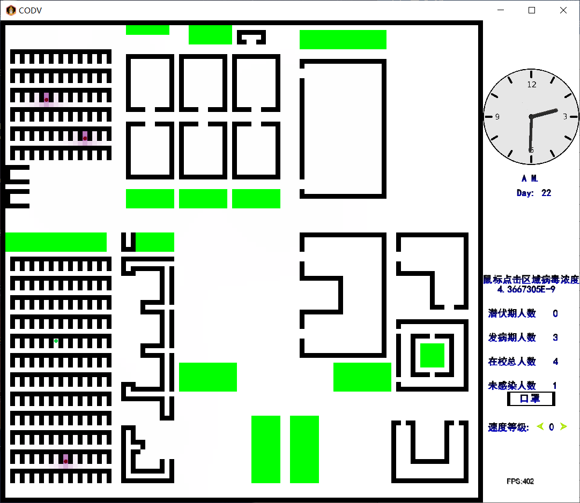

第23天11：17，所有发病患者均送往医院，学校剩余1人健康

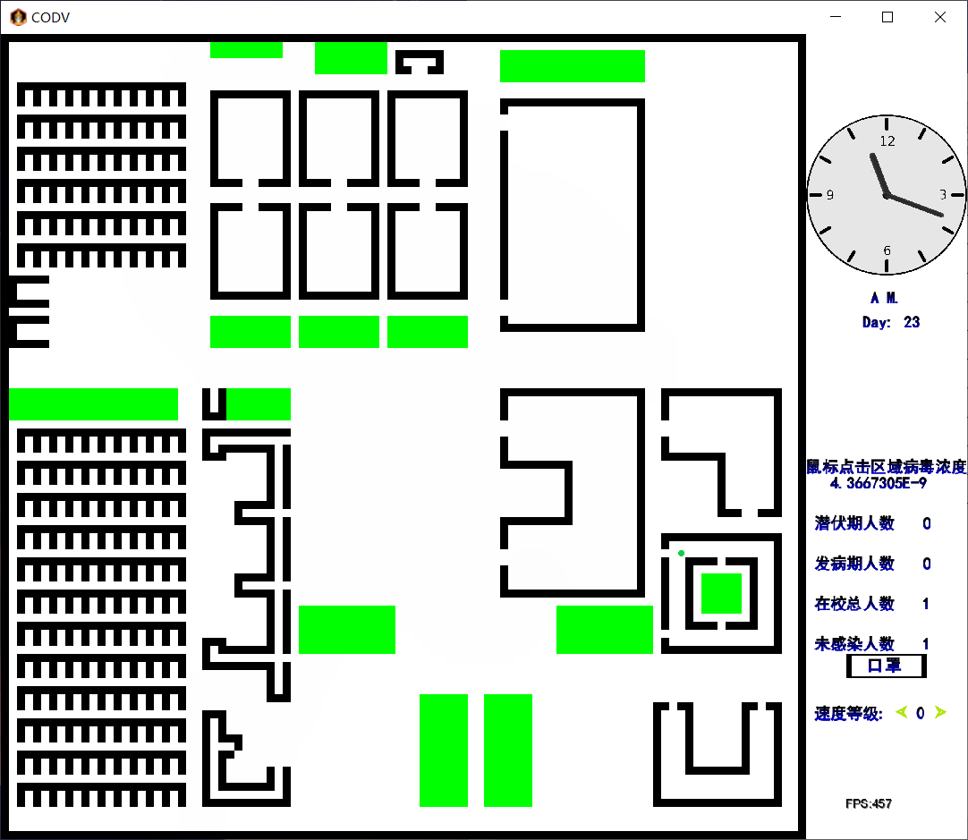

2.

戴口罩：

1.

|  |  |  |  |  |
| --- | --- | --- | --- | --- |
| 天数 | 潜伏期人数 | 发病期人数 | 在校总人数 | 未感染人数 |
| 1 |  |  |  |  |
| 2 |  |  |  |  |
| 3 |  |  |  |  |
| 4 |  |  |  |  |
| 5 |  |  |  |  |
| 6 |  |  |  |  |
| 7 |  |  |  |  |
| 8 |  |  |  |  |
| 9 |  |  |  |  |
| 10 |  |  |  |  |
| 11 |  |  |  |  |
| 12 |  |  |  |  |
| 13 |  |  |  |  |
| 14 |  |  |  |  |
| 15 |  |  |  |  |
| 16 |  |  |  |  |
| 17 |  |  |  |  |
| 18 |  |  |  |  |
| 19 |  |  |  |  |
| 20 |  |  |  |  |
| 21 |  |  |  |  |
| 22 |  |  |  |  |
| 23 |  |  |  |  |
| 24 |  |  |  |  |
| 25 |  |  |  |  |
| 26 |  |  |  |  |
| 27 |  |  |  |  |
| 28 |  |  |  |  |
| 29 |  |  |  |  |
| 30 |  |  |  |  |

2.