BUS 548H

Major Assignment



2016 UNC Chapel Hill Compensation Report

●-●-●

By: Thi Duong

February 11, 2016

**Executive Summary:**

The Classification and Compensation group at the Office of Human Resources at University of Chapel Hill is responsible for maintaining fair and equitable classification and salary decisions for the University’s SPA workforce. The unit maintains the integrity of the State of North Carolina’s career banding program as well as the Department of Labor’s prescribed Fair Labor Standards Act regulations.

The provost of the University of North Carolina at Chapel Hill would like to know in details about the current state of compensation in the university as it relates to job categories (SPA, EPA, and non-permanent). His highest concerns are about potential gender discrimination and salary compression.

The data set is used in this study is completely raw data about employee compensation at the UNC at Chapel Hill. There are different categories that are mentioned. The two broad categories of permanent employees at the University are: Subject to State Personnel Act (SPA) and Exempt (EPA). And the other remaining category is non-permanent employees, people who do not fall into either SPA or EPA.

The purposes of this analytical study are to find out if there is any salary compression/ discrimination with respect to age, gender, years of services, status (permanent and non-permanent), job titles, positions, faculty ranks, and department; and how to improve the compensation system.

The scopes of this report are to:

* + - * 1. Examine the employees’ salaries data not only at the university level but also within the categories (EPA, SPA, and non-permanent).
        2. Analyzing the compensation distribution based on different factors and characteristics.
        3. Highlight any findings that could be of concern to the provost.
        4. Develop the best practice or the optimal model to make predictions about faculty salary
        5. Recommend new policy or strategies for the areas where the provost should focus his attention if his goal is to insure that compensation is fair and equitable across the university.

The methodology used to develop the statistic model is **multi linear regression** using general linear equation: Y=b0+∑(biXi)

1.

According to the statistical analysis, there are total of 12,287 employees, in which, 6,357 are SPA employees, 5,641 are EPA employees, and 289 are non-permanent employees.

2. State Salary Distribution for SPA employees

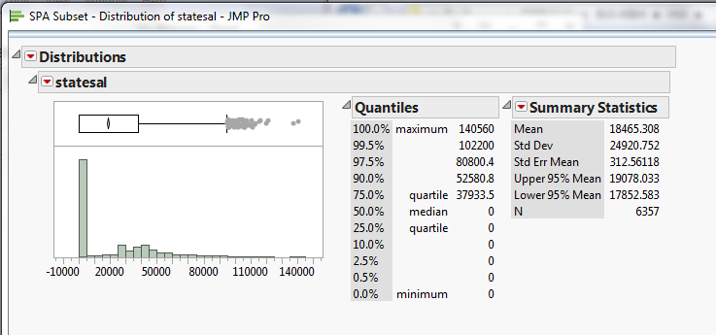

Since mean is not accurate to use for compensation analysis, especially when there is existence of outliers (mean is sensitive to outliers); instead, median is considered the best practice in compensation.

According to the results, the median of state salary is 0, which means there are at least 50% of employees do not have state salary (these people have non-state salary instead). Statistically, there are total of 2695 SPA employees receive state salary, and 3662 out of 6357 SPA employees who have non-state salary. The group of people who do not receive state salary has the average age of 44, and there are more females (102) than males (64)…The 75% quartile is 37934, which is considered very low compared to the maximum point.

The distribution also shows that there are numerous outliers who receive high salaries from state (min: 95,000 and max: 140,560); these people have the average age of 50.

3. Top 5 common job titles for SPA employees:

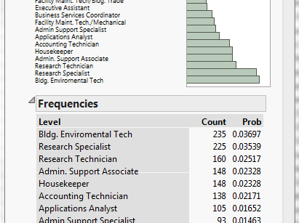

1st: Building Environmental Tech

2nd: Research Specialist

3rd: Research Technician

4th: Admin. Support Associate

5th: House Keeper

**Top 5 common SPA job titles salary distribution:**

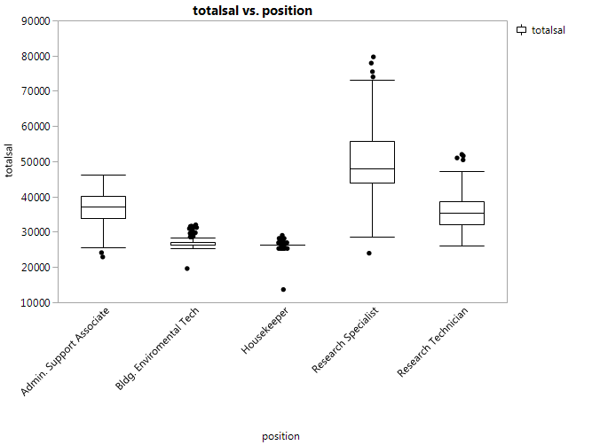

Job titles rank from the highest to the lowest Avg. total salary:

1. Research Specialist: $49,830
2. Admin. Support Associate: $36,747.8
3. Research Technician: $36,004
4. Bldg. Environmental Tech: $27,024
5. Housekeeper: $26259

4.

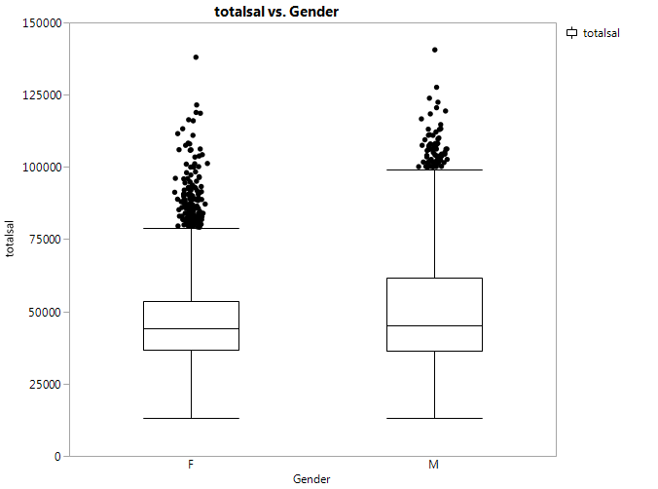

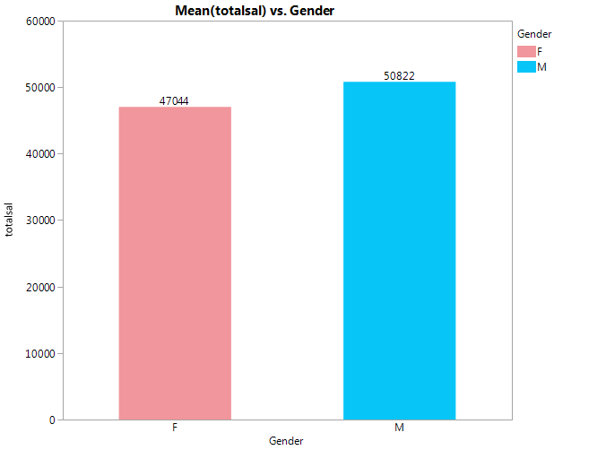

Above graphs show that there is a slight difference in salary distribution between males and females; The MALE boxplot range is a little bit higher than the FEMALE boxplot. The mean bar chart also show male has average salary slightly higher than females. However, the difference in compensation between these two gender groups is not much to be considered as discrimination.

According to the statistical results, male employees group has the Avg. total salary of $50,822 and median of $45,000 while female employees group has the avg. total salary of $47,044 and median of $44,000. Female employee group has more outliers than the male group which pushes the mean to be slightly higher. Considering the median, both these gender group have about the same salary distribution. Overall, there is no evidence of gender discrimination in the SPA subset.

5.

Positions are held by non-permanent employees:

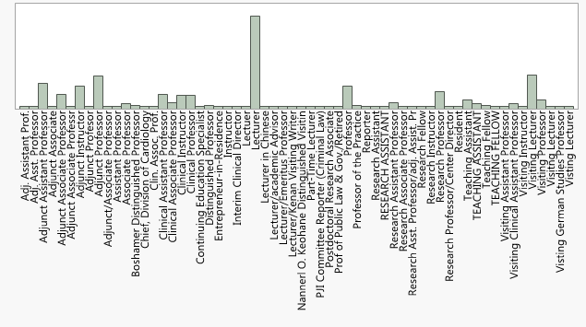

List of the most common positions in non-permanent subset:

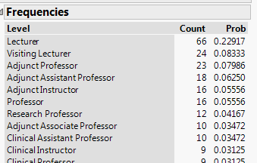

Data Analysis for “years of service”:

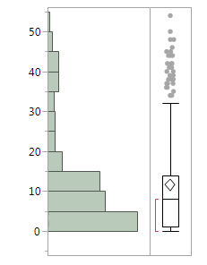

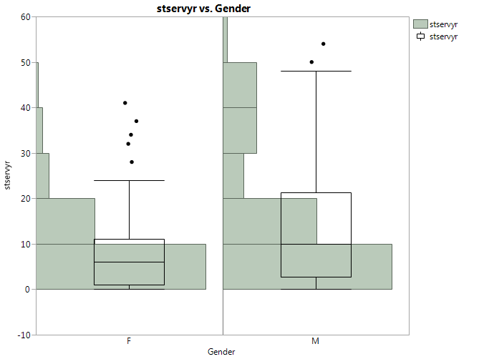

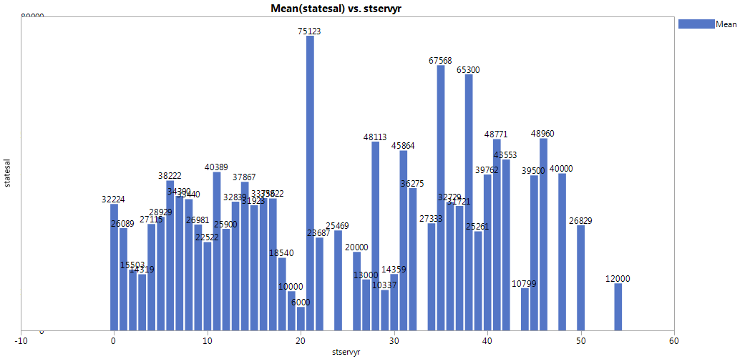

Descriptive statistics about “years of service” for these **non-permanent** employees revealed the following: (used the full version of data that was uploaded on Moodle lately)

1. Distribution of years of services by itself:

* At least 50% of these employees have less than 9 years of services
* The majority of employees have 0-5 years of services
* There are 34 outliers who have much longer years of services than the rest of the employees. Their years of services can run from 34 up to 54.

1. Statistical facts of impacts of “years of service” on other factors (such as **salary, gender, and position titles**)
   * Overall, compare to the Male group, Female group has shorter years of services.
   * Top 3 job titles that have the **longest years of services** (in order from highest to lowest) are:
     1. Lecturer/Emeritus Professor
     2. Adjunct/Associate Professor
     3. Distinguished Professor
   * Year of services vs. State Salary of non-permanent employees:
     1. **0 -20 years**: salary varies from $10,000 up to $40,000
     2. **20 years and up**: salary varies randomly. It can be very low, medium, or very high up. However, the possibility to have higher salary is higher than 0-20 years of services group.
     3. In general, years of services does not significantly affect employee’s state salary. In the other hand, salary is more likely affected by job titles and position ranks.

**Comparing compensation between Non-permanent and others:**

**Non-permanent State Salary Distribution:**

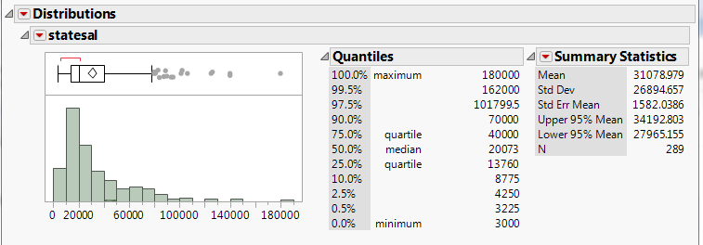

Non-permanent employees have the average salary of $31,079, which is already a low salary level. However, the graph shows there are many outliers that have high values; so the median is the best practice for analyzing data. The median in this case is $20,073, which is quite lower than EPA employees group but much higher than the SPA employees group. In fact, majority of non-permanent employees only make $15,000 to $25,000 in state salary

6.

Overall distribution of compensation (state salary) for EPA employees:

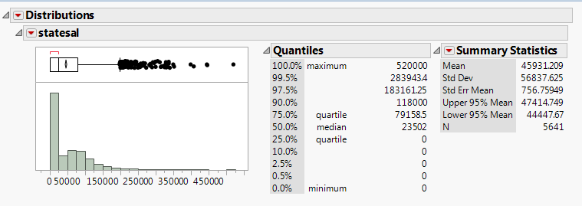

Majority of employees have less than $50,000. Specifically, the median is $23,502, which is very low compare to the maximum point of $520,000

There are many outliers that affects the mean salary since they are **significantly higher** than the majority. These outliers/employees are:

* + 1. Director
    2. Professor
    3. Distinguished professor

Comparing with:

**Overall distribution of state salary for SPA employees:**



The descriptive statistics above show that EPA’s compensation is obviously higher than SPA’s. The university should hire SPA over EPA if they wanted to cut down the expenses.

Below is the statistical summary comparing State Salary between EPA, SPA, and non-permanent employees:

|  |  |  |  |
| --- | --- | --- | --- |
|  | EPA | SPA | Non-permanent |
| Mean | 45931 | 18465 | 31079 |
| Median | 23502 | 0 | 20073 |
| Max | 520000 | 140560 | 180000 |
| Min | 0 | 0 | 3000 |

7.

Compensation Distribution for **EPA faculty members**:

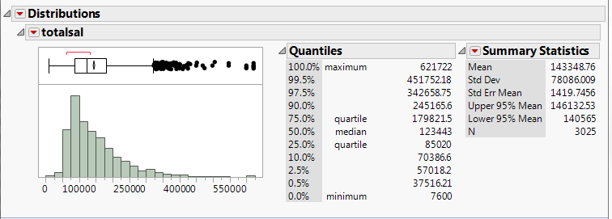

The majority of EPA faculty members make $80,000 to $160,000 per year (total salary), which is considered very high compare to other positions. In fact, faculty members’ salary compensation at university level is also very high. It can be concluded that faculty (professor) are highly paid. Besides, there are numerous of outliers who make even much higher than the rest of members in this particular group. These people are paid more than $320,000 per year.

8.

Faculty Distribution across faculty ranks (assistant, associate, full, and other)

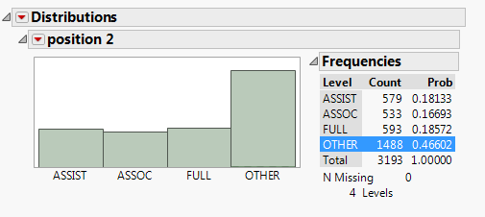

Distribution of faculty across the 3 main ranks assistant, associate, and full are **about the same** which is around 500-600 faculties. Other faculty members whose titles do not clearly fall into one of those ranks are grouped together in OTHER category; and this category have the most faculties compare with the 3 main ranks. The faculties in OTHER category are very diverse in position titles. They are mostly Clinical prof., Research prof., and Distinguished prof.

**Distribution of state salary compare across faculty ranks:**

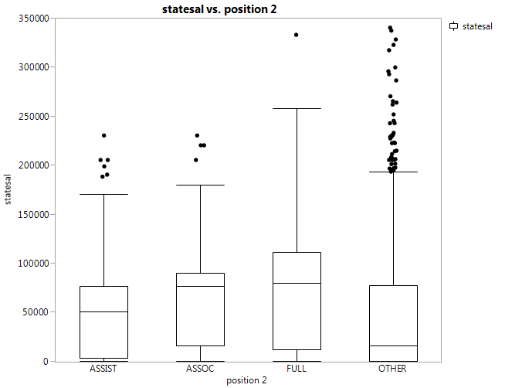

According to the box plot chart and the analyzed statistical summary from JMP, **state salary distribution of faculty members across the 4 ranks appear to be fair.** The order of the faculty ranks from the highest salary level to the lowest salary level is: FULL, ASSOC, ASSIST, and OTHER. Although there are difference in the distribution between these ranks, the difference is not significant between the main 3 ranks.

Full professor group has the highest average state salary ($71,392) as well as the highest median point ($79,435). The second highest group is associate professor with average state salary of $64,368 and median of $76,594. Assistant professor Group’s compensation distribution is just slightly lower than the Associate professor group with the mean of $50,708 and the median of $50,287. And lastly, the OTHER group has the lowest salary level overall with the mean of $45,356 and the median of $15,716; however, there are many outliers which are members that have much higher salaries compare to the rest of members in the same group.

9.

**Faculty Compensation Distribution vs. Gender:**

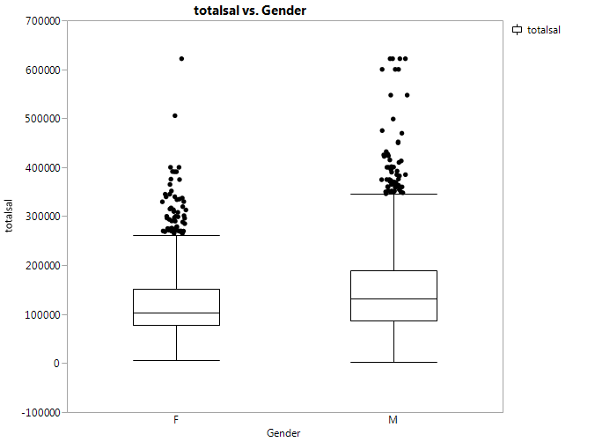

Male faculty members seem to have higher total salaries than female faculty members. The difference, however, is not significant to be concerned. Though, gender should always be the first factor to consider in respect of employments, benefits, compensation, and promotions.

**Faculty Compensation Distribution vs Gender, within ranks:**

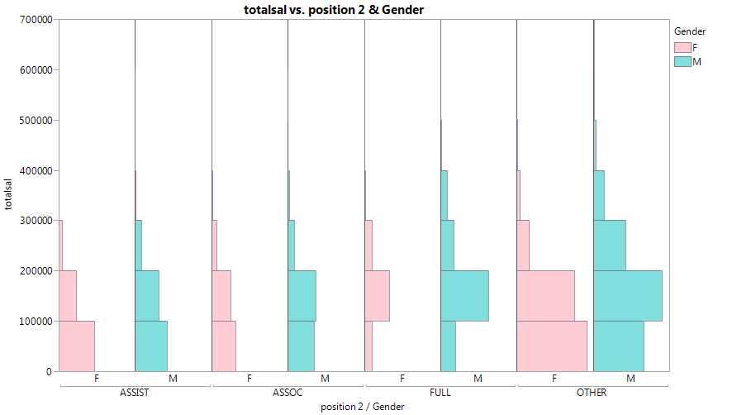

Considering salary distribution between based on gender within the 4 ranks: ASSIST, ASSOC, FULL, and OTHER, again, there are a light difference in salary distribution between male and female. According to the chart, male faculty members most likely have higher salaries than female faculty members. The provost should pay attention in this area.

**10.**

**Total salary distribution vs. Years of services**

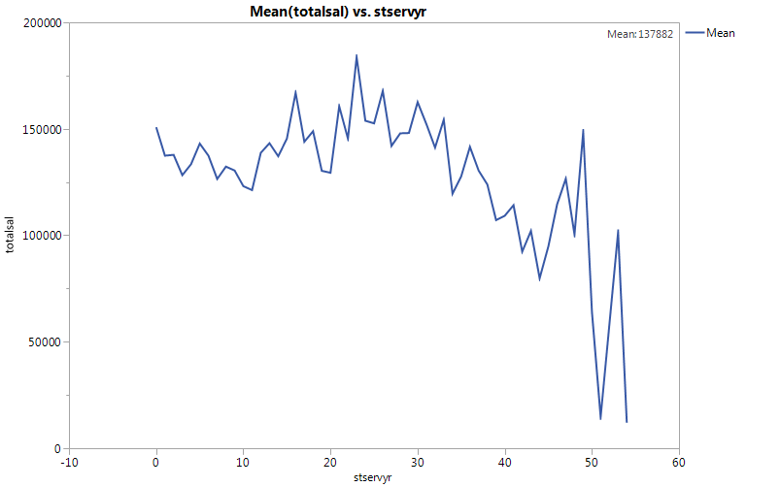

The graph simply shows that salaries get higher at 15-30 years of services. Salaries start going down around 48th year in services, the salary level after this year is even lower than the salaries of whom who have less years of services. This is obviously an issue related to salary compression. The statistic result shows there is evidence where employees with fewer years of service systematically make more than employees who have more years of services.

In addition, the average total salary of faculty members is $137,882 and the median is $118,970. These 2 numbers can tell that there is existence of outliers that cause the significant difference between mean and median. These outliers also need more attention to consider whether or not they appear to be salary discrimination.

When faculty ranks are added to the graph as another X variable, there is evidence shows that faculty rank does affect the compensation distribution based on member’s age. (Graph below).

**Total Salary Distribution vs. Faculty member’s age:**

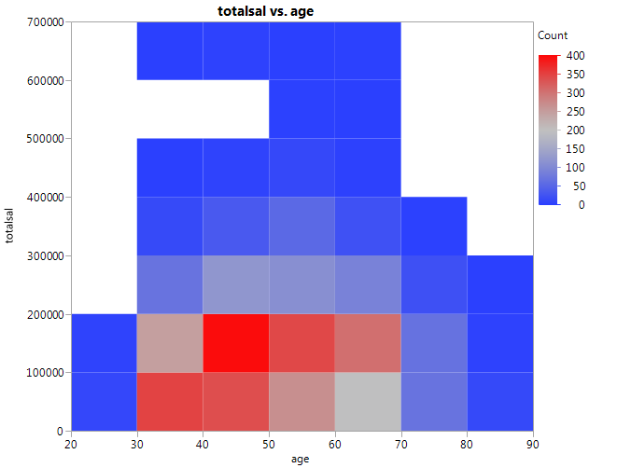

The heatmap shows that the majority of faculty members have salary level of $100,000 to $200,000 and have the age of 40-50. The compensation distribution seem to be fair for this range of age. There are numerous outliers who making more than $300,000 and most of them are from 30 to 70 years old.

An interesting fact was found during the analysis is that the top 8 faculty members at the top of the heatmap, who make at least $600,000, all work in the medical field. They are all from Surgery, Neurosurgery, or Medicine department. They mostly are Clinical Professor, Clinical Associate Professor, and Clinical Assistant Professor. And 7 out of 8 of them are male. This also should need attention for evidence of salary discrimination. In my opinion, this should be considered as a slight gender discrimination.

**Effects of faculty rank on these relationships:**

a. Effects on relationship between compensation and years of services

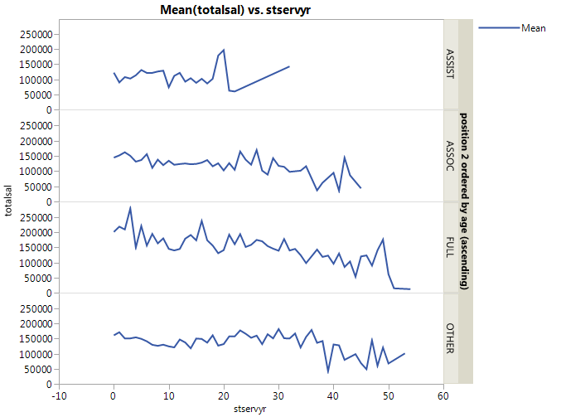

The rank does impact slightly on how compensation is distributed based on member’s years of services. The ASSIST group seems to be the most different from the other ranks and also different from the original chart (before adding rank). In contrast with the other 3 ranks, the salary in this rank starts to go up at the 15th year to the 20th, then goes down rapidly and goes back up after the 20th year. The FULL group seems to have a linear negative trend with years of services which means the longer the employees serve the university, the lower their salaries might get. The remaining 2 ranks seem to have the similar pattern/trend with the original chart (before adding rank) and also similar to each other, accept when they reach the age of 45, the ASSOC rank salary starts going down while the OTHER rank salary has inconsistent up and down salary level and starts going up from the year of 50 to 53.

**b. Effects on the relationship between Age and Compensation**

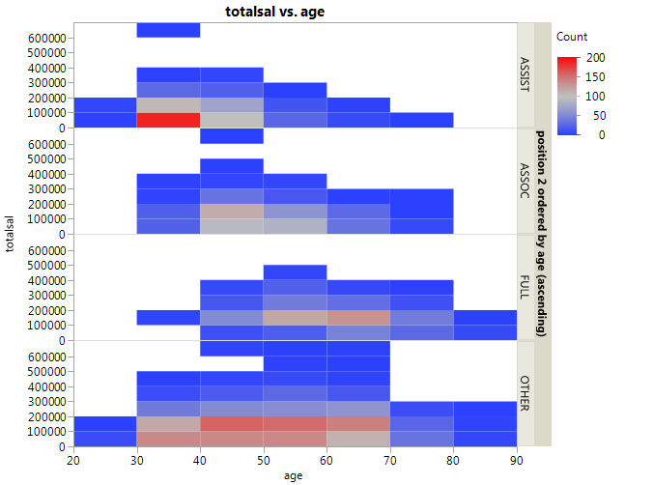

For the 3 main ranks ASSIST, ASSOC, and FULL, the salary level will start going down when it meet the age of 58.

On the other hands, the OTHER rank although has the majority of members having low salaries (as mentioned earlier in this report with low mean and median), there are numerous number of outliers that have much higher salary than the rest in the same rank. The salary distribution appears in a strange pattern between the age of 78 and 90, where salary goes up and down rapidly and reach the peak at the age of 90. These must be outliers and the provost should pay more attention on this rank.

11.

**State salary distribution across 6 departments:**

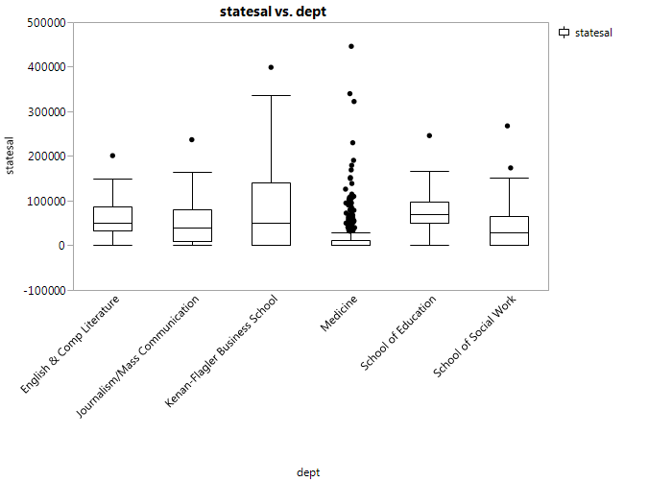

According to the box plot, state salary is distributed quite differently across the departments, except the Medicine department. State salary is most likely in between $0 - $10,000, which is pretty low compare to normal salary level. One of the reasons is that about half of the employees in these 6 departments do not have state salary but they receive non-state salary instead. The data indicates that there are 666 employees having state salary out the total of 1212 employees in this subset.

The descriptive statistic also shows that School of Education has the highest mean ($76,925) and the highest median ($70,040) comparing with the other departments. Kenan-Flagler Business School is the next department has the 2nd highest rank in state salary with the mean of $76,766 and the median of $49,500. The 3rd highest rank in state salary belongs to English & Comp Literature. The next department is Journalism/Mass Communication. School of Social Work is ranked 5th in the state salary distribution. And lastly, medicine department has the lowest mean and median state salary. However, there are numerous of outliers from the medicine department who have higher salaries than the others in the same departments. Below is the descriptive statistic summary of the state salary distribution across 6 departments:

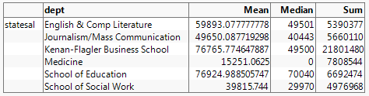

**Total salary distribution across 6 departments:**

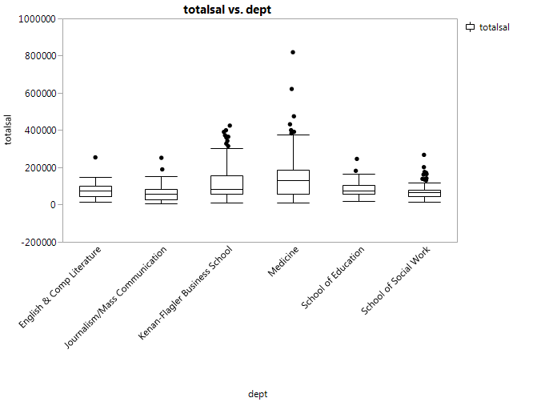

After switching the state salary by total salary, the distribution looks totally different. The majority of employees have salaries around $75,000. The distribution of total salary is close between each departments, except the Medicine department. The Medicine department, this time, is the one to have the highest total salary compare to other departments with the average of $139,204 and the median of $131,415. The 2nd rank in total salary belongs to Kenan-Flagler Business School with the mean of $116,963 and the median of $84,852. The next departments have about the same distribution are English & Comp Literature and School of Education. And finally, School of Social Work is just slightly lower than the previous ones. The descriptive statistic summary is also copied below:

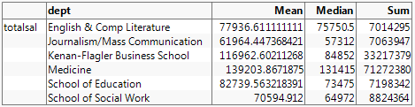

12.

In this study, there is a variety of type of data. Age is considered discrete (ordinal) data, Rank is nominal data, Years of services is ordinal data, and Salary (variable Y) is continuous data. Since Y variable in this case is continuous (although X variables are binary), we can still use multilinear regression for the analysis using the equation: Y=b0+∑(biXi)

**Scatter Plot Matrix**

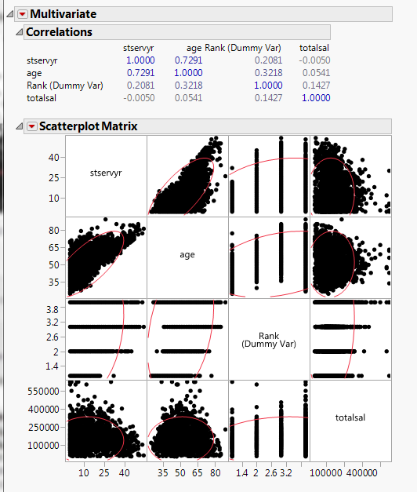

According to the statistical summary of correlations, the relationship between total salary and other variables seems to be weak since the correlations are concernedly low.

**Analysis of total salary by Rank**

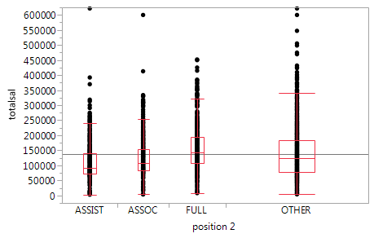

**Bivariate Fit of total salary by years of services**

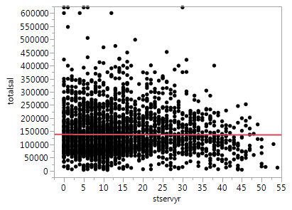

R square = 2.461e-5

**Bivariate Fit of total salary by age**

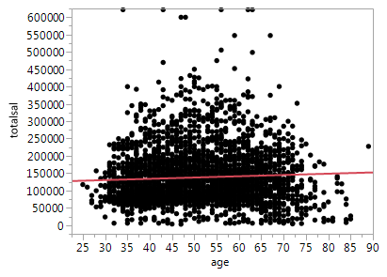

R square = 0.0029

Both R-square of Age variable and Years of services variable in this scenario are extremely low. We can concluded that the significance of these variables are very low and it is difficult to predict the salary based on these variables.

**Full model that includes all variables:**

**Actual by Predicted Plot**

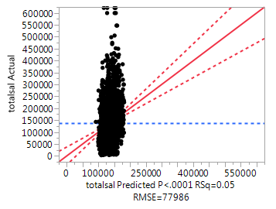

**Summary of Fit**

|  |  |
| --- | --- |
| RSquare | 0.045191 |
| RSquare Adj | 0.043693 |
| Root Mean Square Error | 77985.61 |
| Mean of Response | 137882.3 |
| Observations (or Sum Wgts) | 3193 |

Parameter Estimates

| **Term** |  | **Estimate** | **Std Error** | **t Ratio** | **Prob>|t|** |
| --- | --- | --- | --- | --- | --- |
| Intercept |  | 136045.57 | 7811.643 | 17.42 | <.0001* |
| stservyr |  | -1035.398 | 194.5353 | -5.32 | <.0001* |
| age |  | 265.26855 | 181.5593 | 1.46 | 0.1441 |
| position 2[ASSIST] |  | -27735.57 | 3107.095 | -8.93 | <.0001* |
| position 2[ASSOC] |  | -8772.758 | 2824.46 | -3.11 | 0.0019* |
| position 2[FULL] |  | 29856.663 | 3099.143 | 9.63 | <.0001* |

Residual by Predicted Plot

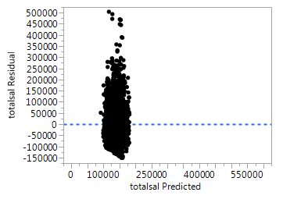

The inferential statistics show that variable Age has p-value > alpha 0.05, therefore, it is not considered a good variable and should be excluded from the model.

**Best model with 2 variables: Years of services and Rank**

**Regression Plot**

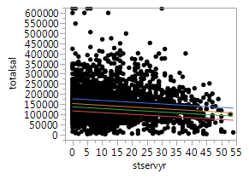

**Actual by Predicted Plot**

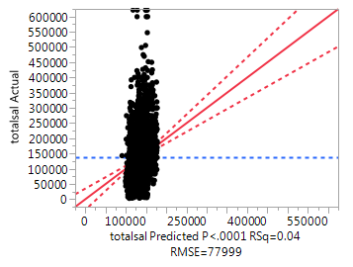

Summary of Fit

|  |  |
| --- | --- |
| RSquare | 0.044551 |
| RSquare Adj | 0.043352 |
| Root Mean Square Error | 77999.49 |
| Mean of Response | 137882.3 |
| Observations (or Sum Wgts) | 3193 |

Parameter Estimates

| **Term** |  | **Estimate** | **Std Error** | **t Ratio** | **Prob>|t|** | **Lower 95%** | **Upper 95%** |
| --- | --- | --- | --- | --- | --- | --- | --- |
| Intercept | Biased | 135932.71 | 2329.999 | 58.34 | <.0001* | 131364.26 | 140501.16 |
| stservyr |  | -851.8326 | 148.5489 | -5.73 | <.0001* | -1143.094 | -560.5715 |
| ASSIST[0] | Biased | 18036.837 | 1984.498 | 9.09 | <.0001* | 14145.816 | 21927.859 |
| ASSOC | Biased | -15971.95 | 3938.028 | -4.06 | <.0001* | -23693.27 | -8250.624 |
| FULL | Biased | 23608.764 | 4068.654 | 5.80 | <.0001* | 15631.321 | 31586.208 |
| OTHER | Zeroed | 0 | 0 | . | . | 0 | 0 |

Effect Tests

| **Source** | **Nparm** | **DF** | **Sum of Squares** | **F Ratio** | **Prob > F** |  |
| --- | --- | --- | --- | --- | --- | --- |
| stservyr | 1 | 1 | 2.0006e+11 | 32.8829 | <.0001* |  |
| position 2 | 3 | 3 | 9.0388e+11 | 49.5231 | <.0001* |  |
|  |  |  |  |  |  |  |
|  |  |  |  |  |  |  |

Residual by Predicted Plot

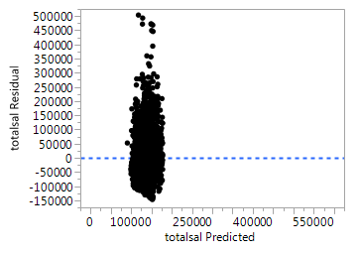

This model has the highest R square (0.04) and Adj. R-square (0.04) compare with the other models that are tested.

All the variables pass the hypothesis test with the p-value < alpha 0.05, therefore they are good variables that should be kept in the model.

Since Rank is categorical variable. Dummy variables are created to replace/substitute the categorical variables and to make the interpretation becomes meaningful. Each employee is assigned to either value 0 or 1 for his/her rank.

The regression model that will enable the provost to predict what faculty salary are based on employees’ faculty rank and years of services. The regression equation will be used for the prediction is as follow:

Y=b0+∑(biXi)

= 135933 – 852 * (years of services) + Match(ASSIST) (0 => 18037 or 1 => -18037) + -15972 * ASSOC + 23609 * FULL + 0 * OTHER

For instance, to calculate the predicted salary of the first employee ABARBANELL, JEFFERY S, 17 years of services and has the rank of ASSOC, the equation is generated as follow:

Y (predicted total salary) = 135933 – 852 * 17 + 18037 – 15972 = 123514

The predicted values using the equation should match the results showed in the last column:

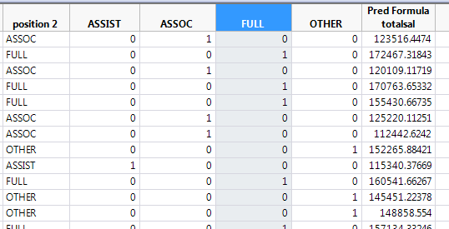

**Recommendations:**

Besides the data that are collected in the data set, there are other factors that need to be considered and analyzed with the salary distribution in order to make the compensation process completely fair across all factors. Some other factors that should be included can be: Geographic (Area), Race/ Ethnicity, and Education/Type of Degree Earned, etc.

The fact findings pointed out that male faculty members appear to have higher salary than female faculty members, both at university level and within rank. Therefore, a small investigation need to be performed and the relevant information about the evidence should be sent to the Office of Human Resources.

Outliers also need more special attention since the outliers found from data are always the ones having very high salary. The provost and involving people should collect information from the outliers, how they get paid much more than others, and what are their other relevant characteristics.

Year of services of the faculty members also need to be noted. There are instances where employees with fewer years of service systematically make more than employees who have more years of services. The Office of Human Resources should adjust the compensation to bring back fairness and equitable classification.

Studies about compensation and classification also should be done in the individual schools on a rolling basis, with the periodic re-evaluation of the regression model, so that the conducted analysis can be more accurate and detail-oriented. In addition, new data could be updated more often.

The provost should use the multi linear regression model conducted in the analysis to predict the faculty salary. The predicted values can help the university on planning ahead on recruiting (what types of professor should be hire more), tax payment (preparing for tax return), budgeting, estimating the amount of money owed to employees, and informing compensation decisions for the university.