Case 4 (Operations Management Application):
This case study involves Alumni (Ch. 15), which are an important source of revenue for colleges and universities. If administrators could determine the factors that influence increases in the percentage of alumni who make a donation (alumni giving rate), they might be able to implement policies that could lead to increased revenue. Research shows that students who are more satisfied with their contact with teachers are more likely to graduate. As a result, one might suspect that smaller class sizes and lower student-faculty ratios might lead to a higher percentage of satisfied graduates, which in turn might lead to increases in the percentage of alumni who make a donation.
The managerial report should contain such as:
1. Choose the best-fit simple linear regression analysis to develop an estimated equation that could be used to predict the alumni-giving rate. (20%)

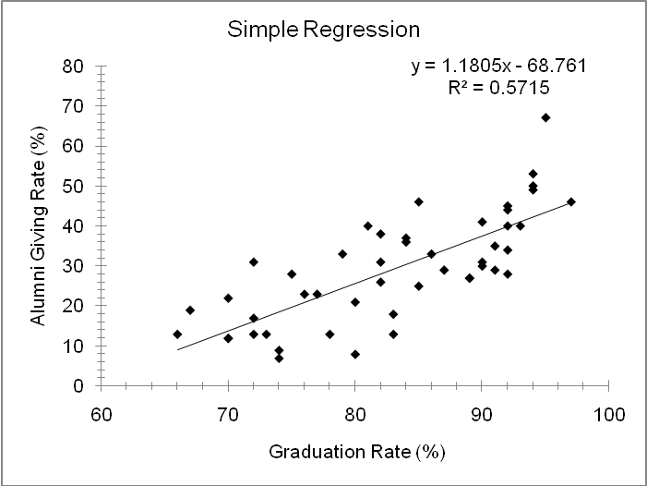

y = 1.1805x – 68.761

2. Use the multiple linear regression analysis to develop an estimated regression equation that could be used to predict the alumni-giving rate given the graduation rate, the percentage of classes with fewer than 20 students, and the student-faculty ratio. Is it a better fit compared with your answer in (1)? Any multicollinearity exists? (30%)
Regression Analysis
 | R² |  | 0.700
 | Adjusted R² |  | 0.679 | n |  | 48
 | R |  | 0.837 | k |  | 3
 | Std. Error |  | 7.610 | Dep. Var. |  | Alumni Giving Rate (%)
 | Regression Analysis
 | R² |  | 0.700
 | Adjusted R² |  | 0.679 | n |  | 48
 | R |  | 0.837 | k |  | 3
 |  | Std. Error |  |  | 7.610 |  |  | Dep. Var. |  |  | Alumni Giving Rate (%)
ANOVA table
Source |  | SS |  |  | df |  |  | MS |  |  | F |  | p-value
Regression |  | 5,943.5311 |  |  | 3 |  |  | 1,981.1770 |  |  | 34.21 |  | 1.43E-11
Residual |  | 2,547.9481 |  |  | 44 |  |  | 57.9079
Total |  | 8,491.4792 |  |  | 47
Regression output |  |  |  |  |  |  |  |  |  |  |  |  | confidence interval
variables |  | coefficients |  |  | std. error |  |  | t (df=44) |  |  | p-value |  | 95% lower |  | 95% upper
Intercept |  | -20.7201 |  |  | 17.5214 |  |  | -1.183 |  |  | .2433 |  | -56.0321 |  | 14.5919
Graduation Rate (%) |  | 0.7482 |  |  | 0.1660 |  |  | 4.508 |  |  | 4.80*10⁻⁵ |  | 0.4137 |  | 1.0827
% of Classes Under 20 |  | 0.0290 |  |  | 0.1393 |  |  | 0.208 |  |  | .8358 |  | -0.2517 |  | 0.3098
Student/Faculty Ratio |  | -1.1920 |  |  | 0.3867 |  |  | -3.082 |  |  | .0035 |  | -1.9714 |  | -0.4126

The multiple regression equation is given as:
y = -20.7201 + 0.7482*Graduation Rate % + 0.029*% of Classes Under 20 – 1.192*Student/Faculty Ratio
There is very little evidence of multi-collinearity.

2. What conclusion and recommendation can you derive from F and t tests in (2)? (20%)
Since the F value is very large, the p-value is very low. So the null hypothesis is rejected and there exists sufficient evidence to indicate a good regression. All the independent variables are significant except for percentage of classes under 20, because the p-value for this variable is very large.

3. With the multiple linear regression equation in (2), what is the alumni-giving rate with graduation rate as 80%, 70% of classes with fewer than 20 students, and student-faculty ratio as 15? (10%)
y = -20.7201 + 0.7482*80+ 0.029*70 – 1.192*15 = 23.2859 %

4. Any possible modification you suggest for a better-fit multiple linear regression model? Adding or dropping independent variable(s)? Change to any nonlinear model? Explain your suggestion. (20%)
The variable % ge of classes under 20 can be dropped, because it is not significant in the model as its p-value is very large. A non-linear model might not be appropriate because we would be dropping off other variables(s) which are significant in the model.

