**Supplemental Material**

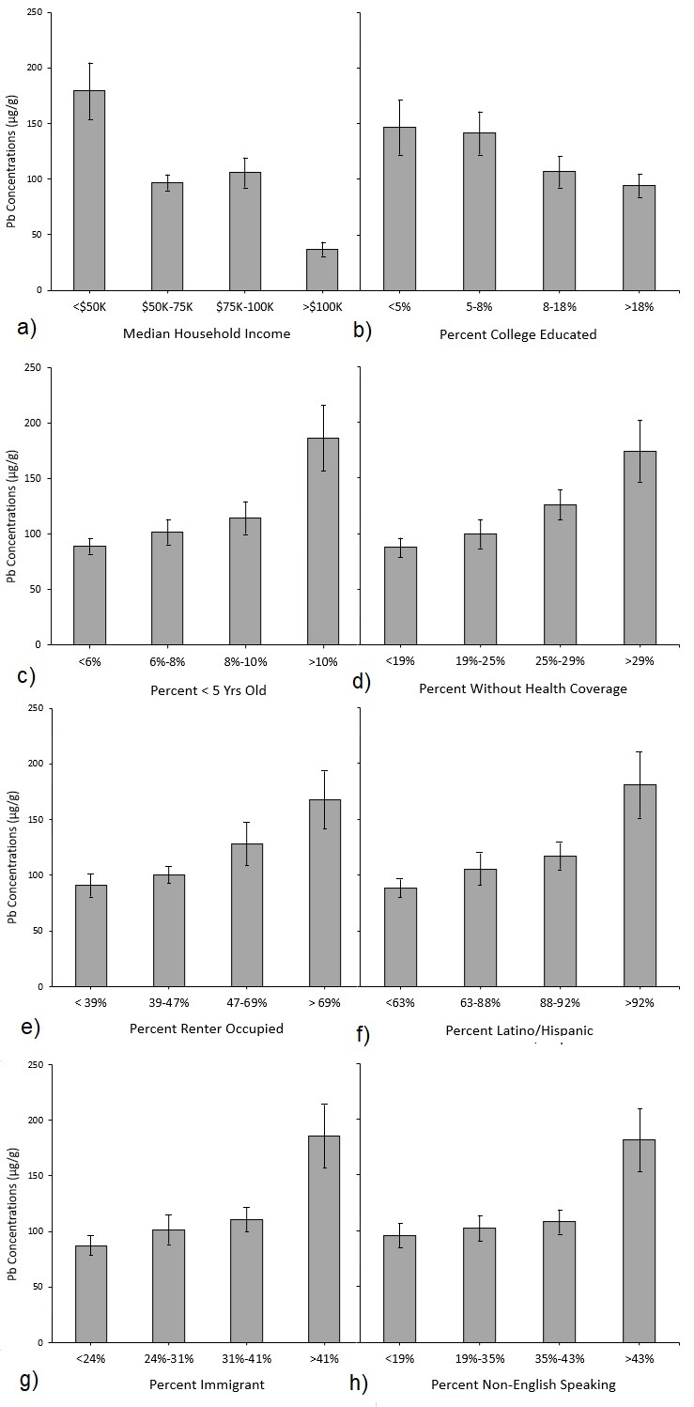

**Figure SI. Average Pb concentrations (95% CI) of soil samples by social and economic characteristics of Census tracts.**

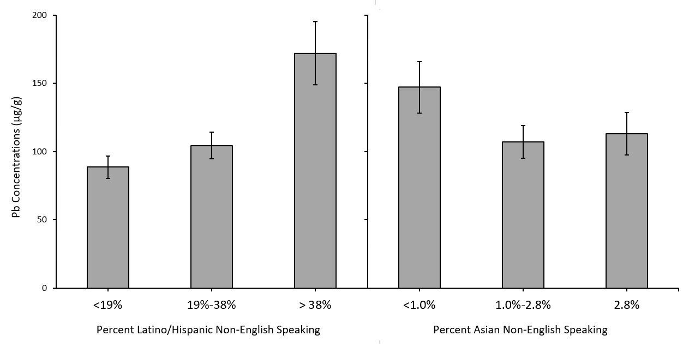**Figure SII. Average Pb concentrations of soil samples grouped into tertiles based on Census tract data for a) percent non-English speaking Latino/Hispanic population and b) percent non-English speaking Asian population.**

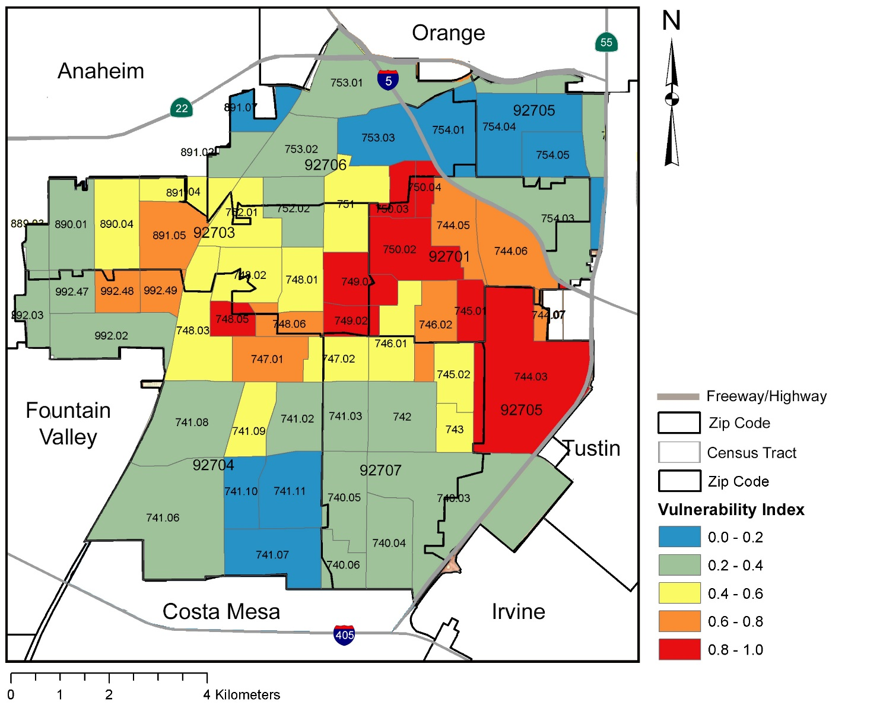**Figure SIII. Map of Santa Ana and Vulnerability Index scores for each Census tract.**

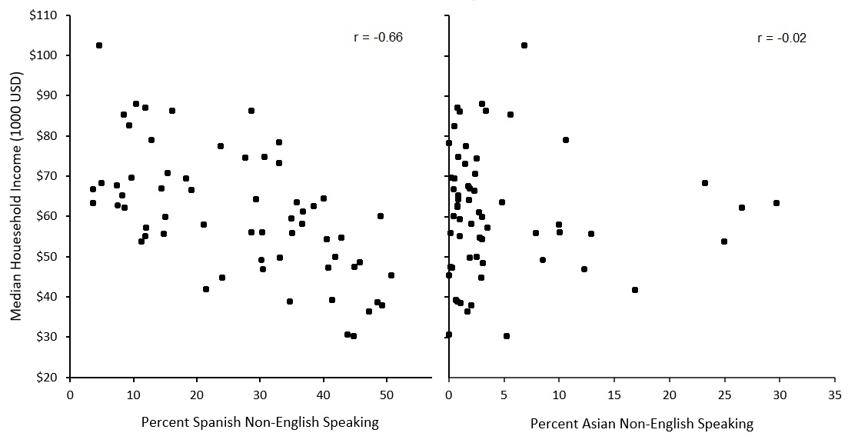**Figure IV. Two-by-two plots and Pearson correlation coefficients (r) of median household income and percent non-English speaking residents for each Census tract.**

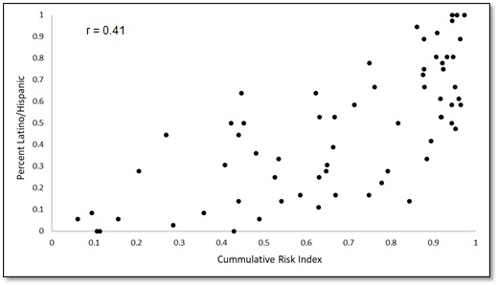

**Figure V. Scatter plot and Pearson correlation coefficients (r) of Cumulative Risk Scores and percent Hispanic populations for each Census tract.**

**Table SI. All Census tracts in Santa Ana ranked by average Pb concentrations.**

|  |  |  |  |
| --- | --- | --- | --- |
| Census Tract | N | Pb (ppm) | Cumulative Risk Index |
| 750.04 | 18 | 610.7 | 1.00 |
| 750.03 | 27 | 356.4 | 1.00 |
| 749.02 | 20 | 128.9 | 1.00 |
| 749.01 | 31 | 373.2 | 0.97 |
| 750.02 | 35 | 169.4 | 0.94 |
| 744.05 | 40 | 129.9 | 0.92 |
| 746.02 | 62 | 216.7 | 0.89 |
| 744.06 | 40 | 144.6 | 0.89 |
| 748.01 | 27 | 136.1 | 0.81 |
| 748.02 | 42 | 134.5 | 0.81 |
| 744.03 | 58 | 83.3 | 0.81 |
| 751 | 22 | 348.9 | 0.78 |
| 746.01 | 26 | 203.2 | 0.78 |
| 752.01 | 38 | 150.5 | 0.75 |
| 891.05 | 30 | 100.8 | 0.75 |
| 744.07 | 11 | 80.7 | 0.72 |
| 740.03 | 65 | 124.4 | 0.67 |
| 748.05 | 20 | 74.3 | 0.67 |
| 745.01 | 28 | 72.2 | 0.67 |
| 760 | 5 | 296.5 | 0.64 |
| 890.04 | 18 | 95.3 | 0.64 |
| 745.02 | 33 | 95.2 | 0.61 |
| 743 | 17 | 92.8 | 0.61 |
| 747.02 | 26 | 97.3 | 0.58 |
| 891.04 | 8 | 82.7 | 0.58 |
| 748.06 | 38 | 78.2 | 0.58 |
| 752.02 | 35 | 117.2 | 0.53 |
| 753.01 | 17 | 91.6 | 0.53 |
| 741.03 | 31 | 84.4 | 0.53 |
| 992.48 | 5 | 63.8 | 0.53 |
| 753.03 | 38 | 154.5 | 0.50 |
| 992.47 | 26 | 108.2 | 0.50 |
| 992.49 | 16 | 72.9 | 0.50 |
| 747.01 | 16 | 68.8 | 0.50 |
| 742 | 21 | 119.4 | 0.47 |
| 757.01 | 18 | 107.6 | 0.44 |
| 889.03 | 19 | 92.0 | 0.44 |
| 741.09 | 18 | 76.0 | 0.42 |
| 741.11 | 26 | 79.2 | 0.39 |
| 758.06 | 22 | 65.6 | 0.36 |
| 754.01 | 35 | 121.2 | 0.33 |
| 741.08 | 33 | 76.5 | 0.33 |
| 891.02 | 21 | 77.0 | 0.31 |
| 759.02 | 12 | 76.6 | 0.31 |
| 753.02 | 20 | 77.5 | 0.28 |
| 754.03 | 43 | 75.9 | 0.28 |
| 992.03 | 18 | 69.6 | 0.28 |
| 754.04 | 18 | 68.7 | 0.25 |
| 891.07 | 11 | 64.1 | 0.25 |
| 748.03 | 22 | 60.2 | 0.22 |
| 740.05 | 30 | 62.3 | 0.17 |
| 740.04 | 19 | 57.9 | 0.17 |
| 740.06 | 11 | 44.3 | 0.17 |
| 741.02 | 23 | 61.9 | 0.14 |
| 890.01 | 24 | 60.8 | 0.14 |
| 992.02 | 18 | 56.4 | 0.14 |
| 741.06 | 19 | 55.1 | 0.11 |
| 741.07 | 12 | 49.0 | 0.08 |
| 754.05 | 18 | 60.7 | 0.06 |
| 755.04 | 9 | 63.5 | 0.03 |
| 741.1 | 19 | 38.7 | 0.00 |

**Table SII. All zip codes in Santa Ana ranked by average Pb concentrations.**

|  |  |  |  |  |  |
| --- | --- | --- | --- | --- | --- |
| Zip Code | N | | Pb (ppm) | |  |
| 92701 | 293 | 199.2 | |  | |
| 92706 | 201 | 158.1 | |  | |
| 92703 | 264 | 130.9 | |  | |
| 92707 | 264 | 99.9 | |  | |
| 92705 | 176 | 80.0 | |  | |
| 92704 | 325 | 69.9 | |  | |
| 92626 | 15 | 38.9 | |  | |
| 92651 | 5 | 26.7 | |  | |