Identification of Bowel tumor using Hybrid ML algorithm in WCE Images
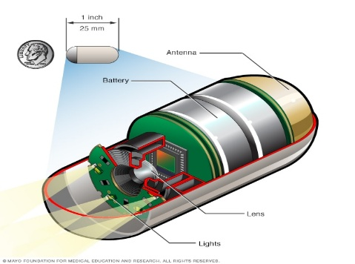
Thiagarajan. A, Deepak.G.V, Er.Perumal Manimekalai College Engineering ,Hosur, India. thiagarajan1610@gmail.com
Abstract
Gastrointestinal (GI) tumors, including cancers of the stomach, small intestine, and colon, pose a significant health risk worldwide. Early detection is essential for effective treatment, but conventional diagnostic methods, such as Wireless Capsule Endoscopy (WCE), require manual analysis of thousands of images, making the process time-consuming and prone to human error. This project proposes a hybrid machine learning (ML) approach to automate GI tumor detection and classification in WCE images, reducing reliance on manual review and improving diagnostic accuracy.
The proposed system utilizes Convolutional Neural Networks (CNNs) for feature extraction and Recurrent Neural Networks (RNNs) for analyzing sequential patterns across WCE images. This combination enables accurate identification, classification of tumors as benign or malignant, and determination of their stage. Preprocessing techniques, including image enhancement and segmentation, further improve model performance. The system is trained on labelled datasets and evaluated using performance metrics such as accuracy, precision, recall, and F1-score.
Unlike existing automated solutions that focus primarily on anomaly detection, this model provides a comprehensive analysis, allowing for early-stage diagnosis and better treatment planning. Additionally, real-time implementation of the system can significantly reduce the workload on healthcare professionals while ensuring consistency and efficiency in GI tumor detection. Future enhancements include cloud-based deployment for accessibility and scalability in clinical applications.
This research bridges the gap between manual expertise and AI-driven automation, offering a robust, efficient, and scalable solution for improving GI tumor detection in WCE images. By enabling early intervention and enhancing clinical decision-making, this system has the potential to revolutionize WCE-based diagnostics and contribute to better patient outcomes.
INTRODUCTION
Gastrointestinal (GI) tumors, including cancers in the stomach, small intestine, and colon, represent a significant global health concern, often leading to severe complications and high mortality rates. One of the primary challenges associated with these tumors is late-stage diagnosis, primarily due to the absence of noticeable early symptoms. This delayed detection often results in limited treatment options, reducing the chances of successful intervention. Hence, there is a growing need for advanced diagnostic tools that can facilitate early detection and classification of GI tumors to improve patient outcomes.
The Role of Wireless Capsule Endoscopy (WCE)

Wireless Capsule Endoscopy (WCE) has emerged as a revolutionary diagnostic technique for visualizing the entire gastrointestinal tract, particularly the small intestine, which is challenging to access using traditional endoscopic methods. WCE involves a swallowable, pill-sized camera that captures thousands of images as it moves through the digestive system, providing detailed insights into the condition of the GI tract. Unlike conventional endoscopic procedures, WCE is non-invasive, more comfortable for patients, and allows comprehensive imaging of regions that were previously difficult to examine.
Despite its advantages, manual analysis of WCE images poses significant challenges. A single WCE examination can generate 50,000 to 60,000 images, requiring a gastroenterologist to manually review each image to identify potential abnormalities. This process is:
- Time-consuming – Taking hours to analyze a single patient's dataset.
- Prone to human error – Fatigue and subjectivity can lead to missed detections.
- Lacking in standardization – Variations in expertise and interpretation can affect diagnostic consistency.
Need for Automation in GI Tumor Detection
With the rapid growth of Artificial Intelligence (AI) and Machine Learning (ML), there is an increasing focus on automating medical diagnostics to improve speed, accuracy, and consistency. Machine learning algorithms, particularly Deep Learning models such as Convolutional Neural Networks (CNNs), have demonstrated exceptional performance in medical image analysis, enabling systems to identify and classify complex patterns in visual data with high accuracy.
However, existing AI-based diagnostic solutions for WCE images face several limitations:
- Most traditional ML models focus solely on tumor detection without classification or staging.
- Current automated systems, such as those in Medtronic PillCam and Olympus Endo Capsule, provide basic image enhancement and annotation rather than full-fledged AI-driven diagnosis.
- Sequential relationships in WCE images (how one image relates to the next) are often ignored, which could lead to misclassification of tumor stages.
Proposed Solution: Hybrid Machine Learning Approach
To address these limitations, this project proposes an AI-driven, hybrid machine learning model for automated GI tumor detection and classification in WCE images. The core components of this system include:
- Convolutional Neural Networks (CNNs) for feature extraction, identifying tumor regions in WCE images.
- Recurrent Neural Networks (RNNs) to analyze sequential patterns across images, improving tumor classification accuracy.
- Hybrid deep learning architecture combining CNN and RNN, optimizing both spatial and temporal analysis of WCE images.
- Tumor classification into benign and malignant, along with stage identification (early-stage vs. advanced-stage) for better treatment planning.
Impact and Significance
The integration of AI and machine learning into WCE image analysis has the potential to revolutionize GI tumor detection by:
- Reducing manual workload for gastroenterologists.
- Increasing diagnostic accuracy and consistency through automated analysis.
- Facilitating early detection, leading to timely treatment and improved survival rates.
- Enhancing decision-making by providing clinicians with objective and data-driven insights.
By developing an advanced hybrid AI system, this project aims to bridge the gap between manual expertise and automated precision, ensuring a faster, more reliable, and scalable solution for GI tumor detection and classification.
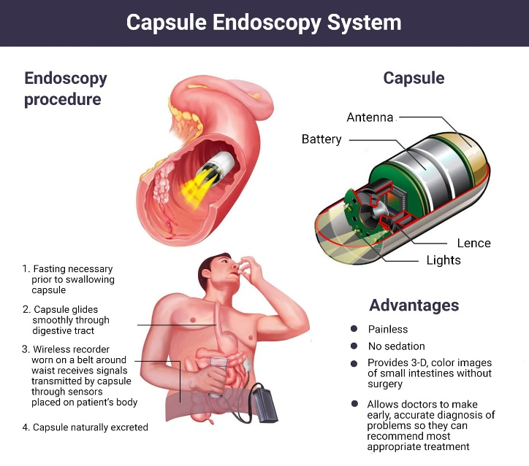
LITERATURE REVIEW
After extensive research in the medical field has shown that early detection of gastrointestinal (GI) tumors remains a challenge, often leading to late diagnoses. Advancements in machine learning (ML) can enhance diagnostic accuracy and reduce manual effort.
This paper presents an AI-driven approach using hybrid ML techniques, including CNNs and RNNs, to automate GI tumor detection in Wireless Capsule Endoscopy (WCE) images. By integrating advanced image processing and AI analysis, the system aims to improve diagnostic efficiency and support healthcare professionals in early tumor identification.
An Accurate Deep Learning-Based Computer-Aided Diagnosis System for Gastrointestinal Disease Detection Using Wireless Capsule Endoscopy Image Analysis. Sameh Abd El-Ghany, Mahmood A. Mahmood, A. A. Abd El-Aziz 2024. [1]
Effective deep learning based segmentation and classification in wireless capsule endoscopy images Panguluri Padmavathi, Jonnadula Harikiran & J. Vijaya.[2]
Falin Zhuo, Haihua Liu, Ning Pan Gastrointestinal Polyps and Tumors Detection Based on Multi-scale Feature-fusion with WCE SequencesarXiv preprint 2022.[3]
Samir Jain, Ayan Seal, Aparajita Ojha A Hybrid Convolutional Neural Network with Meta Feature Learning for Abnormality Detection in Wireless Capsule Endoscopy Images arXiv preprint 2022. [4]
Sodiq Adewole et al.Lesion2Vec: Deep Metric Learning for Few-Shot Multiple Lesions Recognition in Wireless Capsule Endoscopy VideoarXiv preprint 2021. [5]
P. Shanmuga Sundaram & N. Santhiyakumarai., 'An enhancement of computer-aided approach for colon cancer detection in WCE images using ROI-based colour histogram and SVM2 Enhancement 2019'. [6]

PROPOSED SYSTEM
This project proposes a machine learning-based solution to address the limitations of existing methods in detecting and classifying gastrointestinal (GI) tumors. This project seeks to address these issues by leveraging hybrid machine learning techniques, particularly deep learning methods such as Convolutional Neural Networks (CNNs) and Recurrent Neural Networks (RNNs), to automatically detect and classify tumors in Wireless Capsule Endoscopy (WCE) and determine their current stage.
Unlike existing systems, the proposed solution aims to provide robust capabilities for identifying not only the presence of tumors but also differentiating between tumor types (e.g., benign and malignant) and stages (e.g., early-stage and advanced-stage).

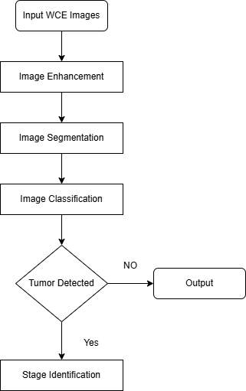
FLOW CHAT

METHODOLOGY OF THE PROPOSED SYSTEM
The proposed system leverages a hybrid deep learning model combining Convolutional Neural Networks (CNNs) and Recurrent Neural Networks (RNNs) for the automated detection, classification, and staging of gastrointestinal (GI) tumors in Wireless Capsule Endoscopy (WCE) images. This methodology ensures efficient feature extraction, sequential pattern recognition, and improved diagnostic accuracy.
1. Data Collection and Preprocessing
The first step involves gathering a labelled dataset of WCE images containing both benign and malignant tumors at various stages. These images undergo preprocessing to enhance quality and remove noise. Key preprocessing techniques include:
- Resizing and Normalization – Standardizing image dimensions and pixel values for consistency.
- Segmentation – Isolating regions of interest (ROI) where tumors are likely to be present.
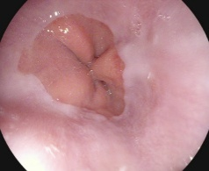
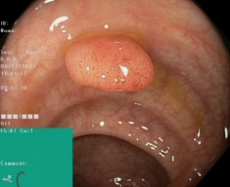
- Data Augmentation – Applying rotation, flipping, and contrast adjustments to improve model generalization.
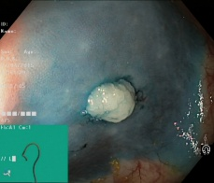
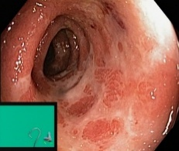
Z-line Polyps

Ulcerative Colitis Dyed and Lifted Polyps

2. CNN for Feature Extraction
CNNs are used to extract spatial features from WCE images. The CNN architecture consists of:
- Convolutional Layers – Detects patterns such as edges, textures, and tumor shapes.
- Pooling Layers – Reduces dimensionality and computational complexity while retaining essential features.
- Fully Connected Layers – Converts extracted features into a classification-ready format.
3. RNN for Sequential Analysis
Since WCE images are captured in a sequence, an RNN is integrated to analyze temporal dependencies between frames. The RNN module:
- Processes sequential image features extracted by CNN to track tumor progression.
- Uses Long Short-Term Memory (LSTM) cells to retain crucial patterns over multiple frames.
- Enhances classification accuracy by considering contextual relationships in WCE images.
4. Model Training and Validation
The hybrid CNN+RNN model is trained using a labelled dataset, with cross-entropy loss as the optimization function. The training process includes:
- Backpropagation and gradient descent optimization to minimize classification errors.
- Hyperparameter tuning (e.g., learning rate, batch size) to improve accuracy.
- Performance evaluation using metrics such as precision, recall, F1-score, and ROC curve.
5. Deployment and Real-Time Prediction
Once trained, the model is deployed in a real-time clinical setting where WCE images are fed into the system for automated tumor detection. The system:
- Classifies benign vs. malignant tumors and identifies tumor stages (early or advanced).
- Provides a graphical user interface (GUI) for clinicians to upload images and receive results instantly.
- Ensures scalability through cloud-based deployment, enabling remote diagnostics.

CONCLUSION
The proposed hybrid CNN+RNN model enhances the early detection, classification, and staging of gastrointestinal (GI) tumors in Wireless Capsule Endoscopy (WCE) images. By automating tumor analysis, the system reduces manual effort, improves diagnostic accuracy, and ensures early intervention. The integration of deep learning significantly optimizes tumor recognition and clinical decision-making. Future advancements, including lightweight AI models and cloud-based deployment, will further enhance scalability, making automated GI diagnostics more accessible and efficient for healthcare professionals.
REFERENCES
- P. Shanmuga Sundaram & N. Santhiyakumarai.,“An enhancement of computer aided approach for colon cancer detection in WCE images using ROI based color histogram and SVM2 Enhancement”.

- Prabhananthakumar Muruganantham & Senthil Murugan Balakrishnan, "Attention Aware Deep Learning Model for Wireless Capsule Endoscopy Lesion Classification and Localization," Journal of Medical and Biological Engineering, 2022.

- Panguluri Padmavathi, Jonnadula Harikiran & J. Vijaya, "Effective deep learning based segmentation and classification in wireless capsule endoscopy images," Multimedia Tools and Applications, 2023.

- Muruganantham, Prabhananthakumar & Balakrishnan, Senthil Murugan. "Attention Aware Deep Learning Model for Wireless Capsule Endoscopy Lesion Classification and Localization," Journal of Medical and Biological Engineering, 2022.

- Padmavathi, Panguluri, Harikiran, Jonnadula & Vijaya, J. "Effective deep learning-based segmentation and classification in wireless capsule endoscopy images," Multimedia Tools and Applications, 2023.

- Ghosh, T., Banerjee, R., & Mukherjee, D. "A Hybrid CNN-RNN Framework for Gastrointestinal Disease Detection Using Capsule Endoscopy Images," IEEE Transactions on Biomedical Engineering, 2021.

- Ribeiro, T., Martins, T., & Silva, J. "Artificial Intelligence-Based Endoscopy: Advances in Deep Learning for Gastrointestinal Disease Detection," Nature Biomedical Engineering, 2022.

