Chat with Data
Data-Egress & Third-Party Access Audit
RAM Pilot edition (repo: chat_with_data_ram_Pilot)
VERDICT: PASS
After two hardening fixes applied during the audit, the application contacts exactly one external service: the company-internal LiteLLM gateway. No user data can reach any other cloud service or third party.
AI Solution Architect: Thiago Alvares
Prepared July 2026 · Document Version 1.0

Contents

1. Executive Summary
This audit examined every network path in the Chat with Data RAM Pilot application to answer one question: can data loaded into the app ever reach a cloud service or third party other than the provided LiteLLM API? The answer, after remediation, is no.
- The Python service contains exactly one network call site (services/llm.py), and it targets only the configured LiteLLM gateway URL. No other module in the service imports any network-capable library.
- The .NET front end makes outbound calls only to the Python service on localhost.
- Application data lives exclusively in server RAM. Nothing is written to a database or cloud storage; the only local writes are application log files. Exports (Word, Excel, PNG) stream directly to the requesting user's browser.
- Two third-party connections were found in the browser front end — Google Fonts and the Chart.js CDN. Neither carried application data, but both were removed during the audit by self-hosting the assets. The application now loads with zero third-party requests.
- A live browser network capture during a full feature exercise confirmed: every request goes to the application host only.
Defense-in-depth recommendations for the production server (a firewall egress allowlist and TLS certificate verification at the gateway) are listed in Section 8. None are blockers.

2. Scope and Method

2.1 What was audited
Repository chat_with_data_ram_Pilot (the version intended for deployment): the Python micro-service (all modules), the .NET front end (all code and configuration), the browser UI (index.html and every asset it loads), Docker/compose files, environment templates, and dependency manifests.

2.2 Method
- Static review — every source file was searched for network-capable imports (requests, urllib, socket, http clients, WebClient/HttpClient) and for any http/https URL. Each hit was traced to its destination and purpose.
- Data-at-rest review — where uploaded data lives, what is written to disk, what the logs contain, and where exports go.
- Dynamic verification — the application was run end-to-end (upload, question, refine, all four export types, health checks) with the browser's full network log captured. Every request was inspected for its destination host.
- Dependency review — Python packages and NuGet packages were checked for known runtime telemetry (none present).

3. Data-Flow Map
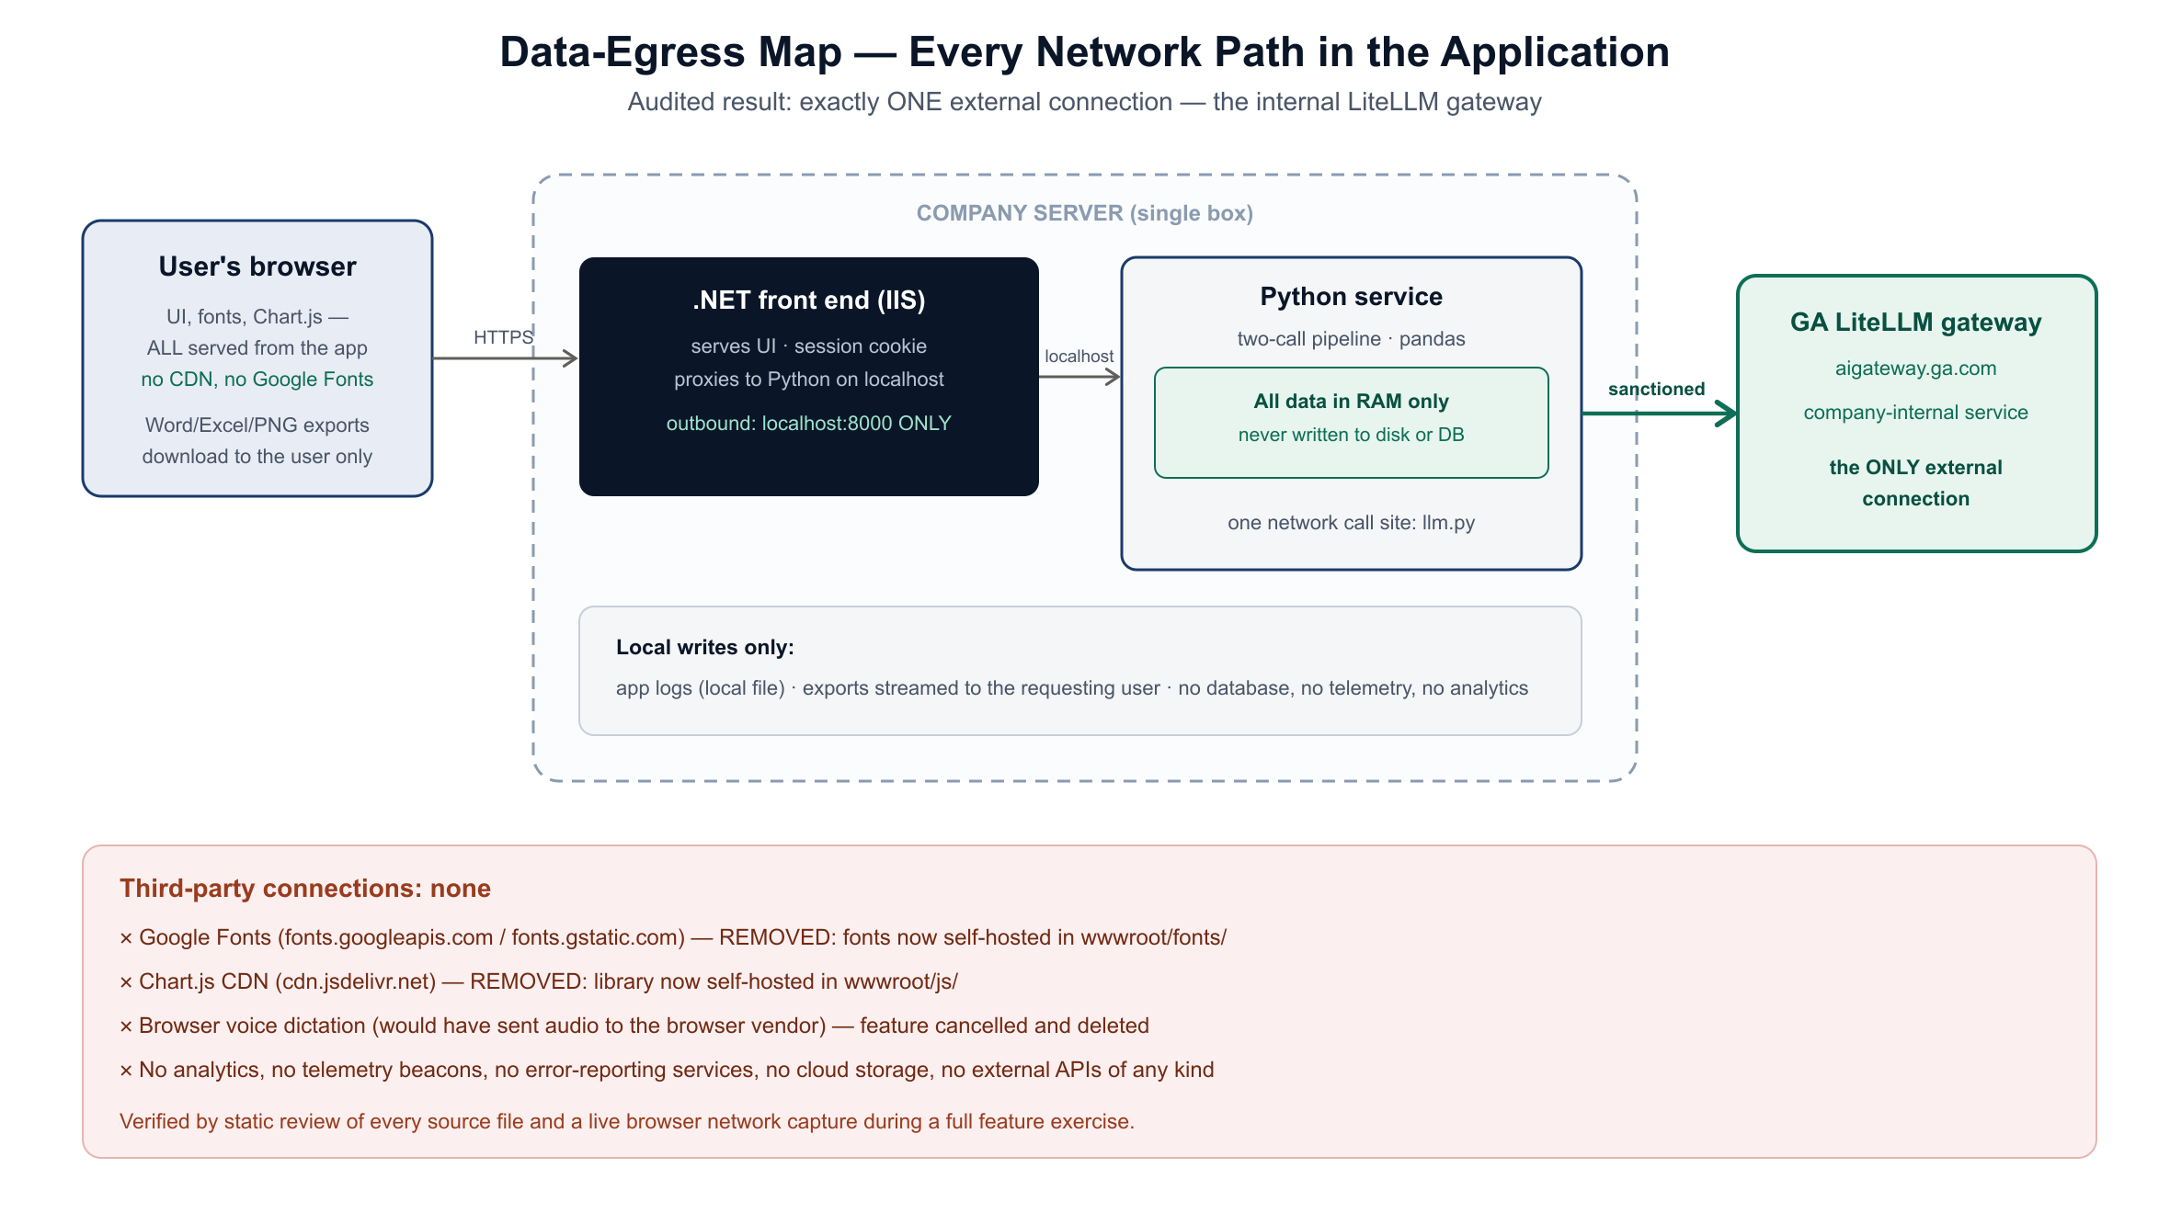
Figure 1 — Every network path in the application. The single sanctioned egress is the internal LiteLLM gateway.
Uploaded files travel: browser → .NET (localhost proxy) → Python, where they are parsed by pandas and held in the Python process memory, keyed by session. Questions run the two-call pipeline; only the pipeline's model calls leave the server, and only toward the gateway.

4. Complete Inventory of Network Touchpoints
Every place in the codebase that can create a network connection, with its destination and audit verdict:
Component | Destination | Data carried | Verdict
services/llm.py (the ONLY Python network call) | LITELLM_API_BASE (GA gateway) | Prompts: schema, question, history, computed results (Section 5) | SANCTIONED
.NET HttpClient (Program.cs) | PythonService:BaseUrl = http://localhost:8000 | Proxied requests, same box | INTERNAL ONLY
Browser → .NET | The application host (IIS) | UI, uploads, answers, exports | INTERNAL ONLY
Browser assets (fonts, Chart.js, logo) | Self-hosted under wwwroot/ | None — static files | LOCAL (fixed in audit)
mock_llm.py (test tool only) | localhost — never deployed as part of the app | Test traffic | LOCAL / TEST ONLY
Logging (logger.py) | Local log file on the server | Timestamps, question snippets | LOCAL WRITE
Exports (Word/Excel/PNG) | Streamed to the requesting user's browser | The user's own results | USER DOWNLOAD
No analytics, telemetry beacons, error-reporting services (e.g. Sentry/App Insights), cloud storage SDKs, or third-party APIs exist anywhere in the codebase.

5. What Is Sent to the LiteLLM Gateway (the Sanctioned Path)
For transparency, this is precisely what the two model calls transmit to the gateway — and it does include excerpts of the loaded data, which is inherent to how the application works:
Sent on | Content
Call 1 (code generation) | The data schema: column names, types, unique counts, up to 3 sample values per column, and the first 3 rows; the user's question; recent conversation history; a preview (up to 1,000 characters) of the previous result.
Call 2 (answer writing) | The computed result of the executed pandas code (as text) plus result metadata (row/column counts).
Refine (one sentence / more detail) | The same stored computed result — re-sent to the gateway with a different phrasing instruction. No new data.
The full raw file is never transmitted — only the schema/sample excerpt and computed results. All of it goes exclusively to the gateway configured in LITELLM_API_BASE, authenticated with the gateway API key.

6. Findings and Remediations

6.1 F1 — Google Fonts (fixed)
The UI loaded the Inter and IBM Plex Mono fonts from fonts.googleapis.com / fonts.gstatic.com. No application data was sent, but each user's browser contacted Google (transmitting IP address and browser metadata), and the app would degrade on an isolated network. Remediation: the font files (latin subsets, 7 files) are now self-hosted under wwwroot/fonts/ with a local stylesheet. Appearance is unchanged.

6.2 F2 — Chart.js CDN (fixed)
The charting library was loaded from cdn.jsdelivr.net. Same class of issue as F1 — no application data, but a third-party contact and an external dependency. Remediation: Chart.js 4.4.0 is now self-hosted at wwwroot/js/chart.umd.min.js.

6.3 F3 — Voice dictation (removed before the audit)
A voice-input feature built during development would have used the browser's speech service (audio sent to the browser vendor's cloud). It was cancelled on request and fully deleted; the audit confirms no trace remains.

6.4 Result after remediation
The application makes zero third-party requests. This was verified live: with the app fully exercised (upload, question, refine, Excel export, raw-data export, Word report export, health checks), the browser's network log showed every request going to the application host only (Section 9).

7. Data at Rest, Logs, and Exports
- In-RAM by design: uploaded DataFrames, conversation history, and results live only in the Python process memory and vanish on restart. The RAM Pilot never writes user data to disk or to any database.
- Logs: the service writes a local rotating log file. Entries include timestamps, session ids, and the first ~80 characters of each question — treat log files with normal server-access controls.
- Exports: Word/Excel/PNG files are generated on the server in memory and streamed to the requesting user's browser download. The server keeps no copy.
- The storage module also contains optional disk/SQL Server backends (unused in this edition; STORAGE_BACKEND=memory). If ever enabled, they write only to the server's own disk or the company SQL Server — still no third party.

8. Residual Considerations and Recommendations
Nothing below is a third-party data path today. These are defense-in-depth measures for the production server:

8.1 Add a firewall egress allowlist (recommended)
The pipeline executes model-generated pandas code on the server. That code comes only from the trusted internal gateway and the prompts constrain it to pandas, but executed Python could in principle import a network library. A server firewall rule allowing outbound traffic ONLY to the LiteLLM gateway host makes 'nothing else can ever be contacted' a property of the infrastructure, not just the code. This is the single most valuable hardening step.

8.2 TLS certificate verification on gateway calls (observation)
llm.py calls the gateway with certificate verification disabled (verify=False), carried over verbatim from the validated prototype (likely due to an internal CA). This does not create a third-party data path, but enabling verification against the company CA bundle at deployment would prevent a hypothetical man-in-the-middle on the internal network. Because this file is part of the frozen analytical core, the recommended change is a deployment decision, not applied in this audit.

8.3 Build-time (not runtime) external contacts
Installing dependencies (pip/NuGet) and building Docker images contacts public package registries from the build machine — standard software supply chain, no application data involved. Optionally set DOTNET_CLI_TELEMETRY_OPTOUT=1 on build machines to silence the .NET SDK's build-time telemetry (the deployed app itself sends none).

8.4 Keep assets vendored
Future UI work should keep fonts/libraries self-hosted — no new CDN links or external scripts. The repository guidance file (CLAUDE.md) records this rule.

9. Verification Evidence

9.1 Static sweep
Search of every .py/.cs/.html/.json/.yml/.sh/.ps1 file for network imports and URLs found: one requests import (llm.py), one call site (requests.post to the configured gateway), and — before remediation — the two front-end CDN references, since removed. No socket, urllib, httpx, aiohttp, smtplib, or WebRequest usage anywhere.

9.2 Live network capture (after remediation)
Full feature exercise with the browser network log recording. Every request and its destination:
Request (in order) | Destination
GET / (the app page) | application host
GET /fonts/fonts.css + 6 x .woff2 font files | application host
GET /js/chart.umd.min.js | application host
GET /images/ga_logo.png | application host
POST /upload/standard · POST /ask · POST /ask/refine | application host
GET /export/last_result · GET /export/debug_result | application host
POST /export/conversation · GET /healthz | application host
External hosts contacted: none. Server-side, the Python service's only outbound call went to the configured gateway address.

10. Conclusion
The architecture is intrinsically well-suited to the requirement: one deliberate egress point, everything else local. The two CDN conveniences inherited from the prototype were the only third-party contacts, they carried no application data, and they have been eliminated by self-hosting. As deployed from this repository, data loaded into Chat with Data can reach exactly one external service — the company's LiteLLM gateway — and nothing else. Applying the Section 8.1 firewall allowlist at go-live will enforce that guarantee at the network level as well.

