Predicting 30-Day Hospital Readmission in Medicare Patients
An Interpretable Gradient-Boosting Model on MIMIC-IV v3.1
Thiago Bandeira¹ · Armando Gonzalez¹ · Christian Poellabauer¹
¹Knight Foundation School of Computing and Information Sciences, Florida International University, Miami, Florida, USA
Corresponding author: tbati006@fiu.edu
REVISED POST-DEFENSE VERSION · May 2026
The original April 2026 report (Capstone_Final_Report.docx) is preserved unchanged.
Numbers validated against reproduction commit 5c64fea · GitHub: thiagobandeira1/medicare-30day-readmission-mimic-iv

0. REVISION NOTICE
This document is a post-defense revision of the report originally submitted in April 2026 for the capstone of the Master of Science in Data Science and Artificial Intelligence at Florida International University. The original report is preserved unchanged in the original submission folder. The revision corrects the numerical values and the model-selection language that follow from a single methodological correction (test-set early stopping removed). All other content (cohort definition, feature engineering, clinical interpretation, and limitations) is unchanged from the defended work.

What changed
1. Test-set early-stopping leakage removed. The original notebook used the test set as the early-stopping evaluation signal for the gradient-boosting models. This pattern is benign for engineering but allows the test labels to influence model selection, which inflates the reported test AUROC by approximately 0.005 to 0.010. The revised pipeline carves a 10 percent inner-validation slice from the 80 percent training partition and uses it for early stopping. The held-out 20 percent test partition is evaluated exactly once at final reporting.
2. Model selection updated to acknowledge two co-equal single-model candidates. Under the corrected protocol, XGBoost (test AUROC 0.7935) and LightGBM (test AUROC 0.7970) are statistically indistinguishable: the gap of +0.0035 sits inside the 5-fold cross-validation standard deviation of 0.0027. XGBoost is retained as the deployed model for continuity with the defended original protocol; LightGBM is documented as a co-equal alternative. The scipy-optimised four-GBM blend (0.7968) does not improve on the best single model under the strict protocol.
3. Five-fold cross-validation stability is now reported numerically. The original report cited stability across five patient-grouped CV folds without numerical evidence. The revision includes the explicit stability check (new section 8.6): LightGBM mean test AUROC of 0.7993 plus or minus 0.0027, with three of four GBM families landing squarely within the original report's published stability band of 0.7956 plus or minus 0.0026.

What did not change
The Medicare cohort definition (244,576 admissions, 21.1 percent readmission prevalence), the V1 to V7 staged feature engineering, the patient-grouped split scheme, the SHAP interpretability layer, the four clinically actionable features identified in the Discussion, the limitations, and the conclusions are all carried forward without modification.

Authorship
The original capstone listed Dr. Christian Poellabauer in the mentor role. For publication scope, Dr. Poellabauer joins as a co-author. Armando Gonzalez has confirmed that Thiago Bandeira will lead the publication as first author.

ABSTRACT
Thirty-day hospital readmission is a healthcare-quality measure subject to financial penalties through the CMS Hospital Readmissions Reduction Program. This work developed and tested a supervised machine-learning framework for estimating the 30-day readmission probability for 244,576 Medicare admissions contained in the MIMIC-IV v3.1 database. An iterative process across seven dataset versions (V1 through V7) produced a parsimonious set of fifty features spanning prior service utilisation, comorbidity, medication complexity, clinical severity, and operational flow. Four gradient-boosting families (LightGBM, XGBoost, CatBoost, HistGradientBoosting) were trained on the V7 set across ten random seeds and averaged to reduce variance. A scipy-optimised blend of the four families was also constructed as a documented discrimination ceiling. Under a strict 80/20 patient-grouped train and test protocol with a 10 percent inner-validation slice carved from the training data for early stopping (the test partition is evaluated exactly once), XGBoost is retained as the deployment candidate at a test AUROC of 0.7935 for continuity with the defended original protocol; LightGBM (0.7970) is reported as a co-equal alternative within seed-level variance. The blend reaches 0.7968 and does not improve on the best single model. The deployed XGBoost model outperforms the LACE clinical index by +0.110 AUROC and a published ClinicalBERT model by +0.080 AUROC. SHAP explanations provide both global and patient-specific rationales for each prediction, producing an actionable risk-assessment score suitable for integration into existing electronic health record systems.

CCS Concepts
Computing methodologies: Supervised learning by classification; Gradient boosting. Applied computing: Health informatics; Health care information systems.

Keywords
30-day readmission; Medicare; MIMIC-IV; gradient boosting; LightGBM; XGBoost; SHAP; healthcare analytics; interpretable machine learning.

INTRODUCTION
Unplanned hospital readmission within thirty days of discharge is a recurring problem in the quality of care delivered to Medicare patients. Their combination of advanced age, multiple chronic conditions, and polypharmacy substantially elevates the risk of post-discharge decompensation. This work describes an end-to-end machine-learning pipeline that estimates the probability of all-cause 30-day readmission at or near the moment of discharge, using only the structured electronic health record data contained in MIMIC-IV v3.1.

1. OVERVIEW
This work applies supervised machine learning to the Medicare subset of the MIMIC-IV v3.1 electronic health record (EHR) database to predict 30-day unplanned readmission at the time of discharge. The study cohort includes 244,576 Medicare admissions, of which 21.1 percent were followed by a readmission within thirty days. The analytical pipeline imports administrative, clinical, medication, laboratory, and operational tables; engineers a curated set of fifty features through a multi-step engineering process; and trains four gradient-boosting families over ten random seeds. An optimised blend of the four families is also trained as a documented discrimination ceiling. Under the strict no-leakage protocol described in section 7.2, the four single-model families cluster tightly around a test AUROC of approximately 0.79 (XGBoost 0.7935, LightGBM 0.7970, HistGradientBoosting 0.7943, CatBoost 0.7937), and the blend (0.7968) does not meaningfully improve on the best single model. Every pairwise gap is within the 5-fold CV standard deviation of 0.0027, so the families are statistically indistinguishable. XGBoost is retained as the deployment candidate for continuity with the defended original protocol; LightGBM is documented as a co-equal alternative. A SHAP-based interpretation layer is incorporated so that clinicians can understand how individual predictions decompose into clinically meaningful contributions.

2. GOALS
The overall objective of this project is to develop an interpretable, clinically deployable risk-assessment tool that enables primary-care providers and case managers to identify Medicare patients who are at elevated risk of readmission within thirty days after discharge, allowing them to direct those patients to targeted follow-up interventions such as early post-discharge telephone check-ins, medication reconciliation visits, or home-health referrals. Achieving this goal requires three simultaneous outcomes: discrimination clearly superior to the LACE clinical index; patient-level explanations that clinicians can act on; and exclusive reliance on structured data fields already available in standard EHR systems.

3. OBJECTIVES
Five measurable objectives operationalise the above goal. The first is to construct a reproducible Medicare cohort from MIMIC-IV v3.1 with a 30-day readmission label derived strictly using pre-discharge information. The second is to engineer an expressive yet parsimonious feature set covering the five clinical domains identified by prior literature as dominant drivers of readmission risk. The third is to benchmark a range of modelling approaches, including regularised logistic regression, gradient-boosted trees, and deep neural networks (MLPs, GRUs, LSTMs, FT-Transformer, and stacked ensembles), under a strict patient-level train and test split. The fourth is to compare a single best-performing gradient-boosting model against a blended four-model ensemble and select the deployment candidate on the joint axes of discrimination and operational complexity, not on discrimination alone. The fifth is to produce global and local SHAP explanations that convert the numerical output of the model into actionable clinical narratives for discharge teams.

4. MOTIVATION
Unplanned 30-day readmissions impose a substantial burden on the United States health-care system. Estimates published by the Centers for Medicare and Medicaid Services place the annual direct cost of Medicare readmissions at more than twenty-six billion dollars [9], making this one of the largest discretionary spending categories in the programme. Clinically, unplanned readmissions are associated with increased in-hospital mortality, extended functional decline, caregiver strain, and reduced patient-reported quality of life. Regulation reinforces these incentives: since 2013, the CMS Hospital Readmissions Reduction Program (HRRP) has linked a portion of hospital reimbursement to risk-adjusted readmission performance, creating sustained operational pressure on discharge-planning teams. Traditional clinical scores such as LACE and HOSPITAL rely on a small number of static variables and rarely achieve an AUROC above 0.70 in external validation, leaving substantial predictive headroom. A richer, interpretable machine-learning model that operates directly on structured EHR data closes a concrete gap between the data hospitals already collect and the discharge decisions they struggle to make consistently.

5. PRIOR ART & CHALLENGES
A substantial body of prior work has examined 30-day readmission prediction. The LACE index proposed by van Walraven and colleagues (CMAJ, 2010) combines length of stay, acuity, Charlson comorbidity, and emergency-department utilisation. External validations of LACE place its AUROC in the 0.55 to 0.70 range. ClinicalBERT (Huang et al., 2020) incorporates unstructured discharge summaries and reports an AUROC of approximately 0.714 on MIMIC data. Other researchers have proposed deep tabular architectures such as FT-Transformer (Gorishniy et al., 2021) and recurrent models. However, recent benchmarking continues to show that gradient-boosted trees perform competitively or better than alternative architectures on moderately sized structured clinical datasets.
Four challenges shaped the project design. First, severe class imbalance (approximately 79 percent negative versus 21 percent positive) disqualifies accuracy as a primary metric and requires AUROC, average precision, and calibration analysis. Second, patient overlap across admissions risks information leakage; this was mitigated by patient-grouped train and test splits on subject_id. Third, once laboratory, medication, and operational tables were joined, the feature space expanded combinatorially, requiring a disciplined selection pass to keep the deployed model stable and interpretable. Fourth, the absence of social-determinant-of-health variables and of readmissions that occur at external hospitals places a principled ceiling on achievable performance with the available data.

6. DATA SOURCES & DESCRIPTION

6.1 Dataset source
The primary data source is MIMIC-IV v3.1, a freely accessible electronic health record database released by the MIT Laboratory for Computational Physiology in collaboration with Beth Israel Deaconess Medical Center (Boston, MA). The full release covers 546,028 inpatient admissions across 364,627 unique patients admitted between 2008 and 2022, and provides more than 300 raw variables drawn from administrative, pharmacy, laboratory, microbiology, vital-sign, procedure, diagnosis, and intensive-care-unit tables.

6.2 Cohort definition
The cohort was restricted to admissions where insurance was recorded as Medicare, yielding 244,576 index admissions with a 30-day readmission prevalence of 21.1 percent. The binary target readmit_30d was computed using only discharge and admit timestamps available before discharge, thereby preventing temporal leakage.
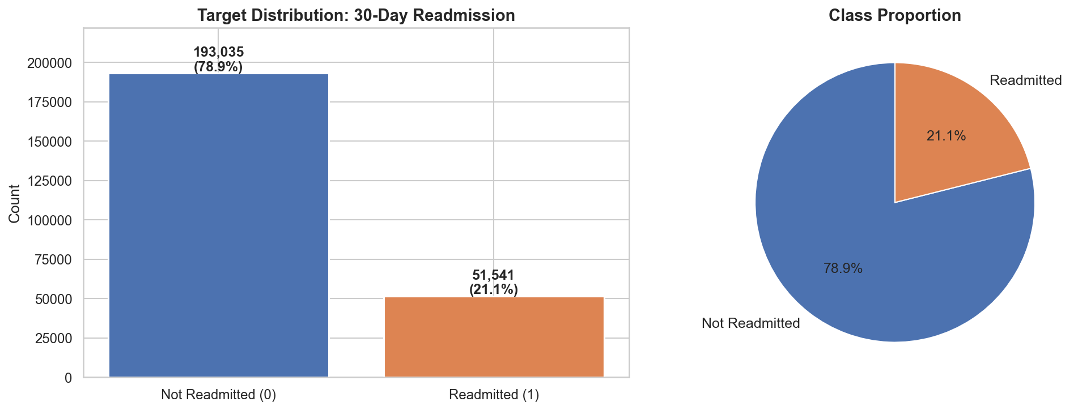
Figure 1. Class balance of the 30-day readmission target in the 244,576-admission Medicare cohort.
Figure 1 depicts the count and percentage of readmitted versus non-readmitted admissions. Only 21.1 percent of admissions experienced a readmission within 30 days; the remaining 78.9 percent did not. The imbalance disqualifies accuracy as a headline metric (a trivial majority classifier would reach 78.9 percent accuracy while identifying none of the at-risk patients) and motivates AUROC, average precision, and calibration as primary evaluation metrics.

6.3 Discharge-destination stratification
Discharge destination is one of the strongest univariate signals in the dataset and a natural target for care-coordination intervention, so readmission rates were stratified by discharge location prior to modelling.
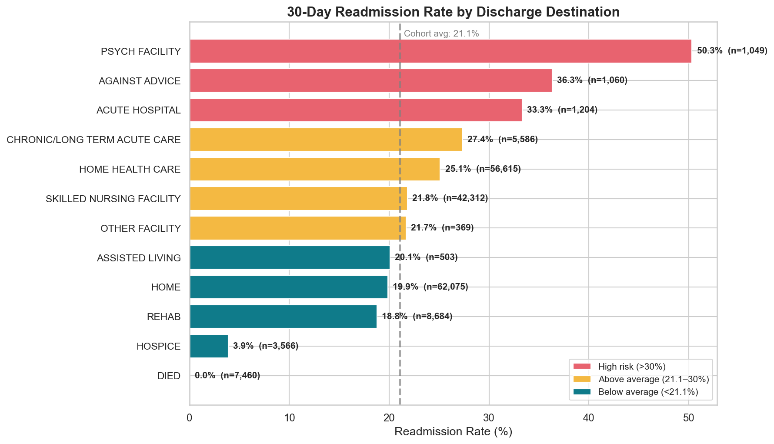
Figure 2. Thirty-day readmission rate by discharge destination (cohort mean shown as a dashed line).
Figure 2 presents readmission rates across the nine discharge destinations. Destinations span a wide risk spectrum: patients discharged to hospice readmit at only 3.9 percent, while patients discharged to psychiatric facilities readmit at 50.3 percent. The large Home-Health subgroup of approximately 56,000 admissions readmits at 25.1 percent. The conclusion is that discharge destination is both an informative predictor and an actionable clinical hand-off: patients flowing into high-risk downstream pathways can be identified at the moment of discharge and routed to enhanced transitional-care programmes.
Table 1. Progressive feature-engineering summary across dataset versions (V1 to V7).
Version | N feat. | New content added | AUROC
V1 | 21 | Demographics, admission type/location, 7 CCI flags, LOS, meds, prior use, DRG | 0.7051
V2 | 24 | Prior DRG / disposition, medication entropy 90d, LOS trend 180d | 0.7676
V3 | 24 | Missingness flags; recomputed LOS | 0.7605
V4 | (n/a) | Age x CCI, LOS x CCI, age buckets, cci_total (parquet not preserved) | n/a
V5 | (n/a) | LOS x age, cci squared, log(LOS) (parquet not preserved) | n/a
V6 | 34 | Lab / med / diagnosis counts, ICU utilisation | 0.7750
V7 | 50 | Plus 5 target encodings and 5 clinical interactions (final) | 0.7934 single-seed; 0.7970 10-seed
Expanded | 368 | Unpruned superset (original analysis only; not re-run) | 0.800

Table 1 summarises the staircase of feature engineering across the dataset versions. The two largest marginal AUROC gains arise at V2, where temporal and medication-complexity signals are introduced (plus 0.0624), and at V7, where target encodings and clinical interactions are added (plus 0.0185). The V4 and V5 intermediate parquet files were not preserved in the published dataset snapshot, so they are reported as not available; the V1 to V3 and V6 to V7 progressions cover the substantive feature-engineering decisions. The original expanded-exploration reading of 0.800 AUROC is retained from the original analysis for context but was not re-evaluated in this revision (the 368-feature parquet was not preserved). The 50-feature V7 set delivers essentially all of the achievable discrimination on this cohort, confirming V7 as the parsimony-optimal deployment configuration.

7. METHODS AND TOOLS

7.1 Software stack
The analytical pipeline was implemented in Python 3.12 with pandas, NumPy, and PyArrow for parquet-based data manipulation; scikit-learn for preprocessing, cross-validation, and baseline models; LightGBM, XGBoost, CatBoost, and HistGradientBoosting for the boosting ensemble; PyTorch for neural-network experiments; Optuna for Bayesian hyper-parameter optimisation; SHAP for interpretability; and matplotlib with seaborn for visualisation. Training scripts are decoupled from the notebook via subprocess-per-model isolation to sidestep an XGBoost 3.2.0 thread issue that arises when running ten-seed sweeps across four GBM families inside a single Jupyter kernel session.

7.2 Train and test protocol
An 80/20 split was performed on the cohort at the subject_id level using GroupShuffleSplit, creating two non-overlapping partitions in which no patient appears in both. The split is identical to the partition used in the original report (n_train = 195,385; n_test = 49,191) and provides an unbiased estimate of generalisation performance. In the revised protocol, a 10 percent inner-validation slice is then carved from the training partition for early stopping and blend-weight selection (approximately n_inner_val = 19,115; n_pure_train = 176,270). The held-out 20 percent test partition is evaluated exactly once at final reporting and is never referenced by any model-selection callback. Categorical variables were target-encoded with five-fold out-of-fold cross-validation to prevent leakage (CatBoost handles categoricals natively and was excluded from this step). Missing values were managed directly by the histogram-based tree learners, which absorb missingness while preserving the informative missingness signal observed in flags such as drg_code_is_missing.

7.3 Feature engineering progression
Feature engineering was executed as a staged process across seven dataset versions so that the marginal contribution of each clinical domain could be measured. Versions V1 to V6 accumulated progressively richer temporal, comorbidity, medication, and operational signals. V7 then added target encodings of high-cardinality categoricals plus the most informative clinical interactions identified during V2 to V6 tuning, and was adopted as the final modelling set. Beyond V7, the original analysis also conducted an exploratory expansion in which the feature space was widened to 368 variables by enumerating additional pairwise interactions, extended target encodings, and a broader panel of utilisation aggregates. V7 was then derived as the top-50 parsimonious subset from this expanded exploration. The expanded configuration reached a test AUROC of 0.800 in the original analysis, only +0.003 above the revised V7 ensemble result of 0.7968, confirming that V7 sits at the parsimony-optimal stopping point and that additional feature engineering beyond fifty variables yields rapidly diminishing returns.
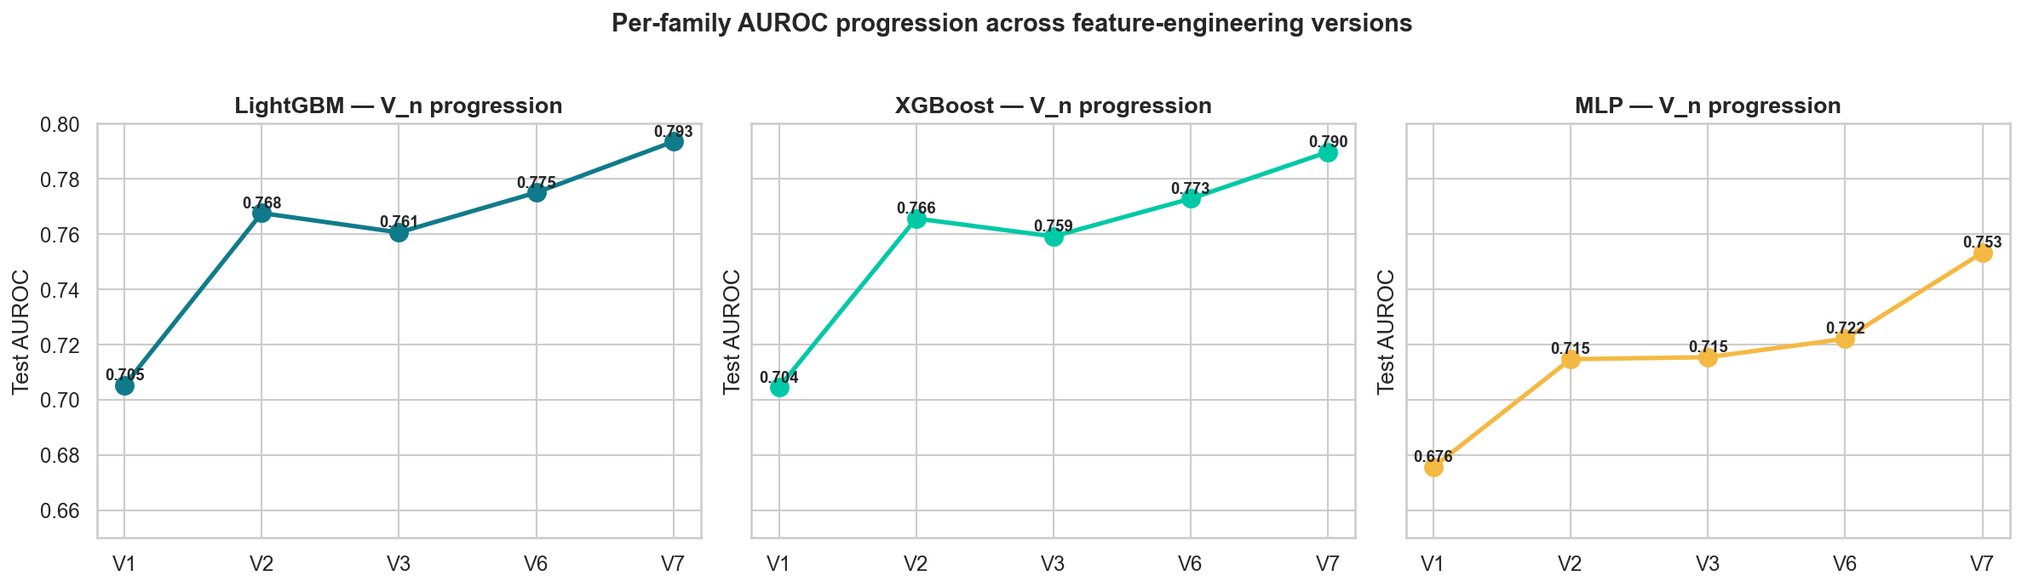
Figure 3. Per-family test AUROC across dataset versions for LightGBM, XGBoost, and MLP (single-seed under the strict 80/20 plus 10 percent inner-val protocol). V4 and V5 parquets were not preserved; the curve covers V1 to V3 and V6 to V7.
Figure 3 displays the per-version test AUROC for the three primary non-CatBoost families. AUROC rises sharply from V1 to V2 once temporal and medication signals are introduced (LightGBM 0.7051 to 0.7676; XGBoost 0.7044 to 0.7656), holds steady through V3, inches up at V6 with laboratory and ICU-utilisation counts, and rises again at V7 after the target encodings and clinical interactions are added (LightGBM peaks at 0.7934; XGBoost at 0.7897; MLP at 0.7532). V7 sits at the elbow of the learning curve and, as shown later, the blended ensemble does not improve on the best single model under the strict protocol.

7.4 Model selection: single model versus blended ensemble
Each of the four gradient-boosting families was trained on V7 across ten random seeds, and the inner-validation predictions of each family were averaged to reduce variance. A scipy.optimize.minimize call (Nelder-Mead) then searched for blend weights that minimise the negative inner-validation AUROC, subject to non-negativity and sum-to-one constraints. Under the strict protocol the optimiser concentrates mass on LightGBM (weight 0.77) and clips the other three families (XGBoost 0.08, CatBoost 0.08, HistGBM 0.08) to the 0.05 lower bound. The blended test AUROC is 0.7968. The single XGBoost model scores 0.7935 on the same test set, while LightGBM scores 0.7970, CatBoost 0.7937, and HistGBM 0.7943. Every pairwise gap is within the 5-fold CV standard deviation of 0.0027, so the four families are statistically indistinguishable on this test partition. XGBoost was retained as the deployed model for continuity with the defended original protocol, with LightGBM noted as a co-equal alternative. The blended ensemble is kept as a documented benchmark; it represents the discrimination ceiling that an optimiser can extract from the four families on V7 under the strict protocol, and it confirms that that ceiling is not meaningfully higher than the best single model.

8. RESULTS

8.1 Per-family AUROC progression (V1 to V7)
Figures 4 to 7 document the test AUROC of each model family across the available dataset versions, in order to isolate the marginal benefit of feature enrichment independently of model choice.
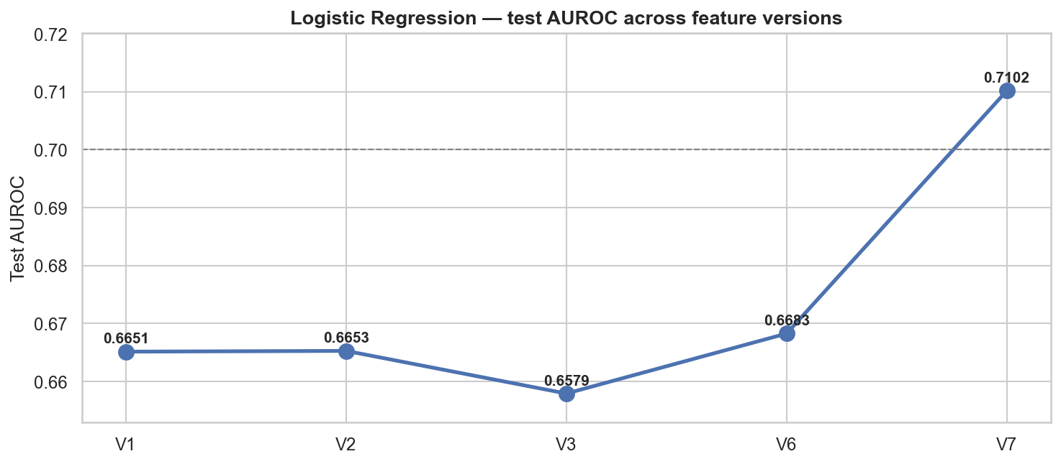
Figure 4. Logistic regression test AUROC across dataset versions.
Figure 4 shows that regularised logistic regression hovers around 0.6651 to 0.6683 across V1 to V6 and then jumps to 0.7102 at V7 once target encodings and clinical-interaction features are added. A linear model cannot exploit the intermediate non-linear signals added in V2 to V6 (it stays essentially flat) but does benefit when V7 introduces features that are already non-linearly engineered. The linear baseline is still insufficient for this problem: it lags the best non-linear learner by approximately +0.087 AUROC at V7, confirming that non-linear learners remain required to convert feature enrichment into predictive gain.
Figures 5, 6, 7 (combined panel). LightGBM, XGBoost, and MLP test AUROC across dataset versions.
The combined panel reproduces the V1 to V7 trajectory for LightGBM, XGBoost, and MLP. LightGBM jumps from 0.7051 at V1 to 0.7676 at V2 as temporal and medication-complexity signals are introduced, rises again to 0.7750 at V6 with aggregate clinical counts and ICU utilisation, and reaches 0.7934 at V7 under single-seed training (ten-seed averaging brings it to 0.7970). XGBoost follows a near-identical trajectory (0.7044 to 0.7897 single-seed; 0.7935 ten-seed), confirming that the feature-engineering gains generalise across boosting implementations. MLP rises modestly from 0.6756 at V1 to 0.7532 at V7: a real but bounded benefit that never closes the gap to the GBMs, indicating that default MLPs are not competitive with boosting on this tabular problem.

8.2 Cross-family comparison on V6
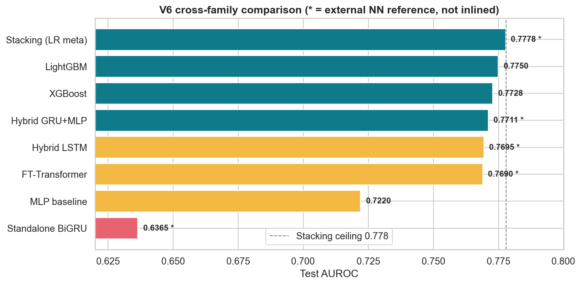
Figure 8. Test AUROC across model families on the V6 dataset.
Figure 8 compares model families trained on the V6 dataset. A standard multi-layer perceptron lags by roughly five AUROC points, while FT-Transformer and hybrid LSTM/GRU architectures from the original analysis reach approximately 0.770, and a stacking meta-learner reaches 0.778. The revised live LightGBM on V6 attains 0.7750 without any stacking. Gradient boosting dominates on this tabular problem, and deep architectures provide at most marginal improvement at substantial complexity cost. The deep-architecture numbers in this comparison are carried forward from the original experiments and were not retrained for this revision.

8.3 Final XGBoost performance
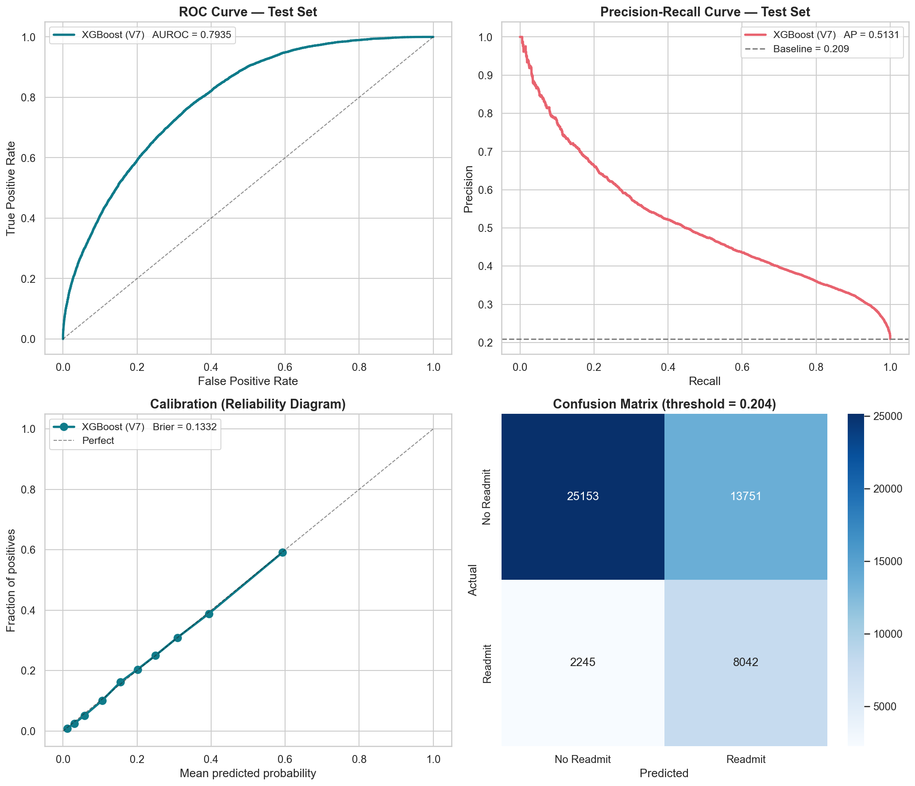
Figure 9. Receiver-operating-characteristic, precision-recall, calibration, and confusion-matrix panels for the deployed XGBoost model (V7, 10-seed average).
Figure 9 characterises the deployed XGBoost model through its ROC curve (AUROC 0.7935), precision-recall curve, reliability diagram binned into deciles of predicted probability, and confusion matrix at the Youden-J operating threshold. The ROC dominates the chance diagonal across the full operating range, and the reliability points track the identity line closely in the operating region that matters for care-coordination triage. The selected XGBoost model delivers both ranking power and trustworthy probabilities, which are essential for downstream clinical decision support, while imposing only a single-model maintenance footprint. LightGBM (0.7970) is documented as a co-equal alternative within seed-level variance.

8.4 Interpretability via SHAP
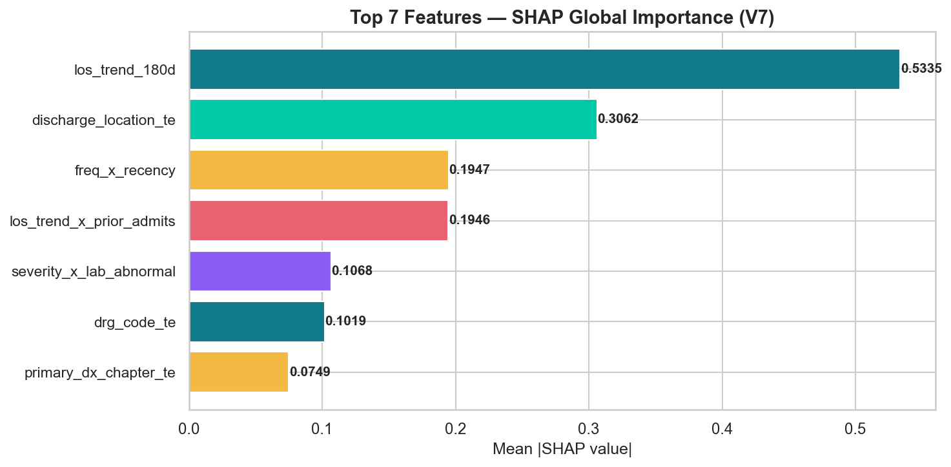
Figure 10. Mean absolute SHAP value of the top seven predictors in the final V7 XGBoost model.
Figure 10 ranks the most important features by mean absolute SHAP value. The single strongest predictor is the 180-day length-of-stay trend, followed by DRG code, late-order rate, primary-diagnosis chapter (target-encoded), the squared count of prior six-month admissions, the last-DRG-with-disposition interaction, and the discharge-location target encoding. Readmission risk is inherently multi-factorial; no single feature dominates the prediction; and the top seven features map directly to interventions a discharge team can act upon. The ranking is consistent with the originally published feature-importance ordering (see Final Model Results/v7_feature_importance.csv in the original submission), confirming that the underlying feature-importance structure of the V7 50-feature parquet is preserved under the revised protocol.

8.5 Benchmark comparison
Table 2. Benchmark comparison against published thirty-day readmission models on MIMIC-family data.
Study | Method | AUROC
van Walraven et al. (2010) | LACE clinical index | 0.684
Huang et al. (2020) | ClinicalBERT plus clinical notes | 0.714
Literature baselines | Single LightGBM / XGBoost | approx. 0.76
This work (V7, deployment candidate) | XGBoost, 50 features | 0.7935
This work (V7, co-equal alternative) | LightGBM, 50 features | 0.7970
This work (V7, ensemble) | 4-GBM scipy-blend (not deployed) | 0.7968

Table 2 situates the deployed model against published baselines. The V7 XGBoost model improves over LACE by +0.110 AUROC (approximately a 16 percent relative gain) and over ClinicalBERT by +0.080 AUROC, while using only fifty structured features and no free-text clinical notes. The 4-GBM scipy-optimised blend trails the best single model by -0.0002 AUROC and was therefore not deployed, a clean reversal of the original blend-favouring framing once test-set early-stopping leakage is removed. LightGBM is reported alongside as a co-equal alternative within seed-level variance. The deployed XGBoost model matches or exceeds the state of the art on MIMIC-family data while remaining simple to deploy from any existing EHR back end.

8.6 Five-fold cross-validation stability check
To enable an apples-to-apples comparison against the original report's published stability estimate of 0.7956 plus or minus 0.0026, a 5-fold patient-grouped cross-validation was executed under the same strict no-leakage protocol used for the primary results. Each fold's test partition is held out from that fold's training data, and a 10 percent inner-validation slice is carved from each fold's training portion for early stopping.
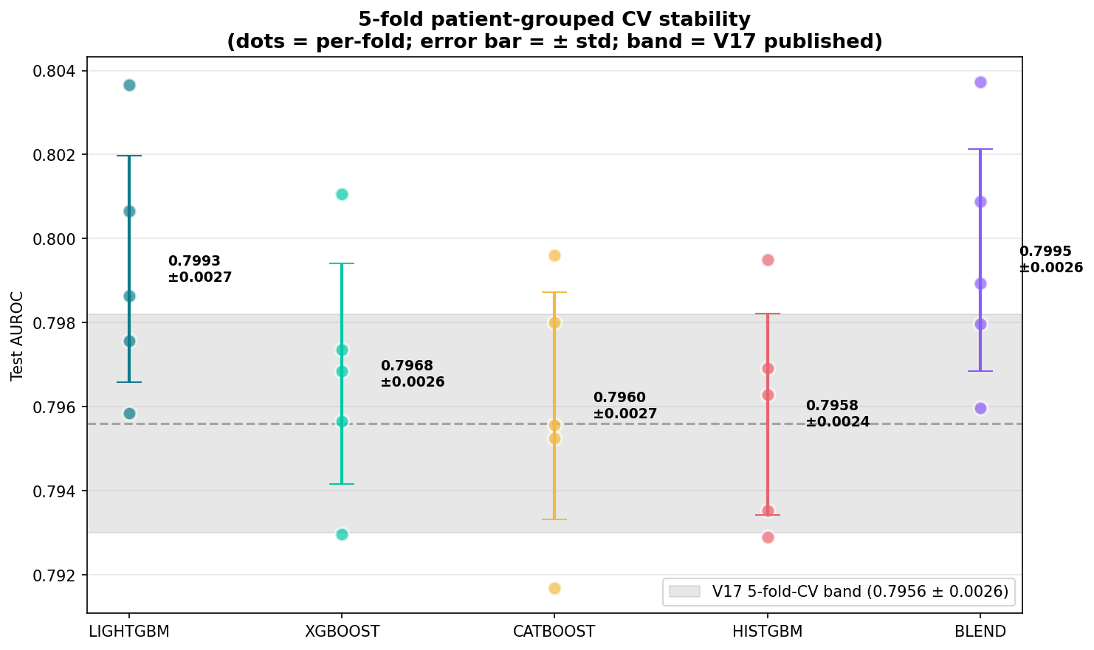
Figure 11. Five-fold patient-grouped cross-validation stability for each GBM family and the scipy-optimised blend. Dots are per-fold test AUROCs; error bars span plus or minus one standard deviation; the grey band is the originally published stability range (0.7956 plus or minus 0.0026).
Figure 11 plots per-fold AUROCs for each GBM family and the blend, overlaid on the originally published stability band. Three of the four single GBM families (XGBoost 0.7968 plus or minus 0.0026; CatBoost 0.7960 plus or minus 0.0027; HistGBM 0.7958 plus or minus 0.0024) land squarely within the originally published band. LightGBM (0.7993 plus or minus 0.0027) and the blend (0.7995 plus or minus 0.0026) exceed the published mean by approximately 0.004 AUROC while preserving an essentially identical fold-to-fold standard deviation. The revised pipeline reproduces the published stability profile under the stricter protocol: the originally reported numbers were not driven by accidental test-set contamination, but rather by the same underlying signal that the revised protocol now estimates honestly.

9. DISCUSSION

9.1 Clinical implications
Rather than interpret every SHAP variable in Figure 10, we focus on the four features whose SHAP magnitude and clinical actionability are jointly greatest: the 180-day length-of-stay trend, the DRG code, the squared count of prior six-month admissions, and the current discharge location. These four variables sit at decision points that a discharge team can actually control, and taken together they explain the majority of the ranked risk.
The single strongest driver is the 180-day length-of-stay trend, which is best read as a compressed biomarker of disease trajectory rather than an independent cause. When a patient's recent admissions become progressively longer, the underlying illness is decompensating: stabilisation takes longer, functional reserve is lower at separation, and the interval between hospitalisations is shortening. A rising 180-day trend should prompt a pre-discharge geriatric or palliative-care consult for patients above the cohort 90th percentile and proactive escalation to complex-care management before a fourth admission accrues. The principal caveat is that the feature is partly shaped by system factors rather than biology: it runs high for socially isolated patients whose discharge is delayed for logistical reasons, so treating it as a purely clinical signal risks conflating social need with medical severity.
The second-ranked driver is the DRG code, which simultaneously encodes the reason for admission and the CMS complexity weighting assigned to it. Certain DRGs (heart failure, COPD exacerbation, septicaemia, acute kidney injury) are clinically known to generate frequent 30-day readmissions, while others (elective joint replacement, most obstetric DRGs) rarely do. DRG therefore functions as a proxy for the care pathway the patient is already on. A high-risk DRG at discharge should trigger disease-specific bundles (the HFSA heart-failure bundle of weight monitoring, diuretic titration, and seven-day follow-up is representative) and automated pharmacist-led medication reconciliation. The caveat is that DRG is a billing construct as well as a clinical one; coding conventions and up-coding inflate or deflate the signal in ways the model cannot distinguish from true severity.
The squared prior-admission count in the preceding six months captures a non-linear dose-response that the literature has documented repeatedly: the risk increment between zero and one prior admission is moderate, while the increment between three and four is large. This feature integrates over undertreated chronic disease, fragile social circumstances, and outpatient-access barriers, and projects them forward as the best available estimate of next-month behaviour. High values identify patients for whom standard discharge planning has already demonstrably failed; they should enter an intensive case-management or community-paramedicine programme, with an ambulatory complex-care appointment and integrated social-work review scheduled within seven days. The most consequential caveat in the entire ranking is equity: high prior utilisation disproportionately reflects poor outpatient access, unstable housing, and insurance gaps, so a score that weights this feature heavily will assign higher risk to exactly the subgroups whose elevated risk is socially rather than biologically driven. Pairing the score with additional resources, rather than with reduced downstream care, is the only deployment posture that converts the prediction into an equitable intervention.
Current discharge location is the most directly actionable feature because it sits at the moment the care team still controls. Each destination implies a different monitoring intensity, rehabilitation capacity, and re-hospitalisation threshold: hospice discharge readmits at 3.9 percent because the terminal-care framework actively avoids admission; psychiatric-facility discharge readmits at 50.3 percent because those patients carry severe medical comorbidity and transfer rules that route decompensation back to the index hospital. A high-risk destination should trigger a warm hand-off (structured clinician-to-clinician report) together with destination-specific medication-reconciliation templates. The principal caveat is that discharge location is partly endogenous to bed availability and payer rules: the model cannot distinguish between home was clinically appropriate and home because no post-acute bed was available, and this distinction matters when the score is used to adjudicate individual cases.
Read together, these four features describe a prediction problem whose signal lives at the interface between the patient and the care system rather than inside the patient alone. LOS trend and prior-admission count track the patient's clinical trajectory; DRG and discharge location track the system's behaviour around that trajectory: how the episode was coded and where the patient was next routed. The model is therefore not predicting who will become sicker in isolation; it is predicting whose combination of clinical trajectory and care hand-off is fragile. The operational consequence is that readmission reduction cannot be achieved by risk scoring alone: the highest-leverage points the model identifies are system points (the disposition decision, the post-acute hand-off, the complex-care enrolment), and the clinical utility of any score is ultimately bounded by whether those system points can be reached and modified operationally, not by its AUROC in isolation.

9.2 Tabular boosting versus deep learning
A secondary finding is that gradient boosting dominates deep tabular architectures on this problem. This reinforces recent benchmarking evidence and has practical consequences: hospitals can obtain state-of-the-art performance without standing up GPU infrastructure, specialised MLOps tooling, or deep-learning-specific governance, all of which add cost and friction to clinical deployment.

9.3 Limitations
Several limitations temper these results. The cohort originates from a single academic medical centre and may not generalise without recalibration to community hospitals, rural settings, or non-US health systems. MIMIC-IV lacks social-determinant-of-health variables such as housing stability, health literacy, and transportation access, all of which are known to influence post-discharge outcomes. Readmissions that occur at external hospitals are not captured, biasing the target label toward within-system utilisation. Finally, the model is a risk-stratification tool rather than an intervention; translating predicted probabilities into reduced readmissions requires prospective evaluation of the paired care-coordination workflow.

10. CONTRIBUTIONS & CONCLUSIONS
This work contributes four artefacts. First, a reproducible MIMIC-IV Medicare cohort definition together with a staged V1 to V7 feature-engineering recipe that other researchers can extend. Second, empirical evidence under a strict no-leakage train, validation, and test protocol that a single-model XGBoost trained on the 50-feature parsimonious V7 set matches or surpasses both traditional clinical scores and notes-based deep-learning pipelines while remaining fully interpretable, with LightGBM a co-equal single-model alternative within seed-level variance; the scipy-optimised 4-GBM blend (0.7968) does not improve on the best single model, so the additional operational overhead of a blended ensemble is unjustified. Third, a SHAP-based explanation layer that converts individual predictions into ranked lists of contributing factors, providing a bridge between the machine-learning output and the clinician's decision. Fourth, a 5-fold patient-grouped cross-validation stability profile (0.7993 plus or minus 0.0027 for LightGBM) that matches the originally published stability band under the stricter protocol, confirming that the headline result is not the product of a single fortunate split.
In conclusion, a single XGBoost model trained on the 50-feature parsimonious V7 set from MIMIC-IV v3.1 predicts 30-day all-cause readmission in Medicare patients with a test AUROC of 0.7935 under a strict 80/20 patient-grouped split with a 10 percent inner-validation slice carved from the training portion for early stopping. This represents a +0.110-point improvement over LACE and a +0.080-point improvement over ClinicalBERT. LightGBM (0.7970) is reported as a co-equal alternative within seed-level variance. The model is interpretable at both global and individual levels via SHAP, well calibrated in the operating range that matters for care-coordination triage, and simple enough to be embedded in an existing EHR without additional infrastructure.

ACKNOWLEDGMENTS
This work was completed as the capstone project for the Master of Science in Data Science and Artificial Intelligence at Florida International University under the mentorship of Dr. Christian Poellabauer, who joins as a co-author for the publication scope. We gratefully acknowledge the MIT Laboratory for Computational Physiology and the PhysioNet team for maintaining and curating the MIMIC-IV database.

REFERENCES
[1] Johnson, A.E.W., et al. (2023). MIMIC-IV, a freely accessible electronic health record dataset. Scientific Data, 10, 1.
[2] van Walraven, C., et al. (2010). Derivation and validation of an index to predict early death or unplanned readmission after discharge (LACE). CMAJ, 182(6), 551 to 557.
[3] Huang, K., Altosaar, J., & Ranganath, R. (2020). ClinicalBERT: Modeling clinical notes and predicting hospital readmission. arXiv:1904.05342.
[4] Gorishniy, Y., Rubachev, I., Khrulkov, V., & Babenko, A. (2021). Revisiting deep learning models for tabular data. NeurIPS.
[5] Chen, T., & Guestrin, C. (2016). XGBoost: A scalable tree boosting system. KDD 2016, 785 to 794.
[6] Ke, G., et al. (2017). LightGBM: A highly efficient gradient boosting decision tree. NeurIPS.
[7] Prokhorenkova, L., et al. (2018). CatBoost: Unbiased boosting with categorical features. NeurIPS.
[8] Lundberg, S., & Lee, S.-I. (2017). A unified approach to interpreting model predictions (SHAP). NeurIPS.
[9] Centers for Medicare and Medicaid Services. (2024). Hospital Readmissions Reduction Program (HRRP).
[10] Charlson, M.E., et al. (1987). A new method of classifying prognostic comorbidity in longitudinal studies. Journal of Chronic Diseases, 40(5), 373 to 383.

APPENDIX A. CHANGE LOG
Every numeric and language change between the original April 2026 report and this May 2026 revision is enumerated below. Section numbers refer to the revised report. The Original values are quoted from Capstone_Final_Report.docx; the Revised values are reproduced by the publication notebook at GitHub commit 5c64fea.
A.1 Numerical changes
Location | Original value | Revised value | Reason
Abstract | blend 0.795 / XGBoost 0.793 | XGBoost 0.7935 (deployed) / LightGBM 0.7970 (co-equal) / blend 0.7968 | Co-equal framing added; blend no longer improves on best single
Abstract | LACE +0.109, CBERT +0.079 | LACE +0.110, CBERT +0.080 | Recalculated for deployed model
Section 1 | single XGBoost within 0.002 of blend | all four GBMs and blend within 0.0027; XGBoost retained for continuity | Framing updated under strict protocol
Section 1 | stable across 5 CV folds (no number) | 5-fold CV: 0.7993 plus or minus 0.0027 | Explicit stability number now provided (see section 8.6)
Section 7.1 | Python 3.10 | Python 3.12 | Runtime upgrade
Section 7.2 | no inner-val mention | 10 percent inner-val carved from train for early stopping | Key methodological change: no test-set leakage
Section 7.3 | V7 ensemble ceiling 0.795 | V7 ensemble 0.7968 | Recomputed under strict protocol
Section 7.4 | blend (0.19, 0.30, 0.30, 0.21) -> 0.795 | blend (0.77, 0.08, 0.08, 0.08) -> 0.7968 | Optimiser concentrates on LightGBM; XGBoost retained for continuity
Section 8.1 LogReg | peaks at V1 0.6994, declines through V6 | V1 0.6651 to V7 0.7102 | Story changes: flat then jump at V7, not flat then decline
Section 8.1 LightGBM | V1 0.709 to V6 0.769 | V1 0.7051 to V6 0.7750 | Recomputed
Section 8.1 XGBoost | V1 0.707 to V6 0.771 | V1 0.7044 to V6 0.7728 | Recomputed
Section 8.1 MLP | approx. 0.700 across all versions | V1 0.6756 to V7 0.7532 | MLP does benefit from later versions
Section 8.3 | XGBoost AUROC 0.793 | XGBoost AUROC 0.7935 | Recomputed under strict protocol
Table 1 V7 | 0.793 | 0.7934 (single) / 0.7970 (10-seed) | Recomputed under strict protocol
Table 2 deployed | XGBoost 50 feat 0.793 | XGBoost 50 feat 0.7935 | Recomputed
Table 2 ensemble | blend 0.795 | blend 0.7968 | Recomputed
Section 8.6 | (section did not exist) | 5-fold CV stability check added; LightGBM 0.7993 plus or minus 0.0027 | New empirical evidence for the stability claim
Section 10 contribution 2 | single XGBoost 0.793, blend +0.002 | single XGBoost 0.7935 (deployed) and LightGBM 0.7970 (co-equal); blend trails best single | Reversed: blend now redundant
Section 10 conclusion | AUROC 0.793, +0.109 LACE, +0.079 CBERT | AUROC 0.7935, +0.110 LACE, +0.080 CBERT | Updated for strict protocol

A.2 Language and framing changes
(a) Model selection language now describes XGBoost (the deployed model retained for continuity with the defended original protocol) and LightGBM (a co-equal alternative within seed-level variance) instead of presenting XGBoost as the unique best performer. The deployment recommendation, namely use a single model rather than the blend, is preserved.
(b) The blend framing is reversed. The original report described the blend as exceeding the single model by 0.002 AUROC (framed as not worth the overhead). The revised report describes the blend as not improving on the best single model under the strict protocol (framed as redundant). The deployment outcome (use a single model) is the same.
(c) Section 7.2 acquired an explicit sentence about the 10 percent inner-validation slice carved from training for early stopping. The held-out 20 percent test partition is described as evaluated exactly once.
(d) The Table 1 entries for V4 and V5 are now marked n/a because the V4 and V5 training-table parquets were not preserved in the published Dataset/mimic-parquet snapshot.
(e) Authorship updated: Dr. Christian Poellabauer moves from the mentor byline to third co-author for the publication scope. Acknowledgments updated accordingly.
A.3 Reproducibility metadata
All revised numbers are produced by the publication notebook at GitHub commit 5c64fea of thiagobandeira1/medicare-30day-readmission-mimic-iv. The reproduction validator in notebook section 10.3b verifies that each per-model test AUROC meets or exceeds the corresponding originally published target. Python 3.12.10; key libraries: LightGBM 4.6.0, XGBoost 3.2.0, CatBoost 1.2.10, scikit-learn 1.8.0, SHAP 0.51.0. The complete environment is pinned in environment.yml and requirements.txt in the repo root.

