|  |
| --- |
| C:\Users\Edward Song\AppData\Local\Microsoft\Windows\INetCacheContent.Word\somberlain_studios.png  sOMBERLAIN STUDIOS presents |
| NBA Game Tracker |
| Track and display information of past and current NBA games |
| Version 0.1  All work Copyright © 2016 by Somberlain Studios.  All rights reserved. |

**Thiago de Andrade Souza**

**Edward Song**

|  |
| --- |
| October 7, 2016 |

**Table of Contents**

Table of Contents

[Site Overview 4](#_Toc463613586)

[Site Structure 4](#_Toc463613587)

[Color Scheme 4](#_Toc463613588)

[Technologies 4](#_Toc463613589)

[Initial Design 5](#_Toc463613590)

[Prototype Site 8](#_Toc463613591)

[Future Features 8](#_Toc463613592)

**Version History**

Please refer to GitHub repository <https://github.com/eddieysong/COMP229_F16_Team_Project_1> for detailed version history.

## ****Site Overview****

*The NBA Game Tracker website is designed to serve as a central repository for detailed NBA game information and statistics.*

## Site Structure

*Home page – displays the most recent matches, with the option to expand the details.*

*All games page – displays all games in the database.*

*Game details game – displays the details of a particular match.*

*Login/registration page – authenticates users to add new game information.*

*Add game page – displays a form for authenticated users to add a new game.*

## Color Scheme

*The site’s color scheme is the same as this document, sandy gold text on dark background. We believe this creates an atmosphere of “a good Cuban and glass of X.O. at the fireplace on a dark night”, which will like appeal to the primary audience of the site: sports fans.*

## Technologies

* *Microsoft Azure for hosting the site*
* *Visual Studio 2015 as IDE*
* *Git and GitHub for version control*

## Initial Design

Home Page

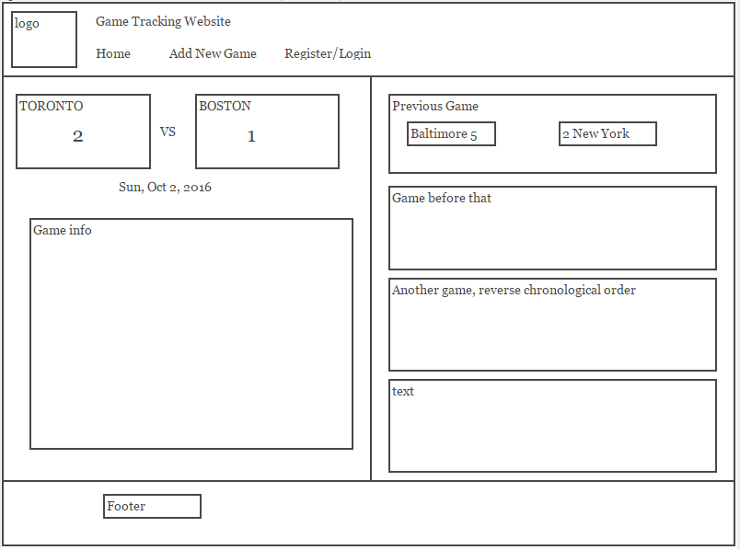

Add Game

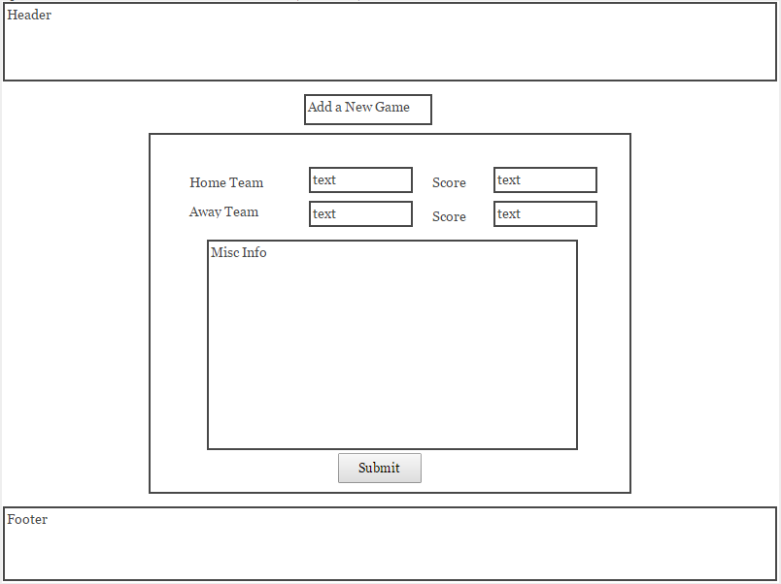

Log In

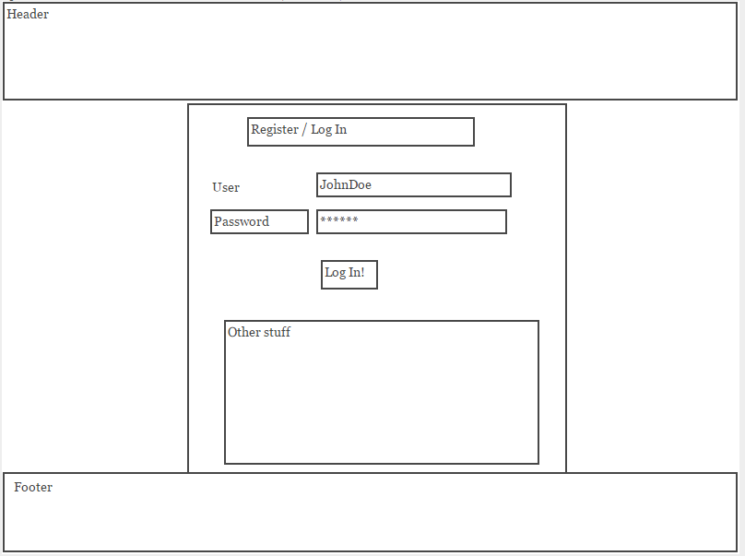

## Prototype Site

**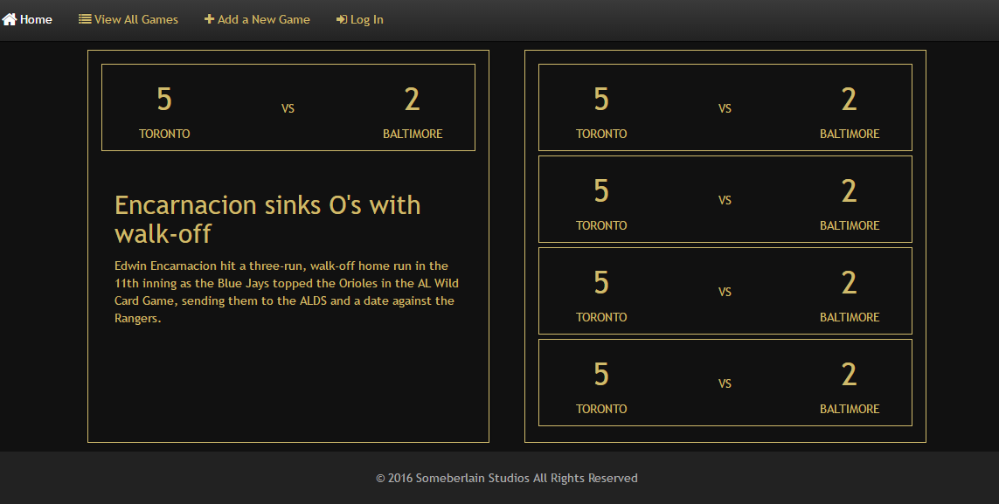**

## Future Features

* *Add graphics to make the site visually more appealing*
* *Setting up a functional database on Azure*
* *Enhance site responsiveness*