|  |
| --- |
| TAPIOCA GAMES |
| Cownnon! |
| **[Cownnon Game specs** |
| Version #01  All work Copyright © 2016 by TApioca Games.  All rights reserved. |
| **Thiago Andrade** |
|  |



|  |
| --- |
| Sep 24th 2016 |

**Table of Contents**

[Your Table of Contents should go here. Make sure that your document’s sections are hyperlinked to their corresponding pages.]

**Version History**

Github Link: <https://github.com/thiagoh/cownnon>

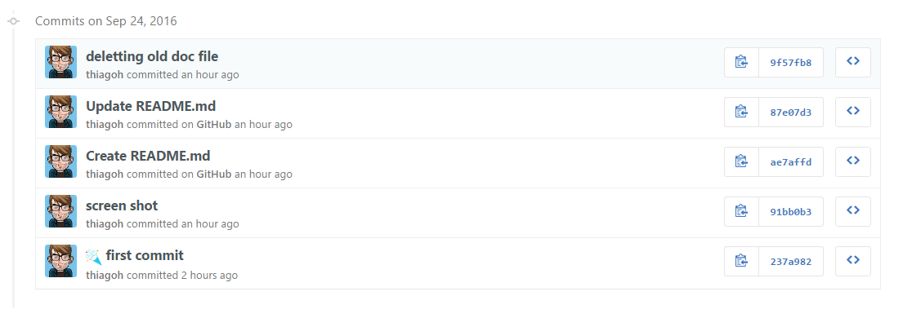

[This is the body of your video game design document. You should add and delete sections as they pertain to your game’s design.]

1. **Game Overview**

*The game is about a cannon that tries to defend itself from animals specially cows. If the cannon can keep alive for a specific amount of time the player wins.*

*(ensure you mention the goal of the game and how to win if applicable)*

1. **Game Play Mechanics**

*The cows jump towards the cannon. The cannon must fire bombs against the animals to kill them, otherwise they are going to keep going in direction to the cannon and eventually touch the cannon, which lowers the cannon’s life.*

*This game is like a tower defender but a little different because the tower is the cannon itself.*

*The cannon is in the left of the screen above a platform. The cannon can move, but there are restrictions as it can only move above the platform. The cannon can shoot several types of bombs: metal bombs and tomatoes.*

* *Metal bombs are the infinite*
* *Tomatoes are larger than the metal bombs but are limited.*

*The enemies are spawned throughout the game. They move by jumping from right to left of the screen. The distance travelled by the cows (by jumping) can change based on a random factor and speed/direction of the wind. The wind’s speed combined with its direction can speed up or slow down the enemies. The wind speed and direction can change at any moment in the game.*

*If the enemies touch the cannon it loses some life. If the cannon’s life reach zero it is dead and the game is over.*

*If the cannon is able to kill all the enemies he wins the game.*

*The game points are calculated based on how many enemies were killed and the cannon life.*

1. **Camera**

*2D game, static platform point of view.*

1. **Controls**

*The first version of the game is playable only by keyboard.*

*WASD keys which are up, left, down, right, respectively.*

*Up and down control the angle of the cannon head so it points to where the bombs are going to be fired.*

*Left and Right control the cannon movement.*

1. **Saving and Loading**

*The game does not saves nor loads at anytime.*

1. **Interface Sketch**

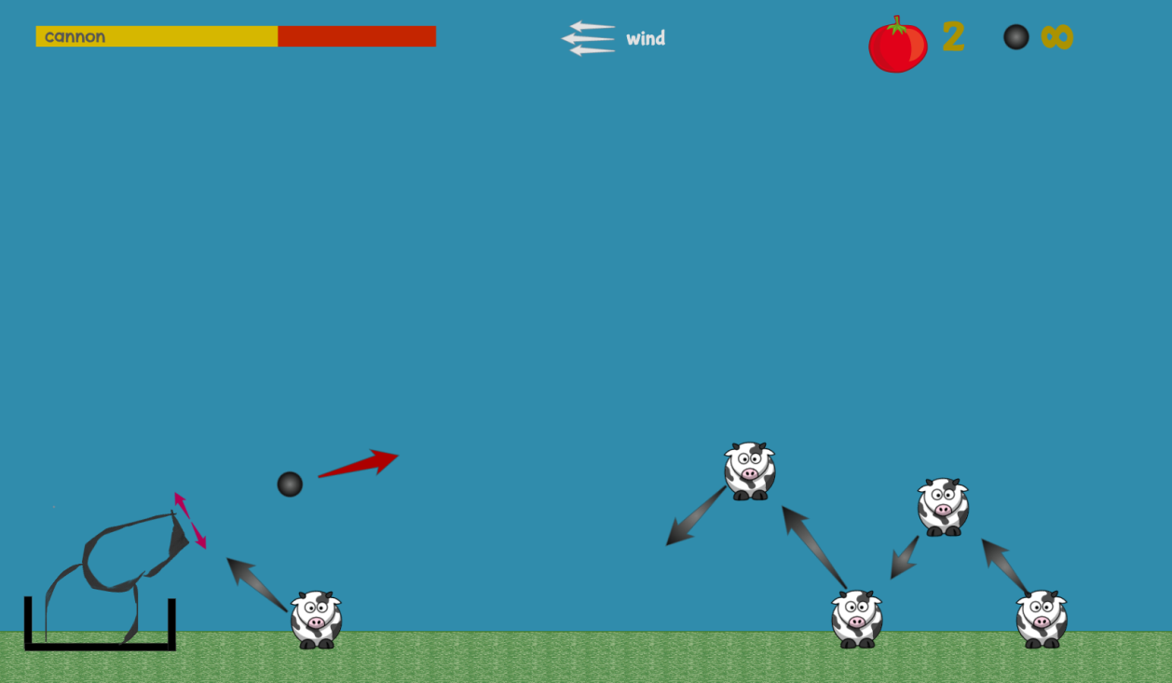

1. **Menu and Screen Descriptions**

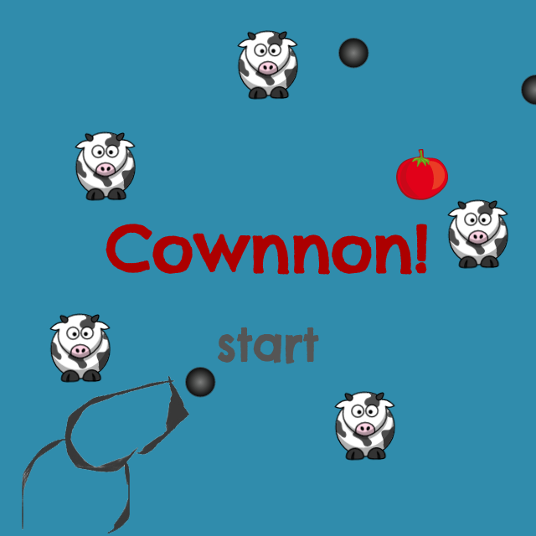

1. **Game World**

*The world is an open field of grass.*

1. **Levels**

*There is only one level in the game.*

1. **Game Progression**

*The game does not progresses as there is only one level*

1. **Characters / Vehicles**

*The cannon. Moves to left and right. Its head angle (relative to the floor) can change, but only in the first quadrant (0º to 90º).*

1. **Non-player Characters**

Not applicable

1. **Enemies**

*Cows*

1. **Weapons**

*Described in the game mechanics*

1. **Items**

*There are no items to catch*

1. **Scoring**

**The cannon scores by killing the cows**

1. **Sound Index**
2. **Story Index**
3. **Art / Multimedia Index**

