|  |
| --- |
| TAPIOCA GAMES |
| Johnny World |
| Johnny World Game specs |
| Version #01  All work Copyright © 2016 by TApioca Games.  All rights reserved. |
| **Thiago Andrade** |
|  |



|  |
| --- |
| Oct 22th 2016 |

**Table of Contents**

[Your Table of Contents should go here. Make sure that your document’s sections are hyperlinked to their corresponding pages.]

**Version History**

Github Link: <https://github.com/thiagoh/johnny-world>

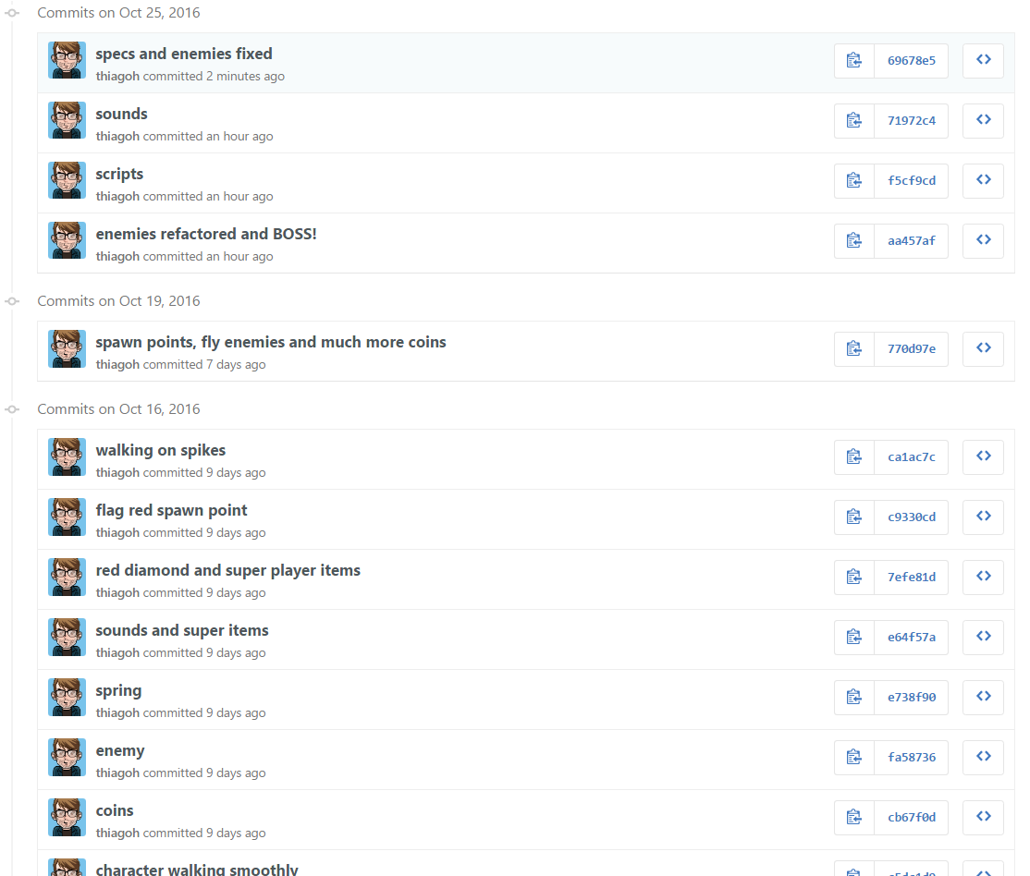

[This is the body of your video game design document. You should add and delete sections as they pertain to your game’s design.]

1. **Game Overview**

*The game is about an Alien called Johnny who lives in a danger World and face a lot of challenges everyday against enemies who want to kill him. His main objectives are keeping himself alive and killing the Giant Alien Boss who wants to govern his world.*

1. **Game Play Mechanics**

*Johnny has to go over the platforms collecting coins which can keep him alive. Killing the enemies around the scene is optional but there are some enemies which blocks the way to a coin or diamonds, so might be a good idea trying to kill them to collect as much coins as you can. Spikes are all over the world and might hurt Johnny if he touches them.*

*Red diamonds gives super powers to Johnny and he gets immortal for some seconds, which can be used to run and kill as much enemies as you can.*

*To kill the enemies Johnny has to jump on their heads but if he touches the body of the enemies he might get hurt as well, so, be careful!*

*Johnny is like a cat, but has more than 7 initial lives!*

*The Giant Alien Boss has three lives, jumps randomly and runs faster than Johnny sometimes. It’s really a hard challenge killing him. You’ll need a lot of patience.*

1. **Camera**

*2D game, scroller platform point of view.*

1. **Controls**

*The game is playable only by keyboard using W(jump) A(left) and D(right).*

1. **Saving and Loading**

*The game does not saves nor loads at anytime.*

1. **Interface Sketch**

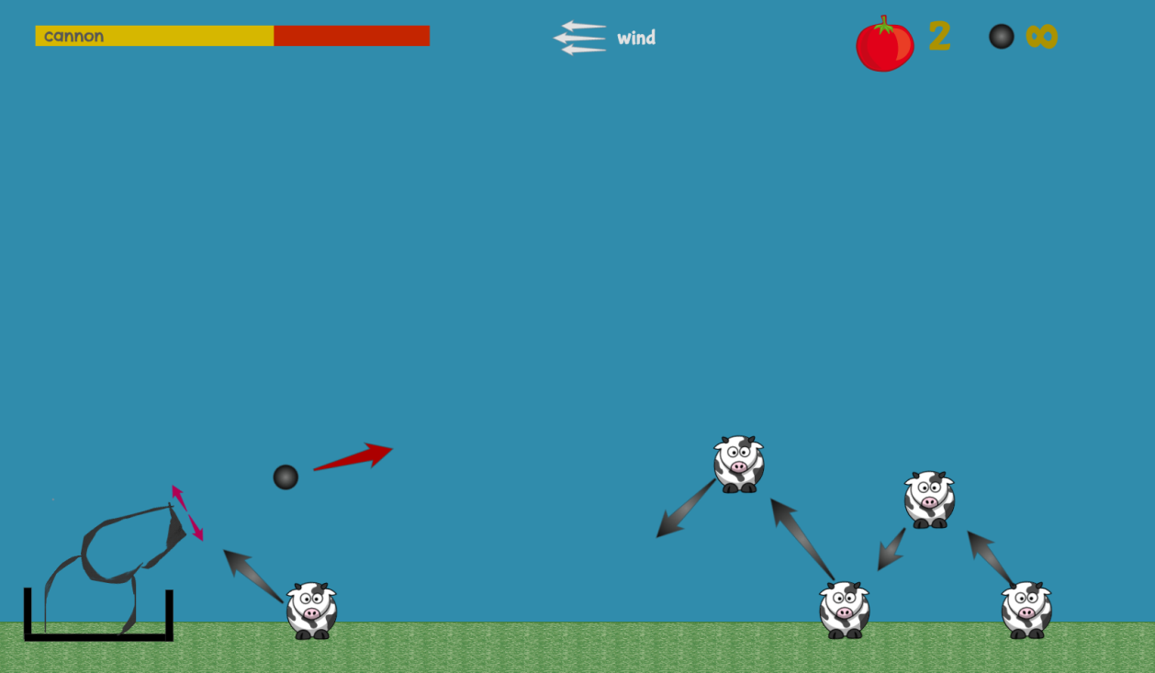

1. **Menu and Screen Descriptions**

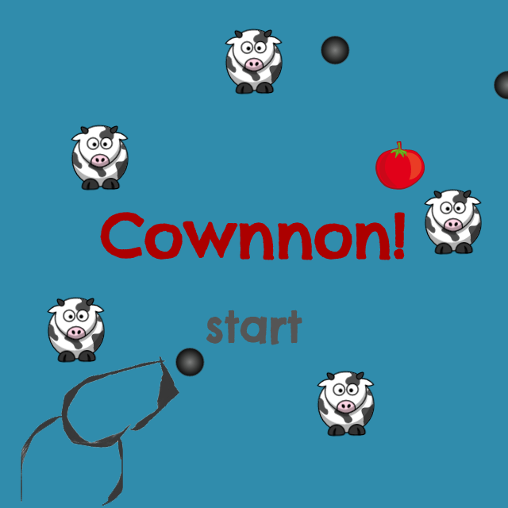

1. **Game World**

*The world is an open field of grass.*

1. **Levels**

*There is only one level in the game.*

1. **Game Progression**

*The game does not progresses as there is only one level*

1. **Characters / Vehicles**

*The cannon. Moves to left and right. Its head angle (relative to the floor) can change, but only in the first quadrant (0º to 90º).*

1. **Non-player Characters**

Not applicable

1. **Enemies**

*Cows*

1. **Weapons**

*Described in the game mechanics*

1. **Items**

*There are no items to catch*

1. **Scoring**

**The cannon scores by killing the cows**

1. **Sound Index**

* **Game-over.ogg**
* **Explosion5.wav**

1. **Art / Multimedia Index**

