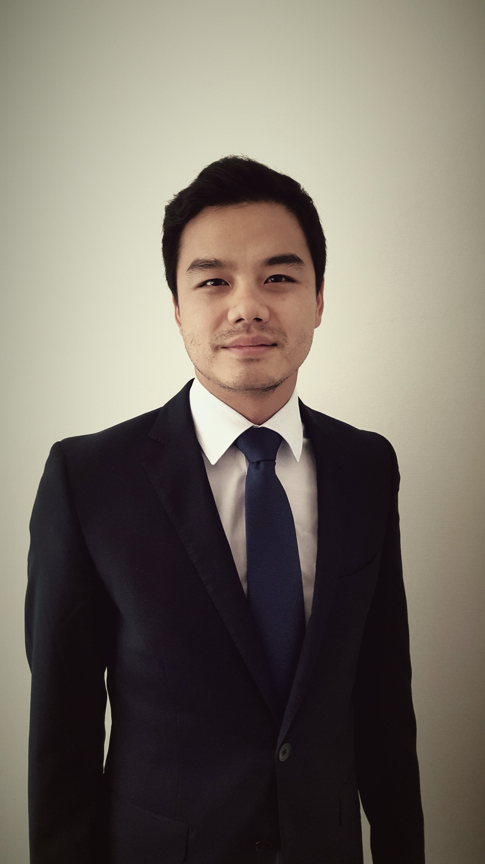

**CURRICULUM VITAE**

**Steven LY**

French national

33 years old

Tel: +33 6 42 80 83 89

Email: [stevenly8884@gmail.com](mailto:stevenly8884@gmail.com)

**Work Experience**

|  |  |  |
| --- | --- | --- |
| Since May 2012   |  | | --- | |  |   **Tokyo, Japan**  *Since May 2018* | **AXA GROUP**  **AXA Group / Centre of excellence**  **Head of Investment accounting and reporting**   * Management of COE team (5 people) and FSSC team (17 people): * Monthly and quarterly accounting closing in IFRS, Solvency II and Japanese GAAP * Quarterly reporting (IFRS disclosures and Solvency II) * Ad hoc project : optimization of processes, IFRS 9, support IFRS 17   **Senior investment accounting and reporting Controller** |
| **Hong Kong**  *March 2017 - Apr 2018*  **Tokyo, Japan**  *March 2016 – Feb 2017*  **Paris, France**  *June 2014 – Feb 2016* | * Transformation and optimization of the investment accounting and reporting activities of AXA Germany / Japan / currently Asia: * Transfer of local activities from AXA local entities to AXA FSSC (financial shared service center) India * Training of AXA FSSC resources * Management of FSSC team: * Monthly and quarterly accounting closing in IFRS and German GAAP (HGB) / Japanese GAAP / HK GAAP * Monthly reporting, such as concentration risk (investment asset database) and local regulatory reporting * Quarterly reporting (IFRS disclosures) * Ad hoc project |
| **Cologne, Germany** | **AXA Germany - Investment reporting specialist** |
| |  | | --- | |  |   *May 2012 – May 2014* | * Analysis and monitoring of the investment performance of life insurance company (Germany), working closely with investment strategy teams * Process of collecting investment information, analyzing results, and preparing quarterly closing analyses and executive reports for management board in Germany and in Paris * Monthly analyses: preparation of dashboard to monitor investment activity for management (CFO), monthly investment performance analyses of each of the life insurance * Assist in special projects (merger, implementation of a new system) * Provide ad-hoc analyses upon request (from Group in Paris, other department in AXA Germany, from Federal Financial Supervisory Authority) |

|  |  |
| --- | --- |
| Oct. 2011 – Dec. 2012 | **BleachLounge *–* Founder** |
| **Cologne, Germany** | *Teeth bleaching esthetic studio*   * Set up of the company * Daily management, accounting, controlling and marketing |

|  |  |
| --- | --- |
| Oct. 2010 – Oct. 2011 | **KPMG Advisory (Private Business Advisory Services) - Consultant** |
| **Paris, France** | *Professional Services (Audit, Tax, and Consultancy services), present in 156 countries with a revenue of 23 billlion USD*   * Accounting review for foreign companies located in France * Preparation of year-end annual statements * Preparation of monthly reporting analyses and dashboard for a French multinational * Project: in forensic department (fraud and litigation) of KPMG * Project: analyzing the social account for a worldwide media group * Preparation of payslips and tax returns |

|  |  |
| --- | --- |
| Dec. 2008 – Aug. 2009 | **SHA Audit – Accountant / auditor** |
| **Paris, France** | *Auditing and Accounting company*   * Auditing and accounting review * Accounting of approximately thirty clients (bookkeeping, monthly tax returns, year-end annual statement) * Preparation of financial forecasts, consultation and advisory |

**Education**

October 2016 **ACCA - Association of Chartered Certified Accountant** (UK)

October 2010 **Master’s degree - Superior Diploma of Accounting and Management** (France)

Aug. 2009 - Aug. 2010 **Linguistic program: Mandarin**, Shanghai International Studies University (China)

Jul. 2007 - Mar. 2008 **Linguistic program: Mandarin and English**, DI QIU CUN School of Beijing (China)

July 2007 **Master's degree of Finance and Accounting**, University of Strasbourg (France)

July 2005 **Bachelor’s degree of Management, Finance & Accounting,** University of Mulhouse (France)

**Computer skills**

* Pack Office: Excel (strong knowledge), Word and PowerPoint
* Accounting software: SAP, Sage, People Soft, Business Object

**Languages**

* French: mother tongue
* English: fluent
* German: fluent
* Mandarin: intermediate

**Activities**

* Interests: Forex trading, Sport (tennis, basket, swimming), reading, cinema
* Travel: China, Korea, Thailand, Finland, Tunisia, Vietnam, Cambodia, United Arab Emirates, USA, Greece