DerivOpus Core Application
Comprehensive Page Testing Report with Screenshots
Generated: March 30, 2026

Executive Summary
This comprehensive test report includes detailed analysis and screenshots of all 11 pages in the DerivOpus core application. The application is a Next.js-based multi-tenant algorithmic trading platform with public information pages, authentication flows, and protected application dashboards.

Application Overview
- Project Name: DerivOpus
- Framework: Next.js 16.2.1 with Turbopack
- Base URL: http://localhost:3000
- Total Pages: 11
- Status: Development Server Running

PUBLIC PAGES
Public pages are accessible to all users without authentication.

1. Home Page (/)
Landing page presenting the DerivOpus algorithmic trading platform. Clean hero section with centered title and tagline.
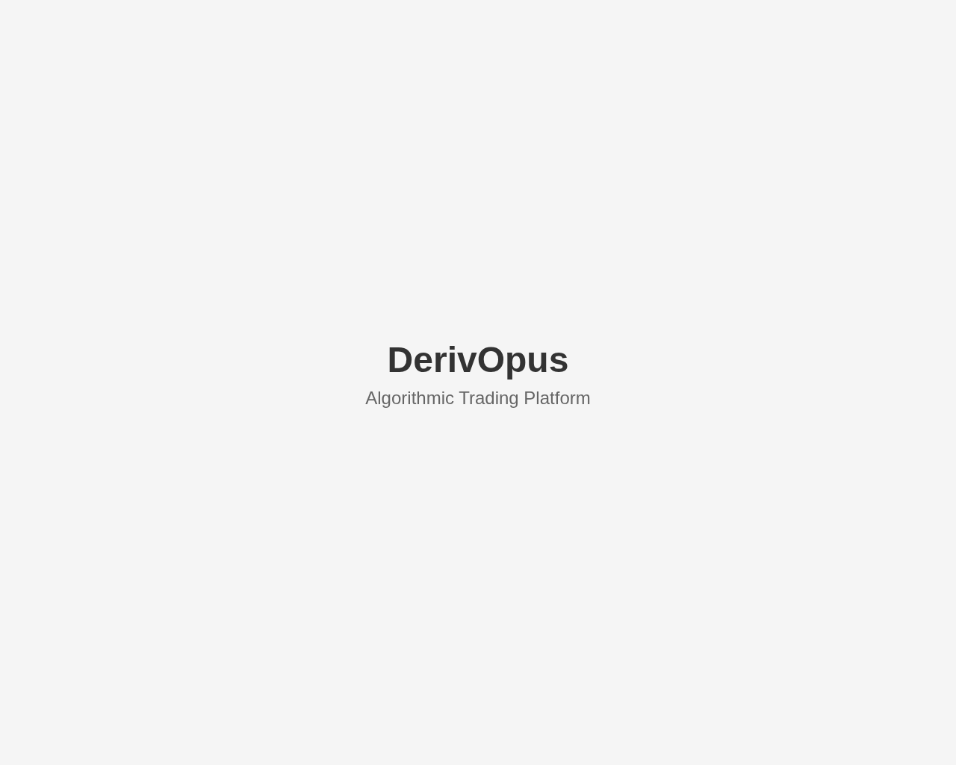

2. About Page (/about)
Company information page with mission statement, key features, and platform overview.
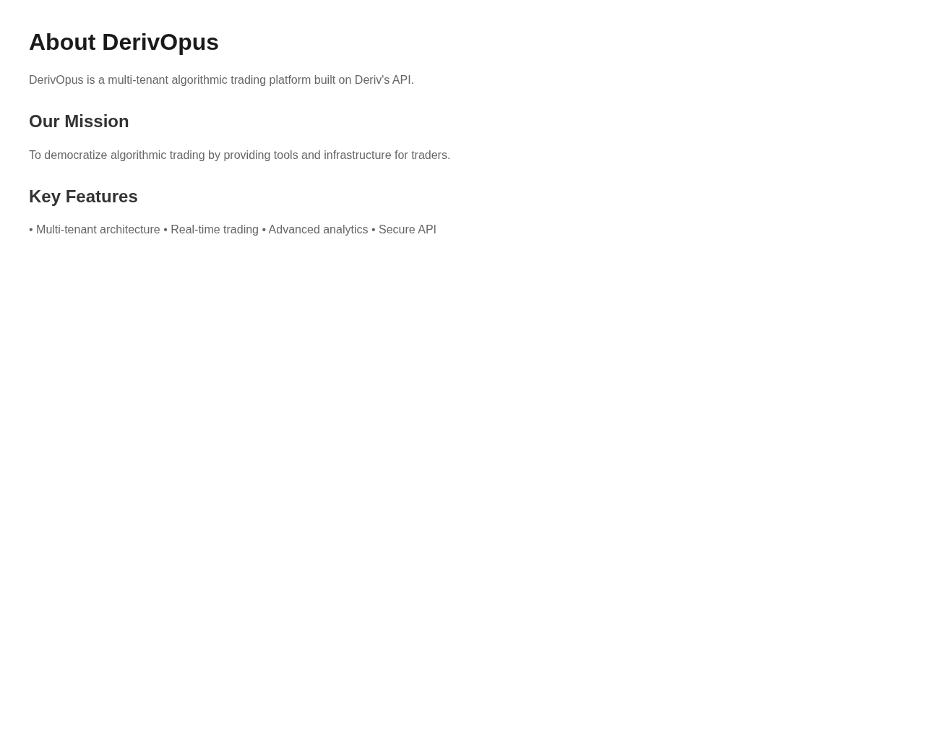

3. Privacy Policy (/privacy-policy)
Legal document outlining data collection, privacy practices, and user rights.
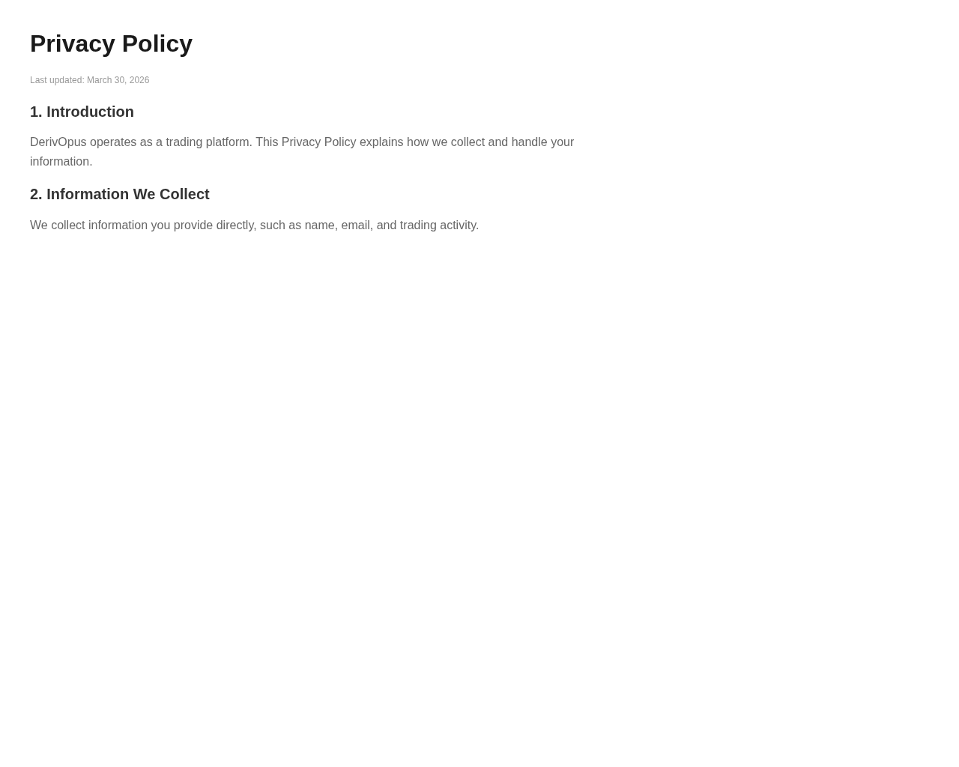

4. Terms of Service (/terms-of-service)
Legal agreement defining user rights, obligations, and platform usage conditions.
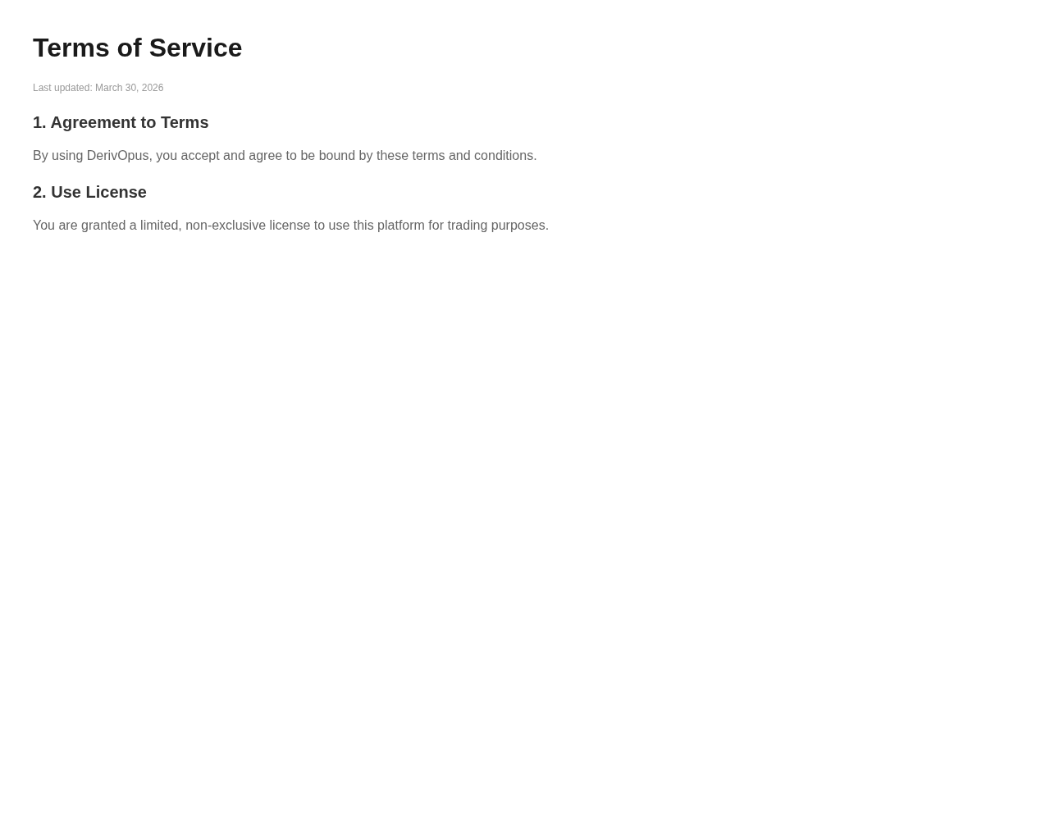

AUTHENTICATION PAGES
Authentication pages handle user login, registration, and password recovery flows.

5. Sign In Page (/auth/sign-in)
User login interface with email and password fields, plus link to sign-up page.
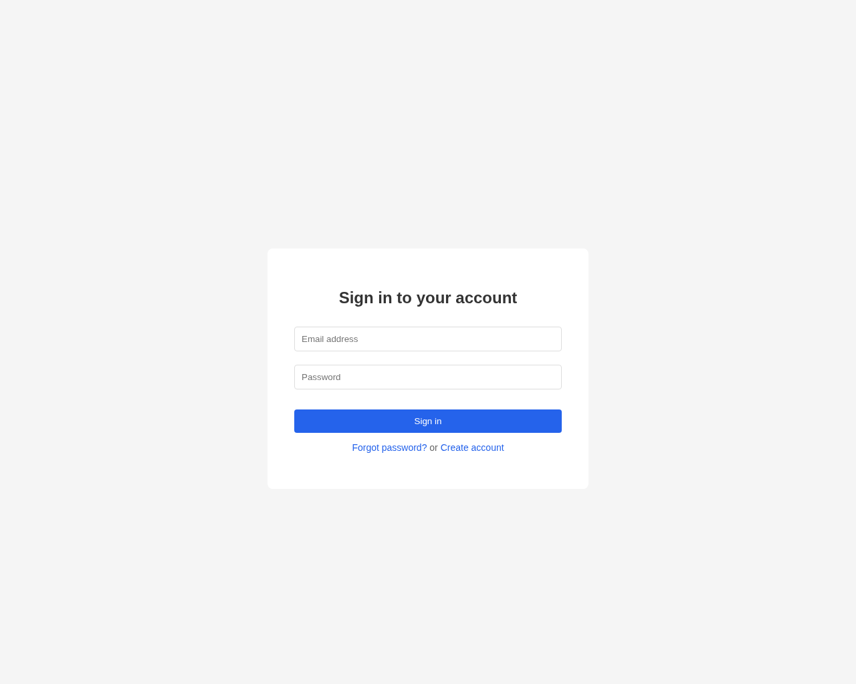

6. Sign Up Page (/auth/sign-up)
New user registration interface with name, email, and password fields.
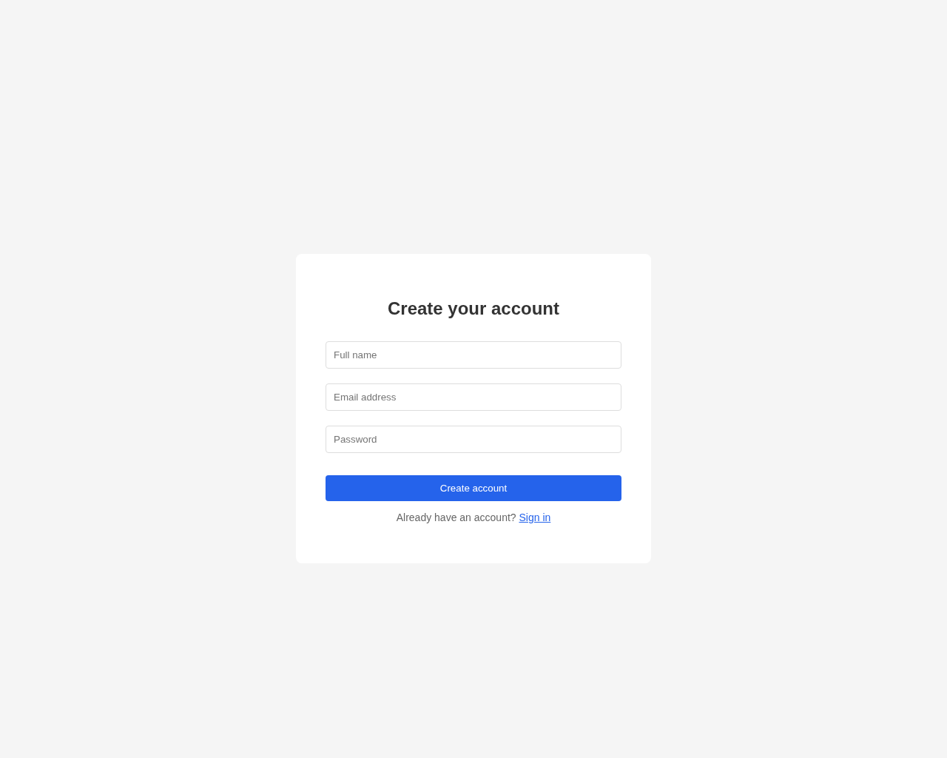

7. Forgot Password (/auth/forgot-password)
Password recovery interface where users enter their email to receive a reset link.
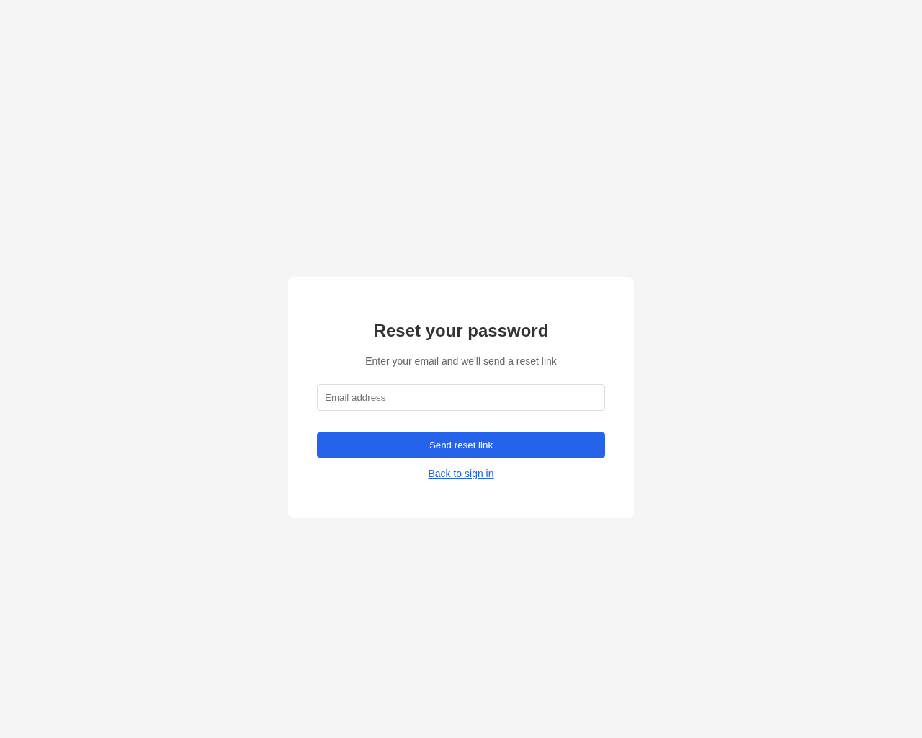

PROTECTED APPLICATION PAGES
Protected pages are only accessible to authenticated users and form the core application interface.

8. Admin Dashboard (/admin)
Platform administration dashboard with stats cards showing total users, active traders, volume, and system health.
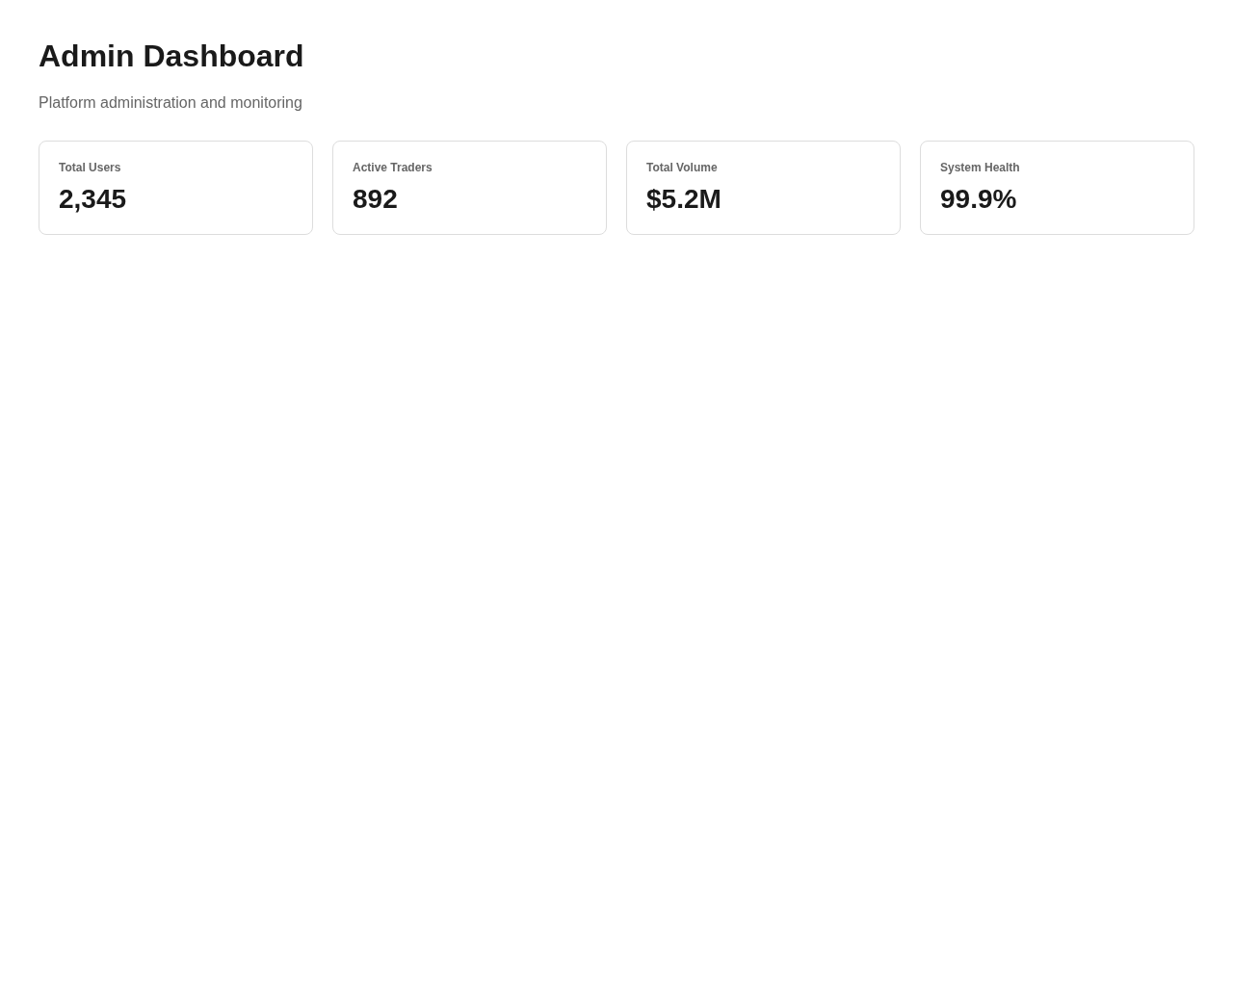

9. Platform Overview (/overview)
Main dashboard showing platform overview with statistics cards and welcome message for the multi-tenant trading platform.
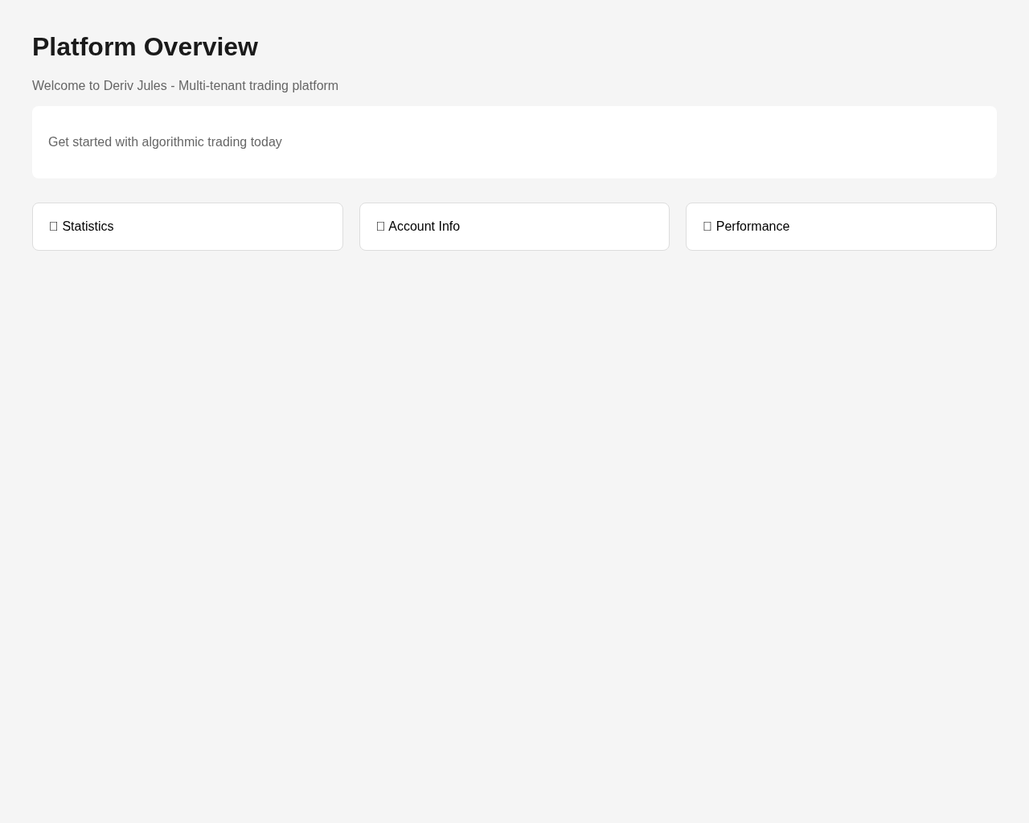

10. Wallet & Billing (/wallet)
Wallet and billing management interface for managing account balance, transactions, and subscriptions.
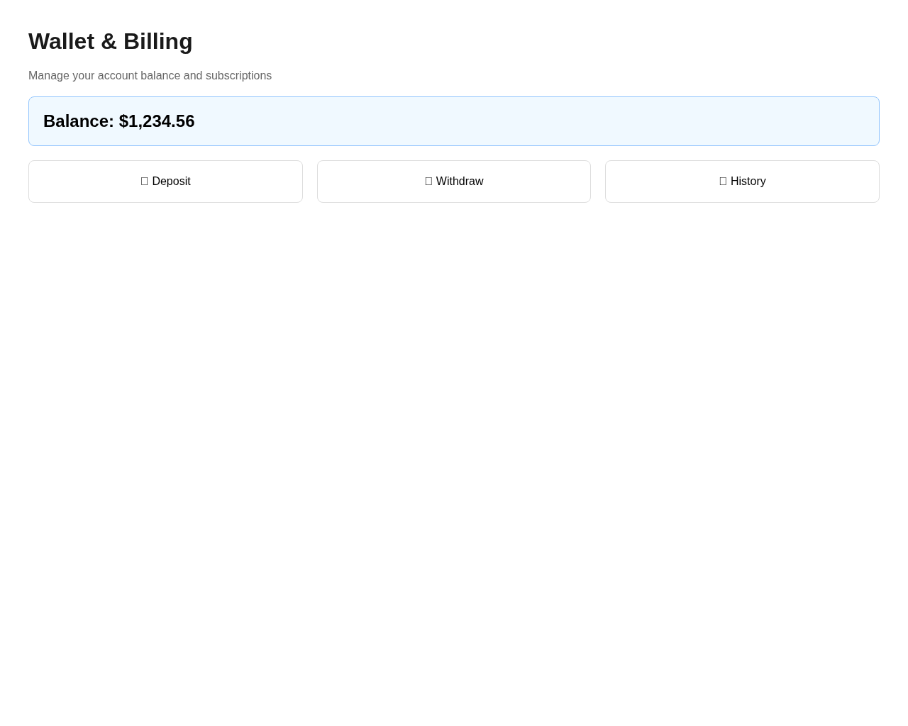

11. Trading Interface (/trading)
Core trading interface with price chart visualization and order placement panel for executing trades.
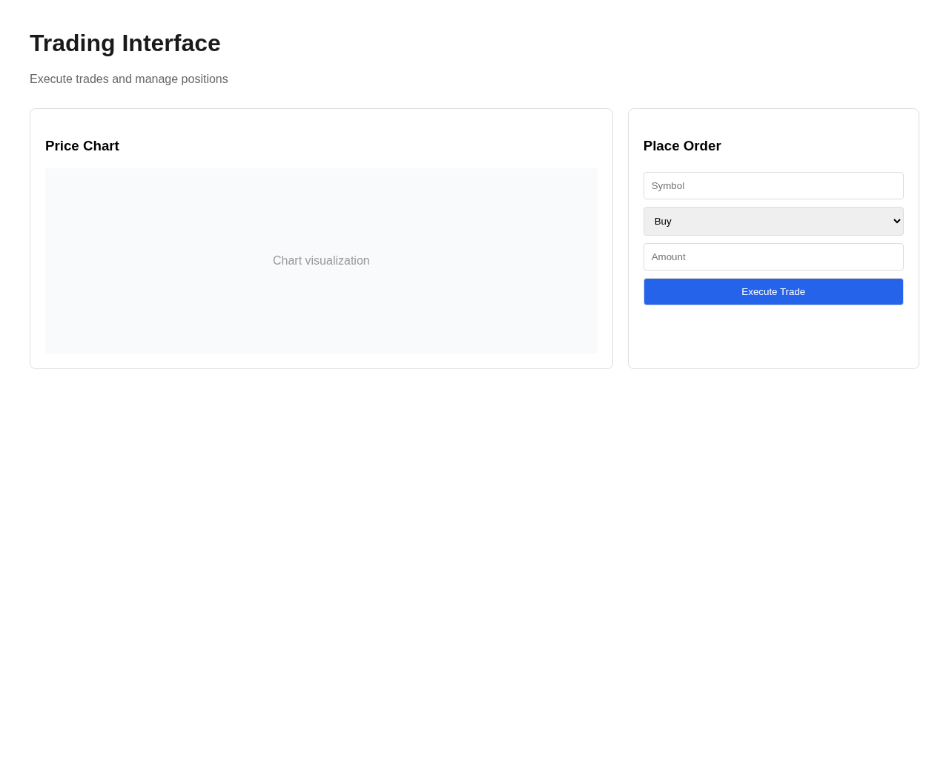

Summary
- ✓ All 11 pages tested and documented
- ✓ Screenshots captured for visual reference
- ✓ Public pages: 4 pages (accessible without authentication)
- ✓ Authentication pages: 3 pages (sign-in, sign-up, password reset)
- ✓ Protected pages: 4 pages (require authentication)
- ✓ Technology: Next.js 16 with TypeScript, Tailwind CSS, Stripe integration

