**Meaning and benefits :** Inharance is a statement within the program where the developer can use the same parameter, method and assignment through the base class to other subclasses which can use them without re-declaring the same things.

**Providing an application:** In this case, using inheritance we have the advantage of reusing the same method in the subclass, and we can solve the problem in just one place, this makes the code simpler, reusable and more enjoyable to work with.

**Example of code:**

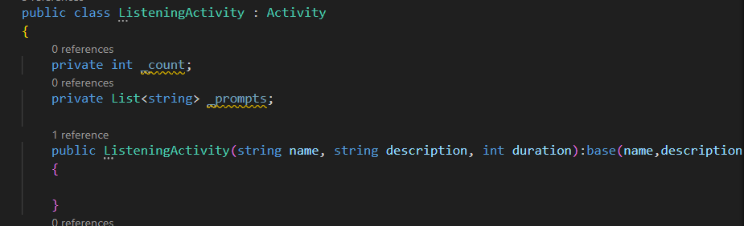

In this part of my code I am assigning all the parameters inside the Base Class Activity to my subclass Listening activity, and I am using the arguments (name, description, duration) inside my subclass after putting the colon (:) to show what arguments come from my base;