UNIVERSIDADE DO VALE DO ITAJAÍ ESCOLA POLITÉCNICA
Processamento Digital de Sinais
2025/2

Tarefa M1 - PDS

Engenharia da Computação
Thiago Yukio Horita Pacheco
Itajaí, 16/09

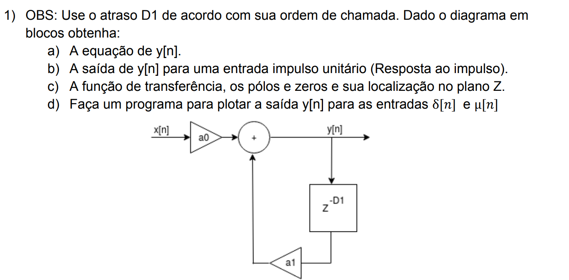

a)
$$y\left[n\right]=a_{0}∙x\left[n\right]+a_{1}∙y[n-9]$$

b)
$$y\left[0\right]=a_{0}∙δ\left(0\right)+a_{1}∙y\left[-9\right]=a_{0}∙1+a_{1}∙0=a_{1}$$
$$y\left[1\right]=a_{0}∙δ\left(1\right)+a_{1}∙y\left[-8\right]=a_{0}∙0+a_{1}∙0=0$$
$$y\left[8\right]=a_{0}∙δ\left(8\right)+a_{1}∙y\left[-1\right]=a_{0}∙0+a_{1}∙0=0$$
$$y\left[9\right]=a_{0}∙δ\left(9\right)+a_{1}∙y\left[0\right]=a_{0}∙0+a_{0}∙a_{1}∙1=a_{0}∙a_{1}$$

c)
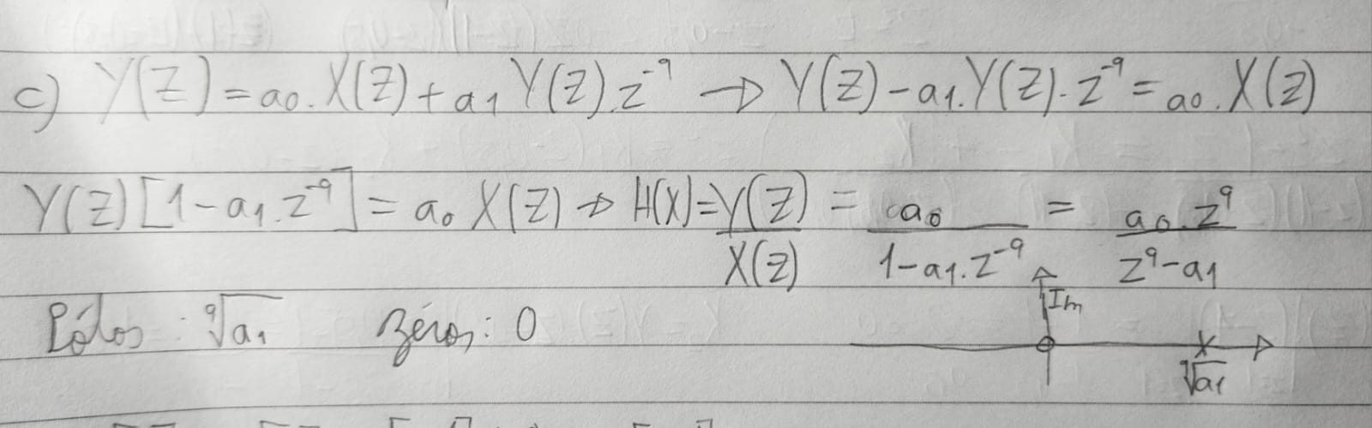

Código:
import numpy as np
import matplotlib.pyplot as plt

n = np.arange(0, 101, 1)

a0 = 1

a1 = 1

x = np.where(n ==0, 1, 0.0)

y = np.zeros(len(n))

for k in range(len(n)):
x_k_9 = x[k-9] if k-9 >= 0 else 0
y_k_9 = y[k-9] if k-9 >= 0 else 0
y[k] = a0*x[k] + a1*y_k_9

plt.subplot(2, 1, 1)
plt.stem(n, x)
plt.ylabel('x[n]')
plt.subplot(2, 1, 2)
plt.stem(n, y)
plt.ylabel('y[n]')
plt.show()

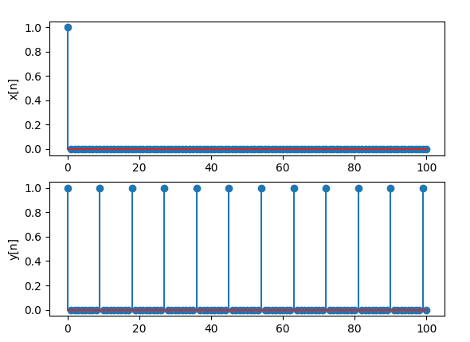

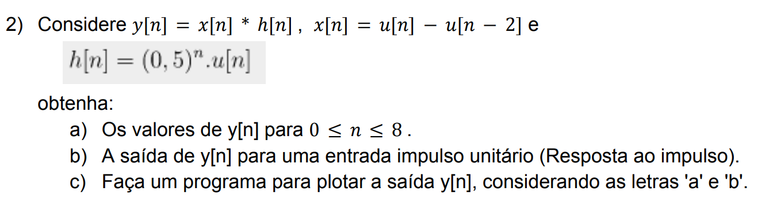

a)
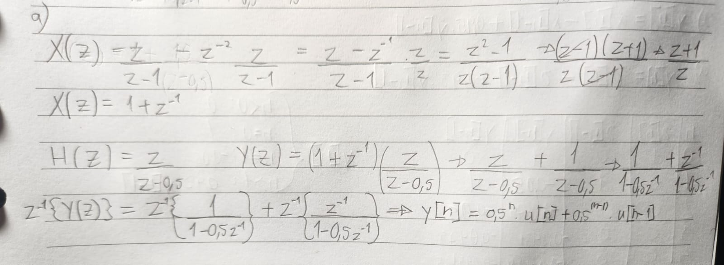

b)
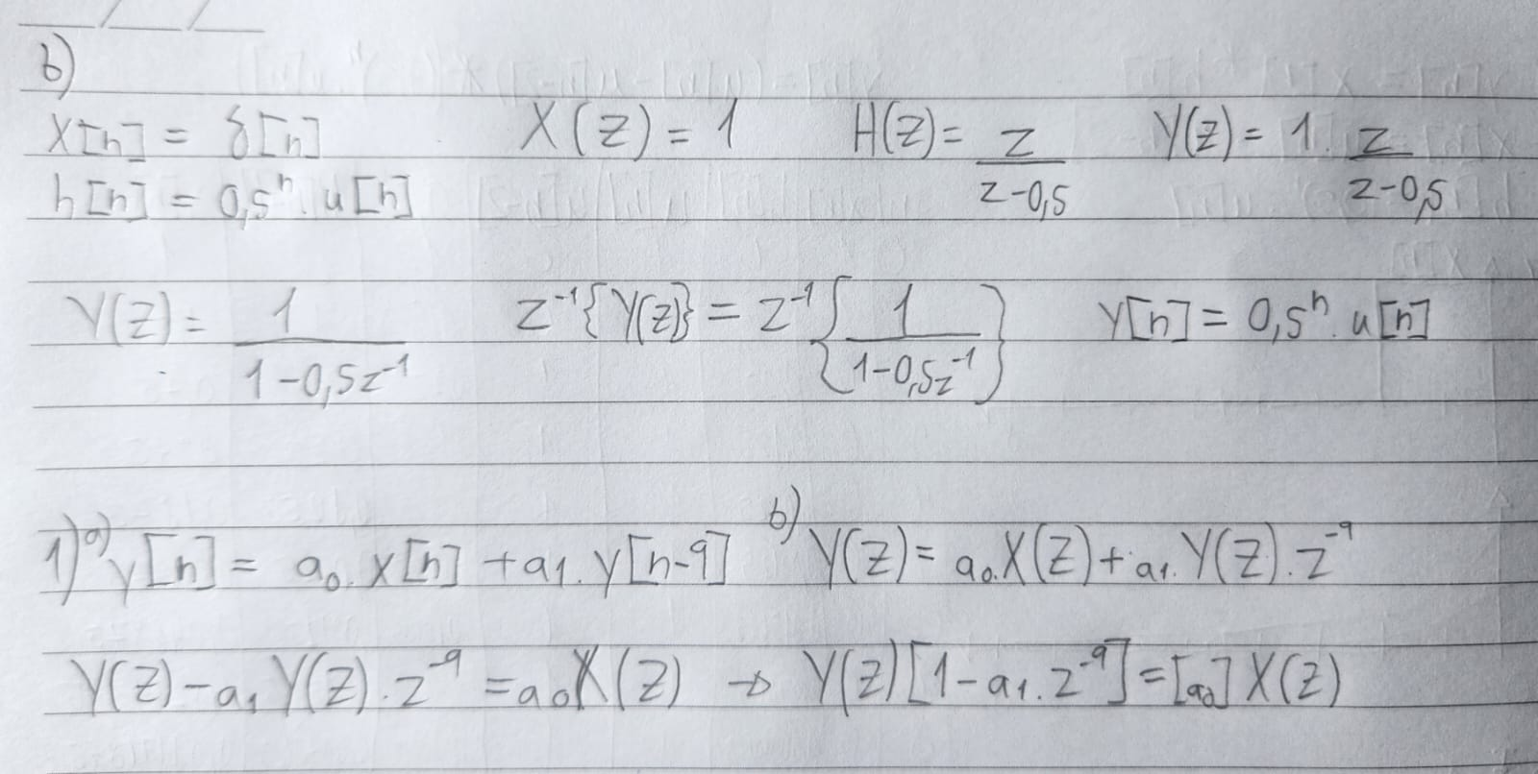

c)
Código da a):
import numpy as np
import matplotlib.pyplot as plt

n = np.arange(0, 9, 1)

x = np.where((n >= 0) & (n < 2), 1, 0.0)
h = np.where(n >= 0, 0.5**n, 0.0)

n = len(x) + len(h) - 1 # Tamanho do sinal de saída

y = np.convolve(x, h) # Convolução

plt.subplot(3, 1, 1)
plt.stem(np.arange(0, len(x)), x)
plt.ylabel('x[n]')

plt.subplot(3, 1, 2)
plt.stem(np.arange(0, len(h)), h)
plt.ylabel('h[n]')

plt.subplot(3, 1, 3)
plt.stem(np.arange(0, len(y)), y)
plt.ylabel('y[n]')
plt.show()

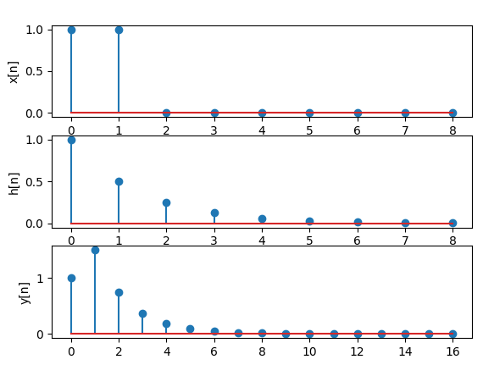

Código da b):
import numpy as np
import matplotlib.pyplot as plt

n = np.arange(0, 9, 1)

x = np.where((n >= 0) & (n < 2), 1, 0.0)
h = np.where(n == 0, 1, 0.0)

# n = len(x) + len(h) - 1 # Tamanho do sinal de saída

y = np.convolve(x, h) # Convolução

plt.subplot(3, 1, 1)
plt.stem(np.arange(0, len(x)), x)
plt.ylabel('x[n]')

plt.subplot(3, 1, 2)
plt.stem(np.arange(0, len(h)), h)
plt.ylabel('h[n]')

plt.subplot(3, 1, 3)
plt.stem(np.arange(0, len(y)), y)
plt.ylabel('y[n]')
plt.show()

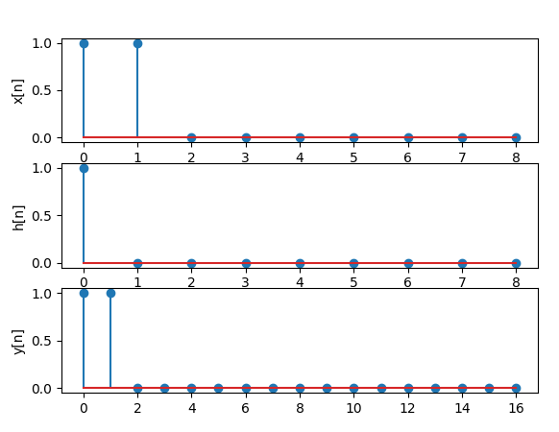

3)
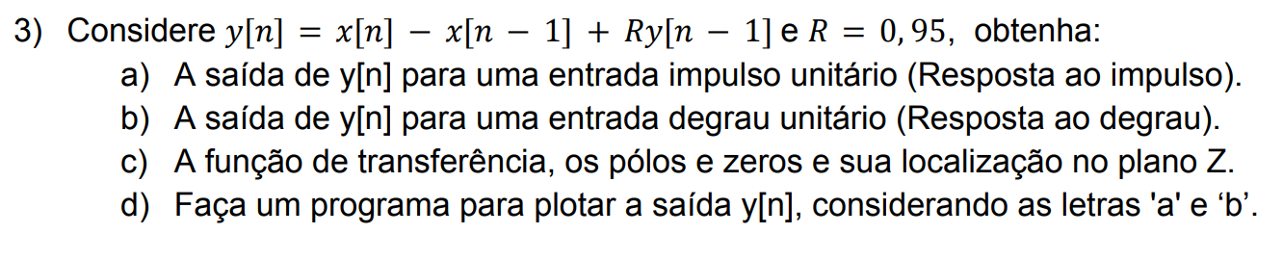

a)
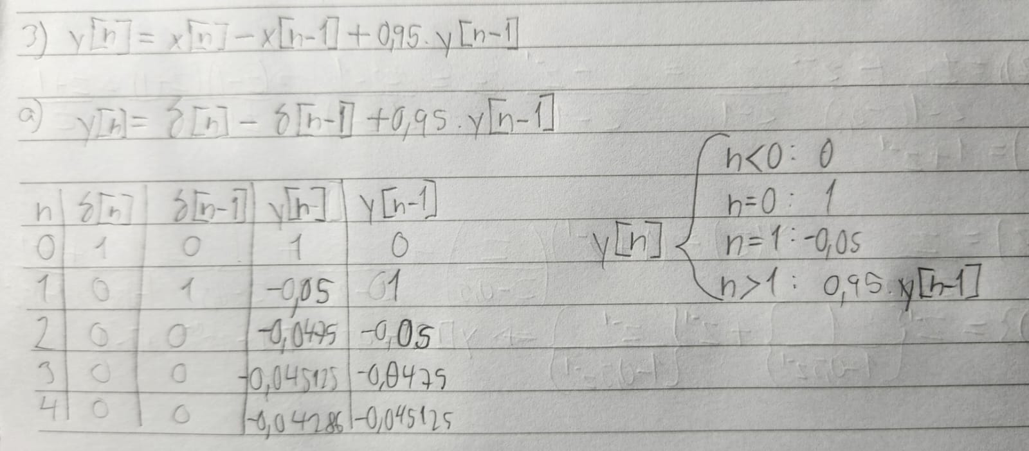

b)
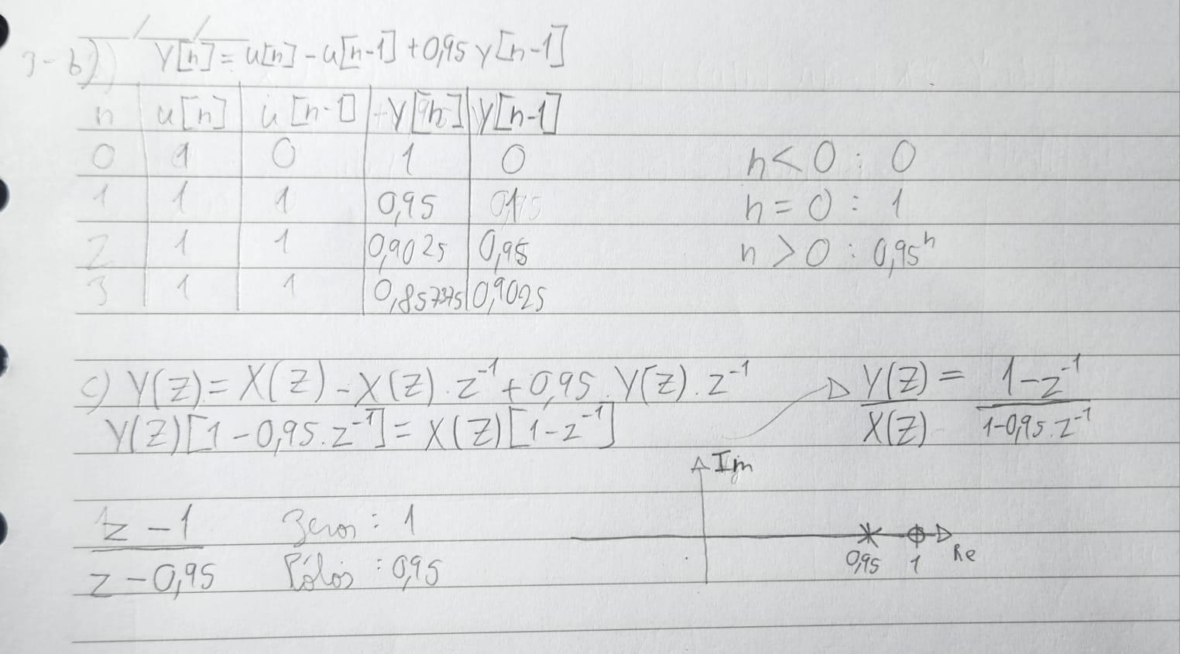

c)


d) Código da a):
import numpy as np
import matplotlib.pyplot as plt

n = np.arange(0, 5, 1)
x = np.where(n==0, 1, 0.0)
y = np.zeros(len(n))

for k in range(len(n)):
x_k_1 = x[k-1] if k-1 >= 0 else 0
y_k_1 = y[k-1] if k-1 >= 0 else 0
y[k] = x[k] - x_k_1 + 0.95*y_k_1

plt.subplot(2, 1, 1)
plt.stem(n, x)
plt.ylabel('x[n]')
plt.subplot(2, 1, 2)
plt.stem(n, y)
plt.ylabel('y[n]')
plt.show()

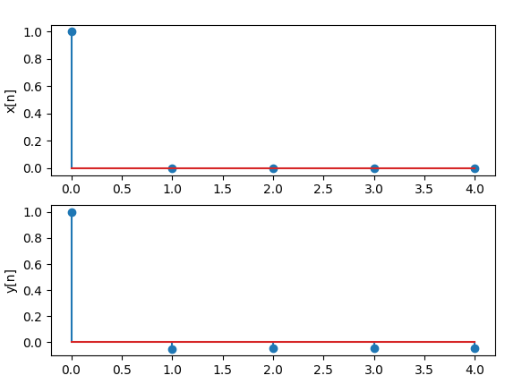

Código da b):
import numpy as np
import matplotlib.pyplot as plt

n = np.arange(0, 5, 1)
x = np.where(n>=0, 1, 0.0)
y = np.zeros(len(n))

for k in range(len(n)):
x_k_1 = x[k-1] if k-1 >= 0 else 0
y_k_1 = y[k-1] if k-1 >= 0 else 0
y[k] = x[k] - x_k_1 + 0.95*y_k_1

plt.subplot(2, 1, 1)
plt.stem(n, x)
plt.ylabel('x[n]')
plt.subplot(2, 1, 2)
plt.stem(n, y)
plt.ylabel('y[n]')
plt.show()

