**fluidmeet.com**

**Page Analysis** Score: 43.9%

General overview

There are numerous problems on your page. The Page Analysis Score is 43.9%. You should work in particular performance, design and content.

|  |  |
| --- | --- |
|  | SEO: 57.4%  Accessibility: 51.2%  Performance: 11.7%  Content: 25.3%  Design: 48.1% |

SEO: 57.4%

SEO Overview

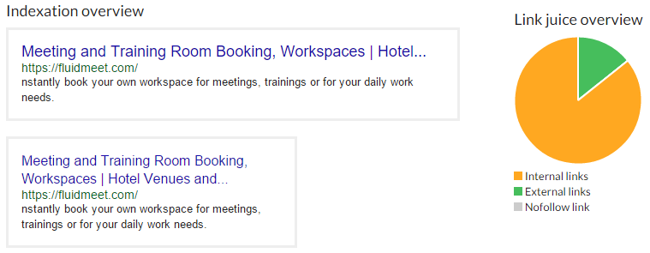

Header information

**Page Title:**The page title is too long.

*Meeting and Training Room Booking, Workspaces | Hotel Venues and Banquet Halls*

78 characters.

*It is recommended to have between 55 and 65 characters. The title of the page has to contain the main keywords and the name of your organisation/brand. Describe the page's content instead of keyword stuffing. Every page has to have a unique title.*

**Meta Description:**Meta description is too short.

*nstantly book your own workspace for meetings, trainings or for your daily work needs.*

86 characters.

*It is recommended to have between 140 and 170 characters. This meta tag should describe the page without being a straight forward list of keywords and has to contain the most important keywords of the page. Ensure that each of your web pages have a unique meta description.*

**Meta attributes**

| **Type** | **Meta** | **Content** |
| --- | --- | --- |
| charset |  | utf-8 |
| name | google-site-verification | hH6ozRrMbvOR5lgJZZYWGwmOANTTSJuRNqfOwB1CwHk |
| name | keywords | meeting room |
| name | description | nstantly book your own workspace for meetings, trainings or for your daily work needs. |
| name | viewport | width=device-width, initial-scale=1.0 |
| http-equiv | x-ua-compatible | IE=edge |

*The meta attribute allow you to inform indications around the page which do not display in visible contents of this one.*

Indexation

**Meta Robots:**The Meta Robots tag allows indexation by search engines.

*(Missing)*

*This meta tag indicates to search engines if they must index or not index, follow or not follow specific links. This tag can be responsible for the absence of your website in search engines index.*

**Robots.txt:**The robots.txt file does not exist.

*The robots.txt file allows you to authorize or forbid the indexation of a page or a directory by a search engine. It also permits you to indicate the location of sitemap(s).*

**Sitemap:**Sitemap is not defined.

***0*** sitemap(s) have been defined.

*A sitemap is a file containing an ordered organisation of the linking structure of your website. This file is not only used to define the importance you attach to each page but also to help the search engines crawl your entire website. The location of the sitemap must be defined in the robots.txt file.*

Duplicate content

**WWW redirection (301):**Current redirection is a 302 redirection.

*It is essential to redirect your web pages to http://www or http:// (with or without www) to avoid duplicate content. Your website has to be accessible through a single address. The redirection should be a 301 redirection (Moved Permanently) rather than a 302 redirection (Moved Temporarily).*

**Link canonical:**Canonical URL is missing.

*(Missing)*

*The attribute link rel="canonical" allows you to avoid duplicate content. This attribute informs the search engine of the preferred version of a page/content in the case you have more than one page with a similar content.*

Multimedia

**Alternative text:**

***8/8*** images have an optimized alternative text.

| **Src** | **Alt** |
| --- | --- |
| /images/slider-img-1.jpg | Slider image |
| /images/slider-img-2.jpg | Slider image |
| /images/slider-img-3.jpg | Slider image |
| /images/slider-img-4.jpg | Slider image |
| /images/slider-img-5.jpg | Slider image |
| /images/ahmed.jpg | Testimonial image |
| /images/rafi.PNG | Testimonial image |
| /images/amar.jpg | Testimonial image |

Networking

**Number of links:**The number of link tags is correct.

There are ***37*** links in your page.

| **N** | **Href** |
| --- | --- |
| 0 | / |
| 1 | / |
| 2 | /venue |
| 3 | / |
| 4 | /Dubai/search-workspace?city=Dubai&day=Day&workspace=all |
| 5 | /application/index/signup |
| 6 | /application/index/login |
| 7 | /application/index/contact-us |
| 8 | # |
| 9 | /application/index/how-to-book |
| 10 | /venue?scrollTo=howtobook |
| 11 | / |
| 12 | / |
| 13 | /venue |
| 14 | /application/index/signup |
| 15 | /application/index/login |
| 16 | /application/index/contact-us |
| 17 | /application/index/how-to-book |
| 18 | /venue?scrollTo=howtobook |
| 19 | # |
| 20 | javascript:bookmarkscroll.scrollTo('content') |
| 21 | javascript:bookmarkscroll.scrollTo('how-work') |
| 22 | javascript:bookmarkscroll.scrollTo('testimonials') |
| 23 | javascript:bookmarkscroll.scrollTo('about') |
| 24 | javascript:bookmarkscroll.scrollTo('contact') |
| 25 | # |
| 26 | /venue |
| 27 | javascript:bookmarkscroll.scrollTo('book-space') |
| 28 | /application/index/login |
| 29 | /application/index/signup |
| 30 | https://www.facebook.com/fluidmeet?fref=ts |
| 31 | https://twitter.com/fluidmeet |
| 32 | https://www.linkedin.com/company/fluidmeet?trk=top_nav_home |
| 33 | https://plus.google.com/108354647198136527432/posts |
| 34 | /application/index/terms |
| 35 | /application/index/privacy-policy |
| 36 | /application/index/refund |

*Too many links in a page decrease the importance of each one of them.*

**Link Juice:**There are more internal links than external links.

***10.8%*** of your links are external links, whether 4/37 links.

*The link juice is to the ratio between internal links and external links. It is used to detect if the site is a gateway with the aim to redirect the user towards another site or not. This ratio must be lower than 50%.*

**Single links:**There is no double link in the page.

***59.5%*** of your links are not single, whether 15/37 links.

**Links without underscores:**There is no links with underscore.

***100%*** of your internal links contain underscores (_), whether 0/33 links.

*The use of underscores "_" in a link is not recommended. These are not recognized by search engines as word separators. You should replace them by hyphens "-".*

*This score is obtained by measuring the ratio between single links and duplicated links.*

**Follow links:**Links are corrects.

***100%*** of your links are followed by search engines, whether 37/37 links.

*This attribute indicates to search engines whether or not this link should be followed. Too many "no-follow" links increase the distribution of the link juice and decrease the importance of the other links. Wherever possible avoid defining more than five "no-follow" links on the same page.*

**Reliable links:**Some links are not reliable.

***75.7%*** are reliable links, whether 28/37 links.

*This ratio corresponds to the number of reliable links. That is to say the number of links which search engines can crawl.*

Content: 25.3%

Content Overview

***Ratio Text/code***

1.12% of text in the page.

***Quantity of keywords***

365 keywords

***Keyword repetition***

224 unique keywords on 365 keywords

Content performance

**Text/code ratio:**Text/Code ratio is too low.

***1.12%*** of your page content is text type.

*The text/code ratio is used to determine the quality of a page. The higher the ratio is, the more important the content will be.*

Semantic

**Titles:**

* H1 Title is missing or empty.
* H2 Title is missing.
* H3 Title is missing.
* Hx titles are not optimized.

| **h1** | **h2** | **h3** | **h4** | **h5** | **h6** |
| --- | --- | --- | --- | --- | --- |
| **0** | **0** | **0** | **0** | **0** | **0** |

*H titles are used to organise the structure of the page in relation to their order of importance. Respect their logical order. Every page has to contain at least a h1 tag.*

**Microdata:**Microdata is not used.

| **Type** |
| --- |

*Microdata are used to markup structured data such as products, comments or blog articles. Use them to help search engines reading your website.*

Keywords

**Title coherence:**Keywords used in Page Title does not appear in most used keywords in body.

***5*** of ***11*** title keywords appear in main keywords of your page.

*Your Key expressions have to be found in the title of the page. If this is not the case either your page's title is not representative of its content or keywords used in the content of the page are not correctly thought through.*

**Keywords density:**The page has enough keywords.

Your page contains ***365*** exploitable keywords, and ***224*** single keywords.

See keywords

#### **Expressions of 1 keyword**

| **N** | **Keyword** | **Occurrences** | **Density** | **Density weighted** |
| --- | --- | --- | --- | --- |
| 1 | and titlex2 | 16 | 7.14% | 8.93% |
| 2 | book ax8 | 10 | 4.46% | 2.32% |
| 3 | your | 10 | 4.46% | 1.65% |
| 4 | space? ax10 | 10 | 4.46% | 2.48% |
| 5 | list ax10 | 10 | 4.46% | 2.48% |
| 6 | space ax8 | 9 | 4.02% | 2.15% |
| 7 | workspace | 8 | 3.57% | 1.32% |
| 8 | fluidmeet | 7 | 3.13% | 1.16% |
| 9 | meeting titlex1 | 5 | 2.23% | 3.97% |
| 10 | room titlex1 | 5 | 2.23% | 3.97% |
| 11 | contact ax3 | 4 | 1.79% | 0.91% |
| 12 | workspaces titlex1 | 4 | 1.79% | 3.8% |
| 13 | business | 3 | 1.34% | 0.5% |
| 14 | email | 3 | 1.34% | 0.5% |
| 15 | find | 3 | 1.34% | 0.5% |
| 16 | training titlex1 | 3 | 1.34% | 3.64% |
| 17 | you | 3 | 1.34% | 0.5% |
| 18 | pay | 3 | 1.34% | 0.5% |
| 19 | online | 3 | 1.34% | 0.5% |
| 20 | daily | 3 | 1.34% | 0.5% |
| 21 | booking titlex1 | 3 | 1.34% | 3.64% |
| 22 | dubai ax1 | 3 | 1.34% | 0.58% |
| 23 | process | 3 | 1.34% | 0.5% |
| 24 | select | 3 | 1.34% | 0.5% |
| 25 | bookings | 3 | 1.34% | 0.5% |
| 26 | like | 2 | 0.89% | 0.33% |
| 27 | compare | 2 | 0.89% | 0.33% |
| 28 | works ax1 | 2 | 0.89% | 0.41% |
| 29 | all | 2 | 0.89% | 0.33% |
| 30 | simple | 2 | 0.89% | 0.33% |
| 31 | get | 2 | 0.89% | 0.33% |
| 32 | suitable | 2 | 0.89% | 0.33% |
| 33 | prices | 2 | 0.89% | 0.33% |
| 34 | testimonials ax1 | 2 | 0.89% | 0.41% |
| 35 | can | 2 | 0.89% | 0.33% |
| 36 | within | 2 | 0.89% | 0.33% |
| 37 | same | 2 | 0.89% | 0.33% |
| 38 | able | 2 | 0.89% | 0.33% |
| 39 | one | 2 | 0.89% | 0.33% |
| 40 | cubicle | 2 | 0.89% | 0.33% |
| 41 | choices | 2 | 0.89% | 0.33% |
| 42 | meetings | 2 | 0.89% | 0.33% |
| 43 | trainings | 2 | 0.89% | 0.33% |
| 44 | work | 2 | 0.89% | 0.33% |
| 45 | plenty | 2 | 0.89% | 0.33% |
| 46 | needs | 2 | 0.89% | 0.33% |
| 47 | reserve | 2 | 0.89% | 0.33% |
| 48 | home ax2 | 2 | 0.89% | 0.5% |
| 49 | policy ax2 | 2 | 0.89% | 0.5% |
| 50 | hotel titlex1 | 2 | 0.89% | 3.47% |

#### **Expressions of 2 keywords**

| **N** | **Keyword** | **Occurrences** | **Density** | **Density weighted** |
| --- | --- | --- | --- | --- |
| 1 | list a ax10 | 10 | 3.13% | 2.65% |
| 2 | a space? ax10 | 10 | 3.13% | 2.65% |
| 3 | book a ax8 | 9 | 2.81% | 2.29% |
| 4 | a space ax8 | 8 | 2.5% | 2.12% |
| 5 | to book ax5 | 6 | 1.88% | 1.5% |
| 6 | to list ax5 | 5 | 1.56% | 1.32% |
| 7 | training room titlex1 | 3 | 0.94% | 3.88% |
| 8 | plenty of | 2 | 0.63% | 0.35% |
| 9 | the same | 2 | 0.63% | 0.35% |
| 10 | trainings or | 2 | 0.63% | 0.35% |

#### **Expressions of 3 keywords**

| **N** | **Keyword** | **Occurrences** | **Density** | **Density weighted** |
| --- | --- | --- | --- | --- |
| 1 | to book a ax5 | 6 | 2.06% | 1.85% |
| 2 | list a space ax5 | 5 | 1.72% | 1.63% |
| 3 | list a space? ax5 | 5 | 1.72% | 1.63% |
| 4 | to list a ax5 | 5 | 1.72% | 1.63% |
| 5 | how to book ax5 | 5 | 1.72% | 1.63% |
| 6 | book a space? ax5 | 5 | 1.72% | 1.63% |
| 7 | how to list ax5 | 5 | 1.72% | 1.63% |
| 8 | book a space ax3 | 3 | 1.03% | 0.98% |
| 9 | in the same | 2 | 0.69% | 0.43% |
| 10 | fluidmeet is a | 2 | 0.69% | 0.43% |

Design: 48.1%

Design Overview

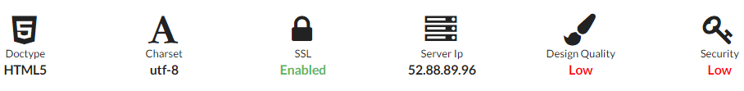

Standardization

**Doctype:**The website doctype is HTML5.

*HTML5*

*Indicating the doctype used in your document is required to validate it. This doctype contains the Document Type Definition (The DTD) which defines tagging standards used in your page.*

**Charset:**Charset is valid.

*Header: utf-8   
Meta: utf-8*

*It is important to define the set of characters used in order to minimize display problems.*

Layout quality

**Table design:**Page does not use design with tables.

*It’s recommended to use divs for the structure of your website instead of Tables.*

**Commented HTML code:**There are HTML code in HTML comments.

***738 b*** of HTML code commented.

*HTML code commented is useless. You should remove it from the page.*

**Frames and iFrames:**Some frame or iframe have been found on the page.

*Frames and iFrames are not recommended because their content is not readable by search engines.*

**Flash:**No flash content has been found on the page.

*Flash animations have become obsolete and have been replaced by CSS3 and HTML5 animations. Flash animations are no longer taken into consideration by mobile devices.*

Server configuration

**Environment:**Server Technology is visible.

***Server:****Apache/2.4.16 (Amazon) OpenSSL/1.0.1k-fips PHP/5.6.12****Technology:****PHP/5.6.12*

*It is highly recommended to hide the information related to technologies used on your web server. This is primarily to avoid giving out too much information that could be used by hackers to gain unauthorized access.*

**ipv6 compatibility:**Website is not ipv6 ready.

***IPv4****: 52.88.89.96 - Reverse: ec2-52-88-89-96.us-west-2.compute.amazonaws.com*

*The IPv6 protocol will soon replace the IPv4 protocol. Your web server should be prepared for the occasion.*

**DNS**

* DNSSEC is not enabled.
* Reverse(s) DNS exists.

host : fluidmeet.com

class : IN

ttl : 592

type : A

ip : 52.88.89.96

host : fluidmeet.com

class : IN

ttl : 3600

type : NS

target : ns35.domaincontrol.com

host : fluidmeet.com

class : IN

ttl : 3600

type : NS

target : ns36.domaincontrol.com

host : fluidmeet.com

class : IN

ttl : 86400

type : SOA

mname : ns35.domaincontrol.com

rname : dns.jomax.net

serial : 2015110500

refresh : 86400

retry : 7200

expire : 3600000

minimum-ttl : 86400

host : fluidmeet.com

class : IN

ttl : 3600

type : MX

pri : 0

target : mail.fluidmeet.com

host : fluidmeet.com

class : IN

ttl : 3600

type : TXT

txt : google-site-verification=81MhAUwB1Dt_jd-58upWv9aVfbEOmTwCyGGmvfUVY3Q

entries : Array

host : fluidmeet.com

class : IN

ttl : 3600

type : TXT

txt : v=spf1 a mx ptr include:secureserver.net ~all

entries : Array

*The DNS (Domain Name System) zone routes the user to the requested active service on the server. DNSSEC allows to reassure the authenticity of the DNS answer, to avoid any attempt of Cache Poisoning.*

Security

**Scannable email address:**   
No email has been found in the page.

*It is recommended to replace the email addresses by images or javascripts to avoid them being crawled by robots and used by spammers.*

**X-XSS-Protection:**X-Xss-Protection header is missing.

*(Missing)*

*Recent browsers have integrated filters in order to detect a possible attack. However, this feature can be disabled. Add the "X-XSS-Protection" HTTP header with "1; mode=block" as a value (1 to indicate the activation, and mode=block to indicate that the entire page must be blocked if a problem occurs) will force the execution of these filters.*

**Content Security Header:**Content-Security-Policy is missing.

*(Missing)*

*Implementing a content security policy explains to the web browser which servers are allowed to deliver resources on the page. If the browser makes a request to an unauthorized server, it will inform the user.*

**Https:**HTTPS is enabled and has a valid certificate.

*Https is a secure communication protocol (SSL). Even for sites that do not collect sensitive customer information, search engines suggest that switching to https may help improve rankings.*

Performance: 11.7%

Performance Overview

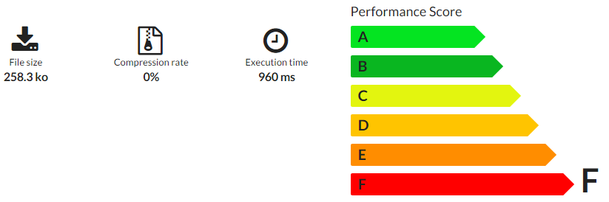

Download optimization

**Page weight:**The page weight is too high.

***258.3 ko*** to download to get your HTML page.

*It is recommended not to go over 50ko for your pages (without considering images and other media. This only concerns the weight of the HTML code).*

**Execution time:**Execution time exceeds 0.5 second.

***960 ms***

*The execution time is the time your server need to return the page's content. The time in not related to the internet connection but depends of the server configuration.*

**Page caching:**The website does not allow page caching.

***No*** cache is configured.

*Caching your pages will decrease their loading time by storing them temporarily on the user's device. The caching delay has to be set depending on the page updating frequency.*

**Compression:**Server does not use file compression.

***No*** compression is configured.

*Compressing your web pages allows you to optimise their loading time by decreasing the amount of data to be downloaded.*

Loading optimization

**Scripts location:**Some scripts are not at the bottom of the page.

***13*** scripts are not in the footer.

*We recommend putting your scripts at the end of your document just before the </body>> tag to improve the loading time.*

**Integrated scripts:**There are too much scripts in the page, you should use external files.

***240.67 ko*** scripts are directly integrated in the page.

*It is better to include Javascript in a separate file to optimise the loading time of the page.*

**Inline CSS:**There are inline CSS in the page.

*This technique is not recommended because it weighs down your page. Use rather CSS classes.*

**Style tags:**There is no style tag in the page.

***0 b*** of CSS styles integrated on your page.

*Avoid integrating your styles directly into the HTML file, it increases considerably the weight of the page. The use of a style attribute is tolerated for only some lines (tolerated until 2ko).*

Accessibility: 51.2%

Accessibility Overview

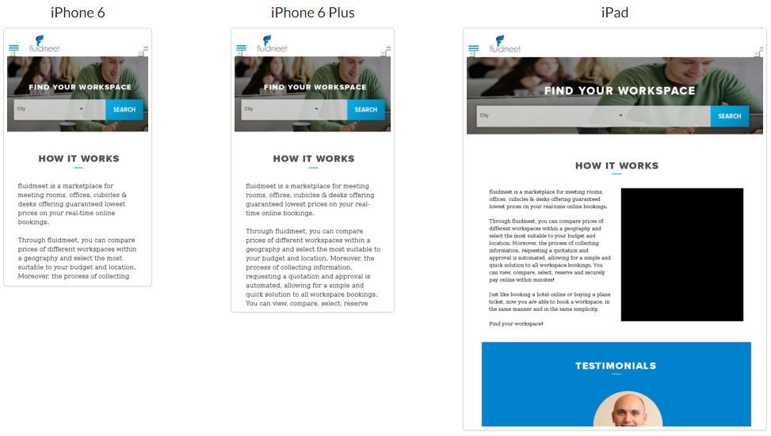

Accessibility

**URL rewriting:**URLs are clean.

*URL rewriting allows you to rewrite this kind of link: http://www.car.com/page.php?id=2&category=3 to a more user-friendly one like: http://www.car.com/sedan-diesel-2009. This option also allows you to add keywords to describe the concerned page.*

**Domain length:**The domain name length is correct.

*fluidmeet.com*

13 characters.

*A long domain name has less chance to be quickly memorized by the user.*

Usability

**Noscript Tag:**NoScript tag is missing.

*The noscript tag is used to display a message to the user when Javascript is not enabled.*

**Bgsound:**There is no Bgsound tag on the page.

*Use the audio tag to deliver audio content on your page instead of the bgsound tag.*

**Input label:**Some form inputs don't have label defined.

| **Input Id** | **Input Label** |
| --- | --- |
| popupDatepicker_day | (Missing) |
| email_id | (Missing) |

Internationalization

**Language:**Content language is defined.

***Lang attribute of the HTML document:****en****Lang attribute of the HTTP header:****(Missing)*

*The language defined in your document has to be the same as the language used on your web pages and the same as used by your main target market.*

Sharing

**Open Graph:**Open Graph is not used.

*Open Graph attributes allow you to define the content of a Facebook page. Choose a picture corresponding to the content of your page rather than a simple logo.*

**Twitter card:**The twitter card is not defined.

*Twitter Cards are miniatures generated during the sharing of a link towards your website. Define a title and a description corresponding to the content of your page.*

**Google+ Publisher:**The page is not linked to Google Plus.

*Connect your Google account on your page by adding a link rel="publisher" tag to define the author of this one.*

Mobile compatibility

**Responsive:**Meta Viewport has been found on the page.

*This tag indicates to mobile devices the dimension of the page to show. It allows to adapt at best your page to small screens. It is typical in Responsive Web Designs.*

**Priorities to solve**

1. Shorten the title.
2. Add keywords in the Meta Description.
3. Configure a 301 redirection on "www." instead of 302.
4. Hide Server Technology.
5. Add a H1 Title.
6. Add a H2 title.
7. Configure X-Xss-Protection header.
8. Configure Content-Security-Policy header.
9. Create a Robots.txt file.
10. Define a Sitemap.
11. Link the page to Google Plus.
12. Reduce Javascript links.
13. Configure the GZIP page compression.
14. Remove HTML code from HTML comments.
15. Improve page execution time.
16. Add a NoScript tag.
17. Add form label to each form input.
18. Add a canonical URL.
19. Put scripts at the bottom of the page.
20. Configure a cache on pages.
21. Avoid frames and iframes.
22. Optimize Facebook sharing.
23. Optimize Twitter Card.
24. Reduce the page weight.
25. Put scripts in an external .js file.
26. Replace inline CSS by CSS classes.
27. Configure ipv6 compatibility.
28. Configure DNSSEC.
29. Increase Text/Code ratio.
30. Use main keywords of the Page Title.
31. Add microdata.