Massemin Lucas (245512)

Perret Thibaud (245782)

Assignment 1 – Report

We followed the tutorial which was pretty much the same code as in our assignment. We read through the code and rewrote it with new names for our variables. We started getting away from the tutorial once the basic moves of the agents and the general space were set up.

As requested, we only kept the following 4 variables to be tweaked within the program: the world size, the number of agents at the beginning, the birth threshold, and the growth rate of the grass at each step. However, we also kept some other global variables to prevent us from hard coding some values (such as the energy of each rabbit at the beginning, the energy lost when procreating, etc.).

We had to define the movements of rabbits because the behavior was different than in the tutorial. Our rabbits will not be able to jump on the same case as other rabbits. We decided that if it tries to go somewhere and it is not possible, we would keep the rabbit in the same place rather than trying again and again (to prevent any infinite loop from happening in case of a rabbit surrounded by many other and not having any free legal moves to do). When they land on a new case, they eat the grass and absorb as many energy as grass cases grew in here. The grass can grow in a case where some grass already existed and we just accumulate how many grew in each case. We also limited their movements to a simple north, west, east and south movement (without combination).

Once rabbits get enough energy, they automatically lose some energy (as defined by the ***BIRTHCOST*** variable) and they procreate by themselves. Not only is this a miracle but this is where the program gets interesting because we can try to keep track of the population as a function of the inputs.

We added a plot that shows how the population of rabbits evolves over time, but also the amount of grass that there is on the whole grid. We found it interesting to see the ratio of amount of grass regarding to the number of rabbits. We included some screenshots of interesting curves a bit further down.

We modified the color palette to have a nice visualization of what happens:

* The grass is green, the more grass there is in one case, the more intense the green gets
* The background is brown to represent the raw dirt
* Rabbits are white circles, and they get red once they hit a low energy level

Most of the time, the rabbits will not die out, they may hit a critical population but since we only need one rabbit to procreate, there is always a possibility that he eats enough and restarts the whole population by itself. The only way to kill them all is to decrease the grass growth rate so that there is to many rabbit eating at some point and once they all die except a few, the grass does not grow fast enough for these last rabbits to find it. We included figure 2 and figure 3 to show the evolution in the case of a more or less stable population and a case of running out of food (respectively).

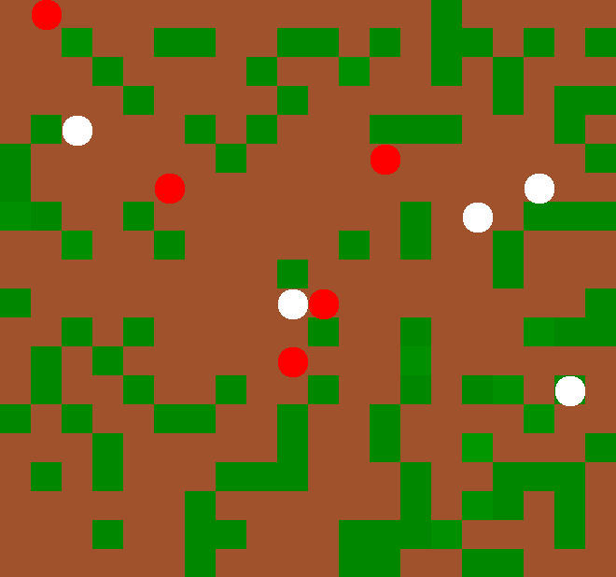

Figure 1 Screenshot of the simulation

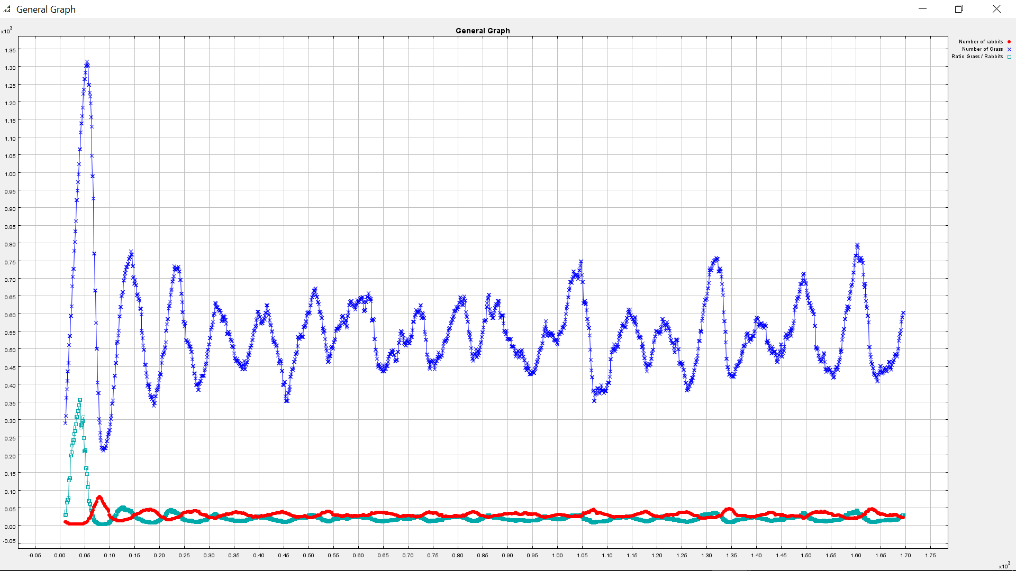

Figure 2 Evolution of the population, amount of grass and the ratio between the two over time

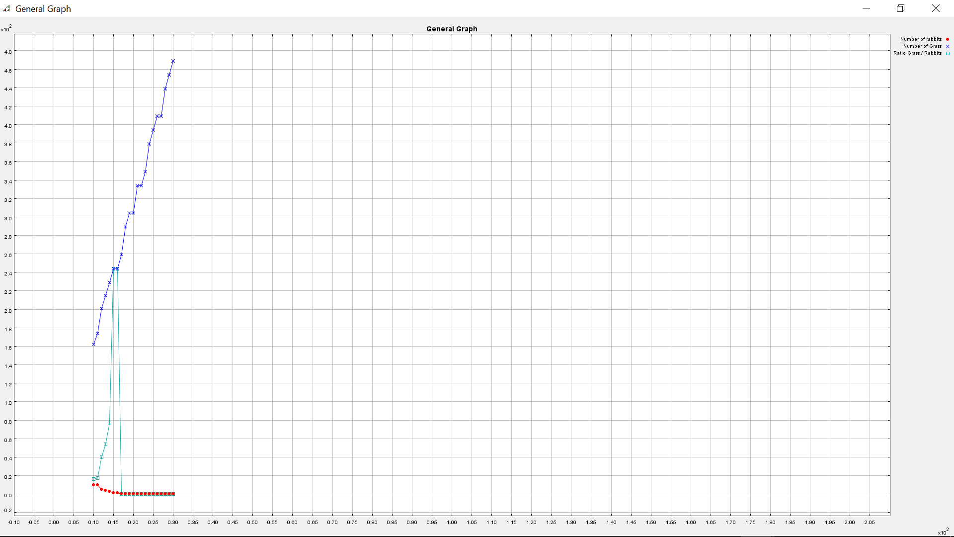

Figure 3 Evolution where all the rabbits died and the grass keeps growing