Software Requirements Specification Template
Software Engineering

The following annotated template shall be used to complete the Software Requirements Specification (SRS) assignment.

Template Usage:
Text contained within angle brackets (‘<’, ‘>’) shall be replaced by your project-specific information and/or details. For example, <Project Name> will be replaced with either ‘Smart Home’ or ‘Sensor Network’.

Italicized text is included to briefly annotate the purpose of each section within this template. This text should not appear in the final version of your submitted SRS.

This cover page is not a part of the final template and should be removed before your SRS is submitted.

Movie Theater Ticketing Service

Software Requirements Specification

Version 1.4

24 September 2026

Group #6
Liliana Yalda, Shayna Phan, Thi Dang

Prepared for
CS 250- Introduction to Software Systems
Instructor: Gus Hanna, Ph.D.
Fall 2023

Revision History

Date | Description | Author | Comments
09-10-2026 | First look | Liliana Yalda, Shayna Phan, Thi Dang | First look
09-17-2026 | Added Intro, Purpose, and Scope material | Liliana Yalda, Shayna Phan, Thi Dang
09-23-2026 | Added section 2: General Description, and some of section 3: Specific requirements | Liliana Yalda, Shayna Phan, Thi Dang
09-24-2026 | Expansion of ideas and finalization/cleanup of document | Liliana Yalda,  Shayna Phan,  Thi Dang

Document Approval

The following Software Requirements Specification has been accepted and approved by the following:
Signature | Printed Name | Title | Date
 | Liliana Yalda, Shayna Phan, Thi Dang | Software Eng. | 09-24-2026
 | Dr. Gus Hanna | Instructor, CS 250

Table of Contents

Revision History ii
Document Approval ii
1. Introduction 1
1.1 Purpose 1
1.2 Scope 1
1.3 Definitions, Acronyms, and Abbreviations 1
1.4 References 1
1.5 Overview 1
2. General Description 2
2.1 Product Perspective 2
2.2 Product Functions 2
2.3 User Characteristics 2
2.4 General Constraints 2
2.5 Assumptions and Dependencies 2
3. Specific Requirements 2
3.1 External Interface Requirements 3
3.1.1 User Interfaces 3
3.1.2 Hardware Interfaces 3
3.1.3 Software Interfaces 3
3.1.4 Communications Interfaces 3
3.2 Functional Requirements 3
3.2.1 <Functional Requirement or Feature #1> 3
3.2.2 <Functional Requirement or Feature #2> 3
3.3 Use Cases 3
3.3.1 Use Case #1 3
3.3.2 Use Case #2 3
3.4 Classes / Objects 3
3.4.1 <Class / Object #1> 3
3.4.2 <Class / Object #2> 3
3.5 Non-Functional Requirements 4
3.5.1 Performance 4
3.5.2 Reliability 4
3.5.3 Availability 4
3.5.4 Security 4
3.5.5 Maintainability 4
3.5.6 Portability 4
3.6 Inverse Requirements 4
3.7 Design Constraints 4
3.8 Logical Database Requirements 4
3.9 Other Requirements 4
4. Analysis Models 4
4.1 Sequence Diagrams 5
4.3 Data Flow Diagrams (DFD) 5
4.2 State-Transition Diagrams (STD) 5
5. Change Management Process 5
A. Appendices 5
A.1 Appendix 1 5
A.2 Appendix 2 5

1. Introduction
This Software Requirements Specification (SRS) document describes the requirements for a movie ticketing website. It defines the functionality, features, and constraints of the system and provides a detailed description of how the system is expected to operate.

1.1 Purpose

The purpose of this Software Requirements Specification is to document the requirements for the movie ticketing website. This document will serve as a guide for the software development team when designing, implementing, and testing the system. It is intended for the software developers, designers, testers, and other project members involved in developing the system.

1.2 Scope
The software product to be developed is a web-based movie ticketing system. The system will allow users to browse available movies at select locations, view movie information, search for available showtimes, select a showing, choose available seats, and purchase movie tickets through the website.
The system will provide users with an accessible way to view available movies and showtimes and complete the ticket purchasing process without needing to purchase tickets in person. The system will also manage information such as movies, theaters, showtimes, seats, and ticket purchases.
The primary goal of the system is to provide a simple and convenient method for users to find movie showtimes and purchase tickets. The system should accurately display available seats and prevent users from purchasing seats that are no longer available.
The system will focus on online movie ticketing and will not be responsible for functions outside of the ticketing system, such as physically operating a movie theater, managing theater employees, or controlling movie playback.

1.3 Definitions, Acronyms, and Abbreviations
1.3.1 E-Tickets: A digital ticket allows customers to enter a movie showing.

1.3.2 Seat Hold: The selected tickets/seats will be held for 5 minutes while the customer completes the purchase.

1.3.3 Refund Policy: Tickets can be returned or exchanged prior to the showing only if
purchased with a user account

1.3.4 External Payment: Accepted payment methods include credit card, PayPal, and bitcoin.

1.3.5 UC: Use Case

1.3.6 FR: Functional Requirement

1.4 References

IEEE Std 830-1998, IEEE Recommended Practice for Software Requirements Specifications

Massimo Felici-School of Informatics 2011, Use Cases

William Y. Arms-Cornell University Computing and Information Science, CS 5150 Software Engineering Scenarios and Use Cases

1.5 Overview
This SRS is organized into five major sections. Section 1 introduces the purpose, scope, terminology, references, and organization of the document. Section 2 provides a general description of the movie ticketing system, including its perspective, major functions, users, constraints, assumptions, and dependencies. Section 3 defines the specific functional and non-functional requirements of the system, including external interfaces, use cases, classes and objects, performance, reliability, availability, security, maintainability, and portability.

2. General Description

2.1 Product Perspective
The movie ticketing system is a web-based application that will interact with several external and internal services to provide online ticket purchasing and ticket management.

2.1.1 System Interfaces

The movie ticketing system will need to handle payments. Thus, connection to banking interfaces and a payment gateway will be necessary in order to process transactions, including payments and refunds. This will connect to services such as PayPal, Apple Pay, and bank/card processors.

The system will also need to connect to internal interfaces for theater management in order to have access to movie information, showtimes, theater locations, ratings, descriptions, and other details about the films. In a similar fashion, the site will need access to showroom information, such as seat layout and real-time availability. This information will also be available to a management interface for logistics such as sales and attendance.

The system will also need integration with an Email/SMS notification service, which will send booking confirmations, electronic tickets, cancellation notices, and other notifications to customers. With this, a login will be necessary, so the system will integrate with authentication and identity verification such as Google or Apple for login information, as well as a database of customers and accounts and potential membership status within the cinema’s loyalty program. Authentication will also need to recognize and block access for any bots trying to mass purchase tickets.

2.1.2 User Interfaces

The system will need to be well organized, straightforward, and easy to use for a wide range of customers. This will require design choices that prioritize readability, such as simple fonts and high-contrast colors, as well as clearly labeled buttons, as customers such that new customers who have never used the system before can easily purchase tickets in under 5 minutes. If an error occurs, it will be properly displayed such that the customer can understand it without prior knowledge, and provide resources for further assistance.

2.2 Product Functions
The ticketing software will allow customers and employees to create accounts and log in. This will enable them to view previous purchases, handle returns and exchanges, manage membership and loyalty program information, and initiate new purchases.

When purchasing a ticket, the system will provide a real-time view of the available theaters, rooms, and showtimes for each movie, as well as the seat availability and layout of the chosen location. After choosing seats, there will be a hold for 5 minutes to allow the user to purchase a maximum of 20 tickets at a time, calculating and displaying the running total plus tax.

Users will then be prompted to provide payment and contact information, and order confirmation and E-tickets will be sent to their preferred email once the purchase is verified via communication with the banking interface. Within their account, customers will be able to manage tickets, including refunds, exchanges, and cancellations, which will update seat availability for other customers.

2.3 User Characteristics

Customers will be those using the software to purchase and manage their tickets and view showtimes. For the sake of usability, customers are assumed to have basic experience with web browsers and nothing beyond common knowledge.

Employees will have access to the system to check and validate purchases and manage returns and exchanges. Employees should be able to learn the system with some basic training.

Administrators will be able to manage accounts and membership information, as well as troubleshoot more complicated system management, including settings and security. They have more experience and in-depth knowledge of how such systems are expected to work.

Managers can view sales and attendance reports and manage showtime schedules and pricing. They are experienced in management and familiar with such processes.

2.4 General Constraints
There are some general constraints for the Movie Theater Ticketing Service. The system needs to keep customer and payment information safe. It should work on common web browsers and mobile devices. The system also needs a database to store information about movies, customers, tickets, and seats. For online payments, the system may need to use an outside payment service. The system should be easy to use for customers and employees. It should also be possible to update and maintain the system in the future.

2.5 Assumptions and Dependencies
We assume that customers will have access to the internet when they use the system online. We also assume that the theater will have computers or other devices for employees to use the system. The system depends on a database to store and access movie, customer, seat, and ticket information. Online payment also depends on an external payment service working properly. If the internet, database, or payment service is not available, some functions of the system may not work correctly. Changes to these factors may require changes to the system requirements.

3. Specific Requirements

3.1 External Interface Requirements

3.1.1 User Interfaces
The system will be used by opening a web browser on a computer, a tablet, or a phone. Customers will be able to look for movies, check showtimes, see how much tickets cost, choose seats when they are available, and buy tickets. The system will also have pages for logging in, signing up, having a loyalty account, making payments, getting ticket details, and giving customer feedback.
The system will work with English, Spanish, and Swedish. The way the system looks should be simple and easy to understand. Administrators and employees will have screens and options for handling theaters, movies, showtimes, tickets, and customer details.

3.1.2 Hardware Interfaces
The system does not require special hardware because it will run through a web browser. Customers can use a computer, tablet, or smartphone with stable internet access. Theater employees can use computers or other supported devices to access the system.
The system may also work with theater hardware such as ticket scanners or barcode/QR code scanners to verify digital tickets. The hardware must be able to connect to the system so ticket information can be checked.

3.1.3 Software Interfaces

The system will connect with several other software systems. It will connect to a database to store customer, movie, showing, ticket, payment, and purchase information. The system will also connect with payment services such as credit cards, PayPal, and Bitcoin.

The system may connect to external movie review websites such as Rotten Tomatoes or IMDB to get movie ratings and critic information. It may also connect with currency exchange services to convert ticket prices to the local currency. The system will need to work with these external services when they are available.

3.1.4 Communications Interfaces
The system will use the internet to communicate between customers, employees, the web server, and the database. Communication should use secure connections to protect customer and payment information.
The system will need to handle many users at the same time and provide live updates for ticket availability and showtimes. When there are too many requests for a high-demand showing, the system will use a queue to control the number of requests. The system should also communicate with payment services and other external services through secure network connections.

3.2 Functional Requirements

3.2.1 Ticket Purchase

3.2.1.1 Introduction

The ticket purchase feature allows customers to select a movie, choose a showing, select tickets or seats, and complete a purchase online. Customers can purchase up to 20 tickets in one transaction. Tickets are available starting two weeks before the showing.

3.2.1.2 Inputs
The system will receive the following inputs from the customer: selected movie, showtime, number of tickets, selected seats for deluxe theaters, ticket type, payment method, and payment information
3.2.1.3 Processing

The system will check the selected movie and showtime and then check the available tickets. The system will calculate the ticket price based on the ticket type and any discount. The system will also make sure the customer is not buying more than 20 tickets at a time. The selected tickets will be held for 5 minutes while the customer completes the purchase.

The system will process the payment and, if the payment is successful, create E-tickets. The system will update the available tickets and save the purchase in the database.

3.2.1.4 Outputs

After a successful purchase, the system will display a purchase confirmation. The customer will receive their E-tickets and payment information. The system will also update the available tickets, purchase history, and loyalty points if the customer has a loyalty account.

3.2.1.5 Error Handling

If there are not enough tickets available, the system will tell the customer that the tickets are unavailable. If the customer tries to purchase more than 20 tickets at a time, the system will not allow the purchase. If payment fails, the system will show an error, and the customer can try again. If the 5-minute purchase time expires, the selected tickets will be released so other customers can purchase them. If there are too many users trying to purchase tickets for the same showing, the customer will be placed in a queue.

3.2.2 User Account Management

3.2.2.1 User Registration

The system will allow the user to create an account by providing a valid name, email address, and password. A verification code/link will be sent to the email upon initial sign-up.

3.2.2.2 Input Validation

The system will reject requests when a required field is left empty or in an invalid format, such as if the password does not match security requirements. Duplicate accounts will also be prevented if the provided email is already associated with an existing account.

3.2.2.3 Authentication

Users will be authenticated via a secure check between the entered email and password and the registered information in the database and verified as a human via CAPTCHA.
`
3.2.3 Movie Search and Selection

3.2.3.1 Movie Search

The system shall accept a movie title or keyword as input and return a display of available movies matching the provided search criteria. An appropriate message will appear if no movies match the search criteria.

3.2.3.2 Movie Information

The system will display the movie’s title, description, genre, duration, rating, release date, language, and available formats. It will indicate whether a movie is currently showing, scheduled for a future date, or unavailable for booking.

3.2.4 Seat Selection

3.2.4.1 Seat Layout

The system will display the seating layout associated with the selected showroom, along with row letters, seat numbers, the screen and walkways in the room, and handicapped seats.

3.2.4.2 Seat Availability

The system will identify and display available seats, temporarily reserved seats, and unavailable or taken seats. One or more seats can be selected at a time. Users will be prevented from selecting seats that are already reserved, in the process of being reserved, or unavailable.

3.2.4.3 Concurrent Booking

The software must verify seat availability before confirming a booking to prevent two users from purchasing the same seat.

3.2.4.4 Seat Reservation Timeout

The system shall mark seats as temporarily reserved for 5 minutes while the user engages in the payment and verification process. If the payment is abandoned or exceeds the configured time, the system will release the seats and make them available again.

3.3 Use Cases

3.3.1 Use Case #1
Book Movie Ticket
Actor(s): Customer

Flow of Events:
- Customer searches for and selects a movie
- Customer selects a cinema, date, and showtime
- Customer selects type of ticket and applies applicable discount
- System displays the available seats
- Customer selects one or more seats
- System verifies that the selected seats are available
- System calculates the total ticket price
- System displays the booking summary
- Customer confirms the booking
- System processes payment
- If payment is successful, the system confirms the booking
- System generates an electronic ticket
- System displays/sends the e-ticket to the customer

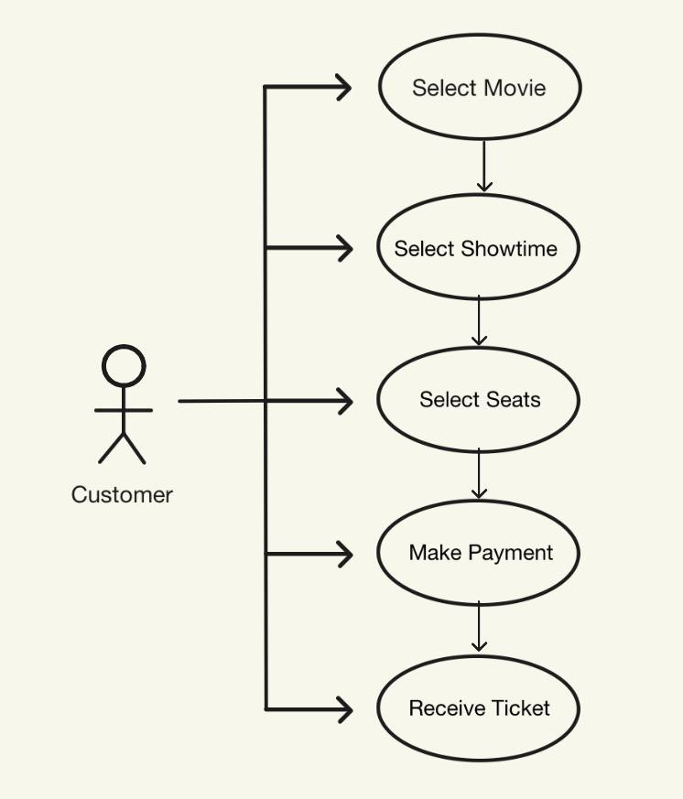

3.3.2 Use Case #2
Cancel Booking

Actor(s): Customer, Payment Service

Flow of Events:
- Customer logs into their account
- Customer views their existing bookings
- Customer selects the booking they wish to cancel
- System retrieves the booking information
- System checks whether the booking is eligible for cancellation
- System displays the applicable cancellation and refund information
- Customer confirms the cancellation
- System changes the booking status to canceled
- System releases the reserved seats
- System calculates the applicable refund
- System sends the refund request to the Payment Service
- Payment Service processes the refund
- System displays the cancellation and refund status to the customer

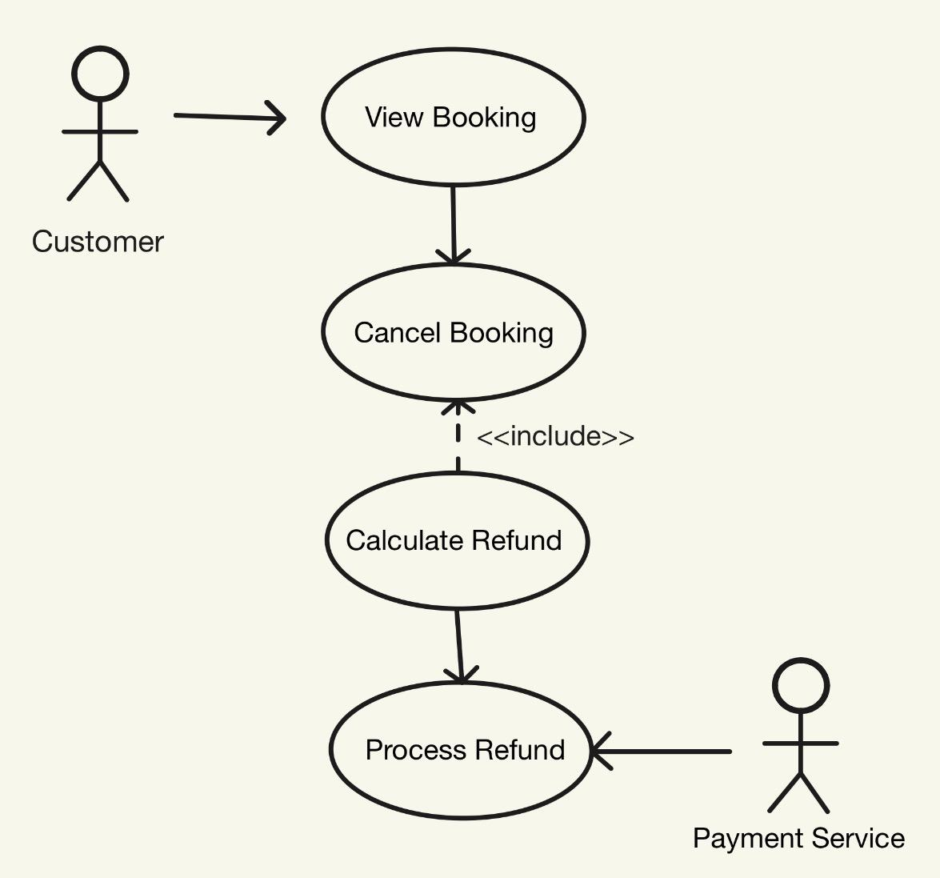

3.3.3 Use Case #3
Redeem Ticket

Actor(s): Cinema Staff

Flow of Events:
- Cinema Staff uses provided hardware to scan ticket/rewards
- Software verifies ticket/rewards
- Rewards are applied according to the loyalty program
- Database validates entry
- System marks ticket as used

3.4 Classes / Objects

3.4.1 User Roles

3.4.1.1 Attributes:
- Role: Customer, Manager, and Employee
- Account
-User ID
- Name
- Email address
- Password
- Membership information
3.4.1.2 Functions:
- Set Role Privileges
- Change Role
- Create account
- Log in
- Manage account
- View purchase history
- View loyalty information

3.4.2 Tickets

3.4.2.1 Attributes:
- Redeemed or Not
- Seat assigned
- Showroom Assigned
- Customer who owns the ticket
- Type of ticket: Adult, Child, Senior, Military, Student
3.4.2.2 Functions:
- Purchase/Assign Ticket to Customer
- Check-in Ticket
- Refund Ticket
- Cancel Ticket

3.4.3 Seats

3.4.3.1 Attributes:
- Availability: Available → Held → Sold
- Ticket associated with Seat
- Row Letter
- Seat number
- Regular versus deluxe seat
3.4.3.2 Functions:
- Change Availability
- Hold seat
- Release seat

3.4.4 Auditorium

3.4.4.1 Attributes:
- Seat Map and Locations
- Capacity
- Accessibility Constraints
- Movie to be Screened
- Deluxe versus regular showroom
3.4.4.2 Functions:
- Create/Edit Auditorium
- Update Seat
- Update Availability
- Update Movie

3.4.5 Payment

3.4.5.1 Attributes:
- Status: Authorized → Captured/Refunded/Failed
- Payment ID
- Payment method
- Associated purchase
3.4.5.2 Functions:
- Check Payment Information
- Validate with Payment Service
- Submit payment to payment service
- Process refund

3.4.6 Policy Values

3.4.6.1 Attributes:
- Seat-Hold Duration
- Refund Window
- Orphan Seat Requirements
- Maximum Tickets per Transaction
3.4.6.2 Functions:
- Configure Policy Values

3.4.7 Screening

3.4.7.1 Attributes:
- Screening ID
- Movie
- Auditorium
- Date and Time
- Publication State: Draft → Published → Unpublished/Cancelled
3.4.7.2 Functions:
- Create Screening
- Update Screening
- Update Publication State
- Cancel Screening

3.5 Non-Functional Requirements

3.5.1 Performance
The system shall meet the following performance requirements under normal operating conditions:
3.5.1.1 Quick to load: 95% of loads complete within 5 seconds.
3.5.1.2 Quick to transact: 95% of transactions complete within 8 seconds.
3.5.1.3 Quick to update: 99% of user interactions with the webpage should register within 3 seconds.
3.5.1.4 Bandwidth: The server can handle 1000 simultaneous requests at once.

3.5.2 Reliability
The system must handle any errors that will cripple the service.
3.5.2.1 Error Handling: The system will be able to identify and, in certain cases, correct errors.

3.5.3 Availability
The service will be available as often as possible, allowing for occasional maintenance periods.
3.5.3.1 Consistent Uptime: The server and website are available for public use 99.9% of the time.

3.5.4 Security
The service will protect customers’ data and prevent unauthorized users from accessing and modifying sensitive data.
3.5.4.1 Authorization: only managers or higher-level clearances shall be able to access secure information from databases.
3.5.4.2 Encryption: customer data should be encrypted with current RSA encryption.

3.5.5 Maintainability
The software will be designed to last and work without frequent and drastic revision upon release. There will be small patches to cover unforeseen problems with the system on a continual basis.
3.5.5.1 Lifespan: The software should be able to function over the next 3 years with minor revisions.
3.5.5.2 Frequency of Revisions: Minor updates will occur every 3 months, while major changes will occur every 3 years.

3.5.6 Portability
The website should run without errors or problems in the most frequently used browser engines.
      - Chrome: Designed for the Chrome browser
3.5.6.2 Common Compatibility: Runs without errors in the 3 most common browsers: Edge, Safari, and Firefox

3.6 Inverse Requirements
State any *useful* inverse requirements.

3.7 Design Constraints
Specify design constrains imposed by other standards, company policies, hardware limitation, etc. that will impact this software project.

3.8 Logical Database Requirements
Will a database be used? If so, what logical requirements exist for data formats, storage capabilities, data retention, data integrity, etc.

3.9 Other Requirements
Catchall section for any additional requirements.

4. Analysis Models
List all analysis models used in developing specific requirements previously given in this SRS. Each model should include an introduction and a narrative description. Furthermore, each model should be traceable the SRS’s requirements.

4.1 Sequence Diagrams

4.3 Data Flow Diagrams (DFD)

4.2 State-Transition Diagrams (STD)

5. Software Design

5.1 Software Architecture Overview

5.1.1 Presentation Layer
This is the part that users interact with through a web browser. Customers can search movies, view showtimes, select seats, purchase tickets, and manage their accounts. Employees, managers, and administrators have different interfaces based on their roles. The system can be accessed through computers, tablets, and smartphones.

5.1.2 Application Layer
This layer contains the main business logic of the system. It handles user accounts, movie searches, screenings, seat selection, ticket purchases, payments, refunds, loyalty information, and policies. It also handles the 5-minute seat hold and maximum 20 tickets per transaction.

5.1.3 Data Layer
The database stores users, movies, screenings, seats, tickets, payments, and purchase information. The application layer reads and updates this information when customers make purchases or when employees and managers update the system.

5.1.4 External Services
The system communicates with external services for payment processing, email/SMS notifications, authentication, CAPTCHA/bot protection, movie reviews, and currency conversion. These services allow the movie ticketing system to provide functions that are outside the main application.

5.2 Architectural Diagram

5.3 UML Class Diagram
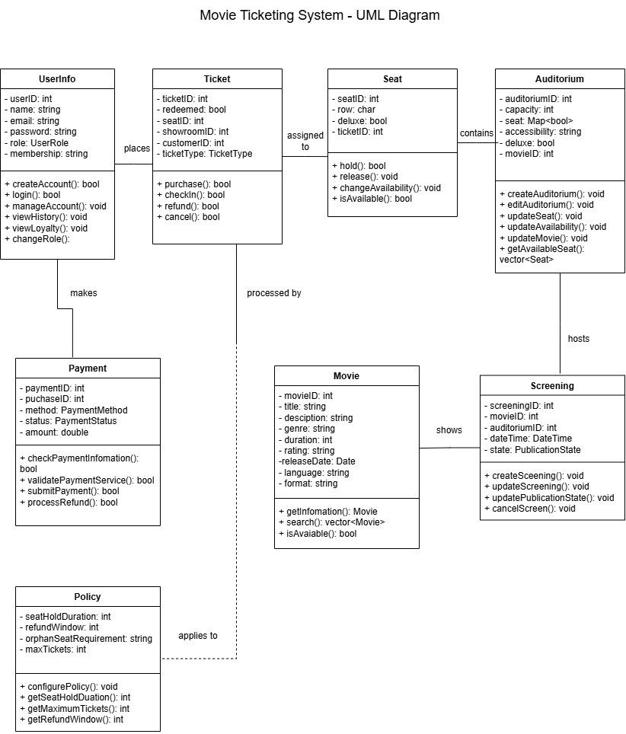

5.4 Class Descriptions

5.4.1 UserInfo

5.4.2 Movie

5.4.3 Screening

5.4.4 Auditorium

5.4.5 Seat

5.4.6 Ticket

5.4.7 Payment

5.4.8 Policy

5.5 Attribute Descriptions

Class | Attribute | Data Type | Description
UserInfo | userID
UserInfo | name
UserInfo | email
UserInfo | password
UserInfo | role
UserInfo | membership

5.6 Operation Descriptions

5.7 Development Plan and Timeline

6. Change Management Process
Identify and describe the process that will be used to update the SRS, as needed, when project scope or requirements change. Who can submit changes and by what means, and how will these changes be approved.

A. Appendices
Appendices may be used to provide additional (and hopefully helpful) information. If present, the SRS should explicitly state whether the information contained within an appendix is to be considered as a part of the SRS’s overall set of requirements.

Example Appendices could include (initial) conceptual documents for the software project, marketing materials, minutes of meetings with the customer(s), etc.

A.1 Appendix 1

A.2 Appendix 2

