Facultad de Comunicación

Revista científica del Centro de Investigación para la Comunicación Aplicada
Facultad de Comunicación. ISSN: 2594-1682
CALL FOR MONOGRAPH
Sintaxis No. 18
Submission Deadline: August 30, 2026
Publication Date: January 2027
Special Issue
Relationships and Conflicts between Government, Society, and Media in Scenarios of Digital Technological Convergence

Over the last few decades, the relationship between media, communication, and power has undergone a profound transformation. Beyond evolving social interactions, digital technology and media convergence have sparked unexpected changes, reshaping the dynamics between civil society, governments, and media outlets (Dettleff & Olivera, 2011). As early as the previous decade, authors such as Whitten-Woodring & James (2012) addressed the complex nexus between media, civil protest, and state repression, even before the full emergence of contemporary social media networks.
Furthermore, when focusing on the potential of digital technologies to enhance transparency and civic engagement, technological convergence has fostered new modes of interaction, access, and agency for the general population. This has bolstered citizen mobilization, the organization of new collectives, and the development of social and political campaigns. This context has led scholars like Okumus (2024) to analyze the relationship between media and society within the political sphere, though the complexities of these interactions permeate the social space at multiple levels.
However, alongside the consolidation of diverse voices and increased access, significant tensions and debates regarding the limits of such interactions have emerged (Ruiz-Méndez, 2024). This has resulted in various governmental attempts at regulation and censorship, as well as shifting dynamics between social media and state authorities (Widayat et al., 2023). Consequently, there is an urgent need for scholarly analysis regarding freedom of expression and the responsibility of information providers.
In this landscape, traditional media face displacement by a new digital reality where information circulates at unprecedented speeds. They must also confront a proliferation of sources, misinformation (Del Prado Flores et al., 2021), and the rise of new economic conglomerates that disrupt classical power structures and the very nature of journalistic practice—as observed by Culloty & Suiter (2021) in their work on media control and the challenges of post-truth.
Revista Sintaxis invites researchers from the social sciences and humanities to submit original research papers that employ scientific methodologies to explore the relationships between government, society, and media, based on—but not limited to—the following thematic axes:
- Digital Culture and New Narratives
- Legal Reforms and Regulatory Control in the Digital Age
- Tensions between Freedom of Expression, State Regulation, and Digital Platforms
- Transformations in Political Communication in the face of Digitalization
- The Role of Media in Constructing Social and Governmental Narratives
- The Impact of Social Media on Citizen Participation and Governance
- Transformation of the Media Ecosystem and Business Models
- Media Concentration and Polarization
- New Forms of Control, Censorship, and Surveillance in the Digital Era
- Case Studies on Conflicts, Alliances, or Negotiations among Political, Social, and Media Actors
- Disinformation and Artificial Intelligence
- Digital Political Violence
- Ethical and Professional Challenges of Journalism in Digital Environmen

We welcome original, unpublished articles using qualitative, quantitative, or mixed methodologies, as well as theoretical approaches from various disciplines, including communication studies, sociology, anthropology, cultural studies, political science, history, gender studies, philosophy, and pedagogy. We especially value contributions that integrate empirical work, quantitative data collection, and critical or situated perspectives.

Submission Guidelines: https://revistas.anahuac.mx/index.php/sintaxis/politicaseditoriales

References
Culloty, E. y Suiter, J. (2021). Disinformation and Manipulation in Digital Media. Information Pathologies. Routledge. https://doi.org/10.4324/9781003054252
Del Prado Flores, R., Arévalo-Martínez, R. I. ., & Góngora Cuevas, G. E. (2021). Comunicación sobre COVID-19 en Twitter: liderazgo y dialéctica. Presidentes de México, España, Estados Unidos. Comuni@cción: Revista De Investigación En Comunicación Y Desarrollo, 12(4), 310-321 https://doi.org/10.33595/2226-1478.12.4.546.
Dettleff, J. A. & Olivera, L. (2011). Primeras planas de diarios enmarcan deseos y no realidades. En Cañizález. A. y Olivera, L., Política y comunicación: Democracia y elecciones en América Latina, Pontificia Universidad Católica del Perú (PUCP).
Okumuş, E. (2024). Media-Society Relations in the Context of Politics. Pamukkale Üniversitesi Sosyal Bilimler Enstitüsü Dergisi, 64, 97-115. https://doi.org/10.30794/pausbed.1430267
Ruiz-Méndez, A. (2024). Tiempo de polarización: una mirada a la crisis de la democracia a través de la comunicación política populista. Sintaxis, (13), 98–120. https://doi.org/10.36105/stx.2024n13.07
Whitten-Woodring, J., & James, P. (2012). Fourth Estate or Mouthpiece? A Formal Model of Media, Protest, and Government Repression. Political Communication, 29(2), 113–136. https://doi.org/10.1080/10584609.2012.671232
Widayat, R. M., Aji, J. S., & Kurniawan, C. (2023). A Systematic Review of Social Media and Government in the Social Science Discipline. Journal of Contemporary Governance and Public Policy, 4(1), 59–74. https://doi.org/10.46507/jcgpp.v4i1.100

Guest Editors
Dr. James A. Dettleff, Profesor Principal e Investigador  Pontificia Universidad Católica del Perú | Dr. Nicolás Rotelli  Profesor e Investigador Universidad Blas Pascal, Córdoba, Argentina. | Dra. Patricia Torreblanca  Profesora de Tiempo Completo, Universidad Nacional Autónoma de México
 | 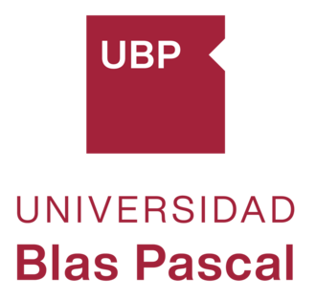 | 
Sintaxis Editorial Team
Dr. Alberto Fernando Ruíz Méndez  Deputy Editor  Universidad Anáhuac México  alberto.ruizm@anahuac.mx  https://orcid.org/0000-0002-3802-2243 | Dr. Rogelio Del Prado Flores  Editor-in-Chief  Universidad Anáhuac México  rogelio.delprado2@anahuac.mx  https://orcid.org/0000-0002-2181-2724

 | 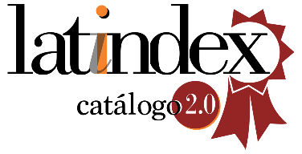 |  | 
 |  |  | 
 | 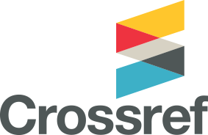 | 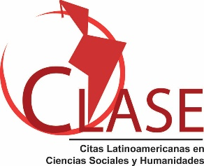 | 

