  - PRACTICE ASSIGNMENT 1 • QUARTER 1, 2026–2027

Group Chat App
with Real-Time Messaging
Advanced Mobile Programming | Course code: CSW434
Student: Nguyễn Đình Thiên | Student ID: 2231200118
Source identifier: nguyendinhthien | Review date: 27 October 2026
Repository: https://github.com/thien-0408/CSW434-AdvancedMobile/tree/main/Lab1

1. Objective and submitted work
Build a React Native application with name-entry and group-chat screens. Use Socket.IO to deliver messages to all connected participants. The supplied sample was reviewed against Lab1.pdf (pages 1–3), copied into this Lab1 folder, and corrected where behavior or reliability was incomplete.

2. Requirement coverage
Assignment requirement | Implementation / evidence
Enter a name; open Group Screen | HomeScreen.js validates the name; App.tsx handles navigation.
Store the name locally | AsyncStorage saves and restores the trimmed display name.
Notify the server when joining | join({userName}) runs on connection and every reconnect.
Send through a socket event | Send emits sendMessage({text}); blank/offline sends are blocked.
Broadcast to all connected users | server.js emits receiveMessage to all clients, including the sender.
Update the interface in real time | FlatList appends broadcasts and shows sender/time; new items scroll into view.
Support multiple participants | Integration tests verify identical delivery to three simultaneous clients.

3. Scope
One shared group, a locally saved display name, and live text messages. Authentication, persistent history, attachments and cloud deployment are outside the required scope. Messages remain in client memory and are not replayed to disconnected clients.

4. Review of the supplied sample
The sample already has both screens, navigation, blank-input checks, message events and multi-client broadcasting. These parts were retained. Changes address the following defects or practical gaps:
Finding | Correction
The client sends an object to join, but the server logs that object as a name. | Validate payload.userName, store it on socket.data and log the actual name.
The module-level socket survives leaving Chat. Joining is not repeated after a reconnect. | Own the socket in the screen effect; attach listeners before connecting, rejoin on connect and disconnect during cleanup.
The name exists only in component state/navigation parameters. | Persist and restore it with AsyncStorage; trim it before saving.
Sender/time come from the client and rows use array indexes. | Set sender, unique message ID and timestamp on the server. Use message IDs as list keys.
Comparing names treats different users with the same name as one sender. | Record ownership using the sending socket ID when the broadcast arrives.
Portraits come from unrelated external URLs. | Replace portraits with participant initials; apply nguyendinhthien to app/report metadata and storage keys.
New messages may be below the viewport; errors only appear in logs. | Scroll on updates, show connection status, block offline sends, and add keyboard/safe-area handling.

5. Flow and event contract
Home → validate name → save locally → navigate to Chat → connect → join → sendMessage → server validates and broadcasts receiveMessage → every client updates FlatList.
Event | Direction and payload
join | Client → server: {userName}. Acknowledgement: {ok, error?}.
sendMessage | Client → server: {text}. Requires a joined user and nonblank text.
receiveMessage | Server → all: {id, text, sender, senderId, time}. Time uses ISO-8601.
The UI retains teal outgoing bubbles, gray incoming bubbles, sender labels, timestamps and a bottom composer. Initials replace example portraits. Framework/package identifiers and upstream license notices remain intact.

6. Setup and execution
Requires Node.js ≥22.11, npm and an Android SDK/emulator. The supplied Android configuration requests SDK / Build Tools 37 and NDK 27.1.12297006. iOS requires macOS, Xcode and CocoaPods.
Terminal / directory | Commands
1 | Lab1/chat-server | npm ci  npm start
2 | Lab1/ChatApplication | npm ci  npm start
3 | Lab1/ChatApplication | npm run android
Launch a second emulator too. Use adb devices and npm run android -- --deviceId <adb-device-id> to target an instance. Both clients must reach the same backend. src/config.js uses http://10.0.2.2:3000 on Android emulators and localhost on iOS Simulator. Physical devices need the computer’s LAN IP and the same Wi-Fi network.

7. Verification results
Executed on 27 October 2026. Full console evidence is in Lab1/reports/.
Check | Result
npm test -- --runInBand (client) | PASS: 8 tests / 3 suites. Rendering, name validation/storage, socket lifecycle, sends and ownership.
npm test (server) | PASS: 7 real-socket integration tests. Three-client broadcast, validation, duplicate names and reconnect.
npm run lint | PASS: ESLint, no errors.
npx tsc --noEmit | PASS: TypeScript check.
Prettier check of changed app files | PASS: matches the supplied formatter settings.
Metro Android production bundle | PASS: bundle written; 19 assets copied. This is not an APK build.

Manual acceptance checklist
- Open two clients with different names; check that blank names do not navigate.
- Send and reply. Both devices should show each message once, with correct alignment, sender and timestamp.
- Relaunch to verify saved names. Leave and rejoin to check listener cleanup.
- Restart the backend; verify status feedback and rejoin. Test scrolling and the keyboard.
Not yet verified: native builds, emulator appearance and device keyboard behavior. This workstation has no Android SDK/emulator; iOS cannot run on Windows. The images on the next page are supplied references, not execution evidence for the modified source.

8. Supplied screen references
Provided by the user as the expected visual direction. Original files are preserved. These are not screenshots captured from the modified application.
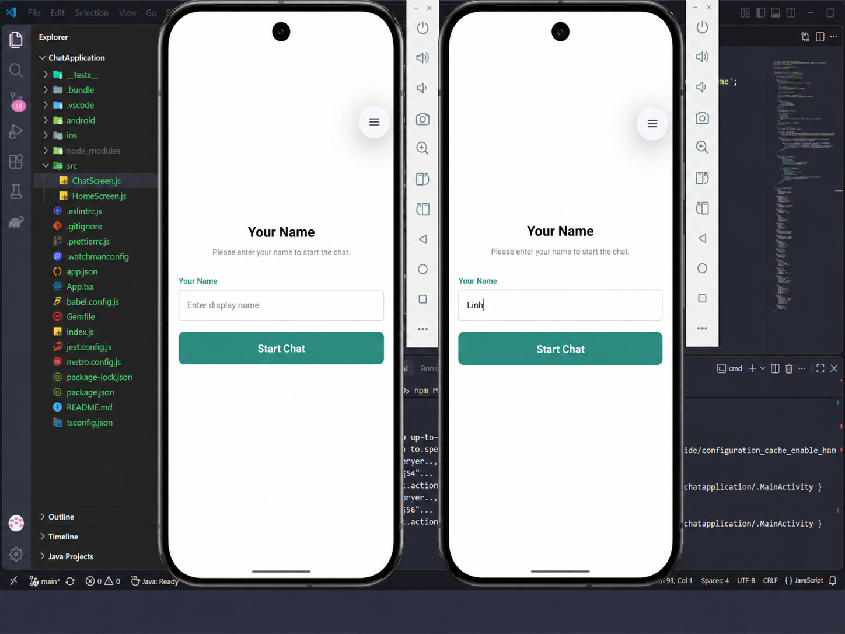
Figure 1. Home Screen reference: display-name input and Start Chat.
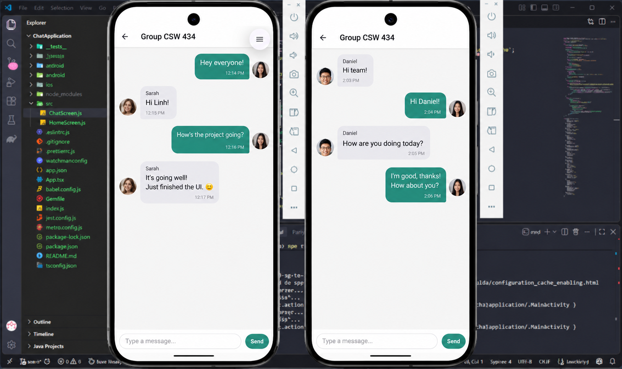
Figure 2. Group Screen reference: outgoing/incoming messages and composer.

