System Specification
Restaurant Order Management System
Group 11
Version 1.1
Document Change Log
Date | Version | Description | Author
01/11/2026 | 1.0 | Merged document: combined the members contributions into one specification | Nguyen Dinh Thuan Thien
02/11/2026 | 1.1 | Merged document: combined the members contributions into one specification | Nguyen Dinh Thuan Thien

I. Restaurant Order Management System

Group 1: View and Search Menu
Prepared by: Nguyen Tien Anh
Purpose: Describes the functional group allowing customers to browse the restaurant menu by category, search for dishes by keyword, sort the results, and view detailed information of each dish. It also allows the administrator to manage the dishes on the menu.
Content Category | Detailed Content
Browse Menu Function | - Customer selects a dish category (e.g., Bowls, Salads, Mains, Drinks)  - Displays the 20 newest dishes of the selected category, with pagination  - Minimum fields: Image, Name, Price, Discount, Status (Available / Sold out)  - Displays a notification if the category has no dishes
Sort Function | - Customer can sort the dish list in ascending or descending order by Price, Discount, or Number of Orders  - Applies to both the category list and the search results
Search Dish Function | - Customer enters a keyword; the system returns the dishes whose name contains the keyword (not case-sensitive)  - Displays a notification if no dish is found  - Asks the customer to enter a keyword if the field is empty
View Dish Details Function | - Customer selects a dish to view detailed information  - Includes: Dish ID, name, image, price, discount, status, number of views, number of orders, short description, and detailed description  - The number of views increases by 1 each time the details are opened
Manage Dish Function (Admin) | - Admin views the dish list by category and can add, update, or delete a dish  - The system validates the information (required fields, unique Dish ID, price ≥ 0, discount from 0% to 100%) and asks for confirmation before deleting  - A dish that already appears in orders is set to “Discontinued” (hidden from the menu) instead of being removed
Business Rules | - Customers can browse and search the menu without logging in  - Discount is a percentage of the current price  - Sold-out dishes are still displayed but cannot be added to the cart  - Only the Admin can add, update, or delete dishes  - The Dish ID is unique and cannot be modified

Group 2: Select Dishes and Manage Cart
Prepared by: Phuc Hoa
Purpose: Describes the functional group allowing customers (guest or registered member, subject to the project’s authentication design) to view dish information, select dishes, add them to a cart, update their selections, and proceed to checkout.
Content Category | Detailed Content
View Dish Information | - The customer selects a dish from the menu  - The system displays available details such as dish name, image (if available), description, price, and availability status  - The system must clearly identify dishes that cannot currently be ordered
Add Dish to Cart | - The customer chooses an available dish, specifies a positive whole-number quantity, and selects Add to Cart  - The system validates the dish and quantity  - If the dish already exists in the active cart, the system may increase its quantity; otherwise, it creates a new cart item  - The cart totals are recalculated and the updated cart is displayed
Update Cart | - The customer can increase or decrease item quantities, remove items, and review each dish’s unit price and line subtotal  - Every change triggers recalculation  - A zero quantity is treated as removal; negative quantities are rejected
Proceed to Checkout | - The customer selects Proceed to Checkout  - The system checks that the cart contains at least one valid item, then revalidates dish availability and current prices before moving to checkout  - If the cart is empty or an item is no longer available, the system displays a clear message and asks the customer to update the cart
Business Rules | - Only dishes marked Available can be added to the cart  - Quantity must be a positive whole number  - Line subtotal = unit price × quantity  - Cart subtotal = sum of all valid cart-item line subtotals  - The system recalculates totals after every cart modification  - Checkout cannot proceed with an empty cart  - Dish availability and price must be checked again before order confirmation  - Any tax, discount, service charge, or delivery fee is applied only if included in the approved project requirements

Group 3: Place Order and Payment
Prepared by: Phuc Hoa
Purpose: Describes the functional group that converts the customer’s validated cart into a confirmed order and records the order and payment information. The Customer is the primary actor; a payment service (only if online payment is integrated) and an email service (only if email notification is implemented) support the process.
Content Category | Detailed Content
Checkout Verification | - Precondition: The cart contains at least one valid item and the required dishes are available  - Customer reviews the cart and chooses Proceed to Checkout  - System verifies that the cart is not empty and that all selected dishes remain available  - Customer logs in or registers if authentication is required by the project policy
Order Information | - Customer provides the required order information; depending on the agreed scope, this may include name, phone number, email, table number, or fulfillment details  - Customer reviews the order summary, quantities, prices, and total amount
Payment Function | - Customer selects one of the payment methods supported by the implemented system  - System validates all required information and recalculates the final amount  - Sensitive payment credentials must not be stored in the restaurant database
Order Creation and Confirmation | - Customer confirms the order  - System creates the order record and its order-item records, with an initial status such as Pending or Confirmed according to the group’s workflow  - System records the payment information and payment status  - System displays an order confirmation containing the order number, ordered items, total amount, and current order status  - If email notification is implemented and a valid email address is available, the system may send an order confirmation email
Exception Handling | - Empty cart: prevent checkout and direct the customer back to the menu  - Dish becomes unavailable: identify the affected item and require the customer to remove it or choose another dish  - Price changes before confirmation: show the updated price and ask the customer to review the new total  - Missing or invalid required information: highlight the relevant field and do not create the order  - Payment fails: show a clear retry or alternative-payment message; do not mark an unsuccessful payment as Paid
Business Rules | - Checkout cannot proceed with an empty cart  - Dish availability and price must be checked again before order confirmation  - The final amount must be recalculated on the server  - The order must contain at least one order item  - Payment status must reflect the actual payment result  - Any tax, discount, service charge, or delivery fee is applied only if included in the approved project requirements
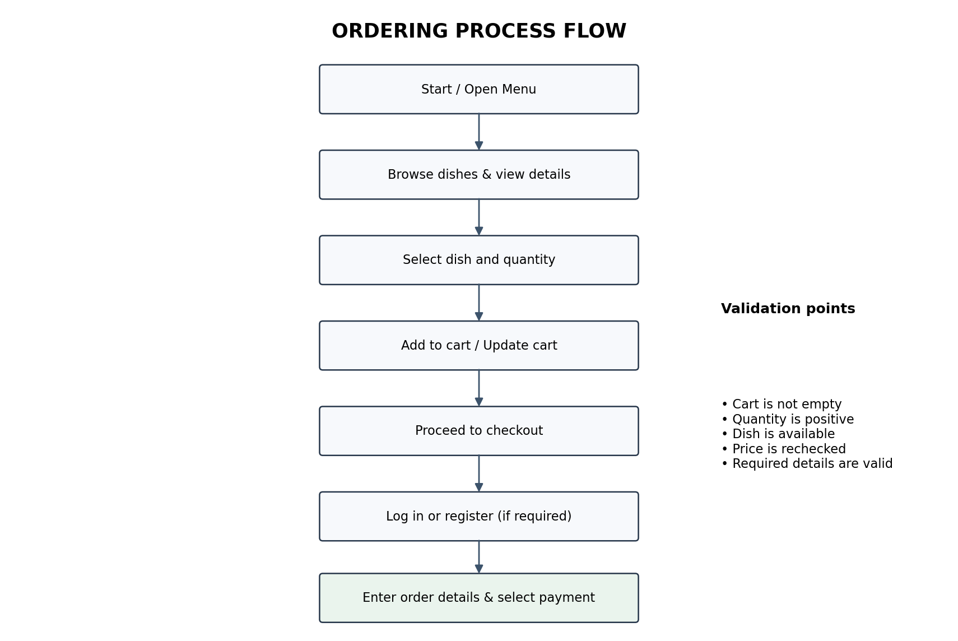
Figure 1. Ordering Process Flow

Group 4: Customer Account Registration and Updates
Prepared by: Truong Quang Huy
Content Category | Detailed Content
Registration Function | - Customers who do not have an account can register using their full name, email address, phone number, and password.  - Before creating the account, the system checks that the email address has not been used and that the password is valid.
View Costumer Information Function | - Before creating the account, the system checks that the email address has not been used and that the password is valid.  - The system stores the customer’s full name, email address, phone number, and delivery address.  - Logged-in customers can view this information.
Update Information Function | - Customers can edit their full name, phone number, and delivery address.
Password Recovery Function | - If customers forget their password, they enter their registered email address.  - The system sends a link or verification code so they can set a new password.
Business Rules | - Each email address can only be registered to one account.  - Customers must log in to view or update their personal information.  - Customers can only update information associated with their own account.  - Password recovery requires access to the registered email address.

Group 5: View and Manage Orders
Prepared by: Phan Duy
Purpose: Describes the functional group allowing customers to review their created orders on the system, view detailed order information, and track the processing status of each order.
Content Category | Detailed Content
Order List Information | - Displays the order list for the current account, sorted with the newest first  - Minimum fields: Order ID, Order Date, Total Amount, Status  - Displays a notification if there are no orders
View Order Details Function | - Customer selects an order to view detailed information  - Includes: item list, quantity, unit price, sub-total, and order summary
Cancel Order Function | - Allows customers to cancel an order if it is still in the “New” status  - The system checks, confirms, and updates the status to “Canceled”
Business Rules | - Customers must log in to view history  - Can only view orders created by their own account  - Customers can only view their order history and order details, but they can cancel orders that are still in the “New” status.

Group 6: System Administration
Prepared by: Nguyen Dinh Thuan Thien
Content Category | Detailed Content
Manage Dishes Function | - Admin can view the dish list by category.  - Admin can add, update, and delete dish information.  - The system validates dish information before saving changes.  - Dishes that already appear in orders are marked as "Discontinued" instead of being permanently deleted.
Manage Users Function | - Admin can view the list of registered customer accounts.  - Admin can view customer information, including full name, email address, and phone number.  - Admin can update or manage customer account information.
Manage Orders Function | - Admin can view the list of orders placed by customers.  - Admin can view detailed order information, including customer information, ordered dishes, quantities, and total amount.  - Admin can track and update order statuses during the processing workflow.  - Admin can manage order cancellations according to the system's business rules.
Business Rules | - Only authenticated Admin users can access system administration functions.  - Only Admin users can manage dish information, customer accounts, and orders.  - The system must validate information before saving any changes.  - Order status updates must follow the defined order processing workflow.

II. Glossary
Term | Definition
Subtotal | - The amount calculated by multiplying the unit price by the quantity.
Checkout | - The process of reviewing an order and submitting it for processing.
Pagination | - Dividing a long list of items into multiple pages.
Precondition | - A condition that must be satisfied before a function can be performed.
Password Recovery | - The process of resetting a forgotten password.
Order Status | - The current state of an order during its processing.
Discontinued | - A status indicating that a dish is no longer offered on the menu.

III. Supplementary Specification
Usability
The system provides a user-friendly interface that is easy to understand and use. The interface automatically adjusts to different screen sizes (responsive).

Reliability
The system should operate continuously to ensure that customers can access the menu, manage their carts, and place orders. Customer and order information must be stored accurately and consistently.

Performance
The system should respond to user requests within a reasonable time. It should support multiple customers accessing the system simultaneously and handle large amounts of dish, customer, and order data efficiently.

Supportability
The system should be designed to facilitate maintenance and future upgrades. Its functions should be organized clearly to support modifications and extensions.

Security
Customers can only view and manage information associated with their own accounts and orders. Administrative functions must only be accessible to authorized Admin users. The system should protect user information and prevent common security vulnerabilities such as SQL Injection and Cross-Site Scripting (XSS).

Design Constraints
The system operates on a web platform using HTML, CSS, PHP, and MySQL. The server runs CentOS 6.0.

IV. Use-Case Diagram
1. Overview Diagram
1.1. List of Actors
STT | Actor | Meaning
1 | Guest | Guests or users who have not yet logged into the system
2 | Customer | A member or user who already has an account and is logged into the system.
3 | Admin | System administrator

1.2. List of Use-cases
STT | Use-case | Meaning | Note (Group)
1 | Browse Menu/Product | Allows users to view the list of available dishes. | 1
2 | Search Dish | Allows users to search for dishes by name. | 1
3 | Manage Dishes | Allows the Admin to view, add, update, and delete dish information. | 1
4 | View Dish Details | Allows users to view detailed information about a selected dish. | 1
5 | Manage Cart | Allows customers to add, update, and remove dishes from their shopping cart. | 2
6 | Checkout / Place Order | Allows customers to provide order information and submit their orders. | 3
7 | Register | Allows new customers to create an account. | 4
8 | Login | Allows registered customers to access their accounts. | 4
9 | View/Update Customer Information | Allows customers to view/update their personal information. | 4
10 | Password Recovery | Allows customers to recover access to their accounts when they forget their passwords. | 4
11 | View Order History | Allows customers to view their previously placed orders. | 5
12 | View Order Details | Allows customers to view detailed information about a selected order. | 5
13 | Cancel Order | Allows customers to cancel orders that meet the cancellation conditions. | 5
14 | Manage Users | Allows the Admin to view and manage customer accounts. | 6
15 | Manage Orders | Allows the Admin to view and manage customer orders. | 6

2. Use-case Browse Menu
2.1 Summary
Allows customers to view the dishes on the menu by category, sort the dish list by price, discount, or number of orders, and inspect the detailed information of a specific dish.
Primary actor: Customer (Guest or Member).
2.2 Flow of events
2.2.1 Main flow
- Customer opens the Menu and selects a dish category.
- System displays the 20 newest dishes of the selected category, with pagination.
- Customer sorts the list (by price, discount, or number of orders) or selects a page.
- System displays the dish list according to the customer’s choice.
- Customer selects a dish to view its details.
- System increases the view count of the dish by 1 and displays the dish details (Dish ID, name, image, price, discount, status, views, orders, short and full description).
- (Optional) Customer adds the dish to the cart from the list or the details screen (extends the Manage Cart use-case).
2.2.2 Alternative flows
- Category has no dishes: System displays “There are no dishes in this category yet” with an option to choose another category.
- Dish is sold out: The dish is still displayed and marked “Sold Out”.
- Dish is discontinued: The dish is not displayed on the menu.
- Connection or data query error: System displays an error message and provides a retry option.
2.3 Special requirements
The price after discount is calculated as: current price × (1 − discount%).
2.4 Pre-conditions (system state before the use-case starts)
None (the customer does not need to log in).
2.5 Post-conditions (system state after the use-case ends)
The dish list or the details of the selected dish are displayed to the customer; the view count of a viewed dish increases by 1, all other data remains unchanged.
2.6 Extension points
Use-case Manage Cart: if the user chooses to add a dish to the cart.
2.7 User interface
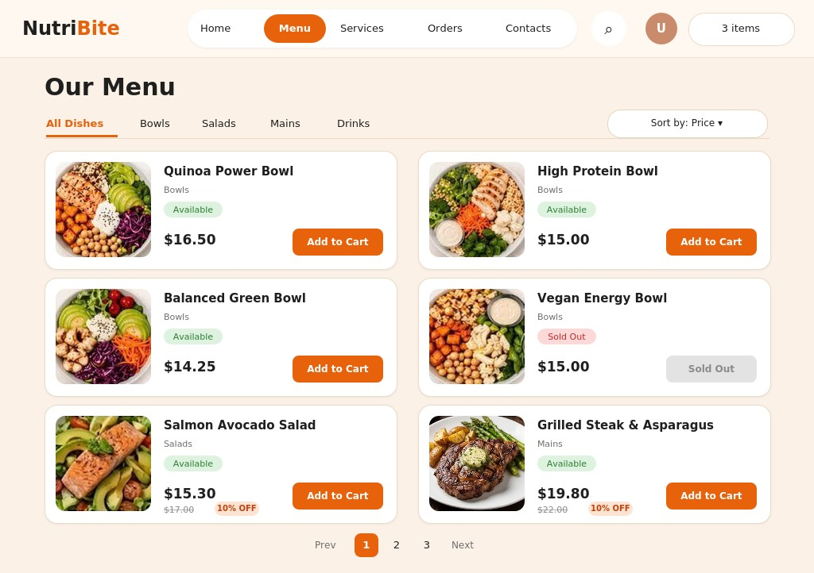
Figure 2. Menu Screen
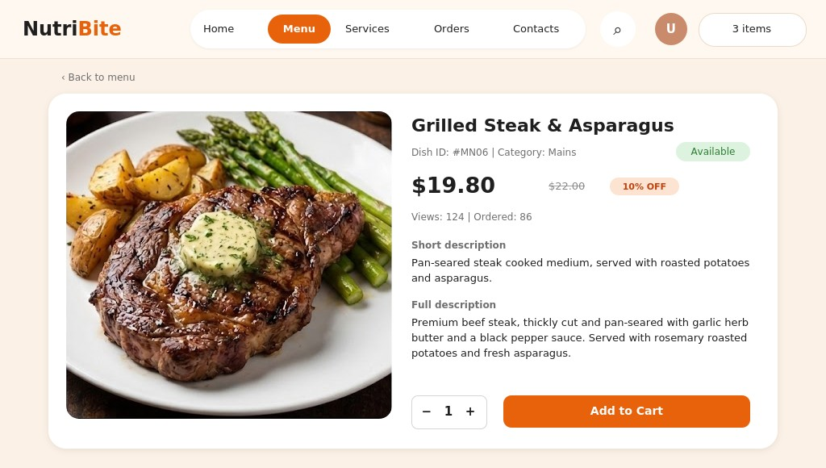
Figure 3. Dish Details Screen
3. Use-case Search Dish
3.1 Summary
Allows customers to search for dishes by entering the name (or part of the name) of a dish, and to sort the search results.
Primary actor: Customer (Guest or Member).
3.2 Flow of events
3.2.1 Main flow
- Customer selects the search function on the Menu screen.
- System displays the search box.
- Customer enters a keyword and submits the search.
- System lists the dishes whose name contains the keyword (not case-sensitive).
- Customer sorts the results (by price, discount, or number of orders) or selects a page (pagination applies when more than 20 dishes are found).
- System displays the dish list according to the customer’s choice.
- (Optional) Customer adds a dish to the cart (extends the Manage Cart use-case).
3.2.2 Alternative flows
- No dish found: System displays “No matching dish found” with an option to enter another keyword.
- Empty keyword: System asks the customer to enter a keyword.
- Connection or data query error: System displays an error message and provides a retry option.
3.3 Special requirements
- The search is not case-sensitive.
- The search should work with Vietnamese text with or without diacritics (e.g., “pho bo” finds “Phở bò”).
- Dishes with the status “Discontinued” are not included in the results.
3.4 Pre-conditions (system state before the use-case starts)
None (the customer does not need to log in).
3.5 Post-conditions (system state after the use-case ends)
The list of matching dishes is displayed to the customer; system data remains unchanged.
3.6 Extension points
Use-case Manage Cart: if the user chooses to add a dish to the cart.
3.7 User interface
The search function uses the Menu screen (Figure 2): results are displayed in the same card layout.
4. Use-case Manage Dish
4.1 Summary
Allows the administrator to view the dish list, search and filter dishes, and add, update, or delete dishes on the menu.
Primary actor: Admin / Restaurant Staff.
4.2 Flow of events
4.2.1 Main flow
- Admin selects Menu Management.
- System displays the dish list with the status summary, search box, and category filter.
- Admin searches by Dish ID or name, or filters by category or status (if needed).
- Admin selects an action: Add New Dish, Edit, or Delete. The corresponding sub-flow below is executed.
4.2.1.1 Add dish
- System displays the Add Dish form (Dish ID, name, category, price, discount, status, image, short and full description).
- Admin enters the dish information and selects Add Dish.
- System validates the information and saves the new dish.
- System displays a success message and refreshes the list.
4.2.1.2 Update dish
- System displays the Update Dish form with the current information (the Dish ID cannot be changed).
- Admin edits the information and selects Save Dish.
- System validates the information and updates the dish.
- System displays a success message and refreshes the list.
4.2.1.3 Delete dish
- System displays a confirmation dialog.
- Admin confirms the deletion.
- System deletes the dish; if the dish already appears in orders, the system sets it to “Discontinued” (hidden from the menu) instead, so old order data is kept.
- System displays a success message and refreshes the list.
4.2.2 Alternative flows
- Dish not found: System displays a notification that no matching results were found.
- Invalid information: If required fields are empty (Dish ID, name, category, price), the Dish ID already exists, the price is less than 0, or the discount is outside 0%–100%, the system displays an error message and the admin corrects the information or cancels.
- Admin cancels the confirmation: System keeps the dish unchanged and returns to the dish list.
- Saving error: System displays an error message and prompts the admin to retry.
4.3 Special requirements
- The dish list must be paginated to improve system performance.
- Dish images must be in a common format (jpg, png) and within a size limit.
4.4 Pre-conditions (system state before the use-case starts)
The admin has successfully logged into the system with administrative privileges.
4.5 Post-conditions (system state after the use-case ends)
The dish is added, updated, or removed from the menu (set to “Discontinued” if it already appears in orders) and saved successfully in the system; otherwise the data remains unchanged.
4.6 Extension points
None.
4.7 User interface
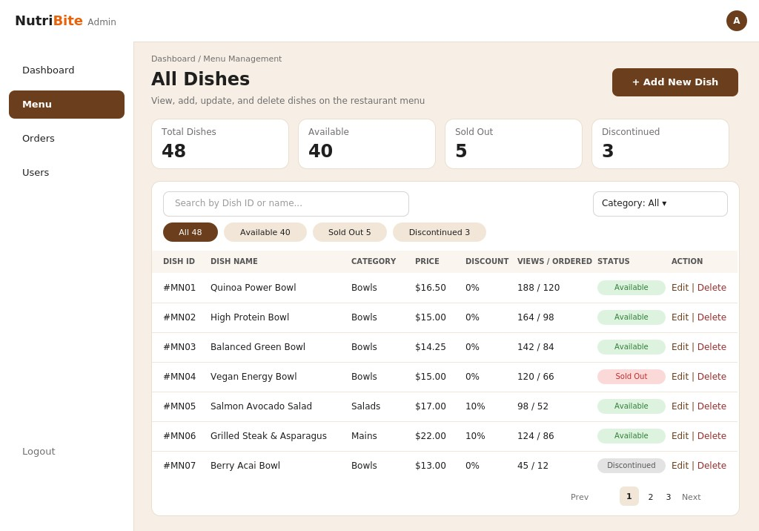
Figure 4. Manage Dish Screen
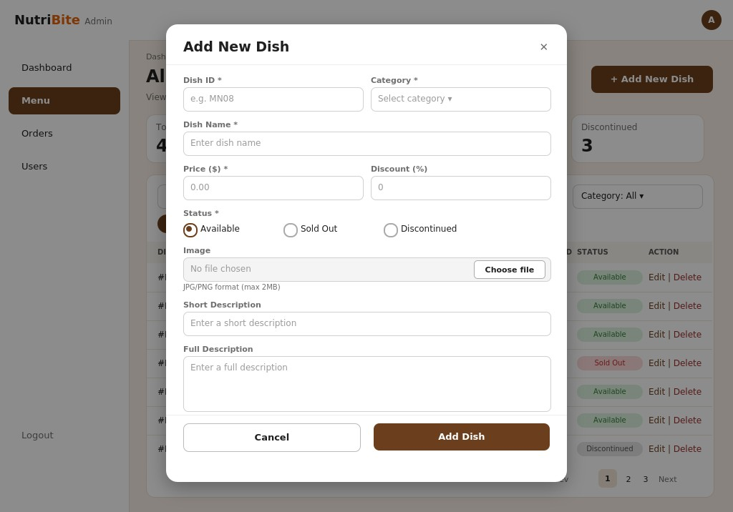
Figure 5. Add Dish Form
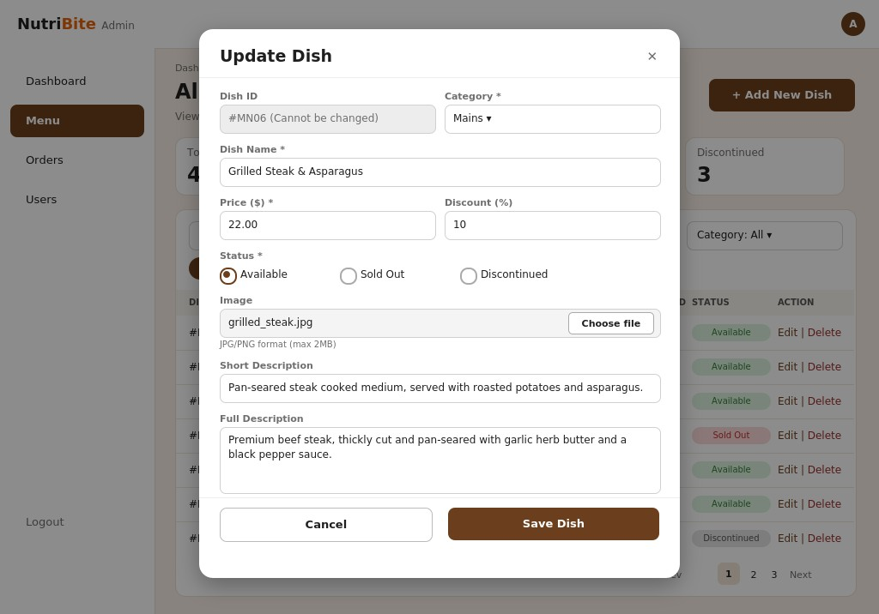
Figure 6. Update Dish Form
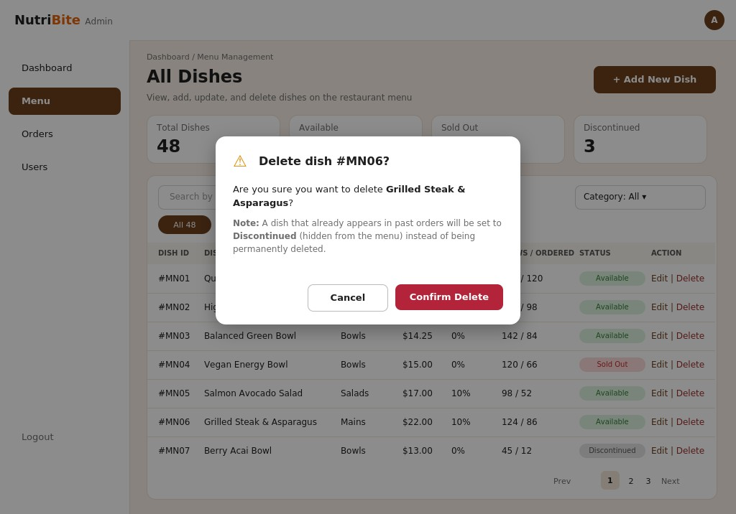
Figure 7. Delete Dish Confirmation
5. Use-case Login
5.1 Summary
The customer logs in to use features that require an account (placing orders and viewing orders).
Primary actor: Customer.
5.2 Flow of events
5.2.1 Main flow
- The customer selects “Log In.”
- The system displays the login form.
- The customer enters their email and password, then clicks “Log In.”
- The system validates the information.
- The system creates a session and redirects the customer to the home page.
5.2.2 Alternative flows
3a. If a field is left blank, the system displays “Please complete all required fields” and returns to Step 3.
4a. If the email or password is incorrect, the system displays an error and returns to Step 3.
3b. If the customer selects “Forgot password?”, the system opens the Reset Password use case.
3c. If the customer selects “Sign up,” the system opens the Register use case.
Exception: If the connection is lost or a system error occurs, the system displays “Unable to log in. Please try again later.”
5.3 Special requirements
None.
5.4 Pre-conditions (system state before the use-case starts)
The customer has an account and is on the login screen.
5.5 Post-conditions (system state after the use-case ends)
The login is successful, the system creates a session, and the customer is redirected to the home page.
5.6 Extension points
- Use-case Reset Password: if the customer selects “Forgot password?” (alternative flow 3b).
- Use-case Register: if the customer selects “Sign up” (alternative flow 3c).
5.7 User interface
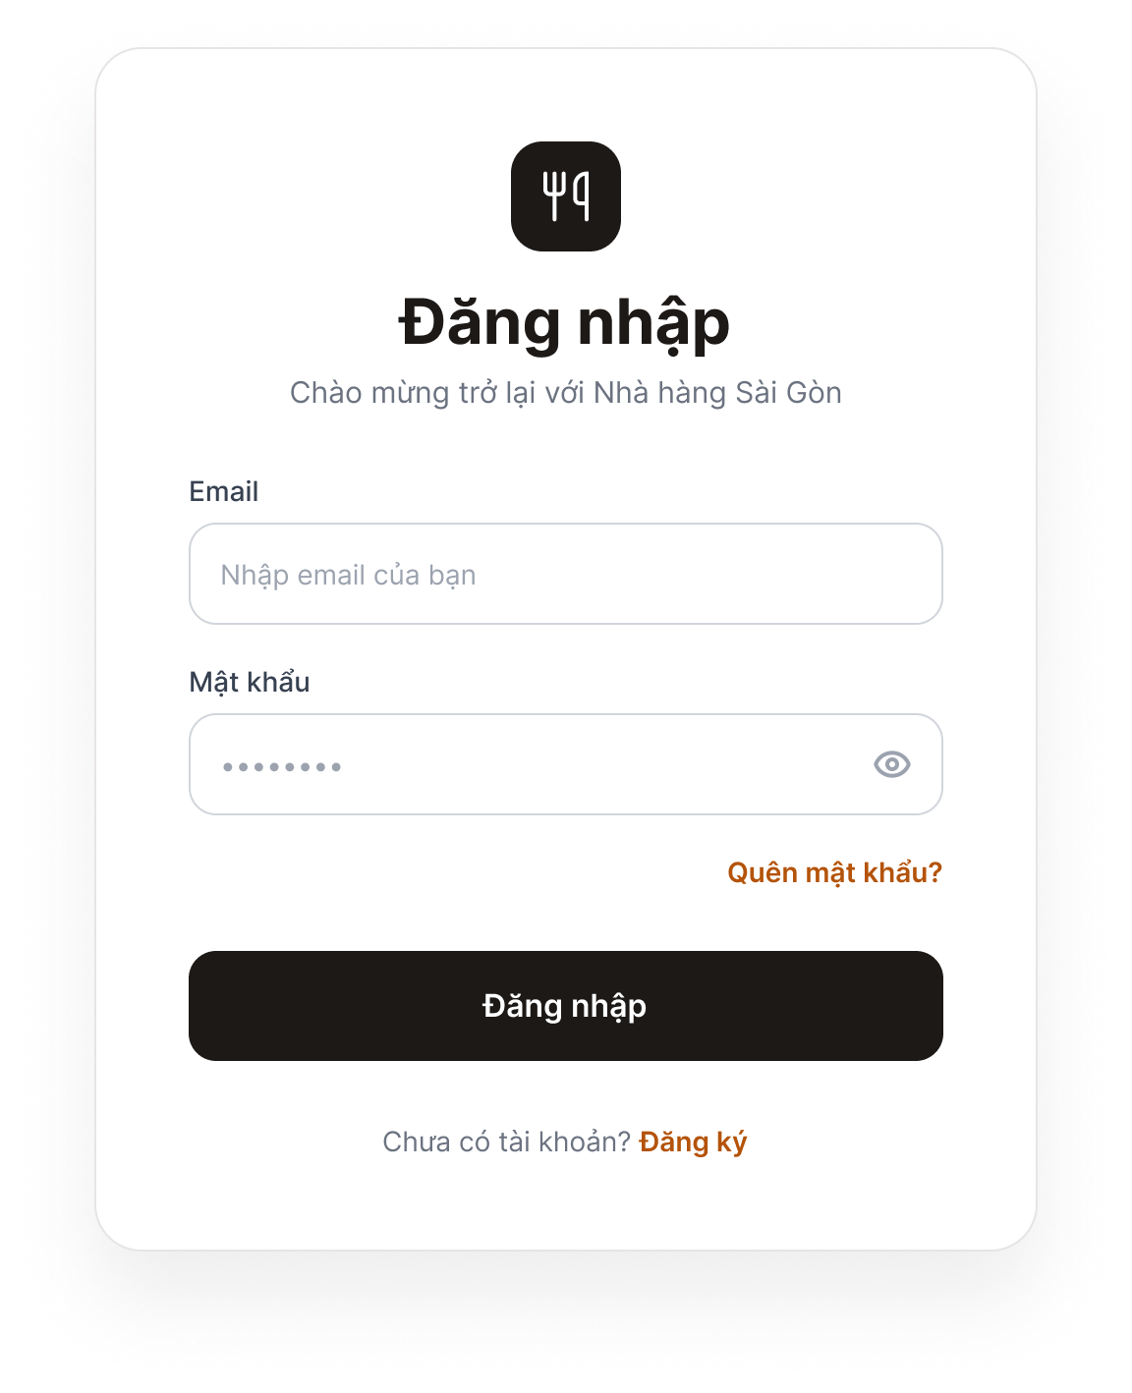
Figure 8. Login Screen
Purpose: Allows customers to log in to the system.
Components: Email field, Password field, “Log In” button, “Forgot password?” link, and “Don’t have an account? Sign up” link.
Behavior: When the user clicks “Log In” with valid credentials, the system redirects to the home page. If the information is incorrect or a field is empty, a red error message appears below the relevant field. Clicking “Forgot password?” opens the Password Recovery screen; clicking “Sign up” opens the Registration screen.
6. Use-case Register
6.1 Summary
A customer without an account creates a new account.
Primary actor: Customer.
6.2 Flow of events
6.2.1 Main flow
- The customer selects “Sign Up.”
- The system displays a form (full name, email, phone number, password, and confirm password).
- The customer enters the information and clicks “Sign Up.”
- The system validates the data and checks that the email address has not been used.
- The system saves the account, displays “Registration successful,” and redirects to the login screen.
6.2.2 Alternative flows
3a. If a field is blank, the system reports missing information and returns to Step 3.
4a. If the email already exists, the system displays “This email address is already in use” and returns to Step 3.
4b. If the email or phone number format is invalid, the system displays an error at the relevant field and returns to Step 3.
4c. If the password is too weak or does not match the confirmation, the system displays an error and returns to Step 3.
Exception: If the connection is lost or a system error occurs, the system displays “Unable to register. Please try again later.”
6.3 Special requirements
None.
6.4 Pre-conditions (system state before the use-case starts)
The customer does not have an account.
6.5 Post-conditions (system state after the use-case ends)
The new account is saved in the system, and the customer is redirected to the login screen.
6.6 Extension points
None.
6.7 User interface
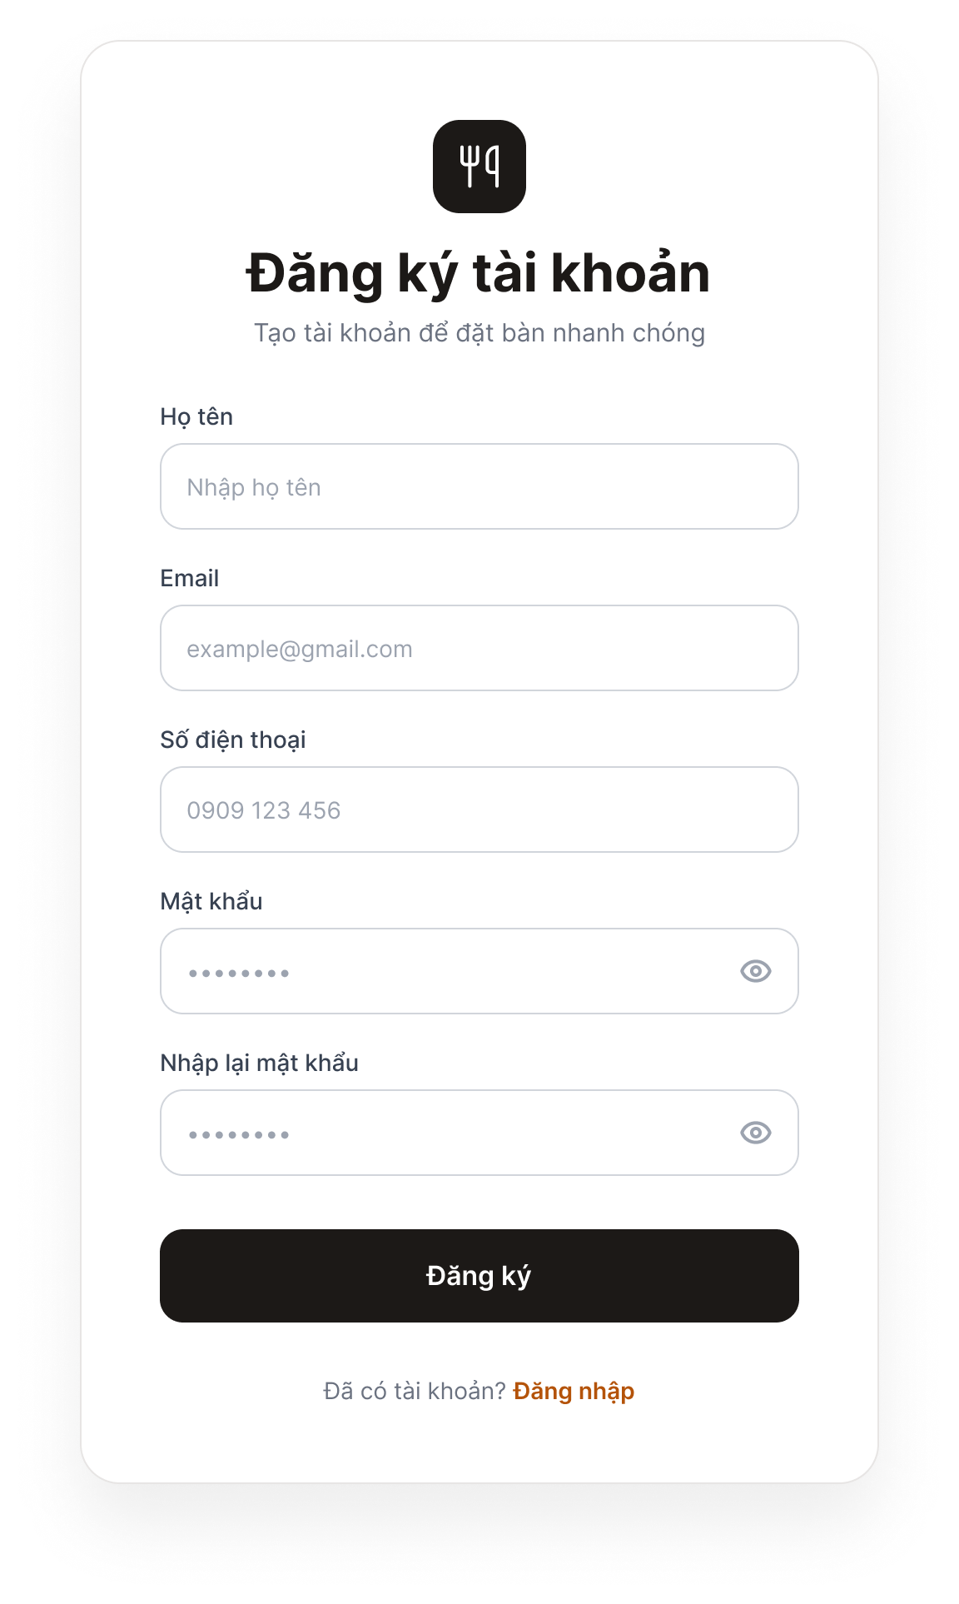
Figure 9. Registration Screen
Purpose: Allows new customers to create an account.
Components: Full Name, Email, Phone Number, Password, and Confirm Password fields; “Sign Up” button; and “Already have an account? Log in” link.
Behavior: When the user clicks “Sign Up” with valid data, the system saves the account, displays “Registration successful,” and opens the Login screen. If the data is invalid, an error appears below the relevant field (email already exists, invalid format, or passwords do not match).
7. Use-case Update Profile
7.1 Summary
The customer views and edits personal information (full name, phone number, and address).
Primary actor: Customer.
7.2 Flow of events
7.2.1 Main flow
- The customer selects “My Profile.”
- The system displays the current information (full name, phone number, and address; email is view-only).
- The customer edits the information and clicks “Save.”
- The system validates the data.
- The system saves the changes and displays “Update successful.”
7.2.2 Alternative flows
3a. If the customer clicks “Cancel,” the system discards the changes and keeps the original information.
4a. If the data is invalid (incorrect phone number format or blank full name), the system displays an error and returns to Step 3.
Exception: If the connection is lost or a system error occurs, the system displays “Unable to update. Please try again later,” and the original information is retained.
7.3 Special requirements
None.
7.4 Pre-conditions (system state before the use-case starts)
The customer is logged in.
7.5 Post-conditions (system state after the use-case ends)
The updated information is saved and displayed in the profile.
7.6 Extension points
None.
7.7 User interface
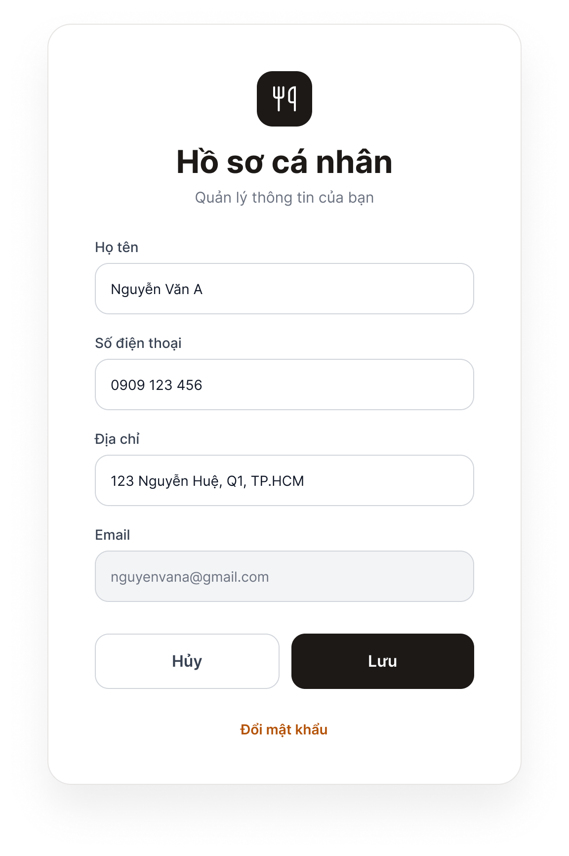
Figure 10. Profile Screen
Purpose: Allows logged-in customers to view and update their personal information.
Components: Full Name, Phone Number, and Address fields; a read-only Email field (gray); “Save” and “Cancel” buttons; and a “Change password” link.
Behavior: Clicking “Save” prompts the system to validate and save the changes, then display “Update successful.” Invalid data triggers an error below the relevant field. Clicking “Cancel” discards the changes and restores the previous information. Clicking “Change password” opens the Password Recovery screen.
8. Use-case Reset Password
8.1 Summary
The customer has forgotten their password and resets it via email.
Primary actor: Customer. The system sends a verification email to the customer.
8.2 Flow of events
8.2.1 Main flow
- The customer selects “Forgot password?”
- The system displays an email field.
- The customer enters their email and clicks “Send Link.”
- The system checks whether the email exists, then sends a link or verification code.
- The customer opens the email and clicks the link (or enters the code).
- The system displays the new-password form.
- The customer enters and confirms the new password, then clicks “Confirm.”
- The system updates the password, displays a success message, and redirects to the login screen.
8.2.2 Alternative flows
4a. If the email does not exist, the system displays an error and returns to Step 3.
5a. If the link or code has expired, the system displays an expiration message and the customer can request a new one.
7a. If the new password is invalid or does not match the confirmation, the system displays an error and returns to Step 7.
Exception: If the email cannot be sent due to a system error, the system displays “Unable to send email. Please try again later.”
8.3 Special requirements
None.
8.4 Pre-conditions (system state before the use-case starts)
The customer has an account but has forgotten the password.
8.5 Post-conditions (system state after the use-case ends)
The new password is saved, and the customer can log in using it.
8.6 Extension points
None.
8.7 User interface
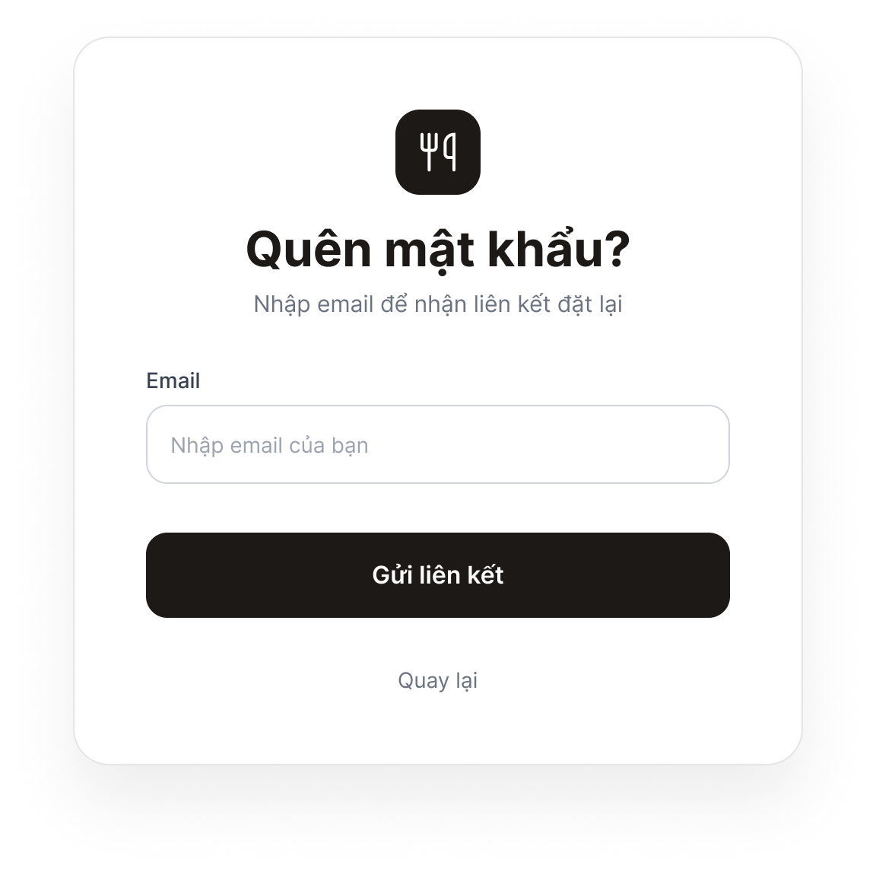
Figure 11. Password Recovery Screen – Step 1: Enter Email
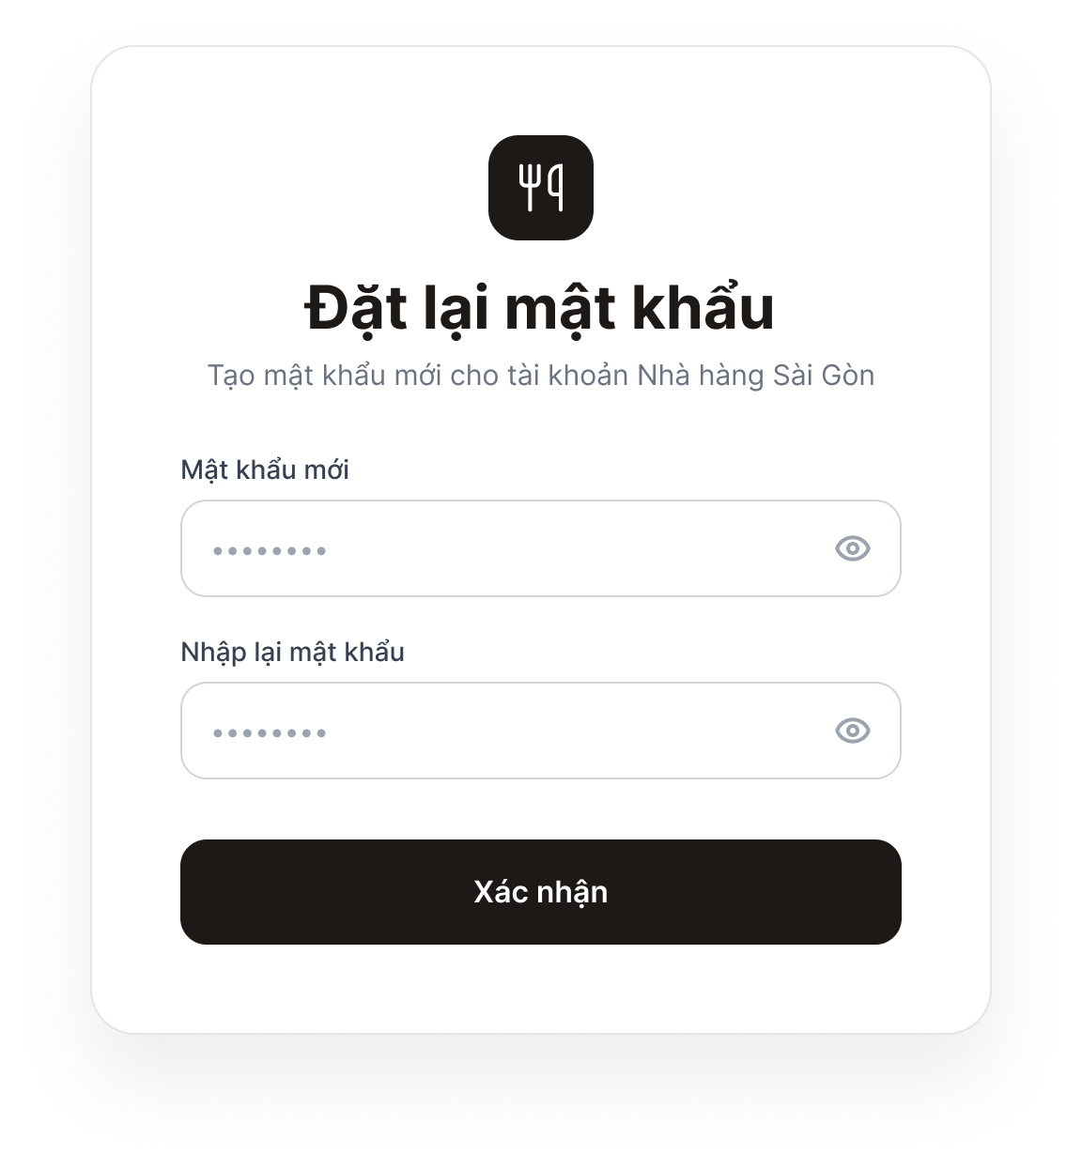
Figure 12. Password Recovery Screen – Step 2: Set a New Password
Purpose: Allows customers who have forgotten their password to reset it via email.
Components: Step 1: Email field and “Send Link” button. Step 2: New Password and Confirm Password fields, and a “Confirm” button.
Behavior: In Step 1, clicking “Send Link” causes the system to send a verification email; if the email address does not exist, an error is displayed. After the customer opens the link in the email, Step 2 appears. Clicking “Confirm” with a valid password updates the password and opens the Login screen. If the link has expired, the system displays an expiration message and allows the customer to request a new link.
9. Use-case Manage User
9.1 Summary
This use case allows an administrator to manage user information within an online sales system. It includes functions to view, add, edit, and delete users.
9.2 Flow of events
9.2.1 Main flow
This use case begins when an administrator manages users.
- The system displays a list of users.
- If the administrator selects “Add,” the “Add user account” event flow is executed.
- If the administrator selects the “Update” function for a user, the “Update user account” event flow is executed.
- If the administrator selects the “Delete” function for a user, the “Delete user account” event flow is executed.

9.2.1.1 Add a user account
- The system prompts the administrator to enter user information.
- The administrator enters the information and requests the addition.
- The system validates the information and adds it to the system.
- The system notifies the user of the outcome of the addition.

9.2.1.2 Update a user account
- The user information display system requires an update.
- The administrator modifies the information as desired.
- The administrator requests the information update.
- The system validates the information and applies the update.
- The system notifies the user of the update result.

9.2.1.3 Delete a user account
- The system requires the administrator to confirm the user deletion action.
- If the administrator confirms the deletion, the system removes the user and all information associated with that user from the system.
- The system notifies the user of the deletion result.

9.2.2 Alternative flows
Nothing

9.3 Special requirements
The list of users must be paginated to improve system performance.

9.4 Pre-conditions (system state before the use-case starts)
The list of users must be paginated to improve system performance.

9.5 Post-conditions (system state after the use-case ends)
If the use case is successful, user information will be added, updated, or removed from the system. Otherwise, the state of the system remains unchanged.

9.6 Extension points
Nothing

9.7 Admin interface
Figure 13. Admin inteface

10. Use-case Manage Cart
10.1 Summary
Goal: Review and maintain selected dishes before checkout.
Primary actor: Customer.
Trigger: Customer opens the cart or chooses an action to modify cart contents.
10.2 Flow of events
10.2.1 Main flow
- Customer opens the cart.
- System displays cart items and totals.
- Customer changes a quantity or removes an item.
- System validates the action.
- System updates the cart and recalculates totals.
- System displays the updated cart.
10.2.2 Alternative flows
- Invalid quantity: System rejects the value and displays a message.
- Item unavailable: System flags the item and asks the customer to remove or replace it.
- Cart becomes empty: System displays an empty-cart message and a link/action to return to the menu.
10.3 Special requirements
- Quantity must be a positive integer.
- The cart subtotal is the sum of line subtotals.
- Checkout is available only when at least one valid item remains.
10.4 Pre-conditions (system state before the use-case starts)
The menu is accessible. The customer has selected at least one dish to add, or has an existing active cart.
10.5 Post-conditions (system state after the use-case ends)
The cart contains the latest valid items and quantities; totals are recalculated.
10.6 Extension points
Use-case Checkout: if the customer selects Proceed to Checkout.
10.7 User interface
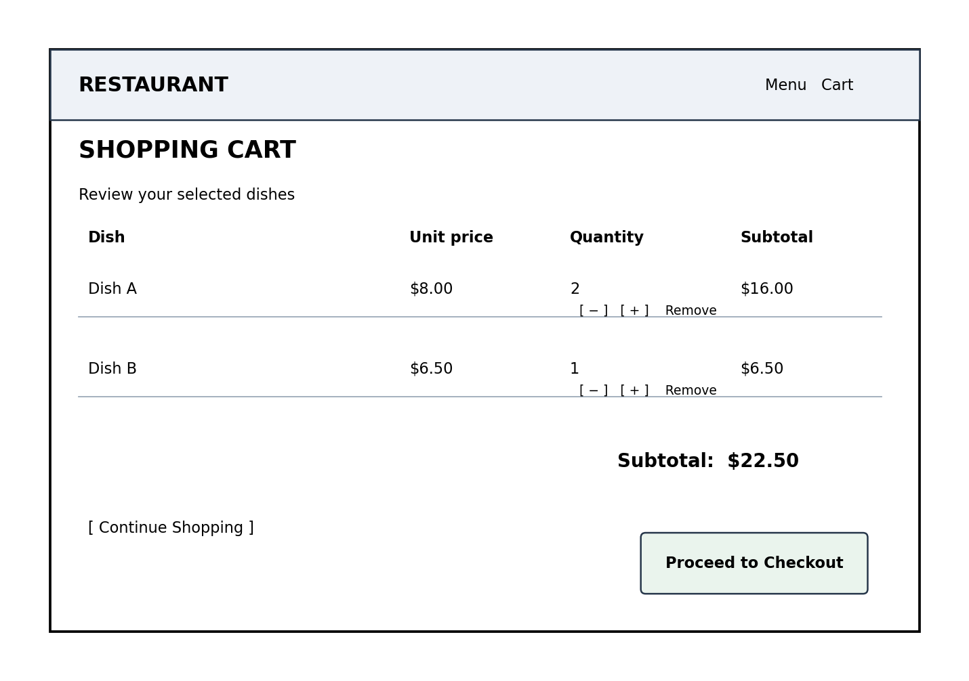
Figure 14. Shopping Cart Screen
The following is a low-fidelity wireframe showing the main information hierarchy and controls for the cart screen.
- Header/navigation: displays the restaurant name or logo and navigation links such as Menu and Cart.
- Page title and guidance: identifies the page as the Shopping Cart and tells the customer to review selected dishes.
- Cart item list: each row displays dish name, unit price, quantity controls, and line subtotal.
- Quantity controls: plus and minus actions allow the customer to adjust the selected quantity. The interface should prevent invalid quantities.
- Remove action: allows the customer to delete an item from the cart.
- Cart summary: displays the subtotal and, only when applicable, separately lists taxes, discounts, service charges, or delivery fees.
- Continue Shopping: returns the customer to the menu without losing the current cart.
- Proceed to Checkout: opens the checkout page when the cart contains at least one valid item.
- Empty-cart state: when no items exist, show a clear message and an action to return to the menu.
11. Use-case Checkout
11.1 Summary
Goal: Submit a valid cart and create an order.
Primary actor: Customer.
Supporting actors: Payment service (only if online payment is integrated); email service (only if email notification is implemented).
Trigger: Customer selects Proceed to Checkout.
11.2 Flow of events
11.2.1 Main flow
- Customer enters checkout.
- System revalidates cart items and prices.
- Customer signs in if required.
- Customer enters required contact/table/fulfillment information.
- System displays order summary and total.
- Customer selects payment method.
- Customer confirms.
- System creates order and order-item records.
- System records payment status.
- System displays confirmation and optionally sends an email.
11.2.2 Alternative flows
- Cart empty: Return to cart/menu.
- Dish unavailable or price changed: Require cart review.
- Invalid required information: Show validation errors.
- Payment unsuccessful: Record failure/pending status and show an appropriate message; do not mark Paid.
11.3 Special requirements
- The final amount must be recalculated on the server.
- The order must contain at least one order item.
- Payment status must reflect the actual payment result.
- Do not store card numbers, CVV, passwords, or other payment credentials.
11.4 Pre-conditions (system state before the use-case starts)
The cart contains at least one valid item. Required dishes are available. Customer identity/order details can be collected according to project policy.
11.5 Post-conditions (system state after the use-case ends)
A new order and order items are stored. Payment status and order status are recorded. A confirmation is displayed.
11.6 Extension points
None.
11.7 User interface
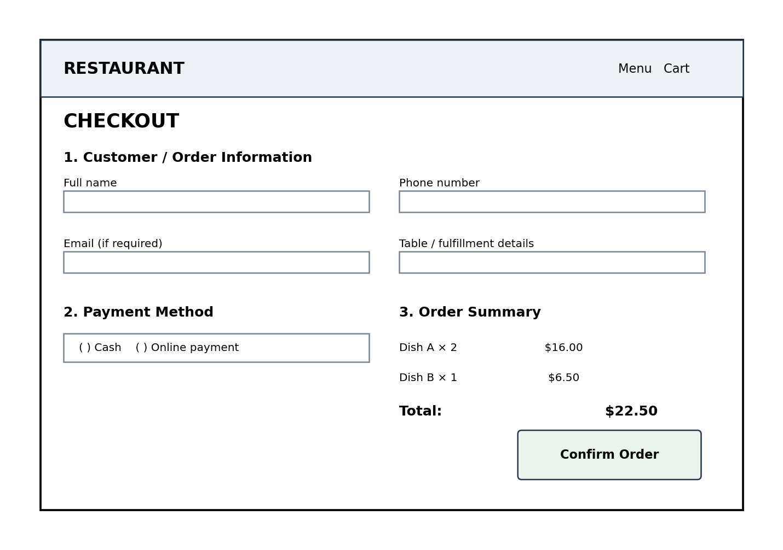
Figure 15. Checkout Screen
The checkout wireframe groups customer/order information, payment selection, and the order summary. The exact fields should be adjusted to the confirmed order type and payment integrations.
- Header/navigation: maintains consistent branding and allows the customer to identify the current stage of ordering.
- Customer/order information: collects only the fields required by the agreed order flow, such as customer name, phone, email, table number, or fulfillment information.
- Payment method: displays only payment methods that are actually supported by the system. For example, Cash or Online Payment should appear only if implemented.
- Order summary: lists selected dishes, quantities, unit prices, line subtotals, and the final total.
- Validation feedback: identifies missing or invalid required information next to the relevant field.
- Confirm Order: submits the checkout request after all required information has been validated.
- Confirmation state: after successful order creation, displays the order number, items, amount, and order status. An email confirmation is shown as sent only if email integration is implemented and succeeds.
General interface requirements (Shopping Cart and Checkout screens):
- Use consistent typography, spacing, button styles, and navigation across the Cart and Checkout screens.
- Make prices and the final total easy to locate and read.
- Clearly distinguish primary actions from secondary actions.
- Provide understandable validation and error messages.
- Ensure the interface remains usable on common desktop and mobile screen sizes.
- Do not display sample placeholder prices or dish names in the final implementation.
12. Use-case View Order
12.1 Summary
Allows customers to view their order history and inspect the detailed information of a specific order.
Primary actor: Customer.
12.2 Flow of events
12.2.1 Main flow
- Customer logs into the system.
- Customer selects Order History.
- System retrieves the order list.
- System displays the order list.
- Customer selects an order.
- System displays the order details.
12.2.2 Alternative flows
- Customer has no orders: System displays “You have no orders yet” with an option to return to the menu.
- Connection or data query error: System displays an error message and provides a retry option.
- Order does not exist or does not belong to the account: Denies access, displays an error message, and returns to the list.
12.3 Special requirements
None.
12.4 Pre-conditions (system state before the use-case starts)
The customer has successfully logged into the system.
12.5 Post-conditions (system state after the use-case ends)
The order list or specific order details are displayed to the customer; order data remains unchanged.
12.6 Extension points
None.
12.7 User interface
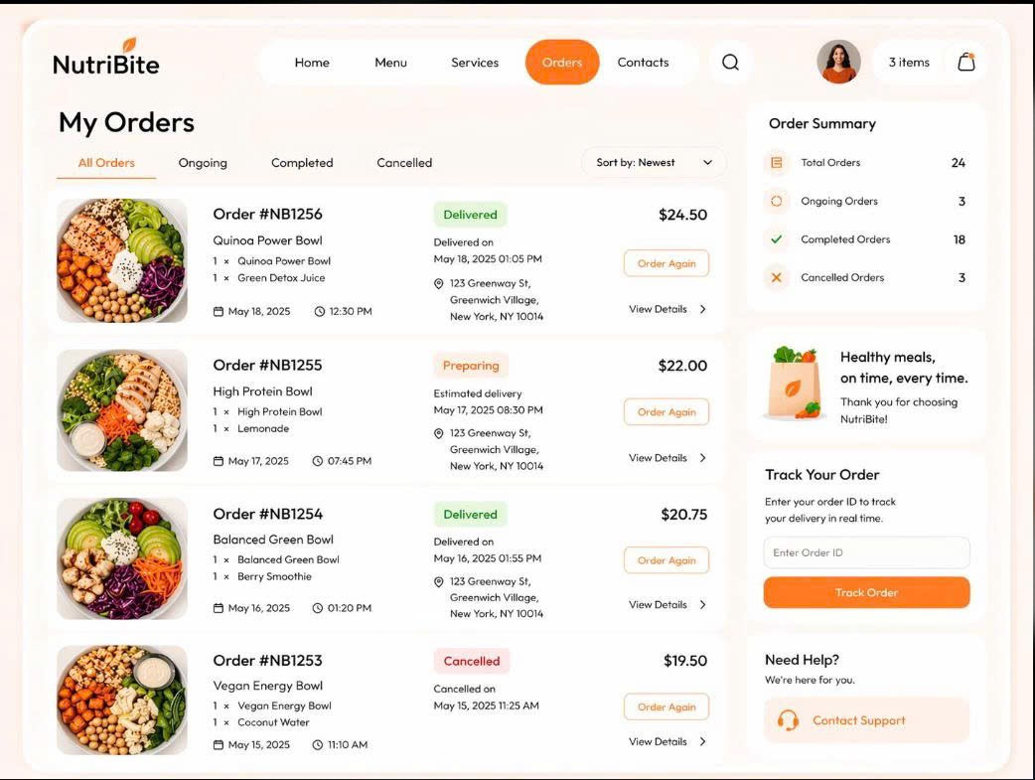
Figure 16. View Order Screen
Purpose: Allows customers to view the history of their placed orders and track their status.
Components: Table (Order ID, Date, Total, Status), View Details button, Cancel Order button.
Behavior: The system loads the list of orders based on the current account. Allows canceling an order if the status is “New”.
13. Use-case Cancel Order
13.1 Summary
Allows customers to request the cancellation of a placed order on the system if the order still meets the cancellation criteria.
Primary actor: Customer.
13.2 Flow of events
13.2.1 Main flow
- Customer selects an order to cancel.
- System checks the order status.
- System verifies that the order is still in the “New” status.
- System prompts the customer to confirm order cancellation.
- Customer confirms the cancellation.
- System updates the order status to “Canceled”.
13.2.2 Alternative flows
- Order is no longer in the “New” status: System does not allow cancellation and displays a rejection notification.
- Customer cancels the confirmation action: System keeps the previous order status and returns to the previous screen.
13.3 Special requirements
None.
13.4 Pre-conditions (system state before the use-case starts)
The customer has successfully logged in and is viewing the order details or order list screen.
13.5 Post-conditions (system state after the use-case ends)
The order status is updated to “Canceled” (if valid); the order data accurately reflects the cancellation status.
13.6 Extension points
None.
14. Use-case Manage Order
14.1 Summary
Allows the administrator to view the complete order list, search for orders, view details, update processing statuses, and save changes in the system.
Primary actor: Admin / Restaurant Staff.
14.2 Flow of events
14.2.1 Main flow
- Admin logs into the Admin account.
- Admin selects Order Management.
- Admin views the order list.
- Admin searches for orders (if needed).
- Admin views the order details.
- Admin updates the status.
- Admin saves the changes.
14.2.2 Alternative flows
- Order not found: The system displays a notification that no matching results were found.
- Invalid status data or saving error: The system displays an error message and prompts the user to verify the update action.
14.3 Special requirements
None.
14.4 Pre-conditions (system state before the use-case starts)
The admin has successfully logged into the system with administrative privileges.
14.5 Post-conditions (system state after the use-case ends)
The order list, detailed information, or order status is updated and saved successfully in the system.
14.6 Extension points
None.
14.7 User interface
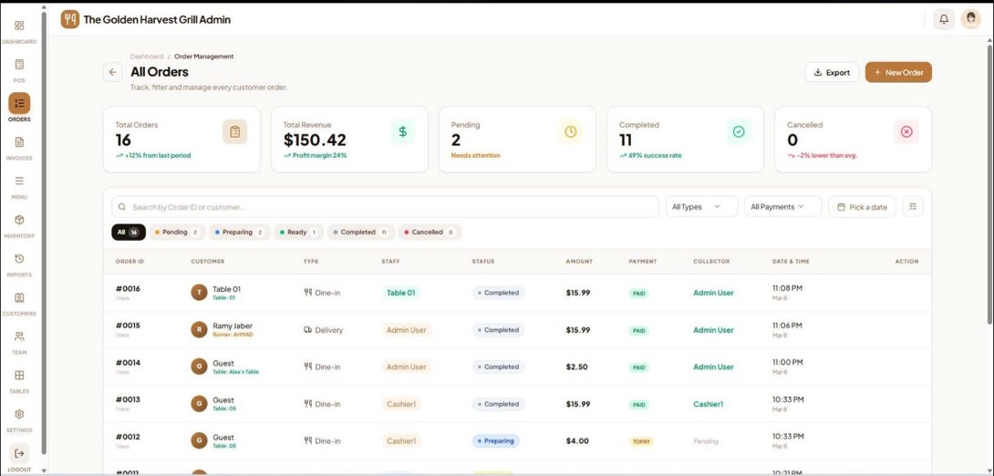
Figure 17. Manage Order Screen
Purpose: Allows Admin/managers to view and update the order processing progress.
Components: Search bar, Status Filter, Order Table, Update Status button.
Behavior: Admin searches for orders, views detailed information, and changes the status (e.g., Pending → Preparing → Completed).
V. Class Diagram
The proposed class diagram models the core objects needed for cart management and checkout. It is a conceptual design; method names and attributes can be adjusted to match the team’s implementation language and coding conventions.
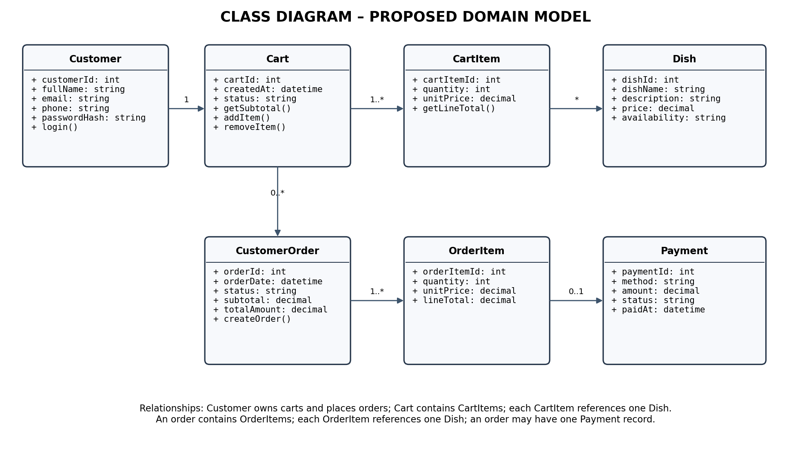
Figure 18. Class Diagram – Proposed Domain Model
Class Responsibilities
- Customer: stores customer profile information and is associated with carts and orders.
- Cart: represents a customer’s active selection and calculates the cart subtotal.
- CartItem: represents one dish and its selected quantity in a cart.
- Dish: stores menu information, price, and availability.
- CustomerOrder: stores the confirmed order header, date, status, and monetary totals.
- OrderItem: stores the dish, quantity, unit price, and line total captured for the order.
- Payment: stores payment method, amount, status, and payment timestamp; it does not store sensitive payment credentials.
VI. Database Design
1. Entity Relationship Diagram (ERD)
The proposed ERD maps the core classes into relational tables. Foreign-key relationships enforce referential integrity between customers, carts, dishes, orders, order items, and payments.
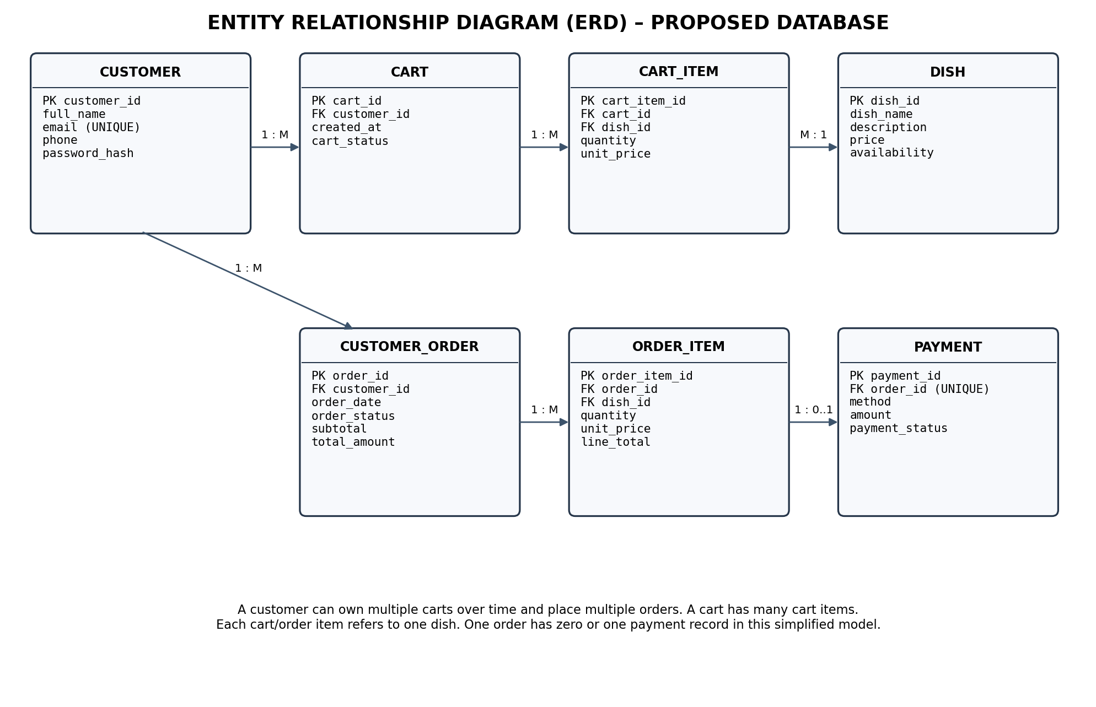
Figure 19. Entity Relationship Diagram (ERD) – Proposed Database
2. Database Table Descriptions, Primary Keys and Foreign Keys
Table | Purpose | Primary Key | Foreign Key(s) | Other Fields
CUSTOMER | Stores registered customer information. | customer_id (PK) | None | full_name, email (UNIQUE), phone, password_hash
DISH | Stores menu dishes and their current selling information. | dish_id (PK) | None | dish_name, description, price, availability
CART | Stores a customer’s cart/session. | cart_id (PK) | customer_id (FK) → CUSTOMER.customer_id (nullable only if guest carts are supported) | created_at, cart_status
CART_ITEM | Stores individual dishes selected in a cart. | cart_item_id (PK) | cart_id (FK) → CART.cart_id; dish_id (FK) → DISH.dish_id | quantity, unit_price
CUSTOMER_ORDER | Stores the order header and customer/order totals. | order_id (PK) | customer_id (FK) → CUSTOMER.customer_id (nullable only if guest checkout is supported) | order_date, order_status, subtotal, total_amount
ORDER_ITEM | Stores each dish included in a confirmed order. | order_item_id (PK) | order_id (FK) → CUSTOMER_ORDER.order_id; dish_id (FK) → DISH.dish_id | quantity, unit_price, line_total
PAYMENT | Stores payment transaction status for an order. | payment_id (PK) | order_id (FK, UNIQUE) → CUSTOMER_ORDER.order_id | method, amount, payment_status, paid_at
2.1 Key and Data Integrity Rules
- Every table has a primary key that uniquely identifies each record.
- Foreign keys must reference an existing parent record, except where an explicitly permitted nullable relationship is used for guest checkout.
- Use DECIMAL (not floating-point) for prices and monetary amounts.
- Store the unit price in CART_ITEM and ORDER_ITEM so historical order totals do not change when a dish’s current menu price changes.
- Use positive integer constraints for quantities and non-negative constraints for prices and totals.
- Use a UNIQUE constraint on CUSTOMER.email if email is the chosen unique login identifier.
- Use a UNIQUE constraint on PAYMENT.order_id in this simplified one-payment-record-per-order model. If the system supports multiple payment attempts, remove this uniqueness and model attempts separately.
- Store password hashes, never plain-text passwords. Do not store card numbers or CVV.
Note: The seven-table schema is intentionally focused on the requested cart and checkout scope. If the group requires restaurant tables, delivery addresses, discounts, menu categories, inventory, or multiple payment attempts, add the corresponding entities and relationships after confirming those requirements.

VII. Design Diagrams
1. Data Flow Diagram – Level 0
Figure 20. DFD Level 0 – Restaurant Ordering Management System

2. Data Flow Diagram – Level 1
Figure 21. DFD Level 1 – Restaurant Ordering Management System

3. Software Architecture – 3-Layer Architecture
Figure 22. Software Architecture – 3-Layer Architecture

