GROUP PROJECT
RESTAURANT ORDER MANAGEMENT SYSTEM
Prepared by: Truong Quang Huy

SECTION I – GROUP 4: CUSTOMER ACCOUNT REGISTRATION AND UPDATES
Registration: Customers who do not have an account can register using their full name, email address, phone number, and password. Before creating the account, the system checks that the email address has not been used and that the password is valid.
Customer information: The system stores the customer's full name, email address, phone number, and delivery address. Logged-in customers can view this information.
Update information: Customers can edit their full name, phone number, and delivery address.
Password recovery: If customers forget their password, they enter their registered email address. The system sends a link or verification code so they can set a new password.
SECTION IV – USE CASE SPECIFICATIONS (IV.5–IV.8)
IV.5 Login
Use case name | Login
Description | The customer logs in to use features that require an account (placing orders and viewing orders).
Actor | Customer
Preconditions | The customer has an account and is on the login screen.
Postconditions | The login is successful, the system creates a session, and the customer is redirected to the home page.
Main flow | 1. The customer selects “Log In.”  2. The system displays the login form.  3. The customer enters their email and password, then clicks “Log In.”  4. The system validates the information.  5. The system creates a session and redirects the customer to the home page.
Alternative flows | 3a. If a field is left blank, the system displays “Please complete all required fields” and returns to Step 3.  4a. If the email or password is incorrect, the system displays an error and returns to Step 3.  3b. If the customer selects “Forgot password?”, the system opens the Reset Password use case.  3c. If the customer selects “Sign up,” the system opens the Register use case.
Exceptions | If the connection is lost or a system error occurs, the system displays “Unable to log in. Please try again later.”

IV.6 Register
Use case name | Register
Description | A customer without an account creates a new account.
Actor | Customer
Preconditions | The customer does not have an account.
Postconditions | The new account is saved in the system, and the customer is redirected to the login screen.
Main flow | 1. The customer selects “Sign Up.”  2. The system displays a form (full name, email, phone number, password, and confirm password).  3. The customer enters the information and clicks “Sign Up.”  4. The system validates the data and checks that the email address has not been used.  5. The system saves the account, displays “Registration successful,” and redirects to the login screen.
Alternative flows | 3a. If a field is blank, the system reports missing information and returns to Step 3.  4a. If the email already exists, the system displays “This email address is already in use” and returns to Step 3.  4b. If the email or phone number format is invalid, the system displays an error at the relevant field and returns to Step 3.  4c. If the password is too weak or does not match the confirmation, the system displays an error and returns to Step 3.
Exceptions | If the connection is lost or a system error occurs, the system displays “Unable to register. Please try again later.”

IV.7 Update Profile
Use case name | Update Profile
Description | The customer views and edits personal information (full name, phone number, and address).
Actor | Customer
Preconditions | The customer is logged in.
Postconditions | The updated information is saved and displayed in the profile.
Main flow | 1. The customer selects “My Profile.”  2. The system displays the current information (full name, phone number, and address; email is view-only).  3. The customer edits the information and clicks “Save.”  4. The system validates the data.  5. The system saves the changes and displays “Update successful.”
Alternative flows | 3a. If the customer clicks “Cancel,” the system discards the changes and keeps the original information.  4a. If the data is invalid (incorrect phone number format or blank full name), the system displays an error and returns to Step 3.
Exceptions | If the connection is lost or a system error occurs, the system displays “Unable to update. Please try again later,” and the original information is retained.

IV.8 Reset Password
Use case name | Reset Password
Description | The customer has forgotten their password and resets it via email.
Actor | Customer. The system sends a verification email to the customer.
Preconditions | The customer has an account but has forgotten the password.
Postconditions | The new password is saved, and the customer can log in using it.
Main flow | 1. The customer selects “Forgot password?”  2. The system displays an email field.  3. The customer enters their email and clicks “Send Link.”  4. The system checks whether the email exists, then sends a link or verification code.  5. The customer opens the email and clicks the link (or enters the code).  6. The system displays the new-password form.  7. The customer enters and confirms the new password, then clicks “Confirm.”  8. The system updates the password, displays a success message, and redirects to the login screen.
Alternative flows | 4a. If the email does not exist, the system displays an error and returns to Step 3.  5a. If the link or code has expired, the system displays an expiration message and the customer can request a new one.  7a. If the new password is invalid or does not match the confirmation, the system displays an error and returns to Step 7.
Exceptions | If the email cannot be sent due to a system error, the system displays “Unable to send email. Please try again later.”

INTERFACE DESIGN – CUSTOMER ACCOUNT
Screen 1: Login
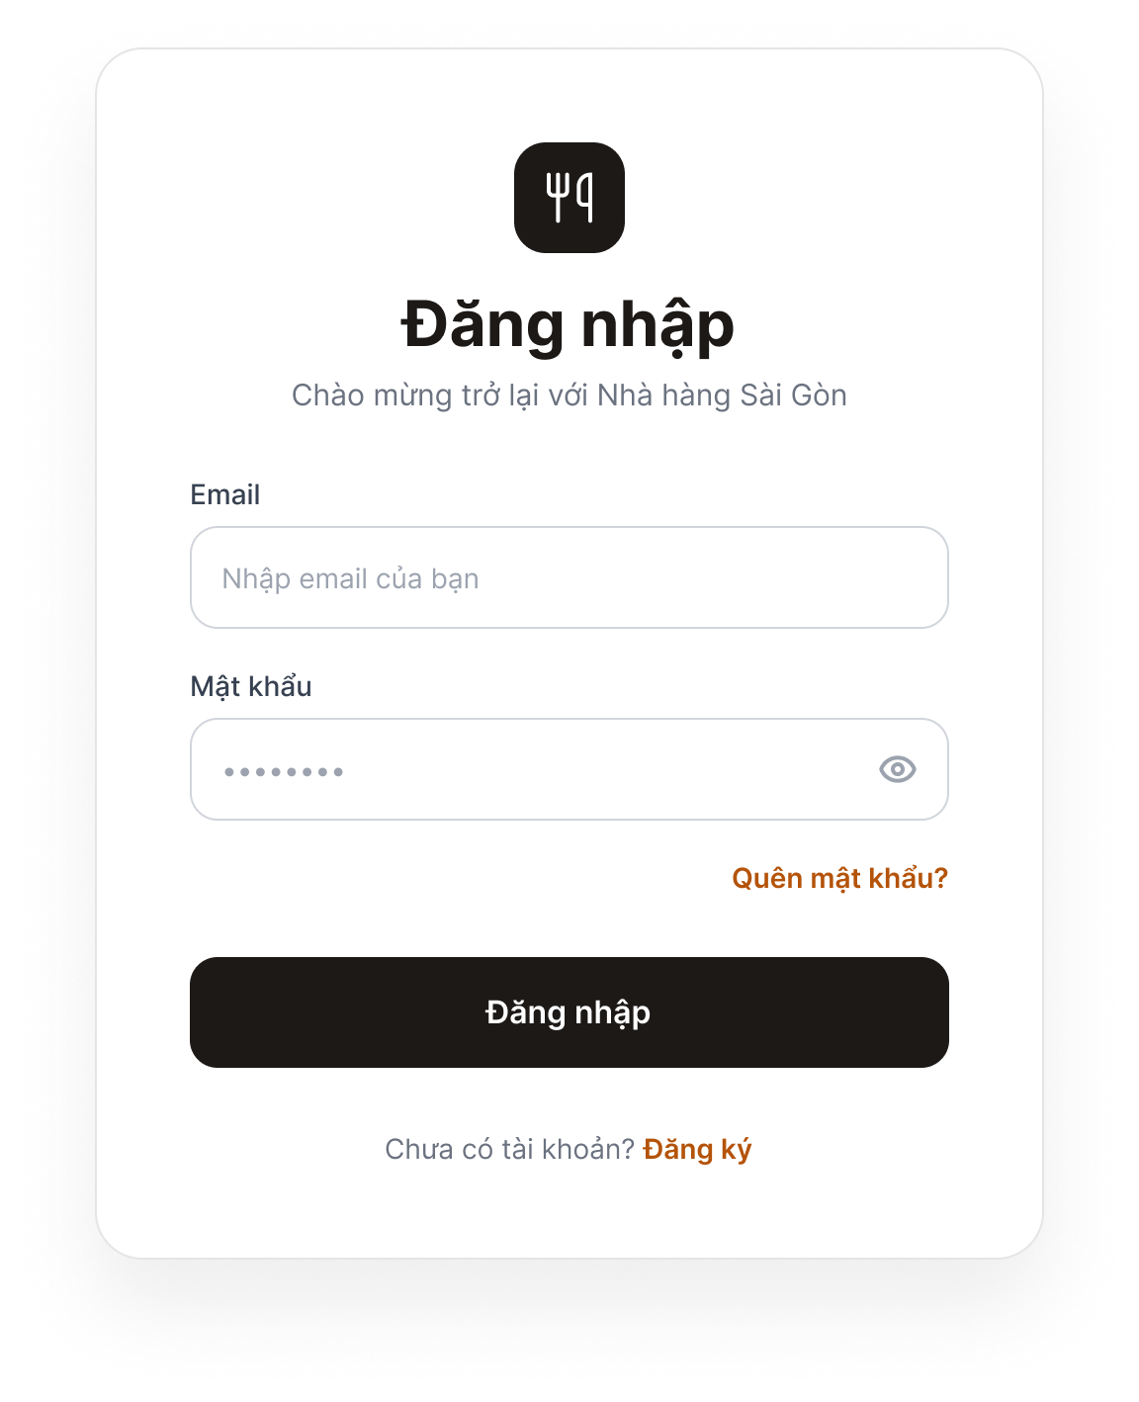
Figure 1. Login Screen
Purpose: Allows customers to log in to the system.
Components: Email field, Password field, “Log In” button, “Forgot password?” link, and “Don't have an account? Sign up” link.
Behavior: When the user clicks “Log In” with valid credentials, the system redirects to the home page. If the information is incorrect or a field is empty, a red error message appears below the relevant field. Clicking “Forgot password?” opens the Password Recovery screen; clicking “Sign up” opens the Registration screen.

Screen 2: Register
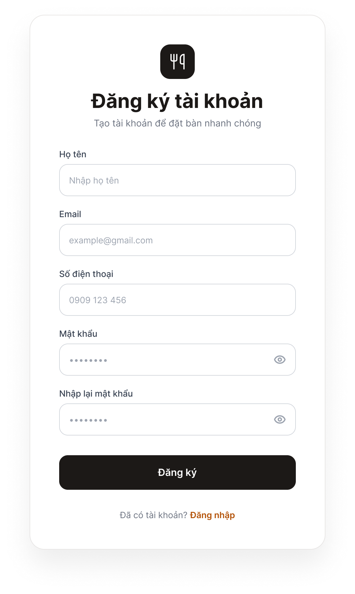
Figure 2. Registration Screen
Purpose: Allows new customers to create an account.
Components: Full Name, Email, Phone Number, Password, and Confirm Password fields; “Sign Up” button; and “Already have an account? Log in” link.
Behavior: When the user clicks “Sign Up” with valid data, the system saves the account, displays “Registration successful,” and opens the Login screen. If the data is invalid, an error appears below the relevant field (email already exists, invalid format, or passwords do not match).

Screen 3: Profile (Update Profile)
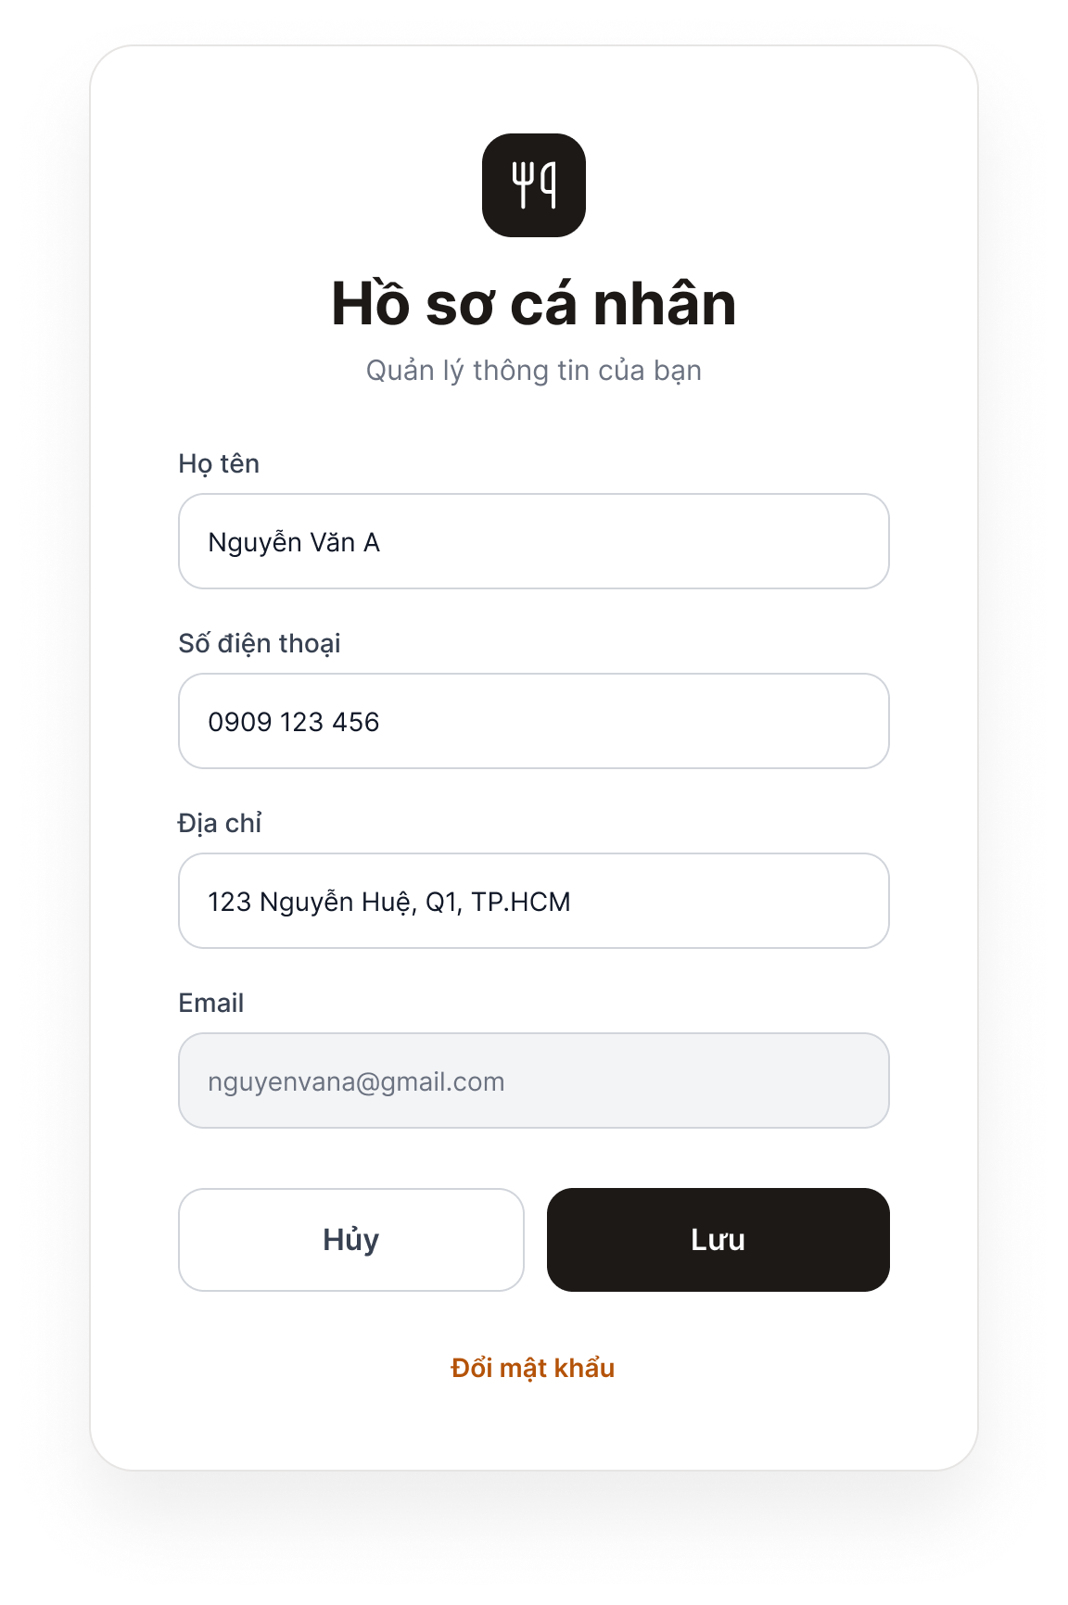
Figure 3. Profile Screen
Purpose: Allows logged-in customers to view and update their personal information.
Components: Full Name, Phone Number, and Address fields; a read-only Email field (gray); “Save” and “Cancel” buttons; and a “Change password” link.
Behavior: Clicking “Save” prompts the system to validate and save the changes, then display “Update successful.” Invalid data triggers an error below the relevant field. Clicking “Cancel” discards the changes and restores the previous information. Clicking “Change password” opens the Password Recovery screen.

Screen 4: Password Recovery (Reset Password)
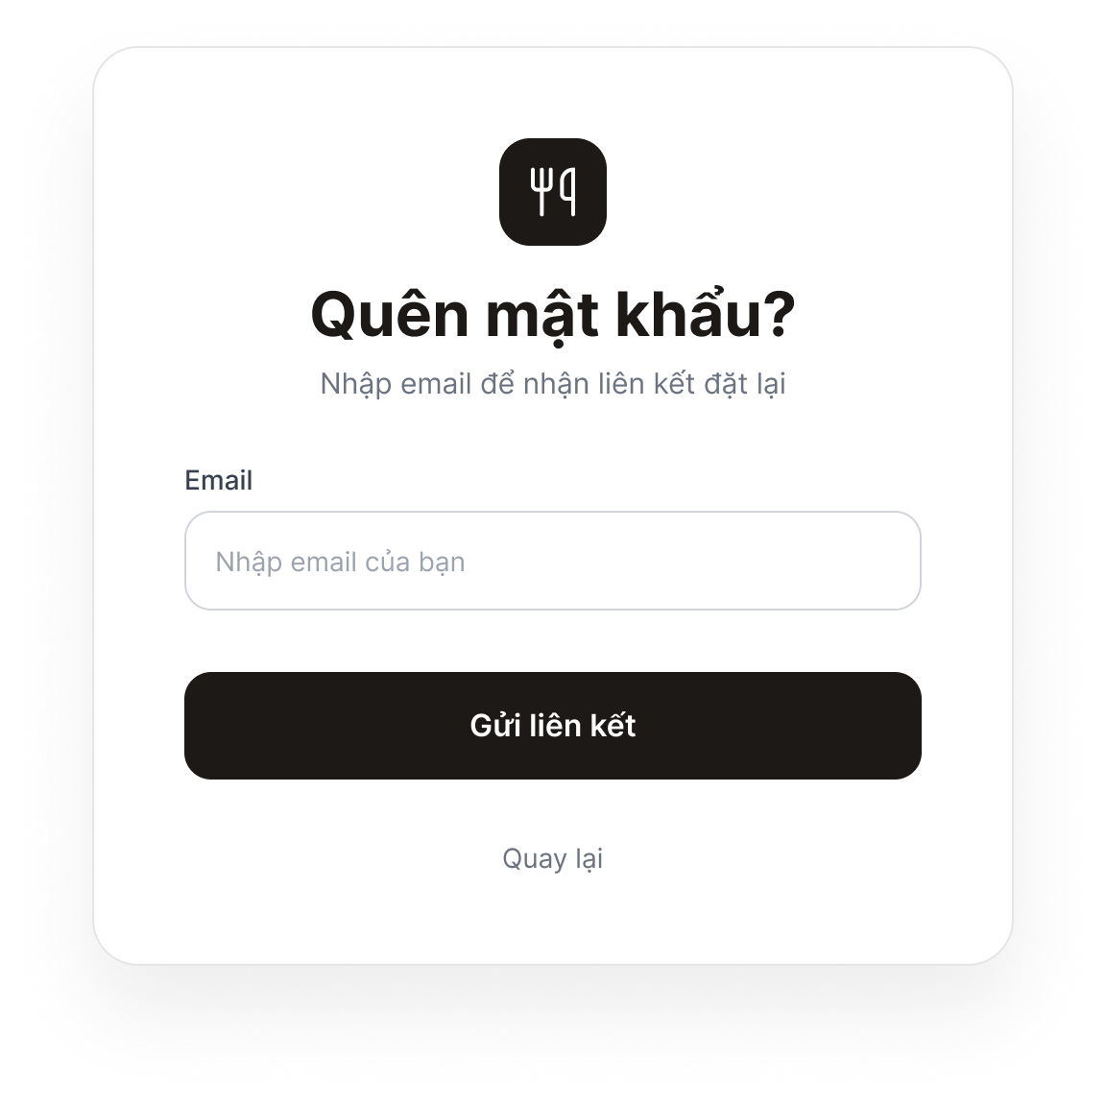
Figure 4a. Password Recovery – Step 1: Enter Email
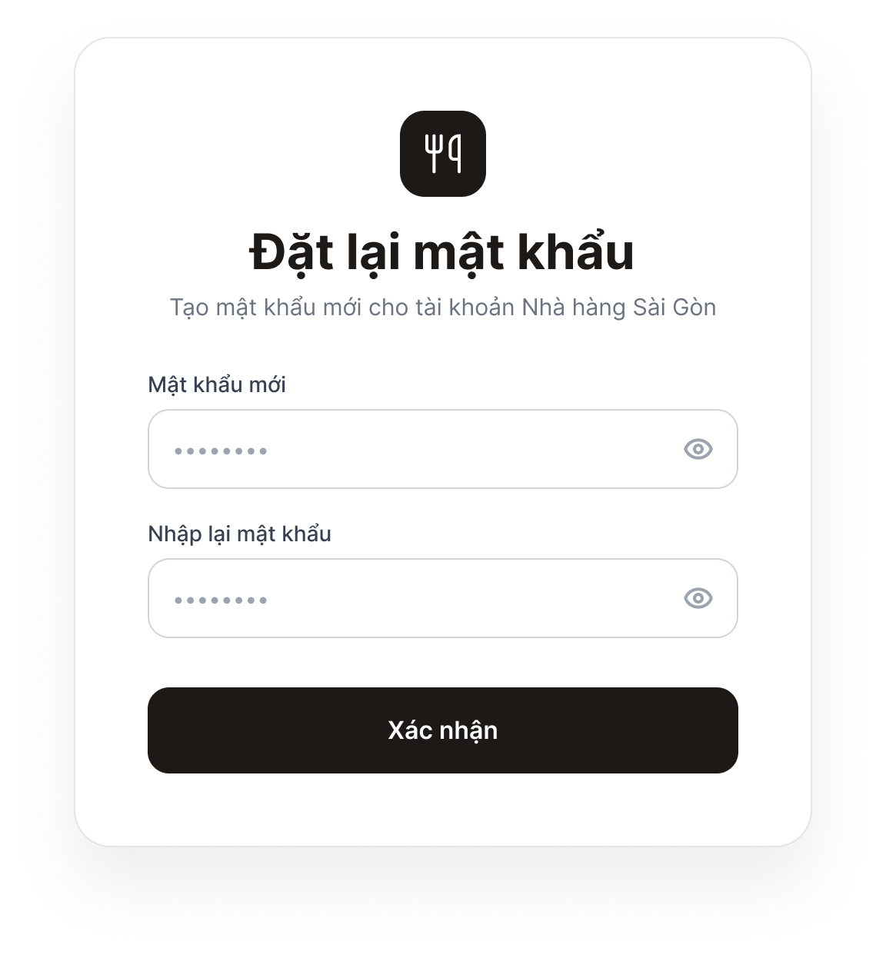
Figure 4b. Password Recovery – Step 2: Set a New Password
Purpose: Allows customers who have forgotten their password to reset it via email.
Components: Step 1: Email field and “Send Link” button. Step 2: New Password and Confirm Password fields, and a “Confirm” button.
Behavior: In Step 1, clicking “Send Link” causes the system to send a verification email; if the email address does not exist, an error is displayed. After the customer opens the link in the email, Step 2 appears. Clicking “Confirm” with a valid password updates the password and opens the Login screen. If the link has expired, the system displays an expiration message and allows the customer to request a new link.

INTERNAL NOTES – DELETE THIS PAGE BEFORE SUBMISSION
The items below are assumptions in the draft. Confirm them with the group, then revise the relevant sections above to ensure consistency.
Item to Confirm | Draft Assumption
Login method | Email and password
Valid password | At least 8 characters (not yet included in the specification; confirm before adding)
Password reset link or code | Expires after 15 minutes (not yet included in the specification)
Email on the Profile screen | View-only; cannot be edited
Actor name | Customer (coordinate with Member 1 when creating the Use Case Diagram)
Account attributes to send to Member 4 | Full name, email, phone number, address, and password (to keep the data table and Class Diagram consistent)

