System Specification
Restaurant Order Management System
Group 11
Version 1.0
Document Change Log
Date | Version | Description | Author
02/11/2026 | 1.0 | Merged document: combined the members’ contributions into one specification

I. Restaurant Order Management System

Group 1: View and Search Menu
Prepared by: Nguyen Tien Anh
Purpose: Describes the functional group allowing customers to browse the restaurant menu by category, search for dishes by keyword, sort the results, and view detailed information of each dish. It also allows the administrator to manage the dishes on the menu.
Content Category | Detailed Content
Functional Purpose | - Helps customers look up dishes on the menu by category or by keyword  - Allows sorting the dish list by price, discount, and number of orders  - Allows the administrator to maintain the dish list (view, add, update, delete)
Target Users/ Actors | - Primary Actor: Customer (Guest or Member)  - Secondary Actor: Admin/ Restaurant Staff (dish management)  - Precondition: None for browsing and searching; the Admin must be logged in to manage dishes
Browse Menu Function | - Customer selects a dish category (e.g., Bowls, Salads, Mains, Drinks)  - Displays the 20 newest dishes of the selected category, with pagination  - Minimum fields: Image, Name, Price, Discount, Status (Available / Sold out)  - Displays a notification if the category has no dishes
Sort Function | - Customer can sort the dish list in ascending or descending order by Price, Discount, or Number of Orders  - Applies to both the category list and the search results
Search Dish Function | - Customer enters a keyword; the system returns the dishes whose name contains the keyword (not case-sensitive)  - Displays a notification if no dish is found  - Asks the customer to enter a keyword if the field is empty
View Dish Details Function | - Customer selects a dish to view detailed information  - Includes: Dish ID, name, image, price, discount, status, number of views, number of orders, short description, and detailed description  - The number of views increases by 1 each time the details are opened
Add to Cart Function | - From the dish list or the dish details, the customer can add an available dish to the current cart (extends the Manage Cart use-case)  - Sold-out dishes cannot be added
Manage Dish Function (Admin) | - Admin views the dish list by category and can add, update, or delete a dish  - The system validates the information (required fields, unique Dish ID, price ≥ 0, discount from 0% to 100%) and asks for confirmation before deleting  - A dish that already appears in orders is set to “Discontinued” (hidden from the menu) instead of being removed
Business Rules | - Customers can browse and search the menu without logging in  - Discount is a percentage of the current price  - Sold-out dishes are still displayed but cannot be added to the cart  - Only the Admin can add, update, or delete dishes  - The Dish ID is unique and cannot be modified

Group 2

Group 3

Group 4: Customer Account Registration and Updates
Prepared by: Truong Quang Huy
Content Category | Detailed Content
Registration | Customers who do not have an account can register using their full name, email address, phone number, and password. Before creating the account, the system checks that the email address has not been used and that the password is valid.
Customer information | The system stores the customer’s full name, email address, phone number, and delivery address. Logged-in customers can view this information.
Update information | Customers can edit their full name, phone number, and delivery address.
Password recovery | If customers forget their password, they enter their registered email address. The system sends a link or verification code so they can set a new password.

Group 5: View Order History
Prepared by: Phan Duy
Purpose: Describes the functional group allowing customers to review their created orders on the system, view detailed order information, and track the processing status of each order.
Content Category | Detailed Content
Functional Purpose | - Helps customers look up order history associated with their account after logging in  - Allows tracking of the progress and processing status of each order
Target Users/ Actors | - Primary Actor: Customer  - Precondition: The customer has successfully logged into the system
Order List Information | - Displays the order list for the current account, sorted with the newest first  - Minimum fields: Order ID, Order Date, Total Amount, Status  - Displays a notification if there are no orders
View Details Function | - Customer selects an order to view detailed information  - Includes: item list, quantity, unit price, sub-total, and order summary
Cancel Order Function | - Allows customers to cancel an order if it is still in the “New” status  - The system checks, confirms, and updates the status to “Canceled”
Business Rules | - Customers must log in to view history  - Can only view orders created by their own account  - The history viewing function is read-only

II. Glossary

III. Supplementary Specification

Usability

Reliability

Performance

Supportability

Security

Design Constraints

IV. Use-Case Diagram

1. Overview Diagram

1.1. List of Actors

1.2. List of Use-cases

2. Use-case Browse Menu

2.1 Summary
Allows customers to view the dishes on the menu by category, sort the dish list by price, discount, or number of orders, and inspect the detailed information of a specific dish.
Primary actor: Customer (Guest or Member).

2.2 Flow of events

2.2.1 Main flow
- Customer opens the Menu and selects a dish category.
- System displays the 20 newest dishes of the selected category, with pagination.
- Customer sorts the list (by price, discount, or number of orders) or selects a page.
- System displays the dish list according to the customer’s choice.
- Customer selects a dish to view its details.
- System increases the view count of the dish by 1 and displays the dish details (Dish ID, name, image, price, discount, status, views, orders, short and full description).
- (Optional) Customer adds the dish to the cart from the list or the details screen (extends the Manage Cart use-case).

2.2.2 Alternative flows
- Category has no dishes: System displays “There are no dishes in this category yet” with an option to choose another category.
- Dish is sold out: The dish is still displayed and marked “Sold Out”.
- Dish is discontinued: The dish is not displayed on the menu.
- Connection or data query error: System displays an error message and provides a retry option.

2.3 Special requirements
The price after discount is calculated as: current price × (1 − discount%).

2.4 Pre-conditions (system state before the use-case starts)
None (the customer does not need to log in).

2.5 Post-conditions (system state after the use-case ends)
The dish list or the details of the selected dish are displayed to the customer; the view count of a viewed dish increases by 1, all other data remains unchanged.

2.6 Extension points
Use-case Manage Cart: if the user chooses to add a dish to the cart.

2.7 User interface
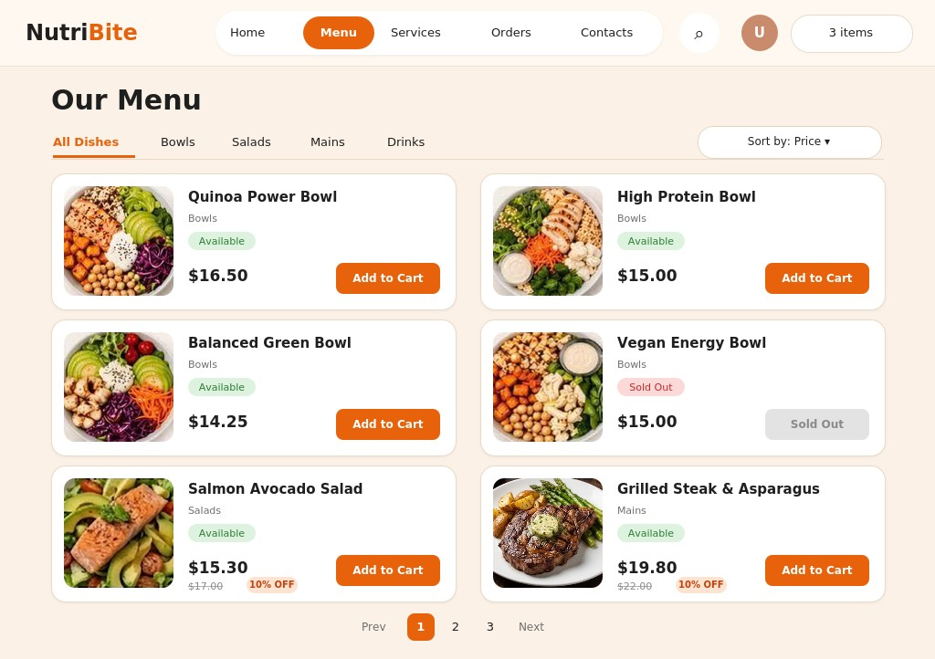
Figure 1. Menu Screen
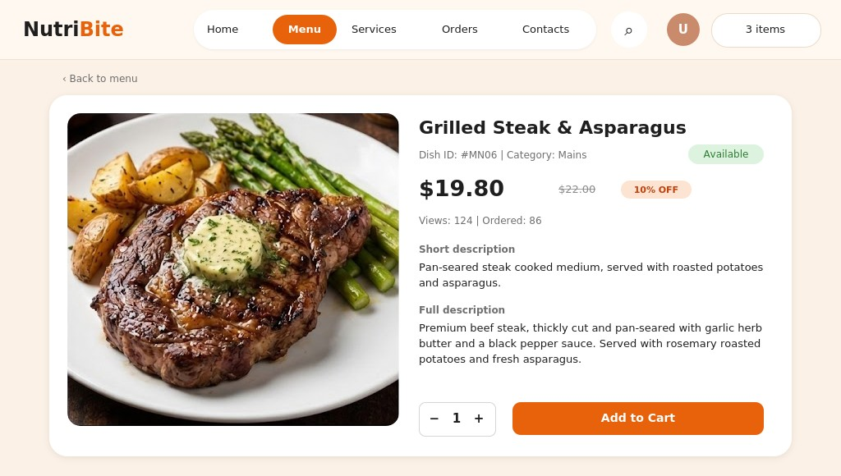
Figure 2. Dish Details Screen

3. Use-case Search Dish

3.1 Summary
Allows customers to search for dishes by entering the name (or part of the name) of a dish, and to sort the search results.
Primary actor: Customer (Guest or Member).

3.2 Flow of events

3.2.1 Main flow
- Customer selects the search function on the Menu screen.
- System displays the search box.
- Customer enters a keyword and submits the search.
- System lists the dishes whose name contains the keyword (not case-sensitive).
- Customer sorts the results (by price, discount, or number of orders) or selects a page (pagination applies when more than 20 dishes are found).
- System displays the dish list according to the customer’s choice.
- (Optional) Customer adds a dish to the cart (extends the Manage Cart use-case).

3.2.2 Alternative flows
- No dish found: System displays “No matching dish found” with an option to enter another keyword.
- Empty keyword: System asks the customer to enter a keyword.
- Connection or data query error: System displays an error message and provides a retry option.

3.3 Special requirements
- The search is not case-sensitive.
- The search should work with Vietnamese text with or without diacritics (e.g., “pho bo” finds “Phở bò”).
- Dishes with the status “Discontinued” are not included in the results.

3.4 Pre-conditions (system state before the use-case starts)
None (the customer does not need to log in).

3.5 Post-conditions (system state after the use-case ends)
The list of matching dishes is displayed to the customer; system data remains unchanged.

3.6 Extension points
Use-case Manage Cart: if the user chooses to add a dish to the cart.

3.7 User interface
The search function uses the Menu screen (Figure 1): results are displayed in the same card layout.

4. Use-case Manage Dish

4.1 Summary
Allows the administrator to view the dish list, search and filter dishes, and add, update, or delete dishes on the menu.
Primary actor: Admin / Restaurant Staff.

4.2 Flow of events

4.2.1 Main flow
- Admin selects Menu Management.
- System displays the dish list with the status summary, search box, and category filter.
- Admin searches by Dish ID or name, or filters by category or status (if needed).
- Admin selects an action: Add New Dish, Edit, or Delete. The corresponding sub-flow below is executed.

4.2.1.1 Add dish
- System displays the Add Dish form (Dish ID, name, category, price, discount, status, image, short and full description).
- Admin enters the dish information and selects Add Dish.
- System validates the information and saves the new dish.
- System displays a success message and refreshes the list.

4.2.1.2 Update dish
- System displays the Update Dish form with the current information (the Dish ID cannot be changed).
- Admin edits the information and selects Save Dish.
- System validates the information and updates the dish.
- System displays a success message and refreshes the list.

4.2.1.3 Delete dish
- System displays a confirmation dialog.
- Admin confirms the deletion.
- System deletes the dish; if the dish already appears in orders, the system sets it to “Discontinued” (hidden from the menu) instead, so old order data is kept.
- System displays a success message and refreshes the list.

4.2.2 Alternative flows
- Dish not found: System displays a notification that no matching results were found.
- Invalid information: If required fields are empty (Dish ID, name, category, price), the Dish ID already exists, the price is less than 0, or the discount is outside 0%–100%, the system displays an error message and the admin corrects the information or cancels.
- Admin cancels the confirmation: System keeps the dish unchanged and returns to the dish list.
- Saving error: System displays an error message and prompts the admin to retry.

4.3 Special requirements
- The dish list must be paginated to improve system performance.
- Dish images must be in a common format (jpg, png) and within a size limit.

4.4 Pre-conditions (system state before the use-case starts)
The admin has successfully logged into the system with administrative privileges.

4.5 Post-conditions (system state after the use-case ends)
The dish is added, updated, or removed from the menu (set to “Discontinued” if it already appears in orders) and saved successfully in the system; otherwise the data remains unchanged.

4.6 Extension points
None.

4.7 User interface
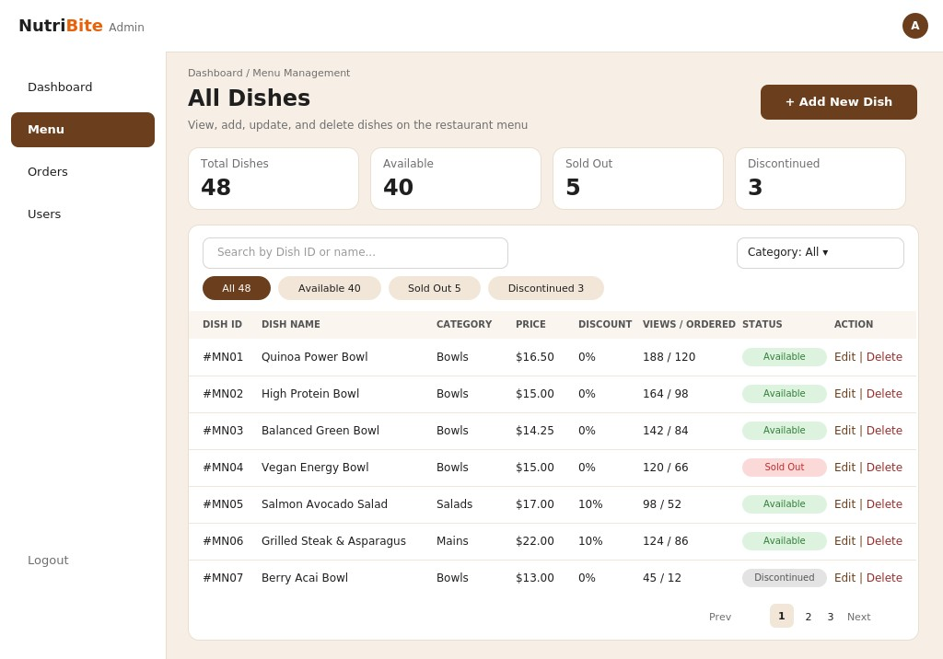
Figure 3. Manage Dish Screen
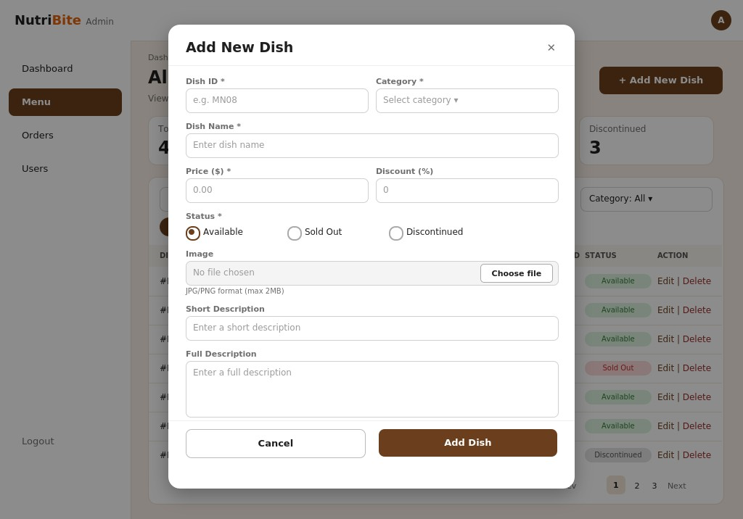
Figure 4. Add Dish Form
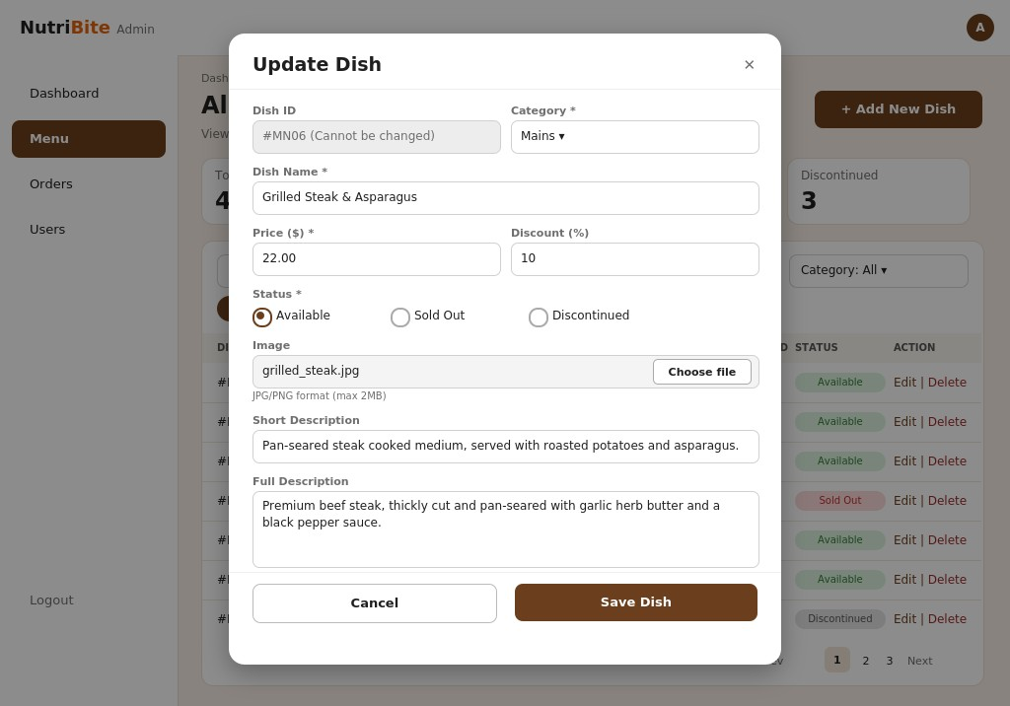
Figure 5. Update Dish Form
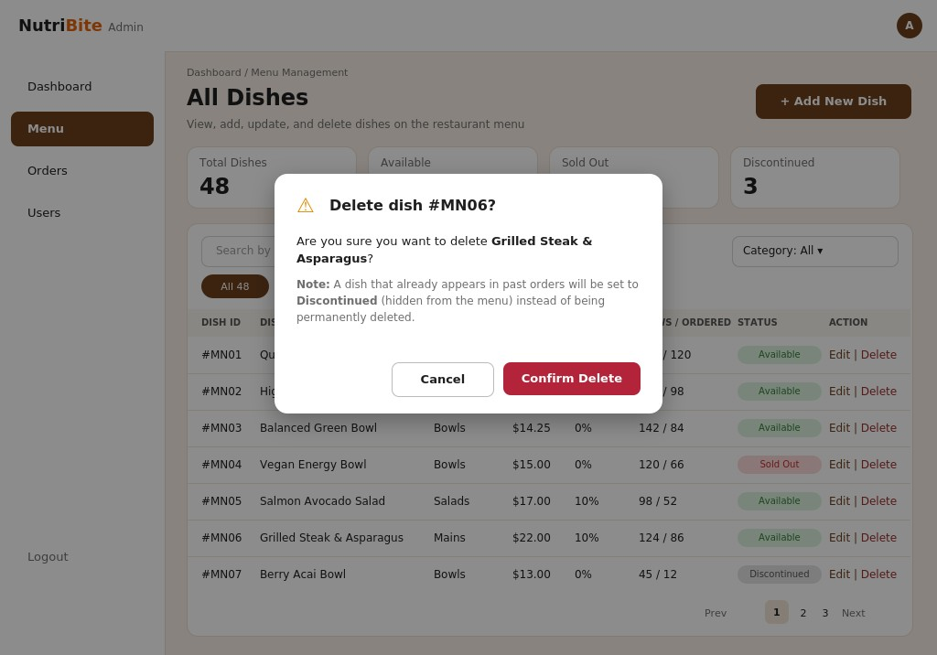
Figure 6. Delete Dish Confirmation

5. Use-case Login

5.1 Summary
The customer logs in to use features that require an account (placing orders and viewing orders).
Primary actor: Customer.

5.2 Flow of events

5.2.1 Main flow
- The customer selects “Log In.”
- The system displays the login form.
- The customer enters their email and password, then clicks “Log In.”
- The system validates the information.
- The system creates a session and redirects the customer to the home page.

5.2.2 Alternative flows
3a. If a field is left blank, the system displays “Please complete all required fields” and returns to Step 3.
4a. If the email or password is incorrect, the system displays an error and returns to Step 3.
3b. If the customer selects “Forgot password?”, the system opens the Reset Password use case.
3c. If the customer selects “Sign up,” the system opens the Register use case.
Exception: If the connection is lost or a system error occurs, the system displays “Unable to log in. Please try again later.”

5.3 Special requirements
None.

5.4 Pre-conditions (system state before the use-case starts)
The customer has an account and is on the login screen.

5.5 Post-conditions (system state after the use-case ends)
The login is successful, the system creates a session, and the customer is redirected to the home page.

5.6 Extension points
- Use-case Reset Password: if the customer selects “Forgot password?” (alternative flow 3b).
- Use-case Register: if the customer selects “Sign up” (alternative flow 3c).

5.7 User interface
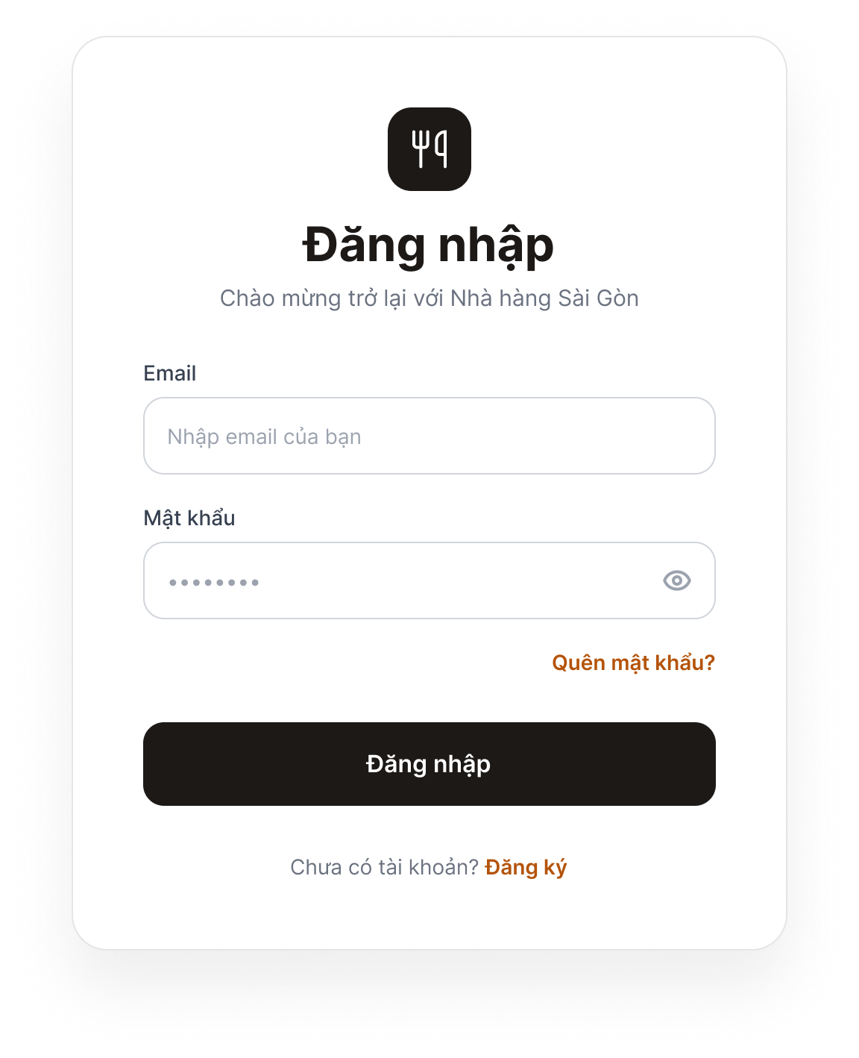
Figure 7. Login Screen
Purpose: Allows customers to log in to the system.
Components: Email field, Password field, “Log In” button, “Forgot password?” link, and “Don’t have an account? Sign up” link.
Behavior: When the user clicks “Log In” with valid credentials, the system redirects to the home page. If the information is incorrect or a field is empty, a red error message appears below the relevant field. Clicking “Forgot password?” opens the Password Recovery screen; clicking “Sign up” opens the Registration screen.

6. Use-case Register

6.1 Summary
A customer without an account creates a new account.
Primary actor: Customer.

6.2 Flow of events

6.2.1 Main flow
- The customer selects “Sign Up.”
- The system displays a form (full name, email, phone number, password, and confirm password).
- The customer enters the information and clicks “Sign Up.”
- The system validates the data and checks that the email address has not been used.
- The system saves the account, displays “Registration successful,” and redirects to the login screen.

6.2.2 Alternative flows
3a. If a field is blank, the system reports missing information and returns to Step 3.
4a. If the email already exists, the system displays “This email address is already in use” and returns to Step 3.
4b. If the email or phone number format is invalid, the system displays an error at the relevant field and returns to Step 3.
4c. If the password is too weak or does not match the confirmation, the system displays an error and returns to Step 3.
Exception: If the connection is lost or a system error occurs, the system displays “Unable to register. Please try again later.”

6.3 Special requirements
None.

6.4 Pre-conditions (system state before the use-case starts)
The customer does not have an account.

6.5 Post-conditions (system state after the use-case ends)
The new account is saved in the system, and the customer is redirected to the login screen.

6.6 Extension points
None.

6.7 User interface
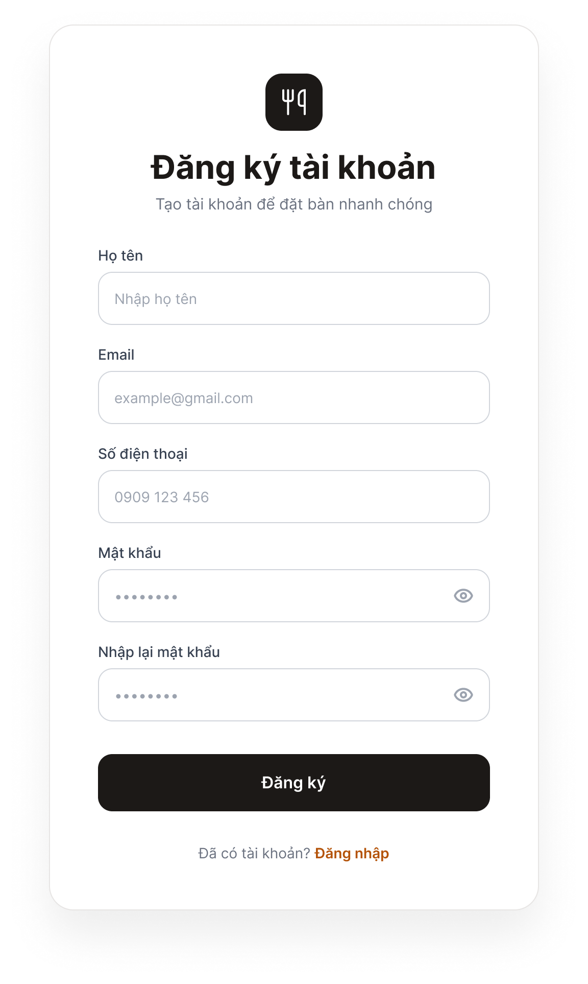
Figure 8. Registration Screen
Purpose: Allows new customers to create an account.
Components: Full Name, Email, Phone Number, Password, and Confirm Password fields; “Sign Up” button; and “Already have an account? Log in” link.
Behavior: When the user clicks “Sign Up” with valid data, the system saves the account, displays “Registration successful,” and opens the Login screen. If the data is invalid, an error appears below the relevant field (email already exists, invalid format, or passwords do not match).

7. Use-case Update Profile

7.1 Summary
The customer views and edits personal information (full name, phone number, and address).
Primary actor: Customer.

7.2 Flow of events

7.2.1 Main flow
- The customer selects “My Profile.”
- The system displays the current information (full name, phone number, and address; email is view-only).
- The customer edits the information and clicks “Save.”
- The system validates the data.
- The system saves the changes and displays “Update successful.”

7.2.2 Alternative flows
3a. If the customer clicks “Cancel,” the system discards the changes and keeps the original information.
4a. If the data is invalid (incorrect phone number format or blank full name), the system displays an error and returns to Step 3.
Exception: If the connection is lost or a system error occurs, the system displays “Unable to update. Please try again later,” and the original information is retained.

7.3 Special requirements
None.

7.4 Pre-conditions (system state before the use-case starts)
The customer is logged in.

7.5 Post-conditions (system state after the use-case ends)
The updated information is saved and displayed in the profile.

7.6 Extension points
None.

7.7 User interface
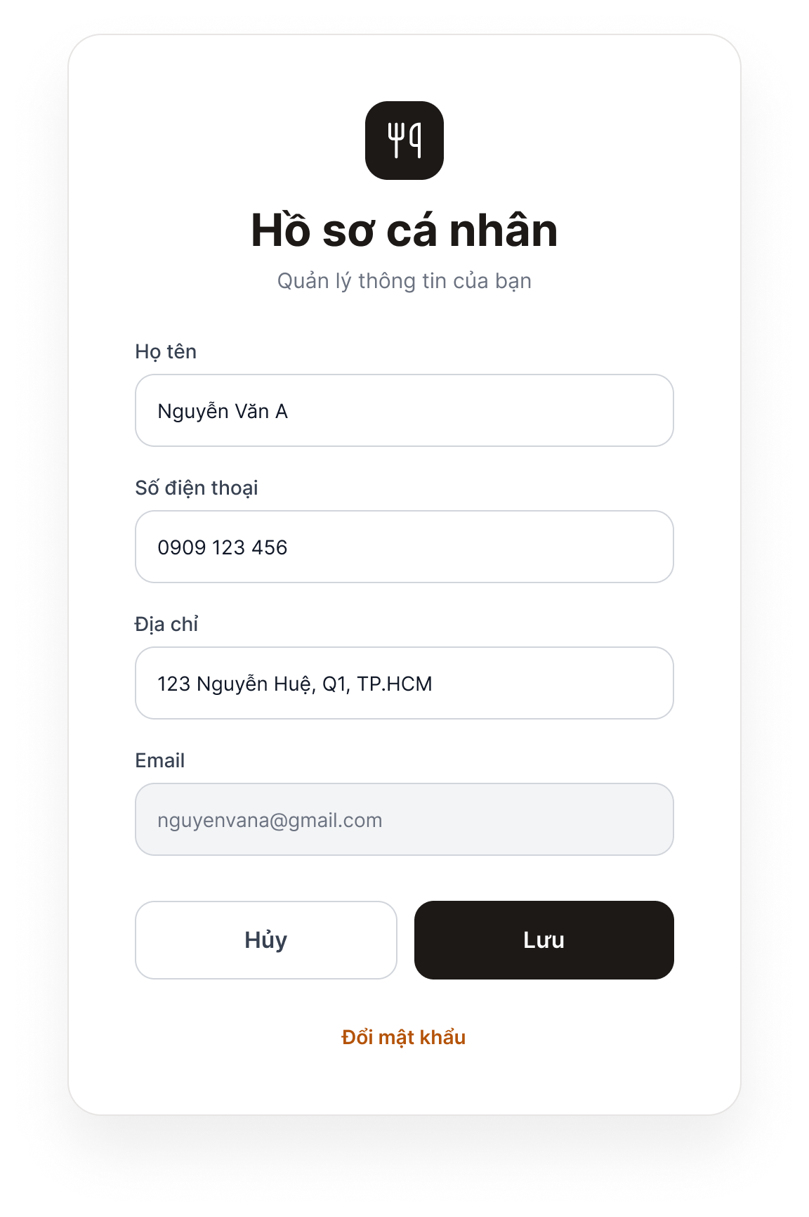
Figure 9. Profile Screen
Purpose: Allows logged-in customers to view and update their personal information.
Components: Full Name, Phone Number, and Address fields; a read-only Email field (gray); “Save” and “Cancel” buttons; and a “Change password” link.
Behavior: Clicking “Save” prompts the system to validate and save the changes, then display “Update successful.” Invalid data triggers an error below the relevant field. Clicking “Cancel” discards the changes and restores the previous information. Clicking “Change password” opens the Password Recovery screen.

8. Use-case Reset Password

8.1 Summary
The customer has forgotten their password and resets it via email.
Primary actor: Customer. The system sends a verification email to the customer.

8.2 Flow of events

8.2.1 Main flow
- The customer selects “Forgot password?”
- The system displays an email field.
- The customer enters their email and clicks “Send Link.”
- The system checks whether the email exists, then sends a link or verification code.
- The customer opens the email and clicks the link (or enters the code).
- The system displays the new-password form.
- The customer enters and confirms the new password, then clicks “Confirm.”
- The system updates the password, displays a success message, and redirects to the login screen.

8.2.2 Alternative flows
4a. If the email does not exist, the system displays an error and returns to Step 3.
5a. If the link or code has expired, the system displays an expiration message and the customer can request a new one.
7a. If the new password is invalid or does not match the confirmation, the system displays an error and returns to Step 7.
Exception: If the email cannot be sent due to a system error, the system displays “Unable to send email. Please try again later.”

8.3 Special requirements
None.

8.4 Pre-conditions (system state before the use-case starts)
The customer has an account but has forgotten the password.

8.5 Post-conditions (system state after the use-case ends)
The new password is saved, and the customer can log in using it.

8.6 Extension points
None.

8.7 User interface
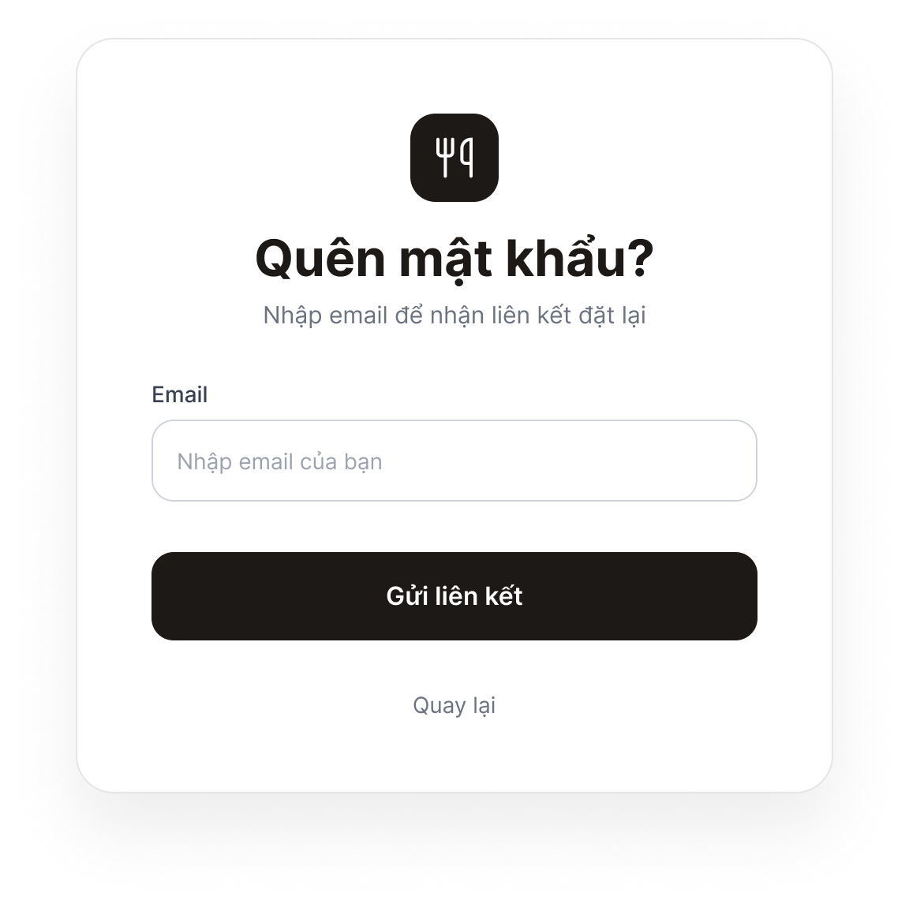
Figure 10. Password Recovery Screen – Step 1: Enter Email
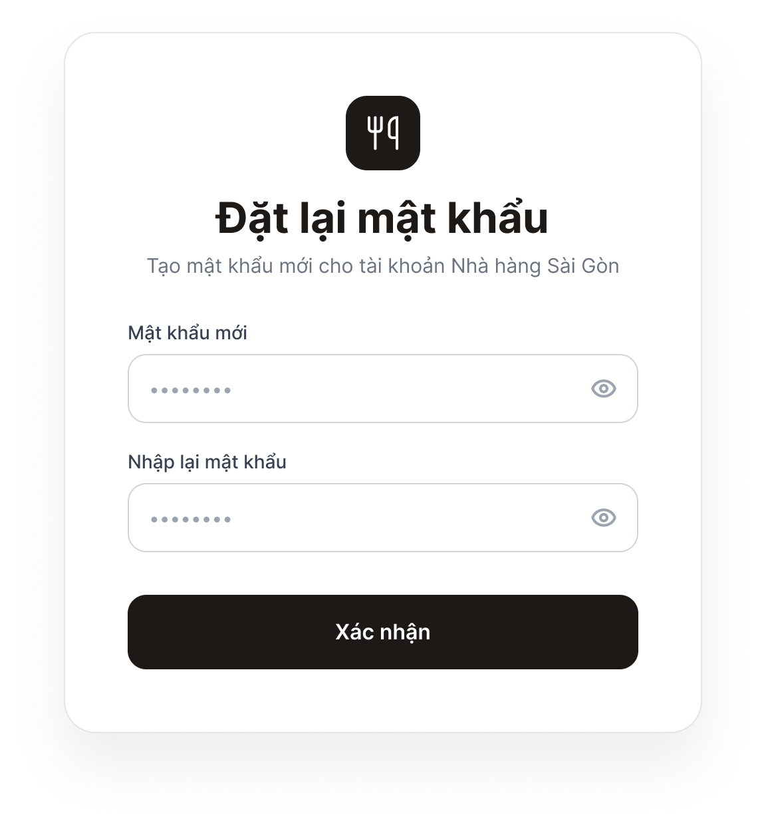
Figure 11. Password Recovery Screen – Step 2: Set a New Password
Purpose: Allows customers who have forgotten their password to reset it via email.
Components: Step 1: Email field and “Send Link” button. Step 2: New Password and Confirm Password fields, and a “Confirm” button.
Behavior: In Step 1, clicking “Send Link” causes the system to send a verification email; if the email address does not exist, an error is displayed. After the customer opens the link in the email, Step 2 appears. Clicking “Confirm” with a valid password updates the password and opens the Login screen. If the link has expired, the system displays an expiration message and allows the customer to request a new link.

9. Use-case Manage User

9.1 Summary

9.2 Flow of events

9.2.1 Main flow

9.2.2 Alternative flows

9.3 Special requirements

9.4 Pre-conditions (system state before the use-case starts)

9.5 Post-conditions (system state after the use-case ends)

9.6 Extension points

9.7 User interface

10. Use-case Manage Cart

10.1 Summary

10.2 Flow of events

10.2.1 Main flow

10.2.2 Alternative flows

10.3 Special requirements

10.4 Pre-conditions (system state before the use-case starts)

10.5 Post-conditions (system state after the use-case ends)

10.6 Extension points

10.7 User interface

11. Use-case Checkout

11.1 Summary

11.2 Flow of events

11.2.1 Main flow

11.2.2 Alternative flows

11.3 Special requirements

11.4 Pre-conditions (system state before the use-case starts)

11.5 Post-conditions (system state after the use-case ends)

11.6 Extension points

11.7 User interface

12. Use-case View Order

12.1 Summary
Allows customers to view their order history and inspect the detailed information of a specific order.
Primary actor: Customer.

12.2 Flow of events

12.2.1 Main flow
- Customer logs into the system.
- Customer selects Order History.
- System retrieves the order list.
- System displays the order list.
- Customer selects an order.
- System displays the order details.

12.2.2 Alternative flows
- Customer has no orders: System displays “You have no orders yet” with an option to return to the menu.
- Connection or data query error: System displays an error message and provides a retry option.
- Order does not exist or does not belong to the account: Denies access, displays an error message, and returns to the list.

12.3 Special requirements
None.

12.4 Pre-conditions (system state before the use-case starts)
The customer has successfully logged into the system.

12.5 Post-conditions (system state after the use-case ends)
The order list or specific order details are displayed to the customer; order data remains unchanged.

12.6 Extension points
None.

12.7 User interface
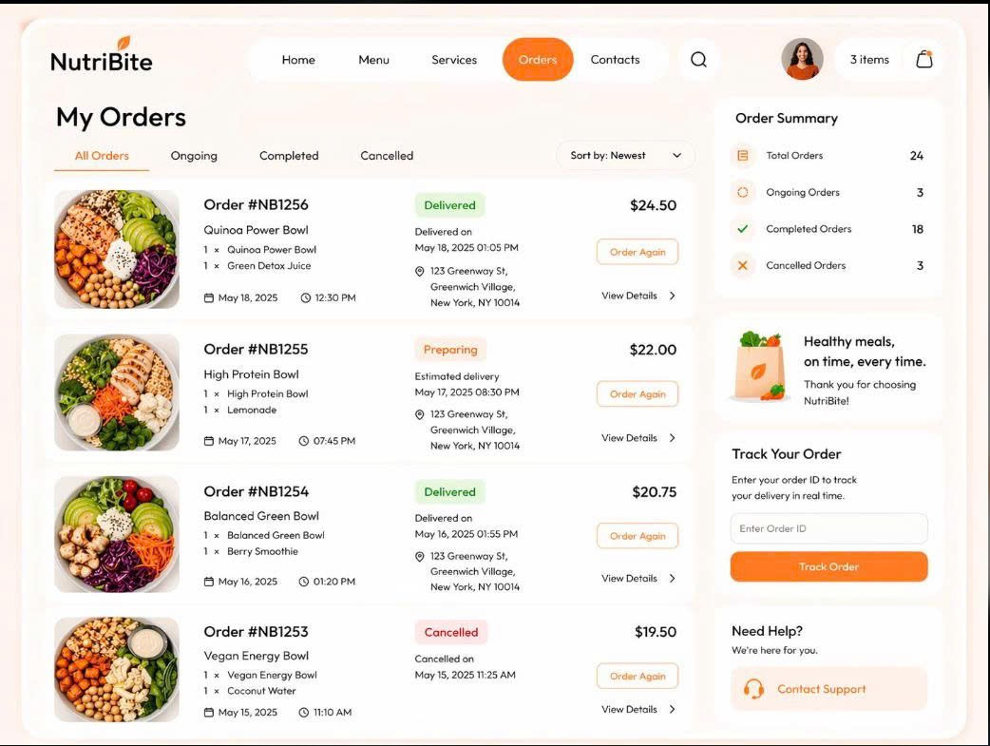
Figure 12. View Order Screen
Purpose: Allows customers to view the history of their placed orders and track their status.
Components: Table (Order ID, Date, Total, Status), View Details button, Cancel Order button.
Behavior: The system loads the list of orders based on the current account. Allows canceling an order if the status is “New”.

13. Use-case Cancel Order

13.1 Summary
Allows customers to request the cancellation of a placed order on the system if the order still meets the cancellation criteria.
Primary actor: Customer.

13.2 Flow of events

13.2.1 Main flow
- Customer selects an order to cancel.
- System checks the order status.
- System verifies that the order is still in the “New” status.
- System prompts the customer to confirm order cancellation.
- Customer confirms the cancellation.
- System updates the order status to “Canceled”.

13.2.2 Alternative flows
- Order is no longer in the “New” status: System does not allow cancellation and displays a rejection notification.
- Customer cancels the confirmation action: System keeps the previous order status and returns to the previous screen.

13.3 Special requirements
None.

13.4 Pre-conditions (system state before the use-case starts)
The customer has successfully logged in and is viewing the order details or order list screen.

13.5 Post-conditions (system state after the use-case ends)
The order status is updated to “Canceled” (if valid); the order data accurately reflects the cancellation status.

13.6 Extension points
None.

14. Use-case Manage Order

14.1 Summary
Allows the administrator to view the complete order list, search for orders, view details, update processing statuses, and save changes in the system.
Primary actor: Admin / Restaurant Staff.

14.2 Flow of events

14.2.1 Main flow
- Admin logs into the Admin account.
- Admin selects Order Management.
- Admin views the order list.
- Admin searches for orders (if needed).
- Admin views the order details.
- Admin updates the status.
- Admin saves the changes.

14.2.2 Alternative flows
- Order not found: The system displays a notification that no matching results were found.
- Invalid status data or saving error: The system displays an error message and prompts the user to verify the update action.

14.3 Special requirements
None.

14.4 Pre-conditions (system state before the use-case starts)
The admin has successfully logged into the system with administrative privileges.

14.5 Post-conditions (system state after the use-case ends)
The order list, detailed information, or order status is updated and saved successfully in the system.

14.6 Extension points
None.

14.7 User interface
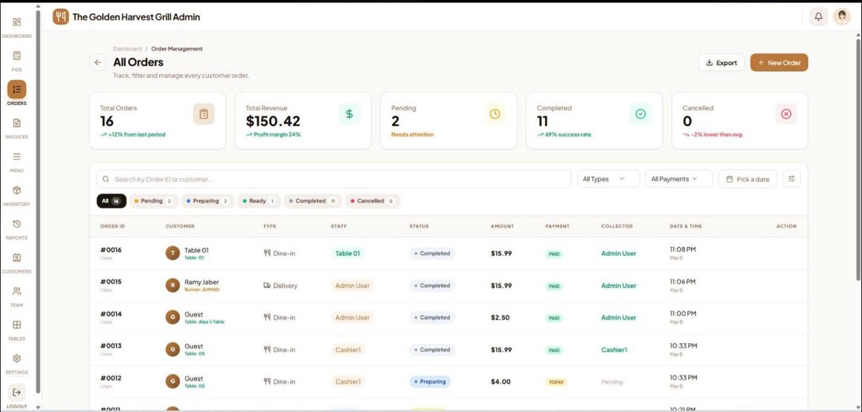
Figure 13. Manage Order Screen
Purpose: Allows Admin/managers to view and update the order processing progress.
Components: Search bar, Status Filter, Order Table, Update Status button.
Behavior: Admin searches for orders, views detailed information, and changes the status (e.g., Pending → Preparing → Completed).

V. Class Diagram

VI. Design Diagrams

1. Data Flow Diagram – Level 0
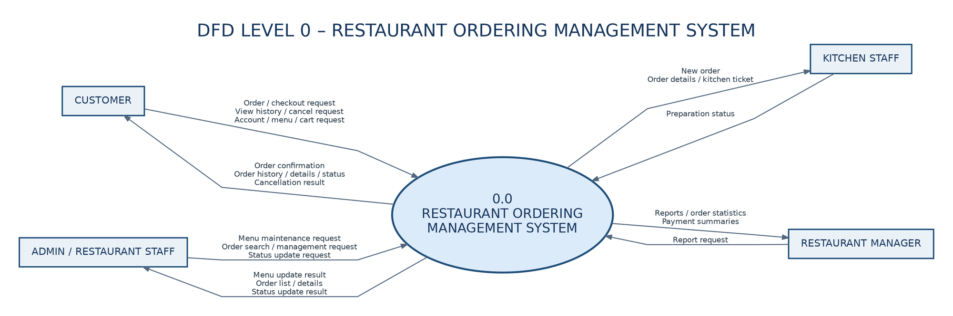
Figure 14. DFD Level 0 – Restaurant Ordering Management System

2. Data Flow Diagram – Level 1
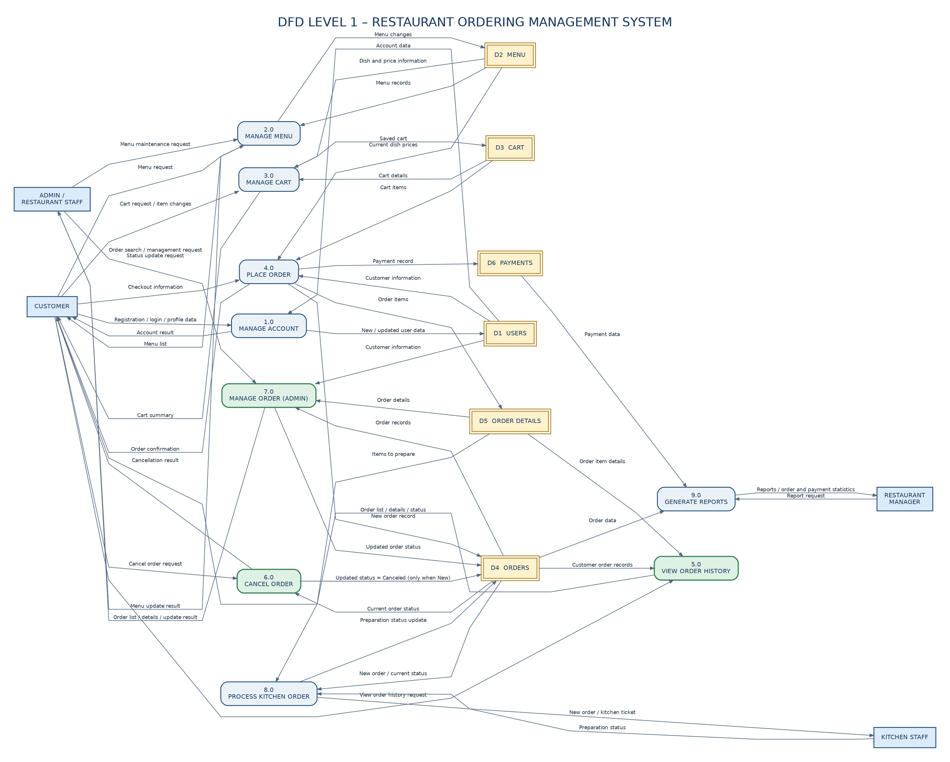
Figure 15. DFD Level 1 – Restaurant Ordering Management System

3. Software Architecture – 3-Layer Architecture
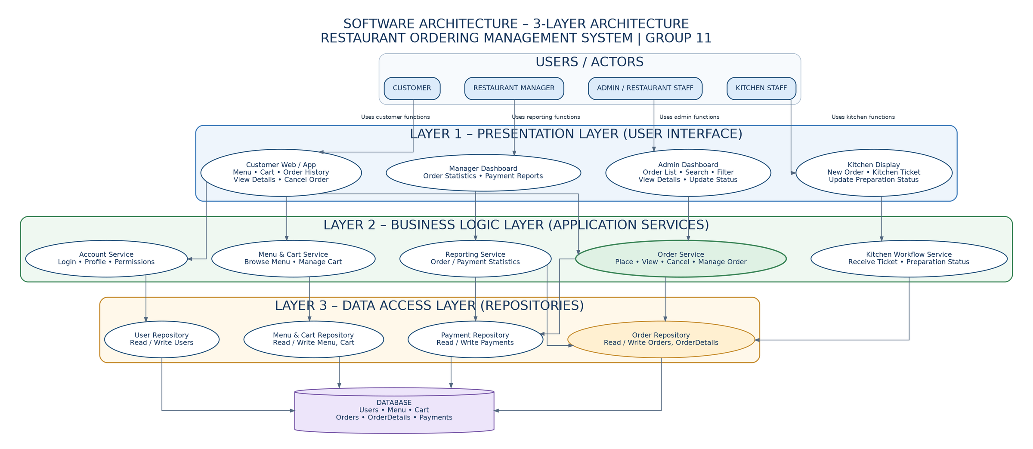
Figure 16. Software Architecture – 3-Layer Architecture

