GROUP PROJECT
RESTAURANT ORDER MANAGEMENT SYSTEM
Prepared by: [Your name]
SECTION IV.2: USE-CASE BROWSE MENU
Attribute/ Component | Detailed Content
Use Case Name | Browse Menu
Primary Actor | Customer (Guest or Member)
Brief Description | Allows customers to view the dishes on the menu by category, sort the dish list by price, discount, or number of orders, and inspect the detailed information of a specific dish
Preconditions | None (the customer does not need to log in)
Postconditions | The dish list or the details of the selected dish are displayed to the customer; the view count of a viewed dish increases by 1, all other data remains unchanged
Basic Flow | Step 1: Customer opens the Menu and selects a dish category  Step 2: System displays the 20 newest dishes of the selected category, with pagination  Step 3: Customer sorts the list (by price, discount, or number of orders) or selects a page  Step 4: System displays the dish list according to the customer’s choice  Step 5: Customer selects a dish to view its details  Step 6: System increases the view count of the dish by 1 and displays the dish details (Dish ID, name, image, price, discount, status, views, orders, short and full description)  Step 7 (optional): Customer adds the dish to the cart from the list or the details screen (extends the Manage Cart use-case)
Alternative & Exception Flows | Category has no dishes: System displays “There are no dishes in this category yet” with an option to choose another category  Dish is sold out: The dish is still displayed and marked “Sold Out”  Dish is discontinued: The dish is not displayed on the menu  Connection or data query error: System displays an error message and provides a retry option
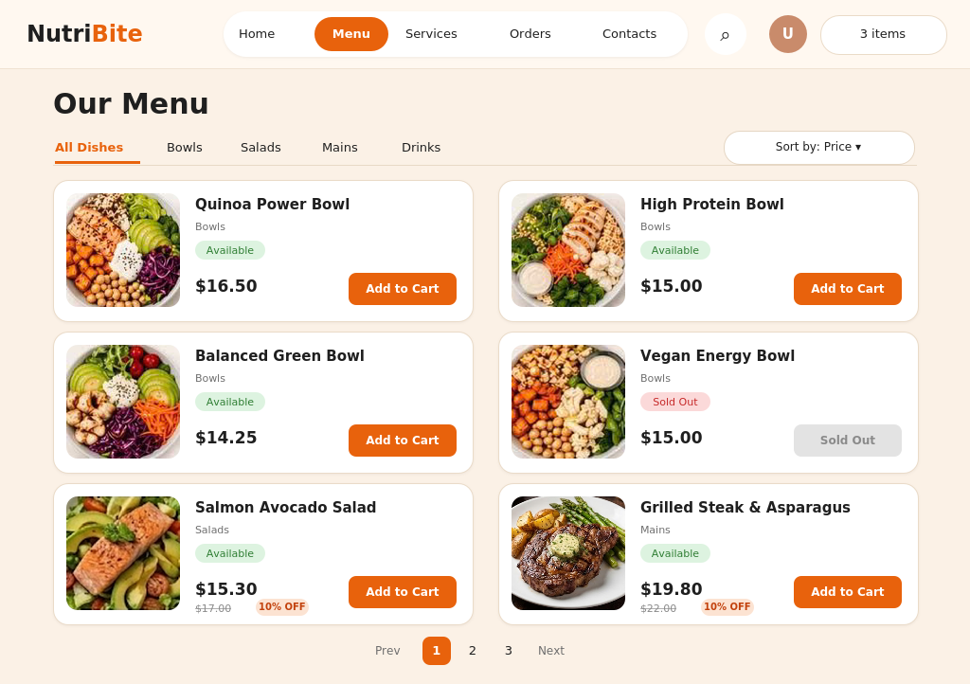
Figure 1. Menu Screen
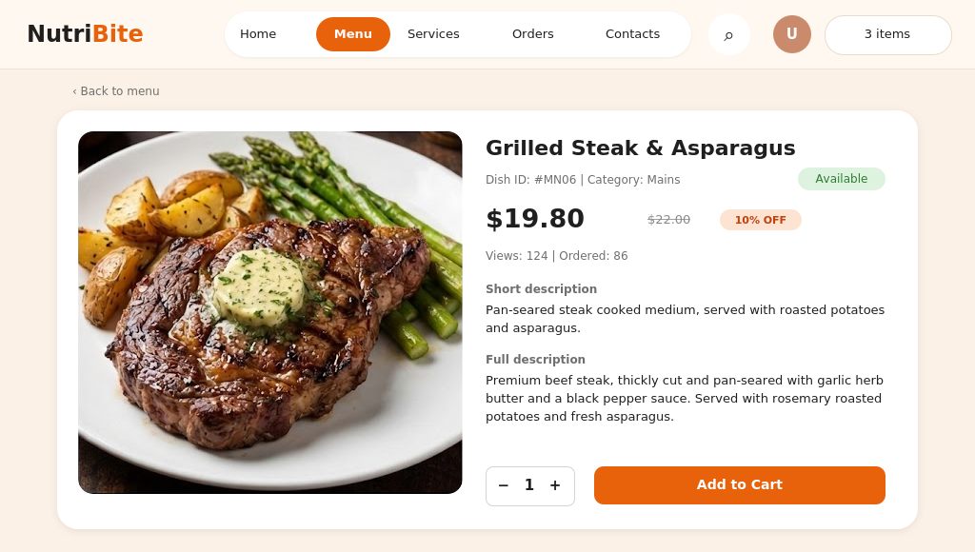
Figure 2. Dish Details Screen
SECTION IV.3: USE-CASE SEARCH DISH
Attribute/ Component | Detailed Content
Use Case Name | Search Dish
Primary Actor | Customer (Guest or Member)
Brief Description | Allows customers to search for dishes by entering the name (or part of the name) of a dish, and to sort the search results
Preconditions | None (the customer does not need to log in)
Postconditions | The list of matching dishes is displayed to the customer; system data remains unchanged
Basic Flow | Step 1: Customer selects the search function on the Menu screen  Step 2: System displays the search box  Step 3: Customer enters a keyword and submits the search  Step 4: System lists the dishes whose name contains the keyword (not case-sensitive)  Step 5: Customer sorts the results (by price, discount, or number of orders) or selects a page (pagination applies when more than 20 dishes are found)  Step 6: System displays the dish list according to the customer’s choice  Step 7 (optional): Customer adds a dish to the cart (extends the Manage Cart use-case)
Alternative & Exception Flows | No dish found: System displays “No matching dish found” with an option to enter another keyword  Empty keyword: System asks the customer to enter a keyword  Connection or data query error: System displays an error message and provides a retry option
The search function uses the Menu screen (Figure 1): results are displayed in the same card layout.
SECTION IV.4: USE-CASE MANAGE DISH
Attribute/ Component | Detailed Content
Use Case Name | Manage Dish (Admin Menu Management)
Primary Actor | Admin/ Restaurant Staff
Brief Description | Allows the administrator to view the dish list, search and filter dishes, and add, update, or delete dishes on the menu
Preconditions | The admin has successfully logged into the system with administrative privileges
Postconditions | The dish is added, updated, or removed from the menu (set to “Discontinued” if it already appears in orders) and saved successfully in the system; otherwise the data remains unchanged
Basic Flow | Step 1: Admin selects Menu Management  Step 2: System displays the dish list with the status summary, search box, and category filter  Step 3: Admin searches by Dish ID or name, or filters by category or status (if needed)  Step 4: Admin selects an action: Add New Dish, Edit, or Delete  Add Dish  Step 5: System displays the Add Dish form (Dish ID, name, category, price, discount, status, image, short and full description)  Step 6: Admin enters the dish information and selects Add Dish  Step 7: System validates the information and saves the new dish  Step 8: System displays a success message and refreshes the list  Update Dish  Step 5: System displays the Update Dish form with the current information (the Dish ID cannot be changed)  Step 6: Admin edits the information and selects Save Dish  Step 7: System validates the information and updates the dish  Step 8: System displays a success message and refreshes the list  Delete Dish  Step 5: System displays a confirmation dialog  Step 6: Admin confirms the deletion  Step 7: System deletes the dish; if the dish already appears in orders, the system sets it to “Discontinued” (hidden from the menu) instead, so old order data is kept  Step 8: System displays a success message and refreshes the list
Alternative & Exception Flows | Dish not found: System displays a notification that no matching results were found  Invalid information: If required fields are empty (Dish ID, name, category, price), the Dish ID already exists, the price is less than 0, or the discount is outside 0%–100%, the system displays an error message and the admin corrects the information or cancels  Admin cancels the confirmation: System keeps the dish unchanged and returns to the dish list  Saving error: System displays an error message and prompts the admin to retry
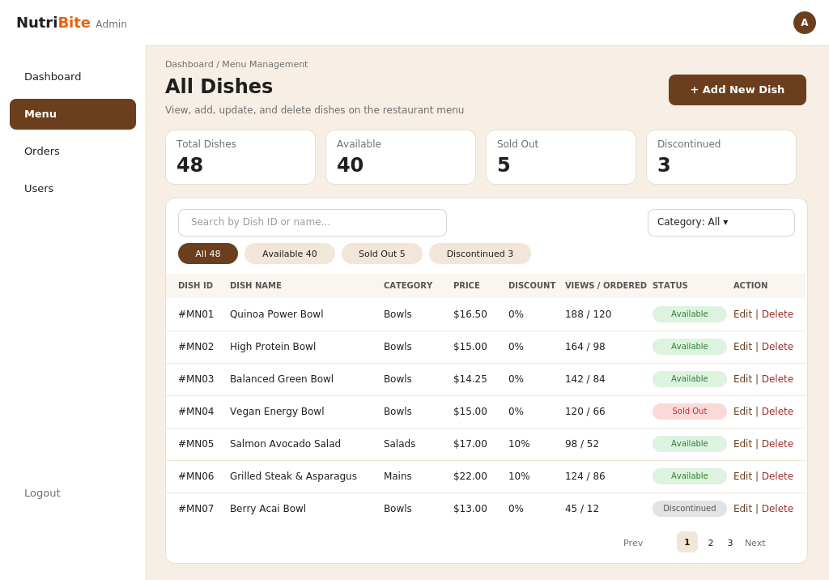
Figure 3. Manage Dish Screen
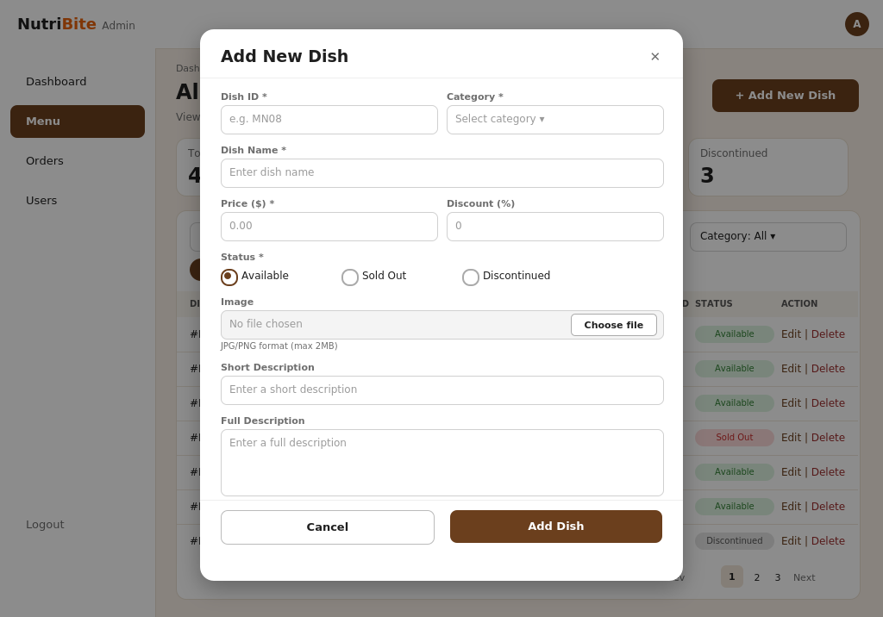
Figure 4. Add Dish Form
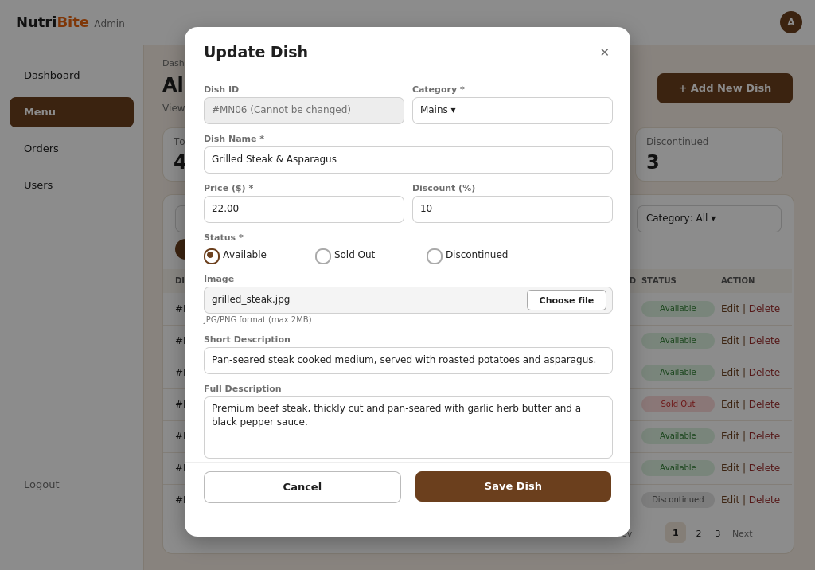
Figure 5. Update Dish Form
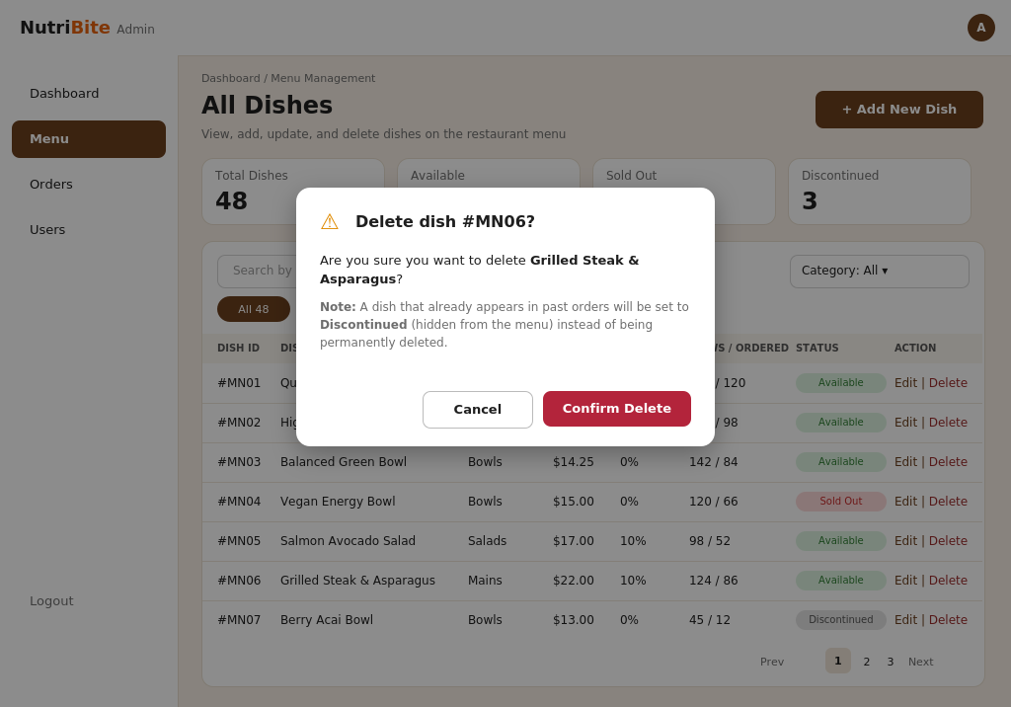
Figure 6. Delete Dish Confirmation

