GROUP PROJECT
RESTAURANT ORDER MANAGEMENT SYSTEM
Prepared by: Phan Duy

SECTION IV.12: USE-CASE VIEW ORDER

Attribute/ Component | Detailed Content
Use Case Name | View Order History
Primary Actor | Customer
Brief Description | Allows customers to view their order history and inspect the detailed information of a specific order
Preconditions | The customer has successfully logged into the system
Postconditions | The order list or specific order details are displayed to the customer; order data remains unchanged
Basic Flow | Step 1: Customer logs into the system  Step 2: Selects Order History  Step 3: System retrieves the order list  Step 4: Displays the order list  Step 5: Customer selects an order  Step 6: Displays order details
Alternative & Exception Flows | Customer has no orders: System displays “You have no orders yet” with an option to return to the menu  Connection or data query error: System displays an error message and provides a retry option  Order does not exist or does not belong to the account: Denies access, displays an error message, and returns to the list
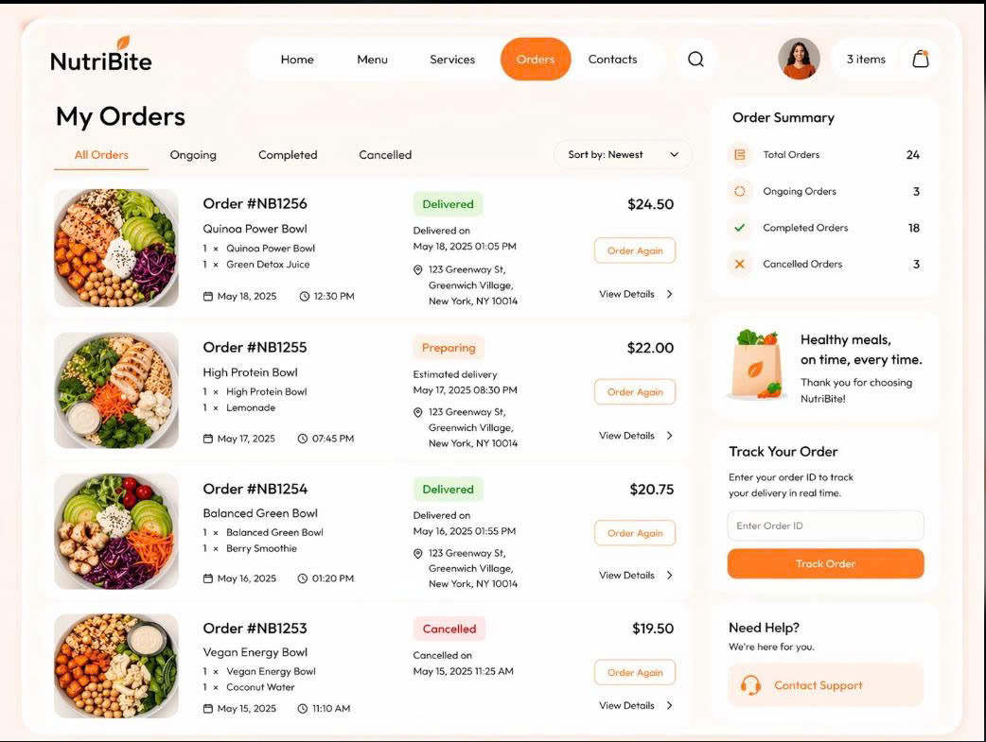
Figure 1. View Order Screen

SECTION IV.13: USE-CASE CANCEL ORDER

Attribute/ Component | Detailed Content
Use Case Name | Cancel Order
Primary Actor | Customer
Brief Description | Allows customers to request the cancellation of a placed order on the system if the order still meets the cancellation criteria
Preconditions | The customer has successfully logged in and is viewing the order details or order list screen
Postconditions | The order status is updated to “Canceled” (if valid); the order data accurately reflects the cancellation status
Basic Flow | Step 1: Customer selects an order to cancel  Step 2: System checks the order status  Step 3: System verifies that the order is still in the “New” status  Step 4: System prompts the customer to confirm order cancellation  Step 5: Customer confirms the cancellation  Step 6: System updates the order status to “Canceled”
Alternative & Exception Flows | Order is no longer in the “New” status: System does not allow cancellation and displays a rejection notification  Customer cancels the confirmation action: System keeps the previous order status and returns to the previous screen

SECTION IV.14: USE-CASE MANAGE ORDER

Attribute/ Component | Detailed Content
Use Case Name | Manage Order (Admin Order Management)
Primary Actor | Admin/ Restaurant Staff
Brief Description | Allows the administrator to view the complete order list, search for orders, view details, update processing statuses, and save changes in the system
Preconditions | The admin has successfully logged into the system with administrative privileges
Postconditions | The order list, detailed information, or order status is updated and saved successfully in the system
Basic Flow | Step 1: Log into the Admin account  Step 2: Select Order Management  Step 3: View the order list  Step 4: Search for orders (if needed)  Step 5: View order details  Step 6: Update the status  Step 7: Save changes
Alternative & Exception Flows | Order not found: The system displays a notification that no matching results were found  Invalid status data or saving error: The system displays an error message and prompts the user to verify the update action
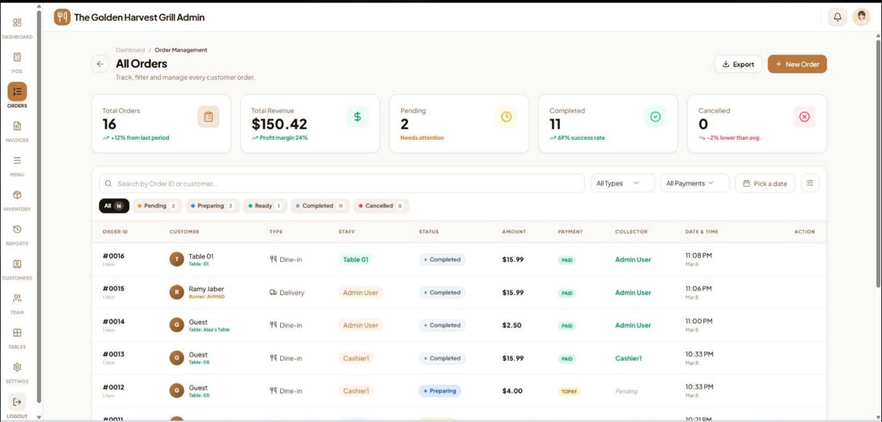
Figure 2. Manage Order Screen

