GROUP PROJECT
RESTAURANT ORDER MANAGEMENT SYSTEM
Prepared by: Truong Quang Huy
INTERFACE DESIGN – CUSTOMER ACCOUNT
Screen 1: Login
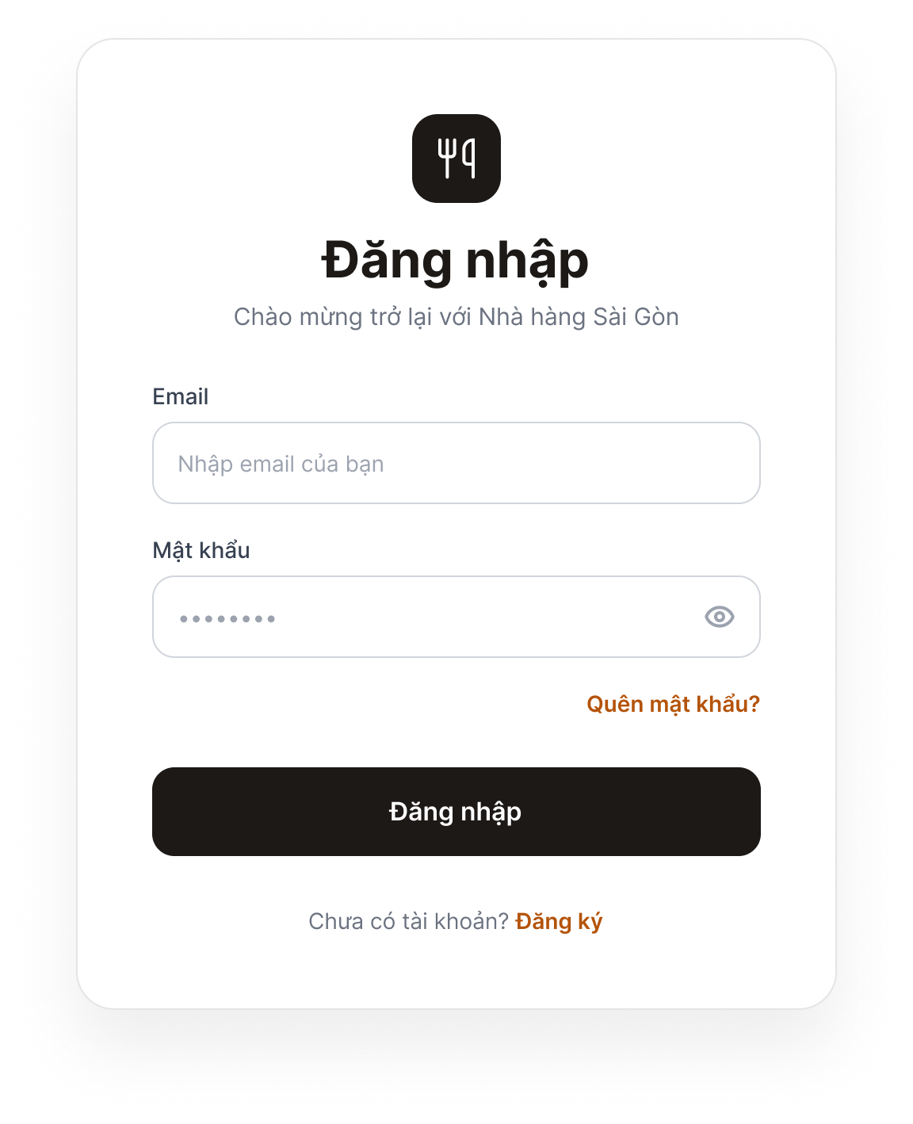
Figure 1. Login Screen
Purpose: Allows customers to log in to the system.
Components: Email field, Password field, “Log In” button, “Forgot password?” link, and “Don't have an account? Sign up” link.
Behavior: When the user clicks “Log In” with valid credentials, the system redirects to the home page. If the information is incorrect or a field is empty, a red error message appears below the relevant field. Clicking “Forgot password?” opens the Password Recovery screen; clicking “Sign up” opens the Registration screen.

Screen 2: Register
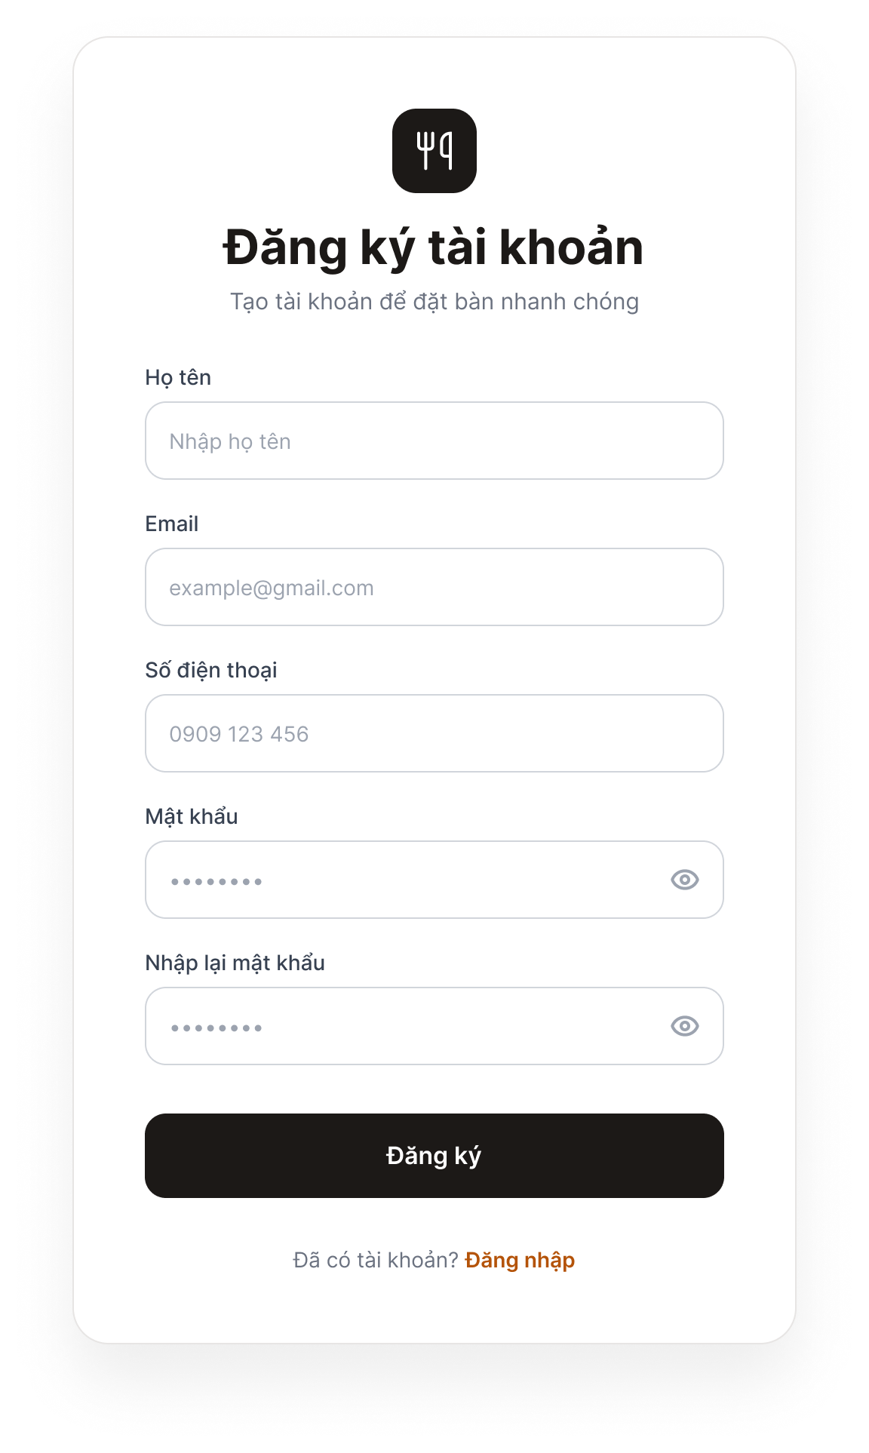
Figure 2. Registration Screen
Purpose: Allows new customers to create an account.
Components: Full Name, Email, Phone Number, Password, and Confirm Password fields; “Sign Up” button; and “Already have an account? Log in” link.
Behavior: When the user clicks “Sign Up” with valid data, the system saves the account, displays “Registration successful,” and opens the Login screen. If the data is invalid, an error appears below the relevant field (email already exists, invalid format, or passwords do not match).

Screen 3: Profile (Update Profile)
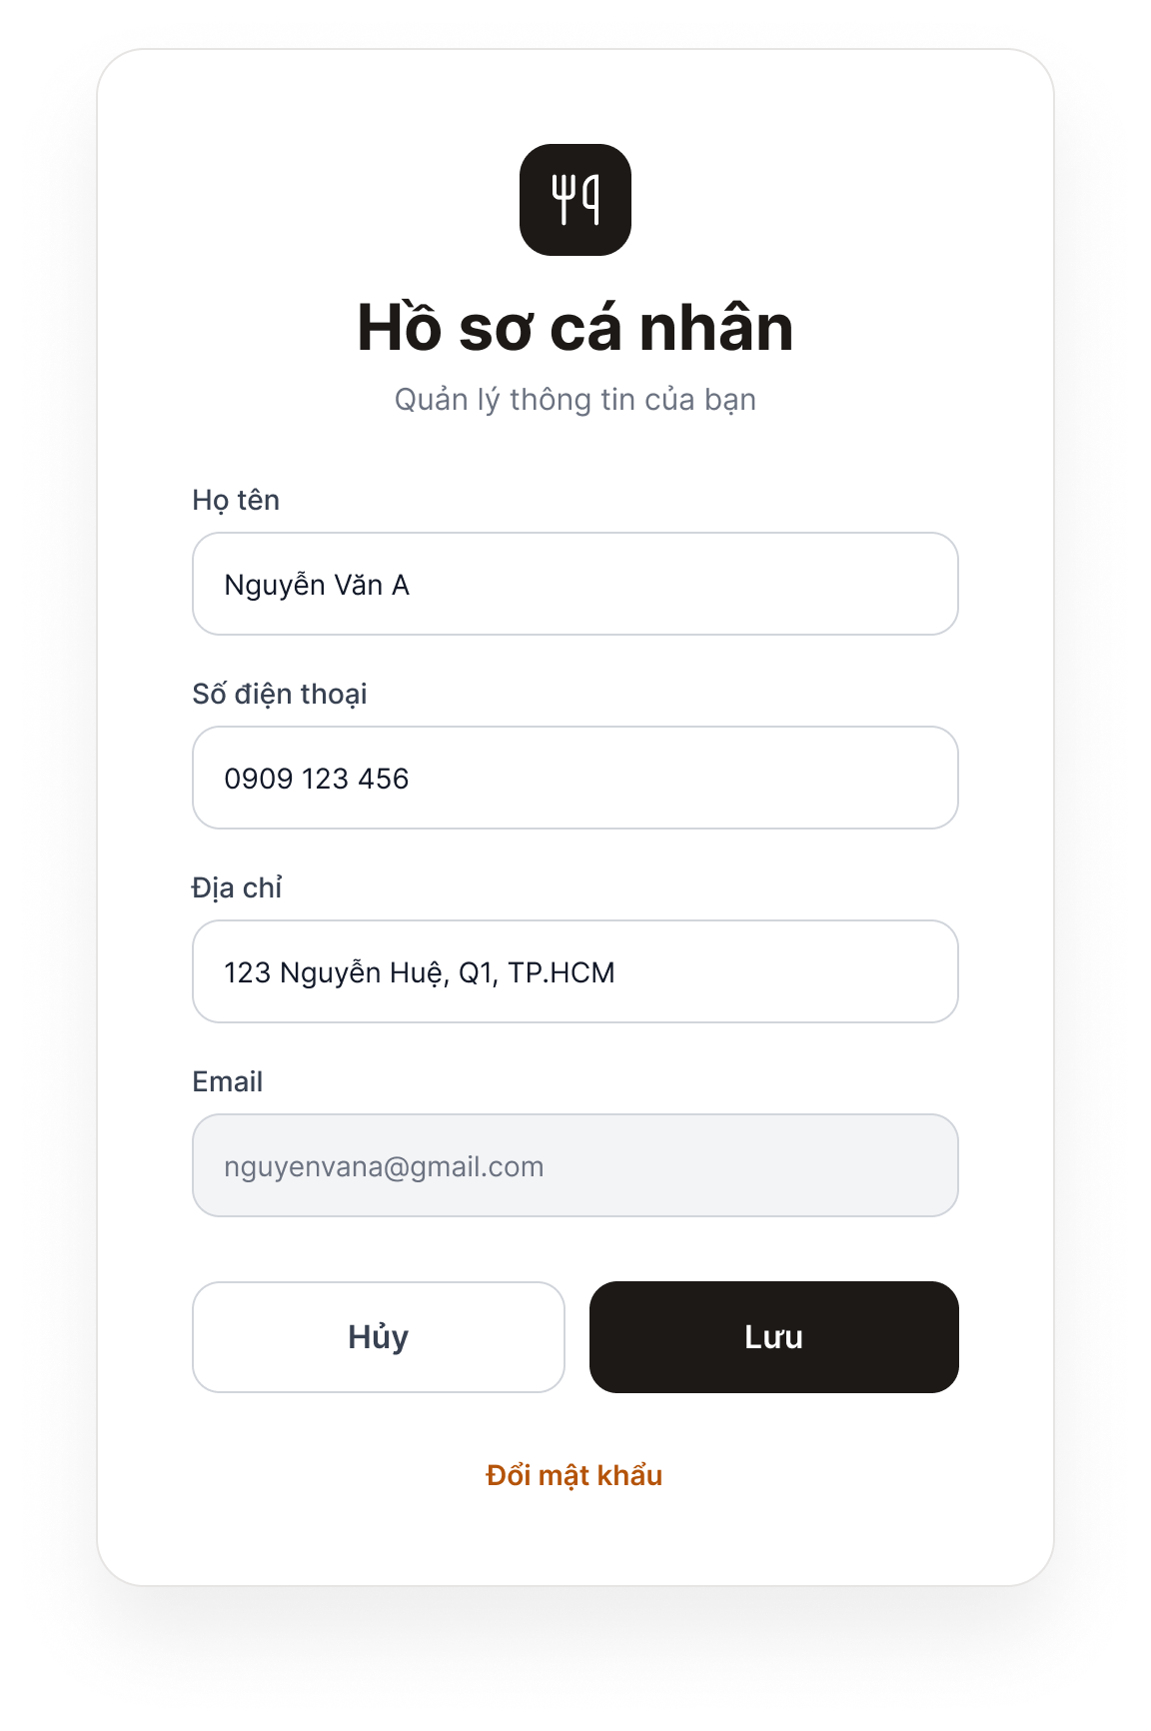
Figure 3. Profile Screen
Purpose: Allows logged-in customers to view and update their personal information.
Components: Full Name, Phone Number, and Address fields; a read-only Email field (gray); “Save” and “Cancel” buttons; and a “Change password” link.
Behavior: Clicking “Save” prompts the system to validate and save the changes, then display “Update successful.” Invalid data triggers an error below the relevant field. Clicking “Cancel” discards the changes and restores the previous information. Clicking “Change password” opens the Password Recovery screen.

Screen 4: Password Recovery (Reset Password)
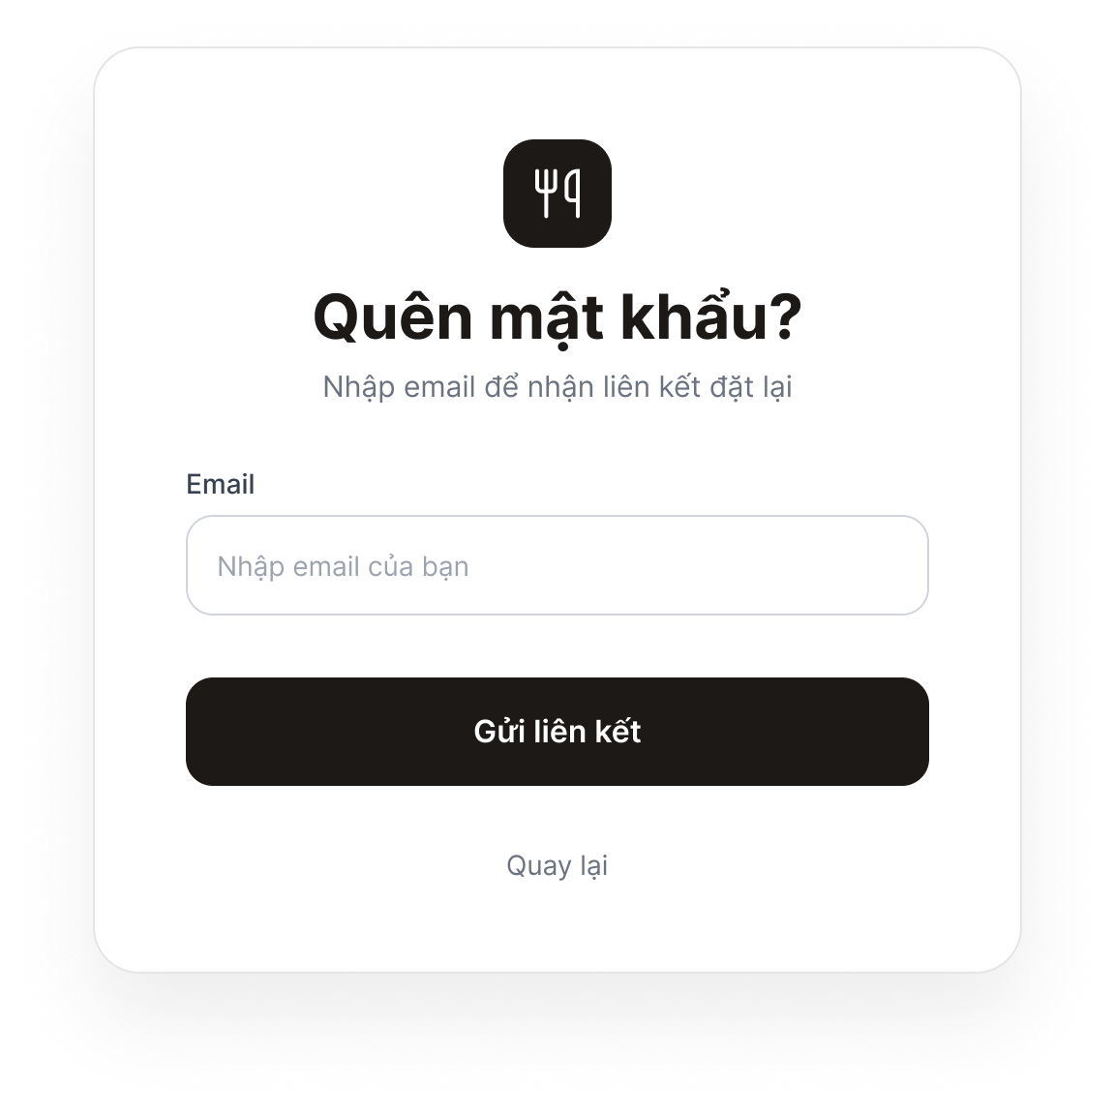
Figure 4a. Password Recovery – Step 1: Enter Email
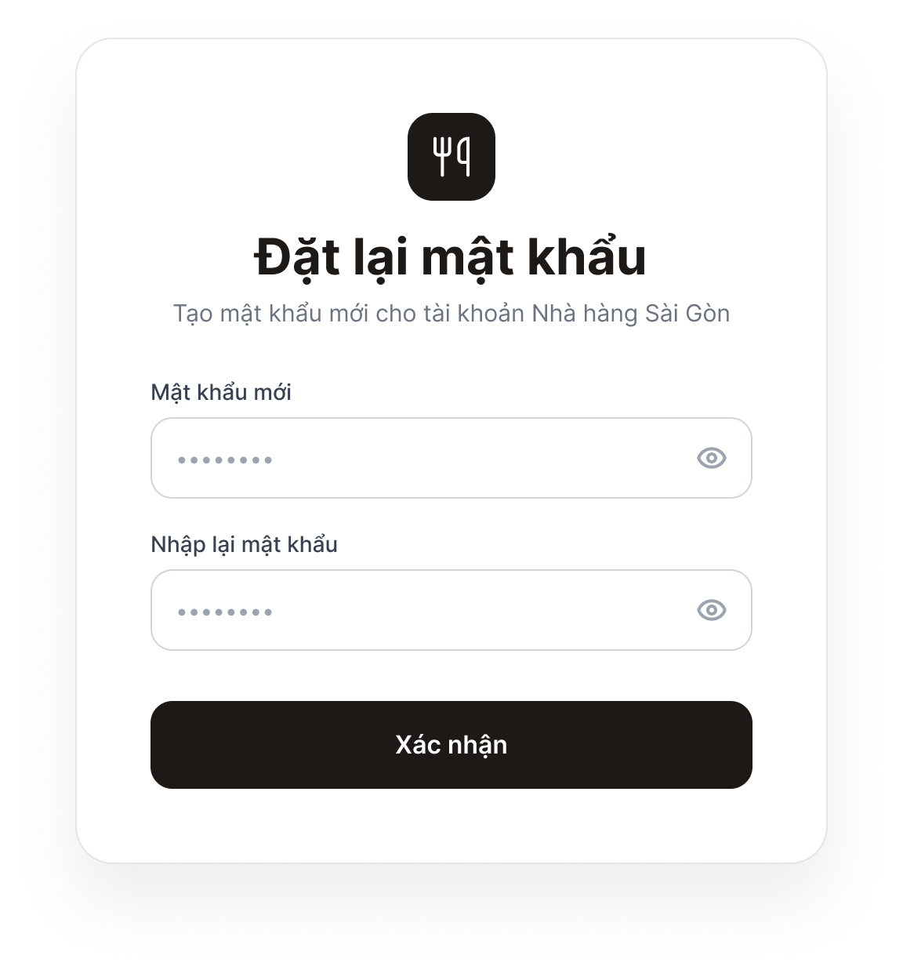
Figure 4b. Password Recovery – Step 2: Set a New Password
Purpose: Allows customers who have forgotten their password to reset it via email.
Components: Step 1: Email field and “Send Link” button. Step 2: New Password and Confirm Password fields, and a “Confirm” button.
Behavior: In Step 1, clicking “Send Link” causes the system to send a verification email; if the email address does not exist, an error is displayed. After the customer opens the link in the email, Step 2 appears. Clicking “Confirm” with a valid password updates the password and opens the Login screen. If the link has expired, the system displays an expiration message and allows the customer to request a new link.

INTERNAL NOTES – DELETE THIS PAGE BEFORE SUBMISSION
The items below are assumptions in the draft. Confirm them with the group, then revise the relevant sections above to ensure consistency.
Item to Confirm | Draft Assumption
Login method | Email and password
Valid password | At least 8 characters (not yet included in the specification; confirm before adding)
Password reset link or code | Expires after 15 minutes (not yet included in the specification)
Email on the Profile screen | View-only; cannot be edited
Actor name | Customer (coordinate with Member 1 when creating the Use Case Diagram)
Account attributes to send to Member 4 | Full name, email, phone number, address, and password (to keep the data table and Class Diagram consistent)

