|  |
| --- |
| GymBuddies - Workout Buddy Finder |
| High Level Requirements Document |
| **Version 1.0** |
| **September 29, 2024** |

**Project Identification**

|  |  |
| --- | --- |
| **Project:** | GymBuddies - Workout Buddy Finder |
| **Prepared By:** | J. Solano, N. N. Nguyen, S. Vu, D. T. Tran, R. Behan |
| **Document Version:** | 1.0 |
| **Published Date:** | October 2, 2024 |

**Contributors**

The following individuals contributed to this document.

|  |  |
| --- | --- |
| **Name** | **Title** |
| Jacob Solano | Contributor/Student |
| Nhu Nam Nguyen | Contributor/Student |
| Ronan Behan | Contributor/Student |
| Duc Thien Tran | Contributor/Student |
| Simon Vu | Contributor/Student |

**Distribution**

This document is distributed to all the following people.

|  |  |
| --- | --- |
| **Name** | **Title** |
| Anjana Shah | Professor/Project Overseer |
| Nhu Nam Nguyen | Contributor/Student |
| Jacob Solano | Contributor/Student |
| Ronan Behan | Contributor/Student |
| Simon Vu | Contributor/Student |
| Duc Thien Tran | Contributor/Student |

**Referenced Documents**

This document refers to the following materials

|  |  |  |  |  |
| --- | --- | --- | --- | --- |
| **Version number** | **Title** | **Author** | **Date** | **Source / Location** |
| 1 | *COMP3059 Delivering_Business Requrements_Summary* | Anjana Shah | 09/29/2024 | Blackboard/Course Content/Lecture Review/Delivering Business Requirements Summary |

**Revision History**

|  |  |  |  |
| --- | --- | --- | --- |
| **Version Number** | **Revision Date** | **Summary of Changes** | **Modified by** |
| 1.0 | September 29, 2024 | First approved version of HLR | Project Team Members |
|  |  |  |  |
|  |  |  |  |

TABLE OF CONTENTS

1. Business Context Diagram

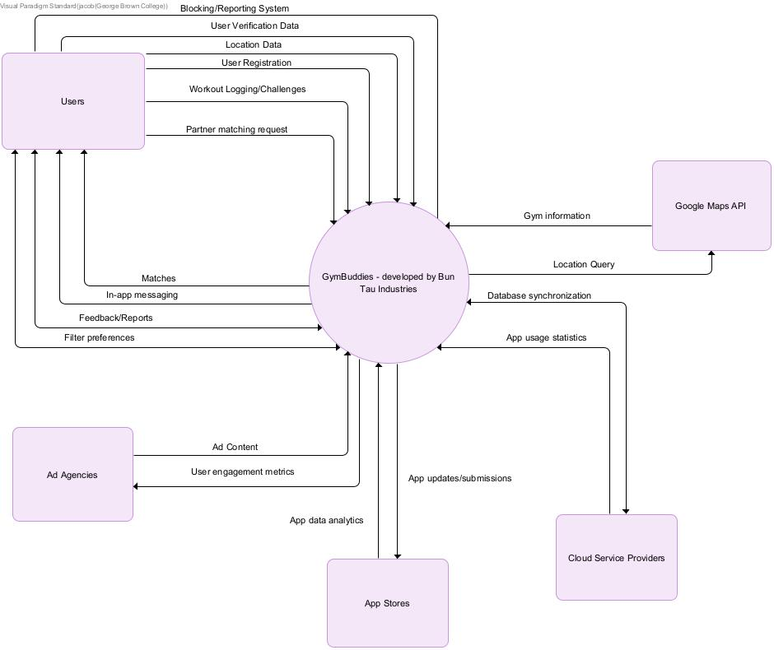

|  |  |
| --- | --- |
| **Requirement Scope Area** | **Description** |
| GymBuddies App Services | Area responsible for providing user matching, communication, workout tracking, and safety features within the fitness partner finding app. |

|  |  |
| --- | --- |
| **External Entity** | **Description** |
| Users | Primary interactors of the app, creating profiles, finding partners, and tracking workouts |
| Ad Agencies | Provide advertisement services to be displayed within the app |
| Cloud Service Providers (Firebase) | Provide infrastructure for backend services, data storage, and real-time communication |
| App Stores (Google Play and App Store) | Platforms for app distribution to Android and iOS users |
| Google Maps API | Provide information about gym facilities to the users |

|  |  |
| --- | --- |
| **Information Flows** | **Description** |
| User registration | New users signing up and creating profiles |
| Partner matching request | User initiating a search for compatible workout partners |
| Location data | User's GPS data for nearby partner and gym suggestions |
| In-app messaging | Communication between matched partners |
| Workout logging | Users inputting their workout data |
| Challenge creation/participation | Users setting up or joining fitness challenges |
| Ad content | Advertisements provided by ad agencies |
| App usage data | Usage statistics sent to cloud services for analysis |
| Gym information | Details about local gyms, facilities, and user reviews |
| User feedback/reports | Users providing feedback or reporting issues |
| App updates | New versions and patches distributed through app stores |
| User verification | Process of verifying user identities for safety |
| User reporting/blocking | Users reporting inappropriate behavior or blocking other users for safety and community management |
| Database synchronization | Real-time data syncing between app and cloud storage |
| Analytics data | User behavior and app performance metrics sent to cloud services |
| App store metrics | Download statistics, ratings, and reviews from app stores |

2. Requirements Scope Statements

|  |  |  |
| --- | --- | --- |
| **HLR#** | **Description** | **Priority**  **(H, M, L)** |
| HLR01 | GymBuddies must provide a user-friendly interface for profile creation and partner matching. | H |
| HLR02 | The application must integrate geolocation services to suggest nearby workout partners and gyms. | H |
| HLR03 | Users must be able to communicate securely with matched partners through an in-app messaging system. | H |
| HLR04 | The app must implement a filter-based system to display potential partners, prioritizing those closest to the user's location. | H |
| HLR05 | Users should be able to track their workouts and view their buddies' activities. | M |
| HLR06 | The application must include safety features such as user verification and reporting systems. | M |
| HLR07 | Users must be able to block and report others who display suspicious activity | M |
| HLR07 | The app should allow integration of Google Maps API to provide details about gym facilities. | H |
| HLR08 | Users must be able to set and participate in fitness challenges with their buddies. | L |
| HLR09 | The application should support in-app advertisements for monetization. | L |
| HLR10 | The system must utilize cloud-based database storage for secure and scalable data management, ensuring real-time synchronization across user devices. | H |
| HLR11 | The backend infrastructure must be designed to handle high concurrent user loads and provide seamless API integration for frontend functionality. | M |
| HLR12 | The system should implement comprehensive app usage analytics to track user engagement, feature popularity, and performance metrics. | L |
| HLR13 | The development team must adhere to app store guidelines and submission processes for both iOS and Android platforms. | M |
| HLR14 | The system should generate periodic reports on app usage, user retention, and growth metrics for stakeholder review. | L |

3. High Level Business Requirements Sign-Off

The undersigned acknowledge their agreement with the contents of Version 1.0 of the High-Level Requirements document for GymBuddies - Workout Buddy Finder.

Following approval of this document, requirements changes will be governed by the project’s change management process, including impact analysis and appropriate reviews and approvals, under the general control of the Project Plan and according to company policy. Approved Change Request Documents, if present, will be attached to this Requirements Document as updates.

|  |  |  |
| --- | --- | --- |
| **Name** | **Project Role and**  **Functional Area** | **Date Signed** |
| Jacob Solano | Team Member, Production | 10-02-2024 |
| Nhu Nam Nguyen | Team Member, Production | 10-02-2024 |
| Duc Thien Tran | Team Member, Production | 10-02-2024 |
| Ronan Behan | Team Member, Production | 10-02-2024 |
| Simon Vu | Team Member, Production | 10-02-2024 |

* Note: physical signatures are not required. Email approvals are acceptable and should be appended to project documents.