|  |  |
| --- | --- |
|  | **FPT ACADEMY INTERNATIONAL**  **FPT – APTECH COMPUTER EDUCATION** |

**Centre Name: ACE-HCMC-2-FPT.**

**Address: 590 Cach Mang Thang 8, District 3, Ho Chi Minh City, Viet Nam.**

**Clinic Management System**

|  |  |  |  |
| --- | --- | --- | --- |
| **Supervisor:** | MR. NGO PHUOC NGUYEN | | |
| **Semester:** | 3 | | |
| **Batch No:** | T1.2009.A0 | | |
| **Group No:** | 1 | | |
| **Order:** | **Full name** | **Roll No.** |
| 1. | Nguyen Hoang Thien An | Student1268834 |
| 2. | Nguyen Ly Minh Hieu | Student1278909 |
| 3. | Vo Phan Hien | Student1275062 |
| 4. | Pham Ngoc Thien | Student1270702 |

January 2022

**Table of Contents:**

This is to certify that

Mr.Nguyen Hoang Thien An

Mr.Nguyen Ly Minh Hieu

Mr.Vo Phan Hien

Mr.Pham Ngoc Thien



have successfully designed and

developed 

Submitted by:

Date of Issue: ________

Authorized Signature: ___________



**REVIEW I 5**

**Acknowledgment 6**

**Problem Definition 7**

1. Introduction 7
2. Project Requirement 7
3. Project Designing 7
4. Functional Logic 9

**Task sheet review 1 12**

**REVIEW II 13**

1. Architecture & Design of the Project 14
2. Data Flowchart 16
   1. Main data flow for guest 16
3. Data Flow Diagram 26
   1. Context Diagram 27
   2. Level 0 DFD 28
   3. Level 1 DFD 29
4. Use Case Diagram 33
   1. Administrator Use Case 34
   2. Staff Use Case 35
   3. Guest Use Case 35
5. Entity–Relationship Design 36
   1. Entity–Relationship Diagram 36
   2. Entities and Properties 37

**Task sheet review 2 44**

**REVIEW I**

**Acknowledgment**

We would like to acknowledge all those who have given support and help us make the project a success.

We wish to express our deep gratitude to all teachers who have been devoting their lives to teach us how to stand-alone and walk ahead.

We are grateful to our families who take care and encourage us even though we are successful or failed, also to our friends who are always care of us. They never leave us alone and always look forward to us when we are on any road of the life.

We are much thankful to the entire staff and chairpersons at the Head Office of Aptech Worldwide, Aptech – Vietnam, and FPT – Aptech Center who have been organizing and looking after our studying course.

There are no words to show our appreciation for teachers of FPT Aptech Centre who have been organizing and looking after us during our studying course to finish this project. Our special thanks Mr Tran Phuoc Sinh who works day by day to teach and guide us, e-Project Team at the Head Office who instruct and help us.

Finally, we would like to offer many thanks to all our schoolfellows for their valuable suggestions.

We would like to thank sincerely!

**Problem Definition**

1. **Introduction**

From the beginning in the scientific laboratories and research establishments, computers have enclosed to become essential for modern business and industry. Today their presence is felt in all way of life such as making passenger reservation for the railways, forecasting the weather, monitors and run power plants, helping hospital to render service to patients etc.

1. **Project Requirement**

Computers have very large storing capacity. Computers also do not make mistakes. Error in computing is generally due to negligence rather than logical faults. The vital characteristics such as each module are to play a center role in ourselves. Since the computer is an electronic data processing machine, it can perform innumerable number of operators in just a few seconds. This processing speed of a computer is usually measured in nanosecond. Computer can perform a

wide range of jobs with speed, accuracy and diligence. The areas of application are many:

* Scientific Application
* Medical Application
* Educational Application
* Business Application

The software is developed for providence clinic. This project deals with the task of computerizing the lab and pharmacy of the providence clinic. The software is developed in Visual Basic containing coding programs. It is a very fast high-level language developed mainly for business purpose. Some new scientific machine and medicines must be stated in the Home Page. Home Page must be designed with an Introduction to the site and all the navigation links available. Upcoming activities must be flashed in the Home Page. The image must be added with its caption and alt attribute defined.

ADMIN: There should be admin Login separate where the entire data of the application can be updated. Admin must maintain the client details and online transaction details. Even keep the track of the all the education activities carried like seminar, practicals. When the lecture is to be conducted and at what time must be stated in the education link.

1. **Function Requirements**

**Scientific Application:** Here there should be description of all the scientific apparatus used (like microscope, Blood Pressure monitors, ECG Machines, Cardiac Event Monitoring, Pulse oximeter, Medical Exam tables)

**Medical Application:** It deals with the medicines. The details of the medicines must be properly categorized. Details like Medicine Type, Code, Name,..

**Education Application:** Here there should be details of lectures and practical’s conducted along with the details of the subject. The details of the staff must be added. Also it takes care of the seminars, lectures and practical conducted.

**Business Application:** The Business application deals with the supply of medicine or scientific machine. It should keep the details of all the business activity like how much transaction is done in which sector (educational, medicine, machines). A proper report must be generated for each section. This part of the application states the progress and

profit level of the company.

**Client Login:** There should be register form for the clinics that can

register their account.

**Online Purchase:** They can purchase the items whether machine or medicines online.

**Feedback:** They can also provide their feedback or suggestion

for their services, quality when they

**Contact US:** Here the details of the contact must be added.

**About Us:** It should flash the details of the clinic.

**Admin Login:** With the help of the admin Login the details of the site can be updated and new details can be added.

**Hardware / Software Requirements**

1. **Server Requirement**

* Hardware

|  |  |
| --- | --- |
| **Component** | **Requirement** |
| **CPU** | Processor type:  Pentium IV-compatible processor or faster  Processor speed:  Recommended: 2.0 GHz or faster |
| **OS** | Microsoft Windows Server 2012 with IIS |
| **Memory (RAM)** | RAM:  Minimum: 4MB  Recommended: 8 GB or more |
| **Hard Drive** | Free space:  Minimum: 200 MB  Recommended: 50 GB or more  Maximum: Operating system maximum |

* Software

|  |  |
| --- | --- |
| **Component** | **Requirement** |
| **Microsoft .NET Framework** | Version 5.0 |
| **RDBMS** | Microsoft SQL Server 2019 |
| **React** | Version 17.0 |

1. **Client Requirement**

* Hardware

|  |  |
| --- | --- |
| **Component** | **Requirement** |
| **CPU** | Processor type:  Pentium III-compatible processor or faster  Processor speed:  Recommended: 1.0 GHz or faster |
| **OS** | All OS (Window, Linux, Android, Mac OS …) |
| **Memory (RAM)** | RAM:  Minimum: 512 MB  Recommended: 1 GB or more  Maximum: Operating system maximum |
| **Hard Drive** | Free space:  Minimum: 10 MB |

* Software

|  |  |
| --- | --- |
| **Component** | **Requirement** |
| **Web Browser** | Chrome, Firefox, Edge |

**Task Sheet Review I**

|  |  |  |  |  |  |
| --- | --- | --- | --- | --- | --- |
| Project Ref. No: 4 | Project Title:  Railway Reservation Manage System | Date of Preparation of Activity Plan | | | |
| No. | Task | Actual Start Date | Actual Days | Team Member Names | Status |
| 01 | Acknowledgment | Jan 12, 2022 | 2 | All Members | Completed |
| 02 | Problem Definition | All Members | Completed |
| 03 | Customer Requirement | All Members | Completed |
| 05 | Hardware/Software | All Members | Completed |
| 06 | Task sheet | All Members | Completed |

|  |  |  |
| --- | --- | --- |
|  | Prepare By: Group 1 | Approved By: Faculty |
| Date: Jan 12, 2022 | Team Leader  Nguyen Hoang Thien An | Mr. Ngo Phuoc Nguyen |

**REVIEW II**

1. **Architecture & Design of the Project**

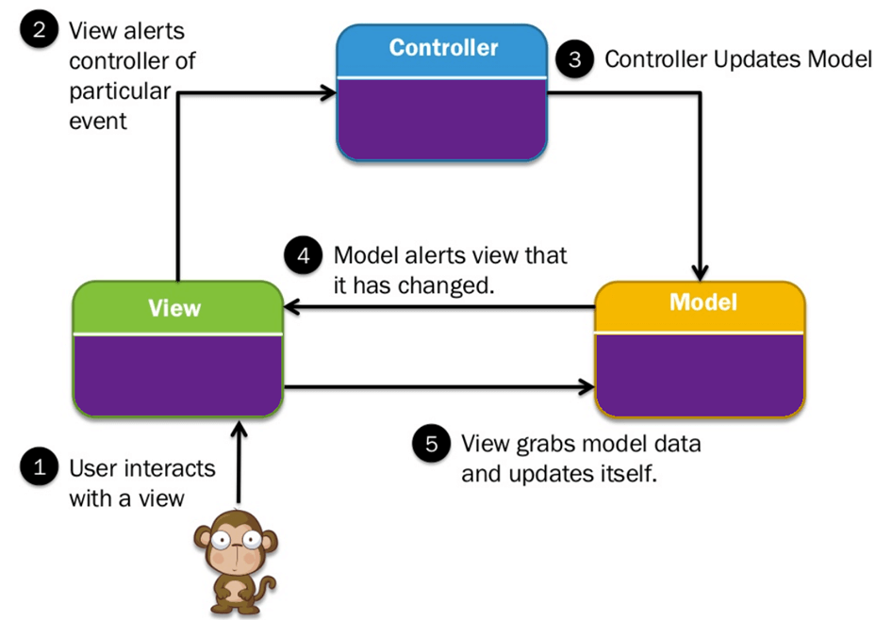

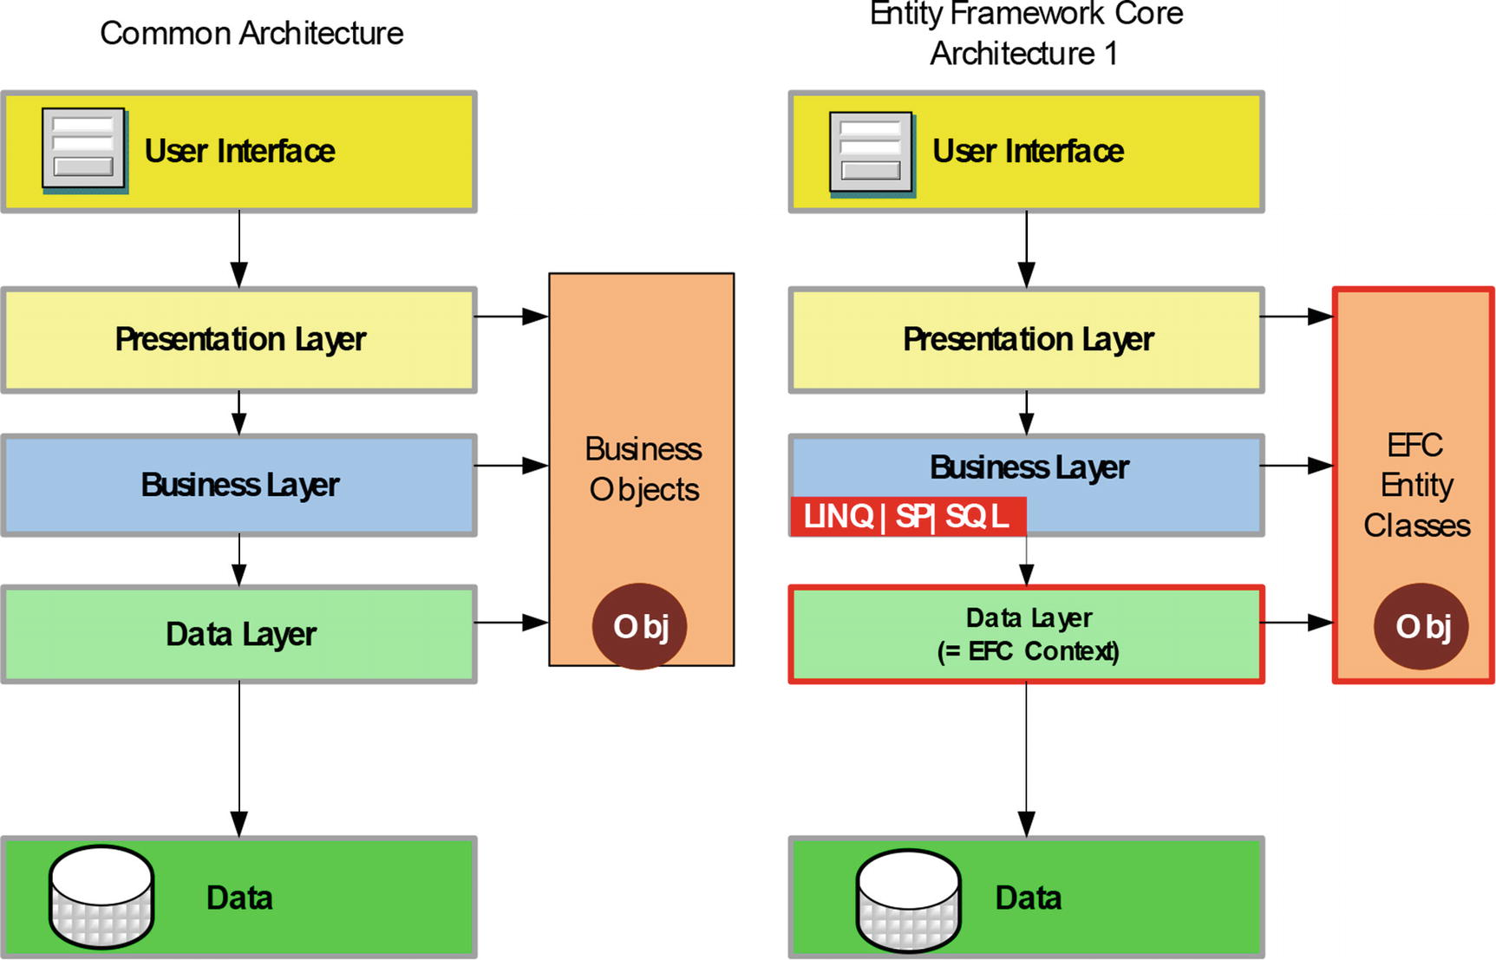

Architecture of the Project

## Presentation Tier:

Is the tier in which the users interact with application. Presentation Tier contents Model, View, Controller used to receive a request and response to User.

Technology: ASP.NET CORE MVC5, Razor, HTML, CSS, JavaScript, Ajax, JQUERY, Bootstrap , ReactJS

## Business Logic Tier:

Is mainly working as the bridge between Data Tier and Presentation Tier. All the Data passes through the Business Tier before passing to the Presentation Tier.

Technology: ASP.NET CORE WEB API

## Data Access Tier:

Is basically the server which stores all the application’s data .Data tier contents Database Tables, Database Views and other means of storing Application Data .

Technology: SQL Server, LINQ

1. **Algorithms - Data Flowchart**

Symbol generates:

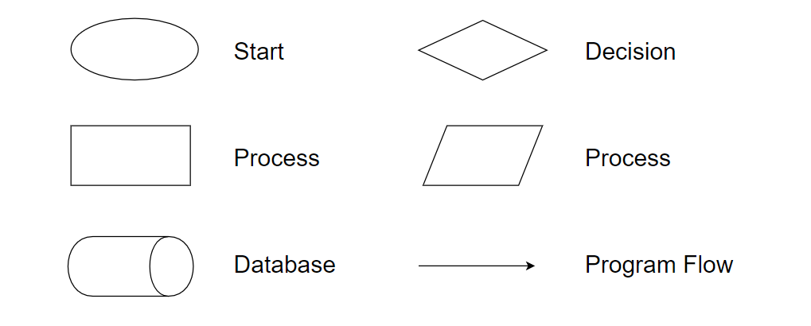

1. Data flow Diagram
2. Context Level:

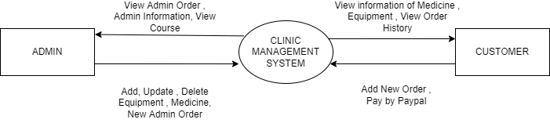

1. The first level of DFD:
2. Customer:

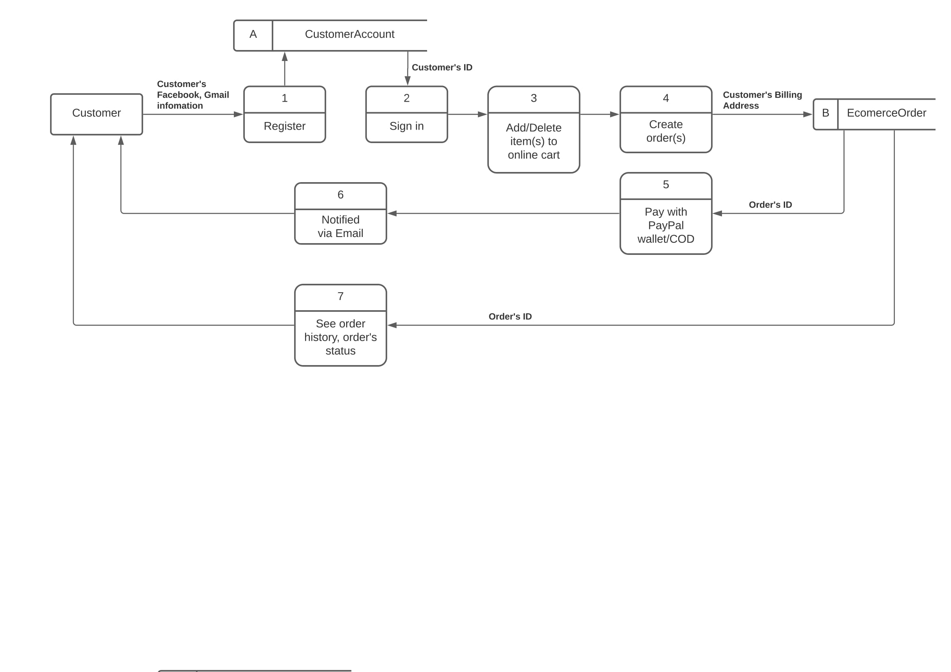

1. Admin:

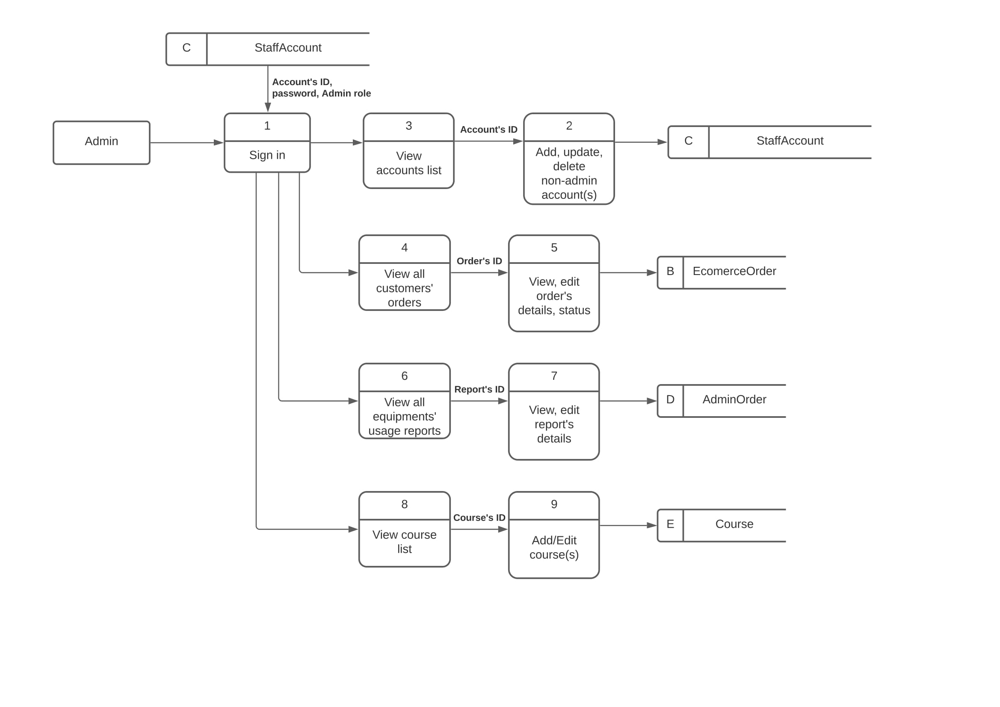

1. The second level of DFD:
2. 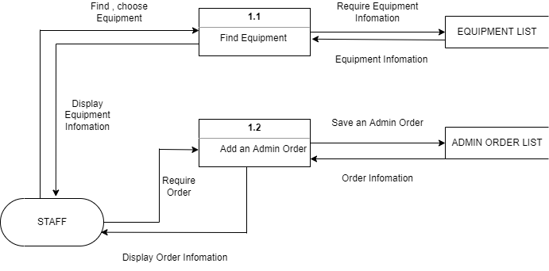Scientific Aplication :