**Admin**

1. **Admin Login**

* Staff must login with correct username and password of admin to use this app. Here for some demo account of staff for testing

|  |  |
| --- | --- |
| Username | Password |
| Manager | 1 |
| Staff01 | 1 |
| Staff02 | 1 |

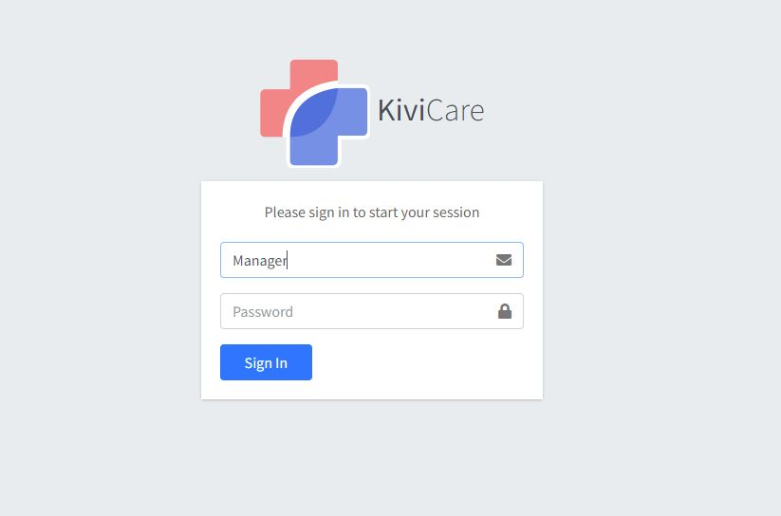

1. Dashboard

After login success, staff will be redirect to dashboard page. In this page, staff will have overview about: Total income, Pending Over Rate, User Registration, Staff Account Available, Course In Month, Feature Product, Rented Equipment.

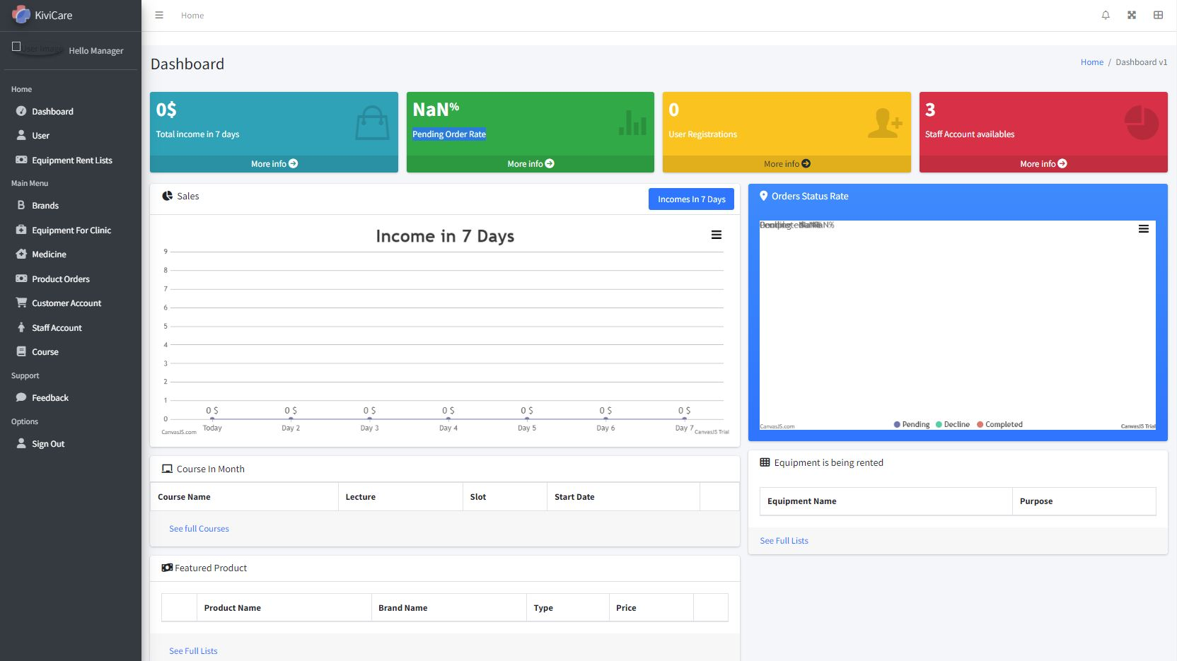

1. User

This page will show profile of staff and registered course that staff registered. Staff can edit him/her profile here.

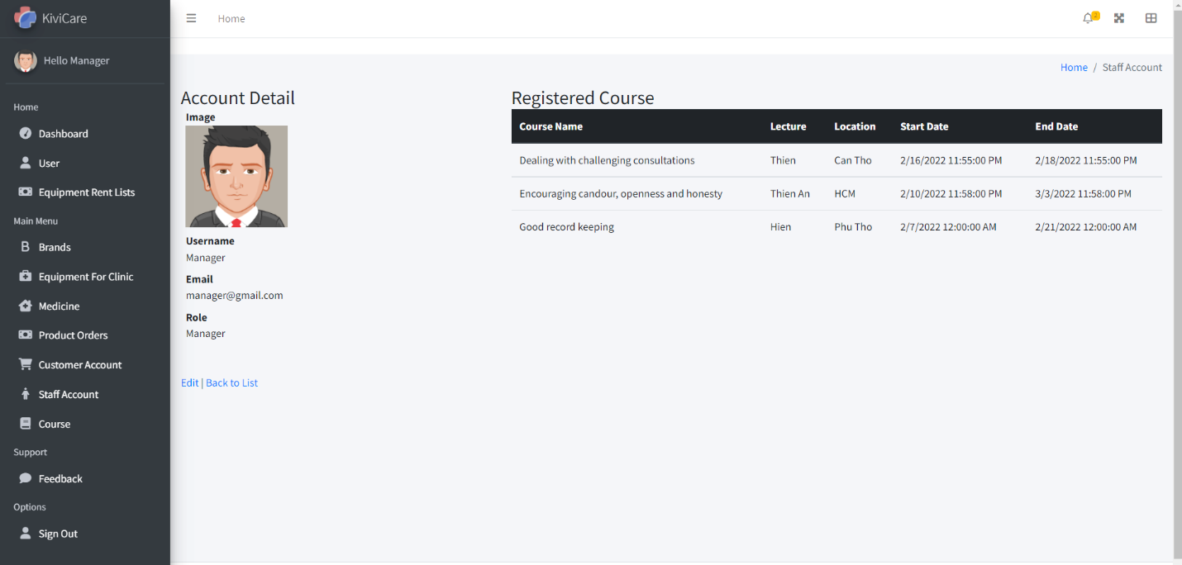

1. Rent List Equipment:

If your account is Manager:

This page will show rented equipment, who rented, quantity and purpose for rent.

You can click finish if this equipment was returned.

You can search rented equipment in textbox below Rent Equipment button.

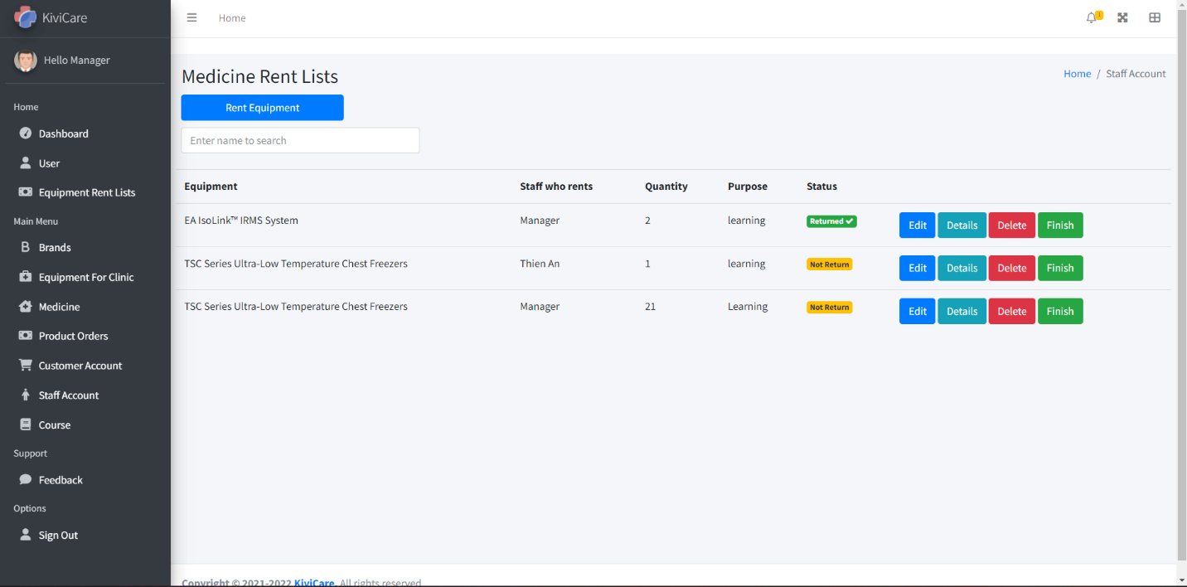

After click Rent Equipment button, you can make a rent equipment order.

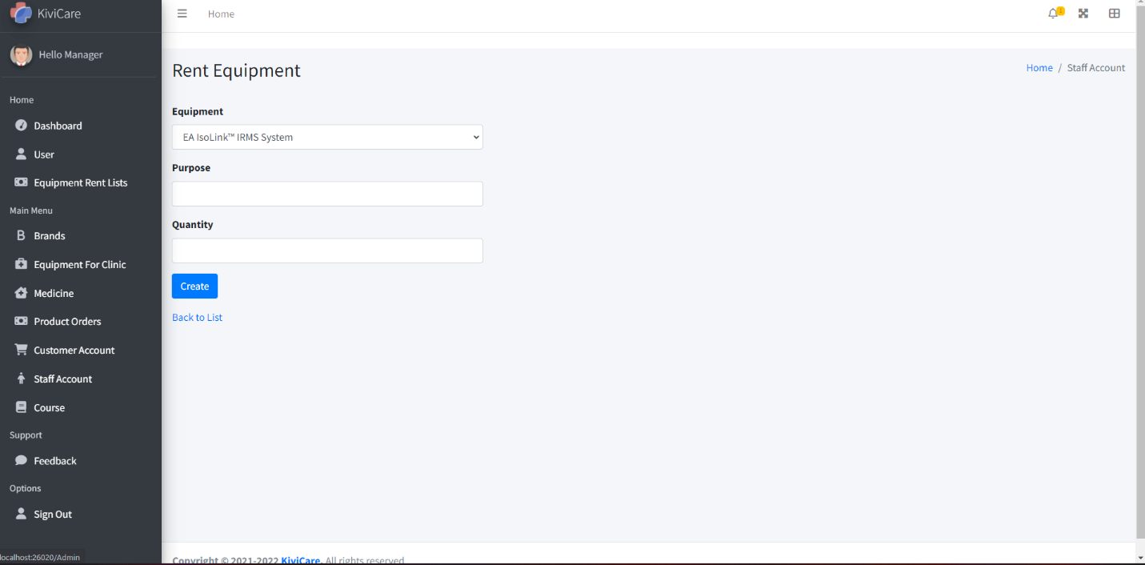

1. Brands:

This page show you all brands of the medicine or equipment. You can add new brand in this page by click Add New Brand button. You can also find brand by text box next to Add New Brand button. You can Edit/ View Detail/ Delete brand by click to each button. You can not delete brand if it exist in any Equipment Rent List or Product Order.

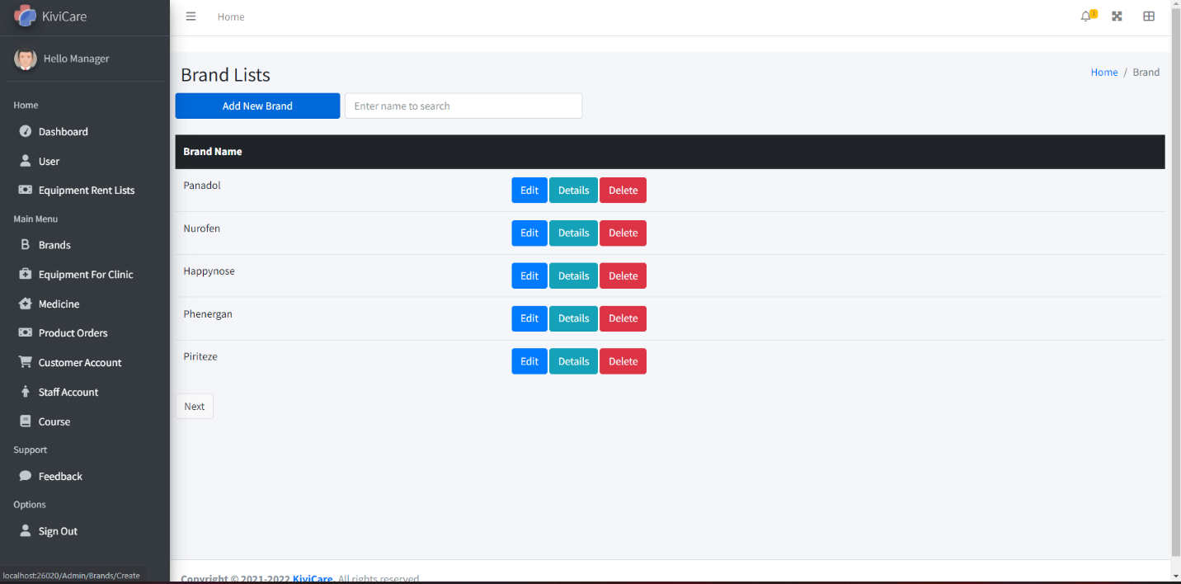

1. Equipment For Clinic:

This page show you all the equipment in the hospital. You can add new equipment in this page by click Add Equipment button. You can also find equipment by text box next to Add Equipment button. You can Edit/ View Detail/ Delete equipment by click to each button. You can not delete equipment if it exist in Equipment Rent List.

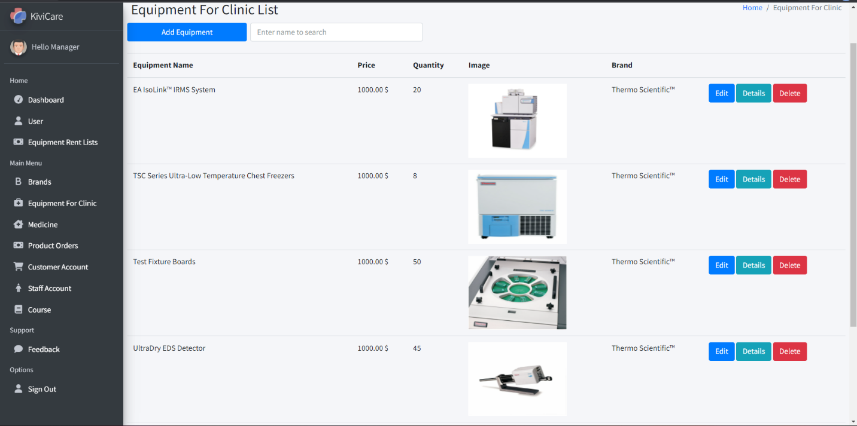

1. Medicine:

This page show you all product customer can buy in e-commerce website. You can add new product in this page by click Add Medicine button. You can also find product by text box next to Add Medicine button. You can Edit/ View Detail by click to each button.

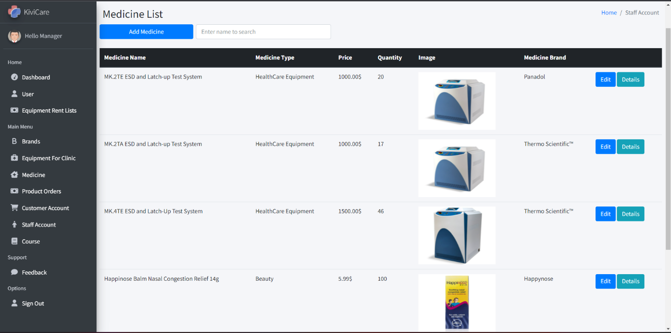

1. Product Order:

This page show you all orders customer create in e-commerce website. You can also find order by text box below header. You can View Detail by click to Detail button. In Detail page, you can decline order or finish it by click to each button.

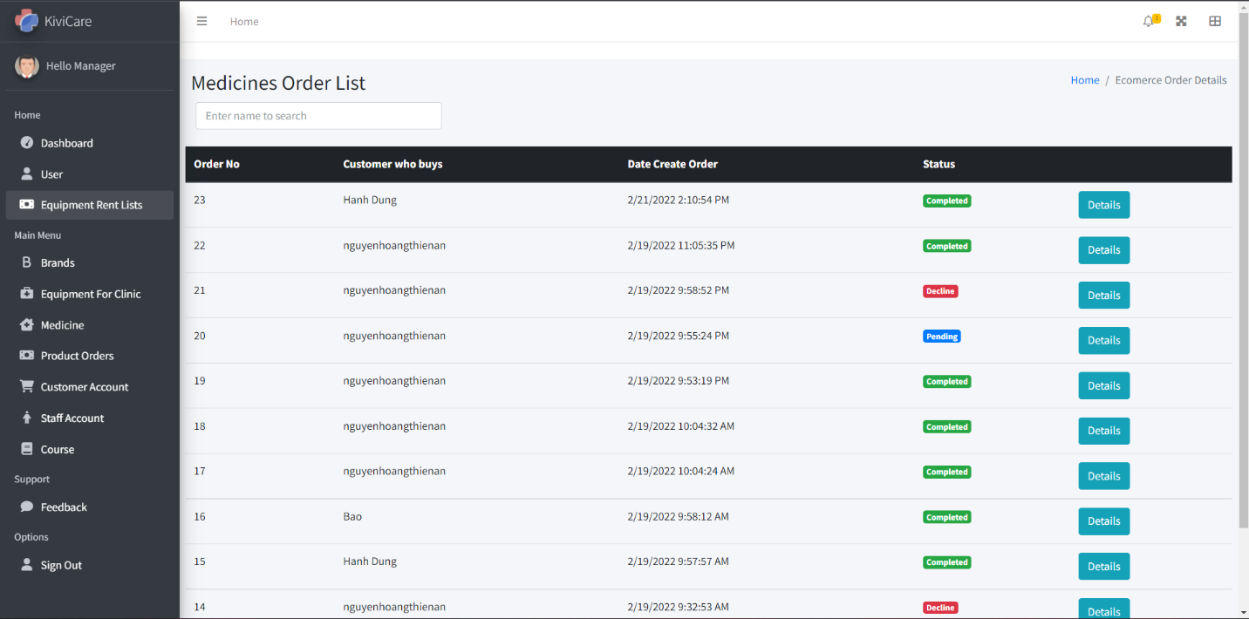

1. Customer Account:

This page show you all customer registered in e-commerce website. You can view block account if you have suspicious about him/her activity.

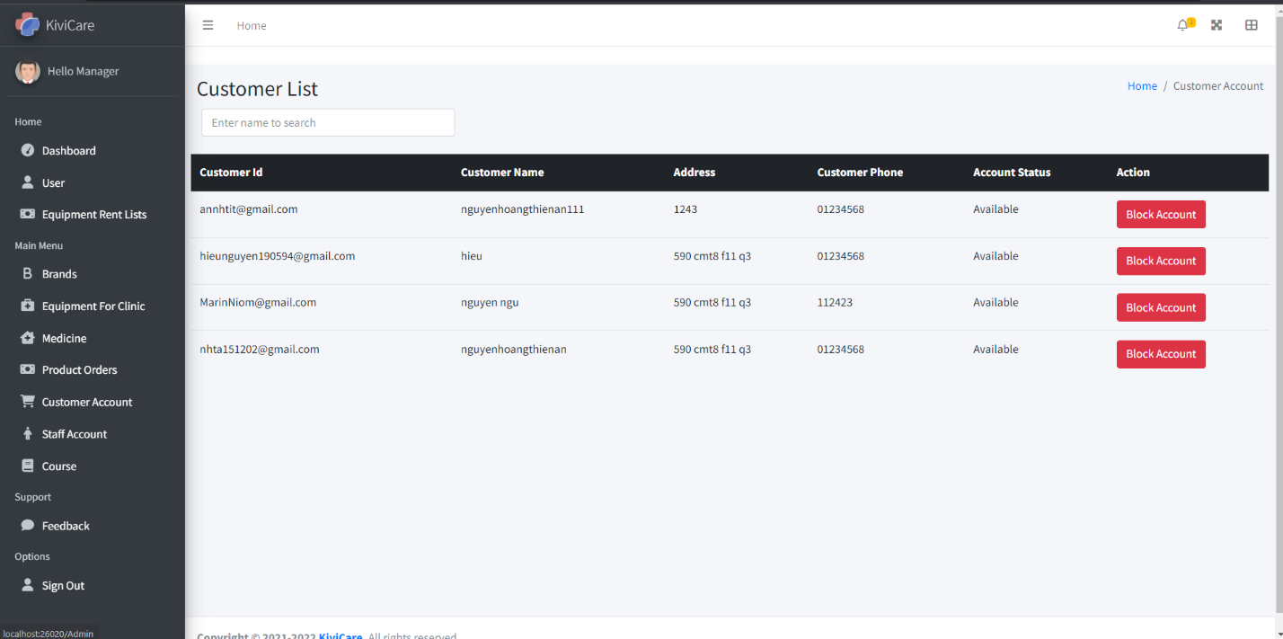

1. Staff Account:
   1. If you are Manager:

This page show you all staff account can login to admin page. You can add new account in this page by click Create Account button. You can also find account by text box next to Create Account button. You can View Detail/ Edit or Delete any staff account.

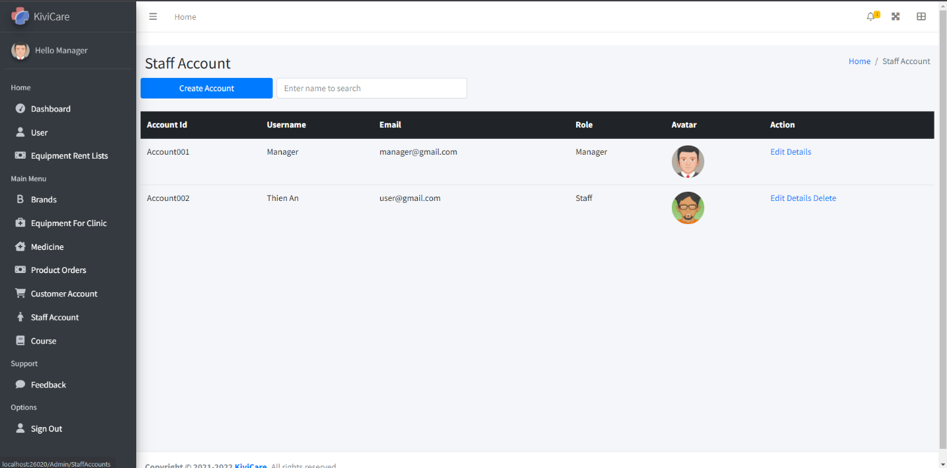

* 1. If you are Staff:

You will be redirect to your profile page.

1. Course:
   1. If you are Manager

This page will show you all seminar, lesson, .. in this hospital. You can Edit/ View Detail/ Register by click to each button. You can create new Course by click to Add new Course button.

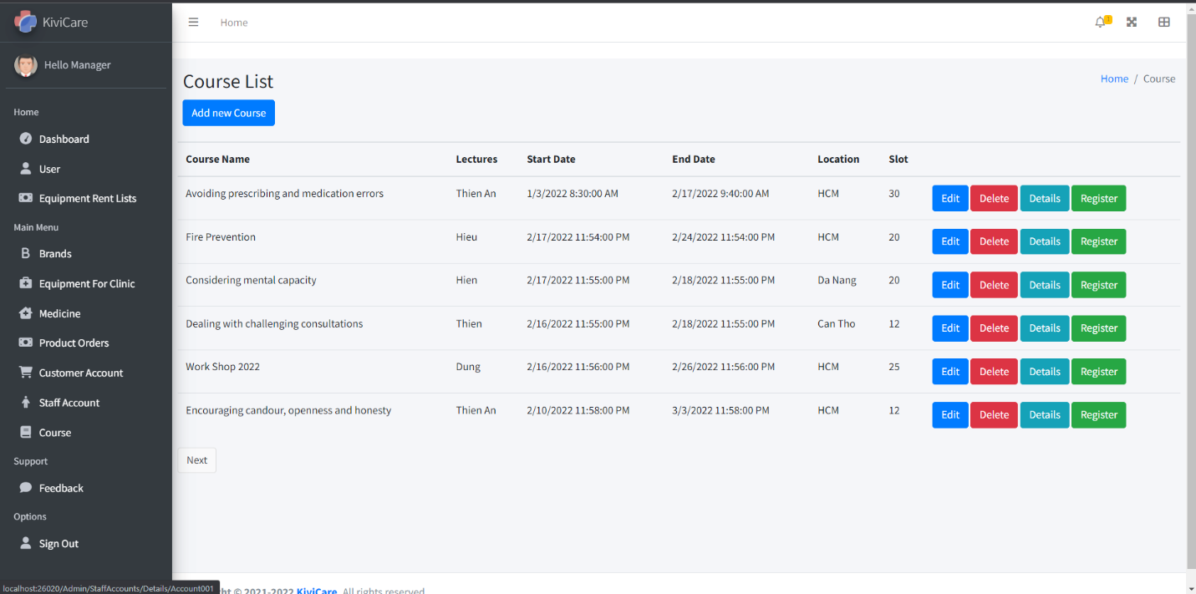

* 1. If you are Staff:

This page will show you all seminar, lesson, .. in this hospital. You can View Detail/ Register by click to each button.

**E-Commerce Website**

1. Guess can Register by click to Register, they have to fill information to register and receive OTP code after click Register.

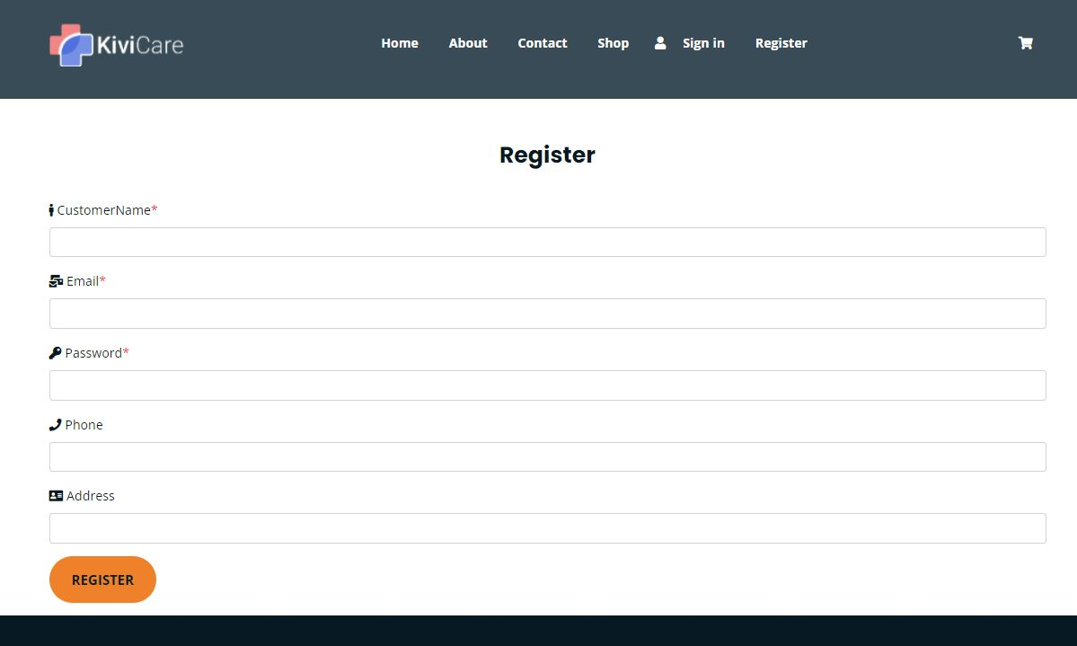

An mail with OTP code will be sent to email guess was registered. He/ She has to fill OTP to active his/her account.

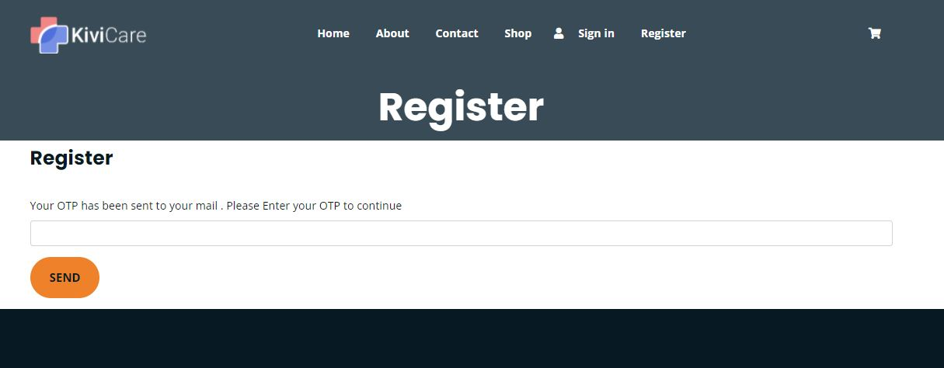

1. Guess can Login easily by click to Sign in.

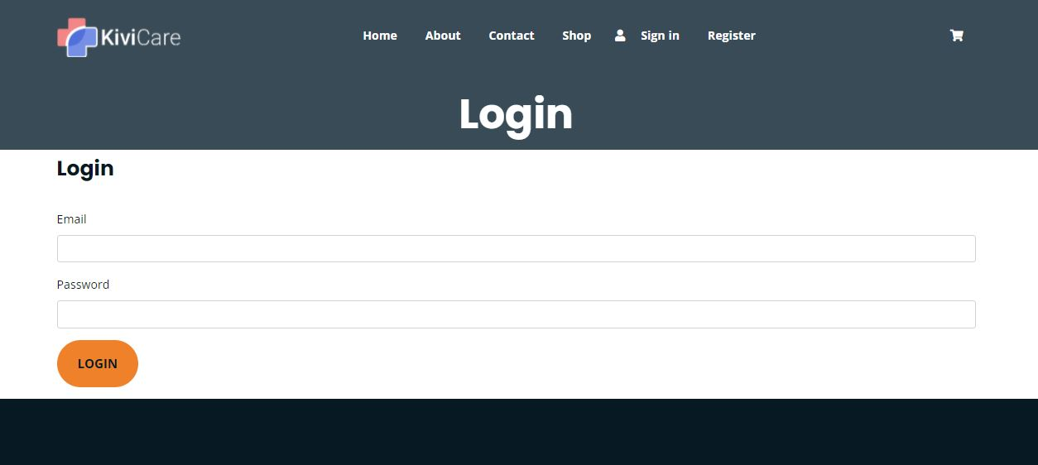

1. Guess can View Homepage, About, Contact and Shop without login in.

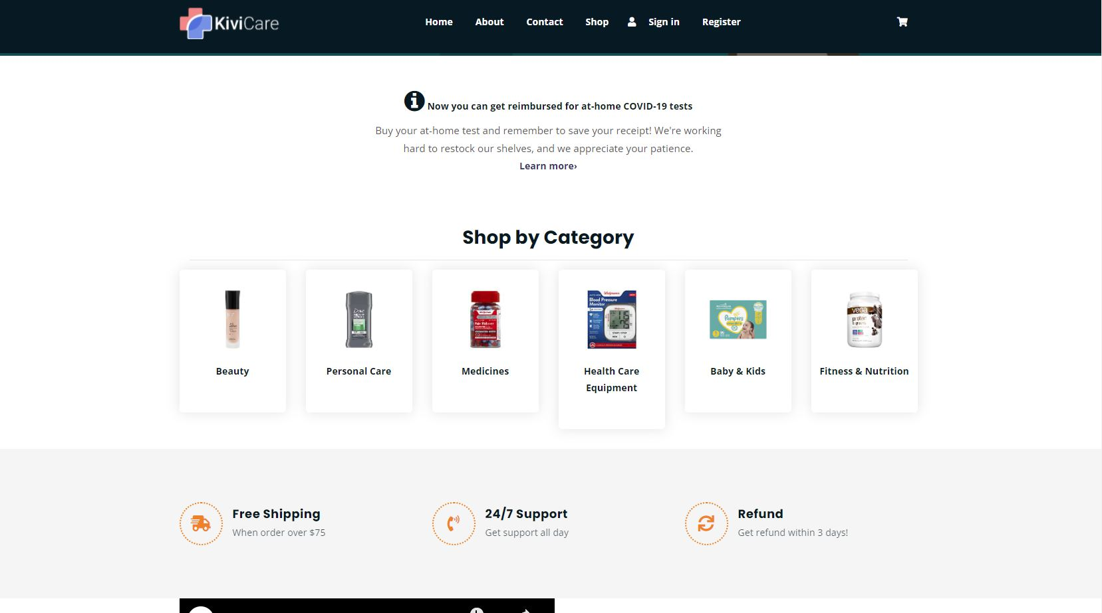

He/she can browse all product available and click on each product to see product details. Guest can also filter product by click to each field like Medicines, Beauty, Fitness & Nutrition,… They can sort product list by popularity, price.

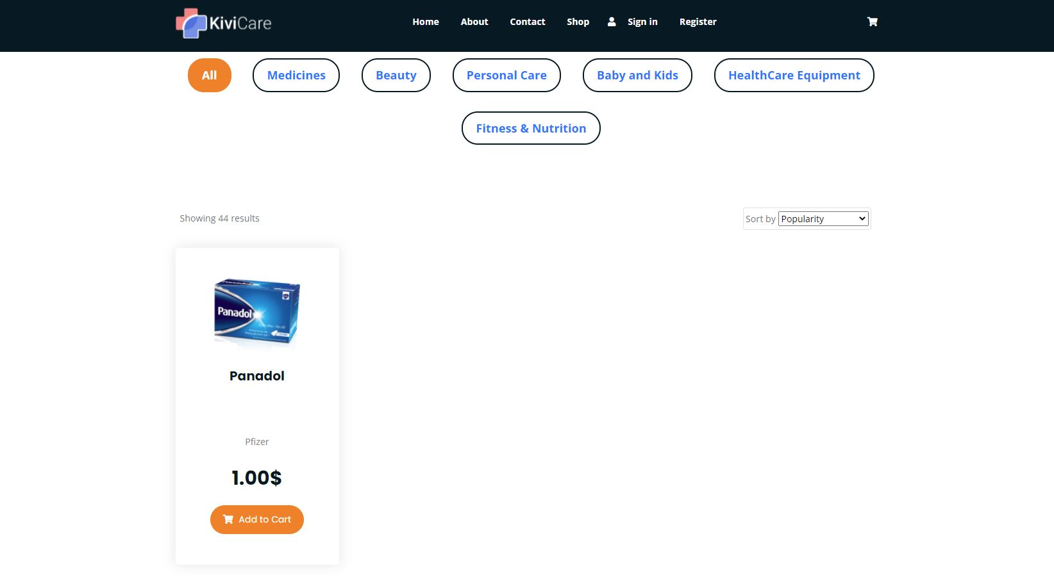

1. After click Add to Cart button, guess will be redirect to Cart page, he/she can edit quantity of product or remove it from cart.

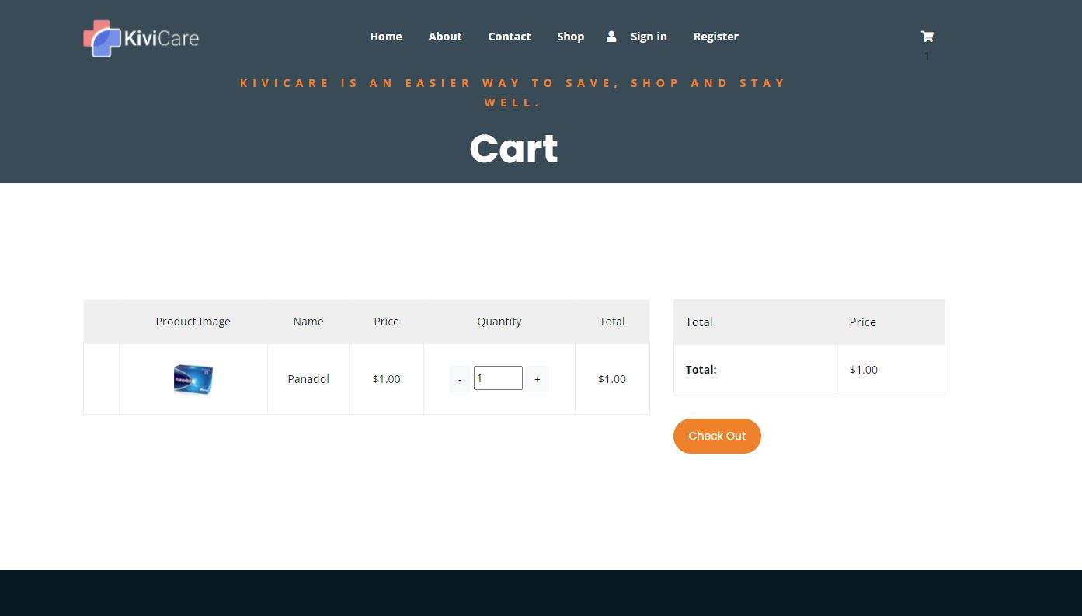

1. After click Check out button, guess will be redirect to Check Out page. This page will show guess list of item he/ she want to order and information to ship. If guess was login, all shipping information will be filled automatic and they can change if they want.

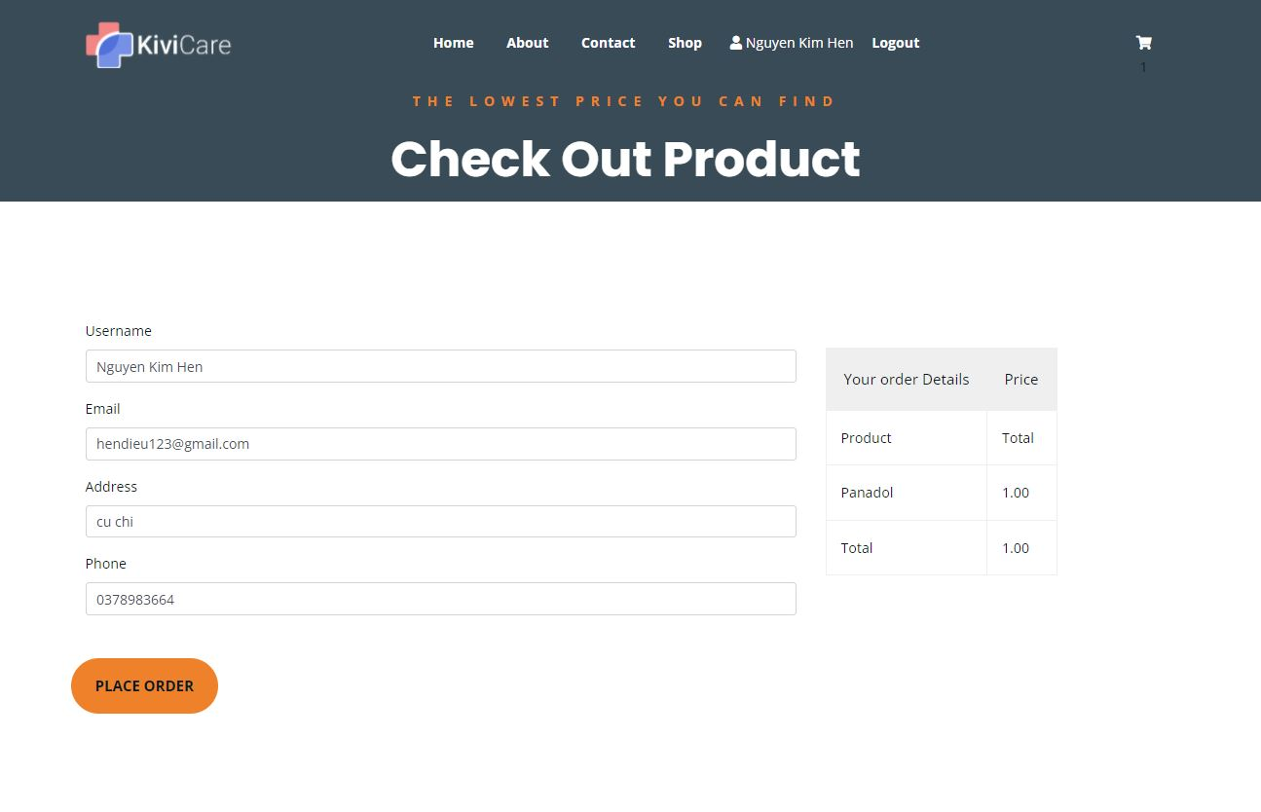

1. After click Place Order, guess will be redirect to thank you page and he/she will receive an email about the order.