CITY UNIVERSITY

HISTORY

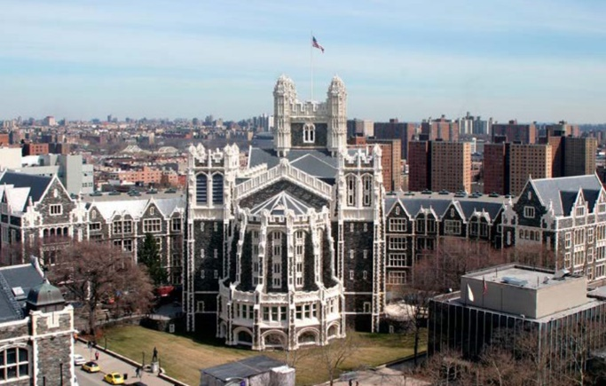

-The City University of New York begins in 1847 with the birth of the Free Academy, where “the children of the rich and the poor take their seats together,”

It has grown over the generations and has become a wonderful modern university with 25 campuses and half a million students.

SPORT

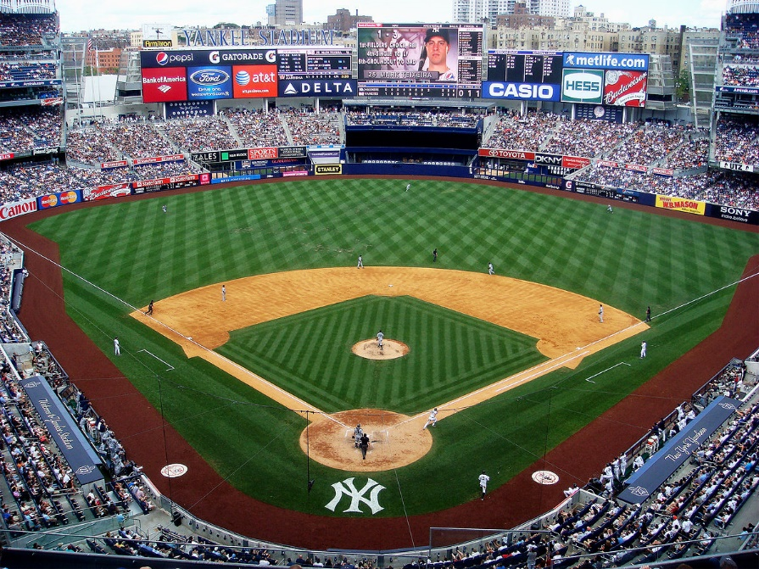

-CUNY has 14 diverse sports, including seven women's sports (volleyball, soccer, basketball, fencing, cross country and indoor and outdoor) and eight men's sports (soccer , cross country, basketball, baseball, volleyball, indoor and outdoor track and field, lacrosse [club]). Many of the school sports have a long history of success and championship, both at the individual and team level.

LIBRARY



-CUNY’s library system is a federation of 31 libraries and the CUNY Central Office of Library Services (OLS) that support learning, teaching, and research to the University’s 25 senior, community, honors, and professional colleges, as well as CUNY’s 100+ research centers and institutes

CANTEEN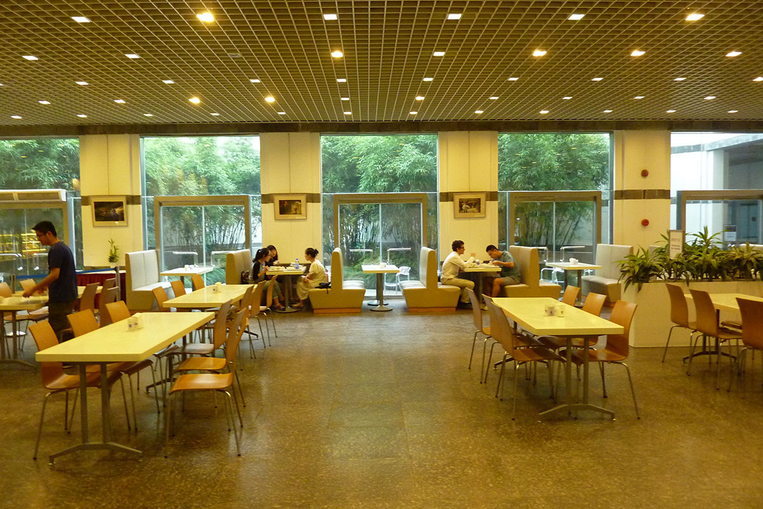

-CUNY does not provide its own food services, but instead relies on nonprofit organizations at each campus, typically known as auxiliary services corporations, which are affiliated with, but legally separate from, the university.

Number of students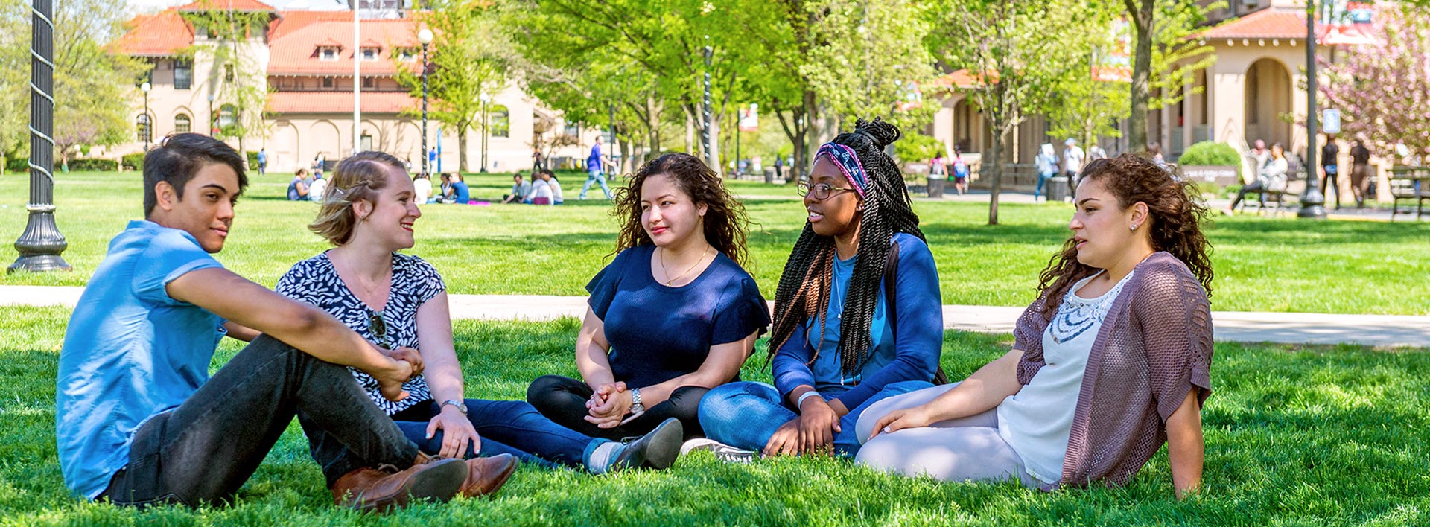

The successful applicant will have competed an academic, college-preparatory high school program.

Applicants: 27,788 Acceptance Rate: 47% Average HS GPA: 3.36

Availability of boardin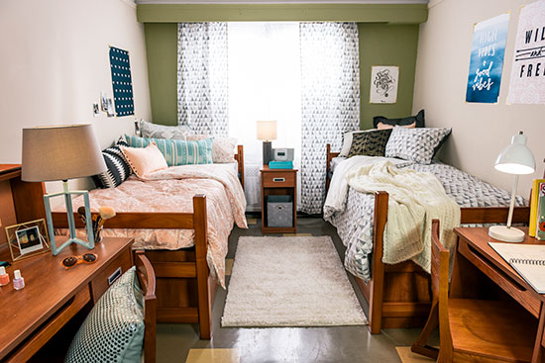

The Towers is City University’s modern on-site student residence conveniently located just a short walk from classrooms, laboratories and all student activities. Choose from several different room layouts and enjoy a safe, comfortable work, study, and living environment. Amenities include free Wi-Fi throughout the building, free modern laundry facilities, fitness center, outside grounds for sports or barbecues and many other comforts.

LOCATION