COLUMBIA UNIVERSITY

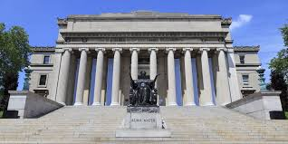HISTORY

-Columbia University (also known as Columbia, and officially as Columbia University in the City of New York) is a private Ivy League research university in New York City. Established in 1754 on the grounds of Trinity Church in Manhattan, Columbia is the oldest institution of higher education in New York and the fifth-oldest institution of higher learning in the United States. It is one of nine colonial colleges founded prior to the Declaration of Independence, seven of which belong to the Ivy League. Columbia is ranked among the top universities in the world by major education publications.

SPORT

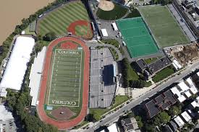

-The eight-institution athletic league to which Columbia University belongs, the Ivy League, also includes Brown University, Cornell University, Dartmouth College, Harvard University, University of Pennsylvania, Princeton University, and Yale University. The Ivy League conference sponsors championships in 33 men's and women's sports and averages 35 varsity teams at each of its eight universities.

**Men's sports**   **Women's sports**

Baseball Archery

Basketball Basketball

Soccer Soccer

Tennis Swimming and diving

Track and field... Tennis...

LIBRARY

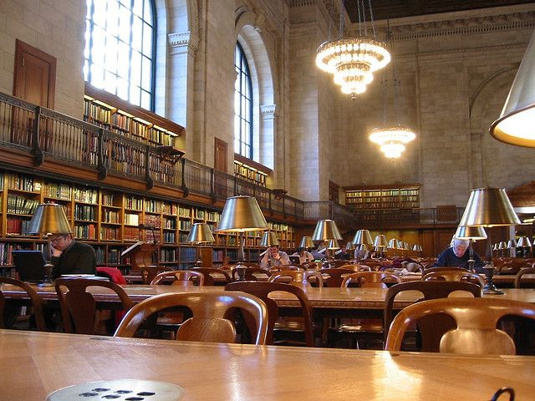

- Columbia University Libraries is the library system of Columbia University and is one of the top five academic library systems in North America and top ten largest libraries by volumes held.[1] With 11.9 million volumes, over 160,000 journals and serials, as well as extensive electronic resources, manuscripts, rare books, microforms, maps, and graphic and audio-visual materials, it is the fifth largest academic library in the United States and the largest academic library in the State of New York.

CATEEN

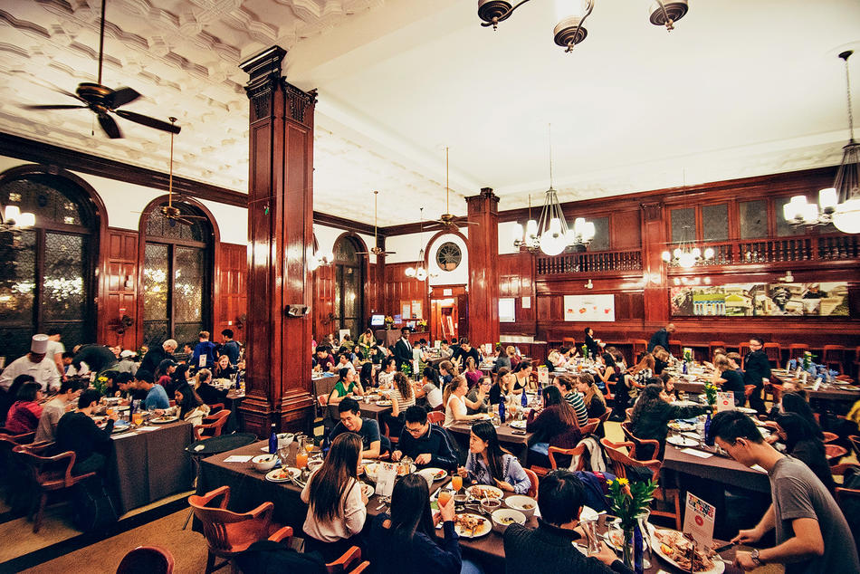-Columbia’s campus dining was recently judged by the Daily Meal to be the best in American higher education. The popular food website annually surveys more than two thousand colleges and ranks their dining halls based on the quality and variety of their offerings, their sustainability practices, and the community-building events they organize. The site’s editors praised Columbia’s chefs for “consistently proving to their students that the 600 menu items served on campus daily are just as good as, if not better than, anything else New York City has to offer.”

Number of students

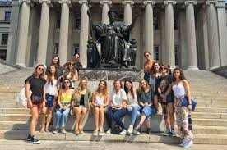

-Brown University had a total applicant pool of 30,432, marking the second largest applicant pool in Brown’s history .Out of those 30,432 applicants, 2,619 students were accepted to the Class of 2018.

Overall, Columbia experienced a 7% overall admissions rate and a 19.7% Early Decision admissions rate .

Availability of boarding

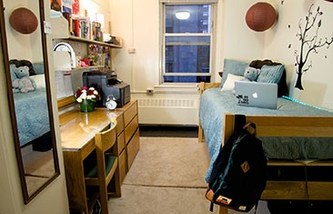

-All first-year students are housed in the Southfield section of campus, the heart of undergraduate life at Columbia. Proximity to Butler Library, Alfred Lerner Hall, John Jay Dining Hall, JJ's Place, and Columbia Health make these residence halls a convenient connection to the Columbia community.

Four different housing options are available to first-year students: Carman Hall, Furnald Hall, John Jay Hall, and the all-class integrated Living Learning Center in Wallach and Hartley Halls. Each hall has a unique set of features and benefits, from singles in corridor-style residences to shared doubles with an adjoining bathroom. Students should review each residence hall to learn more and help narrow down their preferences

LOCATION

