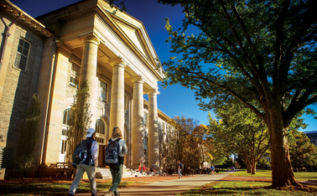CORNELL UNIVERSITY

HISTORY

Cornell University is one of the most famous universities in the US spe cializing in economic and technical training, Cornell is always present in the top 10 prestigious universities in the US and in the world. Field Type: Private Year of establishment: 1865 Number of students: 23,016 Address: Ithaca, New York State 14850, USA

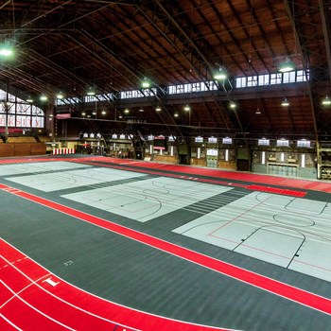SPORT

-The university sponsors 36 varsity sports, as well as numerous intramural and club teams. Cornell participates in NCAA Division I as part of the Ivy League.

**MEN'S SPORTS**   **WOMEN'S SPORTS**

Baseball Basketball

Basketball Cross country

Football Fencing

Sprint Football Soccer

Swimming & diving Squash

Tennis.... Swimming & diving ....

LIBRARY



-To serve the teaching, research and learning of faculty and students, this university has a very large library sy stem (including over 20 libraries; this system is classified into one of 10 systems. America's largest university-research library) with an enormous collect ion of over 7 million printed materials, including books and magazines. This is not to me ntion other types of material such as microforms (including microfilm = microfilm, microfiche = microfiche, etc.), audiovisual materials (non-book materials, AV materials, etc.), maps, etc . The largest library in this networ k is the Olin / Kroch Library (Asia Collection) with a total of over 3 million printed materials.

CANTEEN



-Cornell strive to help you strike the right balance—no matter your culture, your food preferences, or your best study environment. Cornell have what you need to nourish the mind and the body.

Locavore or farm-to-table gourmand? Need the flexibility to eat kosher, halal, gluten-free, or avoid specific allergens? Cornell's got more than 30 dining facilities that include a la carte and all-you-care-to-eat, all across campus

Number of student



-Cornell received more than 49,000 applications and admitted a total of 5,183 students, including early admission candidates, bringing its overall admission rate to 10.6 percent.

Availability of boarding

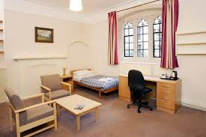

-Cornell's learning and living environment includes seventeen college halls of residence, comprising freshman, senior, and eight Cornell Program Houses and community communities. for Graduate and Professional students. Residential life at Cornell fosters intrinsic and personal values ​​in a friendly and welcoming community.

Location

