FORDHAM UNIVERSITY

HISTORY

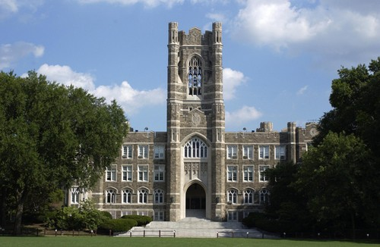

Established in 1841 and named for the Fordham neighborhood of the Bronx in which its original campus is located, Fordham is the oldest Catholic and Jesuit university in the northeastern United States, and the third-oldest university in New York State.

Sport

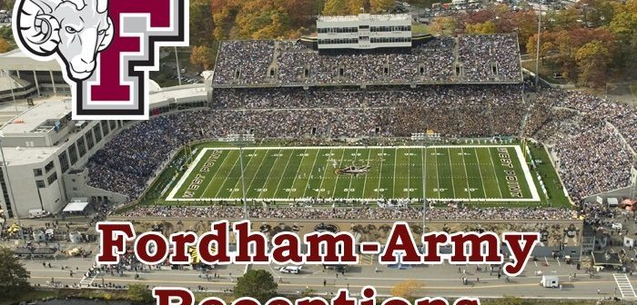

- The university's athletic teams, the Rams, include a football team that boasted a win in the Sugar Bowl, two Pro Football Hall of Famers, two All-Americans, two Canadian Football League All-Stars, and numerous NFL players.

LIBRARY



- Library architecture with ancient style, quiet, large space with many choices for students to freely explore

CANTEEN



The Law School offers the following food and dining options — undergraduate community dining facility, faculty and graduate dining facility, Ram Café, and Jazzman's Library Café.

Number of students



- Fordham enrolls approximately 15,300 students from more than 65 countries, and is composed of ten constituent colleges, four of which are undergraduate and six of which are postgraduate, across three campuses in southern New York State.

Availability of boarding



- In terms of residency: with facilities, students will be supported in the best way for residency.

Location

